

The International Committee on Taxonomy of Viruses
Taxonomy Proposal Form, 2025

Part 1a: Details of taxonomy proposals

Title: | Create 31 new species in the genera Ampelovirus, Closterovirus, Crinivirus, Olivavirus and Velarivirus and abolish one species in the genus Closterovirus
Code assigned: | 2025.019P.Ac,v3,Closteroviridae_31nsp_abolish_1sp

Author(s), affiliation and email address(es):
Given name (+middle initial(s)) | Surname | Affiliation | Email | Corr. author(s)
Nina | Aboughanem-Sabanadzovic | Institute for Genomics, Biocomputing and Biotechnology, Mississippi State University, Mississippi, USA | nja62@msstate.edu
Moshe | Bar-Joseph | Department of Plant Pathology & Weed Research, ARO-The Volcani Center, Rishon Lezion, Israel | mbjoseph@gmail.com
Thierry | Candresse | Université de Bordeaux, INRAE, UMR1332 BFP, Villenave d’Ornon, France | thierry.candresse@inrae.fr
Hano J | Maree | Department of Genetics, Stellenbosch University, South Africa | hjmaree@sun.ac.za
Michael | Melzer | Department of Plant and Environmental Protection Sciences, University of Hawaii, Honolulu, Hawaii, USA | melzer@hawaii.edu
Wulf | Menzel | Plant Virus Department, Leibniz Institute DSMZ, Braunschweig, Germany | Wulf.menzel@dsmz.de
Angelantonio | Minafra | Istituto per la Protezione Sostenibile delle Piante, CNR, Bari, Italy | angelantonio.minafra@cnr.it
Dimitre | Mollov | USDA APHIS PPQ, Beltsville, Maryland, USA | dimitre.mollov@usda.gov
Ioannis E | Tzanetakis | Department of Entomology and Plant Pathology, University of Arkansas, Fayetteville, Akansas, USA | itzaneta@uark.edu
Luisa | Rubino | Istituto per la Protezione Sostenibile delle Piante, CNR, Bari, Italy | luisa.rubino@cnr.it
Sead | Sabanadzovic | Department of Agricultural Science and Plant Protection. Mississippi State University, Mississippi State, Mississippi, USA | ssabanadzovic@entomology.msstate.edu | X

Part 1b: Taxonomy Proposal Submission
ICTV Subcommittee:
Animal DNA Viruses and Retroviruses |  | Bacterial viruses
Animal minus-strand and dsRNA viruses |  | Fungal and protist viruses
Animal positive-strand RNA viruses |  | Plant viruses | X
Archaeal viruses |  | General

List the ICTV Study Group(s) that have seen or have been involved in creating this proposal:
Closteroviridae SG

Optional – complete only if formally voted on by an ICTV Study Group:
Study Group | Number of members
Study Group | Votes in support | Votes against | No vote
Closteroviridae | 10 | 0 | 1

Submission date: | 25/06/2025

Part 1c: Feedback from ICTV Executive Committee (EC) meeting
Executive Committee Meeting Decision code: | X
A – Accept
Ac – Accept subject to revision by relevant subcommittee chair. No further vote required | X
U – Accept without revision but with re-evaluation and email vote by the EC
Uc – Accept subject to revision and re-evaluation and email vote by the EC
Ud – Deferred to the next EC meeting, with an invitation to revise based on EC comments
J - Reject
W - Withdrawn

Comments from the Executive Committee:
The EC voted Ac for this proposal (see the table above for explanation), to allow very minor revisions mainly concerning style issues.

Part 1d: Revised Taxonomy Proposal Submission
Response of proposer:
All the minor style issues have been addressed.

Revision date: | 28/08/2025

Part 3: TAXONOMIC PROPOSAL

Taxonomic changes proposed:
Establish new taxon | X | Split taxon
Abolish taxon | X | Merge taxon
Move taxon |  | Promote taxon
Rename taxon |  | Demote taxon
Move and rename

Etymology (origin) of proposed taxonomic names:
Taxon name | Etymology of the term
“Ampelovirus allamandae” | From host species name Allamanda cathartica
“Ampelovirus alpiniae” | From host species name Alpinia purpurata
“Ampelovirus unesculentae” | From Latin for number one and host species name Manihot esculenta
“Ampelovirus duesculentae” | From Latin for number two and host species name Manihot esculenta
“Ampelovirus unocitri” | From Latin for number one and common host name “citrus”
“Ampelovirus duocitri” | From Latin for number one and common host name “citrus”
“Ampelovirus odontonemae” | From host species name Odontonema strictum
“Ampelovirus pentananas” | From Latin for number five and the host species Ananas comosus
“Ampelovirus hexananas” | From Latin for number six and the host species Ananas comosus
“Ampelovirus septananas” | From Latin for number seven and the host species Ananas comosus
“Ampelovirus sacchari” | From host species name Saccharum officinarum
“Ampelovirus croton” | From common host name “Croton”
“Ampelovirus alphaolivae” | From the first letter of Greek alphabet and common host name “olive”
“Ampelovirus kaki” | From host species name Diospyros kaki
“Ampelovirus perseae” | From host species name Persea lingue
“Closterovirus alphafici” | From the first letter of Greek alphabet and genus of the host Ficus
“Closterovirus betafici” | From the second letter of Greek alphabet and genus of the host Ficus
“Closterovirus cnidi” | From the name of the host plant genus Cnidium
“Closterovirus duocarotae” | From Latin for “two” and host species name Daucus carota
“Closterovirus thesii” | From the name of the host plant genus Thesium
“Closterovirus stellariae” | From the name of the host plant genus Stellaria
“Closterovirus tritici” | From the name of the host plant genus Triticum
“Closterovirus dregeae” | From the name of the host plant genus Dregea
“Crinivirus kurdistanfragariae” | From geographic region (Kurdistan) and host genus Fragaria
“Crinivirus dioscoreae” | From the name of the host plant genus Dioscorea
“Crinivirus mori” | From the name of the host plant genus Morus
“Crinivirus papyriferae” | From the host species Broussonetia papyrifera
“Crinivirus arracaciae” | From the name of host plant genus Arracacia
“Olivavirus oleae” | From the name of host plant genus Olea
“Velarivirus agapanthi” | From the name of host plant genus Agapanthus
“Velarivirus oleae” | From the name of host plant genus Olea

Permission for use of names derived from a living person:
Taxon name | Full name of person from whom the name is derived | Attached

Abstract of Taxonomy Proposal:
Taxonomic rank(s) affected:
Genera Ampelovirus, Closterovirus, Crinivirus, Olivavirus and Velarivirus in the family Closteroviridae
Description of current taxonomy:
Family Closteroviridae is currently composed of seven genera that accommodate 58 species, most of which are classified in one of the four “traditional” genera: Closterovirus (17), Crinivirus (14), Ampelovirus (13) and Velarivirus (9). Two of three recently established genera (Bluvavirus and Menthavirus) are monospecific, while the genus Olivavirus includes 3 species.

Proposed taxonomic change(s):
We propose creation of 31 new species in the family based on recently published data on characterization of viruses with affinities with currently recognized members of the family Closteroviridae.

Justification:
During the search of GenBank, 31 viral genomes with required quality and completeness along with availability of a valid publication were selected as exemplar isolates for typifying proposed new species. All these viruses meet the molecular criteria for species demarcation in the genera as they differ in amino acid content of all 3 relevant virus-encoded proteins (HSP70h, RdRP and CP) with counterparts of 58 already recognized members of the family.

Text of Taxonomy proposal:
Taxonomic rank(s) affected:
Genera Ampelovirus, Closterovirus, Crinivirus, Olivavirus and Velarivirus in the family Closteroviridae

Description of current taxonomy:
The family Closteroviridae is a large and diverse group of filamentous plant viruses (particles of 650−2200 nm in length) with positive-sense (+) RNA genomes. Well-characterized members of the family can be naturally transmitted in a semi-persistent manner by aphids (closteroviruses), whiteflies (criniviruses), mealybugs or soft scales insects (ampeloviruses). The members of this family are known to affect several crops of major economic importance, such as sugar beet, citrus, tomato, lettuce, potato, sweet potato, grapevine, pineapple, cherry, and some ornamentals.

Currently, 58 virus species have been classified in the family Closteroviridae. They are grouped into the following seven genera: Ampelovirus (13 species), Bluvavirus (1 species), Closterovirus (17 species), Crinivirus (14 species), Menthavirus (1 species), Olivavirus (3 species) and Velarivirus (9 species).

Proposed taxonomic change(s):
In the recent years, numerous new viruses related to the recognized closterovirids have been discovered and characterized from various plant hosts. Characterization of these viruses was based mostly on their genomes by using high throughput sequencing approaches. Among the many of closterovirid-related nucleotide sequences available in the GenBank on May 1, 2025, we rigorously selected those with associated published literature in peer-reviewed journals, complete or coding-complete genome sequences, and identity levels of amino acid sequences of the three taxonomically-relevant gene product (HSP70h, CP and RdRP) below current demarcation criteria when compared with orthologs of recognized members in the family.

Therefore, we propose creation of 31 new species (15 in the genus Ampelovirus, 8 in the genus Closterovirus, 5 in the genus Crinivirus, 1 in the genus Olivavirus and 2 in the genus Velarivirus). Virus isolates used to represent newly proposed species along with proposed species nomenclature are listed Table 1. The placement of new members within the family is depicted by the phylogenetic tree presented in Figure 1, while pairwise identity levels are illustrated in Figure 2.

Additionally, because of insufficient characterization of burdock yellows virus [22], the lack of reference material making impossible genome sequencing and its comparison with other members, we propose to abolish the species Closterovirus flavarctii which is typified by this virus.

Demarcation criteria:
The currently valid species demarcation criteria in the family Closteroviridae are: (i) particle size, (ii) coat protein size, (iii) serological specificity, (iv) genome structure and organization, (v) more than 25%difference in amino acid sequence of the relevant gene products (CP, RdRp, HSP70h) among members of distinct species, (vi) vector species and specificity, (vii) natural host range, and (vii) cytopathological features [5].

Justification:
All these viruses meet the molecular criteria for species demarcation in the genera as they differ more than 25% in amino acid content of all 3 relevant virus-encoded proteins (HSP70h, RdRP and CP) with counterparts of 58 already recognized members of the family. Additionally, members of some new species were identified in plants previously not reported susceptible to closterovirids, thus furthering the knowledge on natural hosts for this group of filamentous viruses with large (+)RNA genomes.

References:
- Belete MT, Kim DY, Kim SH, Sun MJ. Molecular characterization and identification of Stellaria aquatica virus C, a novel putative member of the genus Closterovirus infecting Stellaria aquatica in South Korea. Arch Virol. 2024 Jun 24;169(7):153. doi: 10.1007/s00705-024-06070-y. PMID: 38913164.
- Che H, Gao S, Lin Y, Long H, Li Y, Cai L, Li S, Ma Y. Viromics Reveals Two Novel Viruses of the Family Closteroviridae in Codiaeum variegatum Plant with Leaf Variegation Symptoms. Plant Dis. 2025 Jan;109(1):115-122. doi: 10.1094/PDIS-05-24-1013-RE. Epub 2025 Jan 1. PMID: 39215501.
- Che H, Ma Y, Wu Y, Long H. Identification and molecular characterization of two novel viruses from Allamanda cathartica in China. Arch Virol. 2024 May 16;169(6):124. doi: 10.1007/s00705-024-06041-3. PMID: 38753064.
- de Souza J, Fuentes S., Müller, G.; Gamarra, H.; Guzmán, M.; Cuellar, W.; Kreuze J. High throughput sequencing for the detection and characterization of new virus found in arracacha (Arracacia xanthorrhiza). Scientia Agropecuaria 2021:12(4). 471–480.
- Fuchs M, Bar-Joseph M, Candresse T, Maree HJ, Martelli GP, Melzer MJ, Menzel W, Minafra A, Sabanadzovic S, Report Consortium I. ICTV Virus Taxonomy Profile: Closteroviridae. J Gen Virol. 2020 Apr;101(4):364-365. doi: 10.1099/jgv.0.001397. Epub 2020 Mar 5. PMID: 32134375
- Gogile A, Knierim D, Margaria P, Menzel W, Abide M, Kebede M, Kidanemariam D, Abraham A. White yam (Dioscorea rotundata) plants exhibiting virus-like symptoms are co-infected with a new potyvirus and a new crinivirus in Ethiopia. Virus Genes. 2024 Aug;60(4):423-433. doi: 10.1007/s11262-024-02077-4. Epub 2024 Jun 4. PMID: 38833150.
- Gudeta WF, Belete MT, Igori D, Kim SE, Moon JS. Complete genome sequence of cnidium closterovirus 1, a novel member of the genus Closterovirus infecting Cnidium officinale. Arch Virol. 2022 Jun;167(6):1491-1494. doi: 10.1007/s00705-022-05448-0. Epub 2022 Apr 26. PMID: 35474497.
- Hajizadeh M, Zandan NG, Koloniuk I, Sierra-Mejia A, Tzanetakis IE. Characterization, Detection, and Prevalence of a Novel Strawberry Crinivirus. Plant Dis. 2025 May;109(5):988-991. doi: 10.1094/PDIS-08-24-1682-SC. Epub 2025 May 18. PMID: 39636284.
- Hoang DT, Chernomor O, von Haeseler A, Minh BQ, Vinh LS. UFBoot2: Improving the Ultrafast Bootstrap Approximation. Mol Biol Evol. 2018;35(2):518-522. doi:10.1093/molbev/msx281 PMID: 29077904.
- Ito T, Sato A. Three novel viruses detected from Japanese persimmon ‘Reigyoku’ associated with graft-transmissible stunt. Eur J Plant Pathol, 2020;158: 163–175. https://doi.org/10.1007/s10658-020-02063-0
- Kalyaanamoorthy S, Minh BQ, Wong TKF, von Haeseler A, Jermiin LS. ModelFinder: fast model selection for accurate phylogenetic estimates. Nat Methods. 2017 Jun;14(6):587-589. doi: 10.1038/nmeth.4285. Epub 2017 May 8. PMID: 28481363.
- Kondo H, Sugahara H, Fujita M, Hyodo K, Andika IB, Hisano H, Suzuki N. Discovery and Genome Characterization of a Closterovirus from Wheat Plants with Yellowing Leaf Symptoms in Japan. Pathogens. 2023 Feb 21;12(3):358. doi: 10.3390/pathogens12030358. PMID: 36986280.
- Kwibuka Y, Bisimwa E, Blouin AG, et al. Novel Ampeloviruses Infecting Cassava in Central Africa and the South-West Indian Ocean Islands. Viruses. 2021;13(6):1030. Published 2021 May 29. doi:10.3390/v13061030 PMID: 34072594
- Larrea-Sarmiento AE, Olmedo-Velarde A, Wang X, et al. Genetic Diversity of Viral Populations Associated with Ananas Germplasm and Improvement of Virus Diagnostic Protocols. Pathogens. 2022;11(12):1470. Published 2022 Dec 5. doi:10.3390/pathogens11121470 PMID: 36558805.
- Larrea-Sarmiento AE, Galanti R, Olmedo-Velarde A, et al. Characterization of Two Novel Viruses Within a Complex Virome from Flowering Ginger in Hawaii. Plant Dis. 2024;108(10):3001-3009. doi:10.1094/PDIS-10-23-2181-RE PMID: 39327791.
- Letunic I, Bork P. Interactive Tree of Life (iTOL) v6: recent updates to the phylogenetic tree display and annotation tool. Nucleic Acids Res. 2024;52(W1):W78-W82. doi:10.1093/nar/gkae268 PMID: 38613393.
- Li S, Anane RF, Chen Z, Duan C, Wang Z, Gao L, Yu D, Chu B, Yang Z, Wen G, Zhao M. Complete genome sequence of a novel closterovirus isolated from Dregea volubilis. Arch Virol. 2023 May 5;168(5):154. doi: 10.1007/s00705-023-05775-w. PMID: 37145182.
- Liu Q, Zhang S, Mei S, et al. Viromics unveils extraordinary genetic diversity of the family Closteroviridae in wild citrus. PLoS Pathog. 2021;17(7):e1009751. Published 2021 Jul 12. doi:10.1371/journal.ppat.1009751 PMID: 34252150
- Massé D, Candresse T, Filloux D, Massart S, Cassam N, Hostachy B, Marais A, Fernandez E, Roumagnac P, Verdin E, Teycheney PY, Lett JM, Lefeuvre P. Characterization of Six Ampeloviruses Infecting Pineapple in Reunion Island Using a Combination of High-Throughput Sequencing Approaches. Viruses. 2024 Jul 16;16(7):1146. doi: 10.3390/v16071146. PMID: 39066307.
- Mollov D, Filloux D, Grinstead S, Bolus S, Claude L, Fernandez, Julian C, Candresse T, Lockhart B, Roumagnac P, Rott P, Daugrois JH. Sugarcane milc mosaic virus: The rediscovery of and identified but unrecognized virus. Plant Pathol. 2023; 72:312-321. . 2023; 72:312-321. https://doi.org/10.1111/ppa.13654
- Muhire BM, Varsani A, Martin DP. SDT: a virus classification tool based on pairwise sequence alignment and identity calculation. PLoS One. 2014 Sep 26;9(9):e108277. doi: 10.1371/journal.pone.0108277. PMID: 25259891.
- Nakano M, Inouye T. Burdock yellows virus, a closterovirus from Arctium lappa L. Ann Phytopath Soc. Japan 1980;46:7-14.
- Nguyen LT, Schmidt HA, von Haeseler A, Minh BQ. IQ-TREE: a fast and effective stochastic algorithm for estimating maximum-likelihood phylogenies. Mol Biol Evol. 2015;32(1):268-274. doi:10.1093/molbev/msu300 PMID: 25371430.
- Park D, Goh CJ, Hahn Y. Two novel closteroviruses, fig virus A and fig virus B, identified by the analysis of the high-throughput RNA-sequencing data of fig (Ficus carica) latex. Acta Virol. 2021;65(1):42-48. DOI: 10.4149/av_2021_104 PMID: 33151734
- Read DA, Pietersen G, Slippers B, Steenkamp E. Genomic characterization of novel viruses associated with Olea europaea L. in South Africa. Arch Virol. 2024 Sep 27;169(10):210. doi: 10.1007/s00705-024-06132-1. PMID: 39327328.
- Read DA, Roberts R, Swanevelder D, Pietersen G, Thompson GD. Novel viruses associated with plants of the family Amaryllidaceae in South Africa. Arch Virol. 2021 Oct;166(10):2817-2823. doi: 10.1007/s00705-021-05170-3. Epub 2021 Jul 19. PMID: 34279720.
- Ruiz-García AB, Candresse T, Malagón J, Ruiz-Torres M, Paz S, Pérez-Sierra A, Olmos A. Olive Leaf Mottling Virus: A New Member of the Genus Olivavirus. Plants (Basel). 2024 Aug 17;13(16):2290. doi: 10.3390/plants13162290. PMID: 39204726.
- Schönegger D, Marais A, Babalola BM, et al. Carrot populations in France and Spain host a complex virome rich in previously uncharacterized viruses. PLoS One. 2023;18(8):e0290108. Published 2023 Aug 16. doi:10.1371/journal.pone.0290108 PMID: 37585477
- Shin C, Choi D, Shirasu K, Ichihashi Y, Hahn Y. A novel RNA virus, Thesium chinense closterovirus 1, identified by high-throughput RNA-sequencing of the parasitic plant Thesium chinense. Acta Virol. 2022;66(3):206-215. doi:10.4149/av_2022_302 PMID: 36029083
- Wang Y, Song Y, Wang Y, Cao M, Hu T, Zhou X. Discovery and Characterization of a Novel Ampelovirus on Firespike. Viruses. 2020;12(12):1452. Published 2020 Dec 16. doi:10.3390/v12121452 PMID: 33339381
- Zamorano A, Gamboa C, Camilla C, Beltrán F, Magni C, Vaswani S, Martínez-Herrera E, Fiore N. A New Species of Ampelovirus Detected in Persea lingue (Ruiz & Pav.) Nees ex Kopp, a Common Tree of the Threatened Chilean Sclerophyll Forest. Forests. 2023; 14(6):1257. https://doi.org/10.3390/f14061257
- Zhang P, Han TT, Tang JX, Zhong K, Ma Y, Smith WK, Zhao WG, Lu QY. Whole genome sequence of mulberry crinivirus, a new member of the genus Crinivirus. Arch Virol. 2023 Jan 7;168(2):50. doi: 10.1007/s00705-022-05657-7. PMID: 36609709.
- Zhang S, Yang C, Qiu Y, Liao R, Xuan Z, Ren F, Dong Y, Xie X, Han Y, Wu D, Ramos-González PL, Freitas-Astúa J, Yang H, Zhou C, Cao M. Conserved untranslated regions of multipartite viruses: Natural markers of novel viral genomic components and tags of viral evolution. Virus Evol. 2024 Jan 12;10(1):veae004. doi: 10.1093/ve/veae004. PMID: 38361819

Accompanying files:
Filename | Description of contents
2025.019P.A.v1.Closteroviridae_31nsp_abolish_1sp

Tables, Figures:
<Start here>

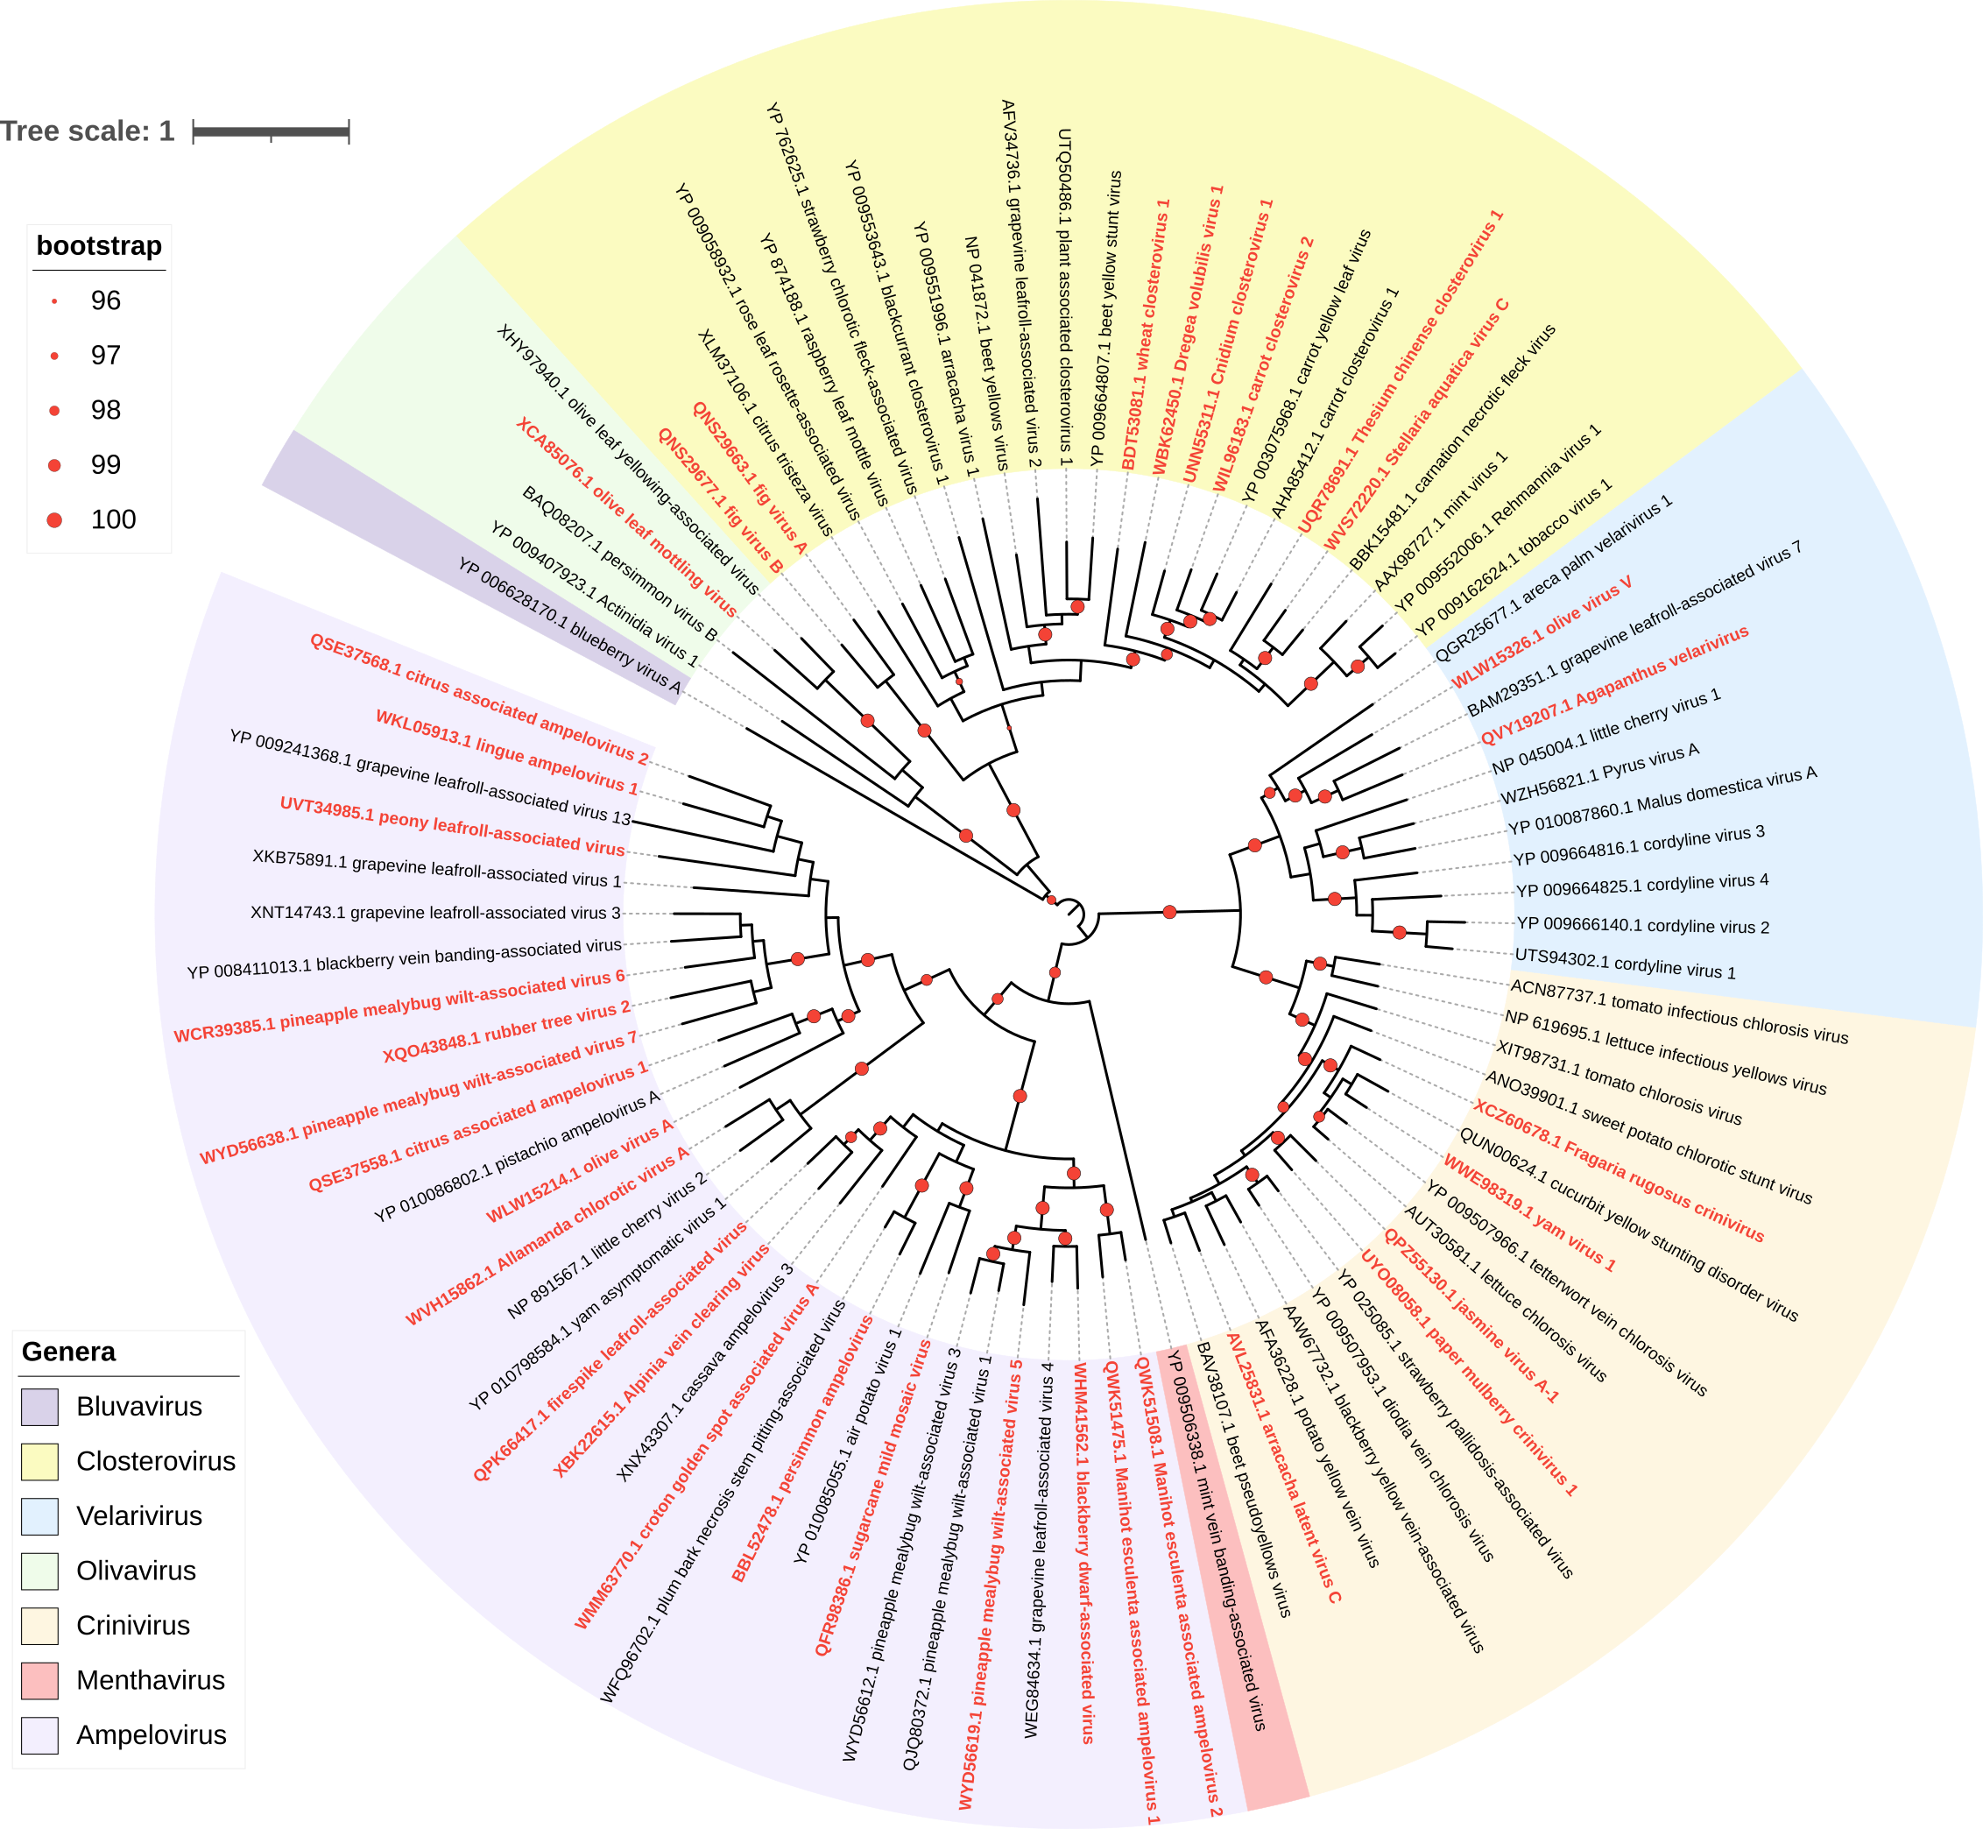Figure 1. Phylogenetic tree showing reorganized family Closteroviridae with viruses representing proposed new species reported in red bold font. Maximum-likelihood phylogenetic tree was constructed on the MAFFT-aligned amino acid sequences of HSP70 protein using IQ-TREE v 1.6.11 [23] with the 1,000 replicates ultrafast bootstrap [9] under best-fit model “LG+F+I+G4” according to BIC as estimated by ModelFinder [11] and visualized with iTOL v7 [16]. The GenBank accession numbers of HSP70h proteins used for analyses along with virus names are indicated at the tips of branches. Presence of red dot on branching point indicates statistical support of >90% with size corresponding to level of bootstrap values. Different genera in the family are color-coded. 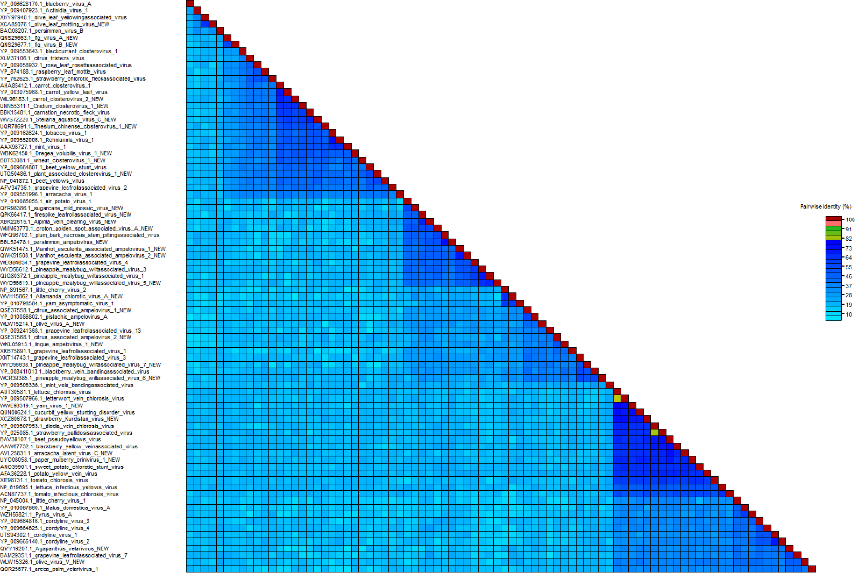

Figure 2. Pairwise identity matrix among the members of the family Closteroviridae based on the HSP70h amino acid sequences. The viruses representing 30 new species are included. The matrix was created in SDT v1.3 [21] on the sequences aligned with ClustalW. Color code key indicating % identities is presented.

Table 1. List of the proposed new species in the family with representative isolates and corresponding GenBank accessions and associated publication.

Genus | Species name | Virus name | GenBank | Ref
Ampelovirus | Ampelovirus allamandae | Allamanda chlorotic virus A | PP212980 | 3
 | Ampelovirus alpiniae | Alpinia vein clearing virus | OQ550018 | 15
 | Ampelovirus unesculentae | Manihot esculenta associated ampelovirus 1 | MT773586 | 13
 | Ampelovirus duesculentae | Manihot esculenta associated ampelovirus 2 | MT773592 | 13
 | Ampelovirus unocitri | citrus associated ampelovirus 1 | MW365401 | 18
 | Ampelovirus duocitri | citrus associated ampelovirus 2 | MW365402 | 18
 | Ampelovirus odontonemae | firespike leafroll-associated virus | MW147758 | 30
 | Ampelovirus pentananas | pineapple mealybug wilt-associated virus 5 | OQ850040 | 19
 | Ampelovirus hexananas | pineapple mealybug wilt-associated virus 6 | OP860296 | 14
 | Ampelovirus septananas | pineapple mealybug wilt-associated virus 7 | OQ850042 | 19
 | Ampelovirus sacchari | sugarcane mild mosaic virus | MN116751 | 20
 | Ampelovirus croton | croton golden spot associated virus A | OR041673 | 2
 | Ampelovirus alphaolivae | olive virus A | OQ863254 | 25
 | Ampelovirus kaki | persimmon ampelovirus | LC488185 | 10
 | Ampelovirus perseae | lingue ampelovirus 1 | OQ805851 | 31
Closterovirus | Closterovirus alphafici | fig virus A | MN817232 | 24
 | Closterovirus betafici | fig virus B | MN817233 | 24
 | Closterovirus cnidi | Cnidium closterovirus 1 | OL804208 | 7
 | Closterovirus duocarotae | carrot closterovirus 2 | OP886455 | 28
 | Closterovirus thesii | Thesium chinense closterovirus 1 | OM801605 | 29
 | Closterovirus stellariae | Stellaria aquatica virus C | PP280820 | 1
 | Closterovirus tritici | wheat closterovirus 1 | LC735716 | 12
 | Closterovirus dregeae | Dregea volubilis virus 1 | MZ779122 | 17
Crinivirus | Crinivirus kurdistanfragariae | strawberry Kurdistan virus | OR387513-4 | 8
 | Crinivirus dioscoreae | yam virus 1 | PP378481-3 | 6
 | Crinivirus mori | mulberry crinivirus | ON931610-11 | 32
 | Crinivirus papyriferae | paper mulberry crinivirus 1 | OL344036-7 | 33
 | Crinivirus arracaciae | arracacha latent virus C | KY451034-5 | 4
Olivavirus | Olivavirus oleae | olive leaf mottling virus | PP869314 | 27
Velarivirus | Velarivirus agapanthi | Agapanthus velarivirus | MT533601 | 26
 | Velarivirus oleae | olive virus V | OQ863266 | 25

