

The International Committee on Taxonomy of Viruses
Taxonomy Proposal Form, 2025

Part 1a: Details of taxonomy proposals

Title: | Create one (1) new genus containing nine (9) new species in the family Tombusviridae
Code assigned: | 2025.018P.Ac.v3.Tombusviridae_1ng_9nsp

Author(s), affiliation and email address(es):
Given name (+middle initial(s)) | Surname | Affiliation | Email address | Corr. author(s)
W. Allen | Miller | Plant Pathology, Entomology & Microbiology Dept., Iowa State University, Ames, USA | wamiller@iastate.edu | X
Zachary | Lozier | Plant Pathology, Entomology & Microbiology Dept., Iowa State University, Ames, USA | zlozier@iastate.edu

Part 1b: Taxonomy Proposal Submission
ICTV Subcommittee:
Animal DNA Viruses and Retroviruses |  | Bacterial viruses
Animal minus-strand and dsRNA viruses |  | Fungal and protist viruses
Animal positive-strand RNA viruses |  | Plant viruses | X
Archaeal viruses |  | General -

List the ICTV Study Group(s) that have seen or have been involved in creating this proposal:
Tombusviridae
Optional – complete only if formally voted on by an ICTV Study Group
Study Group | Number of members
Study Group | Votes in support | Votes against | No vote

Submission date: | 05/06/2025

Part 1c: Feedback from ICTV Executive Committee (EC) meeting
Executive Committee Meeting Decision code: | X
A – Accept
Ac – Accept subject to revision by relevant subcommittee chair. No further vote required | X
U – Accept without revision but with re-evaluation and email vote by the EC
Uc – Accept subject to revision and re-evaluation and email vote by the EC
Ud – Deferred to the next EC meeting, with an invitation to revise based on EC comments
J - Reject
W - Withdrawn

Comments from the Executive Committee:
The EC voted Ac for this proposal. Difficult proposal because no consensus in SG.
Scientifically proposal is fine. First non-plant genus coming from metagenomics.

Very minor revisions mainly concerning style issues.

Part 1d: Revised Taxonomy Proposal Submission
Response of proposer:
All style-related suggestions were accepted.

Revision date: | 28/08/2025

Part 3: TAXONOMIC PROPOSAL

Taxonomic changes proposed:
Establish new taxon | X | Split taxon
Abolish taxon |  | Merge taxon
Move taxon |  | Promote taxon
Rename taxon |  | Demote taxon
Move and rename

Etymology (origin) of proposed taxonomic names:
Taxon name | Etymology of the term
“Rimosavirus” | Rimosa = Latin for leaky, as in leaky scanning and leaky stop codons.
“Rimosavirus zeae” | Associated with Zea mays
“Rimosavirus plasmoparae” | Associated with Plasmopara viticola
“Rimosavirus haemaphysalis” | Associated with Haemaphysalis longicornis (Table 1)
“Rimosavirus rhipicephali” | Associated with Rhipicephalus sanguineus (Table 1)
“Rimosavirus unhubeiense” | Found in Hubei province, China
“Rimosavirus duohubeiense” | Found in Hubei province, China
“Rimosavirus brassicae” | Associated with Brassica caulorapa
“Rimosavirus zizaniae” | Associated with Zizania latifolia
“Rimosavirus sphenodonis” | Associated with Sphenodon punctatus (Table 1)

Permission for use of names derived from a living person:
Taxon name | Full name of person from whom the name is derived | Attached

Abstract of Taxonomy Proposal:
Taxonomic rank(s) affected:
Subfamily Procedovirinae in the family Tombusviridae

Description of current taxonomy:
Currently there are 19 genera and 93 species in the family Tombusviridae. Genera are grouped based on genome organization and sequence similarities of RNA-dependent RNA polymerase (RdRp).

Proposed taxonomic change(s):
Create one new genus in the subfamily Procedovirinae, called “Rimosavirus”, and classify nine new viruses (maize-associated rimosavirus 1 (MaRV1), Plasmopara viticola lesion-associated rimosavirus 1 (PVLaRV1), Taian Tombu tick-associated virus 1 (TTTaV1), Nanning Tombu tick-associated virus 1 (NTTaV1), Hubei rimosavirus 2 (HubRV2), Brassica caulorapa-associated rimosavirus 1 (BCaRV1), Zizania latifolia-associated rimosavirus 1 (ZLaRV1), Hubei rimosavirus 1 (HubRV1), tuatara cloaca-associated rimosavirus 1 (TCaRV1) into nine new species in the genus “Rimosavirus”.

Justification:
All members of the proposed genus have RdRp sequences more similar to those of other tombusvirids than to viruses in other families, but they diverge from those of other tombusvirid genera by as much as the RdRps in different established genera diverge from each other. Secondly, the “Rimosavirus” genome organizations feature tombusvirid-like characteristics such as probable translation of the RdRp (ORF2) by readthrough of a leaky stop codon (placing rimosaviruses in the Procedovirinae) and an intergenic region between ORF2 and the coat protein (CP)-encoding ORF (ORF3). Genomes in the proposed genus differ from other tombusvirids by having (i) a predicted 5’ untranslated region (UTR) over 400 nt long and containing AUGs, (ii) a possible ORF (ORF4) overlapping with ORF3 starting upstream of ORF3. This would be the first genus to combine translation of the RdRp by translational readthrough (which defines members of the Procedovirinae subfamily), with a luteovirus-like readthrough of the ORF3 stop codon.

Text of Taxonomy proposal:
Taxonomic rank(s) affected:
Subfamily Procedovirinae in the family Tombusviridae

Description of current taxonomy:
Currently, there are 19 genera and 93 species in the family Tombusviridae. Tombusvirids have a single positive sense, uncapped, non-polyadenylated genomic RNA of about 4 to 7 kb, with the exception of genus Dianthovirus which has a bipartite genome. With the exception of genus Umbravirus, which encodes no coat protein (CP), tombusvirids form icosahedral T=3 virions. The 5’ proximal two open reading frames (ORFs 1 and 2) encode a replication protein and the RdRp, respectively. ORF2 is translated via ribosomal frameshifting or readthrough of the ORF1 stop codon. Genus Machlomovirus encodes an additional ORF that overlaps with the 5’ end of ORF1 [1]. With the exception of the proposed genus “Rimosavirus”, the 5’ untranslated region (UTR) ranges from about 10 to 142 nt long and contains no AUGs. The 3’ UTR harbors a cap-independent translation element (3’ CITE) at its 5’ end [2] and terminates in CCC at the 3’ end of the viral genome [3]. The ORFs encoding CP and movement proteins are translated from 3’-coterminal subgenomic mRNA(s). Genera are grouped based on genome organization and sequence similarities of RNA-dependent RNA polymerase (RdRp).

Proposed taxonomic change(s):
Create one new genus in the Tombusviridae family called “Rimosavirus”.
Reason for name: Rimosa = “leaky” or “cracked” in Latin. Genomes of viruses in this genus are predicted to have two leaky stop codons (ORFs 1 and 3) and a start codon translated via leaky scanning (ORF3). Also, the name “Rimosavirus” is pleasing to the ear.

Create nine new virus species in genus “Rimosavirus”: “Rimosavirus zeae”, “Rimosavirus plasmoparae”, “Rimosavirus haemaphysalis”, “Rimosavirus rhipicephali”, “Rimosavirus unhubeiense”, “Rimosavirus duohubeiense”, “Rimosavirus brassicae”, Rimosavirus zizaniae”, “Rimosavirus sphenodonis”.

Acronyms, GenBank accession numbers, references and other details are provided in Table 1. Virus names are those provided by original authors (Table 1) with the following changes: (i) tombusvirus or tombus-like virus was replaced with “rimosavirus”, (ii) “associated” was added to the name if not already present, as none of the viruses are known to infect the organism with which they are associated, (iii) a number was added if not in original name in the event that another virus of same genus is identified in the same organism. Species are named for the genus of the organism in which the virus was found, except for “Rimosavirus unhubeiense” and “Rimosavirus duohubeiense”, which are named for the location at which the sequence was found.

“Rimosaviruses” are known only by their genome sequences. All nine “rimosaviruses” were discovered in metagenomics projects by deep sequencing of total RNA associated with the indicated organism (references in Table 1). Other tombusvirids infect only plants, even though many tombusvirid sequences have been found in various animals [4]. Thus, it is unlikely that the “rimosaviruses” associated with invertebrates or a vertebrate infect that organism. No virus particles, disease symptoms, or actual host species capable of supporting virus replication have been reported for any “rimosavirus”.

Demarcation criteria:
To demarcate the genus from other tombusvirid genera, we used the depth of branches in the phylogenetic tree comparing RdRp sequences (Fig. 2). We note that the junction of the branch that includes all the “rimosaviruses” with that of the closest non-rimosa relative (oat chlorotic stunt virus, OCSV) is deeper than many of the branches that separate several other tombusvirid genera from each other, such as the Luteovirus and Dianthovirus genera, and the cluster that includes the Betacarmovirus, Tralespevirus, Alphacarmovirus and Pelarspovirus genera. Secondly, all “rimosaviruses” have a similar genome organization (Fig. 1), which differs from those of all other tombusvirids, including the closest relative OCSV.

No species demarcation criteria exist for this genus, but if we require that the amino acid sequence of at least one protein differs by more than 20% from the homolog in its nearest relative as the cutoff to qualify as a distinct species, then all nine proposed species fit this criterion (genus Luteovirus requires only >10% difference.) As shown in Table 2, the highest amino acid identity between the CP sequences of any of the “rimosaviruses” is 71.1% between MaRV1 and PVLaRV1. Interestingly, the RdRps of BCaRV1 and ZLaRV1 differ by only four amino acids (99.34% identity, see Fig. 2), yet their CPs share only 41.6% identity, justifying their classification as separate species.

Justification:
Genus “Rimosavirus” belongs in Tombusviridae, based on (i) similar RdRp sequence (Fig. 2), (ii) predicted translation of ORFs1-2 via in-frame stop codon readthrough, mediated by tombusvirid-like long-distance base pairing between RNA structures adjacent to the stop codon and in the 3’ UTR [5, 6]. This applies to tombusvirids in the Procedovirinae subfamily. (iii) An intergenic region following ORF2 that is followed by other ORFs including one predicted to encode CP (ORF3).

The virus species in genus “Rimosavirus” differ from those in other genera as follows. (i) The RdRp sequences diverge from those of other genera by as much as the RdRps in different established genera diverge from each other (Fig. 2). (ii) The genome has both in-frame readthrough for translation of the RdRp, and a readthrough domain of the coat protein ORF. The only other genus with a CP readthrough domain is Luteovirus, and in those viruses the RdRp is translated via -1 ribosomal frameshifting. (iii) Only genomes in genus “Rimosavirus” have a 5’ end of >400 nt that contains numerous AUG triplets (unlikely to be translated) upstream of ORF1. (iv) Only genus “Rimosavirus” harbors an ORF (ORF4) that overlaps with the CP ORF (ORF3) starting upstream of ORF3 and which may initiate with a non-AUG start codon (Fig. 1) [5]. Genus Luteovirus has an ORF that overlaps with ORF3, but it initiates with an AUG downstream of the ORF3 start codon.

References:
[1] Carino EJ, Scheets K, Miller WA (2020) The RNA of maize chlorotic mottle virus - an obligatory component of maize lethal necrosis disease - is translated via a variant panicum mosaic virus-like cap-independent translation element. J Virol 94, e01005-20.
[2] Simon AE, Miller WA (2013) 3' cap-independent translation enhancers of plant viruses. Annu Rev Microbiol 67, 21-42.
[3] Pogany J, Fabian MR, White KA, Nagy PD (2003) A replication silencer element in a plus-strand RNA virus. Embo J 22, 5602-5611.
[4] Li L, Victoria JG, Wang C, Jones M, Fellers GM, Kunz TH, Delwart E (2010) Bat guano virome: predominance of dietary viruses from insects and plants plus novel mammalian viruses. J Virol 84, 6955-6965.
[5] Lozier Z, Hill L, Semmann E, Miller WA (2024) A proposed new Tombusviridae genus featuring extremely long 5’ untranslated regions and a luteo/polerovirus-like gene block. Front Virol 4:1422934. doi: 10.3389/fviro.2024.1422934
[6] Cimino PA, Nicholson BL, Wu B, Xu W, White KA (2011) Multifaceted regulation of translational readthrough by RNA replication elements in a tombusvirus. PLoS Pathogens 7, e1002423.
[7] Lappe RR, Elmore MG, Lozier ZR, Jander G, Miller WA, Whitham SA (2022). Metagenomic identification of novel viruses of maize and teosinte in North America. BMC Genomics 23, 767.
[8] Waller SJ, Lamar S, Perry BJ, Grimwood RM, Holmes EC, Geoghegan JL (2022) Cloacal virome of an ancient host lineage – The tuatara (Sphenodon punctatus) – Reveals abundant and diverse diet-related viruses. Virology 575, 43-53.
[9] Chiapello M, Rodríguez-Romero J, Ayllón MA, Turina M. (2020) Analysis of the virome associated to grapevine downy mildew lesions reveals new mycovirus lineages. Virus Evol 6, veaa058.
[10] Ni X-B, Cui X-M, Liu J-Y, Ye R-Z, Wu Y-Q, Jiang, J-F, Sun Y, Wang Q, Shum, M.H.-H., Chang, Q.-C., Zhao, L., Han, X.-H., Ma, K., Shen, S.-J., Zhang, M.-Z., Guo, W.-B., Zhu, J.-G., Zhan, L., Li, L.-J., Ding, S.-J., Zhu, D.-Y., Zhang, J., Xia, L.-Y., Oong, X.-Y., Ruan, X.-D., Shao, H.-Z., Que, T.-C., Liu, G.-Y., Du, C.-H., Huang, E.-J., Wang, X., Du, L.-F., Wang, C.-C., Shi, W.-Q., Pan, Y.-S., Zhou, Y.-H., Qu, J.-L., Ma, J., Gong, C.-W., Chen, Q.-Q., Qin, Q.; Tick Genome and Microbiome Consortium (TIGMIC); Lam, T.T.-Y., Jia, N., Cao, W.-C. (2023). Metavirome of 31 tick species provides a compendium of 1,801 RNA virus genomes. Nature Microbiology 8, 162-173.
[11] Shi M, Lin X-D, Tian J-H, Chen L-J, Chen X, Li C-X, Qin X-C, Li J, Cao J-P, Eden J-S, Buchmann J, Wang W, Xu J, Holmes EC, Zhang Y-Z (2016) Redefining the invertebrate RNA virosphere. Nature 540, 539-543.
[12] Yang S, Mao Q, Wang Y, He J, Yang J, Chen X, Xiao Y, He Y, Zhao M, Lu J, Yang Z, Dai Z, Liu Q, Yao Y, Lu X, Li H, Zhou R, Zeng J, Li W, Zhou C, Wang X, Shen Q, Xu H, Deng X, Delwart E, Shan T, Zhang W. (2022) Expanding known viral diversity in plants: virome of 161 species alongside an ancient canal. Environmental Microbiome 17, 58.
[13] Desalle R, Narechania A, Tessler M (2023) Multiple outgroups can cause random rooting in phylogenomics. Molecular Phylogenetics and Evolution 184, 107806.

Accompanying files:
Filename | Description of contents
2025.018P_RimosavirusesHiRes+SupplFrontVirol24.pdf | Publication [5] describing features of viral genomes in the proposed “Rimosavirus” genus in much more detail.
2025.018P.A.v1.Tombusviridae_1ng_9nsp | spreadsheet

Tables, Figures:

Viral genome | Acronym | Organismª | Locationª | GenBank no. | Referenceª
maize-associated rimosavirus 1 | MaRV1 | maize, teosinte  tuatara^{b} | Irapuato, Mexico;  Takpourewa, New Zealand | OK018181.2 ^{C}  OK018182.1 | [7, 8]
Plasmopara viticola lesion-associated rimosavirus 1 | PVLaRV1 | grapevine downy mildew | Italy | MT311687.1 | [9]
Taian Tombu tick-associated virus 1 | TTTaV1 | Haemaphysalis longicornis (Asian long-horned tick),  H. concinna | Shandong & Jilin, China | ON746540.1 | [10]
Nanning Tombu tick-associated virus 1 | NTTaV1 | Rhipicephalus sanguineus (brown dog tick) | Guangxi, China | ON746539.1 | [10]
Hubei rimosavirus 1 ^{b} | HubRV1^{b} | Chinese land snail | China | NC032992.1 | [11]
Hubei rimosavirus 2 ^{b} | HubRV2 ^{b} | pill worm | China | NC032965.1 | [11]
Brassica caulorapa-associated rimosavirus 1 | BCaRV1 | kohlrabi, tuatara^{c},  H. longicornis | Zhenjiang City, China;  Takpourewa, NZ; Jiangsu, China | MN728812.1 | [8, 10, 12]
Zizania latifolia-associated rimosavirus 1 | ZLaRV1 | Manchurian wild rice,  Tuatara^{c},  H. longicornis | Zhenjiang City, China;  Takpourewa, NZ; Beijing & Henan, China | MN728813.1 | [8, 10, 12]
Tuatara cloaca-associated rimosavirus 1 | TCaRV1 | tuatara (Sphenodon punctatus) | Takpourewa, NZ | OP080581.1 | [8]
Table 1. Names, acronyms, hosts, GenBank accession numbers and cited references of the nine new Rimosavirus species.

ªFor viral genomes found in more than one location, the named virus was first found in the first organism listed at the first location listed by the authors of the first citation listed.
^{b}HubRV1 and HubRV2 were originally named Hubei tombus-like virus 1 (HubTLV1) and (Hubei tombus-like virus 2 (HubTLV2), respectively, in GenBank accessions and [5, 11].
^{c}Viral genomes found in tuatara (all from the island of Takpourewa, New Zealand) that have genome sequence with >93% sequence identity to the listed viral genome. TCaRV1 is distinct the others.
^{C}Complete genome. All others include entire probable coding region but are incomplete at the termini.

Table 2. Coat protein amino acid sequence identity (black, below diagonal) and similarity (gray, above diagonal)
 | MaRV1 | PVLaRV1 | TTTaV1 | NTTaV1 | HubRV2 | BCaRV1 | ZLaRV1 | HubRV1 | TCaRV1
MaRV1 |  | 82.5 | 54.4 | 56.7 | 56.8 | 57.7 | 62.3 | 64.9 | 66.7
PVLaRV1 | 71.1 |  | 51.1 | 55.0 | 54.6 | 58.0 | 61.3 | 62.7 | 63.2
TTTaV1 | 37.3 | 32.0 |  | 68.1 | 77.4 | 48.3 | 62.1 | 58.3 | 56.9
NTTaV1 | 36.6 | 35.9 | 52.8 |  | 76.0 | 52.5 | 62.3 | 56.7 | 56.7
HubRV2 | 37.3 | 35.2 | 67.1 | 60.4 |  | 51.2 | 63.4 | 57.6 | 57.3
BCaRV1 | 43.7 | 42.5 | 34.5 | 36.5 | 38.8 |  | 59.9 | 57.8 | 57.1
ZLaRV1 | 40.1 | 38.7 | 38.9 | 43.0 | 42.7 | 41.6 |  | 62.0 | 61.5
HubRV1 | 47.1 | 44.8 | 37.0 | 37.6 | 40.0 | 40.3 | 45.5 |  | 79.6
TCaRV1 | 44.9 | 45.7 | 35.6 | 38.2 | 39.3 | 41.0 | 44.5 | 66.2

Figures

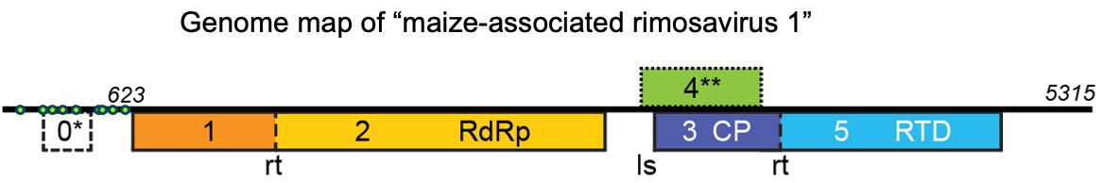

Fig. 1. Genome organization of maize-associated rimosavirus 1 (MaRV1), a typical “rimosavirus”. Base numbering is in italics. Green dots: positions of AUGs in 5’UTR. RdRp = RNA-dependent RNA polymerase, CP = coat protein, RTD = readthrough domain, rt = readthrough site, ls = leaky scanning initiation.
*ORF0 is unlikely to be translated as it is present only in MaRV1 and in a truncated form in PVLaRV1.
**ORF4 lacks in-frame AUG start codon in PVLaRV1, BCaRV1, ZLaRV1, HubRV1, TCaRV1. Maps of all “rimosavirus” genomes are in [5].

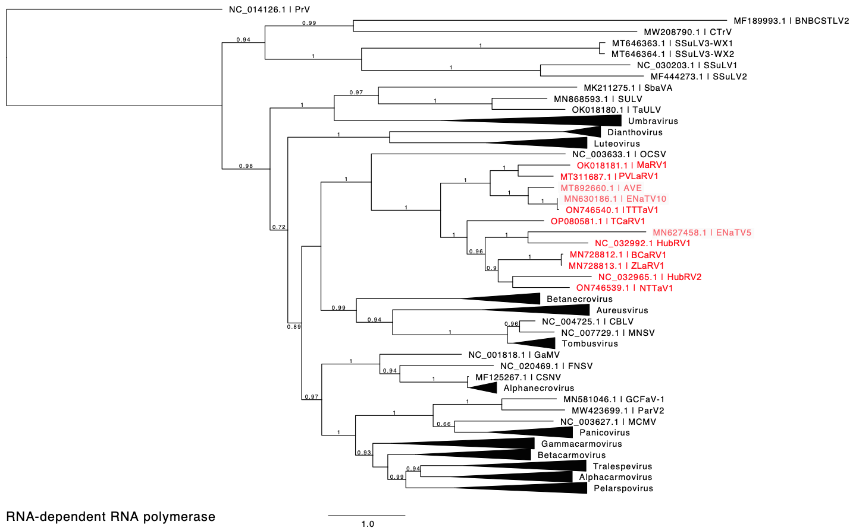

Fig. 2. (From [5] Phylogenetic tree predicting the relationship of selected tombusvirids based on the amino acid sequences of full-length RdRps (ORF1-ORF2 fusion products). Red entries indicate those sequences belonging to the proposed “Rimosavirus” genus. GenBank sequences of light red, shaded viral genomes (AVE, ENaTV10, ENaTV5) remain unpublished in a peer-reviewed journal so are not considered here. (Also, based on >95% sequence identity, ENaTV10 is the same virus as TTTaV1). Branch support values are shown for splits > 0.5 and are calculated from 1,000 resamples of the Shimodaira-Hasegawa test (SH-like local supports). Branch lengths indicate arbitrary units of evolutionary distance. Providence virus (PrV) was used as outgroup because it is the nearest relative outside of the Tombusviridae, which is more likely to give an accurate tree than a more distantly related outgroup [13]. For individual viruses (single member genus or unassigned to genus), GenBank accession numbers and virus acronyms are shown. This open access image is reprinted with permission of the authors.

Fig. 3. Phylogenetic tree predicting the relationship of selected tombusvirids based on the amino acid sequences of full-length RdRps (ORF1-ORF2 fusion products). Red entries indicate those sequences belonging to the proposed “Rimosavirus” genus. Tree is as in Fig. 2 but using hepatitis C virus (HCV) RdRp as outgroup, as has been used for other Tombusviridae trees in ICTV proposals.

