

The International Committee on Taxonomy of Viruses
Taxonomy Proposal Form, 2025

Part 1a: Details of taxonomy proposals

Title: | Create one new species in the genus Deltasatellite (Tolecusatellitidae)
Code assigned: | 2025.015P.Ac.v3.Deltasatellite_1nsp

Author(s), affiliation and email address(es):
Given name (+middle initial(s)) | Surname | Affiliation | Email address | Corr. author(s)
Jesús | Navas-Castillo | IHSM La Mayora, UMA-CSIC, Algarrobo-Costa, Málaga, Spain | jnavas@eelm.csic.es | X
Philippe | Roumagnac | CIRAD, UMR PHIM, Montpellier, France | philippe.roumagnac@cirad.fr
Jose T | Ascencio-Ibáñez | North Carolina State University, Raleigh, USA | jtascenc@ncsu.edu
Jean-Michel | Lett | CIRAD, UMR PVBMT, Saint Pierre de la Réunion, France | lett@cirad.fr
Paola M. | López-Lambertini | INTA-CIAP-IPAVE, Universidad Nacional de Córdoba, Córdoba, Argentina | plopezlambertini@gmail.com
Darren P. | Martin | Institute of Infectious Disease and Molecular Medicine, University of Cape Town, Cape Town, South Africa | darrenpatrickmartin@gmail.com
Simone | Ribeiro | Embrapa Recursos Genéticos e Biotecnologia, Brasília, Brazil | simone.ribeiro@embrapa.br
Cica | Urbino | CIRAD, UMR PHIM, Montpellier, France | cica.urbino@cirad.fr
Arvind | Varsani | The Biodesign Center for Fundamental and Applied Microbiomics, Center for Evolution and Medicine, School of Life Sciences, Arizona State University, Tempe, Arizona, USA | Arvind.varsani@asu.edu
F. Murilo | Zerbini | Dep. de Fitopatologia, Universidade Federal de Viçosa, Viçosa, Brazil | zerbini@ufv.br

Part 1b: Taxonomy Proposal Submission
ICTV Subcommittee:
Animal DNA Viruses and Retroviruses |  | Bacterial viruses
Animal minus-strand and dsRNA viruses |  | Fungal and protist viruses
Animal positive-strand RNA viruses |  | Plant viruses | X
Archaeal viruses |  | General

List the ICTV Study Group(s) that have seen or have been involved in creating this proposal:
Geminiviridae and Tolecusatellitidae Study Group

Optional – complete only if formally voted on by an ICTV Study Group
Study Group | Number of members
Study Group | Votes in support | Votes against | No vote
Roumagnac, Philippe  Ascencio-Ibáñez, Jose T  Lett, Jean-Michel  López-Lambertini, Paola M.  Martin, Darren  Navas-Castillo, Jesús  Ribeiro, Simone  Urbino, Cica  Varsani, Arvind  Zerbini, F. Murilo | Y  Y  Y  Y  Y  Y  Y  Y  Y  Y

Submission date: | 05/06/2025

Part 1c: Feedback from ICTV Executive Committee (EC) meeting
Executive Committee Meeting Decision code: | X
A – Accept
Ac – Accept subject to revision by relevant subcommittee chair. No further vote required | X
U – Accept without revision but with re-evaluation and email vote by the EC
Uc – Accept subject to revision and re-evaluation and email vote by the EC
Ud – Deferred to the next EC meeting, with an invitation to revise based on EC comments
J - Reject
W - Withdrawn

Comments from the Executive Committee:
The EC voted Ac for this proposal (see the table above for explanation), to allow very minor revisions mainly concerning style issues.

Part 1d: Revised Taxonomy Proposal Submission
Response of proposer:
All style-related suggestions were accepted.

Revision date: | 22/08/2025

Part 3: TAXONOMIC PROPOSAL

Taxonomic changes proposed:
Establish new taxon | x | Split taxon
Abolish taxon |  | Merge taxon
Move taxon |  | Promote taxon
Rename taxon |  | Demote taxon
Move and rename

Etymology (origin) of proposed taxonomic names:
Taxon name | Etymology of the term
“Deltasatellite brassicae” | The species epithet (brassicae) refers to the begomovirus species to which it was originally associated: Begomovirus brassicae.

Permission for use of names derived from a living person:
Taxon name | Full name of person from whom the name is derived | Attached

Abstract of Taxonomy Proposal:
Taxonomic rank affected:
Genus Deltasatellite in the family Tolecusatellitidae

Description of current taxonomy:
Tolecusatellitidae / Deltasatellite
The genus Deltasatellite consists of 12 species.

Proposed taxonomic change:
We proposed to create one new species in the genus Deltasatellite: “Deltasatellite brassicae”.

Justification:
Similar to members of the genus Deltasatellite, members of the proposed new species “Deltasatellite brassicae” have all conserved features of deltasatellites, including an A-rich region, a stem-loop with the TAATATTAC nonanucleotide motif, and a region with identity to betasatellites. The isolates share 100% nucleotide identity among themselves, and ≤73.9% identity with known deltasatellites, below the 91% species demarcation threshold. Phylogenetic analysis shows the group forms a distinct clade within New World deltasatellites. We conclude that “Deltasatellite brassicae” represents a new species in the genus Deltasatellite.

Taxonomic rank affected:
Genus Deltasatellite in the family Tolecusatellitidae

Description of current taxonomy:
Tolecusatellitidae /Deltasatellite
The genus Deltasatellite consists of 12 species.

Twelve species are currently assigned to the Deltasatellite genus in the Tolecusatellitidae family:
Deltasatellite codiaeumiflavi, Deltasatellite desmodii, Deltasatellite ipomoeaprimi, Deltasatellite ipomoeasecundi, Deltasatellite ipomoeatertii, Deltasatellite malvastri, Deltasatellite sidaflavusprimi, Deltasatellite sidaflavussecundi, Deltasatellite sidaflavustertii, Deltasatellite solani, Deltasatellite solaniflavusprimi, Deltasatellite solaniflavussecundi.

Proposed taxonomic change:
We proposed to create one new species in the genus Deltasatellite: “Deltasatellite brassicae”, which was isolated associated to the begomovirus cabbage leaf curl virus (Begomovirus brassicae) from black gram (Vigna mungo), cowpea (Vigna unguiculata), Desmodium scorpiurus, and Rhynchosia minima collected from Venezuela [1]. The satellite was termed cabbage leaf curl deltasatellite (CabLCD).

Demarcation criteria:
A 91% pairwise identity species demarcation threshold has been proposed and adopted for the genus Deltasatellite [2].

Justification:
The sequences of CabLCD summarized in Table 1 can be classified into one new species sharing ≤73.9% genome-wide pairwise identity with all classified deltasatellites (Figure 1). Furthermore, this is supported by phylogenetic analysis (Figure 2).

References:
[1] Fiallo-Olivé, E., Bastidas, L., Chirinos, D.T., Navas-Castillo, J., 2021. Insights into emerging begomovirus-deltasatellite complex diversity: the first deltasatellite infecting legumes. Biology 10, 1125.

[2] Briddon, R.W., Navas-Castillo, J., Fiallo-Olivé, E., 2016. ICTV taxonomic Proposal 2016.021a-kP.A.v2.Tolecusatellitidae. Create the Tolecusatellitidae, a new family of single-stranded DNA satellites with two genera. Available online at: http://www.ictv.global/proposals-16/2016.021a-kP.A.v2.Tolecusatellitidae.pdf (accessed June 1, 2025).
[3] Muhire, B.M., Varsani, A., Martin, D.P., 2014. SDT: a virus classification tool based on pairwise sequence alignment and identity calculation. PloS one 9, e108277.

Accompanying files:
Filename | Description of contents
2025.015P.A.v1.Deltasatellite_1nsp | spreadsheet

Tables, Figures:
Table 1: Summary of the new proposed species in the Deltasatellite genus of the Tolecusatellitidae family. The exemplar isolate is highlighted in red.

Genus | Species | Accession # | Deltasatellite name | Acronym | Isolate | Country | Host | Associated begomovirus species
Deltasatellite | “Deltasatellite brassicae” | OK073969 | Cabbage leaf curl deltasatellite | CabLCD | VE-Cp_V1-17 | Venezuela | Cowpea | Begomovirus brassicae
Deltasatellite | Deltasatellite brassicae | OK073970 | Cabbage leaf curl deltasatellite | CabLCD | VE-Cp_V2-17 | Venezuela | Cowpea | Begomovirus brassicae
Deltasatellite | Deltasatellite brassicae | OK073971 | Cabbage leaf curl deltasatellite | CabLCD | VE-Des_V8-17 | Venezuela | Desmodium scorpiurus | Begomovirus brassicae
Deltasatellite | Deltasatellite brassicae | OK073972 | Cabbage leaf curl deltasatellite | CabLCD | VE-Rh_V9-17 | Venezuela | Rhynchosia minima | Begomovirus brassicae
Deltasatellite | Deltasatellite brassicae | OK073973 | Cabbage leaf curl deltasatellite | CabLCD | VE-Rh_V10-17 | Venezuela | Rhynchosia minima | Begomovirus brassicae
Deltasatellite | Deltasatellite brassicae | OK073974 | Cabbage leaf curl deltasatellite | CabLCD | VE-Bg_V12-17 | Venezuela | Black gram | Begomovirus brassicae
Deltasatellite | Deltasatellite brassicae | OK073975 | Cabbage leaf curl deltasatellite | CabLCD | VE-Bg_V13-17 | Venezuela | Black gram | Begomovirus brassicae

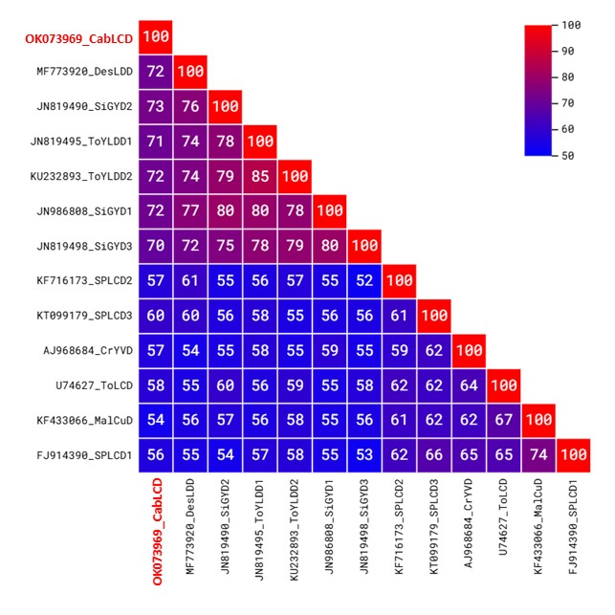
Figure 1: Pairwise identity matrix inferred using SDT [3]. A representative sequence of the proposed new species is highlighted in red.

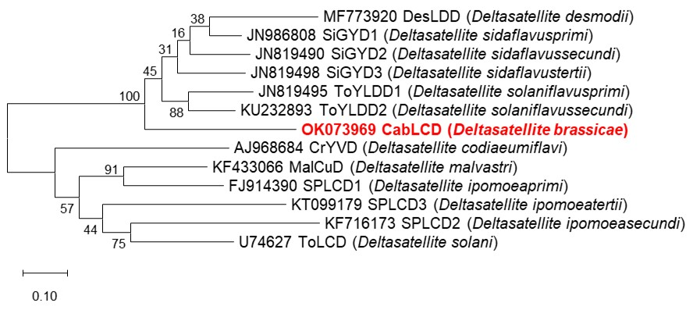

Figure 2: Maximum likelihood phylogenetic tree of representative genomes from each deltasatellite species. Bootstrap values are shown at the nodes. A representative sequence of the proposed new species is highlighted in red.

