

The International Committee on Taxonomy of Viruses
Taxonomy Proposal Form, 2025

Part 1a: Details of taxonomy proposals

Title: | Create five new species in the genus Mastrevirus (family Geminiviridae)
Code assigned: | 2025.012P.Ac.v3.Geminiviridae_Mastrevirus_5nsp

Author(s), affiliation and email address(es):
Given name (+middle initial(s)) | Surname | Affiliation | Email address | Corr. author(s)
Arvind | Varsani | The Biodesign Center for Fundamental and Applied Microbiomics, Center for Evolution and Medicine, School of Life Sciences, Arizona State University, Tempe, USA | Arvind.varsani@asu.edu | X
Jean-Michel | Lett | CIRAD, UMR PVBMT, Saint Pierre de la Réunion, France | lett@cirad.fr
José T | Ascencio- Ibáñez | North Carolina State University, Raleigh, USA | jtascenc@ncsu.edu
Cica | Urbino | CIRAD, UMR PHIM, Montpellier, France | cica.urbino@cirad.fr
Jesús | Navas-Castillo | Instituto de Hortofruticultura Subtropical y Mediterránea “La Mayora” (IHSM-UMA-CSIC), Málaga, Spain | jnavas@eelm.csic.es
Paola | López-Lambertini | INTA-CIAP-IPAVE, Universidad Nacional de Córdoba, Córdoba, Argentina | plopezlambertini@gmail.com
Darren P | Martin | Institute of Infectious Disease and Molecular Medicine, University of Cape Town, Cape Town, South Africa | darrenpatrickmartin@gmail.com
Simone G | Ribeiro | Embrapa Recursos Genéticos e Biotecnologia, Brasília, Brazil | simone.ribeiro@embrapa.br
Philippe | Roumagnac | CIRAD, UMR PHIM, Montpellier, France | philippe.roumagnac@cirad.fr
F Murilo | Zerbini | Dep. de Fitopatologia/BIOAGRO, Universidade Federal de Viçosa, Viçosa, Brazil | zerbini@ufv.br

Part 1b: Taxonomy Proposal Submission
ICTV Subcommittee:
Animal DNA Viruses and Retroviruses |  | Bacterial viruses
Animal minus-strand and dsRNA viruses |  | Fungal and protist viruses
Animal positive-strand RNA viruses |  | Plant viruses | X
Archaeal viruses |  | General

List the ICTV Study Group(s) that have seen or have been involved in creating this proposal:
Geminiviridae and Tolecusatellitidae

Optional – complete only if formally voted on by an ICTV Study Group:
Study Group | Number of members
Study Group | Votes in support | Votes against | No vote

Submission date: | 06/06/2025

Part 1c: Feedback from ICTV Executive Committee (EC) meeting
Executive Committee Meeting Decision code: | X
A – Accept
Ac – Accept subject to revision by relevant subcommittee chair. No further vote required | X
U – Accept without revision but with re-evaluation and email vote by the EC
Uc – Accept subject to revision and re-evaluation and email vote by the EC
Ud – Deferred to the next EC meeting, with an invitation to revise based on EC comments
J - Reject
W - Withdrawn

Comments from the Executive Committee:
The EC voted Ac for this proposal (see the table above for explanation), to allow very minor revisions mainly concerning style issues. The EC noted that species names should be always italicized, except in figures if italicization is not possible.

Part 1d: Revised Taxonomy Proposal Submission
Response of proposer:
All style-related suggestions were accepted. The figures were replaced.

Revision date: | 22/08/2025

Part 3: TAXONOMIC PROPOSAL

Taxonomic changes proposed:
Establish new taxon | X | Split taxon
Abolish taxon |  | Merge taxon
Move taxon |  | Promote taxon
Rename taxon |  | Demote taxon
Move and rename

Etymology (origin) of proposed taxonomic names:
Taxon name | Etymology of the term
“Mastrevirus cenchri” | Genus + plant host (Genitive form -us -> -i) - Cenchrus echinatus
“Mastrevirus croci” | Genus + plant host (Genitive form -us -> -i) - Crocus sativus
“Mastrevirus mexicoense” | Genus + Latinized country of sampling - Mexico
“Mastrevirus purpurei” | Genus + plant host (Genitive form -us -> -i) - Cenchrus purpureus
“Mastrevirus tripterygii" | Genus + plant host (Genitive form -ium -> -ii) - Tripterygium wilfordii

Permission for use of names derived from a living person:
Taxon name | Full name of person from whom the name is derived | Attached

Abstract of Taxonomy Proposal:
Taxonomic rank(s) affected:
Genus Mastrevirus in the family Geminiviridae

Description of current taxonomy:
Monodnaviria; Shotokuvirae; Cressdnaviricota; Repensiviricetes; Geplafuvirales; Geminiviridae; Mastrevirus

There are currently 50 established species in the genus Mastrevirus. New species in the genus Mastrevirus are determined based on a 78% pairwise identity threshold coupled with phylogenetic support.

Proposed taxonomic change(s):
Create five new species in the genus Mastrevirus

Justification:
In the last year, eight genomes of mastreviruses have been identified that cannot be classified at the species level within the current taxonomy framework. These can be classified into five new species sharing <78% pairwise identity with all classified mastreviruses.

Text of Taxonomy proposal:
Taxonomic rank(s) affected:
Genus Mastrevirus in the family Geminiviridae

Description of current taxonomy:
Monodnaviria; Shotokuvirae; Cressdnaviricota; Repensiviricetes; Geplafuvirales; Geminiviridae; Mastrevirus
There are currently 50 established species in the genus Mastrevirus.

Proposed taxonomic change(s):
We propose to create five new species in the genus Mastrevirus to classify eight new genomes of mastreviruses that have been identified in the last year.

Demarcation criteria:
78% genome-wide pairwise identity threshold coupled with phylogenetic support [1].

Justification:
The genome sequences of the mastreviruses summarized in Table 1 can be classified into five new species that share <78% genome-wide pairwise identity as determined using Sequence Demarcation Tool (SDT) v1.2 [2] with all classified mastreviruses (Figure 1). The classification of these into five new species is supported by maximum likelihood phylogenetic inferred using PHYML [3] from the aligned genomes using MAFFT [4] with GTR+I+G4 chosen as the best fit determined using jModelTest [5] (Figure 2).

References:
- Muhire B, Martin DP, Brown JK, Navas-Castillo J, Moriones E, Zerbini FM, Rivera-Bustamante R, Malathi VG, Briddon RW, Varsani A. 2013. A genome-wide pairwise-identity-based proposal for the classification of viruses in the genus Mastrevirus (family Geminiviridae). Archives of Virology. 158(6):1411-24. doi: 10.1007/s00705-012-1601-7. Epub 2013 Jan 23. PMID: 23340592.
- Muhire BM, Varsani A, Martin DP. 2014. SDT: a virus classification tool based on pairwise sequence alignment and identity calculation. PLoS One. 26;9(9):e108277. doi: 10.1371/journal.pone.0108277. PMID: 25259891; PMCID: PMC4178126.
- Guindon S, Dufayard JF, Lefort V, Anisimova M, Hordijk W, Gascuel O. 2010. New algorithms and methods to estimate maximum-likelihood phylogenies: assessing the performance of PhyML 3.0. Systems Biology 59(3):307-21. doi: 10.1093/sysbio/syq010. Epub 2010 Mar 29. PMID: 20525638.
- Katoh K, Rozewicki J, Yamada KD. 2019. MAFFT online service: multiple sequence alignment, interactive sequence choice and visualization. Brief Bioinformatics. 19;20(4):1160-1166. doi: 10.1093/bib/bbx108. PMID: 28968734; PMCID: PMC6781576.
- Darriba D, Taboada GL, Doallo R, Posada D. 2010. jModelTest 2: more models, new heuristics and parallel computing. Nature Methods. 30;9(8):772. doi: 10.1038/nmeth.2109. PMID: 22847109; PMCID: PMC4594756.
- Ben Chéhida S, Devi Bunwaree H, Hoareau M, Moubset O, Julian C, Blondin L, Filloux D, Lavergne C, Roumagnac P, Varsani A, Martin DP, Lett JM, Lefeuvre P. 2024. Increase of niche filling with increase of host richness for plant-infecting mastreviruses. Virus Evolution. 13;10(1):veae107. doi: 10.1093/ve/veae107. PMID: 39717705; PMCID: PMC11665825.
- Hosseini SA, Julian C, Galzi S, Filloux D, Roumagnac P. 2024. First report of saffron-associated mastrevirus 1 from saffron in Iran. Plant Diseases. doi: 10.1094/PDIS-11-24-2462-PDN. Epub ahead of print. PMID: 39673340.
- Tavoosi M, Moradi Z, Mehrvar M, Zakiaghl M. 2025. First identification and complete genomic characterization of saffron dwarf virus from Iran, a novel mastrevirus infecting Crocus sativus. European Journal of Plant Pathology. https://doi.org/10.1007/s10658-025-03051-y
- Valouzi H, Dizadji A, Golnaraghi A, Salami SA, Selmi I, Fontdevila Pareta N, Önder S, Massart S. 2025. First detection of saffron dwarf virus, wheat dwarf virus, wheat dwarf virus-associated alphasatellite and a new putative potyvirus species in saffron in Iran. New Disease Reports 51:e70022. https://doi.org/10.1002/ndr2.70022
- Alcalá-Briseño RI, Casarrubias-Castillo K, López-Ley D, Garrett KA, Silva-Rosales L. 2020. Network Analysis of the Papaya Orchard Virome from Two Agroecological Regions of Chiapas, Mexico. mSystems. 14;5(1):e00423-19. doi: 10.1128/mSystems.00423-19. PMID: 31937673; PMCID: PMC6967384.

Accompanying files:
Filename | Description of contents
2025.012P.A.v1.Geminiviridae_Mastrevirus_5nsp | spreadsheet

Tables, Figures:

Table 1: Summary of the members of the five new species.
Species name | Accession no. | Virus name | Isolate name | Country | Host/source | Ref
“Mastrevirus cenchri” | PQ434710 | Cenchrus echinatus associated virus | 21_REU_E0117_CEAV | Reunion | Cenchrus echinatus | [6]
 | PQ434734 | Cenchrus echinatus associated virus | 22_REU_E0101_CEAV | Reunion | Cenchrus echinatus | [6]
“Mastrevirus croci” | PQ392009 | Mastrevirus sp. croci | CSAV_A9PstI | Iran | Crocus sativus | [7]
 | PP848143 | Saffron dwarf virus | IR | Iran | Crocus sativus | [8]
 | PQ740909 | Saffron dwarf virus | IR:Teh:Saf6:22 | Iran | Crocus sativus | [9]
“Mastrevirus mexicoense” | MN203180 | Mastrevirus sp. UHMV-1.PC-W | UHMV-1.PC-W | Mexico | Unknown (weeds) | [10]
“Mastrevirus purpurei” | PQ434729 | Cenchrus purpureus mild streak virus | 21_REU_E0816_CPMSV | Reunion | Cenchrus purpureus | [6]
“Mastrevirus tripterygii" | MT159331 | Tripterygium mastrevirus A | Won | China | Tripterygium wilfordii | -

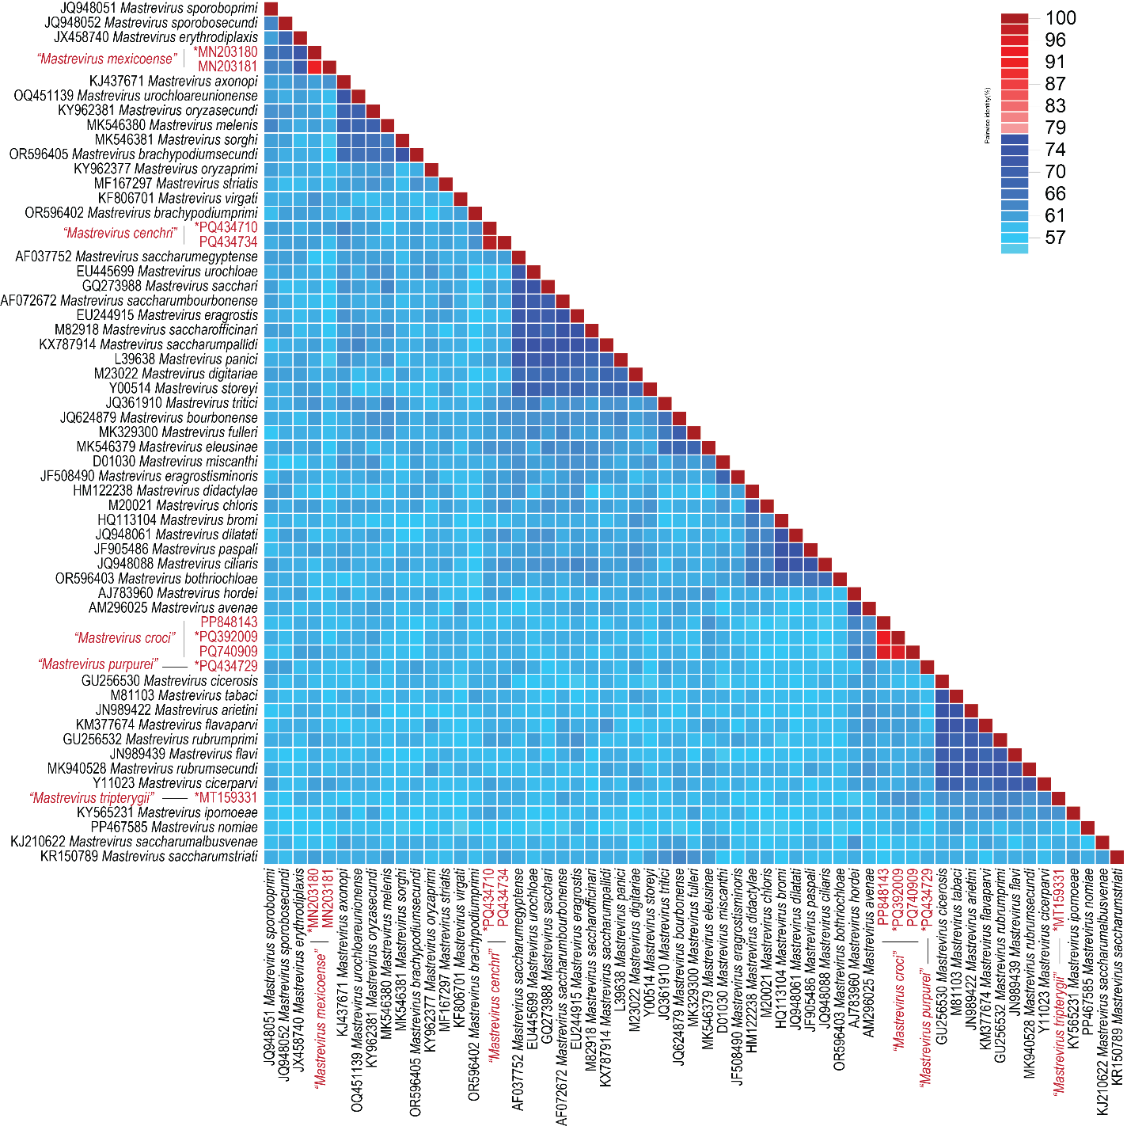

Figure 1: Genome-wide pairwise identity matrix of genomes from each mastrevirus species together with those that are members of the five new species inferred using SDT v1.2 [2]. Representative sequences from the proposed new species (n=5) are marked with “*”.

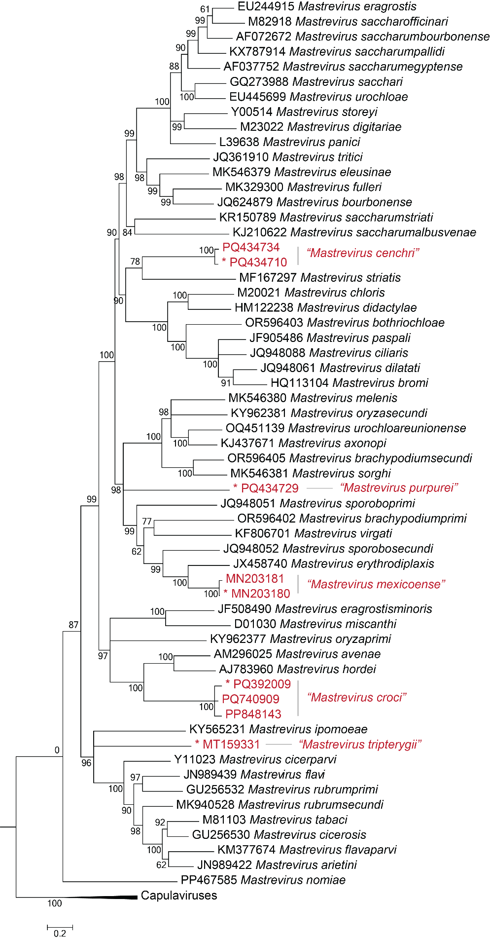
Figure 2: Maximum likelihood phylogenetic tree of representative genomes from each mastrevirus species together with those that are members of the five new species. The phylogenetic tree is rooted using genome sequences of capulaviruses. Representative sequences from the proposed new species (n=5) are marked with “*”.

