

The International Committee on Taxonomy of Viruses
Taxonomy Proposal Form, 2025

Part 1a: Details of taxonomy proposals

Title: | Create one (1) new species in the genus Capulavirus (Geplafuvirales: Geminiviridae)
Code assigned: | 2025.011P.Ac.v3.Geminiviridae_Capulavirus_1nsp

Author(s), affiliation and email address(es):
Given name (+middle initial(s)) | Surname |  | Email address | Corr. author(s)
Philippe | Roumagnac | CIRAD, UMR PHIM, Montpellier, France | philippe.roumagnac@cirad.fr | X
Jose T | Ascencio- Ibáñez | North Carolina State University, Raleigh, USA | jtascenc@ncsu.edu
Jean-Michel | Lett | CIRAD, UMR PVBMT, Saint Pierre de la Réunion, France | lett@cirad.fr
Paola M. | López-Lambertini | INTA-CIAP-IPAVE, Universidad Nacional de Córdoba, Córdoba, Argentina | plopezlambertini@gmail.com
Darren P. | Martin | Institute of Infectious Disease and Molecular Medicine, University of Cape Town, Cape Town, South Africa | darrenpatrickmartin@gmail.com
Jesús | Navas-Castillo | Instituto de Hortofruticultura Subtropical y Mediterránea “La Mayora” (IHSM-UMA-CSIC), Málaga, Spain | jnavas@eelm.csic.es
Simone | Ribeiro | Embrapa Recursos Genéticos e Biotecnologia, Brasília, Brazil | simone.ribeiro@embrapa.br
Cica | Urbino | CIRAD, UMR PHIM, Montpellier, France | cica.urbino@cirad.fr
Arvind | Varsani | The Biodesign Center for Fundamental and Applied Microbiomics, Center for Evolution and Medicine, School of Life Sciences, Arizona State University, Tempe,Arizona, USA | Arvind.varsani@asu.edu
F. Murilo | Zerbini | Dep. de Fitopatologia, Universidade Federal de Viçosa, Viçosa, Brasil | zerbini@ufv.br

Part 1b: Taxonomy Proposal Submission
ICTV Subcommittee:
Animal DNA Viruses and Retroviruses |  | Bacterial viruses
Animal minus-strand and dsRNA viruses |  | Fungal and protist viruses
Animal positive-strand RNA viruses |  | Plant viruses | X
Archaeal viruses |  | General

List the ICTV Study Group(s) that have seen or have been involved in creating this proposal:
Geminiviridae and Tolecusatellitidae Study Group

Optional – complete only if formally voted on by an ICTV Study Group:
Study Group | Number of members
Study Group | Votes in support | Votes against | No vote
Roumagnac, Philippe  Ascencio- Ibáñez, Jose T  Lett, Jean-Michel  López-Lambertini, Paola M.  Martin, Darren  Navas-Castillo, Jesús  Ribeiro, Simone  Urbino, Cica  Varsani, Arvind  Zerbini, F. Murilo | Y  Y  Y  Y  Y  Y  Y  Y  Y  Y

Submission date: | 10/06/2025

Part 1c: Feedback from ICTV Executive Committee (EC) meeting
Executive Committee Meeting Decision code: | X
A – Accept
Ac – Accept subject to revision by relevant subcommittee chair. No further vote required | X
U – Accept without revision but with re-evaluation and email vote by the EC
Uc – Accept subject to revision and re-evaluation and email vote by the EC
Ud – Deferred to the next EC meeting, with an invitation to revise based on EC comments
J - Reject
W - Withdrawn

Comments from the Executive Committee:
The EC voted Ac for this proposal (see the table above for explanation), to allow very minor revisions mainly concerning style issues.

Part 1d: Revised Taxonomy Proposal Submission
Response of proposer:
All style-related suggestions were accepted.

Revision date: | 22/08/2025

Part 3: TAXONOMIC PROPOSAL

Taxonomic changes proposed:
Establish new taxon | x | Split taxon
Abolish taxon |  | Merge taxon
Move taxon |  | Promote taxon
Rename taxon |  | Demote taxon
Move and rename

Etymology (origin) of proposed taxonomic names:
Taxon name | Etymology of the term
“Capulavirus betae” | Species epithet (betae) derived from the host plant: Beta vulgaris L.

Permission for use of names derived from a living person:
Taxon name | Full name of person from whom the name is derived | Attached

Abstract of Taxonomy Proposal:
Taxonomic rank(s) affected:
Genus Capulavirus in the family Geminiviridae

Description of current taxonomy:
Monodnaviria / Shotokuvirae / Cressdnaviricota / Repensiviricetes / Geplafuvirales / Geminiviridae / Capulavirus

Proposed taxonomic change(s):
We proposed to create one new species in the genus Capulavirus: “Capulavirus betae”

Justification:
Similar to members of the Capulavirus genus, members of the proposed new species “Capulavirus betae” have the virion-strand origin of replication nonanucleotide motif ‘TAATATTAC’ and show a typical capulavirus organization, with putative multiple overlapping short ORFs (V3 and V4) upstream of the CP gene that encode putative movement proteins. In addition, genome-wide pairwise analysis of the representative genomes of capulaviruses showed that beet capulavirus 1 sequence genome shared less than 78% identity with all representative genomes of capulaviruses. Since 78% nucleotide identity is the genome-wide species demarcation threshold for capulaviruses, we conclude that beet capulavirus 1 can be classified into the species “Capulavirus betae”, a new species in the genus Capulavirus.

Text of Taxonomy proposal:
Taxonomic rank(s) affected:
Genus Capulavirus in the family Geminiviridae

Description of current taxonomy:
Monodnaviria / Shotokuvirae / Cressdnaviricota / Repensiviricetes / Geplafuvirales / Geminiviridae / Capulavirus

Five species are currently assigned to the genus Capulavirus in the family Geminiviridae: Capulavirus euphorbiae, Capulavirus medicagonis, Capulavirus phaseoli, Capulavirus plantagonis, Capulavirus trifolii.

Proposed taxonomic change(s):
We proposed to create one new species in the genus Capulavirus: “Capulavirus betae”, which was isolated from sugar beet (Beta vulgaris L.) collected from France [1]

Demarcation criteria:
A 78% pairwise identity species demarcation threshold has been proposed and adopted for the genus Capulavirus [2].

Justification:
Based on the sequence analysis, beet capulavirus 1 summarized in Table 1 can be classified into one new species that shares <78% genome-wide pairwise identity with all classified capulaviruses (Figure 1). Furthermore, this is supported by phylogenetic analysis (Figure 2).

References:
[1] Zhang Z, Faure C, Marais A, Monteiro A, Candresse T, 2025. A new capulavirus infecting sugar beet (Beta vulgaris L.) in France. Arch. Virol. 170, 34.
[2] Varsani, A., Roumagnac, P., Fuchs, M., Navas-Castillo, J., Moriones, E., Idris, A., Briddon, R.W., Rivera-Bustamante, R., Murilo Zerbini, F., Martin, D.P., 2017. Capulavirus and Grablovirus: two new genera in the family Geminiviridae. Arch Virol 162, 1819-1831.
[3] Muhire, B.M., Varsani, A., Martin, D.P., 2014. SDT: a virus classification tool based on pairwise sequence alignment and identity calculation. PLoS One 9, e108277.
[4] Larkin, M.A., Blackshields, G., Brown, N.P., Chenna, R., McGettigan, P.A., McWilliam, H., Valentin, F., Wallace, I.M., Wilm, A., Lopez, R., Thompson, J.D., Gibson, T.J., Higgins, D.G., 2007. Clustal W and Clustal X version 2.0. Bioinformatics 23, 2947-2948.

Accompanying files
Filename | Description of contents
2025.011P.A.v1.Geminiviridae_Capulavirus_1nsp | spreadsheet

Tables, Figures:

Table 1: Summary of the new proposed species in the Capulavirus genus of the Geminiviridae family. The new species is highlighted in red font.

Genus | Species | Accession # | Virus name | Acronym | Isolate | Country | Host/Source
Capulavirus | “Capulavirus betae” | PQ682516 | beet capulavirus 1 | BCV1 | 04-24 | France | Beta vulgaris L.

Figure 1: Pairwise identity matrix inferred using SDT v1.2 [3].

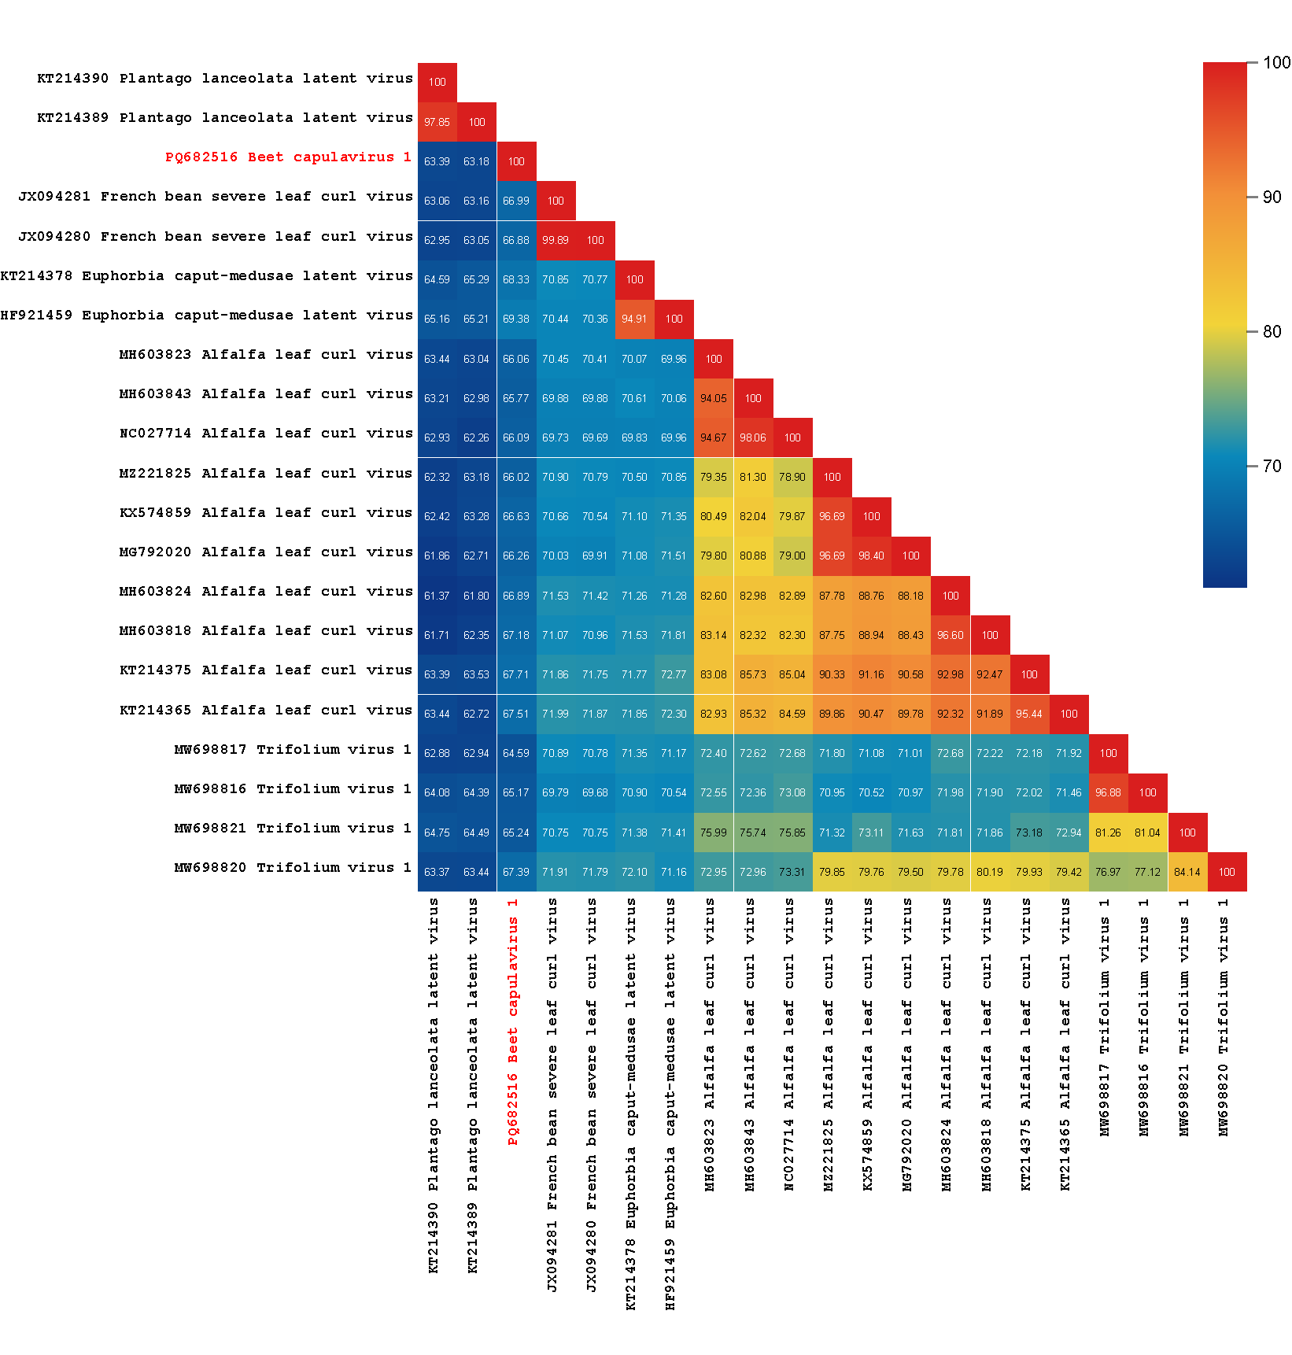

Figure 2: Unrooted Neighbor-joining tree inferred from aligned full-genome nucleotide sequences of all Capulavirus species and “Capulavirus betae”. The genomes were aligned using Clustal W [4] and a Neighbor-joining phylogenetic tree was inferred with Jukes Cantor substitution model and 1000 bootstrap iterations.

