

The International Committee on Taxonomy of Viruses
Taxonomy Proposal Form, 2025

Part 1a: Details of taxonomy proposals

Title: | Create three (3) new species in the genus Begomovirus (family Geminiviridae)
Code assigned: | 2025.010P.Ac.v4.Geminiviridae_Begomovirus_3nsp

Author(s), affiliation and email address(es):
Given name (+middle initial(s)) | Surname | Affiliation | Email address | Corr. author(s)
F Murilo | Zerbini | Dep. de Fitopatologia/ BIOAGRO, Universidade Federal de Viçosa, Viçosa, Brazil | zerbini@ufv.br | X
José T | Ascencio- Ibáñez | North Carolina State University, Raleigh, USA | jtascenc@ncsu.edu
Cica | Urbino | CIRAD, UMR PHIM, Montpellier, France | cica.urbino@cirad.fr
Jean-Michel | Lett | CIRAD, UMR PVBMT, Saint Pierre de la Réunion, France | lett@cirad.fr
Paola | López-Lambertini | INTA-CIAP-IPAVE, Universidad Nacional de Córdoba, Córdoba, Argentina | plopezlambertini@gmail.com
Jesús | Navas-Castillo | Instituto de Hortofruticultura Subtropical y Mediterránea “La Mayora” (IHSM-UMA-CSIC), Málaga, Spain | jnavas@eelm.csic.es
Darren P | Martin | Institute of Infectious Disease and Molecular Medicine, University of Cape Town, Cape Town, South Africa | darrenpatrickmartin@gmail.com
Simone G | Ribeiro | Embrapa Recursos Genéticos e Biotecnologia, Brasília, Brazil | simone.ribeiro@embrapa.br
Philippe | Roumagnac | CIRAD, UMR PHIM, Montpellier, France | philippe.roumagnac@cirad.fr
Arvind | Varsani | The Biodesign Center for Fundamental and Applied Microbiomics, Center for Evolution and Medicine, School of Life Sciences, Arizona State University, Tempe, USA | Arvind.varsani@asu.edu

Part 1b: Taxonomy Proposal Submission
ICTV Subcommittee:
Animal DNA Viruses and Retroviruses |  | Bacterial viruses
Animal minus-strand and dsRNA viruses |  | Fungal and protist viruses
Animal positive-strand RNA viruses |  | Plant viruses | X
Archaeal viruses |  | General

List the ICTV Study Group(s) that have seen or have been involved in creating this proposal:
Geminiviridae and Tolecusatellitidae

Optional – complete only if formally voted on by an ICTV Study Group
Study Group | Number of members
Study Group | Votes in support | Votes against | No vote
Geminiviridae and Tolecusatellitidae

Submission date: | 05/06/2025

Part 1c: Feedback from ICTV Executive Committee (EC) meeting
Executive Committee Meeting Decision code: | X
A – Accept
Ac – Accept subject to revision by relevant subcommittee chair. No further vote required | X
U – Accept without revision but with re-evaluation and email vote by the EC
Uc – Accept subject to revision and re-evaluation and email vote by the EC
Ud – Deferred to the next EC meeting, with an invitation to revise based on EC comments
J - Reject
W - Withdrawn

Comments from the Executive Committee:
The EC voted Ac for this proposal (see the table above for explanation), to allow very minor revisions mainly concerning style issues and the replacement of the figures by original ones.

Part 1d: Revised Taxonomy Proposal Submission
Response of proposer:
All style-related suggestions were accepted. All three figures were replaced, and are now original to avoid copyright issues.

Revision date: | 28/8/2025

Part 3: TAXONOMIC PROPOSAL

Taxonomic changes proposed:
Establish new taxon | X | Split taxon
Abolish taxon |  | Merge taxon
Move taxon |  | Promote taxon
Rename taxon |  | Demote taxon
Move and rename

Etymology (origin) of proposed taxonomic names:
Taxon name | Etymology of the term
"Begomovirus clitoriae" | From the host, Clitoria ternatea
"Begomovirus melochiasecundi" | The second species named after the host, Melochia tomentosa
"Begomovirus citharexyli" | From the host, Citharexylum spinosum

Permission for use of names derived from a living person:
Taxon name | Full name of person from whom the name is derived | Attached

Abstract of Taxonomy Proposal:
Taxonomic rank affected:
Genus Begomovirus in the family Geminiviridae

Description of current taxonomy:
Monodnaviria -> Shotokuvirae -> Cressdnaviricota -> Repensiviricetes -> Geplafuvirales -> Geminiviridae -> Begomovirus
Begomovirus is one of the largest genera in the virosphere, with 464 species. Within the genus Begomovirus, viruses are classified into species based on a 91% genome-wide (or DNA-A in the case of bipartite viruses) pairwise identity threshold [1].

Proposed taxonomic changes:
Creation of 3 new species to classify new begomoviruses that have been identified and described in the literature over the past two years.

Justification:
Members of all 3 proposed new species share <91% genome-wide (or DNA-A in the case of bipartite viruses) pairwise identity with sequences of members of currently established begomovirus species.

Text of Taxonomy proposal:
Taxonomic rank affected:
Genus Begomovirus in the family Geminiviridae

Description of current taxonomy:
Monodnaviria -> Shotokuvirae -> Cressdnaviricota -> Repensiviricetes -> Geplafuvirales -> Geminiviridae -> Begomovirus
Begomovirus is one of the largest genera in the virosphere, with 464 species.

Proposed taxonomic changes:
Create 3 new species in the genus Begomovirus.

Demarcation criteria: 91% genome-wide (or DNA-A in the case of bipartite begomoviruses) pairwise identity threshold [1].

Justification: The 3 begomoviruses summarized in Table 1 can be classified into new species that share <91% genome-wide (or DNA-A in the case of bipartite begomoviruses) pairwise identity with all classified begomoviruses. This is supported by maximum likelihood phylogenetic analysis.

We provide a brief description of each proposed new species below:

"Begomovirus clitoriae" [2]
- Leaf samples from two Clitoria ternatea plants exhibiting yellow mosaic symptoms were collected in Kanpur, Uttar Pradesh, India, in August 2023
- Total DNA was extracted and used as a template for rolling circle amplification (RCA); RCA products were digested with restriction enzymes and a band with ~2.7 kb was cloned and Sanger sequenced
- The clone corresponded to a begomovirus, and sequence demarcation tool SDT analysis indicated a maximum nucleotide sequence identity of 82.6% with the DNA-A of Cajanus scarabaeoides yellow mosaic virus (CsYMV, OM397101) (Figure 1)
- A cognate DNA-B was also cloned and sequence, displaying a maximum nt sequence identity of 72.2% with the DNA-B of Rhincosia yellow mosaic virus (RhYMV, AM999982)
- The authors propose to classify the new begomovirus isolate, named butterfly pea yellow mosaic virus (BpYMV), into a new species, for which they propose the name "Begomovirus clitoriae"

"Begomovirus melochiasecundi" [3]
- The virus was isolated from a non-symptomatic Melochia tomentosa (family Malvaceae) plant; the plant species was confirmed by sequencing of matK and rbcL genes
- The sequence was obtained using standard procedures (RFLP-RCA, cloning) and used for percentage nucleotide identity comparisons (SDT)
- The DNA-A-like sequence shared the highest nucleotide sequence similarity with African monopartite begomoviruses, including tomato curly stunt virus (TCSV) [MT878426] (71.7% identity) (Figure 2)
- No evidence of recombination events, no DNA-B or satellite DNA sequences were detected in the sample
- The authors propose to classify the new begomovirus isolate, named Melochia associated virus (MeAV), into a new species, for which they initially proposed the name "Begomovirus melochiae". However, this species name already exists, and therefore the SG proposes the name "Begomovirus melochiasecundi"

"Begomovirus citharexyli" [4]
- The sequence was obtained using standard procedures (RCA, cloning) and used for percentage nucleotide identity comparisons (SDT)
- The DNA-A-like sequence shares 88.7% nucleotide sequence identity with papaya leaf crumple virus (PaLCrV) isolate (KR071789) and 88.5% with rose leaf curl virus (OQ411588) (Figure 3)
- A putative recombination event was identified in CitLCuV genome at nt position 70-2106, with tomato leaf curl Kerala virus (KF551575) as major parent and Chenopodium leaf distortion virus (MN423112) as minor parent (RDP4, 7 detection methods with significant p values)
- Phylogenetic tree placed CitLCuV in a sister clade to PaLCrV
- No satellite DNA sequences were detected in the sample by PCR methods with universal primers
- The authors propose to classify the new begomovirus isolate, named Citharexylum leaf curl virus (CitLCuV), into a new species, but do not propose a species name
- The SG proposes the species name "Begomovirus citharexyli"
References:
[1] Brown JK, Zerbini FM, Navas-Castillo J, Moriones E, Ramos-Sobrinho R, Silva JC, et al. Revision of Begomovirus taxonomy based on pairwise sequence comparisons. Arch Virol. 2015;160:1593-619.
[2] Akram M, Kumar D, Kamaal N. Complete genome sequence of a novel bipartite begomovirus infecting butterfly pea (Clitoria ternatea L.) in India. Arch Virol. 2024;170:7.
[3] Ouattara A, Kéré D, Hoareau M, Koïta K, Lefeuvre P, Lett JM. A new monopartite begomovirus infecting Melochia tomentosa in Burkina Faso. Arch Virol. 2024;169:240.
[4] Diksha D, Sidharthan VK, Baranwal VK. Identification of a novel monopartite begomovirus associated with leaf curl disease of Citharexylum spinosum in India. Virus Genes 2024;60:568-571.
[5] Muhire BM, Varsani A, Martin DP. SDT: A virus classification tool based on pairwise sequence alignment and identity calculation. PLOS One 2014;9:e108277.
[6] Katoh K, Standley DM. MAFFT multiple sequence alignment software version 7: Improvements in performance and usability. Mol Biol Evol. 2013;30:772.
[7] Nguyen LT, Schmidt HA, von Haeseler A, Minh BQ. IQ-TREE: A fast and effective stochastic algorithm for estimating maximum likelihood phylogenies. Mol Biol Evol. 2015;32:268.
[8] Kalyaanamoorthy S, Minh BQ, Wong TKF, von Haeseler A, Jermiin LS. ModelFinder: Fast model selection for accurate phylogenetic estimates. Nature Methods. 2017;14:587.
[9] Hoang DT, Chernomor O, von Haeseler A, Minh BQ, Vinh LS. UFBoot2: Improving the ultrafast bootstrap approximation. Mol Biol Evol. 2018;35:518.

Accompanying files:
Filename | Description of contents
2025.010P.A.v1.Geminiviridae_Begomovirus_3nsp | spreadsheet
Tables, Figures:

Table 1. Summary of the 3 new species in the genus Begomovirus and their members.
Species name | Accession no. | Virus name | Isolate name | Country | Host/source | Ref.
"Begomovirus clitoriae" | PQ298353 (DNA-A), PQ298354 (DNA-B) | butterfly pea yellow mosaic virus (BpYMV) | India:Kanpur:2024 | India | Clitoria ternatea | 2
"Begomovirus melochiasecundi" | PP897773 | melochia associated virus (MeAV) | Burkina Faso:Goue:Melochia:856BB:2016 | Burkina Faso | Melochia tomentosa | 3
"Begomovirus citharexyli" | OR437368 | Citharexylum leaf curl virus (CitLCuV) | Hyderabad | India | Citharexylum spinosum | 4

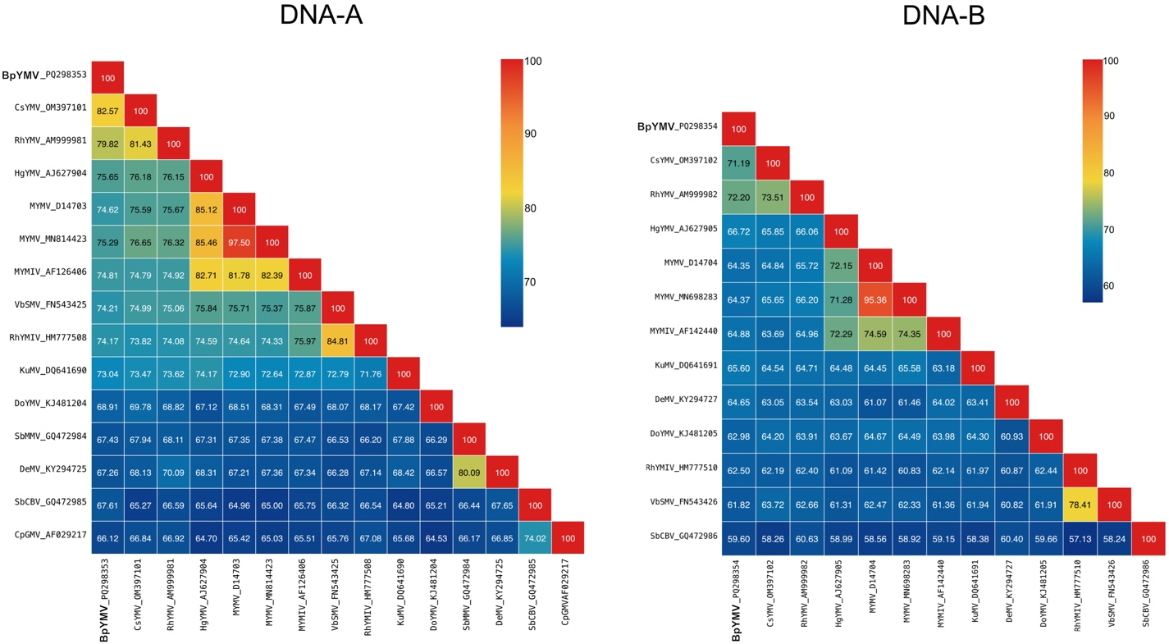

Figure 1. Pairwise nucleotide sequence identities (%) for the full-length DNA-A and DNA-B sequences of butterfly pea yellow mosaic virus (BpYMV; "Begomovirus clitoriae") and the most closely related begomoviruses.

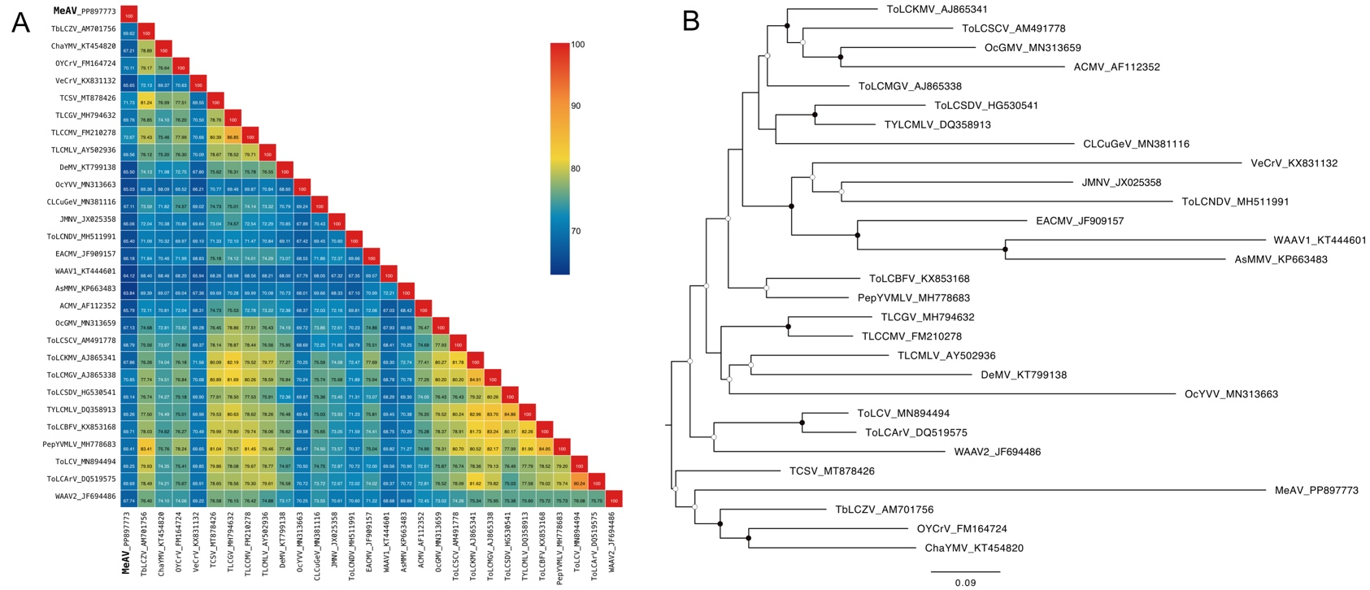

Figure 2. (A) Pairwise nucleotide sequence identity matrix of the complete DNA-A sequence of Melochia associated virus (MeAV; "Begomovirus melochiasecundi") and the most closely related begomoviruses. Identities were calculated with SDT [5] v. 2 (https://github.com/SDT-org/SDT2/releases/tag/v2.0.0. pre.20250723). (B) Midpoint-rooted, maximum-likelihood phylogenetic tree based on the same data set as in (A). Filled circles at the branches indicate bootstrap values >85%, open circles indicate values between 50 and 84%. The scale bar indicates nucleotide substitutions per site. Sequences were aligned with MAFFT [6] and the tree was constructed with IQ-TREE [7] using the TIM3+F+I+G4 nucleotide substitution model (determined by ModelFinder [8]) and the ultrafast bootstrap option [9]. The tree was edited in FigTree (tree.bio.ed.ac.uk/software/figtree).

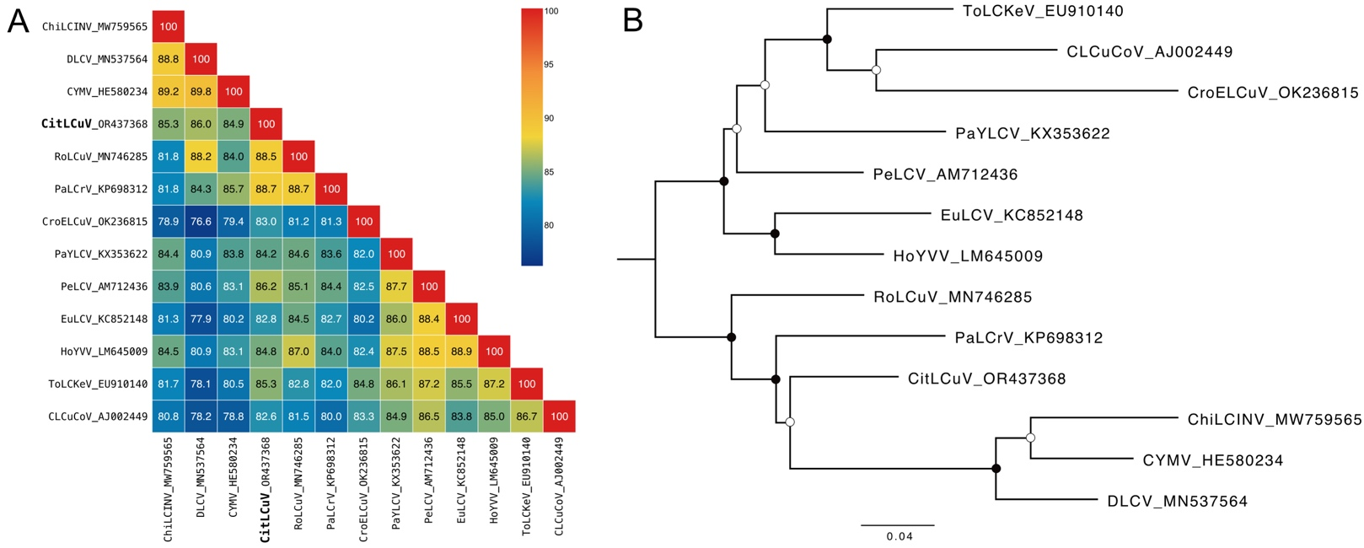

Figure 3. (A) Pairwise nucleotide sequence identiy matrix of the complete genome of Citharexylum leaf curl virus (CitLCuV; "Begomovirus citharexyli") and the most closely related begomoviruses. Identities were calculated with SDT [5] v. 2 (https://github.com/SDT-org/SDT2/releases/tag/v2.0.0. pre.20250723).(B) Maximum-likelihood phylogenetic tree based on the same data set as in (A). (B) Midpoint-rooted, maximum-likelihood phylogenetic tree based on the same data set as in (A). Filled circles at the branches indicate bootstrap values >85%, open circles indicate values between 50 and 84%. The scale bar indicates nucleotide substitutions per site. Sequences were aligned with MAFFT [6] and the tree was constructed with IQ-TREE [7] using the TIM3+F+I+G4 nucleotide substitution model (determined by ModelFinder [8]) and the ultrafast bootstrap option [9]. The tree was edited in FigTree (tree.bio.ed.ac.uk/software/figtree).

