

The International Committee on Taxonomy of Viruses
Taxonomy Proposal Form, 2025

Part 1a: Details of taxonomy proposals

Title: | Create new family “Potyliviridae” in the order Patatavirales
Code assigned: | 2025.009F.Ac.v3.Potyliviridae_newfam

Author(s), affiliation and email address(es):
Given name (+middle initial(s)) | Surname | Affiliation | Email address | Corr. author(s)
Nina | Aboughanem-Sabanadzovic | Institute for Genomics, Biocomputing and Biotechnology, Mississippi State University, Mississippi, USA | nja62@msstate.edu
Massimo | Turina | Institute for Sustainable Plant Protection, CNR, Torino, Italy | massimo.turina@ipsp.cnr.it
Mart | Krupovic | Institut Pasteur, Université Paris Cité, CNRS UMR6047, Cell Biology and  Virology of Archaea Unit, 75015 Paris, France | mart.krupovic@pasteur.fr
Jens H | Kuhn | Frederick, MD 21704, USA | jens_h_kuhn@comcast.net
Sead | Sabanadzovic | Department of Agricultural Science and Plant Protection, Mississippi State University, Mississippi, USA | ssabanadzovic@entomology.msstate.edu | X

Part 1b: Taxonomy Proposal Submission
ICTV Subcommittee:
Animal DNA Viruses and Retroviruses |  | Bacterial viruses
Animal minus-strand and dsRNA viruses |  | Fungal and protist viruses | X
Animal positive-strand RNA viruses |  | Plant viruses
Archaeal viruses |  | General -

List the ICTV Study Group(s) that have seen or have been involved in creating this proposal:
Optional – complete only if formally voted on by an ICTV Study Group:
Study Group | Number of members
Study Group | Votes in support | Votes against | No vote

Submission date: | 25/06/2025

Part 1c: Feedback from ICTV Executive Committee (EC) meeting
Executive Committee Meeting Decision code: | X
A – Accept
Ac – Accept subject to revision by relevant subcommittee chair. No further vote required | X
U – Accept without revision but with re-evaluation and email vote by the EC
Uc – Accept subject to revision and re-evaluation and email vote by the EC
Ud – Deferred to the next EC meeting, with an invitation to revise based on EC comments
J - Reject
W - Withdrawn

Comments from the Executive Committee:
Please run the quality check and address some typos.

Part 1d: Revised Taxonomy Proposal Submission
Response of proposer:
All suggestions addressed/accepted.

Revision date: | 30/08/2025

Part 3: TAXONOMIC PROPOSAL
https://ictv.global/taxonomy/templates
Taxonomic changes proposed:
Establish new taxon | X | Split taxon
Abolish taxon |  | Merge taxon
Move taxon |  | Promote taxon
Rename taxon |  | Demote taxon
Move and rename

Etymology (origin) of proposed taxonomic names:
Taxon name | Etymology of the term
“Potyliviridae” | Coined from ‘poty-like’ and universal family-rank suffix
“Potylivirus” | Coined from ‘poty-like’ and universal genus-rank suffix
“Potylivirus italicum” | From Italia, a country of sample provenience
“Potylivirus uromyci” | From the genus name of the host - Uromyces

Permission for use of names derived from a living person:
Taxon name | Full name of person from whom the name is derived | Attached

Abstract of Taxonomy Proposal:
Taxonomic rank(s) affected: Order

Description of current taxonomy:
Order Patatavirales currently includes a single family, Potyviridae (13 genera; 259 species).

Proposed taxonomic change(s):
To create a second family in the order Patatavirales, with proposed name “Potyliviridae” comprising one new genus (“Potylivirus”) to classify two new species.

Justification:
Creation of a new family “Potyliviridae” comprising a new genus “Potylivirus” with two species is proposed to classify recently discovered group of viruses with monocistronic (+)RNA genomes of ≈7.5-8.0 kb in length. Members of the “Potyliviridae” are distantly related to members of the family Potyviridae, in particular to viruses belonging to the genus Potyvirus. The creation of a new family is strongly supported by phylogenetic analyses.

- Text of Taxonomy proposal:

Taxonomic rank(s) affected: Order

Description of current taxonomy:
Order Patatavirales currently includes a single family, Potyviridae (13 genera and 259 species).

Proposed taxonomic change(s):
To create a second family in the order Patatavirales, with proposed name “Potyliviridae”, comprising one new genus (“Potylivirus”) with two new species.

Demarcation criteria:
Proposed species demarcation criteria are similar to those currently adopted in the closest taxon, family Potyviridae. Therefore, genomes of viruses belonging to different species differ by up to 25% in nucleotide sequences of complete ORFs and/or 20% amino acid sequences of the entire polyproteins. Viruses of the family must be monophyletic in RdRP-based phylogenetic analyses.

Justification:
Potyviridae is the largest family of plant-infecting viruses with (+)RNA genomes, with 259 currently established species included in 13 genera, of which more than 80% (total of 214) belong to the “founding” genus Potyvirus [5,11]. Currently, Potyviridae is the sole taxon in the order Patatavirales and its viruses are distantly related to those of Astroviridae, a family of animal-infecting viruses classified in the order Stellavirales.
Potyviruses are naturally transmitted by aphids in a non-persistent manner. Many members of this genus can cause substantial economic damage, in terms of yield quality and quantity, to various major crops worldwide. Potyviruses are characterized by their filamentous, flexuous virions of ca 700–900 x 11–13 nm in size and non-segmented polyadenylated RNA genomes of 9.7–11 kb with a virus protein (VPg) covalently linked to the 5’ ends of the genomes. The major ORF, encompassing >90% of the genome, codes for a long polyprotein that is self-cleaved into a set of 10 functional proteins (Figure 1). An additional small ORF, named PIPO (pretty interesting Potyviridae ORF) is expressed via translational slippage mechanism as a trans-frame P3N-PIPO protein [5,11].
Recent exploration of the fungal virome has revealed several potyvirus-related viruses via determination and analysis of coding-complete [2,6], or partial [10] genome sequences. In addition, there are several unpublished sequences available in GenBank as well as those generated in recent studies by the authors of this proposal (Aboughanem-Sabanadzovic et al, unpublished data).
Genomes of these viruses, reported in literature as ‘poty-like’ viruses (PLVs), are shorter than those of potyviruses (7.8–8.0 kb versus 10–11 kb) and lack the 3’-terminal polyA tails. They have a uniform genome organization and code for a single major polyprotein of ≈280K with conserved domains of DEAD-like helicase, C4 peptidase and RNA-directed RNA polymerase [2,6,10], as revealed by searches against the NCBI’s Conserved Domain Database. PLVs are most closely related to each other (percentage identities reported in Table 1). However, BLASTp searches revealed that PLV polyproteins also share similarities with counterparts encoded by bona fide potyviruses, especially in their C-terminal halves. Indeed, sometimes these viruses are erroneously considered as members of a putative new genus in the family Potyviridae [10].
Phylogenetic analyses performed on viral RdRPs of PLVs and selected representative viruses of genera in the families Potyviridae and Astroviridae showed that PLVs share an immediate common ancestor with the potyvirids, but belong to a different evolutionary lineage in the order Patatavirales (Figure2), supporting the establishment of a second family.
Pairwise comparisons of ≈180–200 C-terminal amino acid sequences revealed high level of conservation (52–65%) between the polyproteins of all 5 PLVs used in the current analyses. Structural modeling of the C-terminal region (230 aa) of the polyprotein encoded by Plasmopara viticola lesion associated ‘poty-like’ virus 1 (PvLaPLV1) using AlphaFold3 yielded a good quality model with a central alpha-helical domain and unstructured N- and C-terminal extensions. DALI search using this model produced significant hits (Z scores of 10-12) to the experimentally determined capsid protein structures of potyvirids (Figure 3) and other plant viruses with flexible filamentous virions. Notably, the unstructured N- and C-terminal regions typical of flexible filamentous virus CPs are known to be important for capsid protein polymerization and virion flexibility [3,12]. The presence of similar extensions in the PLV CPs suggests that they also form flexible filamentous virions, similar to those of potyvirids.
In summary, based on literature review and our own analyses, we propose creation of a new (second) family “Potyliviridae” in the order Patatavirales, comprising one genus and two species to classify viruses represented by coding-complete genomes and described in peer-reviewed publications [2,6]. The number of family members is destined to grow in the near future, as supported by data of some additional related viruses that are currently incompletely sequenced [10], or awaiting official publication (Aboughanem-Sabanadzovic et al, unpublished data).

References:
- Abramson J, Adler J, Dunger J, Evans R, Green T, Pritzel A, Ronneberger O, Willmore L, Ballard AJ, Bambrick J, Bodenstein SW, Evans DA, Hung CC, O'Neill M, Reiman D, Tunyasuvunakool K, Wu Z, Žemgulytė A, Arvaniti E, Beattie C, Bertolli O, Bridgland A, Cherepanov A, Congreve M, Cowen-Rivers AI, Cowie A, Figurnov M, Fuchs FB, Gladman H, Jain R, Khan YA, Low CMR, Perlin K, Potapenko A, Savy P, Singh S, Stecula A, Thillaisundaram A, Tong C, Yakneen S, Zhong ED, Zielinski M, Žídek A, Bapst V, Kohli P, Jaderberg M, Hassabis D, Jumper JM. Accurate structure prediction of biomolecular interactions with AlphaFold 3. Nature. 2024 Jun;630(8016):493-500. doi: 10.1038/s41586-024-07487-w. Epub 2024 May 8. PMID: 38718835; PMCID: PMC11168924.
- Chiapello M, Rodríguez-Romero J, Nerva L, Forgia M, Chitarra W, Ayllón MA, Turina M. Putative new plant viruses associated with Plasmopara viticola-infected grapevine samples. Ann Appl Biol. 2020, 176:180–191 https://doi.org/10.1111/aab.12563
- DiMaio F, Chen CC, Yu X, Frenz B, Hsu YH, Lin NS, Egelman EH. The molecular basis for flexibility in the flexible filamentous plant viruses. Nat Struct Mol Biol. 2015 Aug;22(8):642-4. doi: 10.1038/nsmb.3054. Epub 2015 Jul 13. PMID: 26167882; PMCID: PMC4527879.
- Hoang DT, Chernomor O, von Haeseler A, Minh BQ, Vinh LS. UFBoot2: Improving the Ultrafast Bootstrap Approximation. Mol Biol Evol. 2018;35(2):518-522. doi:10.1093/molbev/msx281 PMID: 29077904
- Inoue-Nagata AK, Jordan R, Kreuze J, Li F, López-Moya JJ, Mäkinen K, Ohshima K, Wylie SJ, ICTV Report Consortium. ICTV Virus Taxonomy Profile: Potyviridae 2022. J Gen Virol. 2022 May;103(5). doi: 10.1099/jgv.0.001738. PMID: 35506996.
- Jo Y, Choi H, Chu H, Cho WK. Unveiling Mycoviromes Using Fungal Transcriptomes. Int J Mol Sci. 2022 Sep 18;23(18):10926. doi: 10.3390/ijms231810926. PMID: 36142838
- Letunic I, Bork P. Interactive Tree of Life (iTOL) v6: recent updates to the phylogenetic tree display and annotation tool. Nucleic Acids Res. 2024;52(W1):W78-W82. doi:10.1093/nar/gkae268 PMID: 38613393
- Nguyen LT, Schmidt HA, von Haeseler A, Minh BQ. IQ-TREE: a fast and effective stochastic algorithm for estimating maximum-likelihood phylogenies. Mol Biol Evol. 2015;32(1):268-274. doi:10.1093/molbev/msu300 PMID: 25371430
- Wang J, Chitsaz F, Derbyshire MK, Gonzales NR, Gwadz M, Lu S, Marchler GH, Song JS, Thanki N, Yamashita RA, Yang M, Zhang D, Zheng C, Lanczycki CJ, Marchler-Bauer A. The conserved domain database in 2023. Nucleic Acids Res. 2023 Jan 6;51(D1):D384-D388. doi: 10.1093/nar/gkac1096. PMID: 36477806
- Wang J, Ni Y, Liu X, Zhao H, Xiao Y, Xiao X, Li S, Liu H. Divergent RNA viruses in Macrophomina phaseolina exhibit potential as virocontrol agents. Virus Evol. 2020 Dec 18;7(1):veaa095. doi: 10.1093/ve/veaa095. PMID: 33505706
- Wylie SJ, Adams M, Chalam C, Kreuze J, López-Moya JJ, Ohshima K, Praveen S, Rabenstein F, Stenger D, Wang A, Zerbini FM, ICTV Report Consortium. ICTV Virus Taxonomy Profile: Potyviridae. J Gen Virol. 2017 98(3):352-354. doi: 10.1099/jgv.0.000740. Erratum in: J Gen Virol. 2017 Nov;98(11):2893. doi: 10.1099/jgv.0.000960. PMID: 28366187
- Zamora M, Méndez-López E, Agirrezabala X, Cuesta R, Lavín JL, Sánchez-Pina MA, Aranda MA, Valle M. Potyvirus virion structure shows conserved protein fold and RNA binding site in ssRNA viruses. Sci Adv. 2017 Sep 20;3(9):eaao2182. doi: 10.1126/sciadv.aao2182. PMID: 28948231; PMCID: PMC5606705.

Accompanying files:
Filename | Description of contents

Tables, Figures:
<Start here>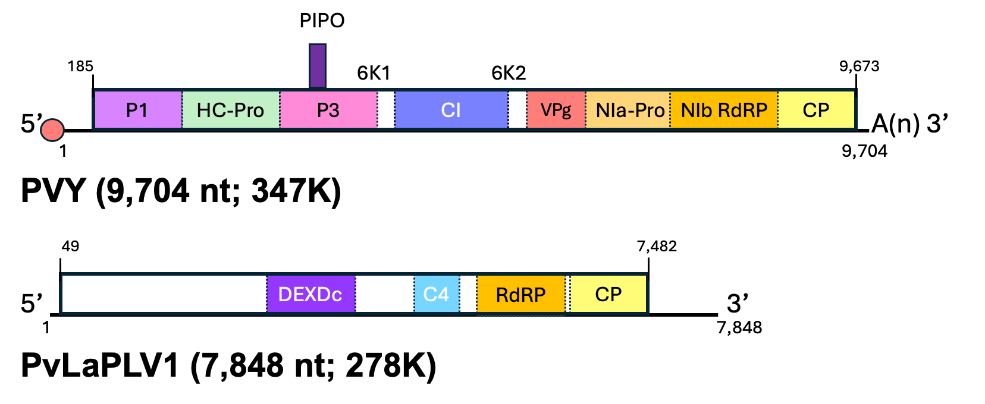
Figure 1. Schematic representation of genome organization of potato virus Y (PVY; X12456.1) and Plasmopara viticola lesion associated poty-like virus 1 (PvLaPLV1), typical members of the genus Potyvirus (family Potyviridae) and proposed genus “Potylivirus” (family “Potyliviridae”). Overall genome lengths (in case of PVY excluding polyA tail) and molecular weight of respective polyproteins encoded by long ORFs are indicated in parentheses. Genomes are represented by lines and the long ORFs coding for polyproteins by boxes with the mature proteolytic products indicated with different colors. The non-translated regions (NTRs) are represented by short lines on each end of the long ORFs. Circles at the 5’ end of the PVY genome depict virus-encoded VPg covalently attached to the initial (5’-terminal) nucleotide. 6K1: 6kDa peptide 1; 6K2: 6kDa peptide 2; C4: C4 peptidase; CI: cylindrical inclusion CP: coat protein; DEXDc: DEXDc helicase; HC-Pro: helper component protease; NIa-Pro: nuclear inclusion a protease; NIb: nuclear inclusion b; P1: protein 1 protease; P3: protein 3; PIPO: pretty interesting Potyviridae ORF; RdRP: RNA-directed RNA polymerase; VPg: virus protein-genome linked.

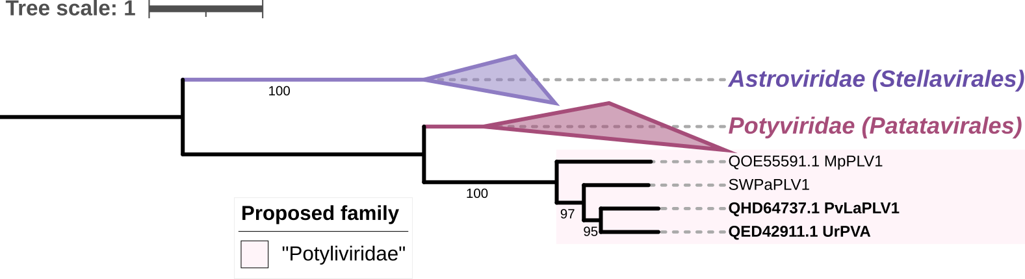

Figure 2. Maximum-likelihood phylogenetic tree showing the relationships of members of the proposed family “Potyliviridae” (shaded in pink) with viruses classified in the Potyviridae, a sole currently recognized family in the order Patatavirales. Viruses of the family Astroviridae were used as an outgroup from a sister-order, Stellavirales. “Potylivirids” form a strongly supported clade distinct from the family Potyviridae. The tree was constructed on a dataset of MAFFT-aligned amino acid sequences of RNA-directed RNA polymerases using IQ-TREE v 1.6.11 [7] with the 1,000 replicates ultrafast bootstrap [3] under best-fit model “LG+I+G4” and visualized with iTOL v7 [6]. The GenBank accession numbers of RdRP amino acid sequences used for analyses along with virus names are indicated at the tips of branches. Ultrafast bootstrap values above 95% are indicated. Viruses proposed to represent two new species are indicated in bold. PvLaPLV1: Plasmopara viticola lesion associated poty-like virus 1; UrPVA: Uromyces potyvirus A; MpPLV1: Macrophomina phaseolina poty-like virus 1; SwPaPLV1: sweet potato associated poty-like virus 1.
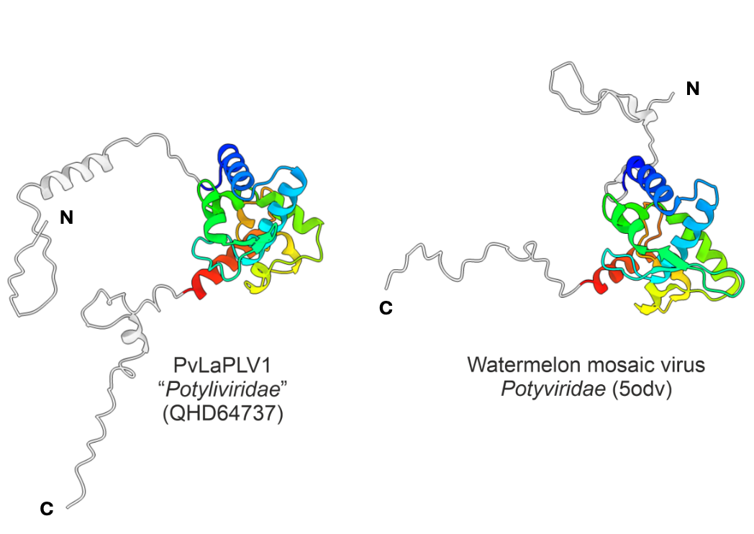
Figure 3. The comparison of the predicted structure of a putative coat protein (CP) of Plasmopara viticola lesion associated poty-like virus 1 (PvLaPLV1, left) with the experimentally determined CP structure of a representative potyvirus, watermelon mosaic virus (right). Structural similarity between the two proteins strongly suggests that members of the proposed family “Potyliviridae” form filamentous and flexuous virions similar to those of potyvirids. The structure of PvLaPLV1 CP was predicted using AlphaFold3 [1]. The central alpha-helical domains of the CPs are colored using the rainbow scheme from blue (N-terminus) to red (C-terminus), whereas the N- and C-terminal unstructured extensions are shown in grey. Table 1. Percentage (%) identity between ‘poty-like’ viruses in the complete nucleotide sequences (above the diagonal) and amino acids of the polyprotein. Two viruses proposed to represent two species in the proposed genus “Potylivirus” are reported in red font.

 | PvLaPLV1 | UrPVA | MpPLV* | SwPaPLV1** | CaPLV1**
PvLaPLV1 |  | 50.87 | 46.61 | 49.10 | 50.59
UrPVA | 40.46 |  | 46.72 | 48.75 | 68.55
MpPLV* | 34.67 | 34.60 |  | 49.77 | 46.25
SwPaPLV1** | 41.89 | 41.17 | 37.70 |  | 49.05
CaPLV1** | 40.50 | 74.33 | 35.54 | 40.56
*- Incomplete genome (missing ≈500 nt at the 5’end)
**- Unpublished data (complete genomes)

