

The International Committee on Taxonomy of Viruses
Taxonomy Proposal Form, 2025

Part 1a: Details of taxonomy proposals

Title: | Create one new family, one genus and 9 species in the order Martellivirales
Code assigned: | 2025.008F.A.v2.Tobaliviridae_newfam

Author(s), affiliation and email address(es):
Given name (+middle initial(s)) | Surname | Affiliation | Email address | Corr. author(s)
Sead | Sabanadzovic | Department of Agricultural Science and Plant Protection, Mississippi State University, Mississippi, USA | ssabanadzovic@entomology.msstate.edu | X
Nina | Aboughanem-Sabanadzovic | Institute for Genomics, Biocomputing and Biotechnology, Mississippi State University, Mississippi, USA | nja62@msstate.edu
Massimo | Turina | Institute for Sustainable Plant Protection, CNR, Torino, Italy | massimo.turina@ipsp.cnr.it
Nobuhiro | Suzuki | Institute of Plant Sciences and Resources, Okayama University, Japan | nsuzuki@okayama-u.ac.jp
Mart | Krupovic | Institut Pasteur, Université Paris Cité, CNRS UMR6047, Cell Biology and  Virology of Archaea Unit, 75015 Paris, France | mart.krupovic@pasteur.fr

Part 1b: Taxonomy Proposal Submission
ICTV Subcommittee:
Animal DNA Viruses and Retroviruses |  | Bacterial viruses
Animal minus-strand and dsRNA viruses |  | Fungal and protist viruses | X
Animal positive-strand RNA viruses |  | Plant viruses
Archaeal viruses |  | General -

List the ICTV Study Group(s) that have seen or have been involved in creating this proposal:
Optional – complete only if formally voted on by an ICTV Study Group:
Study Group | Number of members
Study Group | Votes in support | Votes against | No vote

Submission date: | 20/06/2025

Part 1c: Feedback from ICTV Executive Committee (EC) meeting
Executive Committee Meeting Decision code: | X
A – Accept | X
Ac – Accept subject to revision by relevant subcommittee chair. No further vote required
U – Accept without revision but with re-evaluation and email vote by the EC
Uc – Accept subject to revision and re-evaluation and email vote by the EC
Ud – Deferred to the next EC meeting, with an invitation to revise based on EC comments
J - Reject
W - Withdrawn

Comments from the Executive Committee:

Part 1d: Revised Taxonomy Proposal Submission
Response of proposer:
Revision date:

Part 3: TAXONOMIC PROPOSAL

Taxonomic changes proposed:
Establish new taxon | X | Split taxon
Abolish taxon |  | Merge taxon
Move taxon |  | Promote taxon
Rename taxon |  | Demote taxon
Move and rename

Etymology (origin) of proposed taxonomic names:
Taxon name | Etymology of the term
Tobaliviridae | Coined from “tobamo-like” and universal family-rank suffix “viridae”
Tobalivirus | Coined from “tobamo-like” and universal genus-rank suffix “virus”
Tobalivirus acidomyci | From the name of the host genus - Acidomyces
Tobalivirus armillariae | From the name of the host genus - Armillaria
Tobalivirus auricolariae | From the name of the host genus - Auricolaria
Tobalivirus ibericum | From the geographic location – Iberia (Iberian Peninsula)
Tobalivirus macrophominae | From the name of the host genus - Macrophomina
Tobalivirus lentinulae | From the name of the host genus - Lentinula
Tobalivirus nigrosporae | From the name of the host genus - Nigrospora
Tobalivirus podosphaerae | From the name of the host genus - Podosphaera
Tobalivirus uromyci | From the name of the host genus - Uromyces

Permission for use of names derived from a living person:
Taxon name | Full name of person from whom the name is derived | Attached

Abstract of Taxonomy Proposal:
Taxonomic rank(s) affected:
Order, family, genus, species

Description of current taxonomy:
The order Martellivirales currently contains seven families (Bromoviridae, Closteroviridae, Endornaviridae, Kitaviridae, Mayoviridae, Togaviridae and Virgaviridae) of (+)RNA viruses encoding alphavirus-like replicases.

Proposed taxonomic change(s):
We propose establishing a new family “Tobaliviridae” in the order Martellivirales to classify a growing group of “tobamo-like” viruses characterized from fungi. The proposed family will contain a single genus “Tobalivirus” with nine species.

Justification:
Despite obvious similarities in genome organization and possible expression strategy between tobamoviruses (family Virgaviridae) and “tobamo-like” mycoviruses, differences in:
- primary hosts (plant versus fungi)
- genome size (6.3-6.6 versus 10-13 kb),
- size and nature of proteins encoded by ORF3,
- CP size (17 kDa versus 36 kDa),
- virion morphology (rigid versus flexuous rods) and
- phylogenetically distinct RdRP lineage
justify the proposal for creation of a new family “Tobaliviridae” with a single genus, “Tobalivirus”, containing nine species to classify a set of well-characterized viruses.

Text of Taxonomy proposal:
Taxonomic rank(s) affected:
Order, family, genus, species

Description of current taxonomy:
The order Martellivirales currently contains seven families (Bromoviridae, Closteroviridae, Endornaviridae, Kitaviridae, Mayoviridae, Togaviridae and Virgaviridae) of (+)RNA viruses encoding alphavirus-like replicases.

Proposed taxonomic change(s):
We propose establishing a new family “Tobaliviridae” to classify a growing group of viruses reported from fungi and oomycetes. The proposed family will contain a single genus, “Tobalivirus”, with nine species.

Demarcation criteria:
Species demarcation is based on phylogenetic relationships of their members and differences of >10% in amino acid content in all virus-encoded products.
Proposed family is monogenic; therefore, genus demarcation criteria do not apply at this time.

Justification:
A group of as of yet unclassified mycoviruses with non-segmented (+)RNA genomes of approximately 10-13 kb in size and evolutionarily related to members of the family Virgaviridae, in particular to viruses classified in the genus Tobamovirus, has been reported from virome studies of several different fungi and the meta sample of grapevine leaf lesions caused by the oomycete Plasmopara viticola. Accordingly, in published scientific literature they are commonly referred to as “tobamo-like viruses” [2-6, 13-18] or “mycovirgaviruses” [11, 12]. However, for the sake of simplicity, in this proposal, we will use originally coined terminology “tobamo-like viruses” or TLVs. From a larger pool of TLV sequences available in the GenBank, we selected only those with complete or coding-complete genomes and with associated peer-reviewed publications representing the proposed species.

Tobamoviruses are plant-infecting viruses that belong to the family Virgaviridae and contain non-segmented (+)RNA genomes encapsidated in rigid rod-shaped virions of 300 x 18nm in size [1]. Their quadricistronic genomes of approximately 6.3-6.6 kb in size have a “cap” at the 5’-end, whereas the 3’-terminal sequences fold to form a tRNA-like, amino acid-accepting, structure. The two 5’-proximal ORFs, coding for proteins involved in virus replication (replicase, REP), are translated directly from genomic RNA. ORF1 codes for ~125-130 kDa protein with conserved motifs of viral methyltransferase (MTR) and helicase (Hel). ORF2 encodes RNA-dependent RNA polymerase (RdRP) and is expressed by occasional readthrough of the “leaky” ORF1 termination (amber; UAG) codon as a fusion polyprotein of 180-190 kDa. ORFs 3 and 4 encode the movement (MP) and coat proteins (CP), respectively, and are translated from the two 3’-coterminal subgenomic RNAs (sgRNAs) [1].

TLVs have significantly larger genomes than tobamoviruses (10-13 kb vs 6.3-6.6 kb) (Figure 1). Additionally, genomes of several TLVs do not have tRNA-like structures at their 3’ends but rather terminate with a polyA tract [5, 8,11,12,15]. Concerning the host range, tobamoviruses (and virgavirids in general) exclusively infect plants, whereas TLVs infect fungi.

Nevertheless, TLVs share similarities with tobamoviruses in overall genome organization, that strongly suggest similar expression strategies too. As in tobamoviruses, genomes of most TLVs contain four ORFs (Fig 1). The two 5’-proximal ORFs code for the replicase complex and are translated directly from the genomic RNA, through a “readthrough” mechanism involving the suppression of the termination codon at the end of ORF1, yielding a large polyprotein containing hallmark domains of alphavirus-like replicases: methyltransferase (MTR; cl46422), viral helicase 1 (HEL1; cl26263) and RNA-dependent RNA polymerase 2 (RdRP_2; cl03049). MTR and HEL1 are encoded by ORF1, whereas RdRP_2 is likely translated from ORF2 via readthrough mechanism to give rise to a large (240-270 kDa) polyprotein with a role in virus replication. Expression products of ORFs 1 and 2 of TLVs are homologous to the counterparts encoded by members of the plant-infecting tobamoviruses.

In phylogenetic analyses of the viral RdRPs with those of members of the order Martellivirales (Figure 2), all studied TLVs grouped together to form a sister-clade to virgavirids indicating that they belong to a taxon distinct from the family Virgaviridae. Monophyly of TLVs used in the dataset was supported by 100% bootstrap value.

ORFs 3 and 4 are likely expressed from corresponding subgenomic RNA templates. ORF3 of TLVs codes for a large protein (90-115 kDa, depending on the virus) which is conserved among all known tobamo-like viruses and characterized by the presence of the DEXDc helicase motifs (cl28899). In the original literature, ORF3 has been referred to as the “movement protein”, in part because of BLASTP matches to protein sequences of several gammaflexiviruses annotated as MPs (but not experimentally confirmed). Furthermore, the conserved DEXDc domain from TLVs was identities with the CIs of plant viruses in the Potyviridae family [8]. The real function of this protein is yet to be experimentally ascertained.

ORF4 homologs code for a protein of uniform size (36-38 kDa) with shared amino acid sequences among TLVs and assumed to be a structural (coat) protein involved in virion formation. However, TLV-encoded proteins are double in size (36-38 kDa vs 17kDa) and lack significant identities with tobamovirus CPs, suggesting a different virion morphology. Indeed, a recent study on characterization of Nigrospora aurantiaca tobamo-like virus 1 (NaTLV1) provided an experimental proof for the flexuous nature of NaTLV1 virions based on results of electron microscopy observations of 1,100 nm long filamentous virus-like particles and presence of a major ~37 kDa band in SDS-PAGE analyses of purified virus preparations [8].

In conclusion, despite obvious similarities in genome organization and possible genome expression between plant-infecting tobamoviruses and a group of “tobamo-like” mycoviruses, we think that differences in:
- genome size
- size and nature of proteins encoded by ORF3,
- CP size and virion morphology
- RdRP-based phylogeny and
- host
justify the creation of a new family “Tobaliviridae” with a single genus “Tobalivirus” containing nine species to classify a set of well-characterized viruses.

References:
- Adams MJ, Adkins S, Bragard C, Gilmer D, Li D, MacFarlane SA, Wong SM, Melcher U, Ratti C, Ryu KH, Ictv Report Consortium. ICTV Virus Taxonomy Profile: Virgaviridae. J Gen Virol. 2017 Aug;98(8):1999-2000. doi: 10.1099/jgv.0.000884. Epub 2017 Aug 8. PMID: 28786782
- Chiapello M, Rodríguez-Romero J, Ayllón MA, Turina M. Analysis of the virome associated to grapevine downy mildew lesions reveals new mycovirus lineages. Virus Evol. 2020 Nov 30;6(2):veaa058. doi: 10.1093/ve/veaa058. PMID: 33324489
- Dálya LB, Černý M, de la Peña M, et al. Diversity and impact of single-stranded RNA viruses in Czech Heterobasidion populations. mSystems. 2024;9(10):e0050624. doi:10.1128/msystems.00506-24 PMID: 39287383
- Galán-Cubero R, Córdoba L, Rodríguez-Romero J, Chiapello M, Turina M, Ayllón MA. Molecular Data of a Novel Penoulivirus Associated with the Plant-Pathogenic Fungus Erysiphe necator. Phytopathology. 2022 Jul;112(7):1587-1591. doi: 10.1094/PHYTO-12-21-0536-A. Epub 2022 May 4. PMID: 35509205
- Gilbert KB, Holcomb EE, Allscheid RL, Carrington JC. Hiding in plain sight: New virus genomes discovered via a systematic analysis of fungal public transcriptomes. PLoS One. 2019 Jul 24;14(7):e0219207. doi: 10.1371/journal.pone.0219207. PMID: 31339899
- Guo M, Shen G, Wang J, Liu M, Bian Y, Xu Z. Mycoviral diversity and characteristics of a negative-stranded RNA virus LeNSRV1 in the edible mushroom Lentinula edodes. Virology. 2021 Mar;555:89-101. doi: 10.1016/j.virol.2020.11.008. Epub 2020 Dec 4. PMID: 33308828.
- Hoang DT, Chernomor O, von Haeseler A, Minh BQ, Vinh LS. UFBoot2: Improving the Ultrafast Bootstrap Approximation. Mol Biol Evol. 2018;35(2):518-522. doi:10.1093/molbev/msx281 PMID: 29077904
- Hong M, Tian F, Song Z, Liu H, Tong Y, Zhang T. A novel tobamo-like mycovirus with filamentous particles replicates in plant cells. J Virol. 2025 May 20;99(5):e0210224. doi: 10.1128/jvi.02102-24. Epub 2025 Mar 31. PMID: 40162784; PMCID: PMC12090730.
- Kalyaanamoorthy S, Minh BQ, Wong TKF, von Haeseler A, Jermiin LS. ModelFinder: fast model selection for accurate phylogenetic estimates. Nat Methods. 2017 Jun;14(6):587-589. doi: 10.1038/nmeth.4285. Epub 2017 May 8. PMID: 28481363
- Letunic I, Bork P. Interactive Tree of Life (iTOL) v6: recent updates to the phylogenetic tree display and annotation tool. Nucleic Acids Res. 2024;52(W1):W78-W82. doi:10.1093/nar/gkae268 PMID: 38613393
- Li X, Xie J, Hai D, Sui K, Yin W, Sossah FL, Jiang D, Song B, Li Y. Molecular characteristics of a novel ssRNA virus isolated from Auricularia heimuer in China. Arch Virol. 2020 Jun;165(6):1495-1499. doi: 10.1007/s00705-020-04615-5. Epub 2020 Apr 7. PMID: 32266549.
- Linnakoski R, Sutela S, Coetzee MPA, Duong TA, Pavlov IN, Litovka YA, Hantula J, Wingfield BD, Vainio EJ. Armillaria root rot fungi host single-stranded RNA viruses. Sci Rep. 2021 Apr 1;11(1):7336. doi: 10.1038/s41598-021-86343-7. PMID: 33795735; PMCID: PMC8016926.
- Marzano SL, Nelson BD, Ajayi-Oyetunde O, Bradley CA, Hughes TJ, Hartman GL, Eastburn DM, Domier LL. Identification of Diverse Mycoviruses through Metatranscriptomics Characterization of the Viromes of Five Major Fungal Plant Pathogens. J Virol. 2016 Jul 11;90(15):6846-6863. doi: 10.1128/JVI.00357-16. PMID: 27194764
- Nguyen LT, Schmidt HA, von Haeseler A, Minh BQ. IQ-TREE: a fast and effective stochastic algorithm for estimating maximum-likelihood phylogenies. Mol Biol Evol. 2015;32(1):268-274. doi:10.1093/molbev/msu300 PMID: 25371430
- Pandey, B., Naidu, R.A. & Grove, G.G. Next generation sequencing analysis of double-stranded RNAs from sweet cherry powdery mildew fungus Podosphaera prunicola. J Plant Pathol. 2018 Jun; 100: 435–446. https://doi.org/10.1007/s42161-018-0092-0
- Redila CD, Prakash V, Nouri S. Metagenomics Analysis of the Wheat Virome Identifies Novel Plant and Fungal-Associated Viral Sequences. Viruses. 2021 Dec 7;13(12):2457. doi: 10.3390/v13122457. PMID: 34960726.
- Seitz JM, Voegele RT, Link TI. Mycoviruses in the Rust Fungus Uromyces fabae. Viruses. 2023 Aug 4;15(8):1692. doi: 10.3390/v15081692. PMID: 37632034
- Wang J, Ni Y, Liu X, Zhao H, Xiao Y, Xiao X, Li S, Liu H. Divergent RNA viruses in Macrophomina phaseolina exhibit potential as virocontrol agents. Virus Evol. 2020 Dec 18;7(1):veaa095. doi: 10.1093/ve/veaa095. PMID: 33505706

Accompanying files:
Filename | Description of contents

Tables, Figures:
<Start here>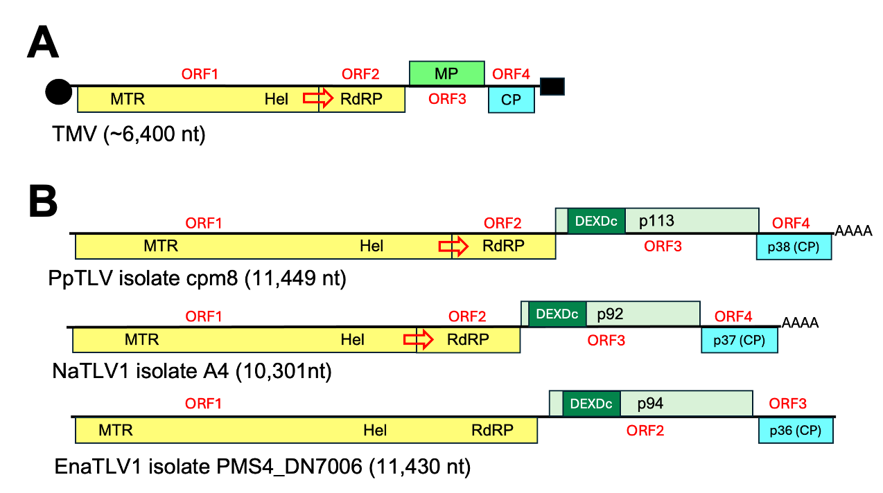

Figure 1. Schematic depiction of genome organization of tobacco mosaic virus (TMV), a typical tobamovirus (panel A), and a few representative members of the proposed family “Tobaliviridae” (panel B). Black circle in TMV genome depicts the 5’ cap, while black rectangle indicates 3’ tRNA-like structure. CP: coat protein; DEXDc: DEXDc helicase; Hel: viral helicase 1; MTR: methyltransferase; ORF: open reading frame; RdRP: RNA-dependent RNA polymerase 2; AAAA: short poly A tail. For extended virus names of tobaliviruses please refer to Table 1 and associated Excel spreadsheet.
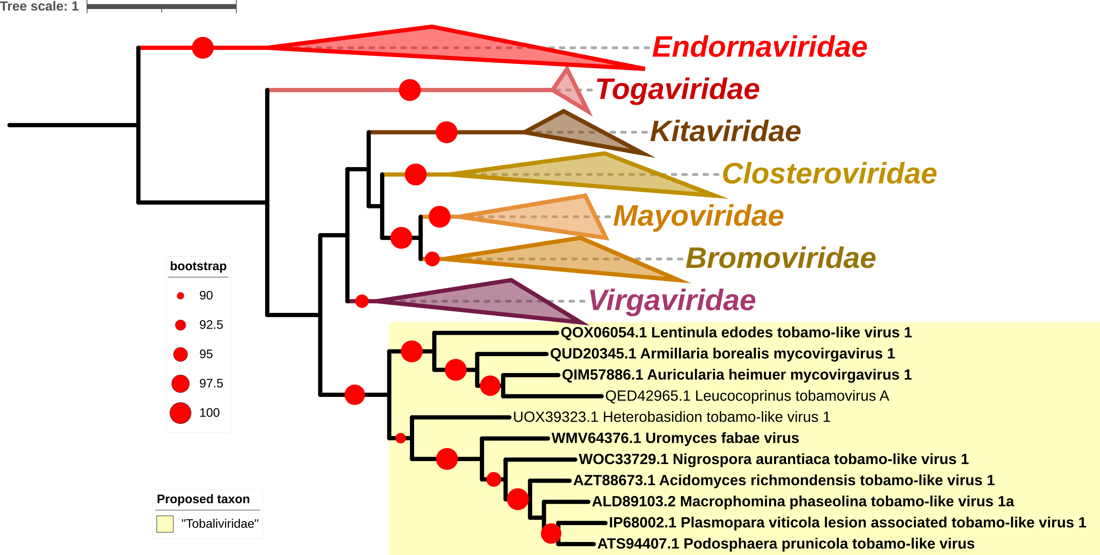Figure 2. Maximum-likelihood phylogenetic tree showing the relationships of members of the proposed family “Tobaliviridae” (shaded in yellow) with viruses classified in seven currently recognized families of the order Martellivirales. “Tobaliviruses” form a strongly supported monophyletic clade, evolutionarily distinct from other families in the order. The tree was constructed on the MAFFT-aligned amino acid sequences of RdRPs using IQ-TREE v 1.6.11 [14] with the 1,000 replicates ultrafast bootstrap [7] under best-fit model “LG+F+I+G4” according to BIC as estimated by ModelFinder [9] and visualized with iTOL v7 [10]. The GenBank accession numbers of RdRP amino acid sequences used for analyses along with virus names are indicated at the tips of branches. Presence of red dot on branching point indicates statistical support of >90% with size corresponding to level of bootstrap values. Names of viruses proposed to represent new species listed in this proposal are indicated in bold.

Table 1. List of the species in the proposed new family “Tobaliviridae”, along with exemplar viruses, their acronyms, corresponding GenBank accessions and associated publications.

Genus | Species name | Virus name | Acronym | GenBank | Ref
Tobalivirus | Tobalivirus acidomyci | Acidomyces richmondensis tobamo-like virus 1 | ArTLV1 | MK279511 | 5
 | Tobalivirus armillariae | Armillaria borealis mycovirgavirus 1 | AbMV1 | MW423800 | 12
 | Tobalivirus auricolariae | Auricularia heimuer mycovirgavirus 1 | AhMV1 | MN928963 | 11
 | Tobalivirus ibericum | Plasmopara viticola lesion associated tobamo-like virus 1 | PvLaTLV1 | MN565665 | 2
 | Tobalivirus macrophominae | Macrophomina phaseolina tobamo-like virus | MpTLV | KF537660 | 13
 | Tobalivirus lentinulae | Lentinula edodes tobamo-like virus 1 | LeTLV1 | MN744727 | 6
 | Tobalivirus nigrosporae | Nigrospora aurantiaca tobamo-like virus 1 | NaTLV1 | OR228589 | 8
 | Tobalivirus podosphaerae | Podosphaera prunicola tobamo-like virus | PpTLV | KY420046 | 15
 | Tobalivirus uromyci | Uromyces fabae virus | UFV | OQ995224 | 17

