

The International Committee on Taxonomy of Viruses
Taxonomy Proposal Form, 2025

Part 1a: Details of taxonomy proposals

Title: | Create new family in order Tolivirales with 3 new genera and 42 new species
Code assigned: | 2025.005F.Ac.v3.Ambiguiviridae_newfam

Author(s), affiliation and email address(es):
Given name (+middle initial(s)) | Surname | Affiliation | Email address | Corr. author(s)
Michael J | Adams | Minehead, UK | mike.adams.virus@gmail.com | X
Xiaohan | Mo | Yunnan Academy of Tobacco Agricultural Science, Kunming, China | 1744167230@qq.com
Hongying | Zheng | Institute of Plant Virology, Ningbo University, Ningbo, China | zhenghongyinghz@163.com

Part 1b: Taxonomy Proposal Submission
ICTV Subcommittee:
Animal DNA Viruses and Retroviruses |  | Bacterial viruses
Animal minus-strand and dsRNA viruses |  | Fungal and protist viruses | X
Animal positive-strand RNA viruses |  | Plant viruses | X
Archaeal viruses |  | General -

List the ICTV Study Group(s) that have seen or have been involved in creating this proposal:
Optional – complete only if formally voted on by an ICTV Study Group:
Study Group | Number of members
Study Group | Votes in support | Votes against | No vote

Submission date: | 26/05/2025

Part 1c: Feedback from ICTV Executive Committee (EC) meeting
Executive Committee Meeting Decision code: | X
A – Accept
Ac – Accept subject to revision by relevant subcommittee chair. No further vote required | X
U – Accept without revision but with re-evaluation and email vote by the EC
Uc – Accept subject to revision and re-evaluation and email vote by the EC
Ud – Deferred to the next EC meeting, with an invitation to revise based on EC comments
J - Reject
W - Withdrawn

Comments from the Executive Committee:
Please expand/ameliorate the abstract.
Please improve figure outlines (running out of page and not presented as a JPG or PNG file)

Part 1d: Revised Taxonomy Proposal Submission
Response of proposer:
All suggestions for improvement accepted and addressed by the authors.

Revision date: | 30/08/2025

Part 3: TAXONOMIC PROPOSAL
https://ictv.global/taxonomy/templates
Taxonomic changes proposed:
Establish new taxon | X | Split taxon
Abolish taxon |  | Merge taxon
Move taxon |  | Promote taxon
Rename taxon |  | Demote taxon
Move and rename

Etymology (origin) of proposed taxonomic names:
Taxon name | Etymology of the term
ambigui- | references the unusual nature of the GDN triad within the RdRP motif of these (+)ssRNA viruses and the ambiguity related to the host of DRV, the first virus described for this group
alphabotriensis | from genus name of fungal host + alpha
alphaerysiphae | from genus name of fungal host + alpha
alphahoplandiae | from Hopland, California: place of origin + alpha
alphamacrophominae | from genus name of fungal host + alpha
alphasetosphaerae | from genus name of fungal host + alpha
alphaverticillii | from genus name of fungal host + alpha
alphaviticolae | from genus name of plant source + alpha
alternariae | from genus name of fungal host
betabotriensis | from genus name of fungal host + beta
betaerysphae | from genus name of fungal host + beta
betahoplandiae | from Hopland, California: place of origin + beta
betamacrophominae | from genus name of fungal host + beta
betasetosphaerae | from genus name of fungal host + beta
betaverticillii | from genus name of fungal host + beta
betaviticolae | from genus name of plant source + beta
botriensis | from genus name of fungal host
colletotrichae | from genus name of fungal host
curvulariae | from genus name of fungal host
deltaerysiphae | from genus name of fungal host + delta
diaporthensis | from genus name of fungal host
diplodiae | from genus name of fungal host
erysiphae | from genus name of fungal host
fusarii | from genus name of fungal host
gammaerysiphae | from genus name of fungal host + gamma
gammahoplandiae | from Hopland, California: place of origin + gamma
glycineae | from genus name of plant source
guiyanense | from place of origin
ixodidae | from order Ixodida (ticks): source of virus
magnaporthensis | from genus name of fungal host
nigrosporae | from genus name of fungal host
oryzae | from genus name of plant source
penicilliae | from genus name of fungal host
periconiae | from genus name of fungal host
phomae | from genus name of fungal host
plasmoporae | from genus name of fungal host
ripopyrdae | from virus name
sclerotiniae | from genus name of fungal host
trichodermae | from genus name of fungal host

Permission for use of names derived from a living person:
Taxon name | Full name of person from whom the name is derived | Attached

Abstract of Taxonomy Proposal:
Taxonomic rank(s) affected:
Order Tolivirales

Description of current taxonomy:
Two families: Tombusviridae and Carmotetraviridae

Proposed taxonomic change(s):
Creation of a new family “Ambiguiviridae” in the order Tolivirales to accommodate three new genera and a total of 42 new species.

Justification:
Over the past two decades, a substantial number of evolutionary related viruses with bicistronic RNA(+) genome, ranging from 2.6 kb to ~5.5 kb in length, have been discovered mostly from fungi and from metagenomic studies. Their ORF1 encodes a protein of unknown function but with conserved domains, while ORF2 codes for a putative RNA-dependent RNA polymerase (RdRP) with similarity to those of plant-infecting viruses in the family Tombusviridae. As this group of viruses is not part of the official virus taxonomy yet, we formally propose their classification in a new family “Ambiguiviridae” in the order Tolivirales.

- Text of Taxonomy proposal:
Taxonomic rank(s) affected:
Order Tolivirales

Description of current taxonomy:
There are two families in the order: Tombusviridae (many plant viruses classified into over 90 species and 18 genera) and Carmotetraviridae (containing a single genus and species).

Proposed taxonomic change(s):
To create a new family “Ambiguiviridae” in the order, having three new genera and a total of 42 new species.

Demarcation criteria:
Members of the proposed new family have two in-frame ORFs that may be translated by readthrough into a single protein. The second predicted ORF is an RdRP clearly related to other viruses in the order but phylogenetically distinct.
New species are being proposed here for viruses that have a coding-complete genome sequence and with less than 78% amino acid identity to those of other species in their predicted P1-P2 protein sequences. This appears to be a logical threshold based on two-way comparisons between all the sequences used (see below).
Members of different genera have less than 35% amino acid identity in comparisons of their predicted P1-P2 protein sequences.

Justification:
The first report of a novel mycovirus with a genome distantly related to members of the plant virus family Tombusviridae was for a virus first named Diaporthe ambigua virus 1 [Priesig et al., 2000]. It subsequently appeared that the fungal host was actually D. perjuncta and the virus name was changed to Diaporthe RNA virus (DRV) [Moleleki et al., 2003]. A substantial number of related viruses have since been discovered (mostly from fungi but some from metagenomic studies) all of which have a (+)RNA genome ranging from 2.6 kb to ~5.5 kb in length that contains two large ORFs in the same reading frame. ORF1 encodes a protein of unknown function but with conserved domains. ORF2 encodes a putative RNA-dependent RNA polymerase (RdRP) that shows an obvious similarity to those of plant viruses in the family Tombusviridae [Gilbert et al., 2019; Preisig et al., 2000] and which has the conserved catalytic core domain of the RdRP of members of the order Tolivirales (cd23179) with three conserved polymerase motifs (A, B, C). There are some distinctive features of the RdRP sequence and in particular all the viruses have a GDN triad in motif C rather than the canonical GDD found in other (+)RNA viruses. ORF1 ends with an amber stop codon and it is thought that the two ORFs are expressed together by ribosomal readthrough (Figure 1). There is no known structural protein and no virions have been observed.

It was suggested that the group might form a new family “Ambiguiviridae” [Gilbert et al., 2019], but others have suggested a family “Mycotombusviridae” [Zhou et al., 2021; Zhou et al., 2023; Yang et al., 2024] and yet others have advocated a genus “Umbramycovirus”, acknowledging a relationship to viruses in the genus Umbravirus (also family Tombusviridae) [Ruiz-Padilla et al., 2021]. However, phylogenetic analysis clearly places these viruses outside the existing family Tombusviridae and there are ‘umbra-like’ viruses of plants that are not closely related to these mycoviruses so it seems unwise to adopt a nomenclature that might suggest otherwise [Simon et al., 2024]. This proposal therefore advocates the family name “Ambiguiviridae” as first suggested in 2019 by Gilbert et al.

A list of the sequences used for this proposal is provided in Ambiguiviridae_newfam_Supp_info.xlsx. This includes all complete (or coding-complete) sequences of putative ambiguiviruses that could be retrieved from GenBank and representative viruses from existing families and genera in the order Tolivirales. ORF1 protein sequences do not align significantly with other known virus sequences but the ORF2 (RdRp) sequences align with other viruses in the order and phylogenetic analysis places these viruses as a single distinct group (Figure 2). With such small genomes and little biological information, it seems best to allocate these viruses to a single family and to create three genera for the major phylogenetic branches in the tree. The predicted P1-P2 readthrough protein sequences were generated for each sequence using ORF Finder (https://www.ncbi.nlm.nih.gov/orffinder/ ). Phylogenetic analysis of these protein sequences (Figure 3) has a similar topology to that for P2 alone but there are no suitable sequences outside the family to provide any outgroup for the analysis.

To help establish genus and species demarcation criteria, two-way comparisons were made between the P1-P2 protein sequences. Details are in the file Ambiguiviridae_newfam_Supp_info.xlsx and the distribution of values is shown in Figure 4. From this, new species are proposed where the sequences have less than 78% amino acid identity to one another, while comparisons of viruses in different genera have amino acid identities <35%. Some sequences analyzed clearly belong to the same species although having very different virus names. Full details of the proposed assignments are provided in the file Ambiguiviridae_newfam_Supp_info.xlsx.

References:
Gilbert KB, Holcomb EE, Allscheid RL, Carrington JC (2019) Hiding in plain sight: New virus genomes discovered via a systematic analysis of fungal public transcriptomes. PLoS One 14:51
Kumar S, Stecher G, Suleski M, Sanderford M, Sharma S, Tamura K (2024) Molecular Evolutionary Genetics Analysis Version 12 for adaptive and green computing. Mol Biol Evol 41:1-9
Moleleki N, van Heerden SW, Wingfield MJ, Wingfield BD, Preisig O (2003) Transfection of Diaporthe perjuncta with Diaporthe RNA virus. Appl Environ Microbiol 69: 3952–3956
Preisig O, Moleleki N, Smit WA, Wingfield BD, Wingfield MJ (2000) A novel RNA mycovirus in a hypovirulent isolate of the plant pathogen Diaporthe ambigua. J Gen Virol 81:3107-3114
Ruiz-Padilla A, Rodríguez-Romero J, Gómez-Cid I, Pacifico D, Ayllón MA (2021) Novel Mycoviruses Discovered in the Mycovirome of a Necrotrophic Fungus. mBio 12:40
Simon AE, Quito-Avila DF, Bera S (2024) Expanding the Plant Virome : Umbra-Like Viruses Use Host Proteins for Movement. Annu Rev Virol 11:283-308
Yang ZJ, Fei ML, Wu GC, Xiang YSB, Zhong J, Su JE, Chen Y (2024) Molecular characterization of a novel mycotombus-like virus isolated from the phytopathogenic fungus Nigrospora oryzae. Arch Virol 169:4
Zhou J, Hu XC, Liang XF, Wang YH, Xie CP, Zheng L (2021) Complete genome sequence of a novel mycovirus from Phoma matteucciicola. Arch Virol 166:317-320
Zhou SY, Chen DP, Fu YJ, Zhou JY, Yang YQ, Xie CP, Zheng L (2023) Characterization of a novel mycotombus-like virus from the plant-pathogenic fungus Phoma matteucciicola. Arch Virol 168:4

N.B. Publications associated with many of the other sequences used are listed in the file Ambiguiviridae_newfam_Supp_info.xlsx

Accompanying files:
Filename | Description of contents
Ambiguiviridae_newfam_Supp_info.xlsx | Details of sequences used;  P1-P2 protein comparison matrix

Tables, Figures:

Figure 1. Genome organization of viruses in the proposed family “Ambiguiviridae”. Two ORFs are predicted in the same reading frame. ORF1 (unknown function) concludes with an amber (UAG) codon that can be suppressed to generate a readthrough protein of up to 121kDa. There are no obvious differences in genome size or organization between members of the three proposed genera.

P1
174-464 aa
P2 (RdRp)
459-552 aa
5’
3’
UAG
P1-P2 705-1096 aa (78-121 kDa)
2669-5436 nt

Figure 2. Maximum Likelihood phylogenetic tree for the predicted P2 (RdRP) protein sequences of all coding-complete ambiguiviruses, together with the RdRP sequences of representative members of existing species within the order Tolivirales. Full details of all the abbreviations and sequences used are in the file Ambiguiviridae_newfam_Supp_info.xlsx. Labels in red are those of the exemplar viruses for each of the proposed new species. Red curly brackets show viruses assigned to the same species.
The phylogeny was inferred using the Maximum Likelihood method and Jones-Taylor-Thornton model of amino acid substitutions and the tree with the highest log likelihood (-67,256.08) is shown. The percentage of replicate trees in which the associated taxa clustered together (1,000 replicates) is shown next to the branches when >50%. The initial tree for the heuristic search was selected by choosing the tree with the superior log-likelihood between a Neighbor-Joining (NJ) tree and a Maximum Parsimony (MP) tree. The NJ tree was generated using a matrix of pairwise distances computed using the Jones-Taylor-Thornton model. The MP tree had the shortest length among 10 MP tree searches, each performed with a randomly generated starting tree. The analytical procedure encompassed 88 amino acid sequences with 658 positions in the final dataset. Evolutionary analyses were conducted in MEGA12 [Kumar et al., 2024] utilizing up to 4 parallel computing threads.
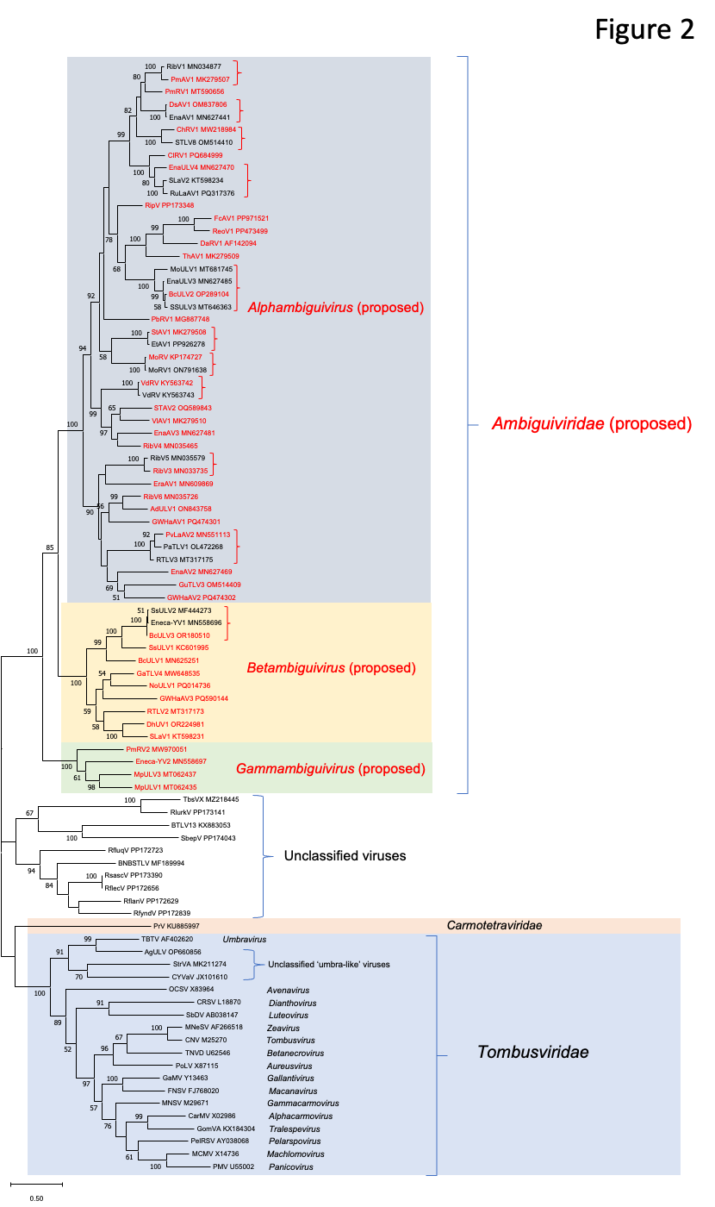

Figure 3. Maximum Likelihood phylogenetic tree for the predicted P1-P2 protein sequences of all coding complete ambiguiviruses. Details are similar to Figure 1 and the tree with the highest log likelihood (-55,421.63) is shown. The analytical procedure encompassed 58 amino acid sequences with 797 positions in the final dataset.
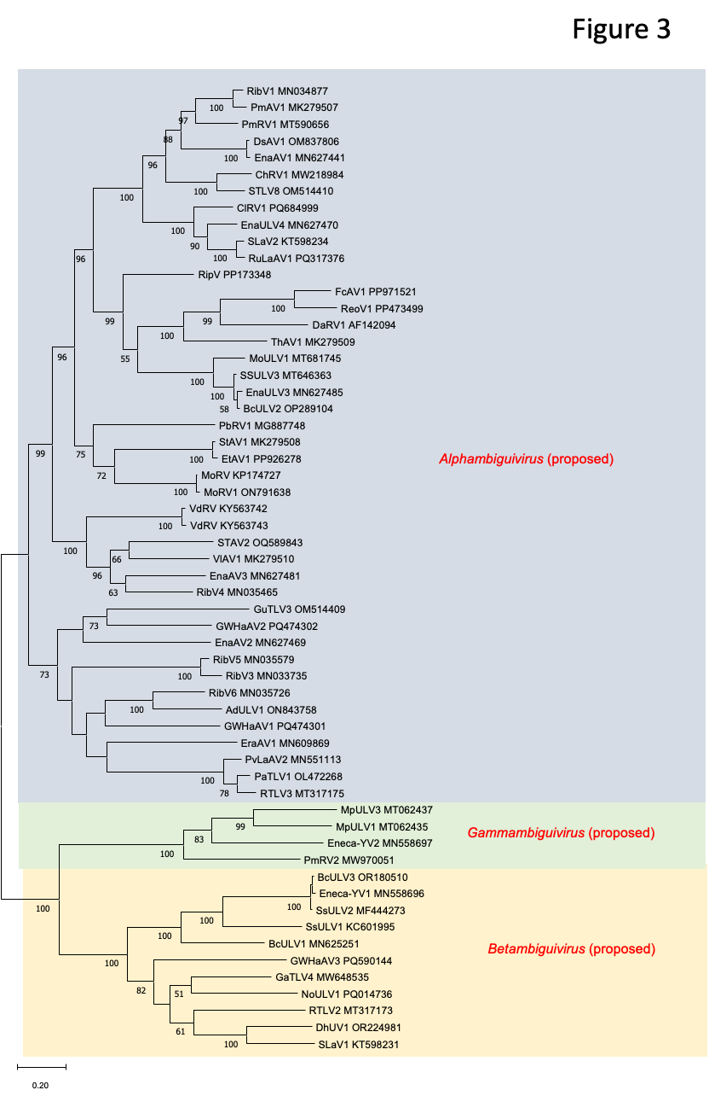
Figure 4. Distribution of amino acid identity values in comparisons between the predicted P1-P2 protein sequences of all coding complete ambiguiviruses as detailed in the file Ambiguiviridae_newfam_Supp_info.xlsx.

