

The International Committee on Taxonomy of Viruses
Taxonomy Proposal Form, 2025

Part 1a: Details of taxonomy proposals

Title: | The description of new Ralstonia phage and its related phage fill some gaps on Caudoviricetes taxonomy
Code assigned: | 2025.090B.Ac,v3,Anamaviridae_1nf

Author(s), affiliation and email address(es):
Given name (+middle initial(s)) | Surname | Affiliation | Email address | Corr. author(s)
Poliane | Alfenas-Zerbini | Universidade Federal de Viçosa, Microbiology Departament, Viçosa, Brazil | palfenas@ufv.br | x
Rafael R. | Rezende | Universidade Federal de Viçosa, Microbiology Departament, Viçosa, Brazil | r.r.rezende@ufv.br

Part 1b: Taxonomy Proposal Submission
ICTV Subcommittee:
Animal DNA Viruses and Retroviruses |  | Bacterial viruses | x
Animal minus-strand and dsRNA viruses |  | Fungal and protist viruses
Animal positive-strand RNA viruses |  | Plant viruses
Archaeal viruses |  | General -

List the ICTV Study Group(s) that have seen or have been involved in creating this proposal: https://ictv.global/sc
Not applied

Optional – complete only if formally voted on by an ICTV Study Group:
Study Group | Number of members
Study Group | Votes in support | Votes against | No vote

Submission date:

Part 1c: Feedback from ICTV Executive Committee (EC) meeting
Executive Committee Meeting Decision code: | X
A – Accept
Ac – Accept subject to revision by relevant subcommittee chair. No further vote required | x
U – Accept without revision but with re-evaluation and email vote by the EC
Uc – Accept subject to revision and re-evaluation and email vote by the EC
Ud – Deferred to the next EC meeting, with an invitation to revise based on EC comments
J - Reject
W - Withdrawn

Comments from the Executive Committee:
The first figure is missing a caption.

Part 1d: Revised Taxonomy Proposal Submission
Response of proposer:
Thank you for pointing this out. The caption has been added immediately below Figure 1

Revision date:

Part 3: TAXONOMIC PROPOSAL
https://ictv.global/taxonomy/templates
Taxonomic changes proposed:
Establish new taxon | x | Split taxon
Abolish taxon |  | Merge taxon
Move taxon | x | Promote taxon
Rename taxon |  | Demote taxon
Move and rename

Etymology (origin) of proposed taxonomic names:
Taxon name | Etymology of the term
“Cocadavirus” | The prefix “Cocada” is the name of a typical Brazilian food from the region of isolation of Ralstonia phage AC1.
“alagoinhas” | The specific epithet “alagoinhas” is the name of a city in Brazil where the Raltonia phage AB1 was isolated.
“Mascarenevirinae” | The prefix “Mascarene” is the name given to the group of islands that form a vast “archipelago” located in the southwestern Indian Ocean, east of Madagascar, where most of the proposed family's members were founded.
“Anamaviridae” | The prefix “Anama” is a tradition of “Family” in the Tupi-guarani language, Brazil's most widely spoken indigenous language.

Permission for use of names derived from a living person:
Taxon name | Full name of person from whom the name is derived | Attached

Abstract of Taxonomy Proposal:
Taxonomic rank(s) affected:
Genus, species, subfamily, family.

Description of current taxonomy: The Bakolyvirus and Naesvirus comprise genera unrelated to any family. As for Tsukubavirus, Beograduvirus and Xanthovirus are associated with the subfamily Kantovirinae, which is not associated with any family.

Proposed taxonomic change(s): Recently, we described a new temperate phage named Ralstonia phage CA1 that infects bacteria Ralstonia solanacearum and Ralstonia pseudosolanacearum. The taxonomy classification of this virus results in the proposal of a new family, “Anamaviridae”, harboring the subfamilies “Mascarenevirinae” a new family, and Kantovirinae, previously not associated with the established family. Also, we proposed the creation of “Cocadavirus alagoinhas” species (Cocadavirus genus) related to the “Mascarenevirinae” subfamily. At last, we proposed moving the “Cocadavirus”, Bakolyvirus, and Naesvirus to the new subfamily “Mascarenevirinae”.

Justification: Based on whole-sequence intergenomic similarity analysis, it was possible to reclassify 28 isolates into species associated with a new genus and other established genera and further, based on the sharing of protein orthogroups, a new subfamily was created, which was associated with a new family and established as a subfamily. This proposal eliminated some taxonomic gaps in families and genera from the Caudoviricetes class.

- Text of Taxonomy proposal:

Taxonomic rank(s) affected: The species from the “Cocadavirus”, Bakolyvirus, Naesvirus, Tsukubavirus, Beograduvirus and Xanthovirus subfamily will be reclassified based on whole-sequence intergenomic similarity analysis performed using VIRIDIC, applying the demarcation criteria of 95% of similarity to species and 70% similarity to genus [1, 2]. Furthermore, we suggested that the genera “Cocadavirus”, Bakolyvirus, Naesvirus, Tsukubavirus, Beograduvirus and Xanthovirus be associated with “Mascarenevirinae” and Kantovirinae subfamilies and both subfamilies be associated with a new family named “Anamaviridae”, based on orthologous gene sharing analyses[1, 2].

Description of current taxonomy: The Bakolyvirus and Naesvirus are genera unrelated to any families. On the other hand, Tsukubavirus, Beograduvirus and Xanthovirus are clades related to the subfamily “Anamavirinae”, which is not associated with any family. The demarcation criteria of 95% similarity to species and 70% similarity to genus were applied for these genera.

Proposed taxonomic change(s): The RS-Phage-CA1 is most similar (67.2 % intergenomic similarity) to phages infecting Ralstonia sampled in Reunion and Mauritius islands, which belong to the genus Bakolyvirus (class: Caudoviricetes) [3]. Until now, the genus Bakolyvirus has not been classified in any family. Given that the RS-Phage-CA1 showed < 70% with other related viruses, which are family orphans, we propose to classify these groups. First, we obtained a dataset composed of 254 viruses’ genome sequences with some similarity to RS-phage-CA1 deposited in GenBank. This dataset was obtained by performing tBLASTn (parameters: -evalue 1e-5) against RS-Phage-CA1 proteins predicted using Prokka v.1.14.5 (parameters: --kingdom Viruses --gcode 11) [18]. The tBLASTn results were filtered to keep only alignments showing query coverage >= 50% and identity >= 35%. As a result, a total of 310 viruses from the database were selected and subjected to redundancy removal using average nucleotide identity (https://bitbucket.org/berkeleylab/checkv/src/master/scripts/), resulting in 254 dereplicated viruses genomes that have some level of similarity to the RS-Phage-CA1. Next, based on principles of universal viral taxonomy [1, 4], we applied the proteomic tree and protein orthology to classify the viruses at the family level. We applied intergenomic distance to classify them at the genus and species levels. Thus, the intergenomic distance reveals six novel genera clustering and fifteen novel species (Figure 1A). The RS-Phage-CA1 was classified as a new species and genus. Next, we confirmed that RS-Phage-CA1 and its related phages did not belong to any known viral family according to the proteomic tree generated by VipTree [5] since they clustered into a monophyletic clade composed of unclassified viruses or family orphans viruses (Figure 2). To better visualize the tree structure and clade formation, we rebuilt the proteomic tree, collapsing the clades unrelated to Phage-CA1 (Figure 1B). A monophyletic clade (Clade I) was observed in the proteomic tree, harboring the RS-Phage-CA1 and phages that infect Ralstonia, Burkholderia, and Xanthomonas, which we propose to be considered a novel viral family. In addition, two well-defined subclades (subclades I and II) were observed. Subclade I comprises phages that infect Xanthomonas and belong to the Kantovirinae subfamily, which is not associated with any family. Subclade II includes the RS-Phage-CA1 and viruses from the genus Bakolyvirus and the genus Naesvirus. Then, we prosposed each subclade be considered two subfamilies into a family that is related to clade I. In the next step, we sought homologous proteins inside the family and subfamilies to be used in demarcation criteria associated with the proteomic tree. For this, we ran Proteinortho v.6.3.0 [6] (parameters: -e=1e-05 -cov=50) using all proteomes of the 254 selected viruses to identify the protein orthogroups (OGs). When not available in Genbank/RefSeq, genes were predicted using Prokka v.1.14.5. We identified five OGs exclusively found in all members of clade I, while two OGs were exclusively found in all members of each subclade in this sense, we propose that clade I be classified as a new family and subclades I and II, each one as a novel subfamily. (Figure 1B and Table 1 to 3). We propose to facilitate the inclusion of new viruses into the family and subfamilies the minimum sequence identity in pairwise alignments (query and subject coverage >= 50%) for a protein to be classified within the selected OGs. For this, we ran BLASTp between proteins within a given OG and between proteins of a given OG and proteins from viruses that do not belong to clade I enriched with proteins of all dsDNA viruses classified in ICTV. Using this approach, we obtained sequence identity thresholds for each selected OG. We confirmed these OGs were exclusively found in clade I, subclade I, or subclade II viruses, except for Howlin OG from subclade II. However, by using the identity thresholds, the true orthologs belonging to Holin OG can be identified. The sequence identity thresholds for each OG can be checked in Figures 3 to 11. The function of the proteins belonging to these OGs was predicted using BlastP and InterProScan [7, 8]. Some proteins give any significant hits and, thus, were kept as hypothetical proteins. The OGs harboring only hypothetical proteins were named using Greek letters (Table 1 to 3). To support using OGs to separate de clades, we performed an RS-Phage-CA1 phylogenetic analysis by aligning each orthogroup protein shared by a sequence of clade I using the MAFFT program [9]. After, the alignments were concatenated, and the best model was defined using the program model-testNG [10]. Following, we used Maximolike Horrid to infer the phylogenetic tree using the program RaxML with a bootstrap test with 1,000 repetitions [11]. As a result, we obtained a phylogenetic tree with a similar structure to VipTree, where, in both cases, the phages were separated into clades with the same biological characteristics as the host (Figure 1C). Together, these results suggest that this group of ortholog proteins is a good marker for the evolutionary history of viruses placed on clade I and fortifies the use of ortholog proteins as a good tool for classifying these viruses.

Demarcation criteria: We propose a creation of the novel “Anamaviridae” family that is defined with the following demarcation criteria: all “Anamaviridae” members belong to monophyletic on the proteomic tree and have the five orthologous proteins above the identity thresholds (in parenthesis): Alpha OG (36.6%), Integrase OG (41.1%), Tail lysozyme OG (30.3%), Beta OG (41.1%) and Gamma OG (37.8%) (Tabel 1). Proceeding, we propose that the Kantovirinae subfamily be classified inside the “Anamaviridae” family following demarcation criteria: the Kantovirinae members belong to the monophyletic subclade I inside the monophyletic clade I of Anamaviridae on the proteomic tree and have the two orthologous proteins above the identity thresholds (in parenthesis): Delta OG (32.4%) and Epsilon OG (97.3%) (Tabel 2). Then, we propose a novel “Mascarenevirinae” subfamily being classified inside the “Anamaviridae” family following demarcation criteria: the “Mascarenevirinae” members belong to the monophyletic subclade II inside the monophyletic clade of “Anamaviridae” on the proteomic tree and have the two orthologous proteins above the identity thresholds (in parenthesis): Holin OG (59.5%) and Tail OG (31.7%) (Tabel 3). At last, we propose that all members of the “Anamaviridae" family be classified in genera and species using the intergenomic distances following demarcation criteria: members of the same genus clustering have intergenomic distance ≥ 70% and same species clustering have intergenomic distance ≥ 95%. The proposal to “Anamaviridae”, Kantovirinae, “Mascarenevirinae”, and the genera and species are summarized in Figure 12.

Justification: Recently, we performed a description of a new bacteriophage infecting Ralstonia named Ralstonia phage CA1. Firstly, we identified a group of phages related to Ralstonia phage CA1. Afterward, we apply the current recommendation of ICTV to bacterial viruses taxonomy, resulting in a clear relation of Ralstonia phage CA1 with these phages, which can be used to fill some gaps in Caudoviricetes taxonomy. Thus, here we propose (1) the classification of new bacteriophage species, (2) the reclassification of some species, (3) the grouping of four orphans family genera in a new subfamily and (4) the creation of a new family grouping of two orphan family subfamilies.

References:
1. Turner D, Kropinski AM, Adriaenssens EM (2021) A roadmap for genome-based phage taxonomy. Viruses 13:506. https://doi.org/10.3390/v13030506
2. Januário BD, de Rezende RR, Morgan T, Alfenas-Zerbini P (2025) Description of two novel bacteriophages of the class Caudoviricetes that infect Ralstonia solanacearum and Ralstonia pseudosolanacearum. Arch Virol 170:86. https://doi.org/10.1007/s00705-025-06271-z
3. Trotereau A, Boyer C, Bornard I, et al (2021) High genomic diversity of novel phages infecting the plant pathogen Ralstonia solanacearum, isolated in Mauritius and Reunion islands. Sci Rep 11:5382. https://doi.org/10.1038/s41598-021-84305-7
4. Simmonds P, Adriaenssens EM, Murilo Zerbini F, et al (2023) Four principles to establish a universal virus taxonomy. PLoS Biol 21:1–23. https://doi.org/10.1371/journal.pbio.3001922
5. Nishimura Y, Yoshida T, Kuronishi M, et al (2017) ViPTree: the viral proteomic tree server. Bioinformatics 33:2379–2380. https://doi.org/10.1093/bioinformatics/btx157
6. Klemm P, Stadler PF, Lechner M (2023) Proteinortho6: pseudo-reciprocal best alignment heuristic for graph-based detection of (co-)orthologs. Front Bioinforma 3:. https://doi.org/10.3389/fbinf.2023.1322477
7. NCBI (2016) BLAST Homepage and Selected Search Pages. NCBI Handout Ser 1–8
8. Paysan-Lafosse T, Blum M, Chuguransky S, et al (2023) InterPro in 2022. Nucleic Acids Res 51:D418–D427. https://doi.org/10.1093/nar/gkac993
9. Nakamura T, Yamada KD, Tomii K, Katoh K (2018) Parallelization of MAFFT for large-scale multiple sequence alignments. Bioinformatics 34:2490–2492. https://doi.org/10.1093/bioinformatics/bty121
10. Darriba D, Posada D, Kozlov AM, et al (2020) ModelTest-NG: A New and Scalable Tool for the Selection of DNA and Protein Evolutionary Models. Mol Biol Evol 37:291–294. https://doi.org/10.1093/molbev/msz189
11. Stamatakis A (2014) RAxML version 8: a tool for phylogenetic analysis and post-analysis of large phylogenies. Bioinformatics 30:1312. https://doi.org/10.1093/BIOINFORMATICS/BTU033

Accompanying files:
Filename | Description of contents

Tables, Figures:

Figure 1: Genomic similarity, proteomic tree, and classification of RS phage. In A whole-sequence intergenomic similarity was generated using VIRIDIC of RS-Phage-CA1, respectively. The dotted lines indicated the species and the inclusion (⊂) into the genera. The heatmap colors in A and B indicate the demarcation criteria to separate bacteriophage species and genera based on the current ICTV classification. In C, the proteomic tree was generated using VipTree to classify phages related to RS-Phage-CA1. The box indicates clade I, subclades I, and II, corresponding to a novel family and two subfamilies. In the same way, the branch colors of the proteomic tree highlight clade I, subclade I, and II. The black triangles indicated collapsed branches of other phages. In D, the phylogenetic tree was reconstructed from concatenated protein sequences from each ortho group shared by phages from clade I with the model LG+I+G4+F, and dots indicate bootstrap values ≥ 60%.

Figure 2. Proteomic tree (Viptree) with 254 selected virus genomes with some level similarity (tBLASTn) to RS-phage-CA1 PP316169 (highlighted in red). The RS-phage-CA1 is present in a monophyletic clade.

 | Table 1. Unique orthogroups (OGs) of clade I
OGs |  | Viruses
 |  | Rs-Phage-CA1 | Burkholderia phage Bcep781 | Xanthomonas oryzae phage OP2 DNA | Burkholderia phage Bcep43 | Burkholderia phage Bcep1 | Burkholderia phage BcepNY3 | Xanthomonas phage KPhi1 | Xanthomonas phage XPP1 | Xanthomonas phage XPP2 | Xanthomonas phage XPP3 | Xanthomonas phage XPP3 | Xanthomonas phage XPP6 | Xanthomonas phage XPP8 | Xanthomonas phage XPP9 | Xanthomonas phage XPV1 | Xanthomonas phage XPV2 | Xanthomonas phage XPV3 | Xanthomonas virus phiXaf18 | Ralstonia phage Adzire, | Ralstonia phageBakolye | Ralstonia phage Elie | Ralstonia phage Jenny | Ralstonia phage Sarlave | Ralstonia phage Simangalove | Xanthomonas phage X2 | Xanthomonas phage MYK3 | Xanthomonas phage BsXeu269p/3 | Xanthomonas phage pXoo2107 | Xanthomonas phage NEB7
α (alpha) OG |  | XDQ96090.1 | AAN38022 | BAE72781 | AAR89312 | AAQ73368 | ABR10555 | APQ41913 | AVO23657 | AVO23784 | AVO23789 | AVO23862 | AVO23988 | AVO24033 | AVO24097 | AVO24212 | AVO24264 | AVO24324 | QFR59556 | QMV32321 | QMV32632 | QMV32949 | QMV33511 | QMV33661 | QMV33706 | QRI46315 | UGL62943 | UUW40452 | UUR56270 | WHB31186
Integrase OG |  | XDQ96064 | AAN38020 | BAE72778 | AAR89310 | AAQ73366 | ABR10553 | APQ41907 | AVO23661 | AVO23716 | AVO23793 | AVO23992 | AVO24029 | AVO24101 | AVO24216 | AVO24260 | AVO24260 | AVO24320 | QFR59561 | QMV32350 | QMV32598 | QMV32978 | QMV33545 | QMV33690 | QMV33735 | QRI46319 | UGL62947 | UUW40388 | UUR56274 | WHB31188
Tail lysozyme OG |  | XDQ96114 | AAN38043 | BAE72798 | AAR89335 | AAQ73392 | ABR10579 | APQ41930 | AVO23710 | AVO23765 | AVO23843 | AVO23969 | AVO24053 | AVO24151 | AVO24193 | AVO24282 | AVO24343 | QFR59551 | QMV32356 | QMV32592 | QMV32984 | QMV33551 | QMV33696 | QMV33741 | QRI46370 | UGL62928 | UUW40437 | UUR56251 | WHB31172 | WHB31172
β (beta) OG |  | XDQ96117 | AAN38046 | BAE72801 | AAR89338 | AAQ73395 | ABR10582 | APQ41934 | AVO23707 | AVO23762 | AVO23840 | AVO23966 | AVO24056 | AVO24148 | AVO24190 | AVO24285 | AVO24346 | QFR59593 | QMV32353 | QMV32595 | QMV32981 | QMV33548 | QMV33693 | QMV33738 | QRI46367 | UGL62924 | UUW40433 | UUR56248 | WHB31169 | WHB31169
γ (gamma) OG |  | XDQ96096 | AAT37988 | BAE72808 | AAR89346 | AAQ73403 | ABR10590 | APQ41940 | AVO23700 | AVO23755 | AVO23832 | AVO23959 | AVO24064 | AVO24140 | AVO24182 | AVO24293 | AVO24353 | QFR59590 | QMV32373 | QMV32576 | QMV33001 | QMV33567 | QMV33655 | QMV33758 | QRI46358 | UGL62917 | UUW40426 | UUR56241 | WHB31221 | WHB31221

Table 2. Unique orthogroups (OGs) of subclade II
OGs | Viruses
OGs | Xanthomonas oryzae phage OP2 DNA | Xanthomonas phage KPhi1 | Xanthomonas phage XPP1 | Xanthomonas phage XPP2 | Xanthomonas phage XPP3 | Xanthomonas phage XPP6 | Xanthomonas phage XPP8 | Xanthomonas phage XPP9 | Xanthomonas phage XPV1 | Xanthomonas phage XPV2 | Xanthomonas phage XPV3 | Xanthomonas virus phiXaf18 | Xanthomonas phage X2 | Xanthomonas phage MYK3 | Xanthomonas phage BsXeu269p/3 | Xanthomonas phage pXoo2107 | Xanthomonas phage NEB7
δ (delta) OG | BAE72822 | APQ41888 | AVO23681 | AVO23736 | AVO23813 | AVO23940 | AVO24083 | AVO24121 | AVO24236 | AVO24314 | AVO24376 | QFR59582 | QRI46338 | UGL62899 | UUW40409 | UUR56292 | WHB31207
ε (epsilon) OG | BAE72796 | APQ41928 | AVO23712 | AVO23767 | AVO23845 | AVO23971 | AVO24051 | AVO24153 | AVO24195 | AVO24280 | AVO24341 | QFR59596 | QRI46372 | UGL62930 | UUW40439 | UUR56253 | WHB31174

 | Table 3. Unique orthogroups (OGs) of subclade II
OGs |  | Viruses
 |  | Rs-Phage-CA1 | Burkholderia phage Bcep781 | Burkholderia phage Bcep781 | Burkholderia phage Bcep43 | Burkholderia phage Bcep43 | Burkholderia phage Bcep1 | Burkholderia phage Bcep1 | Burkholderia phage BcepNY3 | Ralstonia phage Adzire | Ralstonia phage Bakoly | Ralstonia phage Elie | Ralstonia phage Jenny | Ralstonia phage Sarlave | Ralstonia phage Simangalove
Holin OG |  | XDQ96106 | AAN38030 | AAN38031 | AAR89321 | AAR89322 | AAQ73377 | AAQ73378 | ABR10563 | QMV32364 | QMV32584 | QMV32992 | QMV33559 | QMV33646 | QMV33749
Tail OG |  | XDQ96102 | AAN38063 | AAR89355 | AAQ73415 | ABR10603 | QMV32368 | QMV3258 | QMV32996 | QMV33562 | QMV33650 | QMV33753 | QMV33753 | QMV33753 | QMV33753

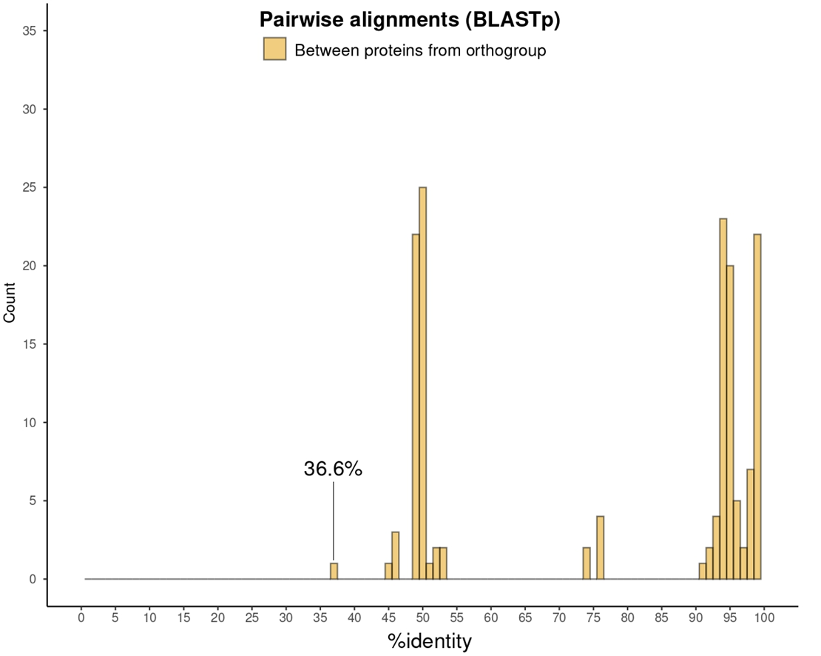
Figure 3. The minimum sequence identity pairwise of proteins from α (alfa) OG.

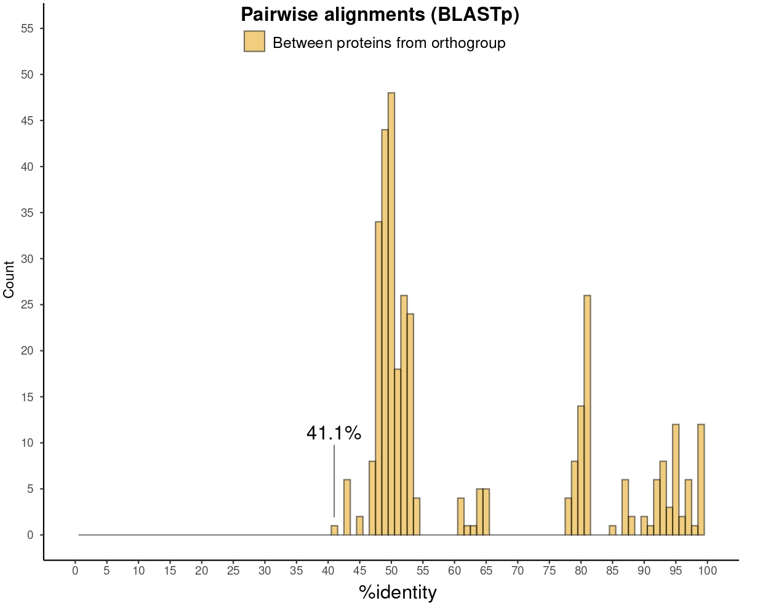
Figure 4. The minimum sequence identity pairwise of proteins from integrase OG.

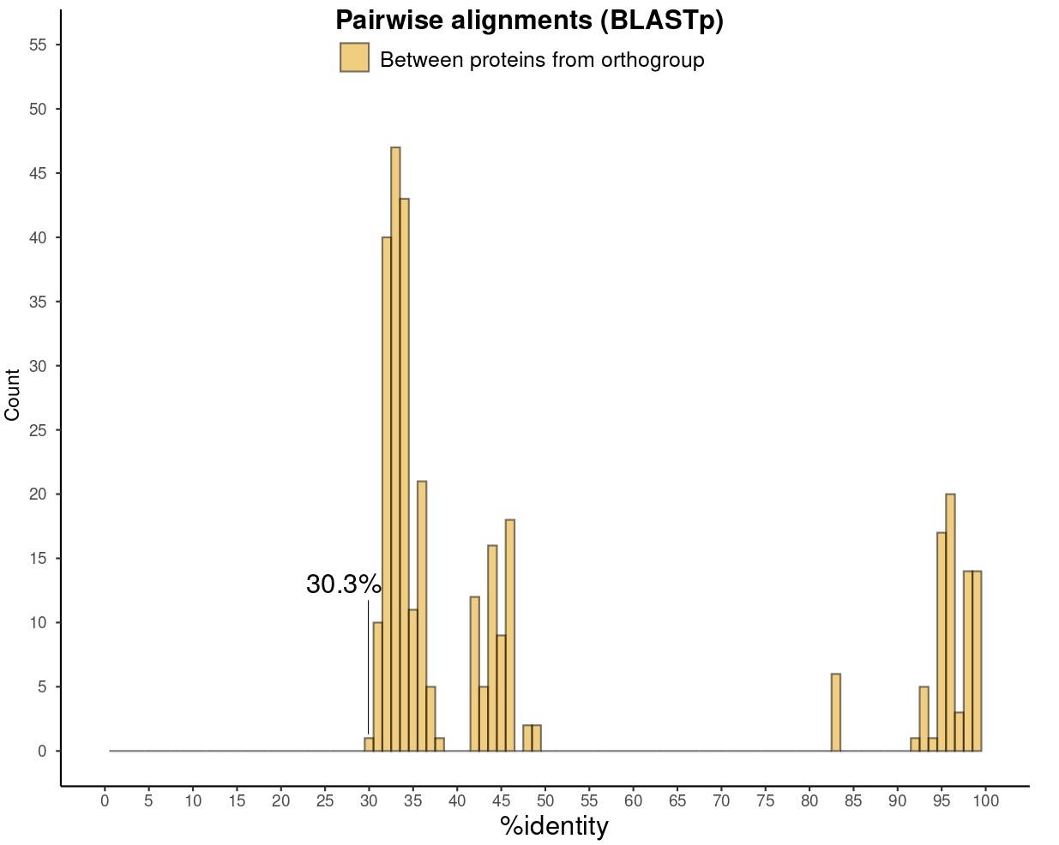
Figure 5. The minimum sequence identity pairwise of proteins from tail lysozyme OG.

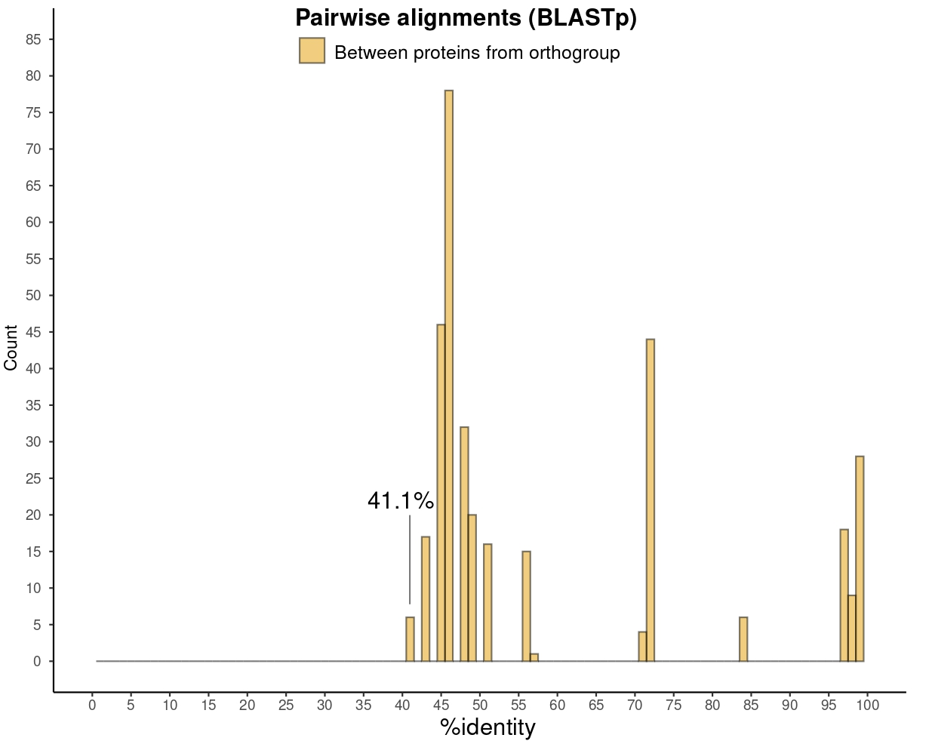
Figure 6. The minimum sequence identity pairwise of proteins from β (beta) OG.

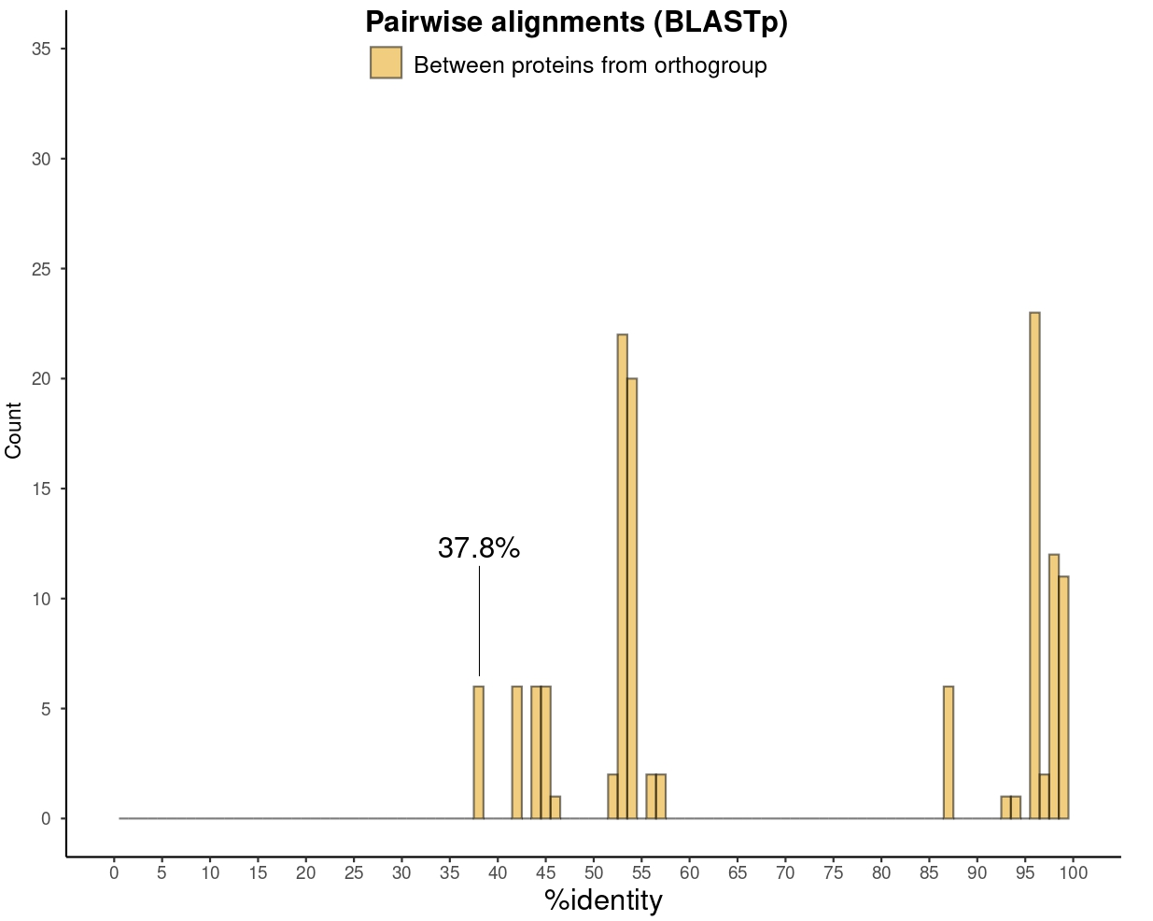
Figure 7. The minimum sequence identity pairwise of proteins from γ (Gamma) OG.

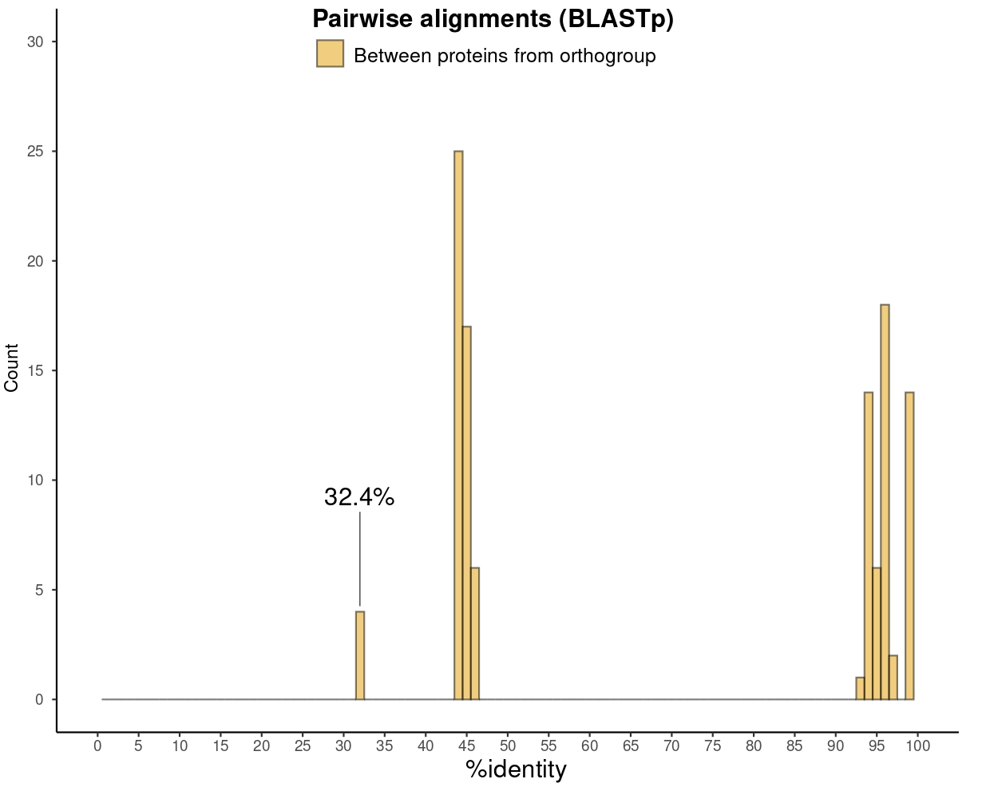
Figure 8. The minimum sequence identity pairwise of proteins from δ (delta) OG.

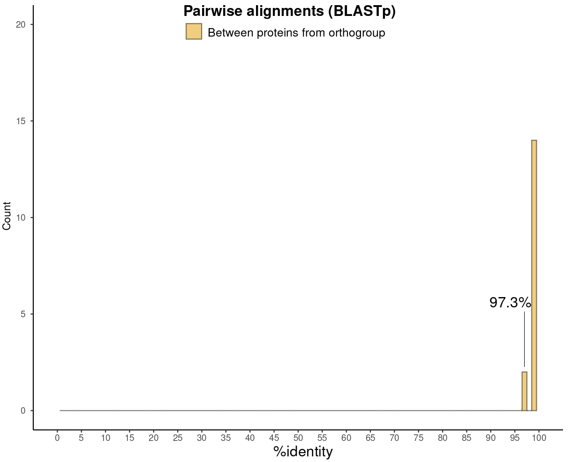
Figure 9. The minimum sequence identity pairwise of proteins from ε (epsilon) OG.

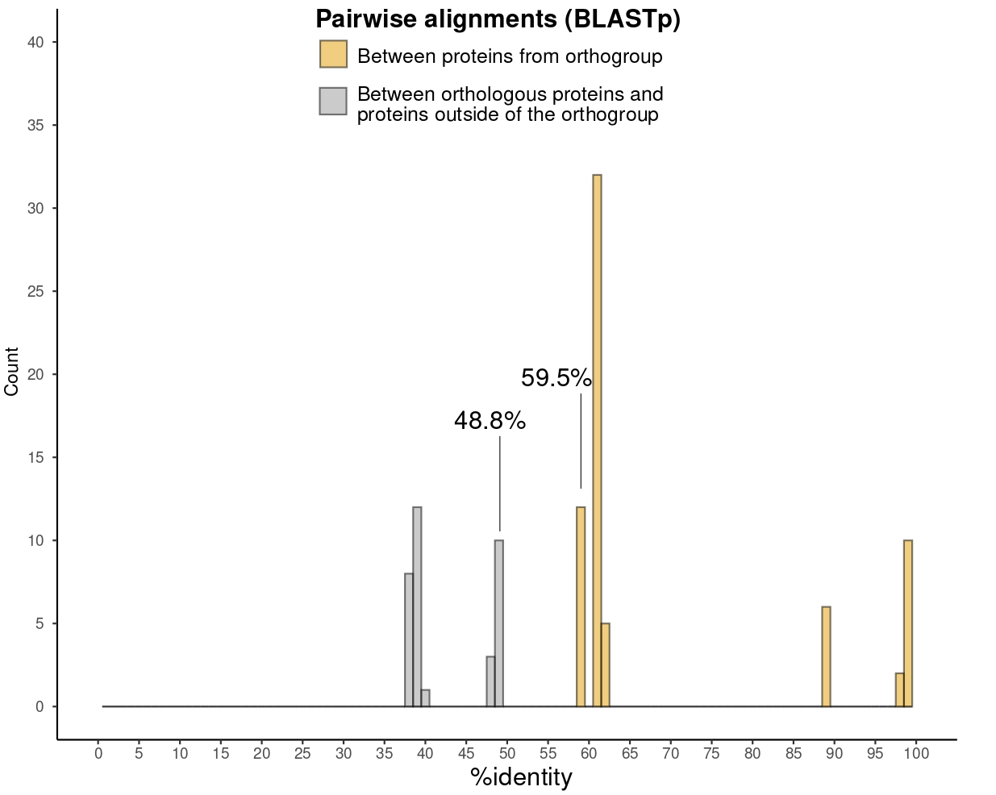
Figure S10. The minimum sequence identity pairwise of proteins from holin OG.

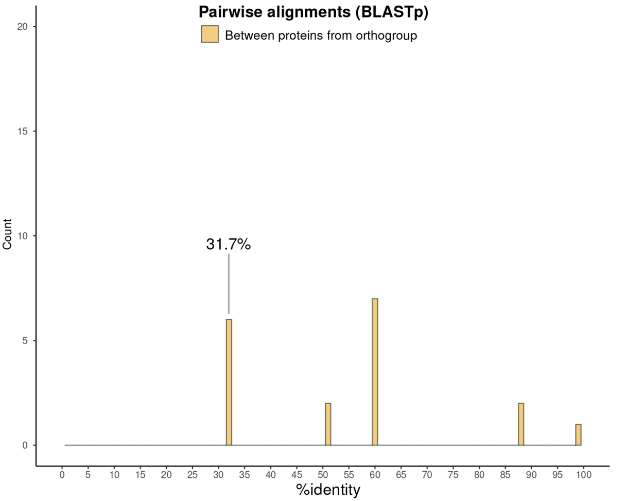
Figure 11. The minimum sequence identity pairwise of proteins from tail OG.
Figure 12. the pro- posed classification and taxonomy of RS phage CA1 and other related phages is shown with the proposed names of a new family, two new subfamilies, and new genera, and species

