

The International Committee on Taxonomy of Viruses
Taxonomy Proposal Form, 2025

Part 1a: Details of taxonomy proposals

Title: | Proposal of a new genus, Acarajevirus, harboring a new species belonging to the Peduoviridae family
Code assigned: | 2025.089B.Ac.v3.Acarajevirus_1ng_1ns

Author(s), affiliation and email address(es):
Given name (+middle initial(s)) | Surname | Affiliation | Email address | Corr. author(s)
Poliane | Alfenas-Zerbini | Universidade Federal de Viçosa, Microbiology Departament, Viçosa, Brazil | palfenas@ufv.br | x
Rafael R. | Rezende | Universidade Federal de Viçosa, Microbiology Departament, Viçosa, Brazil | r.r.rezende@ufv.br

Part 1b: Taxonomy Proposal Submission
ICTV Subcommittee:
Animal DNA Viruses and Retroviruses |  | Bacterial viruses | x
Animal minus-strand and dsRNA viruses |  | Fungal and protist viruses
Animal positive-strand RNA viruses |  | Plant viruses
Archaeal viruses |  | General -

List the ICTV Study Group(s) that have seen or have been involved in creating this proposal: https://ictv.global/sc
Not applied

Optional – complete only if formally voted on by an ICTV Study Group:
Study Group | Number of members
Study Group | Votes in support | Votes against | No vote

Submission date:

Part 1c: Feedback from ICTV Executive Committee (EC) meeting
Executive Committee Meeting Decision code: | X
A – Accept
Ac – Accept subject to revision by relevant subcommittee chair. No further vote required | x
U – Accept without revision but with re-evaluation and email vote by the EC
Uc – Accept subject to revision and re-evaluation and email vote by the EC
Ud – Deferred to the next EC meeting, with an invitation to revise based on EC comments
J - Reject
W - Withdrawn

Comments from the Executive Committee:
In the Excel file: order probably needs to be reversed (first create new genus, then create new species in new genus). Please then verify that there are no validation errors in the Excel file.

Part 1d: Revised Taxonomy Proposal Submission
Response of proposer:
The order has been reversed, with the new genus created first, followed by the new species in that genus. The Excel file was also checked using the validation tool, and no errors were found.

Revision date:

Part 3: TAXONOMIC PROPOSAL
https://ictv.global/taxonomy/templates
Taxonomic changes proposed:
Establish new taxon | x | Split taxon
Abolish taxon |  | Merge taxon
Move taxon |  | Promote taxon
Rename taxon |  | Demote taxon
Move and rename

Etymology (origin) of proposed taxonomic names:
Taxon name | Etymology of the term
“Acarajevirus” | The prefix “Acaraje” is the name of a typical Brazilian food from the region of isolation of Ralstonia phage AB1
“bahia” | The specific epithet “alagoinhas” is the name of the Brazilian state where the Raltonia phage CA1 was isolated.

Permission for use of names derived from a living person:
Taxon name | Full name of person from whom the name is derived | Attached

Abstract of Taxonomy Proposal:
Taxonomic rank(s) affected:
Genus, species

Description of current taxonomy: Peduoviridae is orphan family associated with Caudoviricetes order harboring a total of 58 genera and 126 species.

Proposed taxonomic change(s): We proposed the Ralstonia phage AB1 be classified as new species “Acarajevirus bahia” belonging to a new genus named “Acajaevirus” associated with the family Peduoviridae (Caudoviricetes class)

Justification:
According to recommendation of ICTV to bacterial viruses taxonomy, the Ralstonia phage AB1 is related to other viruses from Peduoviridae family, but no sharing intergenomic similarity enough to be classified to establish species or genus.

- Text of Taxonomy proposal:

Taxonomic rank(s) affected: Recently, our team isolated and described a novel temperate phage that infects Ralstonia solanacearum and Ralstonia pseudosolanacearum named Ralstonia phage AB1 [1]. We had applied the ICTV recommendation to viruses classification [2, 3], and conclude this isolate comprises a new species belong to new genus inside Peduoviridae family. ]

Description of current taxonomy:

Proposed taxonomic change(s): We used VIRIDIC v.1.0r3.6 [4] to compare the complete genome sequences of RS phage AB1 to those of related viruses in the RefSeq/GenBank database. First, we queried the NCBI nt/nr database to search for the sequences most similar to RS phages AB1. Next, we used VIRIDIC with default thresholds of intergenomic similarity to cluster sequences into species (95%) and genera (70%) (Fig. 1). Ralstonia phage AB1 is most similar to the Ralstonia phage RSY1 (species Arsyunavirus RSY1) (54.8% intergenomic similarity), which belongs to the genus Arsyunavirus (family Peduoviridae, class Caudoviricetes). Ralstonia phage RSY1 is a temperate phage that is wide- spread in R. solanacearum [5]. The six orthologous core genes of RS phage AB1 form monophyletic clades with other members from the Peduoviridae family (Fig. 2), according to the criteria for demarcation to that family.

Demarcation criteria: The demarcation criteria adopted are based on intergenomic similarity thresholds: Caudoviricetes sharing ≥95% intergenomic similarity are classified within the same species, while those sharing ≥70% and <95% similarity are classified within the same genus [6]

Justification: We used VIRIDIC v.1.0r3.6 [37] to compare the complete genome sequences of our phage isolates to those of related viruses in the RefSeq/GenBank database. First, we queried the NCBI nt/nr database to search for the sequences most similar to RS phages AB1 and CA1. Next, we used VIRIDIC with default thresholds of intergenomic similarity to cluster sequences into species (95%) and genera (70%).

References:
1. Januário BD, de Rezende RR, Morgan T, Alfenas-Zerbini P (2025) Description of two novel bacteriophages of the class Caudoviricetes that infect Ralstonia solanacearum and Ralstonia pseudosolanacearum. Arch Virol 170:86. https://doi.org/10.1007/s00705-025-06271-z
2. Turner D, Shkoporov AN, Lood C, et al (2023) Abolishment of morphology-based taxa and change to binomial species names: 2022 taxonomy update of the ICTV bacterial viruses subcommittee. Arch Virol 2023 1682 168:1–9. https://doi.org/10.1007/S00705-022-05694-2
3. Simmonds P, Adriaenssens EM, Zerbini FM, et al (2023) Four principles to establish a universal virus taxonomy. PLOS Biol 21:e3001922. https://doi.org/10.1371/journal.pbio.3001922
4. Moraru C, Varsani A, Kropinski AM (2020) VIRIDIC—A Novel Tool to Calculate the Intergenomic Similarities of Prokaryote-Infecting Viruses. Viruses 12:1268. https://doi.org/10.3390/v12111268
5. Askora A, Kawasaki T, Fujie M, Yamada T (2017) Lysogenic Conversion of the Phytopathogen Ralstonia solanacearum by the P2virus ϕRSY1. Front Microbiol 8:1–11. https://doi.org/10.3389/fmicb.2017.02212
6. Turner D, Kropinski AM, Adriaenssens EM (2021) A roadmap for genome-based phage taxonomy. Viruses 13:506. https://doi.org/10.3390/v13030506

Accompanying files:
Filename | Description of contents

Tables, Figures:
<Start here>
Figure 1. Whole-sequence intergenomic similarity analysis performed using VIRIDIC for RS phage AB1. The dotted lines indicate the species' inclusion (⊂) in the genus. The heat map colors in panels A and B indicate the demarcation criteria for bacteriophages.
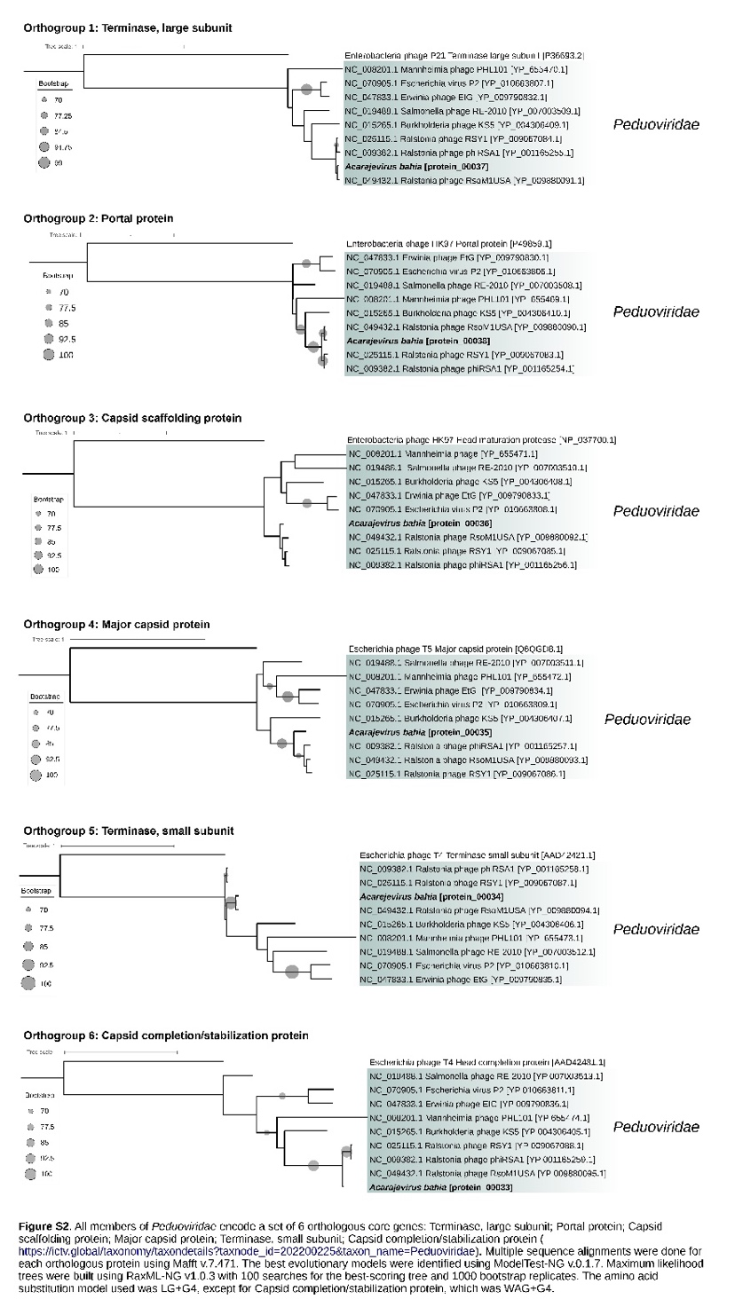
Figure 2. Figure S2. All members of Peduoviridae encode a set of 6 orthologous core genes: Terminase, large subunit; Portal protein; Capsid scaffolding protein; Major capsid protein; Terminase, small subunit; Capsid completion/stabilization protein (https://ictv.global/taxonomy/taxondetails?taxnode_id=202200225&taxon_ name=Peduoviridae). Multiple sequence alignments were done for each orthologous protein using Mafft v.7.471. The best evolutionary models were identified using ModelTest-NG v.0.1.7. Maximum likelihood trees were built using RaxML-NG v1.0.3 with 100 searches for the best-scoring tree and 1000 bootstrap replicates. The amino acid substitution model used was LG+G4, except for Capsid completion/stabilization protein, which was WAG+G4.

