

The International Committee on Taxonomy of Viruses
Taxonomy Proposal Form, 2025

Part 1a: Details of taxonomy proposals

Title: | Create two new species in the genus Yuavirus (class Caudoviricetes)
Code assigned: | 2025.082B.A.v2.Yuavirus_2ns

Author(s), affiliation and email address(es):
Given name (+middle initial(s)) | Surname | Affiliation | Email address | Corr. author(s)
Aaryan | Harshith | Stanford University, Division of Infectious Diseases, Stanford, USA | aaryanh@stanford.edu | X
Paul | Bollyky | Stanford University, Division of Infectious Diseases, Stanford, USA | pbollyky@stanford.edu
Jessica C. | Sacher | Stanford University, Department of Biochemistry, Stanford, USA | jsacher@stanford.edu
Carlo | Armijo | Stanford University, Department of Biochemistry, Stanford, USA | carmijo@stanford.edu
Part 1b: Taxonomy Proposal Submission
ICTV Subcommittee:
Animal DNA Viruses and Retroviruses |  | Bacterial viruses | X
Animal minus-strand and dsRNA viruses |  | Fungal and protist viruses
Animal positive-strand RNA viruses |  | Plant viruses
Archaeal viruses |  | General -

List the ICTV Study Group(s) that have seen or have been involved in creating this proposal: https://ictv.global/sc
Bacterial Viruses Subcommittee

Optional – complete only if formally voted on by an ICTV Study Group:
Study Group | Number of members
Study Group | Votes in support | Votes against | No vote

Submission date: | 22/01/2025

Part 1c: Feedback from ICTV Executive Committee (EC) meeting
Executive Committee Meeting Decision code: | X
A – Accept | x
Ac – Accept subject to revision by relevant subcommittee chair. No further vote required
U – Accept without revision but with re-evaluation and email vote by the EC
Uc – Accept subject to revision and re-evaluation and email vote by the EC
Ud – Deferred to the next EC meeting, with an invitation to revise based on EC comments
J - Reject
W - Withdrawn

Comments from the Executive Committee:

Part 1d: Revised Taxonomy Proposal Submission
Response of proposer:
Revision date:

Part 3: TAXONOMIC PROPOSAL
https://ictv.global/taxonomy/templates
Taxonomic changes proposed:
Establish new taxon | X | Split taxon
Abolish taxon |  | Merge taxon
Move taxon |  | Promote taxon
Rename taxon |  | Demote taxon
Move and rename

Etymology (origin) of proposed taxonomic names:
Taxon name | Etymology of the term
Yuavirus luminis | Derived from the name of the bacteriophage Pseudomonas phage Luminis
Yuavirus vanta | Derived from the name of the bacteriophage Pseudomonas phage vanta

Permission for use of names derived from a living person:
Taxon name | Full name of person from whom the name is derived | Attached

Abstract of Taxonomy Proposal:
Taxonomic rank(s) affected:
Species

Description of current taxonomy:
The genus Yuavirus was established under proposal 2012.008a-dB.A.v3.Yualikevirus. The genus currently consists of five species.

Proposed taxonomic change(s):
Create two new species in the genus Yuavirus.

Justification:
VIRIDIC analysis indicates that both phages satisfy the species similarity threshold proposed by the ICTV Bacterial Viruses Subcommittee. Proteomic and phylogenetic evidence further supports the placement of phages Vanta and Luminis in the genus Yuavirus.

- Text of Taxonomy proposal:

Taxonomic rank(s) affected:
Species

Description of current taxonomy:
The genus Yuavirus was established under proposal 2012.008a-dB.A.v3.Yualikevirus. The genus currently consists of five species.

Proposed taxonomic change(s):
Create two new species in the genus Yuavirus.

Demarcation criteria:
Species demarcation criteria: Phages are deemed as distinct species if they exhibit ≤95% sequence similarity (>5% sequence dissimilarity) across the length of their genome. BLASTn was initially used to identify viruses belonging to the same genus as the isolated phage, and similarity scores were evaluated using the Virus Intergenomic Distance Calculator (VIRIDIC) [3,5].

Genus demarcation criteria: The Bacterial Viruses Subcommittee has established 70% nucleotide identity of the genome length as the cut-off for genera. Genus-level groupings should always be monophyletic in the signature genes, as tested with a phylogenetic tree [4,6].

Justification:
Pseudomonas phage Vanta and Luminis were isolated from processed wastewater samples, courtesy of Stanford University’s Codiga Recovery Center. VIRIDIC analysis indicates that both phages satisfy the species similarity threshold proposed by the ICTV (Figure 1). Proteomic and phylogenetic evidence (Figure 2, Figure 3) further supports the placement of Vanta and Luminis in the genus Yuavirus. Per ICTV standards, the annotated genome of Pseudomonas phages Vanta and Luminis are available for reference in GenBank (PQ628237 and PQ632788).

References:
- Anisimova, M., & Gascuel, O. (2006). Approximate likelihood-ratio test for branches: A fast, accurate, and powerful alternative. Systematic Biology, 55(4), 539–552. https://doi.org/10.1080/10635150600755453
- Dereeper A, Guignon V, Blanc G, Audic S, Buffet S, Chevenet F, Dufayard JF, Guindon S, Lefort V, Lescot M, Claverie JM, Gascuel O. phylogeny.fr: robust phylogenetic analysis for the non-specialist. Nucleic Acids Res. 2008 Jul 1;36(Web Server issue):W465-9. doi: 10.1093/nar/gkn180. Epub 2008 Apr 19. PMID: 18424797; PMCID: PMC2447785.
- Moraru, C., Varsani, A., & Kropinski, A. M. (2020). VIRIDIC—A novel tool to calculate the intergenomic similarities of Prokaryote-Infecting viruses. Viruses, 12(11), 1268. https://doi.org/10.3390/v12111268
- Nishimura, Y., Yoshida, T., Kuronishi, M., Uehara, H., Ogata, H., & Goto, S. (2017). ViPTree: the viral proteomic tree server. Bioinformatics (Oxford, England), 33(15), 2379–2380. https://doi.org/10.1093/bioinformatics/btx157
- Sayers, E. W., Bolton, E. E., Brister, J. R., Canese, K., Chan, J., Comeau, D. C., Connor, R., Funk, K., Kelly, C., Kim, S., Madej, T., Marchler-Bauer, A., Lanczycki, C., Lathrop, S., Lu, Z., Thibaud-Nissen, F., Murphy, T., Phan, L., Skripchenko, Y., . . . Sherry, S. T. (2021). Database resources of the national center for biotechnology information. Nucleic Acids Research, 50(D1), D20–D26. https://doi.org/10.1093/nar/gkab1112
- Turner, D., Kropinski, A. M., & Adriaenssens, E. M. (2021). A Roadmap for Genome-Based
Phage Taxonomy. Viruses, 13(3), 506. https://doi.org/10.3390/v13030506

Accompanying files:
Filename | Description of contents

Tables, Figures:

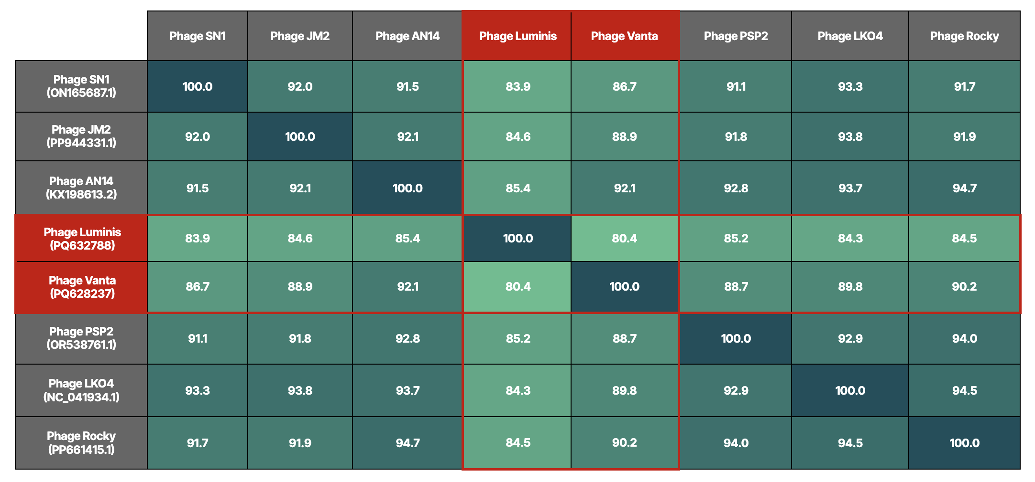
Figure 1 (VIRIDIC Heatmap): Cells in gray denote reference species, whereas red boundaries identify the proposed phages. All similarity scores were evaluated using VIRIDIC [3]. For clarity, raw data was expressed to three significant digits and reformatted using Google Sheets.

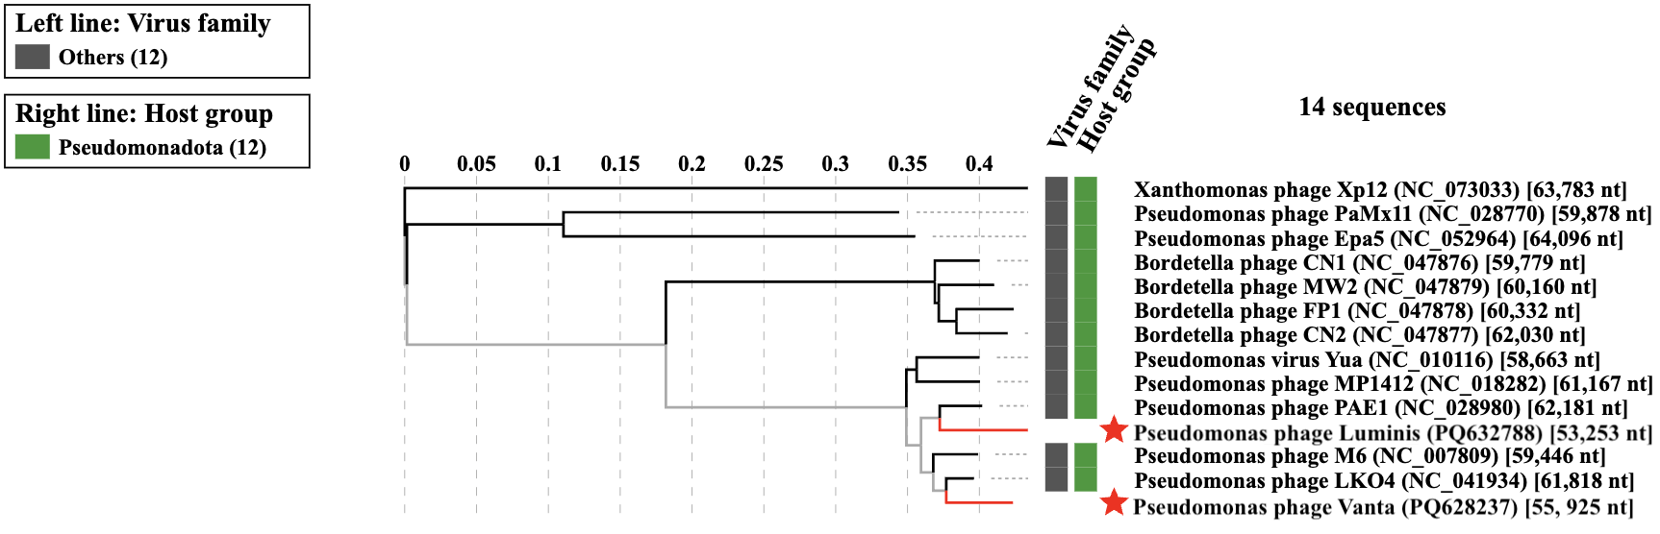

Figure 2: TBLASTX distance tree constructed using VIPTree [4]. Branch lengths are linearly proportional to distance, and Xanthomonas phage Xp12 is used for phyletic contrast. Phages of interest are identified with red stars.

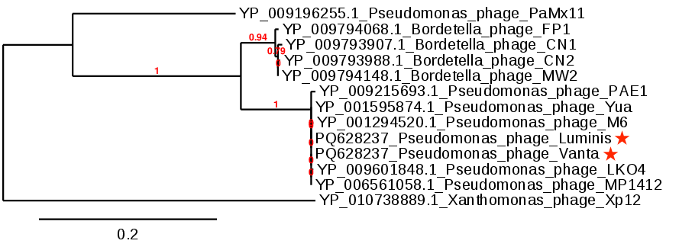

Figure 3: Maximum likelihood phylogenetic tree generated using Phylogeny FR (obscured support value is 0.79) [2]. Alignments were automatically performed using MUSCLE, based on amino acid identity of the large subunit of the terminase protein. Phylogeny was resolved using PhyML and support values were evaluated using default aLRT parameters [1]. Phages of interest are identified with red stars, and Xanthomonas phage Xp12 is used for phyletic contrast

