

The International Committee on Taxonomy of Viruses
Taxonomy Proposal Form, 2025

Part 1a: Details of taxonomy proposals

Title: | Add 12 new species to the genus Yuavirus, Class Caudoviricetes
Code assigned: | 2025.081B.Ac.v3.Yuavirus_12ns

Author(s), affiliation and email address(es):
Given name (+middle initial(s)) | Surname | Affiliation | Email address | Corr. author(s)
Andrew M. | Kropinski | Department of Pathobiology, The Ontario Veterinary College, University of Guelph, Guelph, Ontario, Canada | Phage.Canada@gmail.com | X
Cristina | Moraru | Carl von Ossietzky Universität Oldenburg, Germany | liliana.cristina.moraru@uol.de

Part 1b: Taxonomy Proposal Submission
ICTV Subcommittee:
Animal DNA Viruses and Retroviruses |  | Bacterial viruses | x
xAnimal minus-strand and dsRNA viruses |  | Fungal and protist viruses
Animal positive-strand RNA viruses |  | Plant viruses
Archaeal viruses |  | General -

List the ICTV Study Group(s) that have seen or have been involved in creating this proposal: https://ictv.global/sc
Caudoviricetes Study Group
Optional – complete only if formally voted on by an ICTV Study Group:
Study Group | Number of members
Study Group | Votes in support | Votes against | No vote

Submission date: | 15/06/2025

Part 1c: Feedback from ICTV Executive Committee (EC) meeting
Executive Committee Meeting Decision code: | X
A – Accept
Ac – Accept subject to revision by relevant subcommittee chair. No further vote required | x
U – Accept without revision but with re-evaluation and email vote by the EC
Uc – Accept subject to revision and re-evaluation and email vote by the EC
Ud – Deferred to the next EC meeting, with an invitation to revise based on EC comments
J - Reject
W - Withdrawn

Comments from the Executive Committee:
Please improve the quality of the abstract.

Part 1d: Revised Taxonomy Proposal Submission
Response of proposer:
The text of the abstract has been amended

Revision date: | 01/09/2025

Part 3: TAXONOMIC PROPOSAL
https://ictv.global/taxonomy/templates
Taxonomic changes proposed:
Establish new taxon | x | Split taxon
Abolish taxon |  | Merge taxon
Move taxon |  | Promote taxon
Rename taxon |  | Demote taxon
Move and rename

Etymology (origin) of proposed taxonomic names:
Taxon name | Etymology of the term

Permission for use of names derived from a living person:
Taxon name | Full name of person from whom the name is derived | Attached

Abstract of Taxonomy Proposal:
Taxonomic rank(s) affected:
Genus, species

Description of current taxonomy:
The genus Yuavirus currently consists of five species. Previous proposals related to this genus are 2012.008a-dB.A.v3.Yualikevirus and 2015.006aB.A.v2.Phage_Genera_ren.

Proposed taxonomic change(s):
To create 12 new species in the genus Yuavirus

Justification:
Species classified in the genus Yuavirus represent lytic siphoviruses with genomes of approximately 60kb and a characteristic elongated head structure. This proposal adds 12 new species to the genus, based on intergenomic similarity calculated using VIRIDIC.

- Text of Taxonomy proposal:

Taxonomic rank(s) affected:
Genus, species

Description of current taxonomy:
The genus Yuavirus currently consists of five species. Previous proposals related to this genus are 2012.008a-dB.A.v3.Yualikevirus and 2015.006aB.A.v2.Phage_Genera_ren.

Demarcation criteria:
Species demarcation criteria: Two phages are assigned to the same species if their genomes are more than 95% identical over their genome length for isolates. These values can be calculated by a number of tools, such as BLASTn [1] – usually calculated using intergenomic distance calculator VIRIDIC [2].

Justification:
Species classified in the genus Yuavirus represent lytic siphoviruses with genomes of approximately 60kb and a characteristic elongated head structure. This proposal adds 12 new species to the genus, based on intergenomic similarity calculated using VIRIDIC.

References:
1. Sayers EW, Beck J, Bolton EE, Bourexis D, Brister JR, Canese K, Comeau DC, Funk K, Kim S, Klimke W, Marchler-Bauer A, Landrum M, Lathrop S, Lu Z, Madden TL, O'Leary N, Phan L, Rangwala SH, Schneider VA, Skripchenko Y, Wang J, Ye J, Trawick BW, Pruitt KD, Sherry ST. Database resources of the National Center for Biotechnology Information. Nucleic Acids Res. 2021 Jan 8;49(D1):D10-D17. doi: 10.1093/nar/gkaa892. PMID: 33095870
2. Moraru C, Varsani A, Kropinski AM. VIRIDIC-A Novel Tool to Calculate the Intergenomic Similarities of Prokaryote-Infecting Viruses. Viruses. 2020 Nov 6;12(11):1268. doi: 10.3390/v12111268. PMID: 33172115; PMCID: PMC7694805. http://kronos.icbm.uni-oldenburg.de/viridic/
3. Turner D, Kropinski AM, Adriaenssens EM. A Roadmap for Genome-Based Phage Taxonomy. Viruses. 2021 Mar 18;13(3):506. doi: 10.3390/v13030506. PMID: 33803862; PMCID: PMC8003253.
4. Nishimura Y, Yoshida T, Kuronishi M, Uehara H, Ogata H, Goto S. ViPTree: the viral proteomic tree server. Bioinformatics. 2017; 33(15):2379-2380. doi:10.1093/bioinformatics/btx157. PubMed PMID: 28379287. https://www.genome.jp/viptree/
5. Rohwer F, Edwards R. The Phage Proteomic Tree: a genome-based taxonomy for phage. J Bacteriol. 2002 Aug;184(16):4529-35. PubMed PMID: 12142423
6. Lemoine F, Correia D, Lefort V, Doppelt-Azeroual O, Mareuil F, Cohen-Boulakia S, Gascuel O. NGPhylogeny.fr: new generation phylogenetic services for non-specialists. Nucleic Acids Res. 2019 Jul 2;47(W1):W260-W265. doi: 10.1093/nar/gkz303. PMID: 31028399; PMCID: PMC6602494.
7. Letunic I, Bork P. Interactive Tree Of Life (iTOL) v5: an online tool for phylogenetic tree display and annotation. Nucleic Acids Res. 2021 Jul 2;49(W1):W293-W296. doi: 10.1093/nar/gkab301. PMID: 33885785; PMCID: PMC8265157.

Accompanying files:
Filename | Description of contents
Yuavirus_12ns_VIRIDIC_heatmap.xlsx | VIRIDIC analysis of genus

Tables, Figures:
Table 1. List of new species in the genus Yuavirus

Accession No. | Phage name | Taxon
PP596838.1 | Pseudomonas phage PC1 | “Yuavirus PC1”
PP661417.1 | Pseudomonas phage Bella | “Yuavirus bella”
PP661418.1 | Pseudomonas phage Jack | “Yuavirus jack”
PP944331.1 | Pseudomonas phage JM2 | “Yuavirus JM2”
PP408251.1 | Pseudomonas phage vB_Pa-PAC4 | “Yuavirus PAC4”
PP408253.1 | Pseudomonas phage vB_Pa-PAC6 | “Yuavirus PAC6”
MT118302.1 | Pseudomonas phage Epa38 | “Yuavirus Epa38”
MZ089734.1 | Pseudomonas phage PSA20, | “Yuavirus PSA20”
OR538761.1 | Pseudomonas phage PSP2 | “Yuavirus PSP2”
PQ144889.1 | Pseudomonas phage NEU2024 | “Yuavirus NEU2024”
OQ992553.1 | Pseudomonas phage Clover | “Yuavirus clover”
PP760143.1 | Pseudomonas phage vB_Pae_HLL23 | “Yuavirus HLL23”

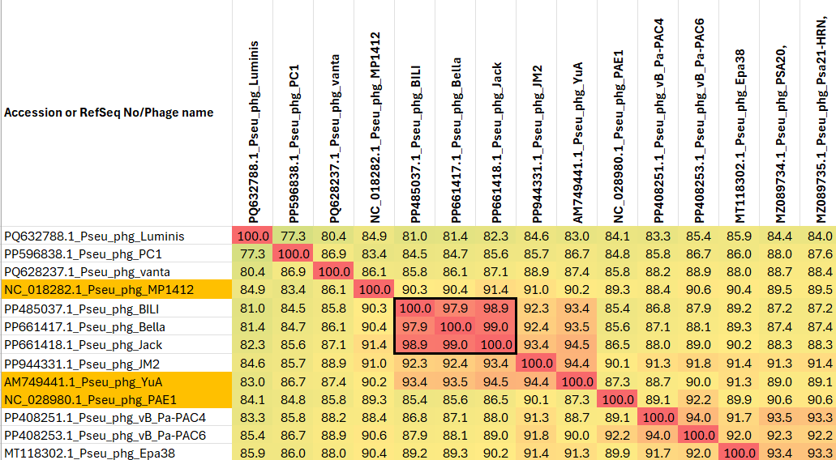

Figure 1. Partial VIRIDIC heat map of this group of phages. VIRIDIC (Virus Intergenomic Distance Calculator; VIRIDIC (Virus Intergenomic Distance Calculator; [3]; http://rhea.icbm.uni-oldenburg.de/VIRIDIC/) computes pairwise intergenomic distances/similarities amongst phage genomes. Names which have been highlighted in gold correspond to existing species. Data values which are bordered in black correspond to strains. Abbreviations: Pseu = Pseudomonas; phg = phage. The complete VIRIDIC heatmap accompanies this proposal as Yuavirus_VIRIDIC heatmap.xlsx

