

The International Committee on Taxonomy of Viruses
Taxonomy Proposal Form, 2025

Part 1a: Details of taxonomy proposals

Title: | Create four (4) new subfamilies, sixteen (16) new genera and sixty-one (78) new species in the family Schitoviridae (Class Caudoviricetes)
Code assigned: | 2025.072B.Ac.v3.Schitoviridae_4_nsf_16ng_78_ns

Author(s), affiliation and email address(es):
Given name (+middle initial(s)) | Surname | Affiliation | Email address | Corr. author(s)
Johannes | Wittmann | Leibniz Institute DSMZ – German Collection of Microorganisms and Cell Cultures GmbH, Braunschweig, Germany | Johannes.Wittmann@dsmz.de | X
Dann | Turner | Department of Applied Sciences, University of the West of England, Bristol, UK | Dann2.Turner@uwe.ac.uk

Part 1b: Taxonomy Proposal Submission
ICTV Subcommittee:
Animal DNA Viruses and Retroviruses |  | Bacterial viruses | x
Animal minus-strand and dsRNA viruses |  | Fungal and protist viruses
Animal positive-strand RNA viruses |  | Plant viruses
Archaeal viruses |  | General -

List the ICTV Study Group(s) that have seen or have been involved in creating this proposal: https://ictv.global/sc
Schitoviridae Study Group
Caudoviricetes Study Group

Optional – complete only if formally voted on by an ICTV Study Group:
Study Group | Number of members
Study Group | Votes in support | Votes against | No vote

Submission date: | 02/06/2025

Part 1c: Feedback from ICTV Executive Committee (EC) meeting
Executive Committee Meeting Decision code: | X
A – Accept
Ac – Accept subject to revision by relevant subcommittee chair. No further vote required | x
U – Accept without revision but with re-evaluation and email vote by the EC
Uc – Accept subject to revision and re-evaluation and email vote by the EC
Ud – Deferred to the next EC meeting, with an invitation to revise based on EC comments
J - Reject
W - Withdrawn

Comments from the Executive Committee:
There seems to be a problem with the spreadsheet because there are references to outside sources, please improve the quality of the abstract, double-check the grouping in figure 2 (Efbeekayvirus - paraphyletic group?)

Part 1d: Revised Taxonomy Proposal Submission
Response of proposer:
The data was entered again in a clean version of the Excel spreadsheet form to remove any links. ViPTree analysis supported the grouping in Fig. 2 for the Efbeekayvirus. Abstract was adapted.

Revision date: | 2/09/2025

Part 3: TAXONOMIC PROPOSAL
https://ictv.global/taxonomy/templates
Taxonomic changes proposed:
Establish new taxon | x | Split taxon
Abolish taxon |  | Merge taxon
Move taxon |  | Promote taxon
Rename taxon |  | Demote taxon
Move and rename

Etymology (origin) of proposed taxonomic names:
Taxon name | Etymology of the term
Brisouvirinae | The name derived from French microbiologist Jean Brisou (1909-2006), who has contributed to the understanding of the taxonomy of Acinetobacter.
Gaffkyvirinae | The name derived from German microbiologist Georg Gaffky (1850-1918).
Gebvirinae | The name derived from the Egyptian god of Earth, Geb.
Waldeevirinae | The name derived from Edward Leslie Waldee who did studies on peritrichous phytopathogenic bacteria.
Aracevirus | The name is derived from the first isolated member, Pseudomonas phage Arace01
Aquintavirus | The name is derived from the name of the first isolated phage of this type, Alteromonas phage vB_AemP_PT15-A5
Atduovirus | The name is derived from the first isolated member, Acinetobacter phage At2
Axvirus | Named after the first isolated member, Sulfitobacter phage vB_SupP_AX
Dongfangvirus | The name is derived from the city where the first member of this genus, Burkholderia phage vB_BpP_HN01, was isolated from
Dowsonvirus | Named after Dowson who described Xanthomonas.
Ekoctavirus | Named after the first isolated member, Escherichia phage EK8
Geeundevigintivirus | Derived from the first isolated member, Pantoea phage G19
Manannanvirus | Named after the Gaelic sea god Manannan.
Mifoctavirus | Named after the first isolated member, Erwinia phage MIF8
Nacbunavirus | The name is derived from the name of the first isolated phage of this type, Acinetobacter phage nACB1 which infects A. beijerinckii
Patisvirus | Named after the first isolated member, Erwinia phage Pastis
Peegeeundecimvirus | The name is derived from the name of the first isolated phage of this type, Vibrio phage vB_VhaP_PG11
Roskoffvirus | The name is derived from the geographic origin of the first isolated member
Sabivirus | Named after the first isolated member, Enterobacter phage vB_Ecl_SABI
Viundeviginityvirus | The name is derived from the name of the first isolated phage of this type, Alteromonas phage vB_AmeP_PT11-V19

Permission for use of names derived from a living person:
Taxon name | Full name of person from whom the name is derived | Attached

Abstract of Taxonomy Proposal:
Taxonomic rank(s) affected:
Subfamily, genus, species

Description of current taxonomy:
The family Schitoviridae was created in 2020 (Taxonomy Proposal 2020.146B.R.Schitoviridae). The family is comprised of nine subfamilies, 57 genera and 106 species

Proposed taxonomic change(s):
Here, we propose to create four (4) new subfamilies:
- “Waldeevirinae”, containing three (3) new genera, “Mifoctavirus”, “Sabivirus” and “Ekoctavirus”, alongside the existing genera Cbunavirus and Efbeekayvirus
- Gaffkyvirinae, containing two (2) genera, Pacinivirus and Vicoquintavirus
- Gebvirinae, containing one (1) new genus, “Dowsonvirus”, and the existing genera Riverridervirus, Pokkenvirus, Philippevirus and Cavevirus
- Brisouvirinae, containing two (2) new genera, “Nacbunavirus” and “Atduovirus” and the existing genus Exceevirus.
Additionally, we intend to create eleven (10) new genera, “Aracevirus”, “Axvirus”, “Dongfangvirus”, “Aquintavirus”, “Geeundevigintivirus”, “Patisvirus”, “Peegeeundecimvirus”, “Manannanvirus”, “Roskoffvirus” and “Viundeviginityvirus”.

Justification:
Using different tools like VIRIDIC [1], VICTOR [2] or ViPTree [3] (Fig 1. and 2) for pairwise nucleotide identity or whole genome analyses of schitoviruses we propose 4 new subfamilies, Brisouvirinae, Gaffkyvirinae, Gebvirinae, and Waldeevirinae and 16 new genera. We used 95% and 70% nucleotide sequence identity over the entire length of the genome as criteria for delimiting species and genera, respectively. At the subfamily level, members of the subfamily share at least 20 % intergenomic distance as determined by VIRIDIC analysis.

- Text of Taxonomy proposal:

Taxonomic rank(s) affected:
Realm Duplodnaviria, kingdom Heunggongvirae, phylum Uroviricota, class Caudoviricetes, family Schitoviridae

Description of current taxonomy:
The family Schitoviridae was created in 2020 (Taxonomy Proposal 2020.146B.R.Schitoviridae). The family is comprised of nine subfamilies, 57 genera and 106 species

Proposed taxonomic change(s):
Create four (4) new subfamilies:
“Waldeevirinae” including three (3) new genera, “Mifoctavirus”, “Sabivirus” and “Ekoctavirus” andmove Cbunavirus and Effbeekayvirus to this subfamily;
Gaffkyvirinae including two (2) genera, Pacinivirus and Vicoquintaviru;s
Gebvirinae including one (1) new genus, “Dowsonvirus”, and move Riverridervirus, Pokkenvirus, Philippevirus and Cavevirus to this subfamily;
Brisouvirinae, containing two (2) new genera, “Nacbunavirus” and “Atduovirus” and move Exceevirus to this subfamily.

Create eleven (11) new genera, “Aracevirus”, “Axvirus”, “Dongfangvirus”, “Aquintavirus, “Geeundevigintivirus”, “Patisvirus”, “Peegeeundecimvirus”, “Manannanvirus”, “Roskoffvirus” and “Viundeviginityvirus”.

Demarcation criteria:
With 70% DNA sequence identity and 95% DNA sequence identity as the criterion for demarcation of genera and species, respectively, each of the proposed species differs from the others with more than 5% at the DNA level as confirmed with VIRIDIC. Sub-family demarcation criteria: Robust clustering in the core genome phylogenetic tree with a suggested minimum shared core gene content of 25%. Members of the same subfamily typically share >20% nucleotide identity across the genome length.

Justification:

The evolutionary relationships between 36 bacteriophage genomes were investigated. Based on proteomic and nucleotide analysis we propose a subfamily-level taxonomy for these phages. Using different tools like VIRIDIC [1], VICTOR [2] or ViPTree] [3] for pairwise nucleotide identity or whole genome analyses of schitoviruses we propose 4 new subfamilies, Brisouvirinae, Gaffkyvirinae, Gebvirinae, and Waldeevirinae and 16 new genera.
Furthermore, 14 genomes were analyzed on the genus level to create ten new genera, “Aracevirus”, “Axvirus”, “Dongfangvirus”, “Aquintavirus, “Geeundevigintivirus”, “Patisvirus”, “Peegeeundecimvirus”, “Manannanvirus”, “Roskoffvirus” and “Viundeviginityvirus”.

References:

- Moraru C, Varsani A, Kropinski AM. VIRIDIC-A Novel Tool to Calculate the Intergenomic Similarities of Prokaryote-Infecting Viruses. Viruses. 2020 Nov 6;12(11):1268. doi: 10.3390/v12111268Gomes M, Domingues R, Turner D, Oliveira H. (2023) Genomic Analysis of Two Novel Bacteriophages Infecting Acinetobacter beijerinckii and halotolerans Species. Viruses.15(3):643. doi: 10.3390/v15030643.
- Meier-Kolthoff JP, Göker M. VICTOR: genome-based phylogeny and classification of prokaryotic viruses. Bioinformatics. 2017 Nov 1;33(21):3396-3404. doi: 10.1093/bioinformatics/btx440. PMID: 29036289; PMCID: PMC5860169.
- Nishimura Y, Yoshida T, Kuronishi M, Uehara H, Ogata H, Goto S. ViPTree: the viral proteomic tree server. Bioinformatics. 2017 Aug 1;33(15):2379-2380. doi: 10.1093/bioinformatics/btx157. PMID: 28379287.
- Wee SK, Yan B, Mustaffa SB, Yap EPH. Genome sequences of Acinetobacter phage At2 and its host Acinetobacter tandoii W4-4-4. Microbiol Resour Announc. 2025 May 22:e0000925. doi: 10.1128/mra.00009-25.
- Liu Y, Zhu C, Liang Y, McMinn A, Zheng K, Wang Z, Wang H, Ren L, Shao H, Sung YY, Mok WJ, Wong LL, Wang M. Genome analysis of vB_SupP_AX, a novel N4-like phage infecting Sulfitobacter. Int Microbiol. 2024 Aug;27(4):1297-1306. doi: 10.1007/s10123-023-00476-5.
- Feltin C, Garneau JR, Morris CE, Bérard A, Torres-Barceló C. Novel phages of Pseudomonas syringae unveil numerous potential auxiliary metabolic genes. J Gen Virol. 2024 Jun;105(6):001990. doi: 10.1099/jgv.0.001990.

Accompanying files:
Filename | Description of contents
Schitoviridae_VIRIDIC.docx | VIRIDIC analysis of new subfamilies
Schitoviridae_VIRIDIC.xlsx | VIRIDIC analysis of schitoviruses

Tables, Figures:

Using different tools like VIRIDIC [1], VICTOR [2] or ViPTree [3] (Fig 1. and 2) for pairwise nucleotide identity or whole genome analyses of schitoviruses we propose 4 new subfamilies, Brisouvirinae, Gaffkyvirinae, Gebvirinae, and Waldeevirinae and 16 new genera. We used 95% and 70% nucleotide sequence identity over the entire length of the genome as criteria for delimiting species and genera, respectively. At the subfamily level, members of the subfamily share at least 20 % intergenomic distance as determined by VIRIDIC analysis.
The newly proposed subfamily “Brisouvirinae” consists of three genera, Exceevirus and the two new genera “Nacbunavirus” and “Atduovirus” (Tab. 1). The name of “Nacbunavirus” is derived from the name of the first isolated phage of this type, Acinetobacter phage nACB1 which infects A. beijerinckii. Its genome consists of 80,130 bp with 95 CDS and 4 tRNA genes [4]. “Atduovirus” is named after phage At2 [4]. All phages of this subfamily infect the genus Acinetobacter.
The new subfamily “Gaffkyvirinae” consists of the two genera Vicoquintavirus and Pacinivirus that both contain phages infecting Vibrio species (Tab. 2), while the “Gebvirinae” subfamily with its genera Cavevirus, Philippevirus, Pokkenvirus, Riverridervirus and the new genus “Dowsonvirus” covers phages mainly infecting Stenotrophomonas and Xanthomonas species (Tab. 3). The first member of this genus, Xanthomonas phage PB119 was isolated in Czech Republic and infects Xanthomonas euversicatoria. Its genome reveals 84 CDS and 9 tRNA genes.
The “Waldeevirinae” subfamily consists of the already established genera Efbeekayvirus covering Klebsiella phages and Cbunavirus mainly consisting of Pectobacterium phages and the three newly proposed genera “Mifoctavirus”, “Ekoctavirus” and “Sabivirus” adding further host genera like Erwinia, Escherichia and Enterobacter to this group of phages (Tab. 4). The name of “Mifoctavirus” derived from Erwinia phage Mif8 that has a genome size of 74,857 bp with 94 CDS. It was originally isolated from dung in Germany. Escherichia phage EK8 is the first member of the “Ekoctavirus” with a genome size of 75,084 bp and 80 CDS and one tRNA gene, it was isolated from hospital wastewater in Turkey. Enterobacter phage vB_Ecl_SABI is the only member of the “Sabivirus” so far and has a genome size of 76,175 bp.
Additionally, we proposed several new genera.
The newly proposed genus “Axvirus” was named after the first member, Sulfitobacter phage vB_SupP_AX, and is a new genus within the Rhodovirinae subfamily (Tab.5). It was isolated in China and revealed a genome size of 75,445 bp with 79 CDS and 4 tRNA genes [5].
Pantoea phage G19 is the first schitovirus isolated against Pantoea and gives the new genus “Geeundevigintivirus” its name. It infects Pantoea agglomerans and was isolated in China.
The name of “Aquintavirus” is derived from the name of the first isolated phage of this type, Alteromonas phage vB_AemP_PT15-A5. It was isolated in Spain and infects Alteromonas mediterranea. Its genome consists of 75,104 bp with 91 CDS.
The newly proposed genus “Pastisvirus” has only one member, Erwinia phage Pastis, which was isolated from soil in France. It revealed a genome size of 74,269 bp with 112 CDS.
The name of “Dongfangvirus” is derived from the city where the first member of this genus, Burkholderia phage vB_BpP_HN01, was isolated from. It was isolated from farm soil and infects Burkholeria pseudomallei. Its genome consists of 71,398 bp with 93 CDS and one tRNA gene.
Pseudomonas phage Arace01 is the first isolated member of “Aracevirus”. It infects P. syringae and was isolated from soil [6]. It revealed a genome size of 76,815 bp with 84 CDS and 2 tRNA genes.
The name for “Viundeviginityvirus” is derived from the name of the first isolated phage of this type, Alteromonas phage vB_AmeP_PT11-V19. It was isolated in Spain and infects Alteromonas mediterranea. Its genome consists of 71,326 bp with 93 CDS.

Regarding the new genus “Peegeeundecimvirus”, the name is derived from the name of the first isolated phage of this type, Vibrio phage vB_VhaP_PG11. It was isolated from seawater in China and infects Vibrio hangzhouensis. Its genome consists of 71,841 bp with 107 CDS.

Vibrio phage D456 g1 is the first member of the new genus “Manannanvirus” named after a Gaelic sea god. It was isolated from seawater and oysters mix and revealed a genome size of 72,254 bp.

For the genus “Roskoffvirus” the name was derived from the geographic origin of the first isolated member, Vibrio phage D500. It was isolated from seawater and oysters mix and revealed a genome size of 78,341 bp.

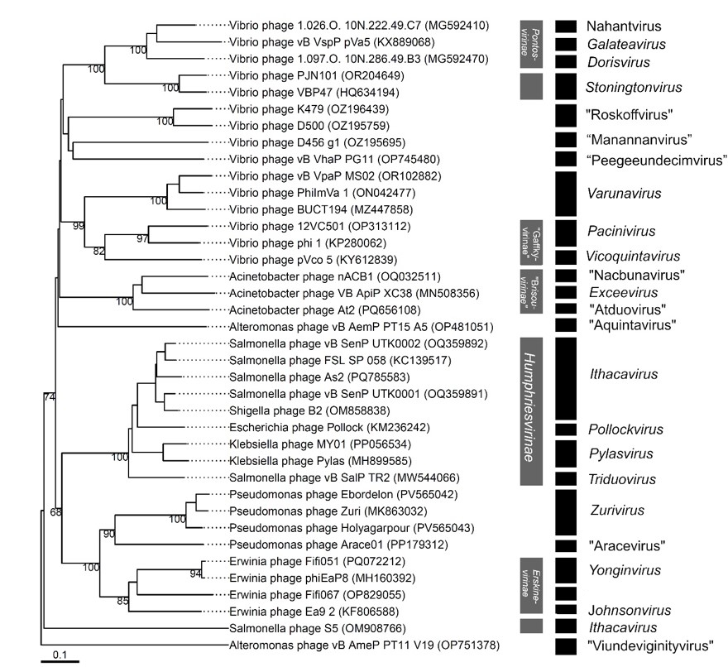
Fig. 1 Phylogenomic GBDP trees inferred using the formula D6 and yielding average support of 62 %. The numbers above branches are GBDP pseudo-bootstrap support values from 100 replications. The branch lengths of the resulting VICTOR trees are scaled in terms of the respective distance formula used.
Fig. 2 Proteomic tree analysis using ViPTree including newly proposed members of the Waldeevirinae subfamily.

