

The International Committee on Taxonomy of Viruses
Taxonomy Proposal Form, 2025

Part 1a: Details of taxonomy proposals

Title: | Create a new subfamily, Santaclaravirinae with three genera (Class Caudoviricetes).
Code assigned: | 2025.071B.Ac.v3.Santaclaravirinae_1nsf_3ng_6ns

Author(s), affiliation and email address(es):
Given name (+middle initial(s)) | Surname | Affiliation | Email address | Corr. author(s)
Andrew M. | Kropinski | Department of Pathobiology, University of Guelph, Guelph, Ontario, Canada | Phage.Canada@gmail.com | x
Cristina | Moraru | Carl von Ossietzky Universität Oldenburg, Germany | liliana.cristina.moraru@uol.de

Part 1b: Taxonomy Proposal Submission
ICTV Subcommittee:
Animal DNA Viruses and Retroviruses |  | Bacterial viruses | x
Animal minus-strand and dsRNA viruses |  | Fungal and protist viruses
Animal positive-strand RNA viruses |  | Plant viruses
Archaeal viruses |  | General -

List the ICTV Study Group(s) that have seen or have been involved in creating this proposal: https://ictv.global/sc
Caudoviricetes Study Group

Optional – complete only if formally voted on by an ICTV Study Group:
Study Group | Number of members
Study Group | Votes in support | Votes against | No vote

Submission date: | 15/06/2025

Part 1c: Feedback from ICTV Executive Committee (EC) meeting
Executive Committee Meeting Decision code: | X
A – Accept
Ac – Accept subject to revision by relevant subcommittee chair. No further vote required | x
U – Accept without revision but with re-evaluation and email vote by the EC
Uc – Accept subject to revision and re-evaluation and email vote by the EC
Ud – Deferred to the next EC meeting, with an invitation to revise based on EC comments
J - Reject
W - Withdrawn

Comments from the Executive Committee:
Please improve the quality of the abstract, there is a lack of phylogenetic tree (not necessary but would improve the proposal).

Part 1d: Revised Taxonomy Proposal Submission
Response of proposer:
The text of the abstract has been amended.

Revision date: | 01/09/2025

Part 3: TAXONOMIC PROPOSAL
https://ictv.global/taxonomy/templates
Taxonomic changes proposed:
Establish new taxon | x | Split taxon
Abolish taxon |  | Merge taxon
Move taxon |  | Promote taxon
Rename taxon |  | Demote taxon
Move and rename

Etymology (origin) of proposed taxonomic names:
Taxon name | Etymology of the term
Santaclaravirinae | Named in honour of Santa Clara University where two of the Escherichia phages were identified
Cyranovirus | Named after Escherichia phage Cyrano
Suquintavirus | Named after Salmonella phage SSU5
Westmeadvirus | Names after The Westmead Institute for Medical Research, where Klebsiella phage pJN2-26 was isolated

Permission for use of names derived from a living person:
Taxon name | Full name of person from whom the name is derived | Attached

Abstract of Taxonomy Proposal:
Taxonomic rank(s) affected: subfamily, genus and species

Description of current taxonomy: Phage-plasmids are a novel, hybrid class of mobile genetic element which retain aspects of both phages and plasmids. These genetic elements have not been previously classified by ICTV.

Proposed taxonomic change(s): Create a new subfamily, Santaclaravirinae with three genera Cyranovirus, Westmeadvirus and Suquintavirus

Justification: These phages represent phage-plasmids, those that exhibit characteristics of both phages as plasmids. These mobile genetic elements can exist as circular replicons and often encode homologs of the ParA/ParB plasmid partitioning proteins. They also have the ability to form virions enabling the lysis and infection of bacteria. The phages described in this proposal share a significant number of protein homologs (c. 83 proteins) and exhibit >50% intergenomic nucleotide sequence similarity, supporting the creation of a new subfamily.

- Text of Taxonomy proposal:

Taxonomic rank(s) affected: subfamily, genus and species

Description of current taxonomy: Phage-plasmids are a novel, hybrid class of mobile genetic element which retain aspects of both phages and plasmids. These genetic elements have not being previously classified by ICTV.

Proposed taxonomic change(s): Create a new subfamily, Santaclaravirinae with three genera Cyranovirus, Westmeadvirus and Suquintavirus

Demarcation criteria: The Bacterial and Archaeal Virus Subcommittee established 70% average nucleotide identity (ANI) threshold for genus classification or 95% ANI for species [8]. Subfamilies are to be created when two or more genera are related below the family level. In practical terms, this usually means that they share a low degree of sequence similarity (usually about 40-50%) and that the genera form a clade in a marker tree phylogeny [8].

Justification:
These phages represent phage-plasmids, those that exhibit characteristics of both phages as plasmids. These mobile genetic elements can exist as circular replicons and often encode homologs of the ParA/ParB plasmid partitioning proteins. They also have the ability to form virions enabling the lysis and infection of bacteria. The phages described in this proposal share a significant number of protein homologs (c. 83 proteins) and exhibit >50% intergenomic nucleotide sequence similarity, supporting the creation of a new subfamily.

References:
1. Sayers EW, Beck J, Bolton EE, Bourexis D, Brister JR, Canese K, Comeau DC, Funk K, Kim S, Klimke W, Marchler-Bauer A, Landrum M, Lathrop S, Lu Z, Madden TL, O'Leary N, Phan L, Rangwala SH, Schneider VA, Skripchenko Y, Wang J, Ye J, Trawick BW, Pruitt KD, Sherry ST. Database resources of the National Center for Biotechnology Information. Nucleic Acids Res. 2021 Jan 8;49(D1):D10-D17. doi: 10.1093/nar/gkaa892. PMID: 33095870
2. O'Leary NA, Wright MW, Brister JR, Ciufo S, Haddad D, McVeigh R, et al. Reference sequence (RefSeq) database at NCBI: current status, taxonomic expansion, and functional annotation. Nucleic Acids Res. 2016;44(D1):D733-45. doi: 10.1093/nar/gkv1189. PMID: 26553804.
3. Moraru C, Varsani A, Kropinski AM. VIRIDIC-A Novel Tool to Calculate the Intergenomic Similarities of Prokaryote-Infecting Viruses. Viruses. 2020 Nov 6;12(11):1268. doi: 10.3390/v12111268. PMID: 33172115; PMCID: PMC7694805. http://kronos.icbm.uni-oldenburg.de/viridic/
4. Nishimura Y, Yoshida T, Kuronishi M, Uehara H, Ogata H, Goto S. ViPTree: the viral proteomic tree server. Bioinformatics. 2017; 33(15):2379-2380. doi:10.1093/bioinformatics/btx157. PubMed PMID: 28379287. https://www.genome.jp/viptree/
5. Rohwer F, Edwards R. The Phage Proteomic Tree: a genome-based taxonomy for phage. J Bacteriol. 2002 Aug;184(16):4529-35. PubMed PMID: 12142423
6. Turner D, Reynolds D, Seto D, Mahadevan P. CoreGenes3.5: a webserver for the determination of core genes from sets of viral and small bacterial genomes. BMC Res Notes. 2013;6:140. doi: 10.1186/1756-0500-6-140. PMID: 23566564.
7. Davis P, Seto D, Mahadevan P. CoreGenes5.0: An Updated User-Friendly Webserver for the Determination of Core Genes from Sets of Viral and Bacterial Genomes. Viruses. 2022 Nov 16;14(11):2534. doi: 10.3390/v14112534. PMID: 36423143; PMCID: PMC9693508.
8. Turner D, Kropinski AM, Adriaenssens EM. A Roadmap for Genome-Based Phage Taxonomy. Viruses. 2021 Mar 18;13(3):506. doi: 10.3390/v13030506. PMID: 33803862; PMCID: PMC8003253.
Lemoine F, Correia D, Lefort V, Doppelt-Azeroual O, Mareuil F, Cohen-Boulakia S, Gascuel O. NGPhylogeny.fr: new generation phylogenetic services for non-specialists. Nucleic Acids Res. 2019 Jul 2;47(W1):W260-W265. doi: 10.1093/nar/gkz303. PMID: 31028399; PMCID: PMC6602494.
9. Letunic I, Bork P. Interactive Tree Of Life (iTOL): an online tool for phylogenetic tree display and annotation. Bioinformatics. 2007 Jan 1;23(1):127-8. doi: 10.1093/bioinformatics/btl529. Epub 2006 Oct 18. PMID: 17050570.
10. Zhou T, Xu K, Zhao F, Liu W, Li L, Hua Z, Zhou X. itol.toolkit accelerates working with iTOL (Interactive Tree of Life) by an automated generation of annotation files. Bioinformatics. 2023 Jun 1;39(6):btad339. doi: 10.1093/bioinformatics/btad339. PMID: 37225402; PMCID: PMC10243930.

Accompanying files:
Filename | Description of contents

Tables, Figures:
<Start here>
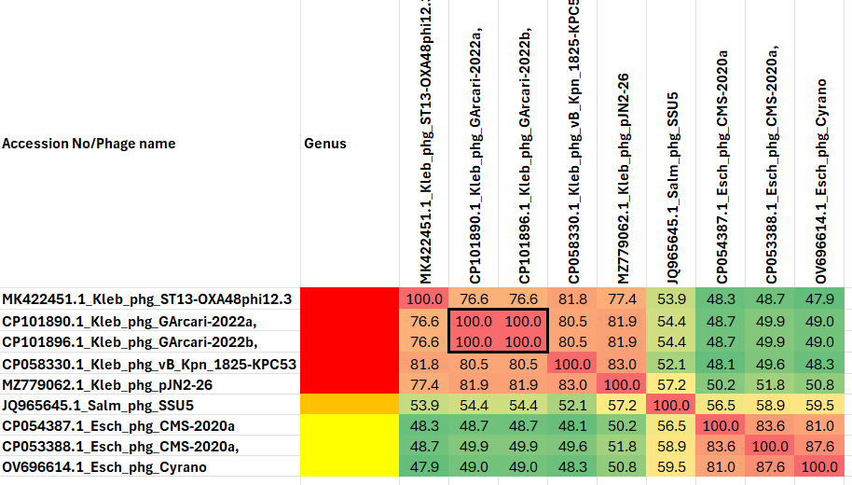

Figure 1. VIRIDIC heat map of a group of phages with the one under discussion. VIRIDIC (Virus Intergenomic Distance Calculator; VIRIDIC (Virus Intergenomic Distance Calculator; [3]; http://rhea.icbm.uni-oldenburg.de/VIRIDIC/) computes pairwise intergenomic distances/similarities amongst phage genomes. Data values which are bordered in black correspond to strains. Abbreviations: Kleb = Klebsiella; Salm = Salmonella; Esch = Escherichia; phg = phage.

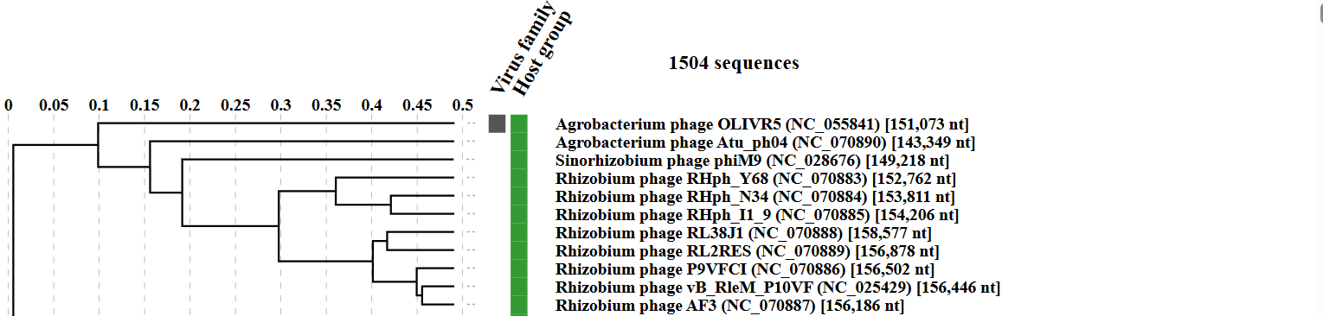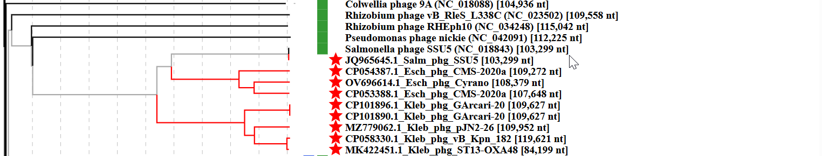

Figure 2. ViPTree analysis (https://www.genome.jp/viptree/; [4]) is based upon Rohwer and Edwards (2002) famous Phage Proteomic Tree [5]. The phages belonging to this subfamily are indicated with red bar.

Table 1. Characteristics of new species in the genus Westmeadvirus
Phage name | Host | Morphotype | Lifestyle | Accession No. | Genome size | No. proteins | No. tRNA
Klebsiella phage pJN2-26 | Klebsiella pneumoniae ST4656 isolate JN2-26 | Siphovirus | Temperate | MZ779062.1 | 109952 bp | 129 | 1
(a) Possesses chromosome (plasmid) partitioning proteins ParA and ParB together with integrase; (b) Klebsiella phages GArcari-2022a and vB_Kpn_1825-KPC53 have not been annotated; (c) Klebsiella phage T13-OXA48phi12.3 is significantly smaller than any of the other phages in this genus

Table 2. Characteristics of species in the genus Suquintavirus
Phage name | Host | Morphotype | Lifestyle | Accession No. | Genome size | No. proteins | No. tRNA
Salmonella phage SSU5 | Salmonella enterica subsp. enterica serovar Typhimurium strain LT2 | Siphovirus | Temperate | JQ965645.1 | 103,229 bp | 130 | 1
Specific reference: Kim M, Kim S, Ryu S. Complete genome sequence of bacteriophage SSU5 specific for Salmonella enterica serovar Typhimurium rough strains. J Virol. 2012 Oct;86(19):10894. doi: 10.1128/JVI.01796-12. PMID: 22966187; PMCID: PMC3457314.
Points: (a) SSU5 showed a high level of sequence identity to cryptic plasmid pHCM2 (106,516 bp; NC_003385) harbored by Salmonella Typhi strain CT18
Points: (a) possesses ParA/B and lysis/lysogeny switch proteins

Table 3. Characteristics of species in the genus Cyranovirus
Phage name | Host | Morphotype | Lifestyle | Accession No. | Genome size | No. proteins | No. tRNA
Escherichia phage Cyrano | Escherichia coli LF82 | Siphovirus | Temperate | OV696614.1 | 108379 bp | 123 | 3
Escherichia phage CMS-2020a | Escherichia coli strain SCU-175 | Siphovirus | Temperate | CP054387.2 | 109272 bp | 168 | 3
Escherichia phage CMS-2020b | Escherichia coli strain SCU-107 | Siphovirus | Temperate | CP053388.2 | 107648 bp | 172 | 3
Points: (a) possesses ParA/B and lysis/lysogeny switch proteins

CoreGenes 3.5 Analysis [7]: revealed that the phages listed above share 83 protein homologs terminase large subunit, major capsid protein, Ig-like domain-containing protein, tail tape measure protein, minor tail protein related to those of coliphage Lambda, holin, endolysin, two spannins, ParA/ParB family protein, DNA primase, DNA helicase, DNA ligase, cobalamin biosynthesis protein CobT, DNA polymerase III alpha subunit, DNA polymerase I, RecA-like recombinase, Cre associated protein, exonuclease, two ribonucleotide-diphosphate reductases, thymidylate synthase, dihydrofolate reductase, adenine methyltransferase, ribonuclease H, and ABC transporter. This indicates that approximately 65.4% of the phage-encoded proteins are conserved.

