

The International Committee on Taxonomy of Viruses
Taxonomy Proposal Form, 2025

Part 1a: Details of taxonomy proposals

Title: | Reinstatement of the species Pepevirus spumicola
Code assigned: | 2025.060B.A.v2.Pepevirus_1ns

Author(s), affiliation and email address(es):
Given name (+middle initial(s)) | Surname | Affiliation | Email address | Corr. author(s)
Jānis | Rūmnieks | Dept. of Structural Biology, Latvian Biomedical Research and Study Center, Riga, Latvia | j.rumnieks@biomed.lu.lv | X

Part 1b: Taxonomy Proposal Submission
ICTV Subcommittee:
Animal DNA Viruses and Retroviruses |  | Bacterial viruses | X
Animal minus-strand and dsRNA viruses |  | Fungal and protist viruses
Animal positive-strand RNA viruses |  | Plant viruses
Archaeal viruses |  | General -

List the ICTV Study Group(s) that have seen or have been involved in creating this proposal: https://ictv.global/sc
Leviviricetes Study Group

Optional – complete only if formally voted on by an ICTV Study Group:
Study Group | Number of members
Study Group | Votes in support | Votes against | No vote

Submission date: | 16/06/2025

Part 1c: Feedback from ICTV Executive Committee (EC) meeting
Executive Committee Meeting Decision code: | X
A – Accept | x
Ac – Accept subject to revision by relevant subcommittee chair. No further vote required
U – Accept without revision but with re-evaluation and email vote by the EC
Uc – Accept subject to revision and re-evaluation and email vote by the EC
Ud – Deferred to the next EC meeting, with an invitation to revise based on EC comments
J - Reject
W - Withdrawn

Comments from the Executive Committee:
Reinstates a previously abolished species, oversight from 2023.001B.Leviviricetes_reorg

Part 1d: Revised Taxonomy Proposal Submission
Response of proposer:
Revision date:

Part 3: TAXONOMIC PROPOSAL
https://ictv.global/taxonomy/templates
Taxonomic changes proposed:
Establish new taxon | X | Split taxon
Abolish taxon |  | Merge taxon
Move taxon |  | Promote taxon
Rename taxon |  | Demote taxon
Move and rename

Etymology (origin) of proposed taxonomic names:
Taxon name | Etymology of the term
Pepevirus spumicola | Pepevirus: an existing genus, phonetically named after Pseudomonas virus PP7  spumicola: L. fem n.,spuma, foam; N.L. masc./fem. suff. cola, an inhabitant of; N.L. fem. n. spumicola, associated with water. Reflects that LeviOr01, the exemplar virus of the proposed species, was isolated from hospital wastewater [1].

Abstract of Taxonomy Proposal:
Taxonomic rank(s) affected:
Species

Description of current taxonomy:
Genus Pepevirus currently holds six genera of bacterial single-stranded RNA viruses (class Leviviricetes). Pseudomonas virus LeviOr01 had previously been assigned to species Pepevirus spumicola, but this species is now abolished and in accordance with the current taxonomy, LeviOr01 is an unclassified Pepevirus.

Proposed taxonomic change(s):
Create species “Pepevirus spumicola” with Pseudomonas virus LeviOr01 as the exemplar virus. This would effectively reinstate a previously abolished species.

Justification:
Sequence analysis suggests that the abolishment of species Pepevirus spumicola was unjustified: according to the currently adopted demarcation criteria for Leviviricetes, Pseudomonas virus LeviOr01 belongs to genus Pepevirus but cannot be assigned to any of the currently recognized constituent species.

- Text of Taxonomy proposal:

Taxonomic rank(s) affected:
Species

Description of current taxonomy:
The genus Pepevirus belongs to family Fiersviridae within order Norzivirales, class Leviviricetes, phylum Lenarviricota and kingdom Orthornavirae in the Riboviria realm. The genus Pepevirus, along with 427 other genera, was established with proposal 2020.095B.R.Leviviricetes which replaced the existing single-stranded RNA (ssRNA) phage taxonomy at the time. Within Pepevirus, two species were created, Pepevirus rubrum with Pseudomonas phage PP7 as the exemplar virus, and Pepevirus spumicola, represented by Pseudomonas phage LeviOr01. A subsequent proposal 2023.001B.Leviviricetes_reorg further reorganized the ssRNA phage taxonomy, during which five new Pepevirus species (Pepevirus faecenecus, Pepevirus faecicola, Pepevirus faecihabitans, Pepevirus faecivicinum and Pepevirus faecivivens) were created while Pepevirus spumicola was abolished. Pseudomonas phage LeviOr01 was not assigned to any of the new species.

Proposed taxonomic change(s):
Create species “Pepevirus spumicola” in genus Pepevirus, assign Pseudomonas virus LeviOr01 (GenBank accession no. LT821717) as the exemplar virus.

Demarcation criteria:
The currently adopted demarcation criteria for Leviviricetes are < 50 % pairwise amino-acid identity (PAAI) of the viral RdRp protein for establishing genera and < 80% RdRp PAAI for establishing species [2].

Justification:
Alignment of RdRp sequences from Pseudomonas phage LeviOr01 and exemplars from the currently recognized Pepevirus species (Figure 1) shows that the LeviOr01 RdRp is 52 to 54% identical to the other proteins (Table 1). According to the demarcation criteria, these results suggest that Pseudomonas phage LeviOr01 represents a separate species within genus Pepevirus and that the previous abolishment of species Pepevirus spumicola was unjustified. To address this issue, it is proposed that the taxonomy of the genus is updated with addition of a new species representing LeviOr01, which would effectively reinstate the previously abolished species. Since the species name “Pepevirus spumicola” has already been used in the scientific literature [3], to avoid further confusion, it is proposed that the same previously used name is chosen for the newly created species.

References:
[1] Pourcel, C., Midoux, C., Vergnaud, G., Latino, L., 2017. A carrier state is established in Pseudomonas aeruginosa by phage LeviOr01, a newly isolated ssRNA levivirus. J Gen Virol 98, 2181-2189
[2] Callanan, J., Stockdale, S.R., Adriaenssens, E.M., Kuhn, J.H., Rumnieks, J., Pallen, M.J., Shkoporov, A.N., Draper, L.A., Ross, R.P., Hill, C., 2021. Leviviricetes: expanding and restructuring the taxonomy of bacteria-infecting single-stranded RNA viruses. Microb Genom 7, 000686
[3] Bae, H.-.W., Ki, H.-.J., Choi, S.-.Y., Cho, Y.-.H., 2025. Pilin regions that select for the small RNA phages in Pseudomonas aeruginosa type IV pilus. J Virol 99, e0194924

Tables, Figures:
<Start here>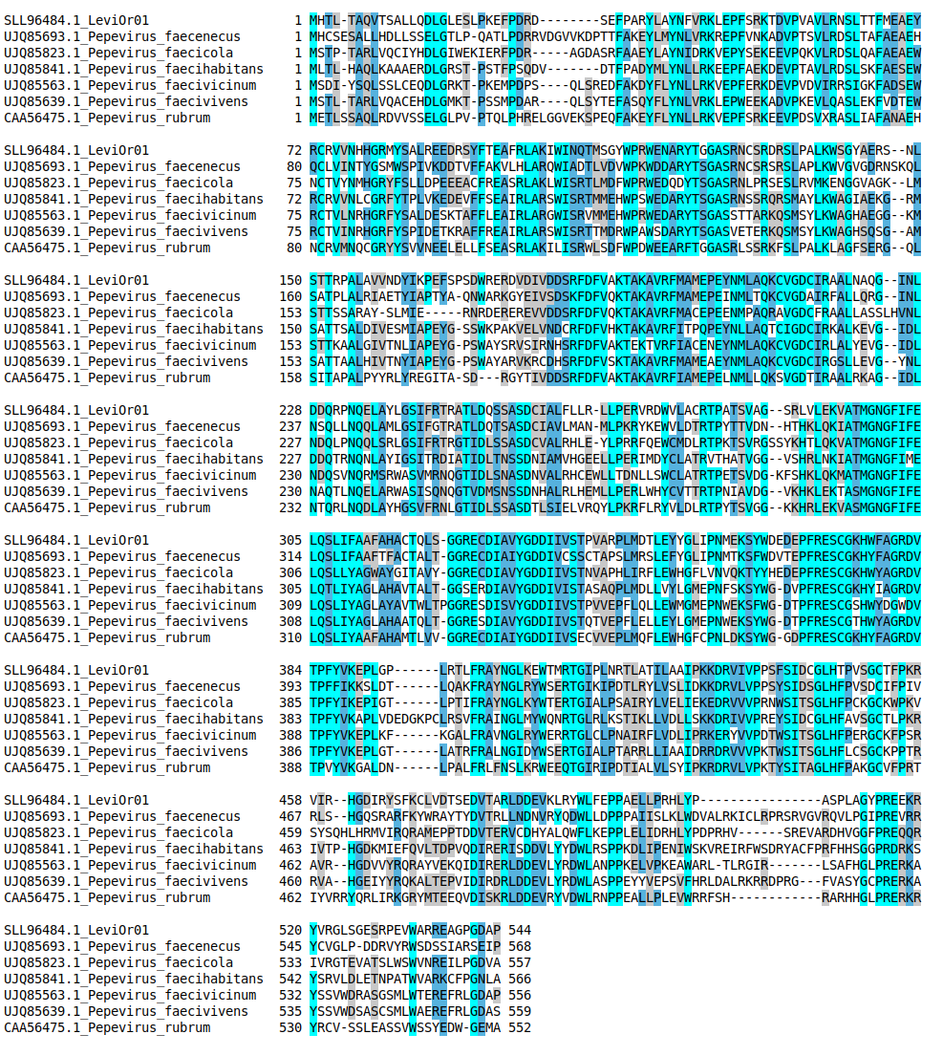Figure 1. Alignment of RdRp protein sequences from Pseudomonas virus LeviOr01 and those from exemplar viruses of the genus Pepevirus. The alignment was generated using mafft (v7.526) with the E-INS-I algorithm.

RdRp from exemplar virus | PAAI with LeviOr01 RdRp (SLL96484.1)
UJQ85693.1 (Pepevirus faecenecus) | 54.3
UJQ85823.1 (Pepevirus faecicola) | 54.2
UJQ85841.1 (Pepevirus faecihabitans) | 53.8
UJQ85563.1 (Pepevirus faecivicinum) | 52.1
UJQ85639.1 (Pepevirus faecivivens) | 52.7
CAA56475.1 (Pepevirus rubrum) | 54.1

Table 1. Pairwise amino acid identity (PAAI) between the RdRp of Pseudomonas virus LeviOr01 and those from exemplar viruses of the genus Pepevirus.

