

The International Committee on Taxonomy of Viruses
Taxonomy Proposal Form, 2025

Part 1a: Details of taxonomy proposals

Title: | Create one new genus (Nitrunavirus) with a single species (Caudoviricetes).
Code assigned: | 2025.052B.Ac.v3.Nitrunavirus_1ng_1ns

Author(s), affiliation and email address(es):
Given name (+middle initial(s)) | Surname | Affiliation | Email address | Corr. author(s)
Andrew M. | Kropinski | Department of Pathobiology, University of Guelph, Guelph, Ontario, Canada | Phage.Canada@gmail.com | x
Ipek | Kurtböke | University of the Sunshine Coast - Faculty of Science, Health, Education and Engineering, Australia | ikurtbok@usc.edu.au

Part 1b: Taxonomy Proposal Submission
ICTV Subcommittee:
Animal DNA Viruses and Retroviruses |  | Bacterial viruses | x
Animal minus-strand and dsRNA viruses |  | Fungal and protist viruses
Animal positive-strand RNA viruses |  | Plant viruses
Archaeal viruses |  | General -

List the ICTV Study Group(s) that have seen or have been involved in creating this proposal: https://ictv.global/sc
Actinophages Study Group

Optional – complete only if formally voted on by an ICTV Study Group:
Study Group | Number of members
Study Group | Votes in support | Votes against | No vote

Submission date: | 015/06/2025

Part 1c: Feedback from ICTV Executive Committee (EC) meeting
Executive Committee Meeting Decision code: | X
A – Accept
Ac – Accept subject to revision by relevant subcommittee chair. No further vote required | x
U – Accept without revision but with re-evaluation and email vote by the EC
Uc – Accept subject to revision and re-evaluation and email vote by the EC
Ud – Deferred to the next EC meeting, with an invitation to revise based on EC comments
J - Reject
W - Withdrawn

Comments from the Executive Committee:
Please improve the quality of the abstract.

Part 1d: Revised Taxonomy Proposal Submission
Response of proposer:
The text of the abstract has been amended.

Revision date: | 01/09/2025

Part 3: TAXONOMIC PROPOSAL
https://ictv.global/taxonomy/templates
Taxonomic changes proposed:
Establish new taxon | x | Split taxon
Abolish taxon |  | Merge taxon
Move taxon |  | Promote taxon
Rename taxon |  | Demote taxon
Move and rename

Etymology (origin) of proposed taxonomic names:
Taxon name | Etymology of the term
Nitrunavirus | Name derived from first isolate phage of its type Nocardia phage NTR1

Permission for use of names derived from a living person:
Taxon name | Full name of person from whom the name is derived | Attached

Abstract of Taxonomy Proposal:
Taxonomic rank(s) affected: genus and species

Description of current taxonomy: As far as we are aware no Nocardia phages have been classified by ICTV

Proposed taxonomic change(s): To create a new genus Nitrunavirus with one new species

Justification:
The bacteriophage NTR1 was isolated from activated sludge and infects three species of Norcardia. NTR1 exhibits a siphovirus morphology and possesses a 65.3 kb genome with 97 predicted protein-coding genes and a single tRNA. Analysis with VIRIDIC and ViPTree indicates that Nocardia phage NTR1 represents a new genus and species that conforms to the established demarcation criteria.

- Text of Taxonomy proposal:

Taxonomic rank(s) affected: genus and species

Description of current taxonomy: As far as we are aware no Nocardia phages have been classified by ICTV

Proposed taxonomic change(s): To create a new genus (Nitrunavirus) with one new species

Demarcation criteria: The Bacterial and Archaeal Virus Subcommittee established 70% average nucleotide identity (ANI) threshold for genus classification or 95% ANI for species [8]. BLASTN analysis [1,2] reveals that it shares24.6 and 14.5% DNA sequence identity with Skermania phage SPI1 and Gordonia phage Evaa, respectively. These are the subject of two additional Taxonomy Proposals.

Justification:
The bacteriophage NTR1 was isolated from activated sludge and infects three species of Norcardia. NTR1 exhibits a siphovirus morphology and possesses a 65.3 kb genome with 97 predicted protein-coding genes and a single tRNA. Analysis with VIRIDIC and ViPTree indicates that Nocardia phage NTR1 represents a new genus and species that conforms to the established demarcation criteria.

References:
1. Sayers EW, Beck J, Bolton EE, Bourexis D, Brister JR, Canese K, Comeau DC, Funk K, Kim S, Klimke W, Marchler-Bauer A, Landrum M, Lathrop S, Lu Z, Madden TL, O'Leary N, Phan L, Rangwala SH, Schneider VA, Skripchenko Y, Wang J, Ye J, Trawick BW, Pruitt KD, Sherry ST. Database resources of the National Center for Biotechnology Information. Nucleic Acids Res. 2021 Jan 8;49(D1):D10-D17. doi: 10.1093/nar/gkaa892. PMID: 33095870
2. O'Leary NA, Wright MW, Brister JR, Ciufo S, Haddad D, McVeigh R, et al. Reference sequence (RefSeq) database at NCBI: current status, taxonomic expansion, and functional annotation. Nucleic Acids Res. 2016;44(D1):D733-45. doi: 10.1093/nar/gkv1189. PMID: 26553804.
3. Moraru C, Varsani A, Kropinski AM. VIRIDIC-A Novel Tool to Calculate the Intergenomic Similarities of Prokaryote-Infecting Viruses. Viruses. 2020 Nov 6;12(11):1268. doi: 10.3390/v12111268. PMID: 33172115; PMCID: PMC7694805. http://kronos.icbm.uni-oldenburg.de/viridic/
4. Nishimura Y, Yoshida T, Kuronishi M, Uehara H, Ogata H, Goto S. ViPTree: the viral proteomic tree server. Bioinformatics. 2017; 33(15):2379-2380. doi:10.1093/bioinformatics/btx157. PubMed PMID: 28379287. https://www.genome.jp/viptree/
5. Rohwer F, Edwards R. The Phage Proteomic Tree: a genome-based taxonomy for phage. J Bacteriol. 2002 Aug;184(16):4529-35. PubMed PMID: 12142423
6. Turner D, Reynolds D, Seto D, Mahadevan P. CoreGenes3.5: a webserver for the determination of core genes from sets of viral and small bacterial genomes. BMC Res Notes. 2013;6:140. doi: 10.1186/1756-0500-6-140. PMID: 23566564.
7. Davis P, Seto D, Mahadevan P. CoreGenes5.0: An Updated User-Friendly Webserver for the Determination of Core Genes from Sets of Viral and Bacterial Genomes. Viruses. 2022 Nov 16;14(11):2534. doi: 10.3390/v14112534. PMID: 36423143; PMCID: PMC9693508.
8. Turner D, Kropinski AM, Adriaenssens EM. A Roadmap for Genome-Based Phage Taxonomy. Viruses. 2021 Mar 18;13(3):506. doi: 10.3390/v13030506. PMID: 33803862; PMCID: PMC8003253.
Lemoine F, Correia D, Lefort V, Doppelt-Azeroual O, Mareuil F, Cohen-Boulakia S, Gascuel O. NGPhylogeny.fr: new generation phylogenetic services for non-specialists. Nucleic Acids Res. 2019 Jul 2;47(W1):W260-W265. doi: 10.1093/nar/gkz303. PMID: 31028399; PMCID: PMC6602494.
9. Letunic I, Bork P. Interactive Tree Of Life (iTOL): an online tool for phylogenetic tree display and annotation. Bioinformatics. 2007 Jan 1;23(1):127-8. doi: 10.1093/bioinformatics/btl529. Epub 2006 Oct 18. PMID: 17050570.
10. Zhou T, Xu K, Zhao F, Liu W, Li L, Hua Z, Zhou X. itol.toolkit accelerates working with iTOL (Interactive Tree of Life) by an automated generation of annotation files. Bioinformatics. 2023 Jun 1;39(6):btad339. doi: 10.1093/bioinformatics/btad339. PMID: 37225402; PMCID: PMC10243930.

Accompanying files:
Filename | Description of contents

Tables, Figures:
<Start here>
Table 1. Characteristics of the phage described in the proposal
Phage name | Hosts | Morphotype | Lifestyle | Accession No. | Genome size | No. proteins | No. tRNA
Nocardia phage NTR1 | Nocardia transvalensis, Nocardia brasiliensis and Nocardia farcinica | Siphovirus | Lytic | MF477236.1 | 65275 bp | 97 | 1
Taylor S, Brown TL, Tucci J, Lock P, Seviour RJ, Petrovski S. Isolation and characterization of bacteriophage NTR1 infectious for Nocardia transvalensis and other Nocardia species. Virus Genes. 2019 Apr;55(2):257-265. doi: 10.1007/s11262-018-1625-5. Epub 2018 Dec 17. PMID: 30560472.

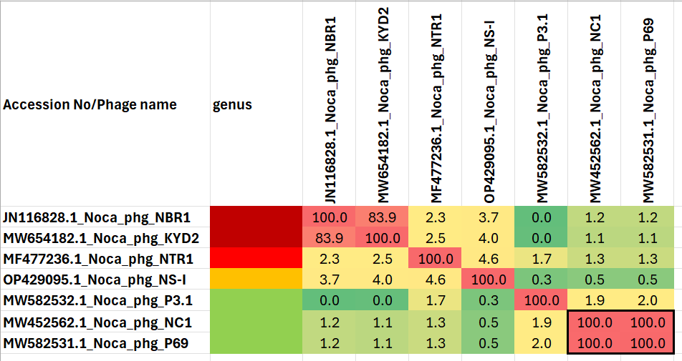

Figure 1. VIRIDIC heat map of a group of phages with the one under discussion indicated with a red arrowhead. VIRIDIC (Virus Intergenomic Distance Calculator; VIRIDIC (Virus Intergenomic Distance Calculator; [3]; http://rhea.icbm.uni-oldenburg.de/VIRIDIC/) computes pairwise intergenomic distances/similarities amongst phage genomes. Data values which are bordered in black correspond to strains. Abbreviations: Noca = Nocardia; phg = phage.

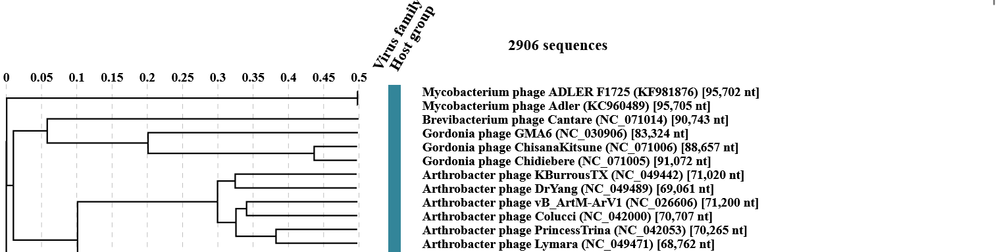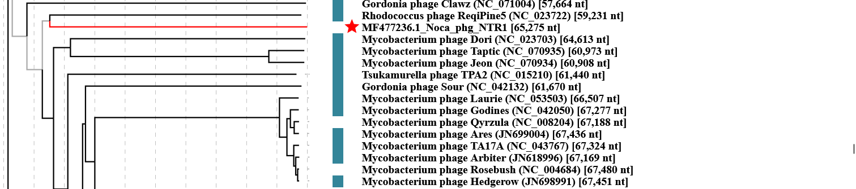
Figure 2. ViPTree analysis (https://www.genome.jp/viptree/; [4]) is based upon Rohwer and Edwards (2002) Phage Proteomic Tree [5]. The phage of interest is indicated with red arrowhead. Abbreviations: Noca = Nocardia; phg = phage.

