

The International Committee on Taxonomy of Viruses
Taxonomy Proposal Form, 2025

Part 1a: Details of taxonomy proposals

Title: | Create one new genus (Peetremavirus) of Mycobacterium phages with eight species (Class Caudoviricetes).
Code assigned: | 2025.048B.Ac.v3.Mycobacterium_phages_1ng_8ns

Author(s), affiliation and email address(es):
Given name (+middle initial(s)) | Surname | Affiliation | Email address | Corr. author(s)
Andrew M. | Kropinski | Department of Pathobiology, University of Guelph, Guelph, Ontario, Canada | Phage.Canada@gmail.com | x
Cristina | Moraru | Carl von Ossietzky Universität Oldenburg, Germany | liliana.cristina.moraru@uol.de
Ipek | Kurtböke | University of the Sunshine Coast - Faculty of Science, Health, Education and Engineering, Australia | ikurtbok@usc.edu.au

Part 1b: Taxonomy Proposal Submission
ICTV Subcommittee:
Animal DNA Viruses and Retroviruses |  | Bacterial viruses | x
Animal minus-strand and dsRNA viruses |  | Fungal and protist viruses
Animal positive-strand RNA viruses |  | Plant viruses
Archaeal viruses |  | General -

List the ICTV Study Group(s) that have seen or have been involved in creating this proposal:
Actinophages Study Group

Optional – complete only if formally voted on by an ICTV Study Group:
Study Group | Number of members
Study Group | Votes in support | Votes against | No vote

Submission date: | 015/06/2025

Part 1c: Feedback from ICTV Executive Committee (EC) meeting
Executive Committee Meeting Decision code: | X
A – Accept
Ac – Accept subject to revision by relevant subcommittee chair. No further vote required | x
U – Accept without revision but with re-evaluation and email vote by the EC
Uc – Accept subject to revision and re-evaluation and email vote by the EC
Ud – Deferred to the next EC meeting, with an invitation to revise based on EC comments
J - Reject
W - Withdrawn

Comments from the Executive Committee:
Please improve the quality of the abstract section.

Part 1d: Revised Taxonomy Proposal Submission
Response of proposer:
Since submission of the original Taxonomy Proposal a series of related phages were deposited in GenBank. The revised proposal includes these.

Revision date: | August 18, 2025

Part 3: TAXONOMIC PROPOSAL
https://ictv.global/taxonomy/templates
Taxonomic changes proposed:
Establish new taxon | x | Split taxon
Abolish taxon |  | Merge taxon
Move taxon |  | Promote taxon
Rename taxon |  | Demote taxon
Move and rename

Etymology (origin) of proposed taxonomic names:
Taxon name | Etymology of the term
Peetremavirus | Name derived from first isolate phage of its type Mycobacterium phage P3MA

Permission for use of names derived from a living person:
Taxon name | Full name of person from whom the name is derived | Attached

Abstract of Taxonomy Proposal:
Taxonomic rank(s) affected: genus and species

Description of current taxonomy: None. Mycobacterium phage P3MA is defined in the Actinobacteriophage Database as a singleton. The prophages have not been included in the database as of writing (18/08/2025)

Proposed taxonomic change(s): Create one new genus Peetremavirus with eight species

Justification: Phage P3MA was isolated on Mycobacterium abscessus 330 while the other proposed members of this genus were identified in the genomes of a variety of M. abscessus isolates. All of these temperate siphoviruses conform to the criteria which we have established for creation of a genera and associated species.

- Text of Taxonomy proposal:

Taxonomic rank(s) affected: genus and species

Description of current taxonomy: None. Mycobacterium phage P3MA is defined in the Actinobacteriophage Database as a singleton. The prophages have not been included in the database as of writing (18/08/2025).

Proposed taxonomic change(s): Create one new genus “Peetremavirus” with eight species

Demarcation criteria: The Bacterial and Archaeal Virus Subcommittee established 70% average nucleotide identity (ANI) threshold for genus classification or 95% ANI for species [8]

Justification: Phage P3MA was isolated on Mycobacterium abscessus 330 while the other proposed members of this genus were identified in the genomes of a variety of M. abscessus isolates. All of these temperate siphoviruses conform to the criteria which we have established for creation of a genera and associated species.

References:
1. Sayers EW, Beck J, Bolton EE, Bourexis D, Brister JR, Canese K, Comeau DC, Funk K, Kim S, Klimke W, Marchler-Bauer A, Landrum M, Lathrop S, Lu Z, Madden TL, O'Leary N, Phan L, Rangwala SH, Schneider VA, Skripchenko Y, Wang J, Ye J, Trawick BW, Pruitt KD, Sherry ST. Database resources of the National Center for Biotechnology Information. Nucleic Acids Res. 2021 Jan 8;49(D1):D10-D17. doi: 10.1093/nar/gkaa892. PMID: 33095870
2. O'Leary NA, Wright MW, Brister JR, Ciufo S, Haddad D, McVeigh R, et al. Reference sequence (RefSeq) database at NCBI: current status, taxonomic expansion, and functional annotation. Nucleic Acids Res. 2016;44(D1):D733-45. doi: 10.1093/nar/gkv1189. PMID: 26553804.
3. Moraru C, Varsani A, Kropinski AM. VIRIDIC-A Novel Tool to Calculate the Intergenomic Similarities of Prokaryote-Infecting Viruses. Viruses. 2020 Nov 6;12(11):1268. doi: 10.3390/v12111268. PMID: 33172115; PMCID: PMC7694805. http://kronos.icbm.uni-oldenburg.de/viridic/
4. Nishimura Y, Yoshida T, Kuronishi M, Uehara H, Ogata H, Goto S. ViPTree: the viral proteomic tree server. Bioinformatics. 2017; 33(15):2379-2380. doi:10.1093/bioinformatics/btx157. PubMed PMID: 28379287. https://www.genome.jp/viptree/
5. Rohwer F, Edwards R. The Phage Proteomic Tree: a genome-based taxonomy for phage. J Bacteriol. 2002 Aug;184(16):4529-35. PubMed PMID: 12142423
6. Turner D, Reynolds D, Seto D, Mahadevan P. CoreGenes3.5: a webserver for the determination of core genes from sets of viral and small bacterial genomes. BMC Res Notes. 2013;6:140. doi: 10.1186/1756-0500-6-140. PMID: 23566564.
7. Davis P, Seto D, Mahadevan P. CoreGenes5.0: An Updated User-Friendly Webserver for the Determination of Core Genes from Sets of Viral and Bacterial Genomes. Viruses. 2022 Nov 16;14(11):2534. doi: 10.3390/v14112534. PMID: 36423143; PMCID: PMC9693508.
8. Turner D, Kropinski AM, Adriaenssens EM. A Roadmap for Genome-Based Phage Taxonomy. Viruses. 2021 Mar 18;13(3):506. doi: 10.3390/v13030506. PMID: 33803862; PMCID: PMC8003253.
Lemoine F, Correia D, Lefort V, Doppelt-Azeroual O, Mareuil F, Cohen-Boulakia S, Gascuel O. NGPhylogeny.fr: new generation phylogenetic services for non-specialists. Nucleic Acids Res. 2019 Jul 2;47(W1):W260-W265. doi: 10.1093/nar/gkz303. PMID: 31028399; PMCID: PMC6602494.
9. Letunic I, Bork P. Interactive Tree Of Life (iTOL): an online tool for phylogenetic tree display and annotation. Bioinformatics. 2007 Jan 1;23(1):127-8. doi: 10.1093/bioinformatics/btl529. Epub 2006 Oct 18. PMID: 17050570.
10. Zhou T, Xu K, Zhao F, Liu W, Li L, Hua Z, Zhou X. itol.toolkit accelerates working with iTOL (Interactive Tree of Life) by an automated generation of annotation files. Bioinformatics. 2023 Jun 1;39(6):btad339. doi: 10.1093/bioinformatics/btad339. PMID: 37225402; PMCID: PMC10243930.

Accompanying files:
Filename | Description of contents
2025,0488.N.Mycobacterium_phage_1ng_7ns | Data for this proposal

Tables, Figures:
<Start here>
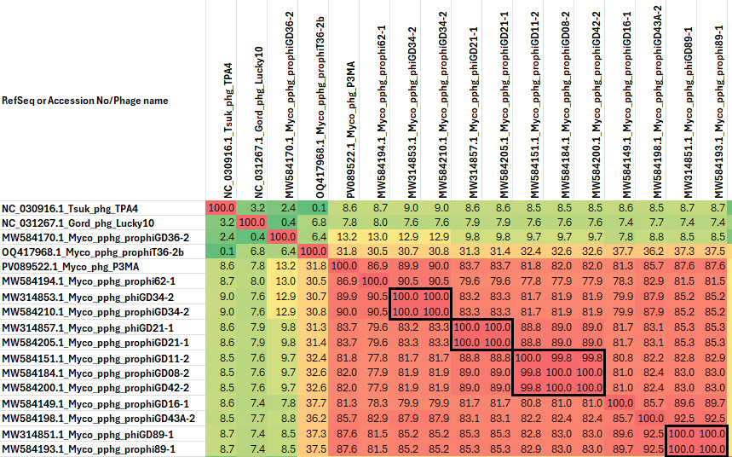
Figure 1. VIRIDIC heatmap of this group of phages. VIRIDIC (Virus Intergenomic Distance Calculator; VIRIDIC (Virus Intergenomic Distance Calculator; [3]; http://rhea.icbm.uni-oldenburg.de/VIRIDIC/) computes pairwise intergenomic distances/similarities amongst phage genomes. Data values which are bordered in black correspond to strains. Abbreviations: phg = phage; pphg = prophage; Gord = Gordonia; Tsuk = Tsukamurella; Myco = Mycobacterium.

Table 1. Characteristics of the phage described in the proposal
Phage name | Host | Morphotype | Lifestyle | Accession No. | Genome size | No. proteins | No. tRNA
Mycobacterium phage P3MA | Mycobacterium abscessus 330 | Siphovirus | Temperate | PV089522.1 | 41151 bp | 63 | 0
Mycobacterium phage prophi62-1 | Mycobacterium abscessus GD62 | Siphovirus | Temperate | MW584194.1 | 39,188 bp | 58 | 0
Mycobacterium phage phiGD34-2 | Mycobacterium abscessus GD41 | Siphovirus | Temperate | MW314853.1 | 40,005 bp | 63 | 0
Mycobacterium phage prophiGD21-1 | Mycobacterium abscessus GD21 | Siphovirus | Temperate | MW584205.1 | 40,775 bp | 62 | 0
Mycobacterium phage prophiGD11-2 | Mycobacterium abscessus GD11 | Siphovirus | Temperate | MW584151.1 | 39,951 bp | 62 | 0
Mycobacterium phage prophiGD16-1 | Mycobacterium abscessus GD16 | Siphovirus | Temperate | MW584149.1 | 40,056 bp | 58 | 0
Mycobacterium phage prophiGD43A-2 | Mycobacterium abscessus GD43A | Siphovirus | Temperate | MW584198.1 | 40,147 bp | 60 | 0
Mycobacterium phage phiGD89-1 | Mycobacterium abscessus GD89 | Siphovirus | Temperate | MW314851.1 | 40,450 bp | 63 | 0

