

The International Committee on Taxonomy of Viruses
Taxonomy Proposal Form, 2025

https://ictv.global/taxonomy/templatesPart 1a: Details of taxonomy proposals

Title: | Create one (1) new family (Lutzviridae), including one (1) new genus (Lutzvirus) [Class: Caudoviricetes]
Code assigned: | 2025.040B.Ac.v3.Lutzviridae_1nf_1ng_1ns

Author(s), affiliation and email address(es):
Given name (+middle initial(s)) | Surname | Affiliation | Email address | Corr. author(s)
Adriele J C | Santos | Department of Microbiology, Federal University of Vicosa, Av. Peter Henry Rolfs, s/n, Campus Universitario, 36570-900, Vicosa, Minas Gerais, Brazil | adriele.docarmo27@gmail.com
Bruna A L | Ayupe | Department of Microbiology, Federal University of Vicosa, Av. Peter Henry Rolfs, s/n, Campus Universitario, 36570-900, Vicosa, Minas Gerais, Brazil | brunleao@yahoo.com.br
Roberto S | Dias | Department of General Biology, Federal University of Viçosa, Av. Peter Henry Rolfs, s/n, Campus Universitario, 36570-900, Viçosa, Minas Gerais, Brazil. | rosousa318@gmail.com | X
Mirelly J F | Silva | Department of Microbiology, Federal University of Vicosa, Av. Peter Henry Rolfs, s/n, Campus Universitario, 36570-900, Vicosa, Minas Gerais, Brazil | mirelly.silva@ufv.br
Carlos H M | Da Silva | Department of Microbiology, Federal University of Vicosa, Av. Peter Henry Rolfs, s/n, Campus Universitario, 36570-900, Vicosa, Minas Gerais, Brazil | carlos.silva4@ufv.br
Andrew M | Kropinski | Department of Pathobiology, University of Guelph, Guelph, Ontario N1G 2W1, Canada | Phage.Canada@gmail.com
Dann | Turner | University of the West of England, Bristol, UK | Dann2.Turner@uwe.ac.uk
Sérgio O | De Paula | Department of General Biology, Federal University of Viçosa, Av. Peter Henry Rolfs, s/n, Campus Universitario, 36570-900, Viçosa, Minas Gerais, Brazil. | depaula@ufv.br | X

Part 1b: Taxonomy Proposal Submission
ICTV Subcommittee:
Animal DNA Viruses and Retroviruses |  | Bacterial viruses | X
Animal minus-strand and dsRNA viruses |  | Fungal and protist viruses
Animal positive-strand RNA viruses |  | Plant viruses
Archaeal viruses |  | General -

List the ICTV Study Group(s) that have seen or have been involved in creating this proposal: https://ictv.global/sc
Caudoviricetes Study Group
Optional – complete only if formally voted on by an ICTV Study Group:
Study Group | Number of members
Study Group | Votes in support | Votes against | No vote

Submission date:

Part 1c: Feedback from ICTV Executive Committee (EC) meeting
Executive Committee Meeting Decision code: | X
A – Accept
Ac – Accept subject to revision by relevant subcommittee chair. No further vote required | X
U – Accept without revision but with re-evaluation and email vote by the EC
Uc – Accept subject to revision and re-evaluation and email vote by the EC
Ud – Deferred to the next EC meeting, with an invitation to revise based on EC comments
J - Reject
W - Withdrawn

Comments from the Executive Committee:
Evelien Adriaenssens should not be a co-author of this proposal (she doesn’t recall being involved). Author table has middle names but those should be initials, are the surnames correct in the columns, delete part 2

Part 1d: Revised Taxonomy Proposal Submission
Response of proposer:
Evelien Adriaenssens' name has been renewed as a co-author of this proposal. The author list has been adjusted to include only middle initials. Last names have been verified and are correct. The proposal was previously sent to Andrew; he assisted in filling out the forms.

Revision date: | 08/20/2025

Part 3: TAXONOMIC PROPOSAL
https://ictv.global/taxonomy/templates
Taxonomic changes proposed:
Establish new taxon | X | Split taxon
Abolish taxon |  | Merge taxon
Move taxon |  | Promote taxon
Rename taxon |  | Demote taxon
Move and rename

Etymology (origin) of proposed taxonomic names:
Taxon name | Etymology of the term
Lutzviridae | In honor of Bertha Lutz, a Brazilian zoologist, politician and diplomat; the suffix -viridae for family taxa.

Permission for use of names derived from a living person:
Taxon name | Full name of person from whom the name is derived | Attached

Abstract of Taxonomy Proposal:
Taxonomic rank(s) affected:
Family, genus, species

Description of current taxonomy:
The bacterial viruses described in this proposal are currently unclassified.

Proposed taxonomic change(s):
We propose a new family, Lutzviridae, which includes a single genus, Lutzvirus, with a single species represented by Oceanotoga phage vB_OteS-UFV02.

Justification:
We propose the establishment of a new viral family, Lutzviridae, including one new genus genus, Lutzvirus, and a single species. Phylogenetic analysis based on whole-genome comparisons using VIPTree demonstrates that Oceanotoga phage vB_OteS-UFV02 (accession OR420712.1) forms an isolated clade, showing no close evolutionary relationship to any other known viruses within the class Caudoviricetes.
Furthermore, vB_OteS-UFV02 can be considered a genomic orphan, as it shares no significant nucleotide similarity with any previously classified viral genomes. BLASTn and VIRIDIC analyses reveal less than 4% nucleotide identity with its closest match, the unclassified Clostridium phage phiCTP1 (accession HM159959.1), which is far below the threshold recommended for family-level classification.
These lines of evidence strongly support the designation of Lutzviridae as a novel family within Caudoviricetes, encompassing bacteriophages that are highly divergent in both genomic content and evolutionary origin.

- Text of Taxonomy proposal:

Taxonomic rank(s) affected:
Species, genus and Family

Description of current taxonomy:
Unclassified Caudoviricetes

Proposed taxonomic change(s):
A. To create a new genus Lutzvirus with one species
B. To create a new family, Lutzviridae to include the genus Lutzvirus

Demarcation criteria:
Species demarcation criteria: Two phages are assigned to the same species if their genomes are more than 95% identical over their genome length for isolates.
These values can be calculated by a number of tools, such as BLASTn [1,2] – usually calculated using intergenomic distance calculator VIRIDIC [3].

Genus demarcation criteria: In search for criteria that create cohesive and distinct genera that are reproducible and monophyletic, the Bacterial Viruses Subcommittee has established 70% nucleotide identity of the genome length as the cut-off for genera. Genus-level groupings should always be monophyletic in the signature genes, as tested with a phylogenetic tree[4].

Subfamily demarcation criteria: Subfamilies are to be created when two or more genera are related below the family level. In practical terms, this usually means that they share a low degree of sequence similarity (usually about 40-50%) and that the genera form a clade in a marker tree phylogeny [4].

Family demarcation criteria: The family is represented by a cohesive and monophyletic group in the main predicted proteome-based clustering tools (ViPTree, GRAViTy dendrogram, vConTACT2 network). Members of the family share a significant number of orthologous genes (the number will depend on the genome sizes and number of coding sequences of members of the family) [4].

Justification:
Phage vB_OteS-UFV02 is a genomic orphan. BLASTn analysis reveals minimal nucleotide sequence similarity (<4%) to the unclassified Clostridium phage phiCTP1 (accession HM159959.1). Whole-genome proteomic analysis using ViPTree and phylogenetic reconstruction suggests that, although there may be a distant protein-level relationship with Clostridium-Bacillus phages, this relationship is weak and evolutionarily remote.

References:
1. Sayers EW, Beck J, Bolton EE, Bourexis D, Brister JR, Canese K, Comeau DC, Funk K, Kim S, Klimke W, Marchler-Bauer A, Landrum M, Lathrop S, Lu Z, Madden TL, O'Leary N, Phan L, Rangwala SH, Schneider VA, Skripchenko Y, Wang J, Ye J, Trawick BW, Pruitt KD, Sherry ST. Database resources of the National Center for Biotechnology Information. Nucleic Acids Res. 2021 Jan 8;49(D1):D10-D17. doi: 10.1093/nar/gkaa892. PMID: 33095870
2. O'Leary NA, Wright MW, Brister JR, Ciufo S, Haddad D, McVeigh R, et al. Reference sequence (RefSeq) database at NCBI: current status, taxonomic expansion, and functional annotation. Nucleic Acids Res. 2016;44(D1):D733-45. doi: 10.1093/nar/gkv1189. PMID: 26553804.
3. Moraru C, Varsani A, Kropinski AM. VIRIDIC-A Novel Tool to Calculate the Intergenomic Similarities of Prokaryote-Infecting Viruses. Viruses. 2020 Nov 6;12(11):1268. doi: 10.3390/v12111268. PMID: 33172115; PMCID: PMC7694805. http://kronos.icbm.uni-oldenburg.de/viridic/
4. Nishimura Y, Yoshida T, Kuronishi M, Uehara H, Ogata H, Goto S. ViPTree: the viral proteomic tree server. Bioinformatics. 2017; 33(15):2379-2380. doi:10.1093/bioinformatics/btx157. PubMed PMID: 28379287. https://www.genome.jp/viptree/

Accompanying files:
Filename | Description of contents

Tables, Figures:
<Start here>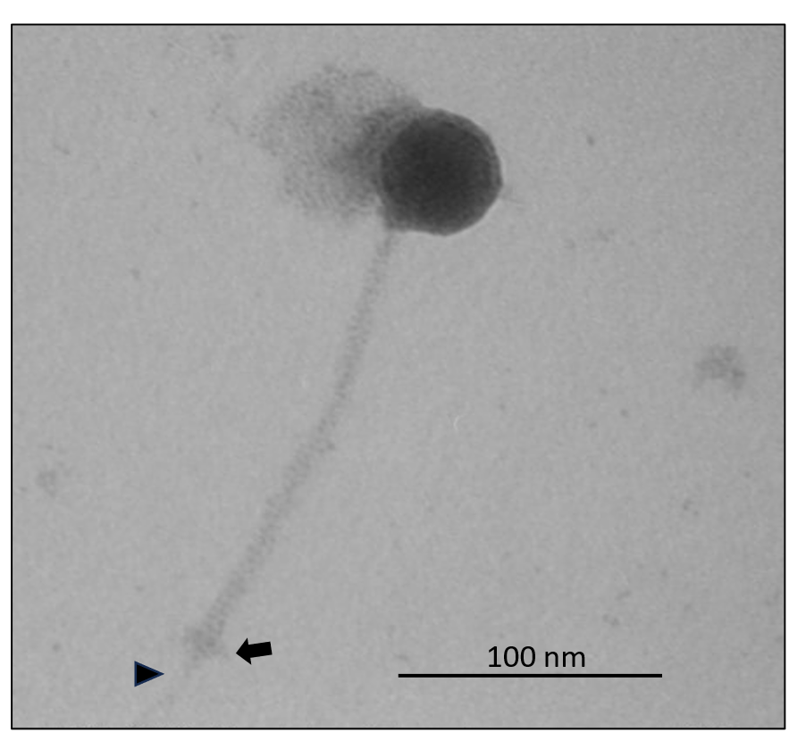
Figure 1. Electron micrograph: Transmission electron micrographs of phage vB_OteS-UFV02 stained with 2% uranyl acetate. Arrow shows the structure of the plate and the arrow head indicates the central structure of the tail fiber. The scale bar represents 100 nm.

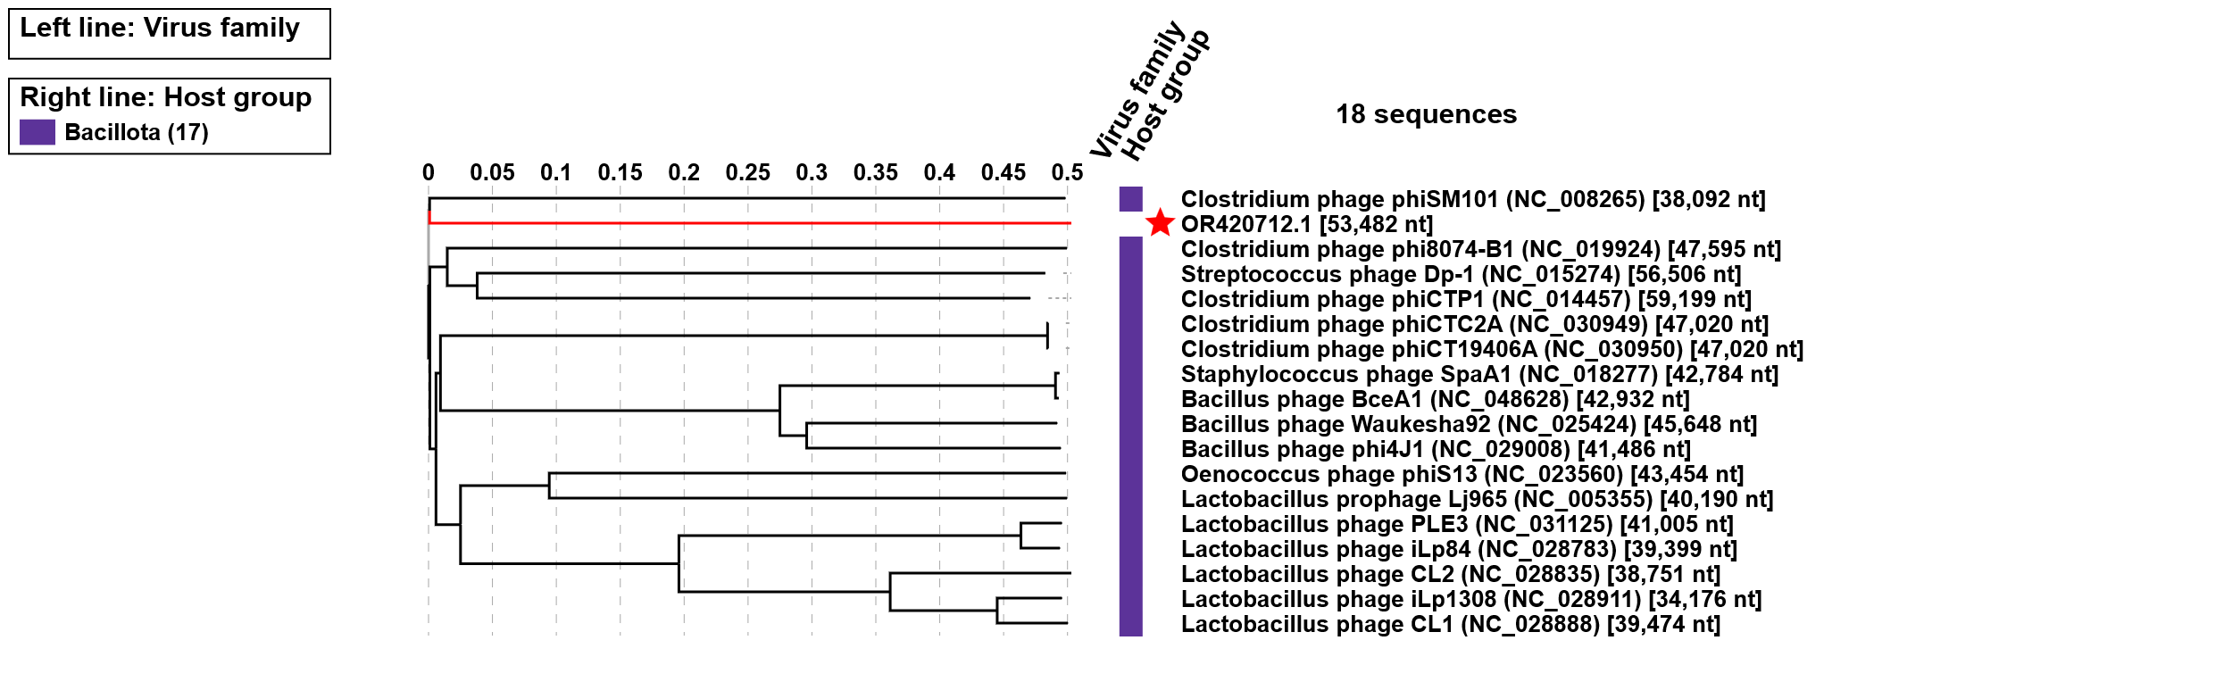

Figure 2. ViPTree analysis: ViPTree analysis (https://www.genome.jp/viptree/; [3]) is based upon Rohwer and Edwards (2002) famous Phage Proteomic Tree [4]. Phage UFV02 is indicated with a red star.

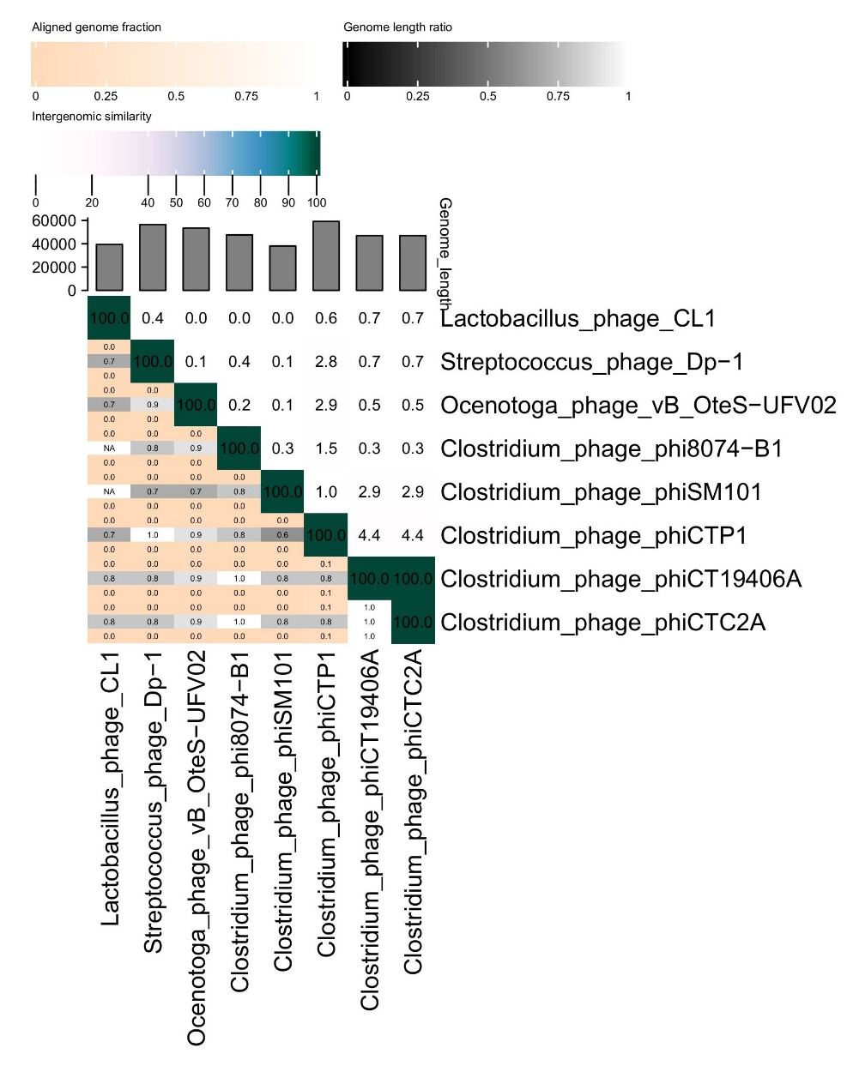
Figure 3: Heatmap generated by VIRIDIC illustrating intergenomic similarities between vB_OteS-UFV02 and phages that showed low levels of similarity using BLASTn.
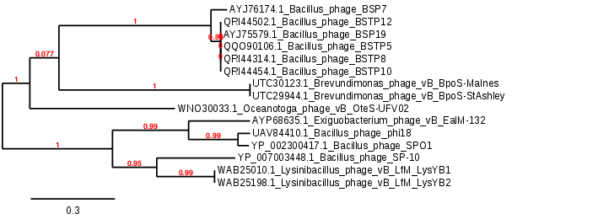

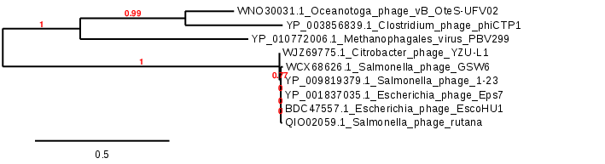
Figure 4. Phylogeny: The phylogenetic tree was constructed using (top) DNA polymerase and (bottom) anaerobic ribonucleoside-triphosphate reductase proteins from these and related phages with phylogeny.fr in “one click” mode [5]. "The "One Click mode" targets users that do not wish to deal with program and parameter selection. By default, the pipeline is already set up to run and connect programs recognized for their accuracy and speed (MUSCLE for multiple alignment and PhyML for phylogeny) to reconstruct a robust phylogenetic tree from a set of sequences." It also includes the use of Gblocks to eliminate poorly aligned positions and divergent regions. "The usual bootstrapping procedure is replaced by a new confidence index that is much faster to compute. See: Anisimova M., Gascuel O. Approximate likelihood ratio test for branches: A fast, accurate and powerful alternative [6] for details.”

Proposal A: To create a new genus, Lutzvirus, with a single species

Origin of the name of this taxon: This taxon is named in honour of the Brazilian zoologist, politician, and diplomat Bertha Maria Júlia Lutz (1894 – 1976). Lutz was “a leading figure in both the Pan American feminist movement and the human rights movement. She was instrumental in gaining women's suffrage in Brazil and represented her country at the United Nations Conference on International Organization, signing her name to the United Nations Charter. In addition to her political work, she was a naturalist at the National Museum of Brazil, specializing in poison dart frogs. She has four frog species and two lizard species named after her.” (https://en.wikipedia.org/wiki/Bertha_Lutz)
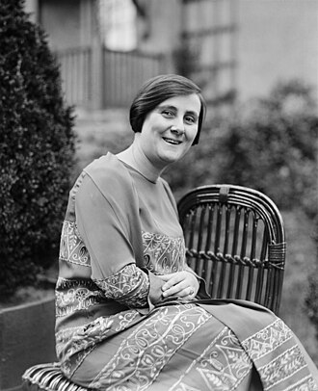
(picture copied from: https://en.wikipedia.org/wiki/Bertha_Lutz#/media/File:Bertha_Lutz_1925.jpg)

Historical aspects: Oceanotoga teriensis is a moderately thermophilic, anaerobic chemo-organotrophic bacterium was isolated from formation fluid samples from an offshore oil-production facility [8]. This acetogenic bacterium can reduce thiosulfate and elemental sulfur to sulfide. Oceanotoga phage vB_OteS-UFV02 was isolated from the water used for water injection in an oil reservoir. The virion features an icosahedral head approximately 47 nm in diameter. A 200 nm long non-contractile tail with a 16 nm wide base plate and a 44 nm long protruding tail fiber (Figure 1).

Genomic data:
Phage name | INSDC | Size (Kb) | GC% | Protein | tRNA
Oceanotoga phage vB_OteS-UFV02 | OR420712.1 | 53.482 | 31.5 | 75 | 0

Phage vB_OteS-UFV02 is a genomic orphan. BLASTn analysis [1,2] reveals minimal (<4%) sequence similarity to unclassified Clostridium phage phiCTP1 (HM159959.1; [9]). ViPTree analysis (Figure 2) and phylogenetic analysis (Figure 4) suggest that while there is some relationship at the protein level to phages of Clostridium-Bacillus it is remote.

Proposal B: To create a new family, Lutzviridae, with a single genus

Origin of the name of this taxon: This taxon is named in honour of Bertha Maria Júlia Lutz (see above for details).

Rationale for creating this taxon: While possessing a commonly observed siphoviral morphotype, the genome, proteomic and phylogenetic data indicate that phage vB_OteS-UFV02 belongs to a deeply rooted branch of bacteriophages. We expect that as research delves into viruses infecting less studied bacterial taxa we will see an increased number of unique species as well as those which can be classified to this taxon.

