

The International Committee on Taxonomy of Viruses
Taxonomy Proposal Form, 2025

Part 1a: Details of taxonomy proposals

Title: | Create four new species in the genus Kanagawavirus (class Caudoviricetes, order Pantevenvirales, family Straboviridae, subfamily Tevenvirinae)
Code assigned: | 2025.031B.Ac.v3.Kanagawavirus_4ns

Author(s), affiliation and email address(es):
Given name (+middle initial(s)) | Surname | Affiliation | Email address | Corresponding author(s)
Michał J. | Wójcicki | Bacteriophage Laboratory, Department of Phage Therapy, Hirszfeld Institute of Immunology and Experimental Therapy, Polish Academy of Sciences, Wroclaw, Poland | michal.wojcicki@hirszfeld.pl | X
Martyna A. | Cieślik | Bacteriophage Laboratory, Department of Phage Therapy, Hirszfeld Institute of Immunology and Experimental Therapy, Polish Academy of Sciences, Wroclaw, Poland | martyna.cieslik@hirszfeld.pl | X
Andrzej | Górski | Bacteriophage Laboratory, Department of Phage Therapy, Hirszfeld Institute of Immunology and Experimental Therapy, Polish Academy of Sciences, Wroclaw, Poland | andrzej.gorski@hirszfeld.pl
Ewa M. | Jończyk-Matysiak | Bacteriophage Laboratory, Department of Phage Therapy, Hirszfeld Institute of Immunology and Experimental Therapy, Polish Academy of Sciences, Wroclaw, Poland | ewa.jonczyk-matysiak@hirszfeld.pl

Part 1b: Taxonomy Proposal Submission
ICTV Subcommittee:
Animal DNA Viruses and Retroviruses |  | Bacterial viruses | X
Animal minus-strand and dsRNA viruses |  | Fungal and protist viruses
Animal positive-strand RNA viruses |  | Plant viruses
Archaeal viruses |  | General

List the ICTV Study Group(s) that have seen or have been involved in creating this proposal:
Caudoviricetes Study Group
Optional – complete only if formally voted on by an ICTV Study Group:
Study Group | Number of members
Study Group | Votes in support | Votes against | No vote

Submission date: | 17/03/2025

Part 1c: Feedback from ICTV Executive Committee (EC) meeting
Executive Committee Meeting Decision code: | X
A – Accept | x
Ac – Accept subject to revision by relevant subcommittee chair. No further vote required
U – Accept without revision but with re-evaluation and email vote by the EC
Uc – Accept subject to revision and re-evaluation and email vote by the EC
Ud – Deferred to the next EC meeting, with an invitation to revise based on EC comments
J - Reject
W - Withdrawn

Comments from the Executive Committee:
Genus in-filling (4 species)

Part 1d: Revised Taxonomy Proposal Submission
Response of proposer:
Abstract checked for clarity

Revision date: | 28/09/2025
Part 3: TAXONOMIC PROPOSAL

Taxonomic changes proposed:
Establish new taxon | X | Split taxon
Abolish taxon |  | Merge taxon
Move taxon |  | Promote taxon
Rename taxon |  | Demote taxon
Move and rename

Etymology (origin) of proposed taxonomic names:
Taxon name | Etymology of the term
Kanagawavirus KLB31 | species name derived from the phage name in the GenBank database – Klebsiella phage vB_KM5a1-KLB31
Kanagawavirus ENC9 | species name derived from the phage name in the GenBank database – MAG: Enterobacter phage ENC9
Kanagawavirus Entb45 | species name derived from the phage name in the GenBank database – Enterobacter phage Entb_45
Kanagawavirus ZX14 | species name derived from the phage name in the GenBank database – Enterobacter phage ZX14

Permission for use of names derived from a living person
Taxon name | Full name of person from whom the name is derived | Attached

Abstract of Taxonomy Proposal:
Taxonomic rank(s) affected:
Realm Duplodnaviria, kingdom Heunggongvirae, phylum Uroviricota, class Caudoviricetes, order Pantevenvirales, family Straboviridae, subfamily Tevenvirinae.

Description of current taxonomy:
Currently, the order Pantevenvirales includes three families: Ackermannviridae, Kyanoviridae, and Straboviridae. Within the Straboviridae family, three subfamilies have been distinguished: Emmerichvirinae, Tevenvirinae, and Twarogvirinae. The Tevenvirinae subfamily comprises 15 genera and 148 species. Currently, the Kanagawavirus genus includes five species: Kanagawavirus cipnine, Kanagawavirus eclm, Kanagawavirus mime, Kanagawavirus pei20, and Kanagawavirus threeohfive.

Proposed taxonomic change(s):
We performed a genomic analysis of phages deposited in the NCBI database. We propose to create four new species in the genus Kanagawavirus.

Justification:
Based on DNA and protein similarity, the four proposed new species are coherent and together with the five known species (Kanagawavirus cipnine, Kanagawavirus eclm, Kanagawavirus mime, Kanagawavirus pei20, and Kanagawavirus threeohfive) can be classified in the genus Kanagawavirus.

Text of Taxonomy proposal:
Taxonomic rank(s) affected:
Realm Duplodnaviria, kingdom Heunggongvirae, phylum Uroviricota, class Caudoviricetes, order Pantevenvirales, family Straboviridae, subfamily Tevenvirinae.

Description of current taxonomy:
Currently, the order Pantevenvirales includes three families: Ackermannviridae, Kyanoviridae, and Straboviridae. Within the Straboviridae family, three subfamilies have been distinguished: Emmerichvirinae, Tevenvirinae, and Twarogvirinae. The Tevenvirinae subfamily comprises 15 genera and 148 species. Currently, the Kanagawavirus genus includes five species: Kanagawavirus cipnine, Kanagawavirus eclm, Kanagawavirus mime, Kanagawavirus pei20, and Kanagawavirus threeohfive.

Proposed taxonomic change(s):
Following genomic analysis of phages deposited in the NCBI database we propose to create four new species in the genus Kanagawavirus.

Demarcation criteria:
Species demarcation criteria: Two phages are assigned to the same species if their genomes are more than 95% identical over their genome length for isolates.
These values can be calculated by several tools, such as BLASTn [1] – usually calculated using the intergenomic distance calculator VIRIDIC [2].

Genus demarcation criteria: In search for criteria that create cohesive and distinct genera that are reproducible and monophyletic, the Bacterial Viruses Subcommittee has established 70% nucleotide identity of the genome length as the cut-off for genera. Genus-level groupings should always be monophyletic in the signature genes, as tested with a phylogenetic tree [3].

Justification:
Based on DNA and protein similarity, the four proposed new species are coherent and together with the five known species (Kanagawavirus cipnine, Kanagawavirus eclm, Kanagawavirus mime, Kanagawavirus pei20, and Kanagawavirus threeohfive) can be classified in the genus Kanagawavirus.

References:
- Sayers EW, Beck J, Bolton EE, Bourexis D, Brister JR, Canese K, Comeau DC, Funk K, Kim S, Klimke W, Marchler-Bauer A, Landrum M, Lathrop S, Lu Z, Madden TL, O'Leary N, Phan L, Rangwala SH, Schneider VA, Skripchenko Y, Wang J, Ye J, Trawick BW, Pruitt KD, Sherry ST. Database resources of the National Center for Biotechnology Information. Nucleic Acids Res. 2021, 49(D1):D10-D17.
- Moraru C, Varsani A, Kropinski AM. VIRIDIC - a novel tool to calculate the intergenomic similarities of prokaryote-infecting viruses. Viruses 2020, 12(11):1268.
- Turner D, Kropinski AM, Adriaenssens EM. A roadmap for genome-based phage taxonomy. Viruses 2021, 13(3):506.
- Nishimura Y, Yoshida T, Kuronishi M, Uehara H, Ogata H, Goto S. ViPTree: the viral proteomic tree server. Bioinformatics 2017, 33(15):2379-2380.
- Rohwer F, Edwards R. The Phage Proteomic Tree: a genome-based taxonomy for phage. J. Bacteriol. 2002, 184(16):4529-35.
- Turner D, Reynolds D, Seto D, Mahadevan P. CoreGenes3.5: a webserver for the determination of core genes from sets of viral and small bacterial genomes. BMC Res. Notes. 2013, 6:140.

Accompanying files:
Filename | Description of contents
2025.031B.Kanagawavirus_4ns.xlsx | To present the proposed taxonomic changes as a comparison of new taxonomic structures.
Tables, Figures:

Figure 1. VIRIDIC heat map: VIRIDIC (Virus Intergenomic Distance Calculator [2]; http://rhea.icbm.uni-oldenburg.de/VIRIDIC/) computes pairwise intergenomic distances/similarities amongst phage genomes. Phages belonging to the same species (nucleotide similarity above 95%) are marked with a red frame. The currently distinguished five species belonging to the genus Kanagawavirus are marked in blue.

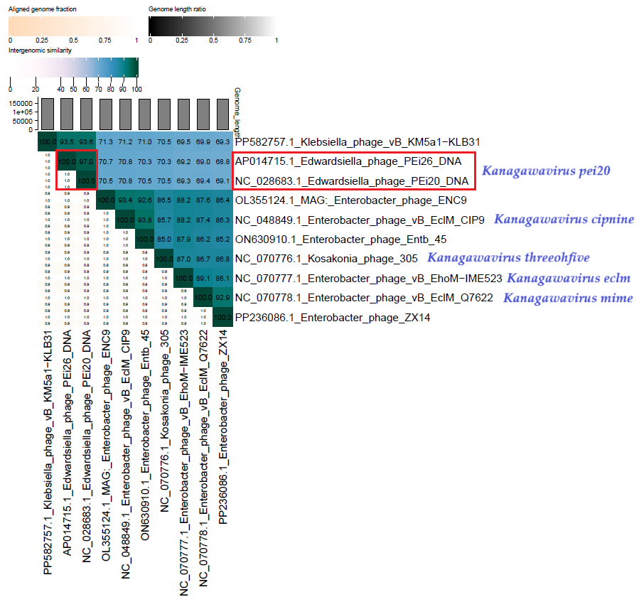

Figure 2. ViPTree analysis*: ViPTree analysis (https://www.genome.jp/viptree/; [4]) is based upon Rohwer and Edwards (2002) Phage Proteomic Tree [5]. The phages of interest are indicated with a red stars and a blue bar.

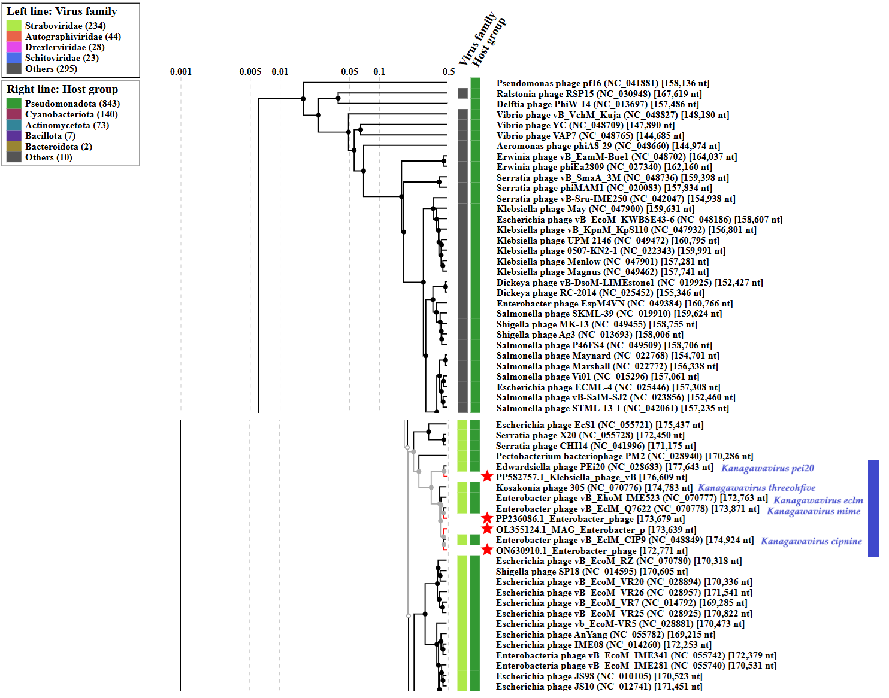

* The Autographiviridae family shown in Figure 2 (automatically labeled by the software) is outdated. In 2025, the Autographiviridae family was elevated to the rank of order and renamed Autographivirales.

Genome summary:

Phage name | RefSeq No. | INSDC | Size (bp) | GC% | Protein | Overall % DNA sequence identity (*) | Overall % homologous proteins (**)
Enterobacter phage vB_EclM_CIP9  (Kanagawavirus cipnine; reference genome) | NC_048849.1 | NC_048849 | 174,924 | 39.9 | 296 | 100.0 | 100.0
Klebsiella phage vB_KM5a1-KLB31 |  | PP582757 | 176,609 | 40.7 | 299 | 71.2 | 87.16
MAG: Enterobacter phage ENC9 |  | OL355124 | 173,639 | 40.1 | 252 | 93.4 | 83.45
Enterobacter phage Entb_45 |  | ON630910 | 172,771 | 40.0 | 284 | 93.8 | 93.92
Enterobacter phage ZX14 |  | PP236086 | 173,679 | 39.9 | 294 | 86.3 | 91.89
(*) determined using VIRIDIC [2]
(**) determined using CoreGenes 3.5 [6]

