

The International Committee on Taxonomy of Viruses
Taxonomy Proposal Form, 2025

Part 1a: Details of taxonomy proposals

Title: | Create three new species in the genus Felixounavirus (class Caudoviricetes, family Andersonviridae, subfamily Ounavirinae)
Code assigned: | 2025.018B.Ac.v3.Felixounavirus_3ns

Author(s), affiliation and email address(es):
Given name (+middle initial(s)) | Surname | Affiliation | Email address | Corr. author(s)
Emilia Andrea V. | Sabban | Department of Science and Technology, Industrial Technology Development Institute, Taguig City, Philippines | dost.eavsabban@gmail.com | X
Stephen Kyle C. | Arcan | Department of Science and Technology, Industrial Technology Development Institute, Taguig City, Philippines | arcan.stephenkyle@gmail.com
Adonis N. | Eclipse | Department of Science and Technology, Industrial Technology Development Institute, Taguig City, Philippines | aneclipse1@gmail.com
Dexter Bryan L. | Esliza | Department of Science and Technology, Industrial Technology Development Institute, Taguig City, Philippines | dlesliza@gmail.com
Paul Jeremy C. | Lanete | Department of Science and Technology, Industrial Technology Development Institute, Taguig City, Philippines | pjclanete@gmail.com
Lindley C. | Susi | Department of Science and Technology, Science Education Institute, Taguig City, Philippines | lindleysusi@gmail.com
Gelito Joseph M. | Sikat | Department of Science and Technology, Industrial Technology Development Institute, Taguig City, Philippines | gjmsikat@itdi.dost.gov.ph | X

Part 1b: Taxonomy Proposal Submission
ICTV Subcommittee:
Animal DNA Viruses and Retroviruses |  | Bacterial viruses | X
Animal minus-strand and dsRNA viruses |  | Fungal and protist viruses
Animal positive-strand RNA viruses |  | Plant viruses
Archaeal viruses |  | General -

List the ICTV Study Group(s) that have seen or have been involved in creating this proposal: https://ictv.global/sc
Caudoviricetes Study Group

Optional – complete only if formally voted on by an ICTV Study Group:
Study Group | Number of members
Study Group | Votes in support | Votes against | No vote

Submission date: | 29/08/2024

Part 1c: Feedback from ICTV Executive Committee (EC) meeting
Executive Committee Meeting Decision code: | X
A – Accept
Ac – Accept subject to revision by relevant subcommittee chair. No further vote required | X
U – Accept without revision but with re-evaluation and email vote by the EC
Uc – Accept subject to revision and re-evaluation and email vote by the EC
Ud – Deferred to the next EC meeting, with an invitation to revise based on EC comments
J - Reject
W - Withdrawn

Comments from the Executive Committee:
Genus in-filling (3 species). There is a potential formatting issue with Excel module

Part 1d: Revised Taxonomy Proposal Submission
Response of proposer:
Corrected

Revision date: | 26/08/2025

https://ictv.global/taxonomy/templates
Taxonomic changes proposed:
Establish new taxon | X | Split taxon
Abolish taxon |  | Merge taxon
Move taxon |  | Promote taxon
Rename taxon |  | Demote taxon
Move and rename

Etymology (origin) of proposed taxonomic names:
Taxon name | Etymology of the term
Felixounavirus vipecomarii | Derived from the geographical sites of isolation in the Philippines: Felixounavirus vipecomarii isolated from Marikina River
Felixounavirus vipecomesa | Derived from the geographical sites of isolation in the Philippines: Felixounavirus vipecomesa isolated from a drainage site in Sta. Mesa, Manila
Felixounavirus vipecohospii | Derived from the geographical sites of isolation in the Philippines: Felixounavirus vipecohospii isolated from sewage at a public hospital in Manila

Permission for use of names derived from a living person:
Taxon name | Full name of person from whom the name is derived | Attached

Abstract of Taxonomy Proposal:
Taxonomic rank(s) affected:
Species

Description of current taxonomy:
The genus Felixounavirus currently includes 97 species.

Proposed taxonomic change(s):
Add three new species, Felixounavirus vipecomarii, Felixounavirus vipecomesa and Felixounavirus vipecohospii to the genus Felixounavirus.

Justification:
Three new species within the genus Felixounavirus are proposed based on the species demarcation criteria of <95% intergenomic similarity. Escherichia phages vB_EcoM_D4, vB_EcoM_E9, and vB_EcoM_H12 are closely related to Felixounavirus TP1 (GenBank NC_041979.1), exhibiting 92.2% intergenomic similarity.

- Text of Taxonomy proposal:

Taxonomic rank(s) affected:
Species

Description of current taxonomy:
The genus Felixounavirus currently consists of 97 species.

Proposed taxonomic change(s):
Add three new species, Felixounavirus vipecomarii, Felixounavirus vipecomesa and Felixounavirus vipecohospii to the genus Felixounavirus.

Demarcation criteria:
Species demarcation: Two phages are classified as the same species if their genomes share more than 95% similarity across their entire genomic content, as determined by VIRIDIC. [1, 2].

Justification:
Three novel species within the genus Felixounavirus are proposed based on a 95% intergenomic similarity threshold used for species demarcation. Escherichia phages vB_EcoM_D4, vB_EcoM_E9, and vB_EcoM_H12 are closely related to Felixounavirus TP1 (GenBank NC_041979.1), exhibiting a maximum of 92.2% intergenomic similarity.

References:
1. Turner D., Kropinski AM, Adriaenssens EM (2021) A roadmap for genome-based phage taxonomy Viruses, 13(3), 506. https://doi.org/10.3390/v13030506

2. Moraru C, Varsani A, Kropinski AM (2020) VIRIDIC — A Novel Tool to Calculate the Intergenomic Similarities of prokaryote-infecting viruses. Viruses 12(11):1268. https://doi.org/10.3390/v12111268

Accompanying files:
Filename | Description of contents

Tables, Figures:
<Start here>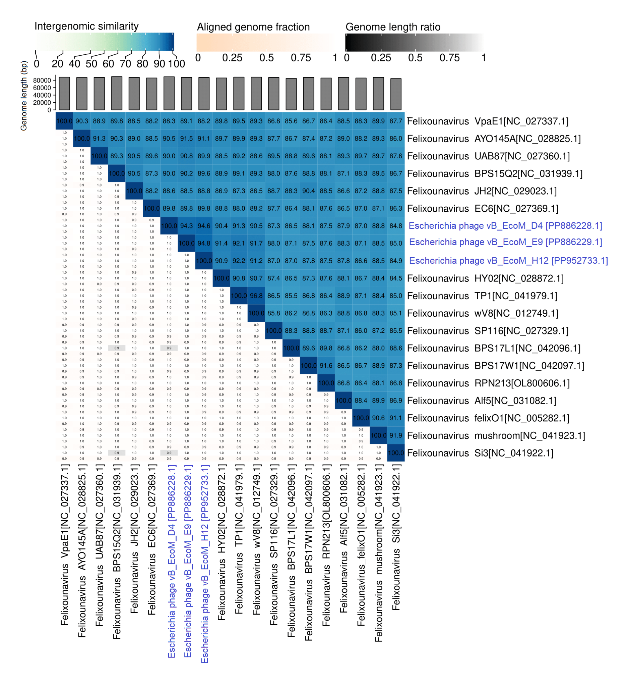Figure 1. Intergenomic similarity scores (VIRIDIC) of three phage isolates against other species included in the genus Felixounavirus. The three phage isolates are highlighted with blue font.

Table 1. Summary of genomic features of the proposed new species of bacteriophages.

