

The International Committee on Taxonomy of Viruses
Taxonomy Proposal Form, 2025

Part 1a: Details of taxonomy proposals

Title: | Create a new subfamily, Durvirinae, with six genera (Class Caudoviricetes).
Code assigned: | 2025.016B.Ac.v3.Durvirinae_1nsf_5ng_9ns

Author(s), affiliation and email address(es):
Given name (+middle initial(s)) | Surname | Affiliation | Email address | Corr. author(s)
Andrew M. | Kropinski | Department of Pathobiology, University of Guelph, Guelph, Ontario, Canada | Phage.Canada@gmail.com | x
Cristina | Moraru | Carl von Ossietzky Universität Oldenburg, Germany | liliana.cristina.moraru@uol.de
Ipek | Kurtböke | University of the Sunshine Coast - Faculty of Science, Health, Education and Engineering, Australia | ikurtbok@usc.edu.au

Part 1b: Taxonomy Proposal Submission
ICTV Subcommittee:
Animal DNA Viruses and Retroviruses |  | Bacterial viruses | x
Animal minus-strand and dsRNA viruses |  | Fungal and protist viruses
Animal positive-strand RNA viruses |  | Plant viruses
Archaeal viruses |  | General -

List the ICTV Study Group(s) that have seen or have been involved in creating this proposal: https://ictv.global/sc
Actinophages Study Group

Optional – complete only if formally voted on by an ICTV Study Group:
Study Group | Number of members
Study Group | Votes in support | Votes against | No vote

Submission date: | 015/06/2025

Part 1c: Feedback from ICTV Executive Committee (EC) meeting
Executive Committee Meeting Decision code: | X
A – Accept
Ac – Accept subject to revision by relevant subcommittee chair. No further vote required | x
U – Accept without revision but with re-evaluation and email vote by the EC
Uc – Accept subject to revision and re-evaluation and email vote by the EC
Ud – Deferred to the next EC meeting, with an invitation to revise based on EC comments
J - Reject
W - Withdrawn

Comments from the Executive Committee:
Please improve the quality of the abstract, there is a lack of phylogenetic tree (not necessary but would improve the proposal).

Part 1d: Revised Taxonomy Proposal Submission
Response of proposer:
Completed. Phylogenetic tree supported splitting the genus Mossrosevirus

Revision date: | August 20, 2025

Part 3: TAXONOMIC PROPOSAL
https://ictv.global/taxonomy/templates
Taxonomic changes proposed:
Establish new taxon | x | Split taxon
Abolish taxon |  | Merge taxon
Move taxon |  | Promote taxon
Rename taxon |  | Demote taxon
Move and rename

Etymology (origin) of proposed taxonomic names:
Taxon name | Etymology of the term
Durvirinae | Name derived from The Actinobacteriophage Database Cluster (DR)
Mossrosevirus | Named after Gordonia phage MossRose
Ligmavirus | Named after Gordonia phage Ligma
Nhagosvirus | Named after Gordonia phage Nhagos
Anclarvirus | Named after Gordonia phage AnClar
Duluthvirus | Named after the city where Gordonia phage LittleMunchkin was isolated

Permission for use of names derived from a living person:
Taxon name | Full name of person from whom the name is derived | Attached

Abstract of Taxonomy Proposal:
Taxonomic rank(s) affected:
Subfamily, genus, species

Description of current taxonomy:
The bacterial viruses described in this proposal are currently unclassified. These lytic siphoviruses are peripherally related to the genus Sourvirus (Taxonomy Protocol 2018.122B.A.v1.Sourvirus)

Proposed taxonomic change(s):
Create a new subfamily (“Durvirinae”) with Sourvirus and five new proposed genera, “Mossrosevirus”, “Ligmavirus” , “Nhagosvirus”, “Anaclarvirus” and Duluthvirus” based upon The Actinobacteriophage Database Cluster DR phages.

Justification: On the basis of VIRIDIC, ViPTree and phylogenetic analyses we recognize that the lytic siphoviruses belonging to The Actinobacteriophages Database Cluster DR represent five new genera ("Mossrosevirus", "Ligmavirus", "Nhagosvirus", "Anclarvirus" and "Duluthvirus") and propose to cluster these in a new subfamily “Durvirinae” with members of the Sourvirus.

- Text of Taxonomy proposal:

Taxonomic rank(s) affected:
Subfamily, genus, species

Description of current taxonomy:
The bacterial viruses described in this proposal are currently unclassified. These lytic siphoviruses are peripherally related to the genus Sourvirus (Taxonomy Protocol 2018.122B.A.v1.Sourvirus)

Proposed taxonomic change(s):
Create a new subfamily (“Durvirinae”) with Sourvirus and five new proposed genera, “Mossrosevirus”, “Ligmavirus”, “Nhagosvirus”, “Anaclarvirus” and Duluthvirus” based upon The Actinobacteriophage Database Cluster DR phages.

Demarcation criteria:
Sub-family demarcation criteria: Robust clustering in the core genome phylogenetic tree with a suggested minimum shared core gene content of 25%. Members of the same subfamily typically share >25% nucleotide identity across the genome length.
Genus demarcation criteria: An intergenomic similarity cut-off of 70%, a combination of average nucleotide identity and alignment fraction is used to determine genera demarcation. Members of the same genus have >70% intergenomic similarity and cluster tightly in marker gene phylogenies.
Species demarcation criteria: A demarcation value of 95% intergenomic similarity was used to define different species according to intergenomic similarity. Members of the same species have >95% intergenomic similarity.

Justification: On the basis of VIRIDIC, ViPTree and phylogenetic analyses we recognize that the lytic siphoviruses belonging to The Actinobacteriophages Database Cluster DR represent five new genera ("Mossrosevirus", "Ligmavirus", "Nhagosvirus", "Anclarvirus" and "Duluthvirus") and propose to cluster these in a new subfamily “Durvirinae” with members of the Sourvirus.

References:
1. Sayers EW, Beck J, Bolton EE, Bourexis D, Brister JR, Canese K, Comeau DC, Funk K, Kim S, Klimke W, Marchler-Bauer A, Landrum M, Lathrop S, Lu Z, Madden TL, O'Leary N, Phan L, Rangwala SH, Schneider VA, Skripchenko Y, Wang J, Ye J, Trawick BW, Pruitt KD, Sherry ST. Database resources of the National Center for Biotechnology Information. Nucleic Acids Res. 2021 Jan 8;49(D1):D10-D17. doi: 10.1093/nar/gkaa892. PMID: 33095870
2. O'Leary NA, Wright MW, Brister JR, Ciufo S, Haddad D, McVeigh R, et al. Reference sequence (RefSeq) database at NCBI: current status, taxonomic expansion, and functional annotation. Nucleic Acids Res. 2016;44(D1):D733-45. doi: 10.1093/nar/gkv1189. PMID: 26553804.
3. Moraru C, Varsani A, Kropinski AM. VIRIDIC-A Novel Tool to Calculate the Intergenomic Similarities of Prokaryote-Infecting Viruses. Viruses. 2020 Nov 6;12(11):1268. doi: 10.3390/v12111268. PMID: 33172115; PMCID: PMC7694805. http://kronos.icbm.uni-oldenburg.de/viridic/
4. Nishimura Y, Yoshida T, Kuronishi M, Uehara H, Ogata H, Goto S. ViPTree: the viral proteomic tree server. Bioinformatics. 2017; 33(15):2379-2380. doi:10.1093/bioinformatics/btx157. PubMed PMID: 28379287. https://www.genome.jp/viptree/
5. Rohwer F, Edwards R. The Phage Proteomic Tree: a genome-based taxonomy for phage. J Bacteriol. 2002 Aug;184(16):4529-35. PubMed PMID: 12142423
6. Turner D, Reynolds D, Seto D, Mahadevan P. CoreGenes3.5: a webserver for the determination of core genes from sets of viral and small bacterial genomes. BMC Res Notes. 2013;6:140. doi: 10.1186/1756-0500-6-140. PMID: 23566564.
7. Davis P, Seto D, Mahadevan P. CoreGenes5.0: An Updated User-Friendly Webserver for the Determination of Core Genes from Sets of Viral and Bacterial Genomes. Viruses. 2022 Nov 16;14(11):2534. doi: 10.3390/v14112534. PMID: 36423143; PMCID: PMC9693508.
8. Turner D, Kropinski AM, Adriaenssens EM. A Roadmap for Genome-Based Phage Taxonomy. Viruses. 2021 Mar 18;13(3):506. doi: 10.3390/v13030506. PMID: 33803862; PMCID: PMC8003253.
Lemoine F, Correia D, Lefort V, Doppelt-Azeroual O, Mareuil F, Cohen-Boulakia S, Gascuel O. NGPhylogeny.fr: new generation phylogenetic services for non-specialists. Nucleic Acids Res. 2019 Jul 2;47(W1):W260-W265. doi: 10.1093/nar/gkz303. PMID: 31028399; PMCID: PMC6602494.
9. Letunic I, Bork P. Interactive Tree Of Life (iTOL): an online tool for phylogenetic tree display and annotation. Bioinformatics. 2007 Jan 1;23(1):127-8. doi: 10.1093/bioinformatics/btl529. Epub 2006 Oct 18. PMID: 17050570.
10. Zhou T, Xu K, Zhao F, Liu W, Li L, Hua Z, Zhou X. itol.toolkit accelerates working with iTOL (Interactive Tree of Life) by an automated generation of annotation files. Bioinformatics. 2023 Jun 1;39(6):btad339. doi: 10.1093/bioinformatics/btad339. PMID: 37225402; PMCID: PMC10243930.
11. Dereeper A, Guignon V, Blanc G, Audic S, Buffet S, Chevenet F, Dufayard JF, Guindon S, Lefort V, Lescot M, Claverie JM, Gascuel O. Phylogeny.fr: robust phylogenetic analysis for the non-specialist. Nucleic Acids Res. 2008 Jul 1;36(Web Server issue):W465-9. doi: 10.1093/nar/gkn180. Epub 2008 Apr 19. PMID: 18424797; PMCID: PMC2447785.

Accompanying files:
Filename | Description of contents
2025.016B.Durvirinae_1nsf_5ng_9ns | Data file for this proposal

Tables, Figures:
<Start here>

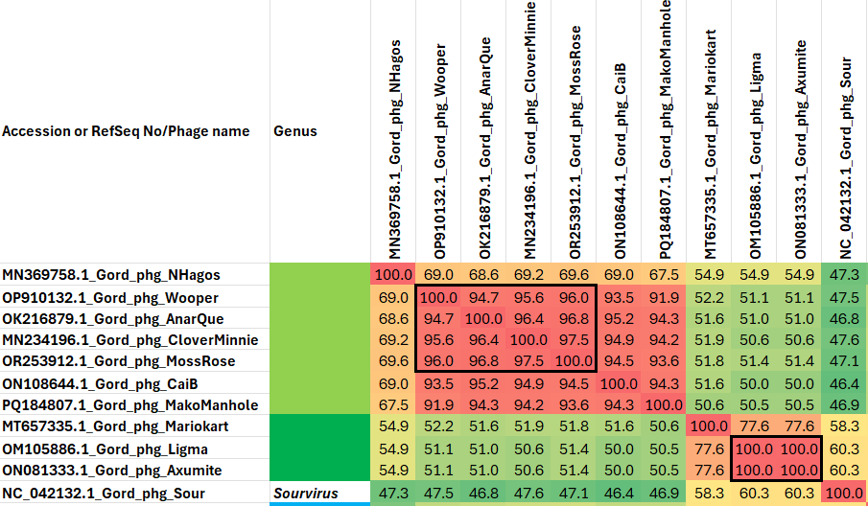

Figure 1. VIRIDIC heat map of the group of phages under discussion. VIRIDIC (Virus Intergenomic Distance Calculator; VIRIDIC (Virus Intergenomic Distance Calculator; [3]; http://rhea.icbm.uni-oldenburg.de/VIRIDIC/) computes pairwise intergenomic distances/similarities amongst phage genomes. Data values which are bordered in black correspond to strains.

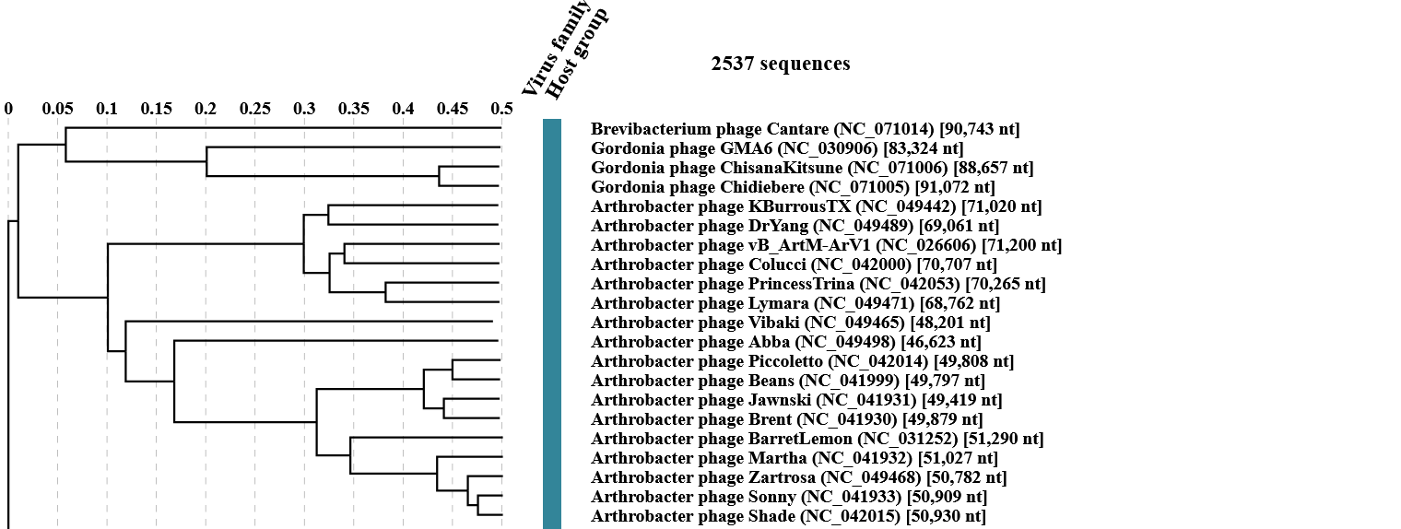
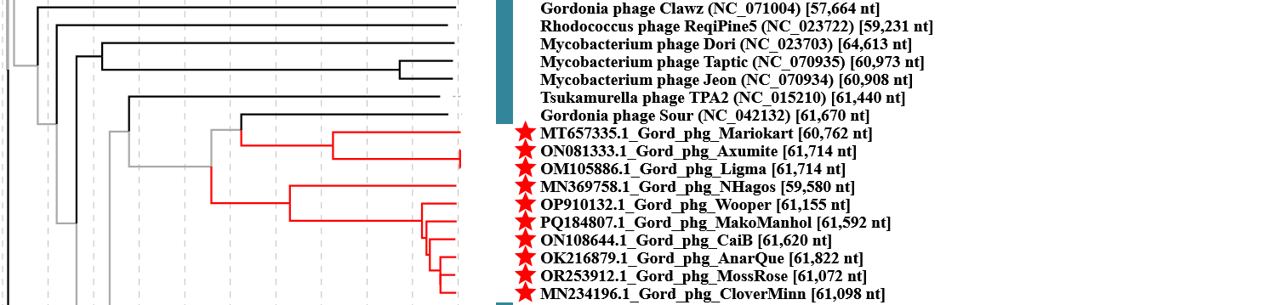
Figure 2. ViPTree analysis (https://www.genome.jp/viptree/; [4]) is based upon Rohwer and Edwards (2002) famous Phage Proteomic Tree [5]. The phages belonging to this subfamily are indicated with red bar.

Table 1. Characteristics of new species in the genus Ligmavirus
Phage name | Host | Morphotype | Lifestyle | Accession No. | Genome size | No. proteins | No. tRNA
Gordonia phage Ligma | Gordonia terrae NRRL B-16283 | Siphovirus | Lytic | OM105886.1 | 61714 bp | 87 | 0
Gordonia phage Mariokart | Gordonia terrae NRRL B-16283 | Siphovirus | Lytic | MT657335.1 | 60762 bp | 83 | 0
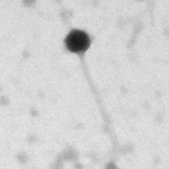

Figure 3. Electron micrograph: Electron micrographs of negatively stained Gordonia phage Ligma (https://phagesdb.org/phages/Ligma/). Limited permission was granted by The Actinobacteriophages Database (https://phagesdb.org/), funded by the Howard Hughes Medical Institute, to use this electron micrograph for this taxonomy proposal; it cannot be reused without permission of The Actinobacteriophages Database.

Table 2. Characteristics of species in the genus Nhagosvirus
Phage name | Host | Morphotype | Lifestyle | Accession No. | Genome size | No. proteins | No. tRNA
Gordonia phage NHagos | Gordonia rubripertincta NRRL B-16540 | Siphovirus | Lytic | MN369758.1 | 59580 bp | 82 | 0

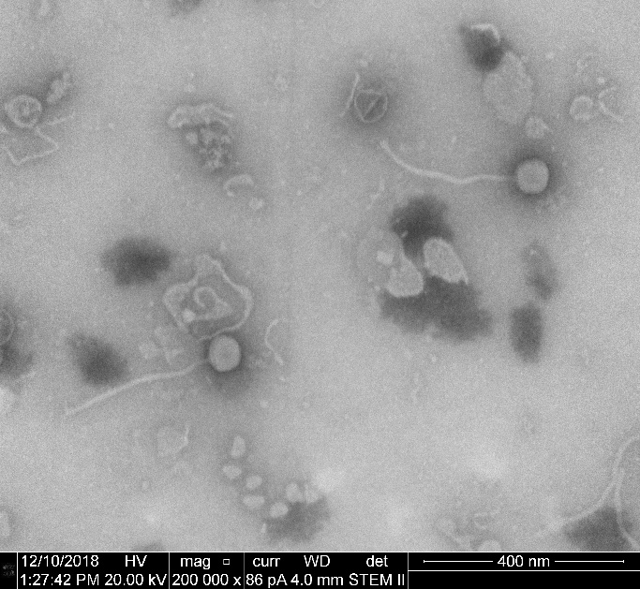
Figure 4. Electron micrograph: Electron micrographs of negatively stained Gordonia phage Nhagos (https://phagesdb.org/phages/Nhagos/). Limited permission was granted by The Actinobacteriophages Database (https://phagesdb.org/), funded by the Howard Hughes Medical Institute, to use this electron micrograph for this taxonomy proposal; it cannot be reused without permission of The Actinobacteriophages Database.

Table 3. Characteristics of species in the genus Mossrosevirus
Phage name | Host | Morphotype | Lifestyle | Accession No. | Genome size | No. proteins | No. tRNA
Gordonia phage MossRose | Gordonia rubripertincta NRRL B-16540 | Siphovirus | Lytic | OR253912.1 | 61072 bp | 84 | 0
Gordonia phage CaiB | Gordonia rubripertincta NRRL B-16540 | Siphovirus | Lytic | ON108644.1 | 61620 bp | 85 | 0
Gordonia phage MakoManhole | Gordonia rubripertincta NRRL B-16540 | Siphovirus | Lytic | PQ184807.1 | 61592 bp | 83 | 0
Genomes are Circularly Permuted

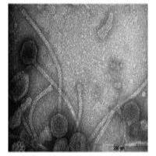
Figure 5. Electron micrograph: Electron micrographs of negatively stained Gordonia phage CaiB (https://phagesdb.org/phages/CaiB/). Limited permission was granted by The Actinobacteriophages Database (https://phagesdb.org/), funded by the Howard Hughes Medical Institute, to use this electron micrograph for this taxonomy proposal; it cannot be reused without permission of The Actinobacteriophages Database.

Table 4. Characteristics of species in the genus Anclarvirus
Phage name | Host | Morphotype | Lifestyle | Accession No. | Genome size | No. proteins | No. tRNA
Gordonia phage AnClar | Gordonia terrae 3612 | Siphovirus | Lytic | MN908693.1 | 61856 bp | 81 | 0
Gordonia phage BiggityBass | Gordonia terrae CAG3 | Siphovirus | Lytic | ON260813.1 | 63202 bp | 84 | 0
Genomes are Circularly Permuted

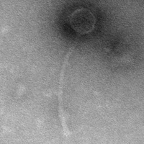
Figure 6. Electron micrograph: Electron micrographs of negatively stained Gordonia phage BiggityBass (https://phagesdb.org/phages/BiggityBass/). Limited permission was granted by The Actinobacteriophages Database (https://phagesdb.org/), funded by the Howard Hughes Medical Institute, to use this electron micrograph for this taxonomy proposal; it cannot be reused without permission of The Actinobacteriophages Database.

Table 5. Characteristics of species in the genus Duluthvirus
Phage name | Host | Morphotype | Lifestyle | Accession No. | Genome size | No. proteins | No. tRNA
Gordonia phage LittleMunchkin | Gordonia terrae CAG3 | Siphovirus | Lytic | OP751153.1 | 63193 bp | 85 | 0
Genomes are Circularly Permuted

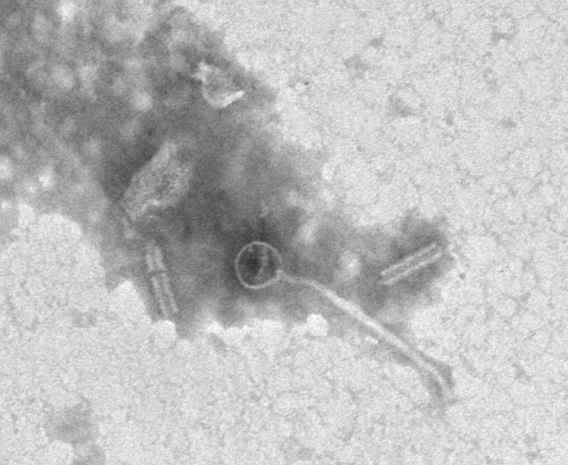
Figure 7. Electron micrograph: Electron micrographs of negatively stained Gordonia phage LittleMunchkin (https://phagesdb.org/phages/LittleMunchkin/). Limited permission was granted by The Actinobacteriophages Database (https://phagesdb.org/), funded by the Howard Hughes Medical Institute, to use this electron micrograph for this taxonomy proposal; it cannot be reused without permission of The Actinobacteriophages Database.

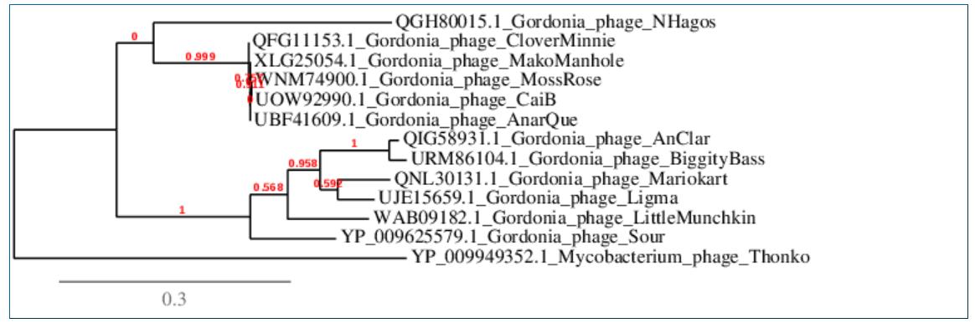
Figure 8. Phylogenetic tree constructed with large subunit terminase proteins from these and related phages using “One Click” phylogeny.fr at http://phylogeny.lirmm.fr/phylo_cgi/simple_phylogeny.cgi [11]. The TerL protein from Mycobacterium phage Thonko (Thonkovirus thonko) serves as the outlier.

CoreGenes 3.5 Analysis [7]: revealed that the phages listed in Table 1, 2 and Gordonia phage Sour share 44 protein homologs, including terminase large subunit, RuvC-like resolvase, portal protein, major capsid proteins (hexamer and pentamer), head-to-tail adaptor, major tail protein, tape measure protein, 3 minor tail proteins, lysin B, exonuclease, DNA primase/polymerase/helicase, DNA polymerase and DNA binding protein. This indicates that approximately 53.0% of the phage-encoded proteins are conserved.

