

The International Committee on Taxonomy of Viruses
Taxonomy Proposal Form, 2025

Part 1a: Details of taxonomy proposals

Title: | Create one new species in the genus Drulisvirus
Code assigned: | 2025.015B.Ac.v3.Drulisvirus_1ns

Author(s), affiliation and email address(es):
Given name (+middle initial(s)) | Surname | Affiliation | Email address | Corr. author(s)
Aubrey Joy P. | Tejada | Industrial Technology Development Institute, Department of Science and Technology (DOST – ITDI), DOST Compound, Taguig, 1631, Philippines | ajptejada@gmail.com | X
Michael Angelou L. | Nada | Industrial Technology Development Institute, Department of Science and Technology (DOST – ITDI), DOST Compound, Taguig, 1631, Philippines | mikeangelounada@gmail.com
Ruth Antoinette D. | Chin | Industrial Technology Development Institute, Department of Science and Technology (DOST – ITDI), DOST Compound, Taguig, 1631, Philippines | chinruthantoinette@gmail.com
Janna Ysabelle O. | Casidsid | Industrial Technology Development Institute, Department of Science and Technology (DOST – ITDI), DOST Compound, Taguig, 1631, Philippines | jycasidsid@gmail.com
Joseph B. | Ancla | Industrial Technology Development Institute, Department of Science and Technology (DOST – ITDI), DOST Compound, Taguig, 1631, Philippines | anclajoseph8492
Marel Jan G. | Joloro | Industrial Technology Development Institute, Department of Science and Technology (DOST – ITDI), DOST Compound, Taguig, 1631, Philippines | mgjoloro.dostvip@gmail.com
Mark Christian C. | Reterta | Industrial Technology Development Institute, Department of Science and Technology (DOST – ITDI), DOST Compound, Taguig, 1631, Philippines | mcreterta@gmail.com
Anton Roi G. | Collado | Industrial Technology Development Institute, Department of Science and Technology (DOST – ITDI), DOST Compound, Taguig, 1631, Philippines | colladoantonr@gmail.com
Sharmen C. | Berlin | Industrial Technology Development Institute, Department of Science and Technology (DOST – ITDI), DOST Compound, Taguig, 1631, Philippines | scberlin@up.edu.ph
Arra B. | Asejo | Industrial Technology Development Institute, Department of Science and Technology (DOST – ITDI), DOST Compound, Taguig, 1631, Philippines | nmry.dostvip@gmail.com
Nikka Marie R. | Yadao | Industrial Technology Development Institute, Department of Science and Technology (DOST – ITDI), DOST Compound, Taguig, 1631, Philippines | abasejo.dost@gmail.com
Virgilio Jr. P. | De Paz | Industrial Technology Development Institute, Department of Science and Technology (DOST – ITDI), DOST Compound, Taguig, 1631, Philippines | virgdepazimperial@gmail.com
Ursela G. | Bigol | Industrial Technology Development Institute, Department of Science and Technology (DOST – ITDI), DOST Compound, Taguig, 1631, Philippines | ugbigol@itdi.dost.gov.ph
Rommel J. | Gestuveo | Industrial Technology Development Institute, Department of Science and Technology (DOST – ITDI), DOST Compound, Taguig, 1631, Philippines | rjgestuveo@gmail.com

Part 1b: Taxonomy Proposal Submission
ICTV Subcommittee:
Animal DNA Viruses and Retroviruses |  | Bacterial viruses | X
Animal minus-strand and dsRNA viruses |  | Fungal and protist viruses
Animal positive-strand RNA viruses |  | Plant viruses
Archaeal viruses |  | General -

List the ICTV Study Group(s) that have seen or have been involved in creating this proposal: https://ictv.global/sc
Caudoviricetes Study Group
Optional – complete only if formally voted on by an ICTV Study Group:
Study Group | Number of members
Study Group | Votes in support | Votes against | No vote

Submission date: | 12/04/2025

Part 1c: Feedback from ICTV Executive Committee (EC) meeting
Executive Committee Meeting Decision code: | X
A – Accept
Ac – Accept subject to revision by relevant subcommittee chair. No further vote required | x
U – Accept without revision but with re-evaluation and email vote by the EC
Uc – Accept subject to revision and re-evaluation and email vote by the EC
Ud – Deferred to the next EC meeting, with an invitation to revise based on EC comments
J - Reject
W - Withdrawn

Comments from the Executive Committee:
Genus in-filling

Part 1d: Revised Taxonomy Proposal Submission
Response of proposer:
Revision date:

Part 3: TAXONOMIC PROPOSAL
https://ictv.global/taxonomy/templates
Taxonomic changes proposed:
Establish new taxon | X | Split taxon
Abolish taxon |  | Merge taxon
Move taxon |  | Promote taxon
Rename taxon |  | Demote taxon
Move and rename

Etymology (origin) of proposed taxonomic names:
Taxon name | Etymology of the term
Drulisvirus workingina | workingina - “ina” is a Filipino term of “mother”, used to honor of working Filipino mothers in science

Permission for use of names derived from a living person:
Taxon name | Full name of person from whom the name is derived | Attached

Abstract of Taxonomy Proposal:
Taxonomic rank(s) affected:
Genus, species

Description of current taxonomy:
The genus Drulisvirus currently includes 19 species and is included in the subfamily Slopekvirinae, family Autoscriptoviridae, order Autographivirales

Proposed taxonomic change(s):
Create one new species, Drulisvirus workingina

Justification:
Escherichia phage vB_VIPECOTPH05B was isolated from Tarlac Provincial Hospital, Tarlac, Philippines. Based on VIRIDIC analysis with other species in the genus Druilisvirus, we propose the creation of a new phage species, Drulisvirus workingina in honor of the working mothers and diverse individuals of the Virology and Vaccine Institute of the Philippines Program.

Text of Taxonomy proposal:

Taxonomic rank(s) affected:
Genus, species

Description of current taxonomy:

The genus Drulisvirus currently includes 19 species.

Proposed taxonomic change(s):

Create one new species, “Drulisvirus workingina”

Demarcation criteria:

Species Demarcation criteria:
Two phages are assigned to the same species if their genomes are more than 95% identical over their genome length using VIRIDIC [2].

Justification:
Escherichia phage vB_VIPECOTPH05B was isolated from Tarlac Provincial Hospital, Tarlac, Philippines. Our taxonomic analyses revealed that Escherichia phage vB_VIPECOTPH05B remains unclassified at the species level. Here, we proposed the creation of a new species, Drulisvirus workingina under the Realms Duplodnaviria, Kingdom Heunggongvirae, Phylum Uroviricota, Class Caudoviricetes, Order Autographivirales, Family Autoscriptoviridae, Subfamily Slopekvirinae, Genus Drulisvirus. The genome is complete with DTR based on checkV [1] analysis and is publicly available in NCBI GenBank database. As a result of genomic characterization using VIRIDIC (Figure 1), we propose the addition of one new species, “Drulisvirus workingina”

References:
- Nayfach, S., Camargo, A. P., Schulz, F., Eloe-Fadrosh, E., Roux, S., & Kyrpides, N. C. (2021). CheckV assesses the quality and completeness of metagenome-assembled viral genomes. Nature biotechnology, 39(5), 578-585.

- Turner, D., Kropinski, A. M., & Adriaenssens, E. M. (2021). A roadmap for genome-based phage taxonomy. Viruses, 13(3), 506.

- Millard, A. D., Denise, R., Lestido, M., Thomas, M., Webster, D., Turner, D., & Sicheritz-Ponten, T. (2024). taxmyPHAGE: Automated taxonomy of dsDNA phage genomes at the genus and species. bioRxiv, 2024-08.

- Nishimura, Y., Yoshida, T., Kuronishi, M., Uehara, H., Ogata, H., & Goto, S. (2017). ViPTree: the viral proteomic tree server. Bioinformatics, 33(15), 2379-2380.

- Moraru, C. (2023). VirClust—A tool for hierarchical clustering, core protein detection and annotation of (prokaryotic) viruses. Viruses, 15(4), 1007.

- Ondov, B. D., Treangen, T. J., Melsted, P., Mallonee, A. B., Bergman, N. H., Koren, S., & Phillippy, A. M. (2016). Mash: fast genome and metagenome distance estimation using MinHash. Genome biology, 17, 1-14.

- Cook, R., Brown, N., Redgwell, T., Rihtman, B., Barnes, M., Clokie, M., ... & Millard, A. (2021). INfrastructure for a PHAge REference database: identification of large-scale biases in the current collection of cultured phage genomes. Phage, 2(4), 214-223.

- Moraru, C., Varsani, A., & Kropinski, A. M. (2020). VIRIDIC—A novel tool to calculate the intergenomic similarities of prokaryote-infecting viruses. Viruses, 12(11), 1268.

- Tamura, K., Stecher, G., & Kumar, S. (2021). MEGA11: molecular evolutionary genetics analysis version 11. Molecular biology and evolution, 38(7), 3022-3027.

- Edgar, R. C. (2004). MUSCLE: multiple sequence alignment with high accuracy and high throughput. Nucleic acids research, 32(5), 1792-1797.

Accompanying files:
Filename | Description of contents
Drulisvirus_1ns.xlsx | An excel file containing the taxonomic classification for new species

Tables, Figures:
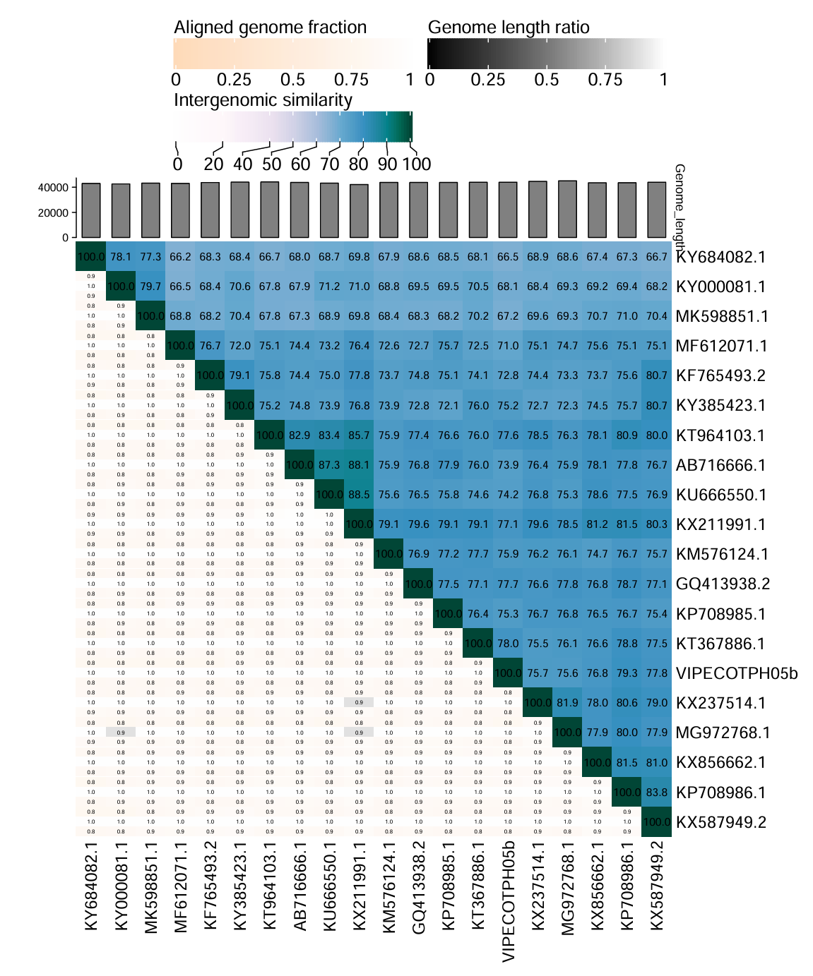
Figure 1. Heatmap of intergenomic similarities among members of the genus Drulisvirus and VIPECOTPH05b.

