

The International Committee on Taxonomy of Viruses
Taxonomy Proposal Form, 2025

Part 1a: Details of taxonomy proposals

Title: | Create one new genus Comeauvirus with two new species (Class: Caudoviricetes).
Code assigned: | 2025.012B.Ac.v3.Comeauvirus_1ng_2ns

Author(s), affiliation and email address(es):
Given name (+middle initial(s)) | Surname | Affiliation | Email address | Corr. author(s)
Andrew M. | Kropinski | Department of Pathobiology, University of Guelph, Guelph, Ontario, Canada | Phage.Canada@gmail.com | x
Cristina | Moraru | Carl von Ossietzky Universität Oldenburg, Germany | liliana.cristina.moraru@uol.de

Part 1b: Taxonomy Proposal Submission
ICTV Subcommittee:
Animal DNA Viruses and Retroviruses |  | Bacterial viruses | x
Animal minus-strand and dsRNA viruses |  | Fungal and protist viruses
Animal positive-strand RNA viruses |  | Plant viruses
Archaeal viruses |  | General -

List the ICTV Study Group(s) that have seen or have been involved in creating this proposal: https://ictv.global/sc
Caudoviricetes Study Group

Optional – complete only if formally voted on by an ICTV Study Group:
Study Group | Number of members
Study Group | Votes in support | Votes against | No vote

Submission date: | 015/06/2025

Part 1c: Feedback from ICTV Executive Committee (EC) meeting
Executive Committee Meeting Decision code: | X
A – Accept
Ac – Accept subject to revision by relevant subcommittee chair. No further vote required | x
U – Accept without revision but with re-evaluation and email vote by the EC
Uc – Accept subject to revision and re-evaluation and email vote by the EC
Ud – Deferred to the next EC meeting, with an invitation to revise based on EC comments
J - Reject
W - Withdrawn

Comments from the Executive Committee:
Please improve the quality of the abstract.

Part 1d: Revised Taxonomy Proposal Submission
Response of proposer:
Revision date:

Part 3: TAXONOMIC PROPOSAL
https://ictv.global/taxonomy/templates
Taxonomic changes proposed:
Establish new taxon | x | Split taxon
Abolish taxon |  | Merge taxon
Move taxon |  | Promote taxon
Rename taxon |  | Demote taxon
Move and rename

Etymology (origin) of proposed taxonomic names:
Taxon name | Etymology of the term
Comeauvirus | Named in honour of André M Comeau who sequenced this virus

Permission for use of names derived from a living person:
Taxon name | Full name of person from whom the name is derived | Attached
Comeauvirus | André M Comeau | x

Abstract of Taxonomy Proposal:
Taxonomic rank(s) affected:
Genus, species

Description of current taxonomy:
The bacterial viruses described in this proposal are currently unclassified

Proposed taxonomic change(s):
Create a new genus “Comeauvirus” and two new species

Justification:
The majority of the Vibrio cholerae phages that we have classified are siphoviruses, while the ones belonging to the proposed genus, “Comeauvirus” are small lytic myoviruses. VIRIDIC and ViPTree analyses reveal that this forms a genus in a cluster of phages including Yokohamavirus PEi21, Yokohamavirus MSW3 and Iodovirus PLPE

- Text of Taxonomy proposal:

Taxonomic rank(s) affected:
Realm Duplodnaviria, kingdom Heunggongvirae, phylum Uroviricota, class Caudoviricetes

Description of current taxonomy:
The bacterial viruses described in this proposal are currently unclassified

Proposed taxonomic change(s):
Create a new genus “Comeauvirus” and two new species

Demarcation criteria:
The Bacterial and Archaeal Virus Subcommittee established 70% average nucleotide identity (ANI) threshold for genus classification or 95% ANI for species [8]

Justification:
The majority of the Vibrio cholerae phages that we have classified are siphoviruses, while the ones belonging to the proposed genus, “Comeauvirus” are small lytic myoviruses. VIRIDIC and ViPTree analyses reveal that this forms a genus in a cluster of phages including Yokohamavirus PEi21, Yokohamavirus MSW3 and Iodovirus PLPE

References:
1. Sayers EW, Beck J, Bolton EE, Bourexis D, Brister JR, Canese K, Comeau DC, Funk K, Kim S, Klimke W, Marchler-Bauer A, Landrum M, Lathrop S, Lu Z, Madden TL, O'Leary N, Phan L, Rangwala SH, Schneider VA, Skripchenko Y, Wang J, Ye J, Trawick BW, Pruitt KD, Sherry ST. Database resources of the National Center for Biotechnology Information. Nucleic Acids Res. 2021 Jan 8;49(D1):D10-D17. doi: 10.1093/nar/gkaa892. PMID: 33095870
2. O'Leary NA, Wright MW, Brister JR, Ciufo S, Haddad D, McVeigh R, et al. Reference sequence (RefSeq) database at NCBI: current status, taxonomic expansion, and functional annotation. Nucleic Acids Res. 2016;44(D1):D733-45. doi: 10.1093/nar/gkv1189. PMID: 26553804.
3. Moraru C, Varsani A, Kropinski AM. VIRIDIC-A Novel Tool to Calculate the Intergenomic Similarities of Prokaryote-Infecting Viruses. Viruses. 2020 Nov 6;12(11):1268. doi: 10.3390/v12111268. PMID: 33172115; PMCID: PMC7694805. http://kronos.icbm.uni-oldenburg.de/viridic/
4. Nishimura Y, Yoshida T, Kuronishi M, Uehara H, Ogata H, Goto S. ViPTree: the viral proteomic tree server. Bioinformatics. 2017; 33(15):2379-2380. doi:10.1093/bioinformatics/btx157. PubMed PMID: 28379287. https://www.genome.jp/viptree/
5. Rohwer F, Edwards R. The Phage Proteomic Tree: a genome-based taxonomy for phage. J Bacteriol. 2002 Aug;184(16):4529-35. PubMed PMID: 12142423
6. Turner D, Reynolds D, Seto D, Mahadevan P. CoreGenes3.5: a webserver for the determination of core genes from sets of viral and small bacterial genomes. BMC Res Notes. 2013;6:140. doi: 10.1186/1756-0500-6-140. PMID: 23566564.
7. Davis P, Seto D, Mahadevan P. CoreGenes5.0: An Updated User-Friendly Webserver for the Determination of Core Genes from Sets of Viral and Bacterial Genomes. Viruses. 2022 Nov 16;14(11):2534. doi: 10.3390/v14112534. PMID: 36423143; PMCID: PMC9693508.
8. Turner D, Kropinski AM, Adriaenssens EM. A Roadmap for Genome-Based Phage Taxonomy. Viruses. 2021 Mar 18;13(3):506. doi: 10.3390/v13030506. PMID: 33803862; PMCID: PMC8003253.
Lemoine F, Correia D, Lefort V, Doppelt-Azeroual O, Mareuil F, Cohen-Boulakia S, Gascuel O. NGPhylogeny.fr: new generation phylogenetic services for non-specialists. Nucleic Acids Res. 2019 Jul 2;47(W1):W260-W265. doi: 10.1093/nar/gkz303. PMID: 31028399; PMCID: PMC6602494.
9. Letunic I, Bork P. Interactive Tree Of Life (iTOL): an online tool for phylogenetic tree display and annotation. Bioinformatics. 2007 Jan 1;23(1):127-8. doi: 10.1093/bioinformatics/btl529. Epub 2006 Oct 18. PMID: 17050570.
10. Zhou T, Xu K, Zhao F, Liu W, Li L, Hua Z, Zhou X. itol.toolkit accelerates working with iTOL (Interactive Tree of Life) by an automated generation of annotation files. Bioinformatics. 2023 Jun 1;39(6):btad339. doi: 10.1093/bioinformatics/btad339. PMID: 37225402; PMCID: PMC10243930.

Accompanying files:
Filename | Description of contents
Comeauvirus_LoA.pdf | Letter of acceptance of Andre Comeau
2025.012B.Comeauvirus_1ng_2ns | Data for this proposal

Tables, Figures:
<Start here>
Origin of the name of this taxon: This genus is named in honour of André M. Comeau (b. 1975, Moncton NB, Canada). He received his PhD from the University of British Columbia (Vancouver, BC, Canada) where he studied the ecology of vibriophages, one of which (VpV262) became the third marine phage ever to be sequenced. He completed a first post-doctorate in France (CNRS, Toulouse), partially funded by a Les Treilles Foundation scientific prize, studying T4 phage genomics, PeSLs and phage-antibiotic synergy (PAS) with Henry M. Krisch. While there, he also collaborated with phage researchers from the G. Eliava Institute and sequenced the first phage of Iodobacteria. A second post-doctorate at Université Laval (Québec QC) led to further diverse phage characterization and sequencing with Hans-W. Ackermann and Sylvain Moineau. He currently holds a senior scientist position as the manager of Dalhousie University's Integrated Microbiome Resource (Halifax, NS, Canada).

Table 1. Characteristics of the phages described in the proposal
Prophage name | Host | Morphotype | Lifestyle | Accession No. | Genome size | No. proteins | No. tRNA
Vibrio phage vB_VchM-138 | Vibrio cholerae | Myovirus | lytic | JQ177064.1 | 44485 bp | 67 | 0
Vibrio phage CP-T1 | Vibrio cholerae ElTor | Myovirus | lytic | JQ177061.1 | 44492 bp | 70 | 0
[Vibrio phage CP-T1]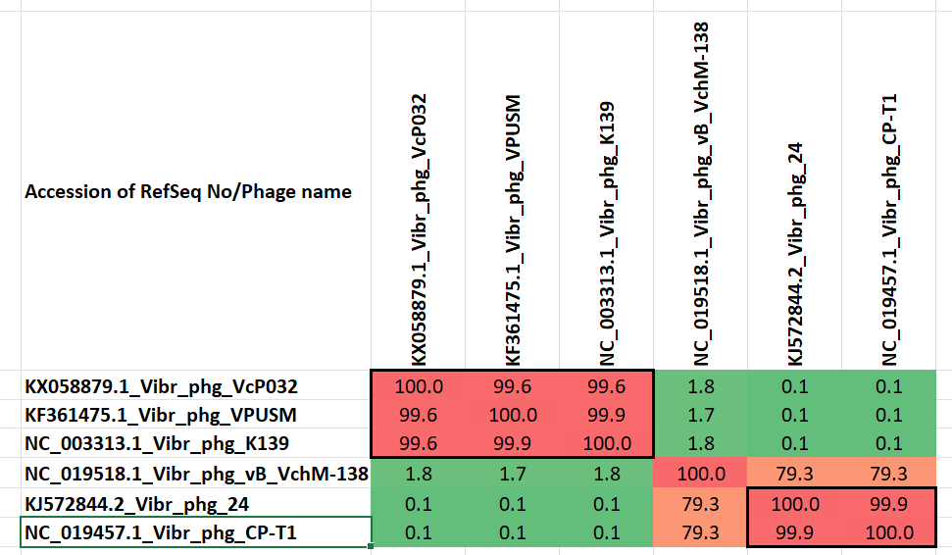Figure 1. VIRIDIC heat map of a group of phages with the ones under discussion indicated with a red bar. VIRIDIC (Virus Intergenomic Distance Calculator; VIRIDIC (Virus Intergenomic Distance Calculator; [3]; http://rhea.icbm.uni-oldenburg.de/VIRIDIC/) computes pairwise intergenomic distances/similarities amongst phage genomes. Data values which are bordered in black correspond to strains. Abbreviations: phg = phage; Vibr = Vibrio

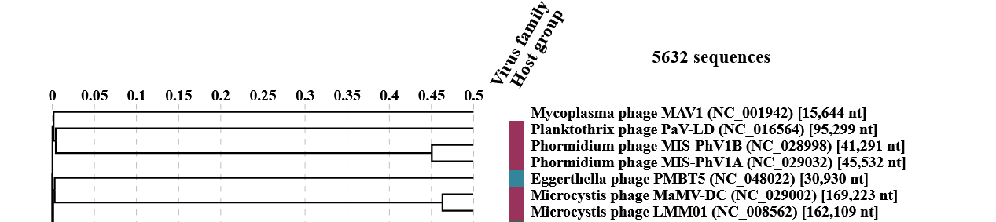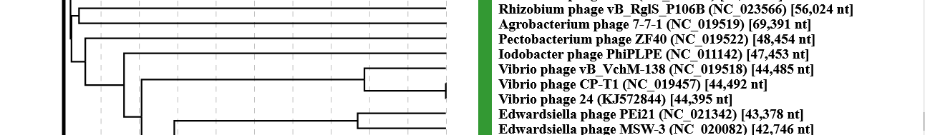

Figure 2. ViPTree analysis: ViPTree analysis (https://www.genome.jp/viptree/; [4]) is based upon Rohwer and Edwards (2002) Phage Proteomic Tree [5]. The taxon under discussion is indicated with a red bar. Abbreviations: phg = phage; Vibr = Vibrio

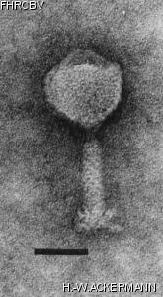

Figure 3. Electron micrographs of negatively stained Vibriophage 138. (derived from The Félix d'Hérelle Reference Center for Bacterial Viruses, H.-W. Ackermann)


Figure 4. André M. Comeau (photo provided by the honouree).

