

The International Committee on Taxonomy of Viruses
Taxonomy Proposal Form, 2025

Part 1a: Details of taxonomy proposals

Title: | Create a new subfamily, Alvaradovirinae, with three genera in the Class Caudoviricetes
Code assigned: | 2025.002B.Ac.v3.Alvaradovirinae_1nsf_3ng_10ns

Author(s), affiliation and email address(es):
Given name (+middle initial(s)) | Surname | Affiliation | Email address | Corr. author(s)
Andrew M. | Kropinski | Department of Pathobiology, The Ontario Veterinary College, University of Guelph, Guelph, Ontario, Canada | Phage.Canada@gmail.com
Cristina | Moraru | Carl von Ossietzky Universität Oldenburg, Germany | liliana.cristina.moraru@uol.de
Anca M. | Segall | Department of Chemistry and Biochemistry, SDSU, San Diego, CA, USA | asegall@sdsu.edu
Johannes | Wittmann | Leibniz Institute DSMZ, | Johannes.wittmann@dsmz.de | X

Part 1b: Taxonomy Proposal Submission
ICTV Subcommittee:
Animal DNA Viruses and Retroviruses |  | Bacterial viruses | x
xAnimal minus-strand and dsRNA viruses |  | Fungal and protist viruses
Animal positive-strand RNA viruses |  | Plant viruses
Archaeal viruses |  | General -

List the ICTV Study Group(s) that have seen or have been involved in creating this proposal: https://ictv.global/sc
Caudoviricetes Study Group
Optional – complete only if formally voted on by an ICTV Study Group:
Study Group | Number of members
Study Group | Votes in support | Votes against | No vote

Submission date: | 15/06/2025

Part 1c: Feedback from ICTV Executive Committee (EC) meeting
Executive Committee Meeting Decision code: | X
A – Accept
Ac – Accept subject to revision by relevant subcommittee chair. No further vote required | x
U – Accept without revision but with re-evaluation and email vote by the EC
Uc – Accept subject to revision and re-evaluation and email vote by the EC
Ud – Deferred to the next EC meeting, with an invitation to revise based on EC comments
J - Reject
W - Withdrawn

Comments from the Executive Committee:
Please improve the quality of the abstract, there is a lack of phylogenetic tree (not necessary but would improve the proposal). The demarcation criteria for subfamily are not present in the proposal and should be added.

Part 1d: Revised Taxonomy Proposal Submission
Response of proposer:
Corrections completed

Revision date: | August 28, 2025

Part 3: TAXONOMIC PROPOSAL
https://ictv.global/taxonomy/templates
Taxonomic changes proposed:
Establish new taxon | x | Split taxon
Abolish taxon |  | Merge taxon
Move taxon |  | Promote taxon
Rename taxon |  | Demote taxon
Move and rename

Etymology (origin) of proposed taxonomic names:
Taxon name | Etymology of the term
Alvaradovirinae | Named after Juan Bautista Valentín Alvarado y Vallejo (1809 – 1882) who was governor of California from 1837–1842
Amaduovirus | Named after Achromobacter phage AMA2
Nyaakvirus | Named after Achromobacter phage nyaak_TL1

Permission for use of names derived from a living person:
Taxon name | Full name of person from whom the name is derived | Attached

Abstract of Taxonomy Proposal:
Taxonomic rank(s) affected:
Subfamily, genus and species

Description of current taxonomy:
Achromobacter phage JWX belongs to the genus Steinhofvirus which was created via Taxonomy Proposals 2018.007B.A.v4.rename137gen6sp and 2016.020a-dB.A.v1.Jwxvirus. This genus currently contains two species: Steinhofvirus JWX and Steinhofvirus sv8324

Proposed taxonomic change(s):
To create a new subfamily “Alvaradovirinae” with three genera “Steinhofvirus”, “Amaduovirus” and “Nyaakvirus”; and move Steinhofvirus sv8324 to the genus “Amaduovirus”

Justification: In keeping with the criteria established [3] and supported by VIRIDIC, ViPTree, CoreGenes and phylogenetic analyses we have sufficient evidence to support the creation of this new subfamily, genera and associated species

- Text of Taxonomy proposal:

Taxonomic rank(s) affected:
Subfamily, genus and species

Description of current taxonomy:
Achromobacter phage JWX belongs to the genus Steinhofvirus which was created via Taxonomy Proposals 2018.007B.A.v4.rename137gen6sp and 2016.020a-dB.A.v1.Jwxvirus. This genus currently contains two species: Steinhofvirus JWX and Steinhofvirus sv8324

Proposed taxonomic change(s):
To create a new subfamily “Alvaradovirinae” with three genera “Steinhofvirus”, “Amaduovirus” and “Nyaakvirus”; and move Steinhofvirus sv8324 to the genus “Amaduovirus”

Demarcation criteria:
Genus demarcation criteria: An intergenomic similarity cut-off of 70%, a combination of average nucleotide identity and alignment fraction is used to determine genera demarcation. Members of the same genus have >70% intergenomic similarity and cluster tightly in marker gene phylogenies.
Species demarcation criteria: A demarcation value of 95% intergenomic similarity was used to define different species according to intergenomic similarity. Members of the same species have >95% intergenomic similarity.
Subfamily demarcation criteria:
Subfamilies are to be created when two or more genera are related below the family level. In practical terms, this usually means that they share a low degree of sequence similarity (usually about 40-50%) and that the genera form a clade in a marker tree phylogeny [3].

Justification: In keeping with the criteria established [3] and supported by VIRIDIC, ViPTree, CoreGenes and phylogenetic analyses we have sufficient evidence to support the creation of this new subfamily, genera and associated species

References:
1. Sayers EW, Beck J, Bolton EE, Bourexis D, Brister JR, Canese K, Comeau DC, Funk K, Kim S, Klimke W, Marchler-Bauer A, Landrum M, Lathrop S, Lu Z, Madden TL, O'Leary N, Phan L, Rangwala SH, Schneider VA, Skripchenko Y, Wang J, Ye J, Trawick BW, Pruitt KD, Sherry ST. Database resources of the National Center for Biotechnology Information. Nucleic Acids Res. 2021 Jan 8;49(D1):D10-D17. doi: 10.1093/nar/gkaa892. PMID: 33095870
2. Moraru C, Varsani A, Kropinski AM. VIRIDIC-A Novel Tool to Calculate the Intergenomic Similarities of Prokaryote-Infecting Viruses. Viruses. 2020 Nov 6;12(11):1268. doi: 10.3390/v12111268. PMID: 33172115; PMCID: PMC7694805. http://kronos.icbm.uni-oldenburg.de/viridic/
3. Turner D, Kropinski AM, Adriaenssens EM. A Roadmap for Genome-Based Phage Taxonomy. Viruses. 2021 Mar 18;13(3):506. doi: 10.3390/v13030506. PMID: 33803862; PMCID: PMC8003253.
4. Nishimura Y, Yoshida T, Kuronishi M, Uehara H, Ogata H, Goto S. ViPTree: the viral proteomic tree server. Bioinformatics. 2017; 33(15):2379-2380. doi:10.1093/bioinformatics/btx157. PubMed PMID: 28379287. https://www.genome.jp/viptree/
5. Rohwer F, Edwards R. The Phage Proteomic Tree: a genome-based taxonomy for phage. J Bacteriol. 2002 Aug;184(16):4529-35. PubMed PMID: 12142423
6. Lemoine F, Correia D, Lefort V, Doppelt-Azeroual O, Mareuil F, Cohen-Boulakia S, Gascuel O. NGPhylogeny.fr: new generation phylogenetic services for non-specialists. Nucleic Acids Res. 2019 Jul 2;47(W1):W260-W265. doi: 10.1093/nar/gkz303. PMID: 31028399; PMCID: PMC6602494.
7. Letunic I, Bork P. Interactive Tree Of Life (iTOL) v5: an online tool for phylogenetic tree display and annotation. Nucleic Acids Res. 2021 Jul 2;49(W1):W293-W296. doi: 10.1093/nar/gkab301. PMID: 33885785; PMCID: PMC8265157.
8. Dereeper A, Guignon V, Blanc G, Audic S, Buffet S, Chevenet F, Dufayard JF, Guindon S, Lefort V, Lescot M, Claverie JM, Gascuel O. Phylogeny.fr: robust phylogenetic analysis for the non-specialist. Nucleic Acids Res. 2008 Jul 1;36(Web Server issue):W465-9. doi: 10.1093/nar/gkn180. Epub 2008 Apr 19. PMID: 18424797; PMCID: PMC2447785.

Accompanying files:
Filename | Description of contents
Alvaradovirinae VIRIDIC_heatmap.xlsx | VIRIDIC intergenomic similarity data

Tables, Figures:

Table 1A. To add one new species to the genus Steinhofvirus
Phage name | Host | Morphotype | Lifestyle | Accession No. | Genome size | No. proteins | No. tRNA
Achromobacter phage SE2 | Achromobacter sp. | Siphovirus | Lytic | OQ817844.1 | 45648 bp | 71 | 1

Table 1B. To create a new genus (Amaduovirus) with two species
Phage name | Host | Morphotype | Lifestyle | Accession No. | Genome size | No. proteins | No. tRNA
Achromobacter phage AMA2 | Achromobacter marplatensis | Siphovirus | Lytic | MT241607.1 | 45901 bp | 68 | 1(*)
Achromobacter phage 83-24 (**) | Achromobacter xylosoxidans | Siphovirus | Lytic | KP202970.1 | 48216 bp | 61 | 1
(*) discovered using tRNAscan-SE (https://lowelab.ucsc.edu/tRNAscan-SE/)
(**) transferred from Steinhofvirus due to the level of DNA sequence similarity

Table 1C. Characteristics of the phages belonging to the genus Nyaakvirus
Phage name | Host | Morphotype | Lifestyle | Accession No. | Genome size | No. proteins | No. tRNA
Achromobacter phage tuull (partial) | Achromobacter ruhlandii | Siphovirus | Lytic | OR396896.1 | 47460 bp | 87 | 1
Achromobacter phage vB_AxyS_19-32_Axy06 (*) | Achromobacter xylosoxidans I2BC | Siphovirus | Lytic | MK962627.1 | 45830 bp | 55 | 1
Achromobacter phage ehaak_LB5 | Achromobacter sp. | Siphovirus | Lytic | OQ817833.1 | 46435 bp | 64 | 1
Achromobacter phage emuu_LB7 | Achromobacter sp. | Siphovirus | Lytic | OQ817834.1 | 46012 bp | 63 | 1
Achromobacter phage AMA1 | Achromobacter marplatensis | Siphovirus | Lytic | MT241605.2 | 46328 bp | 62 | 1(**)
Achromobacter phage maay_LB1 | Achromobacter sp. | Siphovirus | Lytic | OQ817838.1 | 46086 bp | 63 | 1
Achromobacter phage vB_AxyS_19-32_Axy14 | Achromobacter xylosoxidans I2BC | Siphovirus | Lytic | MK962633.1 | 46703 bp | 60 | 1
Achromobacter phage nyaak_TL1 | Achromobacter sp. | Siphovirus | Lytic | OQ817839.1 | 46478 bp | 67 | 1
(*) genome has 2978 bp direct terminal repeats
(**) discovered using tRNAscan-SE (https://lowelab.ucsc.edu/tRNAscan-SE/)

At the time of original submission, phage vB_Ade_ART (MH746817.1; host: Achromobacter denitrificans PR1) should be considered a member of this subfamily but its genome is 95343 bp i.e. twice as large as most of the phages in this proposal. Examination of the sequence reveals two copies of the major capsid and terminase large subunit proteins leading to the conclusion that it is chimeric. This has now been corrected (MH746817.2).
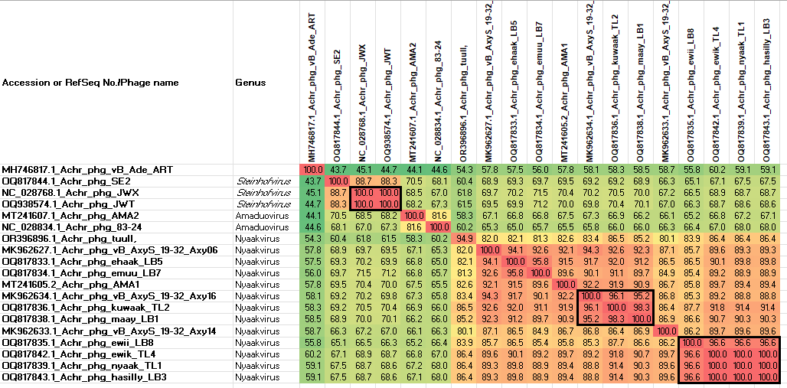

Figure 1. VIRIDIC heat map (Virus Intergenomic Distance Calculator; VIRIDIC (Virus Intergenomic Distance Calculator; [3]; http://rhea.icbm.uni-oldenburg.de/VIRIDIC/) heatmap for this group of phages. It computes pairwise intergenomic distances/similarities amongst phage genomes. Data values which are bordered in black correspond to strains. Abbreviations: Achr = Achromobacter; phg = phage. Because of the size of this diagram we have included the original Excel spreadsheet to render the numbers more visible (Alvaradoviridae_VIRIDIC heatmap).
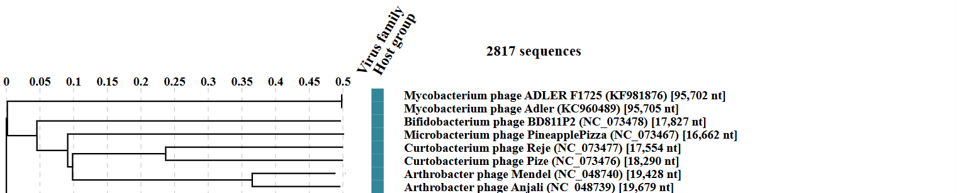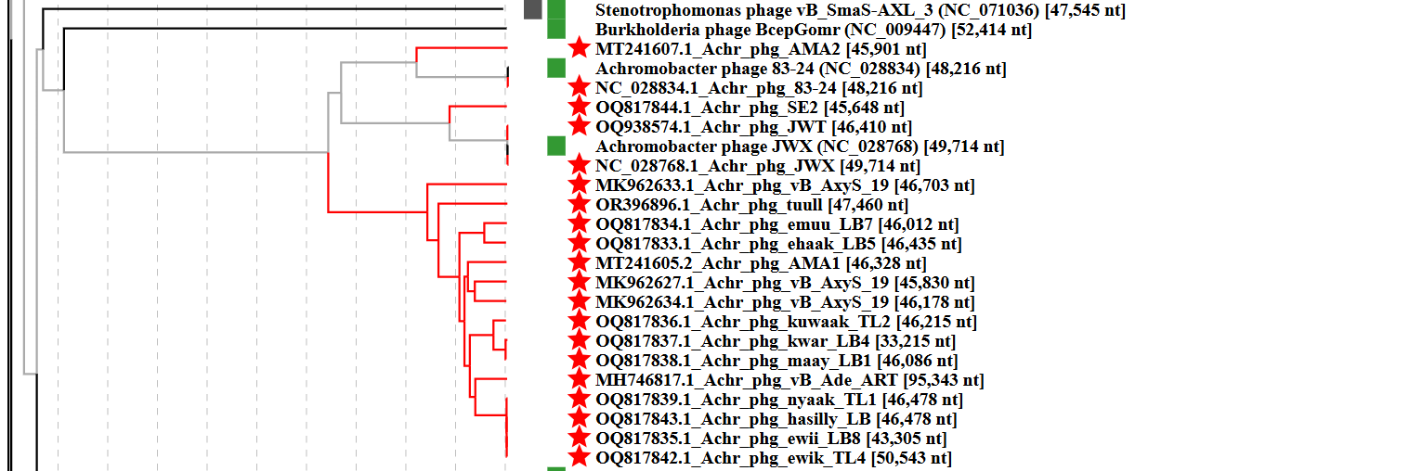Figure 2: ViPTree analysis (https://www.genome.jp/viptree/; [4]) is based upon Rohwer and Edwards (2002) famous Phage Proteomic Tree [5]. The phages of interest are indicated with red stars. Abbreviations: Achr = Achromobacter; phg = phage.

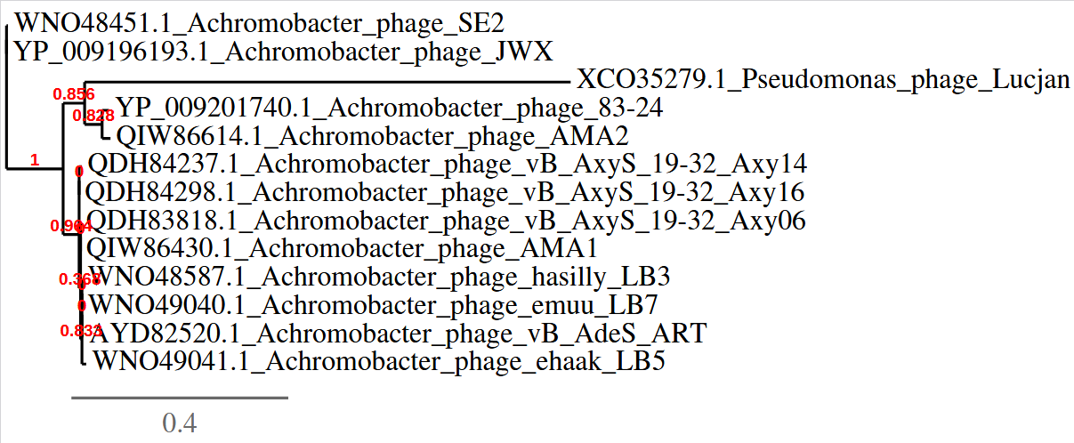
Figure 3: Phylogenetic analysis of the large subunit terminases from these and Pseudomonas phage Lucjab (outlier) created using “One Click” phylogeny.fr at http://phylogeny.lirmm.fr/ [8] confirms the three genera that we have proposed.

CoreGenes 5 Analysis [7]: revealed that the phages listed in Table 1A-C share 41 protein homologs, including tape measure domain protein, terminase large subunit, transcriptional regulator, dCMP deaminase, and thymidylate synthase. This indicates that approximately 62.4% of the phage-encoded proteins are conserved.

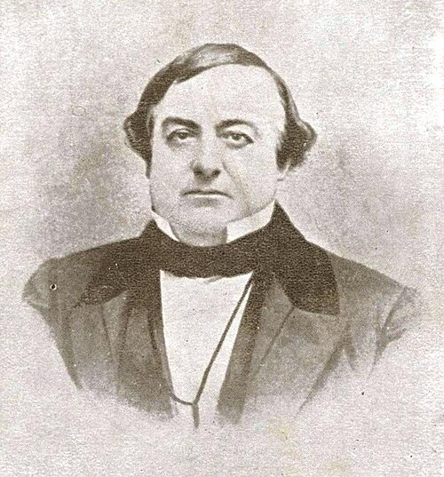

Juan Bautista Valentín Alvarado y Vallejo (1809 – 1882) governor of California from 1837–1842 (from: (https://en.wikipedia.org/wiki/Juan_Bautista_Alvarado)

