

The International Committee on Taxonomy of Viruses
Taxonomy Proposal Form, 2025

Part 1a: Details of taxonomy proposals

Title: | Two new families of tailless icosahedral archaeal viruses
Code assigned: | 2025.003A.Ac.v3.Tailless_icosahedral_2nf

Author(s), affiliation and email address(es):
Given name (+middle initial(s)) | Surname | Affiliation | Email address | Corr. author(s)
Yifan | Zhou | Institut Pasteur, Université Paris Cité, CNRS UMR6047, Cell Biology and Virology of Archaea Unit, Paris, France | yifan.zhou@pasteur.fr
Ana | Gutiérrez-Preciado | Ecologie Systématique Evolution, CNRS, Université Paris-Saclay, AgroParisTech, Gif-sur-Yvette, France | ana.gutierrez@universite-paris-saclay.fr
David | Moreira | Ecologie Systématique Evolution, CNRS, Université Paris-Saclay, AgroParisTech, Gif-sur-Yvette, France | david.moreira@universite-paris-saclay.fr
Michail M. | Yakimov | Extreme Microbiology, Biotechnology and Astrobiology Group, Institute of Polar Sciences, ISP-CNR, Messina, Italy | mikhail.iakimov@cnr.it
Purificación | López-García | Ecologie Systématique Evolution, CNRS, Université Paris-Saclay, AgroParisTech, Gif-sur-Yvette, France | puri.lopez@universite-paris-saclay.fr
Mart | Krupovic | Institut Pasteur, Université Paris Cité, CNRS UMR6047, Cell Biology and Virology of Archaea Unit, Paris, France | mart.krupovic@pasteur.fr | X

Part 1b: Taxonomy Proposal Submission
ICTV Subcommittee:
Animal DNA Viruses and Retroviruses |  | Bacterial viruses
Animal minus-strand and dsRNA viruses |  | Fungal and protist viruses
Animal positive-strand RNA viruses |  | Plant viruses
Archaeal viruses | X | General -

List the ICTV Study Group(s) that have seen or have been involved in creating this proposal:
Optional – complete only if formally voted on by an ICTV Study Group:
Study Group | Number of members
Study Group | Votes in support | Votes against | No vote

Submission date: | 20.06.2025

Part 1c: Feedback from ICTV Executive Committee (EC) meeting
Executive Committee Meeting Decision code: | X
A – Accept
Ac – Accept subject to revision by relevant subcommittee chair. No further vote required | X
U – Accept without revision but with re-evaluation and email vote by the EC
Uc – Accept subject to revision and re-evaluation and email vote by the EC
Ud – Deferred to the next EC meeting, with an invitation to revise based on EC comments
J - Reject
W - Withdrawn

Comments from the Executive Committee:
Update “taxonomic rank affected” and correct typos.

Part 1d: Revised Taxonomy Proposal Submission
Response of proposer:
All corrected.

Revision date: | 24.08.2025

Part 3: TAXONOMIC PROPOSAL
Taxonomic changes proposed:
Establish new taxon | X | Split taxon
Abolish taxon |  | Merge taxon
Move taxon |  | Promote taxon
Rename taxon |  | Demote taxon
Move and rename

Etymology (origin) of proposed taxonomic names:
Taxon name | Etymology of the term
Salinicovirales | from saline (referring to the source environment) and icosahedral
Ducavirales | from du (Lithuanian for two) and capsid, referring to two major capsid proteins
Halicoviridae | from haloarchaeal icosahedral virus
Nanicoviridae | from nanohaloarchaeal icosahedral virus
Ertavirus | after volcano Erta Ale which rises southeast of Lake Assale (Karum), source of isolation/sequencing
Alevirus | after volcano Erta Ale which rises southeast of Lake Assale (Karum), source of isolation/sequencing
danakilense | Latinized species epithet is derived from Danakil depression, source of isolation/sequencing

Permission for use of names derived from a living person:
Taxon name | Full name of person from whom the name is derived | Attached

Abstract of Taxonomy Proposal:
Taxonomic rank(s) affected:
Orders, families, genera, species

Description of current taxonomy:
Class Laserviricetes currently includes one order, Halopanivirales, with 3 families of viruses infecting halophilic archaea of the class Halobacteria (Simuloviridae and Sphaerolipoviridae) and thermophilic bacteria of the genus Thermus (Matsushitaviridae).

Proposed taxonomic change(s):
Create two new monotypic orders, “Salinicovirales” and “Ducavirales”, for classification of viruses associated with haloarchaea (new family “Halicoviridae”) and nanohaloarchaea (new family “Nanicoviridae”), respectively.

Justification:
The two recently discovered viruses encode divergent single jelly-roll major capsid proteins, justifying their inclusion in the Singelaviria realm. However, their relationship to each other as well as to currently known members of the order Halopanivirales is very distant, detectable only through sensitive profile-profile comparisons and structure-based searches. Consistently, VipTree analysis showed that both viruses form distinct branches in the proteome-wide phylogenomic tree.

Text of Taxonomy proposal:
Taxonomic rank(s) affected:
Orders, families, genera, species

Description of current taxonomy:
Class Laserviricetes currently includes one order, Halopanivirales, with 3 families of viruses infecting halophilic archaea of the class Halobacteria (Simuloviridae and Sphaerolipoviridae) and thermophilic bacteria of the genus Thermus (Matsushitaviridae).

Proposed taxonomic change(s):
Create two new monotypic orders, “Salinicovirales” and “Ducavirales”, for classification of viruses associated with haloarchaea (new family “Halicoviridae”) and nanohaloarchaea (new family “Nanicoviridae”), respectively.

Demarcation criteria:
We propose using 95% sequence identity as a species demarcation threshold, to be consistent with the classification of other bacterial and archaeal viruses. For family and order demarcations, we used proteome-wide phylogenomic analysis with VipTree, which was further supported by comparative genomics and analysis of the protein structures.

Justification:
Geothermally influenced salt lakes in the Danakil Depression, Ethiopia, some of the most extreme ecosystems known, are dominated by microbial communities consisting of haloarchaea and nanohaloarchaea (Belilla et al., 2021; Gutiérrez-Preciado et al., 2024). Analysis of metagenomes from Lake Assale or Karum (samples Ass and 9Ass collected during different years), cave reservoir at the Dallol proto-volcano salt canyons (9Gt) and two of the Western-Canyon Lakes (WCL2 and WCL3) (Gutiérrez-Preciado et al., 2024) using geNomad (Camargo et al., 2024) and VirSorter2 (Guo et al., 2021) yielded 2,085 viral contigs (≥5 kb). Among these, two complete virus genomes (circular contigs, i.e., with direct terminal redundancies) could be assigned to haloarchaeal and nanohaloarchaeal hosts, respectively, based on specific CRISPR spacer-protospacer matches (Zhou et al., 2025). Based on the presence of signature genes involved in virion morphogenesis, these viruses could be assigned to Singelaviria, a realm including dsDNA viruses with tailless icosahedral capsids formed from single jelly-roll fold major capsid proteins. Here, we propose classifying the two viruses into two new orders and two new families (Table 1).

Family “Halicoviridae”
Danakil haloarchaeal icosahedral virus 1 (DHIV1) genome was assembled as a circular molecule of 13.6 kb (Fig. 1a). BlastP analysis did not reveal significant hits to signature proteins encoded by previously characterized viruses. However, sensitive profile-profile comparison with HHsearch showed that DHIV1 encodes a homolog of one of the two single jelly-roll (SJR) major capsid proteins (MCP) typical of members of the order Halopanivirales. Structural modeling of the putative major capsid protein followed by structure-based searches using DALI and FoldSeek confirmed the relationship between the MCP of DHIV1 and halopanivirals. Notably, proviruses distantly related to halopanivirals and encoding only one of the two MCPs have been observed previously in other archaea, such as Archaeoglobus veneficus (Makarova et al., 2014). It has been hypothesized that halopanivirals have evolved from an ancestor with a single SJR MCP (Makarova et al., 2014; Krupovic et al., 2019). Thus, DHIV1 might represent a virus group more closely resembling the ancestor of halopanivirals. Consistently, in the tree based on whole-proteome comparison, DHIV1 branched outside of a group comprising Halopanivirales (Fig. 2). Furthermore, the genome of DHIV1 (13.6 kb) is considerably shorter than those of halopanivirals (16-31 kb). Based on high divergence of the DHIV1 proteins, including the MCP, and the fact that this virus encodes only one of the two MCPs, we propose classifying DHIV1 outside of Halopanivirales, into a new order, “Salinicovirales”, and new family “Halicoviridae”.

Family “Nanicoviridae”
Danakil nanohaloarchaeal icosahedral virus 1 (DNIV1) genome was assembled as a circular molecule of 18 kb (Fig. 1b). Three related complete virus genomes were identified in the IMG/VR database (Fig. 3). Two of these viruses, namely, DNIV1 and SNIV1, similar to members of Halopanivirales, encode two SJR MCPs, which are identifiable similar to the homologs encoded by simuloviruses. Notably, however, the two other viruses, CNIV1 and CNIV2, encode distinct variants of the two MCPs, suggesting horizontal gene transfer between simuloviruses and DNIV1 ancestor. This hypothesis was confirmed by phylogenetic analysis of the two MCPs (Fig. 4a). Notably, in the phylogeny of the putative genome packaging ATPase, all four DNIV1-like viruses clustered together, outside of a group including halopanivirals and related proviruses (Fig. 4b). Importantly, besides the two MCP genes, none of the DNIV1-like viruses shared considerable similarity with halopanivirals or other viruses in the databases. Consistently, in the VipTree analysis, the four DNIV1-like viruses formed a group distinct from other known viruses. Thus, we propose classifying DNIV1 into a new order, “Ducavirales”, and new family “Nanicoviridae”. Although SNIV1, CNIV1 and CNIV2 genomes are complete, they are not available in GenBank. Thus, at this time, we will only classify DNIV1.

References:
Belilla J, Iniesto M, Moreira D, Benzerara K, López-García JM, López-Archilla AI, Reboul G, Deschamps P, Gérard E, López-García P. Archaeal overdominance close to life-limiting conditions in geothermally influenced hypersaline lakes at the Danakil Depression, Ethiopia. Environ Microbiol. 2021; 23(11):7168-7182. doi: 10.1111/1462-2920.15771. PMID: 34519149
Camargo AP, Roux S, Schulz F, Babinski M, Xu Y, Hu B, Chain PSG, Nayfach S, Kyrpides NC. Identification of mobile genetic elements with geNomad. Nat Biotechnol. 2024; 42(8):1303-1312. doi: 10.1038/s41587-023-01953-y. PMID: 37735266
Capella-Gutiérrez S, Silla-Martínez JM, Gabaldón T. trimAl: a tool for automated alignment trimming in large-scale phylogenetic analyses. Bioinformatics. 2009; 25(15):1972-3. doi: 10.1093/bioinformatics/btp348. PMID: 19505945
Edgar RC. Muscle5: High-accuracy alignment ensembles enable unbiased assessments of sequence homology and phylogeny. Nat Commun. 2022; 13(1):6968. doi: 10.1038/s41467-022-34630-w. PMID: 36379955
Guo J, Bolduc B, Zayed AA, Varsani A, Dominguez-Huerta G, Delmont TO, Pratama AA, Gazitúa MC, Vik D, Sullivan MB, Roux S. VirSorter2: a multi-classifier, expert-guided approach to detect diverse DNA and RNA viruses. Microbiome. 2021; 9(1):37. doi: 10.1186/s40168-020-00990-y. PMID: 33522966
Gutiérrez-Preciado A, Dede B, Baker BA, Eme L, Moreira D, López-García P. Extremely acidic proteomes and metabolic flexibility in bacteria and highly diversified archaea thriving in geothermal chaotropic brines. Nat Ecol Evol. 2024 Oct;8(10):1856-1869. doi: 10.1038/s41559-024-02505-6. PMID: 39134651
Krupovic M, Dolja VV, Koonin EV. Origin of viruses: primordial replicators recruiting capsids from hosts. Nat Rev Microbiol. 2019; 17(7):449-458. doi: 10.1038/s41579-019-0205-6. PMID: 31142823
Makarova KS, Wolf YI, Forterre P, Prangishvili D, Krupovic M, Koonin EV. Dark matter in archaeal genomes: a rich source of novel mobile elements, defense systems and secretory complexes. Extremophiles. 2014; 18(5):877-93. doi: 10.1007/s00792-014-0672-7. PMID: 25113822
Minh BQ, Schmidt HA, Chernomor O, Schrempf D, Woodhams MD, von Haeseler A, Lanfear R. IQ-TREE 2: New Models and Efficient Methods for Phylogenetic Inference in the Genomic Era. Mol Biol Evol. 2020; 37(5):1530-1534. doi: 10.1093/molbev/msaa015. PMID: 32011700
Zhou Y, Gutiérrez-Preciado A, Liu Y, Moreira D, Yakimov MM, López-García P, Krupovic M. Nested parasitism in hypersaline environments: viruses and virus satellites of haloarchaea and their nanosized cellular symbionts. bioRxiv. 2025; doi: https://doi.org/10.1101/2025.02.15.638363.
Zhou Y, Wang Y, Prangishvili D, Krupovic M. Exploring the archaeal virosphere by metagenomics. Methods Mol Biol. 2024;2732:1-22. doi: 10.1007/978-1-0716-3515-5_1. PMID: 38060114

Accompanying files:
Filename | Description of contents

Tables, Figures:
Table 1. Proposed taxonomy and classified viruses.
Order | Family | Genus | Species | Virus name | GenBank accession | Genome size, bp
Salinicovirales | Halicoviridae | Ertavirus | Ertavirus danakilense | DHIV1 | PQ827550 | 13570
Ducavirales | Nanicoviridae | Alevirus | Alevirus danakilense | DNIV1 | PQ827561 | 18021

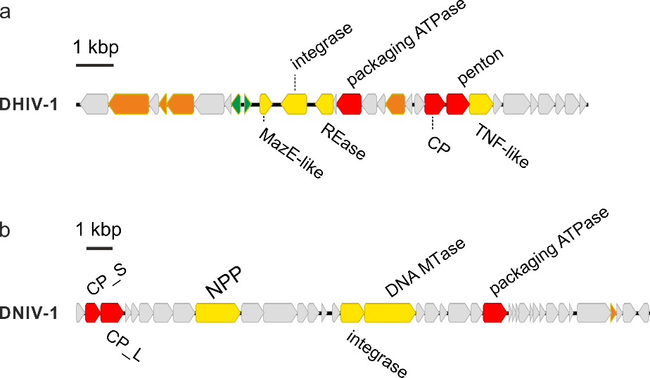

Figure 1. Genome maps of new singelaviruses. a. Danakil haloarchaeal icosahedral virus 1 (DHIV1). b. Danakil nanohaloarchaeal icosahedral virus 1 (DNIV1). CP_S, capsid protein (small); CP_L, capsid protein (large); REase, restriction endonuclease; TNF-like, TNF-like jelly-roll domain protein; NPP, nucleotide pyrophosphatase/phosphodiesterase.

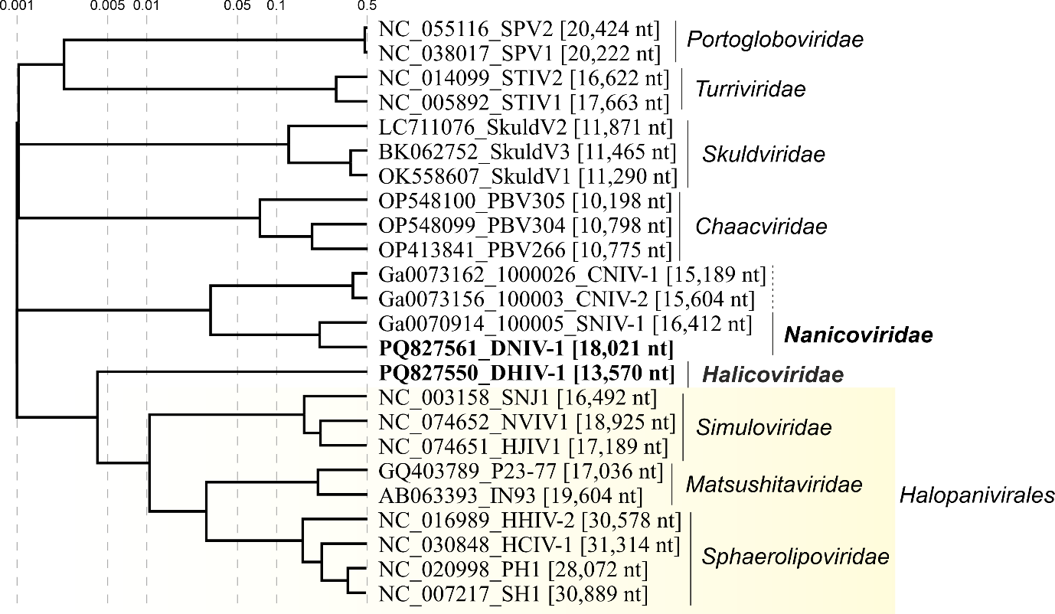

Figure 2. Genome-wide proteomic tree of representative archaeal tailless icosahedral viruses. Viruses from the Danakil Depression are highlighted in bold font. The proteomic trees are based on all-versus-all proteomic similarity matrix and are mid-point rooted. Branch lengths are log-scaled.

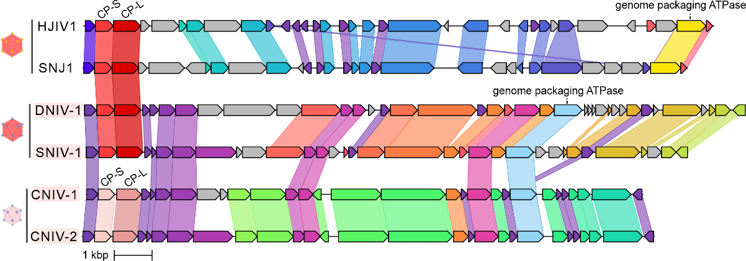

Figure 3. Comparison of four DNIV1-like viruses and two halopanivirals. HJIV1 and SNJ1 belong to family Simuloviridae (order Halopanivirales). Homologous genes (>25% identity) are highlighted using the same color and linked via shadings.

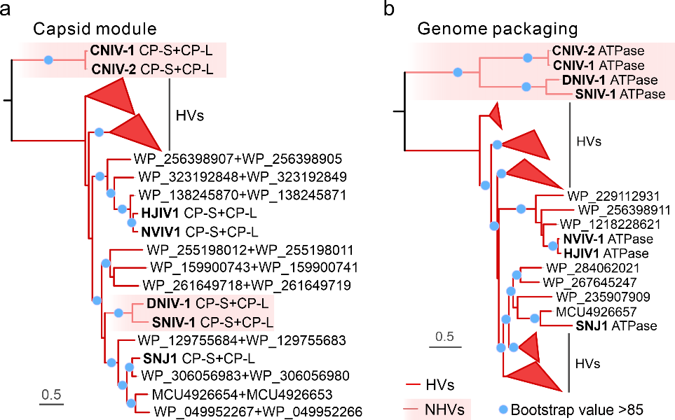

Figure 4. Maximum likelihood phylogenies of the major capsid proteins and genome packaging ATPase of archaeal signelavirians. a. Phylogenetic analysis based on the concatenated alignment of the two SJR MCPs. Note that DNIV1 and SNIV1 are nested among simulovirid homologs, whereas CNIV1 and CNIV2 cluster outside. b. Phylogenetic analysis based on the putative genome packaging ATPase. All four DNIV1-like viruses cluster outside of halopanivirals. Branches with bootstrap support values higher than 85% are indicated with blue circles. The sequences were aligned using Muscle5 with default parameters (Edgar, 2022), and non-informative columns were removed from the alignment using trimAl v1.2 with option -gt 0.2 (Capella-Gutiérrez et al., 2009). Next, a phylogenetic tree was constructed based on the trimmed alignment using IQ-TREE v2.2.2.2 with the following parameters: -m MFP, -alrt 1000 (Minh et al., 2020). The best fitting models for phylogenetic reconstructions were Q.pfam+F+I+R4 (for a) and Q.pfam+I+G4 (for b), respectively.

