

The International Committee on Taxonomy of Viruses
Taxonomy Proposal Form, 2025

Part 1a: Details of taxonomy proposals

Title: | Create four new species in the family Phasmaviridae
Code assigned: | 2025.006M.Ac.v4.Phasmaviridae_4nsp

Author(s), affiliation and email address(es):
Given name (+middle initial(s)) | Surname | Affiliation | Email address | Corr. author(s)
Matthew J | Ballinger | Biological Sciences, Mississippi State University, Mississippi State, USA | ballinger@biology.msstate.edu | X
Sandra | Junglen | Institute of Virology, Charité – Berlin University Medicine, Berlin, Germany | sandra.junglen@charite.de
Lander | De Coninck | Division of Clinical and Epidemiological Virology, KU Leuven, Leuven, Belgium | lander.deconinck@kuleuven.be

Part 1b: Taxonomy Proposal Submission
ICTV Subcommittee:
Animal DNA Viruses and Retroviruses |  | Bacterial viruses
Animal minus-strand and dsRNA viruses | X | Fungal and protist viruses
Animal positive-strand RNA viruses |  | Plant viruses
Archaeal viruses |  | General -

List the ICTV Study Group(s) that have seen or have been involved in creating this proposal:
Phasmaviridae Study Group

Optional – complete only if formally voted on by an ICTV Study Group:
Study Group | Number of members
Study Group | Votes in support | Votes against | No vote
Phasmaviridae | 3

Submission date: | 13/06/2025

Part 1c: Feedback from ICTV Executive Committee (EC) meeting
Executive Committee Meeting Decision code: | X
A – Accept
Ac – Accept subject to revision by relevant subcommittee chair. No further vote required | X
U – Accept without revision but with re-evaluation and email vote by the EC
Uc – Accept subject to revision and re-evaluation and email vote by the EC
Ud – Deferred to the next EC meeting, with an invitation to revise based on EC comments
J - Reject
W - Withdrawn

Comments from the Executive Committee:
Ac for minor typographical edits and consistent Abstract format across all Subcommittees

Part 1d: Revised Taxonomy Proposal Submission
Response of proposer:
Revision date: | 18/09/2025

Part 3: TAXONOMIC PROPOSAL

Taxonomic changes proposed:
Establish new taxon | X | Split taxon
Abolish taxon |  | Merge taxon
Move taxon |  | Promote taxon
Rename taxon |  | Demote taxon
Move and rename

Etymology (origin) of proposed taxonomic names:
Taxon name | Etymology of the term
Wuhivirus inferensa | Named for the host, Sesamia inferens
Orthophasmavirus vrasenense | Named for the Culex pipiens collection location (Vrasene, Belgium)
Orthophasmavirus vitinea | Named for host common name, the grapevine worm (vitis + tinea)
Orthophasmavirus lycotinea | Named for the host common name, the tomato worm (lyco- + tinea)

Abstract of Taxonomy Proposal:
Taxonomic rank(s) affected:
Species in the family Phasmaviridae.

Description of current taxonomy:
The family Phasmaviridae includes 32 species organized across seven genera.

Proposed taxonomic change(s):
Create four new species in the family Phasmaviridae.

Justification:
Coding-complete virus genome sequences are available to justify creation of four new species. Each exhibits < 95% L protein amino acid sequence identity to other exemplar viruses in the family Phasmaviridae.

Taxonomic rank(s) affected:
Species.

Description of current taxonomy:
The family Phasmaviridae includes 32 species organized across seven genera. These include Jonvirus, Wuhivirus, Hymovirus, Sawastrivirus, Feravirus, Cicadellivirus, and Orthophasmavirus.

Proposed taxonomic change(s):
We propose the creation of one new species in the genus Wuhivirus and three new species in the genus Orthophasmavirus:

Demarcation criteria:
The species demarcation criterion across all genera in the family Phasmaviridae is < 95% identity in the amino acid (aa) sequence of the complete L protein (the RNA-dependent RNA polymerase [RdRp])¹. The maximum aa identities shared between proposed new exemplar viruses and established phasmavirids ranges from 39.36 to 94.36%.

Justification:
The presence of coding-complete sequences for each of the three genome segments is sufficient for phasmavirid classification in the absence of a cultured isolate.

Wuhivirus inferensa is represented by exemplar virus Sanya sesamia inferens phasmavirus 1 (SSiPV). The virus was discovered in metagenomic sequences of Sesamia inferens and Scirpophaga incertulas collected in Sanya, China.

Orthophasmavirus vrasenense is represented by Culex orthophasmavirus 2 (CPV2), discovered in metagenomes of Culex pipiens biotype molestus collected in Vrasene, Belgium².

Orthophasmavirus vitinea is represented by Lobesia botrana phasmavirus (LbPV), discovered in metagenomes of Lobesia botrana collected in Germany³.

Orthophasmavirus lycotinea is represented by Tuta absoluta phasmavirus 1 (TaPhV1), discovered in metagenomes of Tuta absoluta collected in Piracicaba, Brazil⁴.

References:
1. Kuhn, J. H. & Hughes, H. R. ICTV Virus Taxonomy Profile: Phasmaviridae 2024. J. Gen. Virol. 105, 1–2 (2024).
2. De Coninck, L. et al. Lack of abundant core virome in Culex mosquitoes from a temperate climate region despite a mosquito species-specific virome. mSystems 9, (2024).
3. Debat, H., Gomez-Talquenca, S. & Bejerman, N. RNA Virus Discovery Sheds Light on the Virome of a Major Vineyard Pest, the European Grapevine Moth (Lobesia botrana). Viruses 17, 1–20 (2025).
4. Becerra-García, R. E., Hernández-Pelegrín, L., Crava, C. M. & Herrero, S. Characterization of the Tuta absoluta virome reveals higher viral diversity in field populations. J. Invertebr. Pathol. 211, (2025).

Tables, Figures:
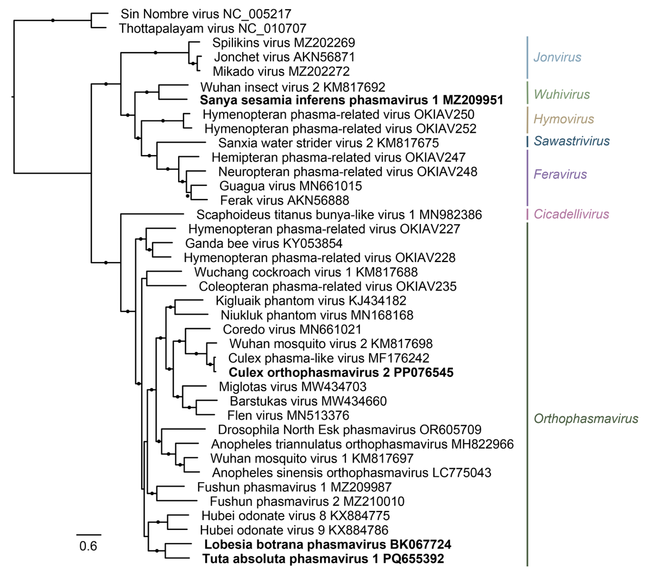
Figure 1. Phylogenetic relationships of proposed and established virus taxa in the family Phasmaviridae. A phylogram of L protein amino acid sequences of exemplar phasmavirids. Two members of the family Hantaviridae are included as an outgroup. Branches with SH-like FastTree support values >0.95 are labeled with a black circle. Tips are labeled with names of exemplar viruses. Clade labels on the right are genus names. Exemplar names of four proposed species are shown in bold typeface.

