Table S1. Nimaviral genomes used in this study.
Virus | Abbreviation | Accession | Length | GC% | CDS | Completeness
Marsupenaeus japonicus endogenous nimavirus | MjeNMV | LC738868.1 | 306,008 | 33 | 111 | Complete
Melicertus latisulcatus majanivirus | MelaMJNV | LC738874.1 | 287,061 | 32 | 104 | Complete
Metapenaeopsis lamellata majanivirus | MetlamMJNV | AP027153.1 | 267951 | 27 | 106 | Complete
Penaeus monodon majanivirus A | PemoMJNVA | LC738870.1 | 294144 | 40 | 115 | Complete
Penaeus monodon majanivirus B | PemoMJNVB | LC738871.1 | 360,489 | 35 | 114 | Complete
Litopenaeus vannamei majanivirus | LvMJNV | LC738872.1 | 280452 | 35 | 119 | Complete
Penaeus semisulcatus majanivirus | PeseMJNV | LC738873.1 | 291934 | 42 | 110 | Complete
Metapenaeus ensis majanivirus | MeenMJNV | LC738876.1 | 292,272 | 29 | 101 | Complete
Metapenaeus joyneri majanivirus | MejoMJNV | LC738878.1 | 401182 | 26 | 124 | Complete
Trachysalambria curvirostris majanivirus | TrcuMJNV | LC738879.1 | 283150 | 28 | 101 | Complete
Marsupenaeus japonicus pemonivirus | MjPMNV | AP027202.1 | 323944 | 48 | 102 | Complete
Melicertus latisulcatus pemonivirus | MelaPMNV | LC738875.1 | 359647 | 48 | 109 | Complete
Penaeus monodon endogenous nimavirus | PmeNMV | LC738869.1 | 300002 | 45 | 94 | Complete
Penaeus semisulcatus pemonivirus | PesePMNV | AP027152.1 | 277334 | 43 | 102 | Complete
Hemigrapsus takanoi nimavirus | HtNMV | LC738882.1 | 251731 | 47 | 111 | Coding-complete
Trachysalambria curvirostris nimavirus | TrcuNMV | LC738880.1 | 331684 | 47 | 107 | Complete
Sesarmops intermedium nimavirus | SiNMV | LC738884.1 | 267936 | 44 | 104 | Complete
Chiromantes dehaani nimavirus | CdNMV | AP027155.1 | 285096 | 44 | 99 | Complete
Metapenaeus ensis nimavirus | MeNMV | LC738877.1 | 341,283 | 44 | 117 | Complete
Sicyonia whispovirus | SicyWSV | LC738881.1 | 347,493 | 54 | 89 | Complete
Pasiphaea japonica whispovirus | PajaWSV | LC738885.1 | 276272 | 35 | 86 | Complete
Chionoecetes opilio bacilliform virus | CoBV | LC741431.1 | 243979 | 40 | 105 | Complete
White spot syndrome virus | WSSV | NC_003225.3 | 309286 | 41 | 177 | Complete

Table S2. ANI matrix for closely related penaeid endogenous nimavirus MAGs (1).
ANI | MjeNMV | MlMJNV | PemoMJNVA | PeseMJNV | PemoMJNVB
MjeNMV | 100% | 97.50% | -- | -- | --
MlMJNV | 97.50% | 100% | -- | -- | --
PemoMJNVA | -- | -- | 100% | 92.89% | 81.01%
PeseMJNV | -- | -- | 92.89% | 100% | 80.63%
PemoMJNVB | -- | -- | 81.01% | 80.63% | 100%
See Table S1 for the abbreviations of the virus names. --: ANI undetermined (too few matches to meet the threshold defined by ani.rb).
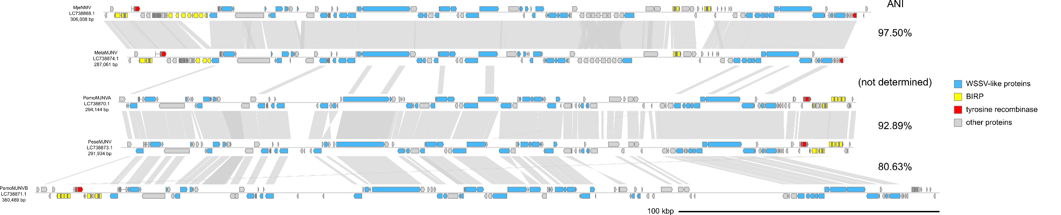
Figure S1. Genome diagrams of closely related penaeid endogenous nimavirus MAGs (1).
Arrows indicate predicted genes and their transcriptional orientations. Gray ribbons indicate pairwise BLASTN hits (e-value :1−e20, bitscore: 1000, identity: 70%). See Table S1 for the abbreviations of the virus names.

Table S3. ANI matrix for closely related penaeid endogenous nimavirus MAGs (2).
ANI | PmeNMV | PesePMNV | MjPMNV | MlPMNV
PmeNMV | 100% | 81.34% | 75.75% | --
PesePMNV | 81.34% | 100% | -- | --
MjPMNV | 75.75% | -- | 100% | 96.29%
MlPMNV | -- | -- | 96.29% | 100%

See Table S1 for the abbreviations of the virus names. --: ANI undetermined (too few matches to meet the threshold defined by ani.rb).
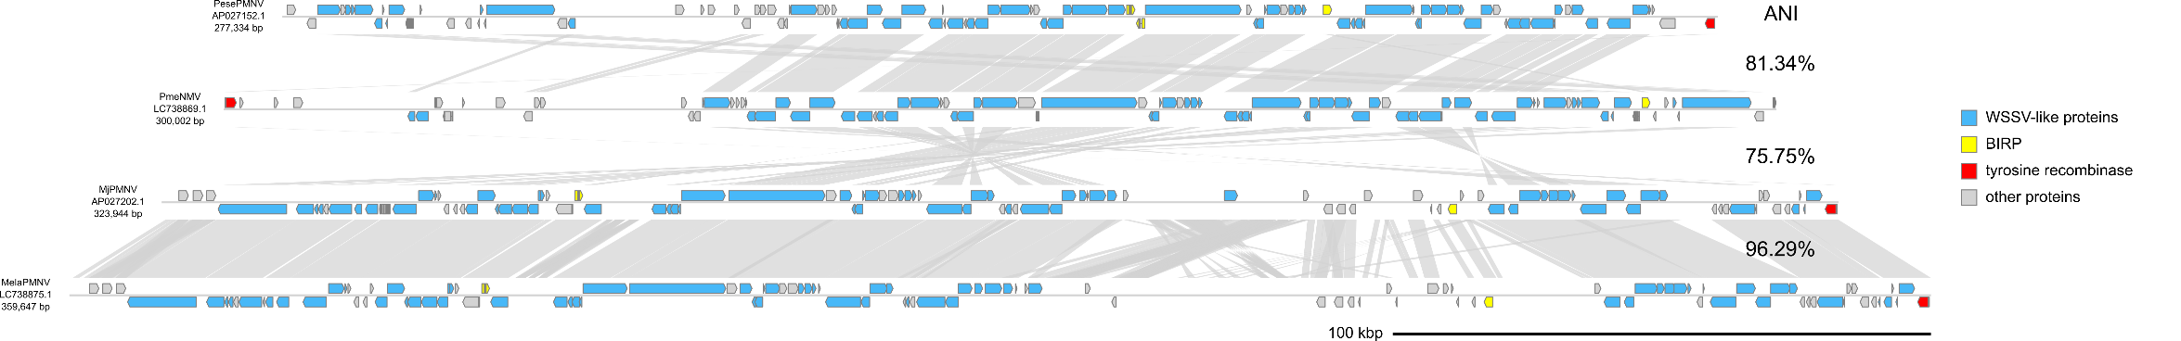
Figure S2. Genome diagrams of closely related penaeid endogenous nimavirus MAGs (2).
Arrows indicate predicted genes and their transcriptional orientations. Gray ribbons indicate pairwise BLASTN hits (e-value :1−e20, bitscore: 1000, identity: 70%). See Table S1 for the abbreviations of the virus names.

Table S4. ANI matrix for closely related sesarmid endogenous nimavirus MAGs.
ANI | SiNMV | CdNMV
SiNMV | 100% | 95.11%
CdNMV | 95.11% | 100%

See Table S1 for the abbreviations of the virus names.
Figure S3. Genome diagrams of closely related sesarmid endogenous nimavirus MAGs.
Arrows indicate predicted genes and their transcriptional orientations. Gray ribbons indicate pairwise BLASTN hits (e-value :1−e20, bitscore: 1000, identity: 70%). See Table S1 for the abbreviations of the virus names.

