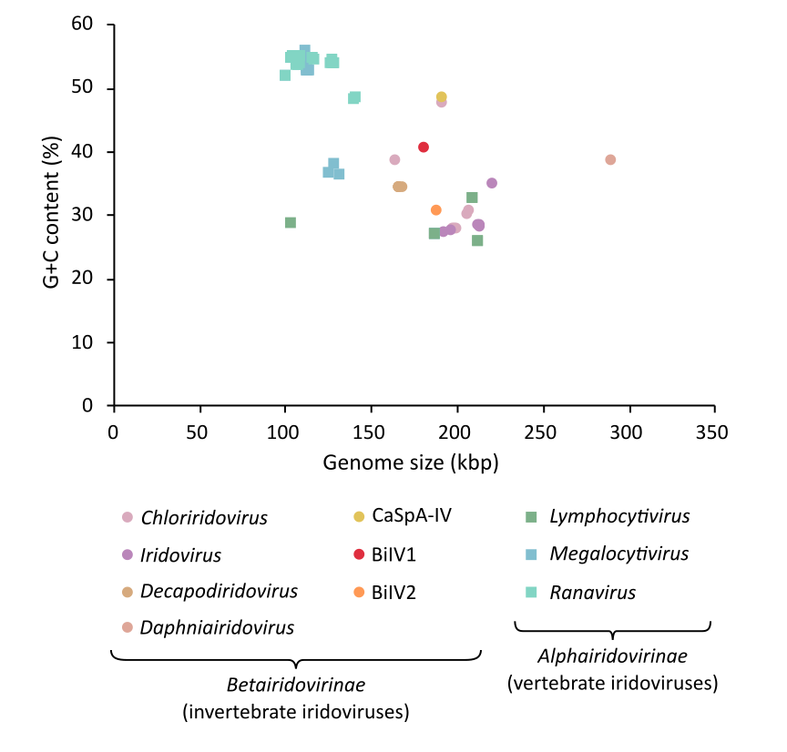
Figure 1. Genome size (kbp) plotted against G+C content (%) for a representative set of Iridoviridae genomes. Alphairidovirinae are represented by squares, with genera within this subfamily represented by different colours. Betairidovirinae are represented by circles, with the four defined genera within this subfamily, and the three species within no assigned genus (including BiIV1), represented by different colours. Within the Betairidovirinae subfamily, Anopheles minimus iridovirus (accession number KF938901) has the smallest genome size at 163,023 kbp, and Daphnia iridovirus 1 (accession number LS484712) has the largest at 288,858 kbp. G+C content within Betairidovirinae ranges between 27.75% (cricket iridovirus – accession number OK181107) and 48.75% (carnivorous sponge associated iridovirus – accession number ON887238).
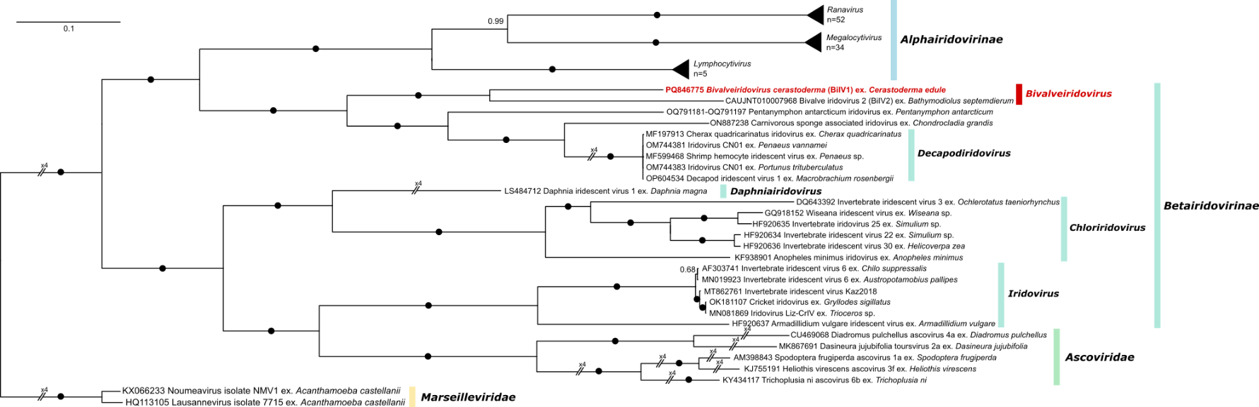
Figure 2. Bayesian consensus tree constructed from a concatenated multiple amino acid alignment of major capsid protein, DNA-directed RNA polymerase II subunit Rpb2, putative A32-like packaging ATPase, putative CTD phosphatase-like protein, putative helicase protein, and putative transcription elongation factor S-II-like protein from BiIV1, 113 other Iridoviridae, five Ascoviridae and two Marseilleviridae. The tree is rooted to the Marseilleviridae clade. Branch labels denote posterior probabilities, with black circles used when posterior probability = 1.
Figure 3. Electron micrographs of a common cockle, Cerastoderma edule, infected with bivalve iridovirus 1 (BiIV1). (A) Two host cells infected with BiIV1, with the nuclei, N, showing condensed chromatin (CC), and mature and immature BiIV1 virions in the cytoplasm (Cyt). The left cell has a large electron-lucent assembly site (*) containing a few mature virions and many immature, developing virions. The right cell contains a paracrystalline array of virus particles. Scale bar = 2 µm. (B) Higher magnification of the right cell, with numerous mature virions (black arrowheads), a few immature, developing virions (white arrowheads), and putative viral DNA prior to packing (white arrow). Scale bar = 500 nm. (C) Higher magnification of the left cell, with mature virions (black arrowheads) and immature, empty and developing capsids (white arrowheads). Scale bar = 500 nm. (D) High magnification of mature virions in a paracrystalline array, showing detail of the naked capsids containing an electron dense core. Scale bar = 500 nm.
Figure 4. Histopathology images of Cerastoderma edule infected with bivalve iridovirus 1 (BiIV1). A) Infiltrating haemocytes within the connective tissues surrounding the digestive gland tubules (DG) were observed to possess basophilic inclusions (arrowheads) in the cytoplasm. Scale bar = 50 µm. B) Higher magnification of haemocytes with basophilic inclusions (black arrowheads) within the cytoplasm. Nuclei of the affected cells also showed marginated and condensed chromatin (white arrowheads). Scale bar = 50 µm.

