

The International Committee on Taxonomy of Viruses
Taxonomy Proposal Form, 2025

Part 1a: Details of taxonomy proposals

Title: | Addition of novel genera and species, and reclassification of some species in the Nudiviridae
Code assigned: | 2025.002D.v4.Nudivirdae_2ng_17ns_1mvsp

Author(s), affiliation and email address(es):
Given name (+middle initial(s)) | Surname | Affiliation | Email address | Corr. author(s)
Jamie | Bojko | Teesside University, UK | J.Bojko@tees.ac.uk | x
Jirka | Petersen | Wageningen University, NL | jirmanpet@gmail.com
Amy | Burgess | Teesside University, UK | A.Burgess@tees.ac.uk
Monique | Van Oers | Wageningen University, NL | monique.vanoers@wur.nl | x
Elisabeth | Herniou | Tours University, FR | Elisabeth.herniou@univ-tours.fr
Robert L. | Harrison | Beltsville Agricultural Research Center, USDA, USA | robert.l.harrison@usda.gov

Part 1b: Taxonomy Proposal Submission
ICTV Subcommittee:
Animal DNA Viruses and Retroviruses | x | Bacterial viruses
Animal minus-strand and dsRNA viruses |  | Fungal and protist viruses
Animal positive-strand RNA viruses |  | Plant viruses
Archaeal viruses |  | General

List the ICTV Study Group(s) that have seen or have been involved in creating this proposal:
Baculoviridae and Nudiviridae study group

Optional – complete only if formally voted on by an ICTV Study Group:
Study Group | Number of members
Study Group | Votes in support | Votes against | No vote

Submission date: | 29/5/2025

Part 1c: Feedback from ICTV Executive Committee (EC) meeting
Executive Committee Meeting Decision code: | X
A – Accept
Ac – Accept subject to revision by relevant subcommittee chair. No further vote required
U – Accept without revision but with re-evaluation and email vote by the EC
Uc – Accept subject to revision and re-evaluation and email vote by the EC
Ud – Deferred to the next EC meeting, with an invitation to revise based on EC comments
J - Reject
W - Withdrawn

Comments from the Executive Committee:

Part 1d: Revised Taxonomy Proposal Submission
Response of proposer:
Revision date:

Part 2: Not applicable

Part 3: TAXONOMIC PROPOSAL

Taxonomic changes proposed:
Establish new taxon | x | Split taxon
Abolish taxon |  | Merge taxon
Move taxon |  | Promote taxon
Rename taxon |  | Demote taxon
Move and rename | x

Etymology (origin) of proposed taxonomic names:
Taxon name | Etymology of the term
Epsilonnudivirus | Derived from appropriate Greek letter in order of discovery
Zetanudivirus | Derived from appropriate Greek letter in order of discovery
Alphanudivirus apimelliferae | Epithet derived from the genitive of the host species name as explained in van Oers et al. [2023); In this case from the host Epithet derived from Apis mellifera (genitive melliferae) (letters in bold used for epithet).
Gammanudivirus arapsonii | Epithet derived from Aratus pisonii (already a gentive)
Gammanudivirus casapidi | Epithet derived from Callinectes sapidus (genitive sapidi)
Gammanudivirus marosenbergii | Epithet derived from Macrobrachium rosenbergii (already a genitive)
Gammanudivirus memercanariae | Epithet derived from Menippe mercenaria (genitive mercenariae)
Gammanudivirus pevannamei | Epithet derived from Penaeus vannamei (already a genitive)
Epsilonnudivirus cracrangonis | Epithet derived from Crangon crangon (genttive crangonis)
Epsilonnudivirus dikhaemobaphes | Epithet derived from Dikerogammarus haemobaphes (same as genitive)
Epsilonnudivirus faxopropinqui | Epithet derived from Faxonius propinquus (genitive propingui)
Epsilonnudivirus faxorustici | Epithet derived from the host species name Faxonius rusticus (genitive rustici)
Epsilonnudivirus faxovirilis | Epithet derived from Faxonius virilis (same as genitive)
Zetanudivirus cucafricani | Epithet derived from Cuculoecus (genitive africani)
Zetanudivirus echiclaytoni | Epithet derived from Echinophilopterus claytoni (already a genitive)
Zetanudivirus hespinigeri | Epithet derived from Heterodoxus spiniger (genitive spinigeri)
Zetanudivirus laperplexi | Epithet derived from Lagopoecus perplexus (genitive perplexi)
Zetanudivirus fraroseicapillae | Epithet derived from Franciscoloa roseicapillae (already a genitive)
Zetanudivirus myptilorhynchi | Epithet derived from Myrsidea ptilorhynchi (already a genitive)

Permission for use of names derived from a living person
Taxon name | Full name of person from whom the name is derived | Attached
NA | NA | NA

Abstract of Taxonomy Proposal:
Taxonomic rank(s) affected:
Genus and species

Description of current taxonomy:
The current taxonomy in place includes the Alphanudivirus (n=7 species), Betanudivirus (n=1 species), Gammanudivirus (n=4 species), and Deltanudivirus (n=1 species), within the Nudiviridae.

Proposed taxonomic change(s):
We propose to create two new genera, move one species to a new genus, and create 17 new species.

Justification:
New discoveries of nudiviruses from crustaceans and insects (Petersen et al. 2024) have resulted in a more diverse understanding of the Nudiviridae. The crustacean nudiviruses split clearly into two groups, which should be considered at the genus level for this viral family. Two new genera found to infect lice are new to science and require incorporation into the nudivirus taxonomy. In addition to the genus level amendments, there are also several species that now need to be appropriately placed into the Alphanudivirus, Gammanudivirus, and the two new genera, Epsilonnudivirus and Zetanudivirus.

Text of Taxonomy proposal:
Taxonomic rank(s) affected:
Genus and species

Description of current taxonomy:
The Nudiviridae currently includes the genera Alphanudivirus, Betanudivirus, Gammanudivirus, and Deltanudivirus.

Proposed taxonomic change(s):
We propose to add three new genera, move one existing species, and create 18 new species. The reasoning behind this is as follows for each taxon affected:
- The Alphanudivirus will have the following new species included, due to phylogenetic clustering within this genus, and significant genetic difference from existing species: Alphanudivirus apimelliferae.
- The Gammanudivirus will have the following new species included, due to phylogenetic clustering within this genus, and significant genetic difference from existing species: Gammanudivirus memercanariae; Gammanudivirus casapidi; Gammanudivirus marosenbergii; Gammanudivirus arapsonii; Gammanudivirus pevannamei.
- Several new species also have significant phylogenetic divergence from existing genera, denoting the need for two new genera: Epsilonnudivirus and Zetanudivirus.
- The newly erected Epsilonnudivirus will have the following new species included, due to phylogenetic clustering outside of other genera, and significant genetic difference from existing genera groups: Epsilonnudivirus cracrangonis (this species is moved from Gammanudivirus); Epsilonnudivirus dikhaemobaphes; Epsilonnudivirus faxopropinqui; Epsilonnudivirus faxovirilis; and Epsilonnudivirus faxorustici.
- The newly erected Zetanudivirus will have the following new species included, due to phylogenetic clustering outside of other genera, and significant genetic difference from existing genera, including: Zetanudivirus hespinigeri; Zetanudivirus laperplexi; Zetanudivirus cucafricani; Zetanudivirus echiclaytoni; Zetanudivirus fraroseicapillae; Zetanudivirus myptilorhynchi

Demarcation criteria:
Demarcation criteria are not fully defined for nudiviruses, at any level of organisation currently. We propose the following for our new genera and the species they contain. In terms of core gene alignments, each exemplar virus of a new species in this proposal is identical for 88% or less at the nucleotide level and equal to or less than 88% identical at the protein sequence level to earlier defined exemplar nudiviruses. For example, the average percent identity of the 17 core genes that show no duplication (38k, ac81, DNApol, helicase, lef-4, lef-8, lef-9, p33, p47, p74, pif-1, pif-2, pif-3, pif-4, pif-6, vp39, vp91), separating HzNV1 and HzNV2 is 99.0%, separating isolates CoNV1, CoNV2, and CoNV3 is 99.6-99.8%, and the percent identity separating FrrNV from FrpNV (Petersen et al. 2024) is 98.9%. The closest species to this boundary are FvNV and FrNV (86.97% nucleotide similarity; 87.84% core protein similarity). Based on this, we suggest that the protein and genomic similarity should sit at 90% as the barrier for defining isolates that present within the same species, relative to the first viral genome sequenced.

At the genera level, intragenus and intergenus average pairwise core protein sequence identities for exemplar viruses in current and proposed genera are as follows:

Alpha | 35% - 100% |  | Core protein similarity range (%)
Beta | 26% - 29% | 99% - 100%
Gamma | 26% - 28% | 29% - 30% | 43% - 100%
Delta | 27% - 29% | 29% | 30% - 32% | 100%
Epsilon | 26% - 28% | 29% - 31% | 35% - 38% | 30% - 32% | 39% - 100%
Zeta | 25% - 28% | 27% - 29% | 27% - 29% | 29% - 31% | 27% - 30% | 38% - 100%
 | Alpha | Beta | Gamma | Delta | Epsilon | Zeta

From this table, we propose a provisional cut-off value of 38% for determining if two viruses belong to the same or different genera. This should be fortified with phylogenetic topology and branch distance, to show their relatedness. If the viruses being compared exhibit an average core gene amino acid sequence identity equal to or less than 38%, then they are considered to belong to different genera. There is some inconsistency in the alphanudivirus group as it currently stands, which may need revisiting, where GbNV is distinct (35% core protein similarity), which, when removed, changes to 43% core protein similarity within the Alphanudivirus genus. However, GbNV is rather unique, and few available viruses can be used to develop a more robust placement for this species at this time.

The following additional criteria for future species to be included in the new genera are as follows:
Epsilonnudivirus – to be included in this genus, the host should be a crustacean, and the viral genome should phylogenetically group together with existing species in this genus, sharing above 38% protein similarity.
Zetanudivirus – to be included in this genus, the host should be a louse, and the viral genome should phylogenetically group together with existing species in the genus, sharing above 38% protein similarity.

Justification:
Placement of new species in new and proposed genera is consistent with the species and genus demarcation criteria described above and their phylogenetic clustering in Figure 1. Please also see the level of identity of core genes in pairwise amino acid comparisons between nudiviruses in Figure 2.

References:
Allain, T. W., Stentiford, G. D., Bass, D., Behringer, D. C., & Bojko, J. (2020). A novel nudivirus infecting the invasive demon shrimp Dikerogammarus haemobaphes (Amphipoda). Scientific reports, 10(1), 14816.
Bojko, J., Burgess, A. L., Allain, T. W., Ross, E. P., Pharo, D., Kreuze, J. F., & Behringer, D. C. (2022). Pathology and genetic connectedness of the mangrove crab (Aratus pisonii)–a foundation for understanding mangrove disease ecology. Animal Diseases, 2(1), 8.
Bojko, J., Walters, E., Burgess, A., & Behringer, D. C. (2022). Rediscovering “Baculovirus-A” (Johnson, 1976): The complete genome of ‘Callinectes sapidus nudivirus’. Journal of Invertebrate Pathology, 194, 107822.
Bojko, J., Duermit-Moreau, E., Gandy, R., & Behringer, D. C. (2023). A new member of the Nudiviridae from the Florida stone crab (Menippe mercenaria). Virology, 588, 109910.
Petersen, J. M., Burgess, A. L., van Oers, M. M., Herniou, E. A., & Bojko, J. (2024). Nudiviruses in free-living and parasitic arthropods: evolutionary taxonomy. Trends in Parasitology 40, 744-762.
Stratton, C. E., Reisinger, L. S., Behringer, D. C., Gray, S. N., Larson, E. R., & Bojko, J. (2024). North American crayfish harbour diverse members of the Nudiviridae. Virology, 598, 110183.
van Oers, M.M., Herniou, E.A., Jehle, J.A., Krell, P.J., Abd-Alla, A.M.M., Ribeiro,. B.M., Theilmann, D.A., Hu, Z., Harrison, R.L. (2023). Developments in the classification and nomenclature of arthropod-infecting large DNA viruses that contain pif genes. Archives of Virology 168, 82. doi: 10.1007/s00705-023-05793-8.

Accompanying files:
Filename | Description of contents
2025.002D.v4.Nudivirdae_2ng_17ns_1mvsp.xlsx | Accompanying Excel sheet

Tables, Figures: Please see tables and figures below.

See following pages

Table 1. Novel virus genome sizes, open reading frame numbers, and accession numbers.

Novel species | Exemplar virus name | Abbr. | Genome size (bp) | ORF  count | Accession
Alphanudivirus apimelliferae | Apis mellifera nudivirus | AmNV | 129467 | 106 | OR596894
Gammanudivirus arapsonii | Aratus pisonii nudivirus | ApNV | 108983 | 90 | ON061174
Gammanudivirus casapidi | Callinectes sapidus nudivirus | CsNV | 122436 | 98 | ON638996
Gammanudivirus marosenbergii | Macrobrachium rosenbergi nudivirus | MrNV | 108126 | 115 | MW484891
Gammanudivirus memercanariae | Menippe mercenaria nudivirus | MmNV | 99336 | 83 | OQ725696
Gammanudivirus pevannamei | Penaeus vannamei nudivirus | PvNV | 119883 | 100 | OM066077
Epsilonnudivirus cracrangonis | Crangon crangon nudivirus | CcNV | 132068 | 106 | NC_076945
Epsilonnudivirus dikhaemobaphes | Dikerogammarus haemobaphes nudivirus | DhNV | 119695 | 106 | MT488302
Epsilonnudivirus faxopropinqui | Faxonius propinquus nudivirus | FpNV | 130164 | 120 | PP539709
Epsilonnudivirus faxorustici | Faxonius rusticus nudivirus | FrNV | 147048 | 126 | PP539711
Epsilonnudivirus faxovirilis | Faxonius virilis nudivirus | FvNV | 144948 | 127 | PP539710
Zetanudivirus cucafricani | Cuculoecus africanus nudivirus | CafNV | 84329 | 89 | BK068074
Zetanudivirus echiclaytoni | Echinophilopterus claytoni | EcNV | 85720 | 89 | BK068075
Zetanudivirus hespinigeri | Heterodoxus spiniger nudivirus | HxsNV | 97269 | 104 | BK068078
Zetanudivirus laperplexi | Lagopoecus perplexus nudivirus | LpNV | 90164 | 95 | BK068079
Zetanudivirus fraroseicapillae | Franciscoloa roseicapillae nudivirus | FrrNV | 83884 | 100 | BK068077
Zetanudivirus myptilorhynchi | Myrsidea ptilorhynchi nudivirus | MpNV | 87845 | 99 | BK068080

Table 2. Currently less-well characterized viruses with complete genomes that appear to belong to the family Nudiviridae

Novel species | Exemplar virus name | Abbr. | Genome size (bp) | ORF  count | Accession
NA | Ctenocephalides orientis nudivirus | CoNV -1 | 90736 | 86 | BK068081
NA | Phenacoccus solenopsis nudivirus | PsNV | 189841 | 139 | MT833891

Figure 1. A Phylogenetic tree incorporating all of the known nudivirus isolates, incorporating new discoveries from Petersen et al. (2024). Virus acronyms on the tree with a black star are already incorporated into the ICTV. Those with an orange star are new and being incorporated in this proposal. The proposed or existing genus is noted at each section of the tree that it represents. Viruses without a star remain to be defined. All nodes on the tree are above a minimum threshold of 70, but the majority factor above 95.The selected baculoviruses are added as an outgroup.

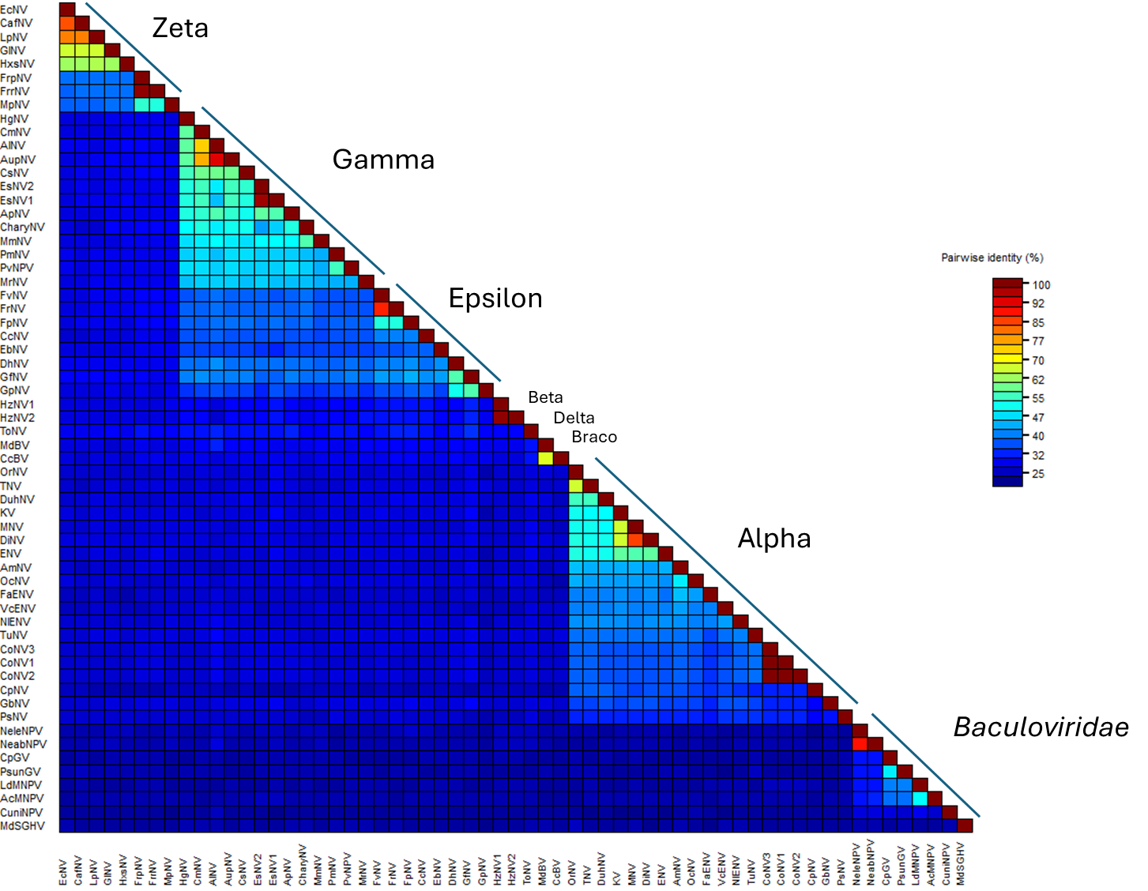

Figure 2. A sequence demarcation plot for the core protein concatenated file used to provide the phylogenetic tree in Figure 1. The same annotation is outlined on the figure, highlighting where different genera and families are represented.

