

The International Committee on Taxonomy of Viruses
Taxonomy Proposal Form, 2024

Part 1a: Details of taxonomy proposals

Title: | Create two new species in the genus Citlodavirus (Geplafuvirales: Geminiviridae)
Code assigned: | 2024.008P.A.v1.Geminiviridae_Citlodavirus_2nsp

Author(s), affiliation and email address(es):
Name | Affiliation | Email address | Corresponding author(s) X
Roumagnac, Philippe | CIRAD, UMR PHIM, Montpellier, France | philippe.roumagnac@cirad.fr | X
Ascencio-Ibanez, Jose | North Carolina State University, Raleigh, USA | jtascenc@ncsu.edu
Lett, Jean-Michel | CIRAD, UMR PVBMT, Saint Pierre de la Réunion, France | lett@cirad.fr
López-Lambertini, Paola M. | INTA-CIAP-IPAVE, Universidad Nacional de Córdoba, Córdoba, Argentina | plopezlambertini@gmail.com
Martin, Darren P. | Institute of Infectious Disease and Molecular Medicine, University of Cape Town, Cape Town, South Africa | darrenpatrickmartin@gmail.com
Navas-Castillo, Jesús | Instituto de Hortofruticultura Subtropical y Mediterránea “La Mayora” (IHSM-UMA-CSIC), Málaga, Spain | jnavas@eelm.csic.es
Ribeiro, Simone | Embrapa Recursos Genéticos e Biotecnologia, Brasília, Brazil | simone.ribeiro@embrapa.br
Urbino, Cica | CIRAD, UMR PHIM, Montpellier, France | cica.urbino@cirad.fr
Varsani, Arvind | The Biodesign Center for Fundamental and Applied Microbiomics, Center for Evolution and Medicine, School of Life Sciences, Arizona State University, Tempe,Arizona, USA | Arvind.varsani@asu.edu
Zerbini, F. Murilo | Dep. de Fitopatologia, Universidade Federal de Viçosa, Viçosa, Brasil | zerbini@ufv.br

Part 1b: Taxonomy Proposal Submission
ICTV Subcommittee:
Animal DNA Viruses and Retroviruses |  | Bacterial viruses
Animal minus-strand and dsRNA viruses |  | Fungal and protist viruses
Animal positive-strand RNA viruses |  | Plant viruses | X
Archaeal viruses |  | General -

List the ICTV Study Group(s) that have seen or have been involved in creating this proposal:
Geminiviridae and Tolecusatellitidae Study Group

Optional – complete only if formally voted on by an ICTV Study Group:
Study Group | Number of members
Study Group | Votes in support | Votes against | No vote
Roumagnac, Philippe  Ascencio-Ibanez, Jose  Lett, Jean-Michel  López-Lambertini, Paola M.  Martin, Darren  Navas-Castillo, Jesús  Ribeiro, Simone  Urbino, Cica  Varsani, Arvind  Zerbini, F. Murilo | Y  Y  Y  Y  Y  Y  Y  Y  Y  Y

Submission date: | 10/06/2024

Part 1c: Feedback from ICTV Executive Committee (EC) meeting
Executive Committee Meeting Decision code: | X
A – Accept | A
Ac – Accept subject to revision by relevant subcommittee chair. No further vote required
U – Accept without revision but with re-evaluation and email vote by the EC
Uc – Accept subject to revision and re-evaluation and email vote by the EC
Ud – Deferred to the next EC meeting, with an invitation to revise based on EC comments
J - Reject
W - Withdrawn

Comments from the Executive Committee:

Part 1d: Revised Taxonomy Proposal Submission
Response of proposer:
Revision date: | DD/MM/YYYY

Part 3: TAXONOMIC PROPOSAL

Name of accompanying Excel module:
2024.008P.A.v1.Geminiviridae_Citlodavirus_2nsp.xlsx

Taxonomic changes proposed:
Establish new taxon | x | Split taxon
Abolish taxon |  | Merge taxon
Move taxon |  | Promote taxon
Rename taxon |  | Demote taxon
Move and rename

Is any taxon name used here derived from that of a living person: |  | N
Taxon name | Person from whom the name is derived | Attached X

Abstract of Taxonomy Proposal:
Proposed changes:
Add two species in the Citlodavirus genus

Taxonomic rank(s) affected:
Citlodavirus genus in the Geminiviridae family

Description of current taxonomy:
Monodnaviria / Shotokuvirae / Cressdnaviricota / Repensiviricetes / Geplafuvirales / Geminiviridae / Citlodavirus

Proposed taxonomic change(s):
We proposed to add two new species to the Citlodavirus genus, Citlodavirus apijamaicaense and Citlodavirus myricae.

Justification:
Similar to members of the Citlodavirus genus, members of the proposed new species Citlodavirus apijamaicaense and Citlodavirus myricae have the virion-strand origin of replication nonanucleotide motif ‘TAA TAT TAC’, a relatively large genome (3918 nt and 3775 nt, respectively) and unique genome arrangements that, in both cases, include the putative mp gene (888 nt and 912 nt, respectively) that is similar in size to the mp gene in the DNA-B of bipartite begomoviruses. Genome-wide pairwise analysis of the representative genomes of citlodaviruses showed that Citlodavirus apijamaicaense and Citlodavirus myricae share less than 78% identity with all representative genomes of citlodaviruses and between each other. Since 78% nucleotide identity is the genome-wide species demarcation threshold for citlodaviruses, we conclude that Citlodavirus apijamaicaense and Citlodavirus myricae represent two new species in the genus Citlodavirus.

Text of Taxonomy proposal:
Taxonomic rank(s) affected:
Citlodavirus genus in the Geminiviridae family (Order Geplafuvirales)

Description of current taxonomy:
Monodnaviria / Shotokuvirae / Cressdnaviricota / Repensiviricetes / Geplafuvirales / Geminiviridae / Citlodavirus

Four species are currently assigned to the Citlodavirus genus in the Geminiviridae family:

- Citlodavirus broussonetiae
- Citlodavirus camelliae
- Citlodavirus citri
- Citlodavirus passiflorae

Proposed taxonomic change(s):
We propose to add two new species to the Citlodavirus genus: (i) Citlodavirus apijamaicaense, which was isolated from honeybees (Apis mellifera) collected from Westmoreland, Jamaica (Bandoo et al., 2024); and (ii) Citlodavirus myricae, which was isolated from Myrica rubra plants in Yunnan, China (Gao et al., 2023).

Demarcation criteria:
A 78% pairwise identity species demarcation threshold has been proposed and adopted for the genus Citlodavirus (Roumagnac et al., 2022).

Justification:
A group of closely related viruses isolated from citrus in China, Thailand, and Turkey, Camellia japonica and Camellia sinensis in China, Passiflora edulis in Brazil, and Broussonetia papyrifera in China was assigned in 2021 to the genus Citlodavirus (Roumagnac et al., 2022). The genome sizes of these viruses are approximately 20% larger than those of other known monopartite geminiviruses, ranging from 3639 to 3763 nt. These viruses have the virion-strand origin of replication nonanucleotide motif ‘TAATATTAC’ and a unique genome arrangement that includes a putative mp gene (891–921 nt in size), which likely encodes a protein product homologous to that encoded by the DNA-B component of bipartite begomoviruses (genus Begomovirus).

New Citlodavirus species: Citlodavirus apijamaicaense
One isolate of apiscitlodal virus has been characterized from bees collected from Westmoreland, Jamaica (Bandoo et al., 2024). Its 3918 nt long genome sequence share less than 68.9% with all other known geminiviruses within currently established species (Figure 1), with the highest identity with passion fruit chlorotic mottle virus (MG696802). Reconstruction of the evolutionary relationships of the complete genome sequences of all citlodaviruses and one representative mulcrilevirus (genus Mulcrilevirus) reveals that apiscitlodal virus groups with citlodaviruses with strong phylogenetic support (Figure 2). This virus is clearly related to previously recognized geminiviruses, based on genome organization, similarities in the origin of replication (5'-TAATATTAC-3'), and the presence of homologous genes. Specifically, apiscitlodal virus has a genome arrangement similar to those of citlodaviruses (Figure 3), containing the larger putative mp gene (888 nt) that is most similar in size to the mp gene in the DNA-B molecule of bipartite begomoviruses. Consequently, we propose creating a new Citlodavirus species named Citlodavirus apijamaicaense (origin of the species name: api from apis the organism from with the virus was isolated and jamaicaense from Jamaica, the country where the bees were collected).

New Citlodavirus species: Citlodavirus myricae
One isolate of Myrica rubra citlodavirus 1 (MRV1) has been characterized from Myrica rubra collected in Yunnan, China (Gao et al., 2023). Its 3775 nt long genome sequence shares less than 65.3% with all other known geminiviruses within currently established species (Figure 1), with the highest identity with citrus chlorotic dwarf virus (JQ920490). The reconstruction of the evolutionary relationships of the complete genome sequences of all citlodaviruses and one representative mulcrilevirus reveals that MRV1groups with citlodaviruses, with strong phylogenetic support (Figure 2). This virus is clearly related to previously recognized geminiviruses, based on genome organization, similarities in the origin of replication (5'-TAATATTAC-3'), and the presence of homologous genes. Specifically, similar to members of the Citlodavirus genus, MRV1 has a genome arrangement (Figure 3) that includes the larger putative mp gene (912 nt) that is most similar in size to the mp gene in the DNA-B molecule of bipartite begomoviruses. Consequently, we propose creating a new Citlodavirus species named Citlodavirus myricae (origin of the species name: myricae from Myrica, the Latin name of the botanical genus of the host from which the virus was isolated).

References:
Bandoo, R.A., Kraberger, S., Varsani, A., 2024. Two novel geminiviruses identified in bees (Apis mellifera and Nomia sp.). Viruses 16, 602.
Gao, L., Anane, R.F., Chen, Z., He, Y., Li, S., Zi, S., Yang, Z., Chu, B., Wen, G., Zhao, M., 2023. Complete genome sequence analysis of a novel citlodavirus isolated from the leaves of Myrica rubra in Yunnan. Arch Virol 168, 139.
Larkin, M.A., Blackshields, G., Brown, N.P., Chenna, R., McGettigan, P.A., McWilliam, H., Valentin, F., Wallace, I.M., Wilm, A., Lopez, R., Thompson, J.D., Gibson, T.J., Higgins, D.G., 2007. Clustal W and Clustal X version 2.0. Bioinformatics 23, 2947-2948.
Muhire, B.M., Varsani, A., Martin, D.P., 2014. SDT: a virus classification tool based on pairwise sequence alignment and identity calculation. PLoS One 9, e108277.
Roumagnac, P., Lett, J.M., Fiallo-Olivé, E., Navas-Castillo, J., Zerbini, F.M., Martin, D.P., Varsani, A., 2022. Establishment of five new genera in the family Geminiviridae: Citlodavirus, Maldovirus, Mulcrilevirus, Opunvirus, and Topilevirus. Arch Virol 167, 695-710.

Tables, Figures: Table 1: Summary of the two new proposed species in the Citlodavirus genus of the Geminiviridae family. The new species are highlighted in red font.

Genus | Species | Accession # | Virus name |  | Acronym | Isolate | Country | Host/Source
Citlodavirus | Citlodavirus apijamaicaense | PP467584 | apiscitlodal virus | --- |  | HBJA2_10 | Jamaica | Apis mellifera
 | Citlodavirus myricae | OP374189 | Myrica rubra citlodavirus 1 | MRV1 |  | YN | China | Myrica rubra

Figure 1: Pairwise identity matrix inferred using SDT v1.2 (Muhire et al., 2014).

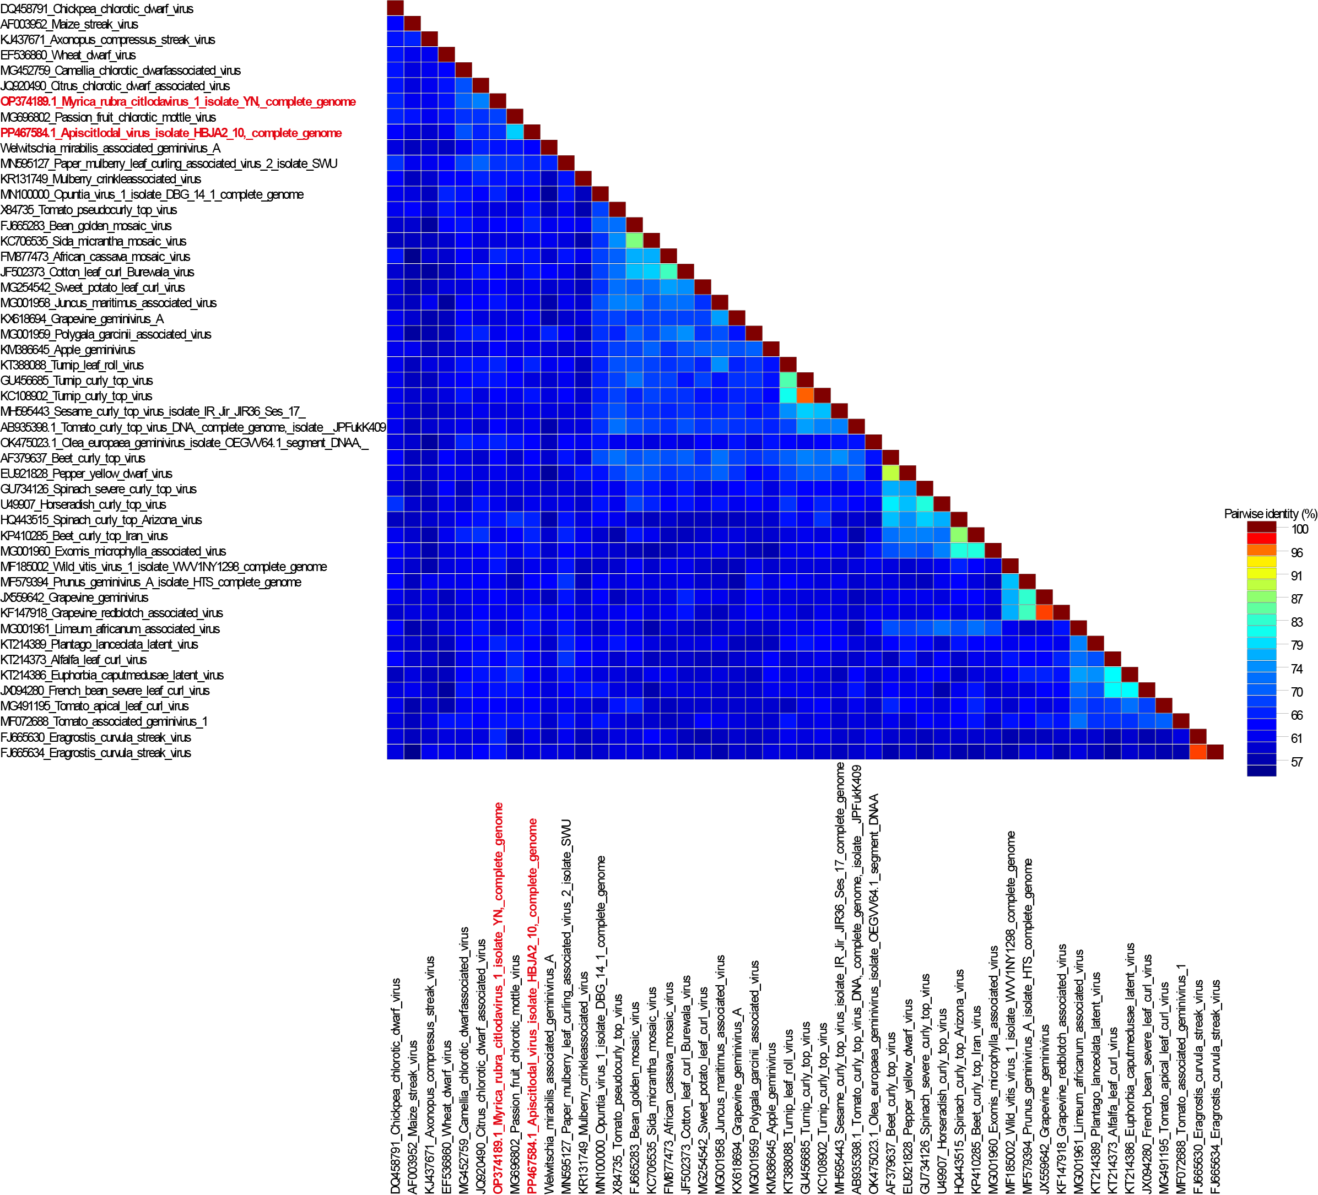

Figure 2: Unrooted neighbor-joining tree inferred from aligned full-genome nucleotide sequences of all Citlodavirus species, one species of the Mulcrilevirus genus, Citlodavirus apijamaicaense and Citlodavirus myricae. The genomes were aligned using Clustal W (Larkin et al., 2007) and a Neighbor-joining phylogenetic tree was inferred with Jukes Cantor substitution model and 1000 bootstrap iterations.

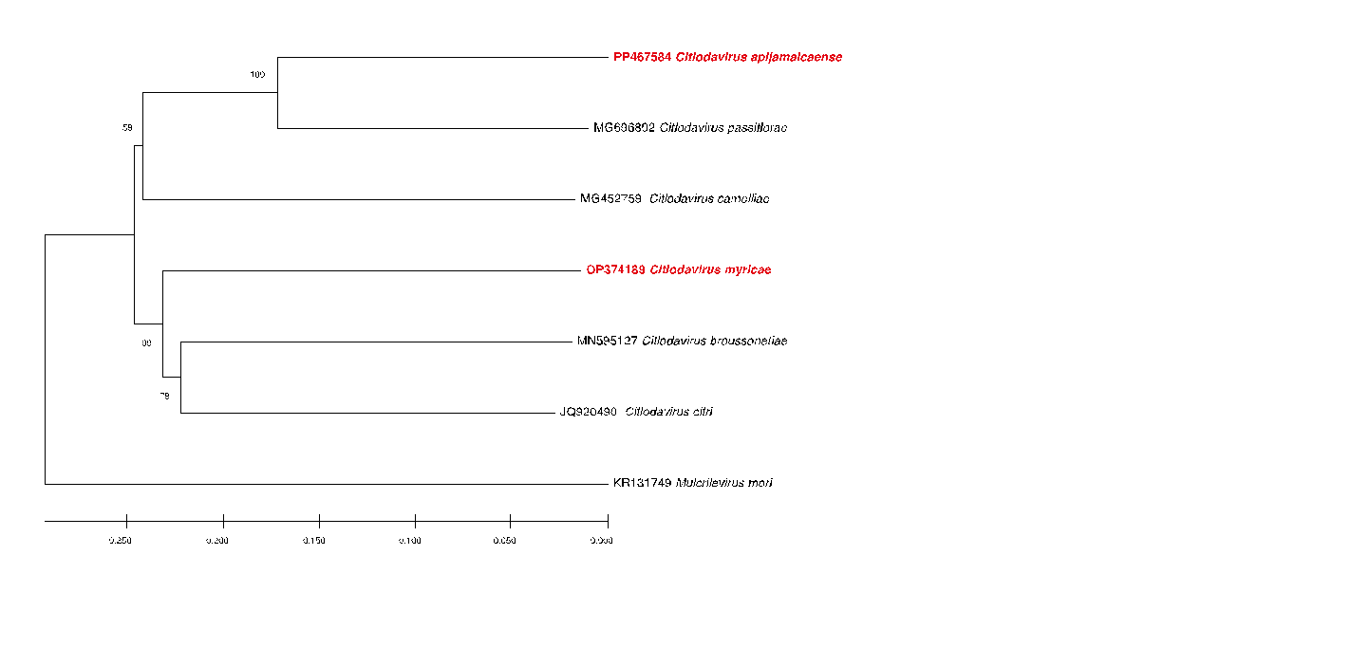
Figure 3: Illustration of the genome organization of Citlodavirus apijamaicaense and Citlodavirus myricae

