

The International Committee on Taxonomy of Viruses
Taxonomy Proposal Form, 2024

Part 1a: Details of taxonomy proposals

Title: | Create three new species in the genus Badnavirus (Ortervirales: Caulimoviridae)
Code assigned: | 2024.005P.A.v1.Caulimoviridae_3nsp

Author(s), affiliation and email address(es):
Name | Affiliation | Email address | Corresponding author(s)
Umber M | INRAe, UR ASTRO, Domaine de Duclos, 97170 Petit Bourg, Guadeloupe, France | marie.umber@inrae.fr
Dasgupta I | University of Delhi South Campus, Benito Juarez Road, New Delhi-110021, India | indranil57@hotmail.com
Geering ADW | QAAFI, The University of Queensland, St Lucia QLD 4072, Australia | a.geering@uq.edu.au
Hafrén A | Swedish University of Agriculture, Almas Allé 5, 75007 Uppsala, Sweden | anders.hafren@slu.se
Hull R | Retired from John Innes Centre | rogerhull@btinternet.com
Kreuze J | International Potato Center (CIP), Headquarters, P.O. Box 1558, Lima 15024, Peru | j.kreuze@cgiar.org
Leisner S | University of Toledo, Department of Biological Sciences, Toledo, OH. 43606, USA | scott.leisner@utoledo.edu
Muller E | CIRAD, UMR AGAP Institut, Avenue Agropolis  34398 Montpellier cedex 5, France | emmanuelle.muller@cirad.fr
Pappu H | Department of Plant Pathology, Washington State University, Pullman, WA, U.S.A | hrp@wsu.edu
Pooggin M | PHIM Plant Health Institute, Univ Montpellier, INRAE, CIRAD, IRD, Institute Agro, 34980 Montpellier, France | mikhail.pooggin@inrae.fr
Richer-Pöggeler K | Julius Kühn-Institut, Messeweg 11-12, D-38104 Braunschweig, Germany | katja.richert-poeggeler@julius-kuehn.de
Seal S | Natural Resources Institute, University of Greenwich, Central Avenue, Chatham Maritime, Kent ME4 4TB. UK | S.E.Seal@greenwich.ac.uk
Stavolone L | Institute for Sustainable Plant Protection, National Research Council, via Amendola 165/A I-70126 Bari, Italy | livia.stavolone@ipsp.cnr.it
Teycheney PY | CIRAD, UMR PVBMT, 7 chemin de l’IRAT, 97410 Saint Pierre, La Réunion, France | teycheney@cirad.fr | X

Part 1b: Taxonomy Proposal Submission <
ICTV Subcommittee:
Animal DNA Viruses and Retroviruses |  | Bacterial viruses
Animal minus-strand and dsRNA viruses |  | Fungal and protist viruses
Animal positive-strand RNA viruses |  | Plant viruses | X
Archaeal viruses |  | General

List the ICTV Study Group(s) that have seen or have been involved in creating this proposal:
Caulimoviridae

Optional – complete only if formally voted on by an ICTV Study Group:
Study Group | Number of members
Study Group | Votes in support | Votes against | No vote
Caulimoviridae | 12 | 0 | 2

Submission date: | 14/06/2024

Part 1c: Feedback from ICTV Executive Committee (EC) meeting
Executive Committee Meeting Decision code: | X
A – Accept | X
Ac – Accept subject to revision by relevant subcommittee chair. No further vote required
U – Accept without revision but with re-evaluation and email vote by the EC
Uc – Accept subject to revision and re-evaluation and email vote by the EC
Ud – Deferred to the next EC meeting, with an invitation to revise based on EC comments
J – Reject
W – Withdrawn

Comments from the Executive Committee:

Part 1d: Revised Taxonomy Proposal Submission
Response of proposer:
Revision date: | DD/MM/YYYY

Part 3: TAXONOMIC PROPOSAL

Name of accompanying Excel module:
2024.005P.A.v1.Caulimoviridae_3nsp.xlsx

Taxonomic changes proposed:
Establish new taxon | X | Split taxon
Abolish taxon |  | Merge taxon
Move taxon |  | Promote taxon
Rename taxon |  | Demote taxon
Move and rename

Is any taxon name used here derived from that of a living person? | N

Abstract of Taxonomy Proposal:
Taxonomic rank(s) affected:
Genus Badnavirus.

Description of current taxonomy:
The family Caulimoviridae [1] currently comprises 11 genera whose members share similar genome organization. The molecular species demarcation criteria is <80% identity of nucleotide sequences in the reverse transcriptase (RT) / ribonuclease H (RNase H) region of the polymerase. Genus Badnavirus [2] currently includes 71 species and is the largest genus within the family Caulimoviridae.

Proposed taxonomic change(s):
We propose the creation of three new species in the genus Badnavirus: Badnavirus fatsiae, Badnavirus tetainflatheobromae and Badnavirus zizphi.

Justification:
Complete genomes of the exemplar members of the three proposed new species were sequenced and published recently. Their organizations are similar to those of other members of genus Badnavirus. Phylogenetic analyses place them in this genus as distinct representatives of novel species.

Text of Taxonomy proposal
- Creating species Badnavirus fatsiae in the genus Badnavirus

Badnavirus fatsiae can be considered a new species in the genus Badnavirus for the following reasons:
- Its exemplar isolate, Fatsia badnavirus 1 (FaBV1, [3]), has a 7,313-bp circular double-stranded (ds) DNA genome with an organization typical of members of the genus Badnavirus, with 3 putative open reading frames (ORF1 to ORF3). ORF3 encodes a large putative polyprotein with the conserved domains of a cysteine-rich zinc finger-like RNA binding protein, a pepsin-like aspartate protease, a reverse transcriptase and an RNase H.
- The genome of FaBV1 harbors a putative tRNA^{Met} primer binding site.
- In phylogenetic analyses using the RT/RH1 domain nucleotide sequence, FaBV1 groups within the genus Badnavirus (Fig. 1). Its closest relative is Polyscias mosaic virus (PoMV, species Badnavirus tessellopolysciatis) (Table 1).
- FaBV1 displays only 67.9% nucleotide (nt) sequence identity with PoMV in the RT/RH1 domain (Table 1), which is below the species demarcation criterion of 80% nt sequence identity, justifying the classification of Badnavirus fatsiae as a separate species.
- Species name complies with the binomial nomenclature, with the free epithet derived from genus Fatsia to which FaBV’s host plant Fatsia japonica belongs.

- Creating species Badnavirus tetainflatheobromae in the genus Badnavirus
Badnavirus tetainflatheobromae can be considered a new species in the genus Badnavirus for the following reasons:
- Its exemplar isolate, cacao swollen shoot Ghana T virus (CSSGTV, Gha4-15[5]), has a 7,512 bp circular double-stranded (ds) DNA genome with an organization typical of the exemplar isolates of other cacao swollen shoot virus species, with 5 putative open reading frames (ORF1 to ORF5), including two ORFs overlapping with ORF3 [3]. ORF3 encodes a large putative polyprotein with the conserved domains of a zinc-finger, a pepsin-like aspartate protease, a reverse transcriptase and an RNase H.
- In phylogenetic analyses using the RT/RH1 domain nucleotide sequence, CSSGTV groups within the genus Badnavirus (Fig. 1). Its closest relative is cacao swollen shoot Ghana Q virus (CSSGQV, species Badnavirus epsiloninflatheobromae) (Table 1).
- CSSGTV displays only 66.7% nucleotide (nt) sequence identity with CSSGQV in the RT/RH1 domain (Table 1), which is below the species demarcation criterion of 80% nt sequence identity, justifying the classification of Badnavirus tetainflatheobromae as a separate species.
- Species name complies with the binomial nomenclature, with the free epithet derived from genus Theobroma to which CSSGTV’s host plant Theobroma cacao belongs.

- Creating species Badnavirus ziziphi in the genus Badnavirus
Badnavirus ziziphi can be considered a new species in the genus Badnavirus for the following reasons:
- Its exemplar isolate, jujube badnavirus WS (JuBWS, [6]), has a 6,450 bp circular double-stranded (ds) DNA genome. Although on the lower size range among badnaviruses, its genome has an organization typical of members of the genus Badnavirus with 3 putative open reading frames (ORF1 to ORF3). ORF3 encodes a large putative polyprotein with the conserved domain of a zinc-finger, a pepsin-like aspartate protease, a reverse transcriptase and an RNase H.
- The genome of JuBWS harbors a putative tRNA^{Met} primer binding site.
- In phylogenetic analyses using the RT/RH1 domain nucleotide sequence, JuBWS groups within the genus Badnavirus (Fig. 1). Its closest relative is Jujube mosaic-associated virus (JuMaV, species Badnavirus tesselloziziphi) (Table 1).
- JuBWS displays 76.9% nucleotide (nt) sequence identity with JuMaV in the RT/RH1 domain (Table 1), which is below the species demarcation criterion of 80% nt sequence identity, justifying the classification of Badnavirus ziziphi as a separate species.
- Species name complies with the binomial nomenclature, with the free epithet derived from genus Ziziphus to which JuBWS’ host plant Ziziphus jujuba belongs.

References:
[1] Teycheney PY, Geering ADW, Dasgupta I, Hull R, Kreuze JF, Lockhart B, Muller E, Olszewski N, Pappu H, Pooggin MM, Richert-Pöggeler KR, Schoelz JE, Seal S, Stavolone L, Umber M (2020) ICTV Virus Taxonomy Profile: Caulimoviridae. J Gen Virol. 101(10):1025-1026. https://doi.org/10.1099/jgv.0.001497
[2] Geering, A.D.W. (2021) Badnaviruses (Caulimoviridae). In: Bamford, D.H. and Zuckerman, M. (eds.)
Encyclopedia of Virology, 4th Edition, vol. 3, pp. 158–168. Oxford: Academic Press. http://dx.doi.org/10.1016/B978-0-12-814515-9.00147-8
[3] Yang Z, Chen Z, Bakht F, Li S, Zi S, Li X, Zhao X, Wen G, Zhao M (2024) Complete genome sequence of a novel badnavirus infecting Fatsia japonica in China. Arch Virol 169, 97. https://doi.org/10.1007/s00705-024-06023-5
[4] Muller E (2021). Cacao Swollen Shoot Virus (Caulimoviridae). In: Bamford, D.H. and Zuckerman, M. (eds.)
Encyclopedia of Virology, 4th Edition, vol. 3, 274-284. https://doi.org/10.1016/B978-0-12-809633-8.21295-8
[5] Liu B, Zhang G, Song D, Wang Q, Li H, Gu A, Bai J (2022) Complete genome sequence of a novel virus belonging to the genus Badnavirus in jujube (Ziziphus ujube Mill.) in China. Arch Virol 167, 1885–1888. https://doi.org/10.1007/s00705-022-05482-y

Figure 1: Phylogenetic tree showing placement of Fatsia badnavirus 1 (FaBV1; exemplar isolate of species Badnavirus fatsiae), cacao swollen shoot Ghana T virus (CSSGTV, exemplar isolate of species Badnavirus tetainflatheobromae) and jujube badnavirus WS (JuBWS, exemplar isolate of species Badnavirus zizphi).
Maximum likelihood phylogenetic tree showing the relationships between sequences of viruses from the different genera in the family Caulimoviridae. Phylogenetic analyses were performed on the coding part of polymerase gene sequences of exemplar virus isolates of each viral species, corresponding to nucleotide positions 3741–5654 in the genome of cauliflower mosaic virus (V00141). Nucleotide sequence alignment was generated using MAFFT and phylogenetic analyses was done using IQTree v. 1.7 beta with HKY model. Support values above 95% from UltraFast bootstrap method with 10,000 replicates are shown above nodes. Saccharomyces cerevisiae Ty3 virus (genus Metavirus, family Metaviridae) was used as an outgroup. Colored dots indicate genera. Type members of the proposed new species are shown with open circles and in red boxes.

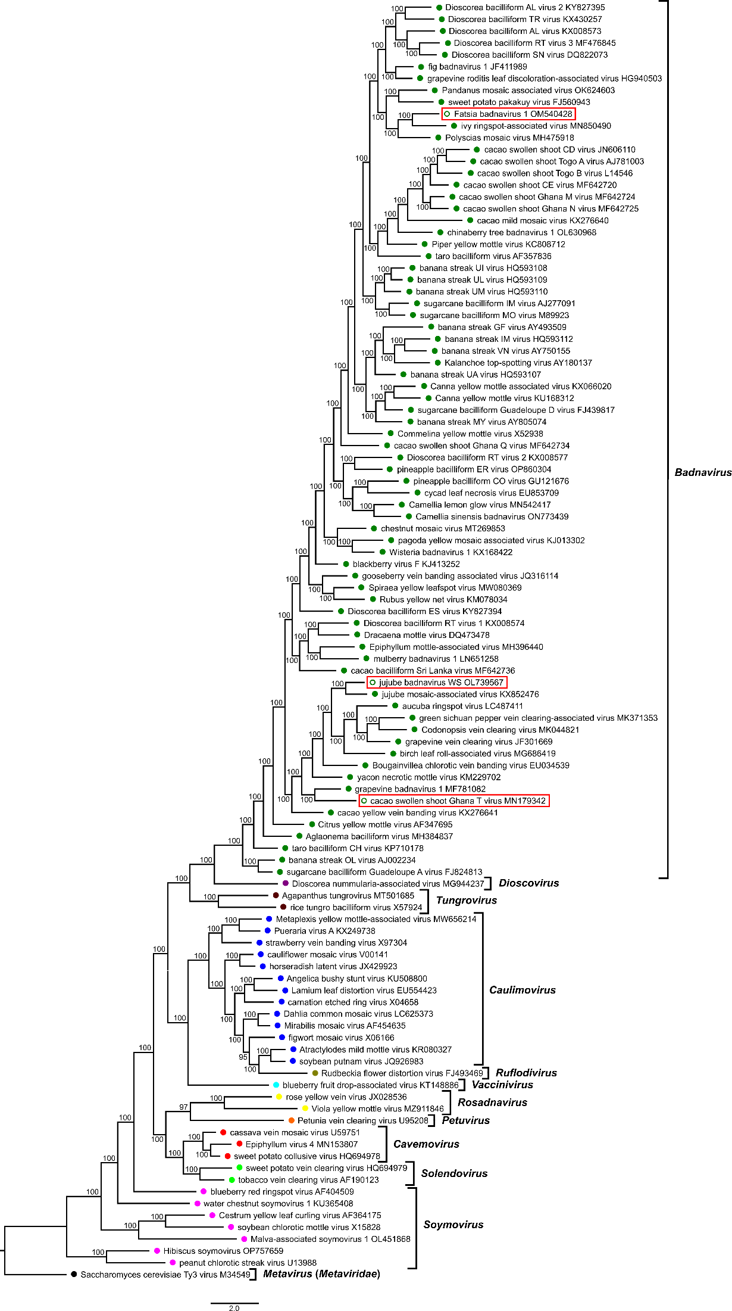
Table 1: Percent nucleotide identities for the Caulimoviridae in pol gene nucleotide sequences.
Figures corresponding to type members of the proposed new species are highlighted in orange.

