

Part 1: TITLE, AUTHORS, APPROVALS, etc

Code assigned: | 2023.031P
Short title: Create a new species in the genus Apscaviroid (Pospiviroidae)

Author(s) and email address(es)
Chiumenti M, Navarro B, Di Serio F | michela.chiumenti@ipsp.cnr.it;  beatriz.navarro@ipsp.cnr.it;  francesco.diserio@ipsp.cnr.it
Author(s) institutional address(es) (optional)
Istituto per la Protezione Sostenibile delle Piante, Consiglio Nazionale delle Ricerche, Via Amendola 122/D, 70122 - Bari, Italy
Corresponding author
Francesco Di Serio (francesco.diserio@ipsp.cnr.it)

List the ICTV Study Group(s) that have seen this proposal

Avsunviroidae and Pospiviroidae Study Group

ICTV Study Group comments and response of proposer

ICTV Study Group votes on proposal

Study Group | Number of members
Study Group | Votes support | Votes against | No vote
Avsunviroidae and Pospiviroidae | 6 | 0 | 1
Authority to use the name of a living person

Is any taxon name used here derived from that of a living person (Y/N) | N

Taxon name | Person from whom the name is derived | Permission attached (Y/N)

Submission dates
Date first submitted to SC Chair | June 23, 2023
Date of this revision (if different to above)
ICTV-EC comments and response of the proposer
Part 2: NON-TAXONOMIC PROPOSAL
Text of proposal

Part 3: TAXONOMIC PROPOSAL
Name of accompanying Excel module
2023.031P.A.v2.Pospiviroid_1nsp
Abstract
A new viroid fulfils the criteria to be classified as a member of a new species in the genus Apscaviroid. Here we propose to create the species Apscaviroid japanvitis to classify Japanese grapevine viroid reported in grapevine in Japan.

Text of proposal
Japanese grapevine viroid (JGVd) was discovered in grapevine in Japan [1], where it has been identified through high-throughput sequencing technology. The JGVd genome sequence consists of 367 nt (GenBank accession No. LC500206) with a high G+C content (60.8%), a feature typical of most viroids. The RNA adopts a compact predicted rod-like secondary structure, with most (90%) paired nucleotides, that contains the typical central conserved region (CCR) reported for all members of the genus Apscaviroid. The CCR and the flanking imperfect inverted repeat sequences form the typical hairpin I likely involved in replication of apscaviroids. Moreover, the terminal conserved region, observed in members of the genera Apscaviroid, Pospiviroid, and Coleviroid, is also present in the JGVd rod-like secondary structure [1]. JGVd is clustered in the genus Apscaviroid, close to Persimmon viroid (PVd), in a Maximum likelihood phylogenetic tree based on an alignment including the sequences of representative members of all viroid species in the family Pospiviroidae. Altogether these data support that JGVd is to be considered as a new species in the genus Apscaviroid.

The current ICTV species demarcation criteria for the genus Apscaviroid (https://ictv.global/ictv/proposals/2021.015P.R.Viroid_demarcation_criteria.pdf) establish that “Viroids with rod-like or quasi rod-like conformation, with the TCR, with the CCR identical to that of members of the other species of the genus and with less than 78% pairwise sequence identity with respect to the members of the genus are classified in different species. For viroids with pairwise identity scores close to 78% evidence of distinct biological properties should be provided.”

According with the sequence identity matrix calculated considering all the members of the genus Apscaviroid [2], JGVd has the highest pairwise sequence identity of 60.8% with a variant of PVd, thus showing values below the threshold identity score of 78% established by ICTV (Fig. 2).

Since JGVd fulfils all the criteria established by ICTV to create a new species in the genus Apscaviroid, we propose to create the species Apscaviroid japanvitis to classify this viroid in this genus.

Origin of the name of the species: The species name japanvitis derives from the country (Japan) and the host (grapevine in the genus Vitis) in which the viroid has been identified.

Supporting evidence

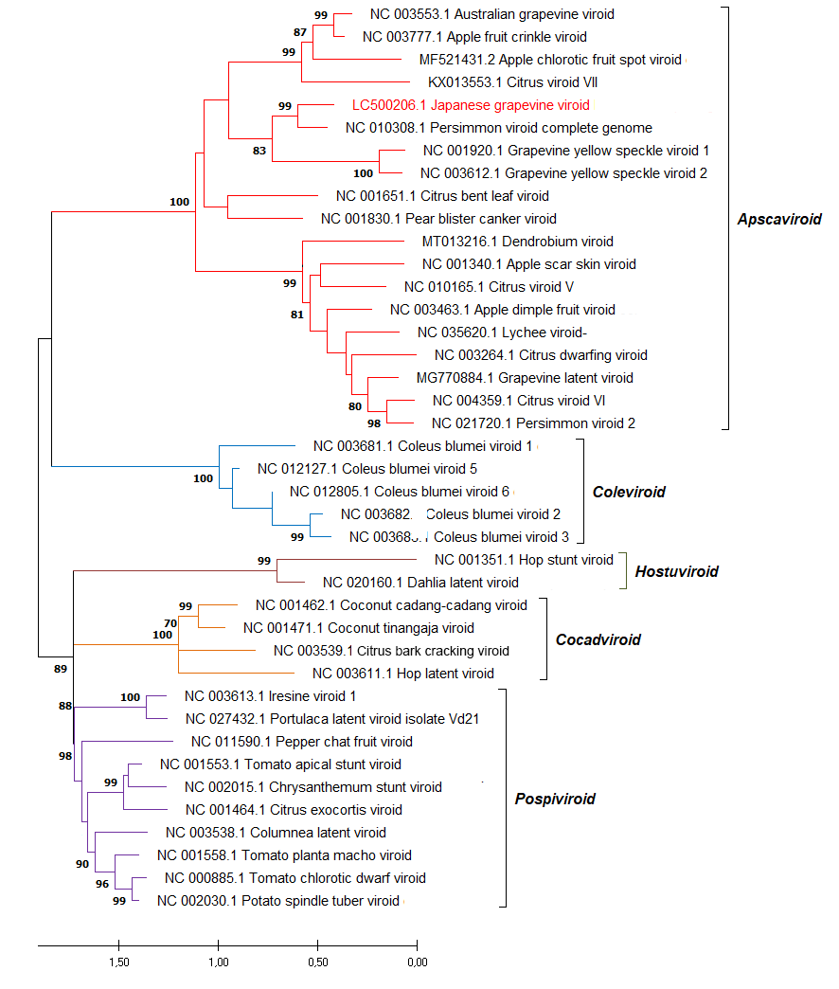

Figure 1
Maximum likelihood phylogenetic tree inferred with the reference variants of the species currently established by ICTV in the five genera of the family Pospiviroidae and Japanese grapevine viroid (in red). Bootstrap values >70 % (generated by 1,000 replicates) are shown at nodes. The tree is drawn to scale, with branch lengths measured in the number of substitutions per site.
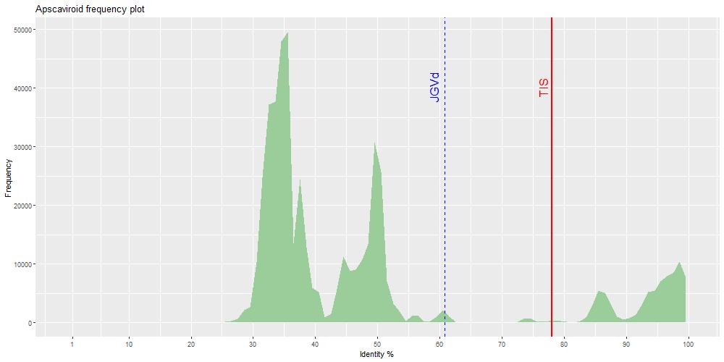

Figure 2.
Distribution of PWISs between full-length sequence variants of viroids classified in the genus Apscaviroid (family Pospiviroidae). The threshold identity score (TIS) proposed as a species demarcation criterion for the genus Apscaviroid (78%) is indicated by a red, vertical line. The maximum pairwise identity score (60,8%) calculated for Japanese grapevine viroid (JGVd) is marked by a blue, broken, vertical line.

References

- Chiaki Y, Ito T (2020) Characterization of a distinct variant of hop stunt viroid and a new apscaviroid detected in grapevines. Virus Genes 56:260-265. doi: 10.1007/s11262-019-01728-1. PMID: 31916137.
- Chiumenti M, Navarro B, Candresse T, Flores R, Di Serio F (2021) Reassessing species demarcation criteria in viroid taxonomy by pairwise identity matrices. Virus Evol. 7:veab001. doi: 10.1093/ve/veab001. PMID: 33623708; PMCID: PMC7887442.

