

Part 1: TITLE, AUTHORS, APPROVALS, etc

Code assigned: | 2023.020P
Short title: Create ten species in the genus Enamovirus (Sobelivirales:Solemoviridae)
Author(s) and email address(es)
Sõmera M | merike.somera@taltech.ee
Corresponding author
Merike Sõmera merike.somera@taltech.ee
List the ICTV Study Group(s) that have seen this proposal
Solemoviridae SG

ICTV Study Group comments and response of proposer
ICTV Study Group votes on proposal
Study Group | Number of members
Study Group | Votes support | Votes against | No vote
Solemoviridae SG | 4 |  | 0
Authority to use the name of a living person
Is any taxon name used here derived from that of a living person (Y/N) | N

Taxon name | Person from whom the name is derived | Permission attached (Y/N)

Submission dates
Date first submitted to SC Chair | June 22, 2023
Date of this revision (if different to above)
ICTV-EC comments and response of the proposer
Following the EC request to reconsider the use of acronyms as species epithets, the Study Group confirmed the decision of using the acronyms as species epithets.

Part 3: TAXONOMIC PROPOSAL
Name of accompanying Excel module
2023.020P.Uc.v1.Enamovirus_10nsp
Abstract
A search in the NCBI GenBank revealed ten new viruses which tentatively belong to the genus Enamovirus. Analysis of their genome and RdRP sequences confirms that these viruses can be recognized as the novel species in the genus Enamovirus.

The growing number of sequenced genomes is providing a basis to set and specify the numeric values for the species demarcation criteria. We propose the following sequence-based changes:

- Differences in amino acid sequence identity of RdRPs of greater than 10%;
- Differences in nucleotide sequence identity of genomes around or greater than 25%.

Text of proposal
Enamoviruses are a genetically diverse group of viruses that share several distinct characteristics:
- transmission by aphids in a persistent circulative and non-propagative manner, being highly dependent on interactions between the virus and the aphid vector;
- phloem-limited spread in the plant, lack of mechanical transmission;
- a high degree of vector specificity;
- close serological relationships between most members;
- virions are isometric, 25 to 30 nm in size;
- their genome is a single-stranded (ss) positive-sense RNA molecule of approximately 5.6 to 6.1 kb with a small genome-linked protein (VPg) covalently attached to the 5′ end of the genomic RNA (Fig. 1);
- ORF0 encodes a viral suppressor protein;
- ORF1 encodes a polyprotein that is proteolytically processed to several domains, including a serine protease and a VPg;
- ORF2 encodes a viral RdRP;
- ORF3 encodes a viral capsid protein (CP);
- ORF4 is missing;
- ORF5 encodes a read-through domain protein (RTD) via suppression of ORF3 stop codon, functioning as a viral phloem-limiting movement protein, and an aphid-transmission factor;
- enamovirus genomes are prone to recombination, therefore, many species are risen via modular evolution.

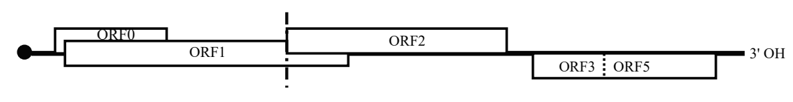
Fig.1. Typical genome organization of enamovirus genome.

For a long period, pea enation mosaic virus 1 (PEMV1) was the only known representative of enamoviruses. The current list of enamoviruses includes five species mainly isolated from agriculturally important crops. During the last decade, availability of high-throughput sequencing technologies has accelerated the discovery of new species. Our search in the NCBI GenBank database has revealed 10 more tentative species belonging to the genus Enamovirus not yet recognized by the ICTV.

Most of new viruses have the complete or near-complete genomes sequenced, and they show a genome organization characteristic of enamoviruses. Partial genomes have available for a few viruses, and these sequences show the highest identity to the enamoviral sequences.

The descriptions of these new species candidates are given as follows:

Agregatum virus 2 (AgV2) was identified from billygoat weed (Ageratum conyzoides) samples from Fuding, China in 2019 using high-throughput sequencing (HTS). The genome ends were verified with RACE. Assembled genome (OP660857) is composed of 5523 nt and has a genome organization characteristic of enamoviruses. Phylogenetic analysis of viral P1-P2 polyprotein revealed citrus vein enation virus and pepper enamovirus (the new species described herein below) as the closest relatives to AgV2 (Zhao et al. 2023).

Arracacha latent virus E (ALVE) was identified from arracacha (Arracacia xanthorrhiza) samples from Ancash, Peru using HTS. The genome ends were not verified. Assembled genome (MF136435) is composed of 4035 nt and has a genome organization characteristic of enamoviruses. Phylogenetic analysis of viral RdRPs revealed grapevine enamovirus 1 as the closest relative to ALVE. Leafhoppers (Empoasca spp.) found colonizing arracacha field at CIP la Molina station were positive for ALVE by PCR. Subsequent attempts to transmit ALVE to indicator plants failed (De Souza et al. 2021).

Bean enamovirus 1 (BEV1) was identified from common bean (Phaseolus vulgaris) samples from Kunming, China (Yunnan province) in 2022 using HTS. The genome ends were not verified. Assembled genome (MZ361924) is composed of 5781 nt and has a genome organization characteristic of enamoviruses. Phylogenetic analysis revealed alfalfa enamovirus 1 and pea enation mosaic virus 1 as the closest relatives to BEV1 (Lu et al. 2022).

Black pepper virus E (BPVE) was identified from black pepper (Piper nigrum) samples from the Xinglong Tropical Botanical Garden, Hainan, China in 2019 using HTS. The genome ends were verified with RACE. Assembled genome (MZ702869) is composed of 5656 nt and has a genome organization characteristic of enamoviruses. Phylogenetic analysis of P1-P2 and CP sequences revealed citrus vein enation virus and pepper enamovirus (the new species described herein below) as the closest relatives to BPVE (Ma et al. 2022).

Celmisia lyallii enamovirus (ClEV) was identified from publicly available plant transcriptome of Celmisia lyallii collected in New Zealand. The genome ends were not verified. Assembled genome (BK059370) is composed of 5639 nt and has a genome organization characteristic of enamoviruses. Phylogenetic tree constructed based on the P1–P2 sequences grouped ClEV with citrus vein enation virus and pepper enamovirus (the new species described herein below) (Kavi Sidhartan et al .2022).

Green Sichuan pepper enamovirus (GSPEV) was identified from green Sichuan pepper (Zanthoxylum armatum) collected from China in 2017 using HTS. The genome ends were not verified. Assembled genome (MH323436) is composed of 5587 nt and has a genome organization characteristic of enamoviruses. The phylogenetic analysis of the RdRP sequences grouped GSPEV and grapevine enamovirus 1 in a branch separated from a cluster of other enamoviruses (Cao et al 2019).

Kummerowia striata enamovirus (KSEV) was identified from Japanese clover (Kummerowia striata) growing in Zhenjiang ancient canal ecosystem in Jiangsu province, China in 2019 using HTS. Assembled partial genome (MN814310) is composed of 4463 nt and it is phylogenetically related to enamoviruses (Yang et al 2022).

Pepper enamovirus (PeEV) was identified from chili pepper (Capsicum sp.) collected in Rwanda in 2016 using HTS. Assembled genome (MG470803) is composed of 5656 nt and it is phylogenetically related to enamoviruses (Skeleton et al. 2018).

Plantago enamovirus (PlEV) was identified from ribwort plantain (Plantago lanceolata) collected in the Åland Islands, South-West Finland in 2013 using HTS combined with PCR. Sequenced genome fragment (MH397359) is composed of 887 nt and it is phylogenetically related to grapevine enamovirus 1. PlEV was transmitted to Chenopodium quinoa via mechanical transmission but not by the rosy apple aphid Dysaphis plantaginea (Susi et al. 2019). The sequenced fragment shows the highest percentage of identities (65.6%) to the sequence of grapevine enamovirus 1 isolate SE-BR (KY820716) with 59% of query coverage in BLASTN analysis performed at the NCBI website.

Red clover enamovirus 1 (RCEV1) was identified from green pea (Pisum sativum) and non-crop perennial legumes collected in Germany Landkeis Meissen and Münster in 2016/2017. Assembled genome (MN412742) is composed of 5809 nt and has a genome organization characteristic of enamoviruses. Also, the sequence is phylogenetically related to enamoviruses (Gaafar et al. 2020).

The species demarcation criteria for genus Enamovirus are following:

• Differences in breadth and specificity of host range;
• Failure of cross-protection in either one-way or two-way relationships;
• Differences in serological specificity with discriminatory polyclonal or monoclonal antibodies;
• Differences in amino acid sequence identity of any gene product of greater than 10%.

Here, we have aligned the nucleotide sequences of their genomes and amino acid sequences of their RNA-directed RNA polymerases (RdRPs; encoded by the most conserved ORF) translated from ORF2 starting with ribosomal frameshift site.

Identity percentages seen between their RdRPs confirm they all share less than 90% of identity, that is consistent with novel species demarcation criteria (Table 1).

The lowest identity percentages between the genome sequences were seen for two new viruses— Kummerowia striata enamovirus and Arracacha latent virus E—which may be related to alignment of their partial genome sequences with the sequences of other viruses covering the complete or near-complete genomes (Table 2). The highest identity percentage exceed up to 75%, seen for the cluster of legume-infecting viruses (Fig. 1).

The growing number of sequenced genomes is providing a basis to set and specify the numeric values for the species demarcation criteria. Regarding that, we propose to change and set additional criteria for the species demarcation in the genus Enamovirus:

• Differences in breadth and specificity of host range;
• Failure of cross-protection in either one-way or two-way relationships;
• Differences in serological specificity with discriminatory polyclonal or monoclonal antibodies;
• Differences in amino acid sequence identity of RdRPs of greater than 10%;
• Differences in nucleotide sequence identity of genomes around or greater than 25%.

Taxonomic binominal species names are presented in an accompanying Excel module (2023.020P.N.v1.Enamovirus_10nsp).

Supporting evidence
Table 1. Identity percentages seen between amino acid sequences of viral RdRPs translated from ORF2 extracted from the genomes of recognized and tentative new enamoviruses. Multiple sequence alignment was obtained using MUSCLE algorithm.

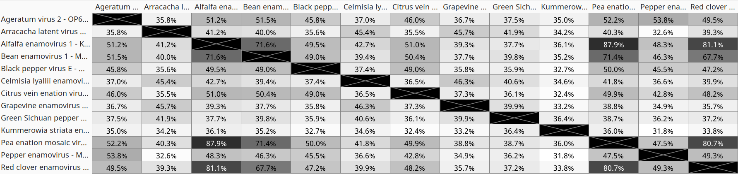

Table 2. Identity percentages seen between nucleotide sequences of viral genomes of recognized and tentative new enamoviruses retrieved from NCBI GenBank. Multiple sequence alignment was obtained using MUSCLE algorithm.

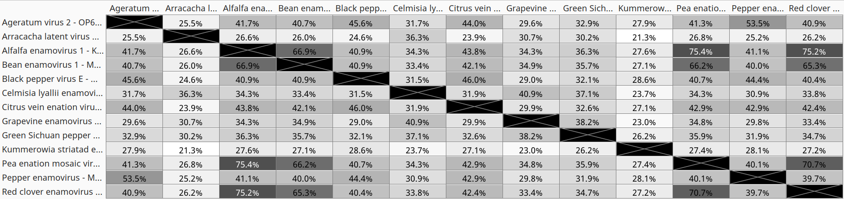

Fig. 1. Phylogenetic tree base on multiple alignment of viral RdRP sequences generated using Neighbor-Jointing Method. Branch labels indicate substitutions per site.

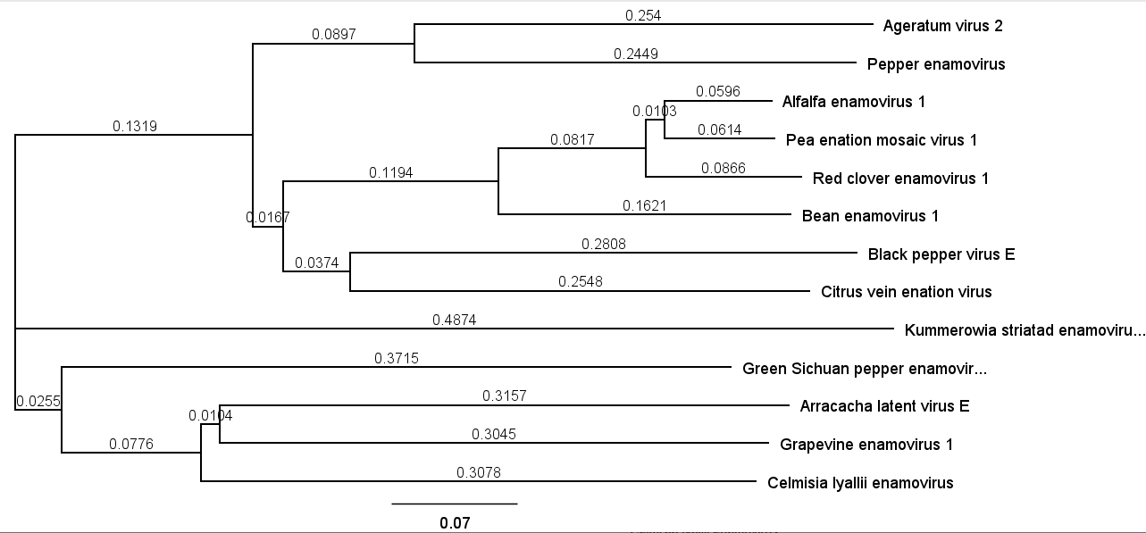
References

Zhao F, Li J, Hao X, Liu H, Qiao Q, Wang S, Tian Y, Wang Y, Zhang D, Zhang Z (2023) Genomic characterization of two new viruses infecting Ageratum conyzoides in China. Arch Virol 168:55. DOI: 10.1007/s00705-023-05781-y. PMID: 37145192

De Souza et al (2021) High throughput sequencing for the detection and characterization of new virus found in arracacha (Arracacia xanthorrhiza). Scientia Agropecuaria vol.12 no.4 Trujillo oct./dic. 2021
DOI: 10.17268/sci.agropecu.2021.051

Lu RB, Lan PX, Kang RJ, Tan GL, Chen XJ, Li R, Li F(2022) Genomic characterization of a new enamovirus infecting common bean. Arch Virol. 167:999-1002. DOI: 10.1007/s00705-022-05387-w. PMID: 35142942

Ma Y, Xing F, Che H, Gao S, Lin Y, Li S (2022) The Virome of Piper nigrum: Identification, Genomic Characterization, Prevalence, and Transmission of Three New Viruses of Black Pepper in China. Plant Dis 106:2082-2089. DOI: 10.1094/PDIS-12-21-2692-RE. PMID: 35253482

Kavi Sidharthan V, Nagendran K, Baranwal VK (2022) Exploration of plant transcriptomes reveals five putative novel poleroviruses and an enamovirus. Virus Genes 58:244-253. DOI: 10.1007/s11262-022-01896-7. PMID: 35347589

Cao M, Zhang S, Li M, Liu Y, Dong P, Li S, Kuang M, Li R, Zhou Y (2019) Discovery of Four Novel Viruses Associated with Flower Yellowing Disease of Green Sichuan Pepper (Zanthoxylum Armatum) by Virome Analysis. Viruses 11:696. DOI: 10.3390/v11080696. PMID: 31370205

Yang S, Mao Q, Wang Y, He J, Yang J, Chen X, Xiao Y, He Y, Zhao M, Lu J, Yang Z, Dai Z, Liu Q, Yao Y, Lu X, Li H, Zhou R, Zeng J, Li W, Zhou C, Wang X, Shen Q, Xu H, Deng X, Delwart E, Shan T, Zhang W (2022). Expanding known viral diversity in plants: virome of 161 species alongside an ancient canal. Environ Microbiome 17:58. DOI: 10.1186/s40793-022-00453-x. PMID: 36437477

Skeleton et al (2018) First report of Pepper veinal mottle virus, Pepper yellows virus and a novel enamovirus in chilli pepper (Capsicum sp.) in Rwanda. New Dis Rep 37:5. DOI: 10.5197/j.2044-0588.2018.037.005

Susi H, Filloux D, Frilander MJ, Roumagnac P, Laine AL (2019) Diverse and variable virus communities in wild plant populations revealed by metagenomic tools. PeerJ. 7:e6140. DOI: 10.7717/peerj.6140. PMID: 30648011

Gaafar YZA, Herz K, Hartrick J, Fletcher J, Blouin AG, MacDiarmid R, Ziebell H (2020) Investigating the Pea Virome in Germany-Old Friends and New Players in the Field(s). Front Microbiol 11:583242. DOI: 10.3389/fmicb.2020.583242. PMID: 33281777

