

Part 1: TITLE, AUTHORS, APPROVALS, etc

Code assigned: | 2023.018P
Short title: Create 16 new species in the family Secoviridae (Picornavirales)
Author(s) and email address(es)
Fuchs M, Hily J-M, Petrzik K, Sanfaçon H, Thompson J, van der Vlugt R, Wetzel T | mf13@cornell.edu; Jean-Michel.HILY@vignevin.com; petrzik@umbr.cas.cz; helene.sanfacon@agr.gc.ca; jeremy.thompson@mpi.govt.nz; rene.vandervlugt@wur.nl; thierry.wetzel@drl.rlp.de
Author(s) institutional address(es) (optional)

Cornell University (MF)
IFV (JMH)
Institute of Plant Molecular Biology (KP)
Agriculture and Agri-Food Canada (HS)
Ministry for Primary Industries (JT)
Wageningen University (RvdV)
DLR Rheinpfalz (TW)
Corresponding author
Marc Fuchs, mf13@cornell.edu
List the ICTV Study Group(s) that have seen this proposal

ICTV Plant Viruses Subcommittee
Secoviridae Study Group

ICTV Study Group comments and response of proposer

ICTV Study Group votes on proposal

Study Group | Number of members
Study Group | Votes support | Votes against | No vote
Secoviridae Study Group | 6 | 0 | 1
Authority to use the name of a living person

Is any taxon name used here derived from that of a living person (Y/N) | N

Taxon name | Person from whom the name is derived | Permission attached (Y/N)

Submission dates
Date first submitted to SC Chair | June, 26 2023
Date of this revision (if different to above)
ICTV-EC comments and response of the proposer
Part 2: NON-TAXONOMIC PROPOSAL
Text of proposal

Part 3: TAXONOMIC PROPOSAL
Name of accompanying Excel module
2023.018P.A.v1.Secoviridae _16nsp.xlsx
Abstract

This taxonomic proposal considers the recognition of 16 new virus species (Table 1) based on species demarcation criteria in the family Secoviridae of less than 75% amino acid sequence identity in the coat protein(s) and/or less than 80% amino acid sequence identity in the conserved Pro-Pol region (from the protease CG motif to the polymerase GDD motif), and/or distinct plant hosts and biological properties:
- Cheravirus alpinum, Cheravirus trillii, and Cheravirus orobanchis in the genus Cheravirus
- Fabavirus gynostemmae, Fabavirus yuccae, and Fabavirus avii in the genus Fabavirus
- Sadwavirus gammananas in the genus Sadwavirus
- Stralarivirus elaterii in the genus Stralarivirus
- Torradovirus erigeronis in the genus Torradovirus
- Nepovirus alphaparis, Nepovirus carolinense, Nepovirus fontinalis, Nepovirus lonchitis, and Nepovirus vittariae in the genus Nepovirus
- Waikavirus lactucae, and Waikavirus rhododendri in the genus Waikavirus
Text of proposal
Creation of a first novel species in the genus Cheravirus of the family Secoviridae. The complete genome sequence of alpine wild prunus virus (AWPV) was determined from two wild Prunus species (P. brigantina, P. mahaleb) and one apricot (P. armeniaca) accession by high-throughput sequencing [1]. The 5’ and 3’ ends of the bipartite genome were characterized by RACE or poly(A)-anchored PCR. The full-length RNA1 of AWPV isolate Pm from P. mahaleb is 7,491 nt long (GenBank acc. no. OP328249), and the RNA2 is 3,568 nt long (GenBank acc. no. OP328250), excluding the poly(A) tail. The genome organization of AWPV is similar to those of other members of the genus Cheravirus in the family Secoviridae (Figure 1). The three CPs and the conserved Pro-Pol region of AWPV have 45.3% and 89.2% amino acid sequence identity with Orobanche cernua secovirus (OcSV, member of the proposed new species Cheravirus orobanchis, see below), the closest related virus in the genus Cheravirus. ML phylogenetic trees generated using the CPs (Figure 2) and conserved Pro-Pol (Figure 3) sequences of AWPV and representative members of the family Secoviridae confirmed the clustering of AWPV in the genus Cheravirus. Considering the species demarcation criteria for the family Secoviridae, we propose to classify alpine wild prunus virus (AWPV) as a member of a novel species named Cheravirus alpinum in the genus Cheravirus of the family Secoviridae (Table 1).

Creation of a second novel species in the genus Cheravirus of the family Secoviridae.
The complete coding sequence of the genome of Trillium govanianum cheravirus (TgCV) was determined from Trillium govanianum, a medicinal herb native to the Himalayas, by transcriptome library data mining [2]. The RNA1 and RNA2 sequences of TgCV isolate India that were characterized were 7,081 nt (GenBank acc. no. BK013325) and 3,503 nt (full-length coding region) (GenBank acc. no. BK013326) long, respectively. The genome organization of TgCV is similar to those of other members of the genus Cheravirus in the family Secoviridae (Figure 1). The three CPs and the conserved Pro-Pol region of TgCV have 41% and 86% amino acid sequence identity with alpine wild prunus virus (AWPV, member of the proposed new species Cheravirus alpinum, see above), the closest related virus in the genus Cheravirus. ML phylogenetic trees generated using the CPs (Figure 2) and conserved Pro-Pol (Figure 3) sequences of TgCV and representative members of the family Secoviridae confirmed the clustering of TgCV in the genus Cheravirus. Considering the species demarcation criteria for the family Secoviridae, we propose to classify Trillium govanianum cheravirus (TgCV) as a member of a novel species named Cheravirus trillii in the genus Cheravirus of the family Secoviridae (Table 1).

Creation of a third novel species in the genus Cheravirus of the family Secoviridae. The complete coding sequence of the genome of Orobanche cernua secovirus (OcSV) was determined from Orobanche cernua var. cumana, a species of herb, by transcriptome data mining [3]. The incomplete RNA1 of OcSV isolate China is 6,841 nt (GenBank acc. no. BK061326) in size and encodes a 255 kDa polyprotein, while the incomplete RNA2 is of 3,481 nt (GenBank acc. no. BK061327) in size and encodes a 117 kDa polyprotein. The genome organization of OcSv is similar to those of other members of the genus Cheravirus in the family Secoviridae (Figure 1). The three CPs and the conserved Pro-Pol region of OcSV have 71.3% and 89.4% amino acid sequence identity with alpine wild prunus virus (AWPV, member of the proposed new species Cheravirus alpinum, see above), the closest related virus in the genus Cheravirus. ML phylogenetic trees generated using the CPs (Figure 2) and conserved Pro-Pol (Figure 3) sequences of OcSV and representative members of the family Secoviridae confirmed the clustering of OcSV in the genus Cheravirus. Considering the species demarcation criteria for the family Secoviridae, we propose to classify Orobanche cernua secovirus (OcSV) as a member of a novel species named Cheravirus orobanchis in the genus Cheravirus of the family Secoviridae (Table 1).

Creation of a first novel species in the genus Fabavirus of the family Secoviridae. The complete coding sequence of the genome of Gynostemma pentaphyllum secovirus (GpSV) was determined from Gynostemma pentaphyllum, a climbing vine, by transcriptome data mining [3]. The incomplete RNA1 of GpSV isolate China is 5,704 nt (GenBank acc. No. BK061324) in size and encodes a 205 kDa polyprotein, while the incomplete RNA2 is of 3,061 nt (GenBank acc. No. BK061325) in size and encodes a 112 kDa polyprotein. The genome organization of GpSV is similar to those of other members of the genus Fabavirus in the family Secoviridae (Figure 1). The two CPs and the conserved Pro-Pol region of GpSV have 72.6% and 79.9% amino acid sequence identity with cucurbit mild mosaic virus (CuMMV, member of the species Fabavirus boehmeriaae), the closest related virus in the genus Fabavirus. ML phylogenetic trees generated using the two CPs (Figure 2) and conserved Pro-Pol (Figure 3) sequences of GpSV and representative members of the family Secoviridae confirmed the clustering of GpSV in the genus Fabavirus. Considering the species demarcation criteria for the family Secoviridae, we propose to classify Gynostemma pentaphyllum secovirus (GpSV) as a member of a novel species named Fabavirus gynostemmae in the genus Fabavirus of the family Secoviridae (Table 1).

Creation of a second novel species in the genus Fabavirus of the family Secoviridae. The complete coding sequence of the genome of yucca gloriosa secovirus (YgSV) was determined in Yucca gloriosa, an evergreen shrub, by transcriptome data mining [3]. The incomplete RNA1 of YgSV isolate VFLL015B is 6,309 nt (GenBank acc. No. BK061335) in size and encodes a 205 kDa polyprotein, while the incomplete RNA2 is of 5,477 nt (GenBank acc. No. BK061336) in size and encodes a 112 kDa polyprotein. The genome organization of YgSV is similar to those of other members of the genus Fabavirus in the family Secoviridae (Figure 1). The two CPs and the conserved Pro-Pol region of YgSV have 23.8% and 50.8% amino acid sequence identity with gentian mosaic virus (GeMV, member of the species Fabavirus gentianae), respectively, the closest related viruses in the genus Fabavirus. ML phylogenetic trees generated using the CPs (Figure 2) and conserved Pro-Pol (Figure 3) sequences of YgSV and representative members of the family Secoviridae confirmed the clustering of YgSV in the genus Fabavirus. Considering the species demarcation criteria for the family Secoviridae, we propose to classify yucca gloriosa secovirus (YgSV) as a member of a novel species named Fabavirus yuccae in the genus Fabavirus of the family Secoviridae (Table 1).

Creation of a third novel species in the genus Fabavirus of the family Secoviridae. The complete coding sequence of the genome of cherry virus F (CVF) was determined in sweet cherry (Prunus avium) cv. Tragana-edessis and sour cherry (P. cerasus) cv. Rannaja by high-throughput sequencing [4]. The full-length RNA1 of CVF isolate Stac-3B_C12 is 6,166 nt long (GenBank acc. No. MH998210), and the near complete RNA2 is 4,083 nt long (GenBank acc. No. MH998217), excluding the poly(A) tail. The genome organization of CVF is similar to those of other members of the genus Fabavirus in the family Secoviridae (Figure 1). The two CPs and the conserved Pro-Pol region of CVF have 58.4% and 82.2% amino acid sequence identity with prunus virus F (PrVF, member of the species Fabavirus pruni), the closest related virus in the genus Fabavirus. ML phylogenetic trees generated using the CPs (Figure 2) and conserved Pro-Pol (Figure 3) sequences of CVF and representative members of the family Secoviridae confirmed the clustering of CVF in the genus Fabavirus. Considering the species demarcation criteria for the family Secoviridae, we propose to classify cherry virus F (CVF) as a member of a novel species named Fabavirus avii in the genus Fabavirus of the family Secoviridae (Table 1).

Creation of a novel species in the genus Sadwavirus, subgenus Cholivirus, of the family Secoviridae. The complete coding sequence of the genome of Ananas comosus secovirus (AcSV) was determined from Ananas comosus by transcriptome data mining [3]. The incomplete RNA1 of AcSV isolate Yellow Mauritius 1 is 6,405 nt (GenBank acc. no. BK061318) in size and encodes a 215 kDa polyprotein, while the incomplete RNA2 is of 3,863 nt (GenBank acc. no. BK061319) in size and encodes a 127 kDa polyprotein. The genome organization of AcSV is similar to those of other members of the genus Sadwavirus in the family Secoviridae (Figure 1). The CP and the conserved Pro-Pol region of AcSV have 84.6% and 55.9% amino acid sequence identity with pineapple secovirus B (PSVB, member of the species Sadwavirus betananas), respectively, the closest related viruses in the genus Sadwavirus. ML phylogenetic trees generated using the CP (Figure 2) and conserved Pro-Pol (Figure 3) sequences of AcSV and representative members of the family Secoviridae confirmed the clustering of AcSV in the genus Sadwavirus. Considering the species demarcation criteria for the family Secoviridae, we propose to classify Ananas comosus secovirus (AcSV) as a member of a novel species named Sadwavirus gammananas of the family Secoviridae (Table 1).

Creation of a novel species in the genus Stralarivirus of the family Secoviridae. The complete coding sequence of the genome of cohombrillo-associated virus (CoAV) was determined in Ecballium elaterium, the quirting cucumber, by high-throughput sequencing [5]. The near complete RNA1 of CoAV isolate ES is 6,934 nt (GenBank acc. no. OP019481) in size and encodes a 240 kDa polyprotein, while the incomplete RNA2 is of 3,501 nt (GenBank acc. no. OP019482) in size and encodes a 104 kDa polyprotein. The genome organization of CoAV is similar to those of other members of the genus Stralarivirus in the family Secoviridae (Figure 1). The two CPs and the conserved Pro-Pol region of CoAV have 39% and 54% amino acid sequence identity with strawberry latent ringspot virus (SLRSV, member of the species Stralarivirus fragariae), respectively, the closest related viruses in the genus Stralarivirus. ML phylogenetic trees generated using the CPs (Figure 2) and conserved Pro-Pol (Figure 3) sequences of CoAV and representative members of the family Secoviridae confirmed the clustering of CoAV in the genus Stralarivirus. Considering the species demarcation criteria for the family Secoviridae, we propose to classify cohombrillo-associated virus (CoAV) as a member of a novel species named Stralarivirus elaterii of the family Secoviridae (Table 1).

Creation of a first species in the genus Torradovirus of the family Secoviridae. The complete genome sequence of fleabane yellow mosaic virus (FbYMV) was determined in Erigeron annuus, a flowering plant, by high-throughput sequencing [6]. The complete RNA1 of FbYMV isolate 2007-12EA is 7,133 nt (GenBank acc. no. OL979629) in size and encodes a 248 kDa polyprotein, while the complete RNA2 is of 4,810 nt (GenBank acc. no. OL979630) in size and encodes a 139 kDa polyprotein with an overlapping open reading frame of 23 kDa protein at the N-terminus. The genome organization of FbYMV is similar to those of other members of the genus Torradovirus in the family Secoviridae (Figure 1). The three CPs and the conserved Pro-Pol region of FbYMV have 49% and 67% amino acid sequence identity with carrot torradovirus 1 (CaTV1, member of the species Torradovirus carotae), respectively, the closest related viruses in the genus Torradovirus. Considering the species demarcation criteria for the family Secoviridae, we propose to classify fleabane yellow mosaic virus (FbYMV) as a member of a novel species named Torradovirus erigeronis of the family Secoviridae (Table 1).

Creation of a first novel species in the genus Nepovirus of the family Secoviridae. The complete coding sequence of the genome of paris nepovirus 1 (ParNV1) was determined in Paris yunnanensis, a flowering plant, by high -throughput sequencing [7]. The near complete RNA1 of ParNV-1 isolate YLJ is 7,339 nt (GenBank acc. no. OP374158) in size and encodes a 255 kDa polyprotein, while the near complete RNA2 is of 4,620 nt (GenBank acc. no. OP374159) in size and encodes a 153 kDa polyprotein. The genome organization of ParNV-1 is similar to those of other members of the genus Nepovirus in the family Secoviridae (Figure 1). The CP and conserved Pro-Pol region of ParNV-1 have 43% and 67% amino acid sequence identity with horse nettle virus A (HNVA, member of the proposed new species Nepovirus carolinense, see below), respectively, the closest related virus in the genus Nepovirus. Considering the species demarcation criteria for the family Secoviridae, we propose to classify Paris nepovirus 1 (ParNV-1) as a member of a novel species named Nepovirus alphaparis of the family Secoviridae (Table 1).

Creation of a second novel species in the genus Nepovirus of the family Secoviridae. The complete genome sequence of horse nettle virus A (HNVA) was determined in Solanum carolinense, a perennial herbaceous plant, by high-throughput sequencing [8]. The complete RNA1 of HNVA isolate MD-1 is 7,522 nt (GenBank acc. no. OP292294) in size and encodes a 258 kDa polyprotein, while the complete coding sequence of RNA2 is of 4,710 nt (GenBank acc. no. OP292295) in size and encodes a 150 kDa polyprotein. The genome organization of HNVA is similar to those of other members of the genus Nepovirus in the family Secoviridae (Figure 1). The CP and conserved Pro-Pol region of HNVA have 52% and 67% amino acid sequence identity with potato virus B (PVB, member of the species Nepovirus betasolani), respectively, the closest related virus in the genus Nepovirus. Considering the species demarcation criteria for the family Secoviridae, we propose to classify horse nettle virus (HNVA) as a member of a novel species named Nepovirus carolinense of the family Secoviridae (Table 1).

Creation of a third novel species in the genus Nepovirus of the family Secoviridae. The complete coding sequence of the genome of common water moss secovirus (CwmSV) was determined in Fontinalis antipyretica, a water moss, by transcriptome mining [9]. The incomplete RNA1 of CwmSV isolate ERR2040966 is 7,057 nt (GenBank acc. no. OX380383) in size and the incomplete RNA2 is 4,366 nt (GenBank acc. no. OX380442) in size. The genome organization of CwmSV is similar to those of other members of the genus Nepovirus in the family Secoviridae (Figure 1). The CP and conserved Pro-Pol region of CwmSV have 31% and 68% amino acid sequence identity with grapevine Bulgarian latent virus (GBLV, member of the species Nepovirus bulgariense), respectively, the closest related virus in the genus Nepovirus. Considering the species demarcation criteria for the family Secoviridae, we propose to classify common water moss secovirus (CwmSV) as a member of a novel species named Nepovirus fontinalis of the family Secoviridae (Table 1).

Creation of a fourth novel species in the genus Nepovirus of the family Secoviridae. The complete coding sequence of the genome of tomato fern secovirus (TfSV) was determined in Lonchitis hirsuta, a fern, by transcriptome mining [9]. The incomplete RNA1 of TfSV isolate ERR2041189 is 6,489 nt (GenBank acc. no. OX380481) in size, while the near complete RNA2 is 7,061 nt (GenBank acc. no. OX380490) in size. The genome organization of TfSV is similar to those of other members of the genus Nepovirus in the family Secoviridae (Figure 1). The CP and conserved Pro-Pol region of TfSV have 84% and 77% amino acid sequence identity with tomato shoestring fern secovirus (SfSV, member of the proposed new species Nepovirus vittariae, see below), respectively, the closest related virus in the genus Nepovirus. Considering the species demarcation criteria for the family Secoviridae, we propose to classify tomato fern secovirus (TfSV) as a member of a novel species named Nepovirus lonchitis of the family Secoviridae (Table 1).

Creation of a fifth novel species in the genus Nepovirus of the family Secoviridae. The complete coding sequence of the genome of shoestring fern secovirus (SfSV) was determined in Vittaria lineata, a fern, by transcriptome mining [9]. The incomplete RNA1 of SfSV isolate ERR2040940 is 6,485 nt (GenBank acc. no. OX380465) in size, while the near complete RNA2 is 5,719 nt (GenBank acc. no. OX380478) in size. The genome organization of SfSV is similar to those of other members of the genus Nepovirus in the family Secoviridae (Figure 1). The CP and conserved Pro-Pol region of SfSV have 84% and 77% amino acid sequence identity with tomato fern secovirus (TfSV, member of the proposed new species Nepovirus lonchitis, see above), respectively, the closest related virus in the genus Nepovirus. Considering the species demarcation criteria for the family Secoviridae, we propose to classify shoestring fern secovirus (SfSV) as a member of a novel species named Nepovirus vittariae of the family Secoviridae (Table 1).

Creation of a first novel species in the genus Waikavirus of the family Secoviridae. The complete genome sequence of lettuce waikavirus 1 (LWV1) was determined in Lactuca sativa by high-throughput sequencing and RACE PCR [10]. The complete RNA sequence of isolate JG1 is 11,929 nt (GenBank acc. no. MT348710) in size and encodes a 389 kDa polyprotein with an overlapping open reading frame coding a 9.7 kDa protein at the N-terminus. The genome organization of LWV1 is similar to those of other members of the genus Waikavirus in the family Secoviridae (Figure 1). The CP and conserved Pro-Pol region of LWV1 have 53% and 61% amino acid sequence identity with red clover-associated virus 1 (RCaV1, member of the species Waikavirus trifolii), respectively, the closest related virus in the genus Waikavirus. Considering the species demarcation criteria for the family Secoviridae, we propose to classify lettuce waikavirus 1 (LWV1) as a member of a novel species named Waikavirus lactucae of the family Secoviridae (Table 1).

Creation of a second novel species in the genus Waikavirus of the family Secoviridae. The complete coding sequence of the of Rhododendron delavayi secovirus (RdSV) was determined in the ornamental Rhododendron delavayi, by transcriptome data mining [3]. The complete RNA sequence of isolate Kun Ming is 12,434 nt (GenBank acc. no. BK061334) in size and encodes a 422 kDa polyprotein. The genome organization of RdSV is similar to those of other members of the genus Waikavirus in the family Secoviridae (Figure 1). The CP and conserved Pro-Pol region of RdSV have 34% and 53% amino acid sequence identity with poaceae Liege virus 1 (PolV1, member of the species Waikavirus liegense), respectively, the closest related virus in the genus Waikavirus. Considering the species demarcation criteria for the family Secoviridae, we propose to classify Rhododendron delavayi secovirus (RdSV) as a member of a novel species named Waikavirus rhododendri of the family Secoviridae (Table 1).

Supporting evidence

Table 1: List of newly proposed virus species in the family Secoviridae with their names, genus, and NCBI accession numbers.

Virus name Virus species Genus GenBank acc. no.
alpine wild prunus virus Cheravirus alpinum Cheravirus RNA1 OP328249
RNA2 OP328250
Trillium govanianum cheravirus Cheravirus trillii Cheravirus RNA1 BK013325
RNA2 BK013326
Orobanche cernua secovirus Cheravirus orobanchis Cheravirus RNA1 BK061326
RNA2 BK061327
Gynostemma pentaphyllum secovirus Fabavirus gynostemmae Fabavirus RNA1 BK061324
RNA2 BK061325
yucca gloriosa secovirus Fabavirus yuccae Fabavirus RNA1 BK061335
RNA2 BK061336
cherry virus F Fabavirus avii Fabavirus RNA1 MH998210
RNA2 MH998217
Ananas comosus secovirus Sadwavirus gammananas Sadwavirus RNA1 BK061318
RNA2 BK061319
cohombrillo-associated virus Stralarivirus elaterii Stralarivirus RNA1 OP019481
RNA2 OP019482
fleabane torradovirus Torradovirus erigeronis Torradovirus RNA1 OL979629
RNA2 OL979630
paris nepovirus 1 Nepovirus alphaparis Nepovirus RNA1 OP374158
RNA2 OP374159
horse nettle virus A Nepovirus carolinense Nepovirus RNA1 OP292294
RNA2 OP292295
common water moss secovirus Nepovirus fontinalis Nepovirus RNA1 OX380383
RNA2 OX380442
tomato fern secovirus Nepovirus lonchitis Nepovirus RNA1 OX380481
RNA2 OX380490
shoestring fern secovirus Nepovirus vittariae Nepovirus RNA1 OX380465
lettuce waikavirus 1 Waikavirus lactucae Waikavirus MT348710
Rhododendron delavayi secovirus Waikavirus rhododendri Waikavirus BK061334

Figure 1. Genome organization of representative members of the nine genera (Comovirus, Fabavirus, Nepovirus, Stralarivirus, Cheravirus, Sadwavirus, Torradovirus, Sequivirus, Waikavirus) in the family Secoviridae. Each RNA is shown with open reading frames (ORFs) represented with boxes. Circles at the 5' end of viral genomic RNA depict viral genome-linked proteins (VPg). Black circles represent VPg experimentally confirmed and open circles represent putative VPgs. The poly(A) tails at the 3' end of viral genomic RNAs are depicted with (An), when appropriate. Protein domains with conserved motifs for the putative NTP-binding domain protein (Hel, green), VPg (peach), 3C-like proteinase (Pro, dark blue), RNA-dependent RNA polymerase (Pol, light blue), movement protein (MP, orange) and coat protein(s) (CPs, red) are shown. Proteinase cleavage sites identified experimentally or predicted by sequence comparisons are indicated by solid vertical lines. The three sub-genera of sadwaviruses are indicated. Virus acronyms are: CPMV: cowpea mosaic virus (type isolate of the species Comovirus vignae); BBWV2: broad bean wilt virus 2 (type isolate of the species Fabavirus betaviciae); ArMV: Arabis mosaic virus (type isolate of the species Nepovirus arabis; subgroup A of the genus Nepovirus); TBRV: tomato black ring virus (type isolate of the species Nepovirus nigranuli; subgroup B of the genus Nepovirus); ToRSV: tomato ringspot virus (type isolate of the species Nepovirus lycopersici; subgroup C of the genus Nepovirus); SLRSV: strawberry latent ringspot virus (type isolate of the species Stralarivirus fragariae); CLRV: cherry rasp leaf virus (type isolate of the species Cheravirus avii): SMoV: strawberry mottle virus (type isolate of the species Sadwavirus fragariae); CLVA: chocolate lily virus A (type isolate of the species Sadwavirus fritillariae); SDV: satsuma dwarf virus (type isolate of the species Sadwavirus citri): ToTV: tomato torradovirus (type isolate of the species Torradovirus lycopersici); PYVF: parsnip yellow fleck virus (type isolate of the species Sequivirus pastinacea); and RTSV: rice tungro spherical virus (type isolate of the species Waikavirus oryzae).
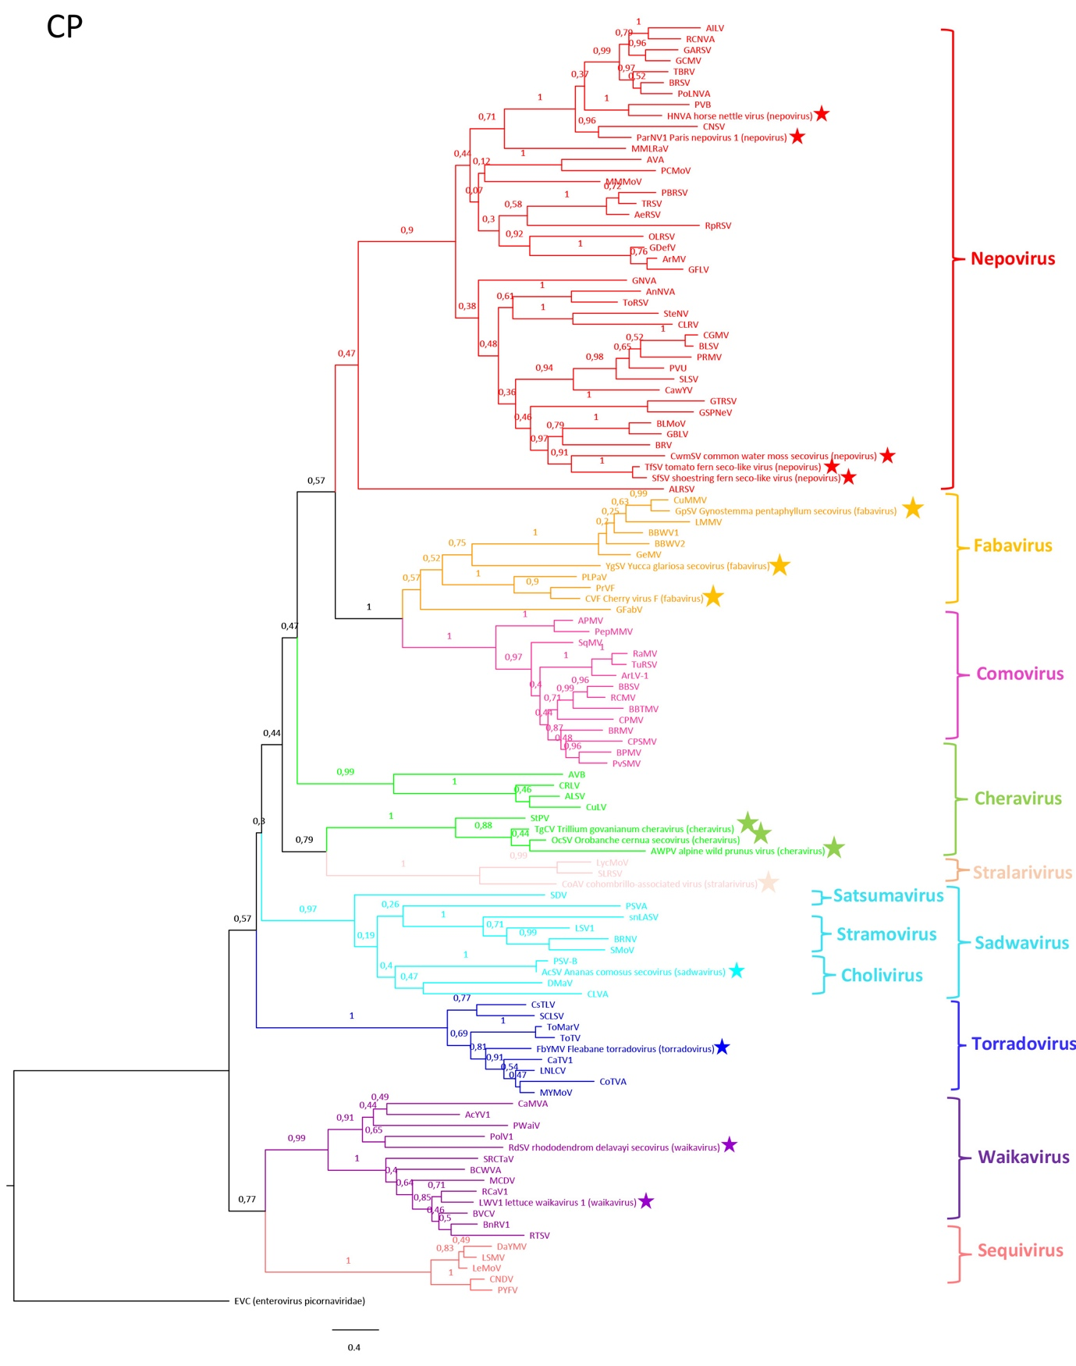
Figure 2. Phylogenetic tree of the coat protein(s) amino acid sequence of the 16 newly proposed species (depicted by a star) in the family Secoviridae and 98 representatives of the different genera in the family Secoviridae. In the cases that more than one CP domain is present, the two or three CP domains were combined. The evolutionary history was inferred by using the Maximum Likelihood method and Le_Gascuel_2008 model [11]. The tree with the highest log likelihood (-79542.90) is shown. The percentage of trees in which the associated taxa clustered together is shown next to the branches. Initial tree(s) for the heuristic search were obtained automatically by applying Neighbor-Join and BioNJ algorithms to a matrix of pairwise distances estimated using a JTT model, and then selecting the topology with superior log likelihood value. A discrete Gamma distribution was used to model evolutionary rate differences among sites (3 categories (+G, parameter = 3.2793)). The tree is drawn to scale, with branch lengths measured in the number of substitutions per site. This analysis involved 117 amino acid sequences. All positions with less than 95% site coverage were eliminated, i.e., fewer than 5% alignment gaps, missing data, and ambiguous bases were allowed at any position (partial deletion option). There were a total of 371 positions in the final dataset. Evolutionary analyses were conducted in MEGA X [12]
). The final dataset consisted of a total of 412 positions. Sequence accession numbers of type isolates of recognized species and of viruses proposed as type isolates of new species in the family Secoviridae are as follows: ToRSV (tomato ringspot virus, D12477), AnNVA (anemone nepovirus A, MH898478), SteNV (Stenotaphrum nepovirus, MZ325762), BRV (blackcurrant reversion virus, AF020051), GBLV (grapevine Bulgarian latent virus, FN691935), BLSV (blueberry latent spherical virus, AB649297), SLSV (soybean latent spherical virus, KX424572), PRMV (peach rosette mosaic virus, (KJ572573), CawYV (caraway yellow virus, MK492274), CLRV (cherry leaf roll virus, FR851462), GNVA (grapevine nepovirus A, MT507291), MMMoV (melon mild mottle virus, AB518486), RpRSV (raspberry ringspot virus, AY303788), PoLNVA (poaceae Liege nepovirus A, MW289236), MMLRaV (mulberry mosaic leaf roll-associated virus, KC904084), AeRSV (Aeonium ringspot virus, JQ670669), PBRSV (potato black ringspot virus, KC832892), TRSV (tobacco ringspot virus, AY363727), GDefV (grapevine deformation virus, AY291208), ArMV (Arabis mosaic virus, AY017339), GFLV (grapevine fanleaf virus, X16907), OLRSV (olive latent ringspot virus, AJ277435), PCMoV (petunia chlorotic mottle virus, KX812816), BRSV (beet ringspot virus, X04062), RCNA (red clover nepovirus A, MG253829), TBRV (tomato black ring virus, AY157994), AILV (artichoke Italian latent virus, LT608396), GARSV (grapevine Anatolian ringspot virus, AY291207), GCMV (grapevine chrome mosaic virus, X15163), CNSV (cycas necrotic stunt virus, AB073148), PVB (potato virus B, KX656671), GSPNeV (green Sichuan pepper nepovirus, MH323434), ParNV1 (paris nepovirus 1, OP374159), HNVA (horse nettle virus A, OP292295), CwmSV (common water moss secovirus, OX380442), TfSV (tomato fern secovirus, OX380490), SfSV (shoestring fern secovirus, OX380478), APMV (Andean potato mottle virus, L16239),CPSMV (cowpea severe mosaic virus, M83309), PvSMV (Phaseolus vulgaris severe mosaic virus, MN837499), BRMV (bean rugose mosaic virus, KP404603), BPMV (bean pod mosaic virus, U70866), TuRSV (turnip ringspot virus, GQ222382), CPMV (cowpea mosaic virus, X00729), ArLV1 (Arabidopsis latent virus 1, MH899121), RCMV (red clover mottle virus, M14913), BBTMV (broad bean true mosaic virus, GU810904), SqMV (squash mosaic virus, AB054689), PepMMV (pepper mild mosaic virus, MK990556), GFabV (grapevine fabavirus, KX241485), PrVF (prunus virus F, KX269871), CuMMV (cucurbit mild mosaic virus, EU881937), LMMV (lamium mild mosaic virus, KC595305), GeMV (gentian mosaic virus, AB084453), BBWV2 (broad bean wilt virus 2, AF225954), PLPaV (peach latent pitting-associated virus, KY867751), BBWV1 (broad bean wilt virus 1, AB084451), GpSv (Gynostemma pentaphyllum secovirus, BK061325), YgSV (yucca gloriosa secovirus, BK061336), CVF (cherry virus F, MH998217), BRNV (black raspberry necrosis virus, DQ344640), SMoV (strawberry mottle virus, AJ311876), LSV1 (lettuce secovirus 1, KX925438), SDV (satsuma dwarf virus, AB009959), DMaV (dioscorea mosaic-associated virus, KU215539), SnLaSV (surrounding non-legume associated secovirus, MN412740), PSVA (pineapple secovirus A, MN809924), PSVB (pineapple secovirus B, OM777136), CLVA (chocolate lily virus A, JN052074), AcSv (Ananas comosus secovirus, BK061319), ALSV (apple latent spherical virus, AB030941), CuLV (currant latent virus, KT692953), CRLV (cherry leafroll virus, AJ621358), AVB (arracacha virus B, JQ581051), StPV (stocky prune virus, OP328252), AWPV (alpine wild prunus virus, OP328250), TgCV (Trillium govanianum cheravirus, BK013326), OcSv (Orobanche cernua secovirus, BK061327), ToTV (tomato torrado virus, DQ388880), ToMarV (tomato marchitez virus, EF681765), MYMoV (motherwort yellow mottle virus, KM229701), CoTVA (Codonopsis torradovirus A, NC035220), CsTLV (cassava torrado-like virus, OK040226), LNLCV (lettuce necrotic leaf curl virus, KC855267), CaTV1 (carrot torradovirus 1, KF533720), SCLSV (squash chlorotic leaf spot virus, KU052531), FbYMB (fleabane yellow mosaic virus, OL979630), LSMV (lettuce star mosaic virus, MT348706), PYFV (parsnip yellow fleck virus, D14066), AcYV1 (Actinidia yellowing virus 1, MN180070), PWaiV (persimmon waikavirus, LC488189), CamVA (camlelia virus A, MW545173), PolV1 (poaceae Liege virus 1, MW289237), BCWVA (blackcurrant waikavirus A, MN701059), BnRV1 (brassica napus RNA virus 1, MH844554), RCaV1 (red clover-associated virus 1, MH325329), CNDV (carrot necrotic dieback virus, EU980442), MCDV (maize chlorotic dwarf virus, U67839), RTSV (rice tungro spherical virus, M95497), BVCV (bellflower vein chlorosis virus, KT238881), LWV1 (lettuce waikavirus 1, MY348710), RdSV (Rhododendron delavayi secovirus, BK061334), LycMoV (lychnis mottle virus, KR011033), SLRSV (strawberry latent ringspot virus, AY860979), and CoAv (cohombrillo-associated virus, OP019482). The combined sequence of the three CPs from poliovirus (EVC, species Enterovirus C, NP_041277, genus Enterovirus, family Picornaviridae) was used as an outgroup to root the tree.
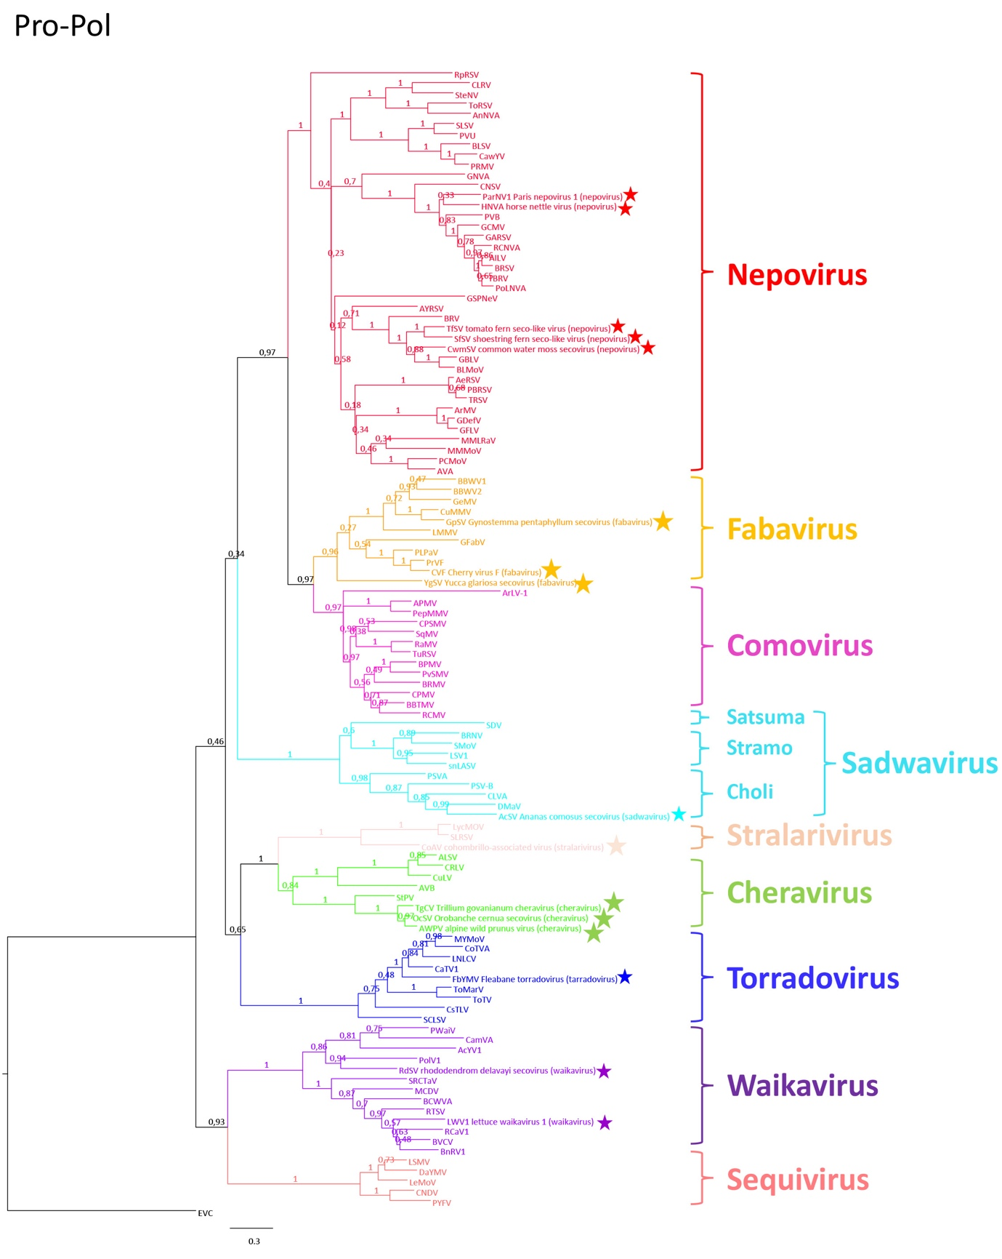
Figure 3. Phylogenetic tree of the amino acid sequence of the conserved protease-polymerase (Pro-Pol) region (from the protease CG motif to the polymerase GDD motif) of the 16 newly proposed species (depicted by a star) in the family Secoviridae and 95 representatives of the different genera in the family Secoviridae. The evolutionary history was inferred by using the Maximum Likelihood method and Le_Gascuel_2008 model [11]. The tree with the highest log likelihood (-57604.70) is shown. The percentage of trees in which the associated taxa clustered together is shown next to the branches. Initial tree(s) for the heuristic search were obtained automatically by applying Neighbor-Join and BioNJ algorithms to a matrix of pairwise distances estimated using a JTT model, and then selecting the topology with superior log likelihood value. A discrete Gamma distribution was used to model evolutionary rate differences among sites (2 categories (+G, parameter = 1.3553)). The rate variation model allowed for some sites to be evolutionarily invariable ([+I], 2.16% sites). The tree is drawn to scale, with branch lengths measured in the number of substitutions per site. This analysis involved 113 amino acid sequences. All positions with less than 95% site coverage were eliminated, i.e., fewer than 5% alignment gaps, missing data, and ambiguous bases were allowed at any position (partial deletion option). There were a total of 394 positions in the final dataset. Evolutionary analyses were conducted in MEGA X [12]. Sequence accession numbers of type isolates of recognized species and of viruses proposed as type isolates of new species in the family Secoviridae are as follows: ToRSV (tomato ringspot virus, L19655), AnNVA (anemone nepovirus A, MH898479), SteNV (Stenotaphrum nepovirus, MZ325761), BRV (blackcurrant reversion virus, AF368272), GBLV (grapevine Bulgarian latent virus, FN691934), CawYV (caraway yellow virus, MK494273), BLSV (blueberry latent spherical virus, AB649296), SLSV (soybean latent spherical virus, KX424571), PRMV (peach rosette mosaic virus, AF016626), CLRV (cherry leaf roll virus, FR851461), AYRSV (artichoke yellow ringspot virus, AM087671), GNVA (grapevine nepovirus A, MT507290), MMMoV (melon mild mottle virus, AB518485), RpRSV (raspberry ringspot virus, AY303787), PoLNVA (poaceae Liege nepovirus A, MW289235), MMLRaV (mulberry mosaic leaf roll-associated virus, KC904083), AeRSV (Aeonium ringspot virus, JX304792), PBRSV (potato black ringspot virus, KC832890), TRSV (tobacco ringspot virus, U50869), GDefF (grapevine deformation virus, HE613269), ArMV (Arabis mosaic virus, AY303786), GFLV (grapevine fanleaf virus, D00915), PCMoV (petunia chlorotic mottle virus, KX812815), BRSV (beet ringspot virus, D00322), RCNA (red clover nepovirus A, MG253828), TBRV (tomato black ring virus, AY157993), AILV (artichoke Italian latent virus, LT608395), GARSV (grapevine Anatolian ringspot virus, HE774604), GCMV (grapevine chrome mosaic virus, X15346), CNSV (cycas necrotic stunt virus, AB073147), PVB (potato virus B, KX656670), GSPNeV (green Sichuan pepper nepovirus, MH323435), ParNV1 (paris nepovirus 1, OP374158), HNVA (horse nettle virus A, OP292294), CwmSV (common water moss secovirus, OX380383), TfSV (tomato fern secovirus, OX380481), SfSV (shoestring fern secovirus, OX380465), APMV (Andean potato mottle virus, MN148891), TuRSV (turnip ringspot virus, GQ222381), CPSMV (cowpea severe mosaic virus, M83830), PvSMV (phaseolus vulgaris severe mosaic virus, MN837498), BRMV (bean rugose mosaic virus, KP404602), BPMV (bean pod mosaic virus, U70866), CPMV (cowpea mosaic virus, X00206), ArLV1 (Arabidopsis latent virus 1, MH899120), RCMV (red clover mottle virus, X64886), BBTMV (broad bean true mosaic virus, GU810903), SqMV (squash mosaic virus, AB054688), PepMMV (pepper mild mosaic virus, MK990555), GFabV (grapevine fabavirus, KX241484), PcSMV (phaseolus vulgaris severe mosaic virus, MN837498), PrVF (prunus virus F, KX269870), CuMMV (cucurbit mild mosaic virus, EU881936), LMMV (lamium mild mosaic virus, KC595304), GeMV (gentian mosaic virus, AB084452), BBWV2 (broad bean wilt virus 2, AF225953), PLPaV (peach latent pitting-associated virus, KY867750), BBWV1 (broad bean wilt virus 1, AB084450), GpSV (Gynostemma pentaphyllum secovirus, BK061324), YgSV (yucca gloriosa secovirus, BK061335), CVF (cherry virus F, MH998210), StPV (stocky prune virus, OP328251), AWPV (alpine wild prunus virus, OP328249), TgCV (Trillium govanianum cheravirus, BK013325), OcSv (Orobanche cernua secovirus, BK061326), BRNV (black raspberry necrosis virus, DQ344639), SMoV (strawberry mottle virus, AJ311875), LSV1 (lettuce secovirus 1, KX925437), SDV (satsuma dwarf virus, AB009958), DMaV (dioscorea mosaic-associated virus, KU215538), PSVA (pineapple secovirus A, MN809923), PSVB (pineapple secovirus B, OM777135), AcSV (Ananas comosus secovirus, BK061318), SnLaSV (surrounding non-legume associated secovirus, MN412739), CLVA (chocolate lily virus A, JN052073), ALSV (apple latent spherical virus, AB030940), CuLV (currant latent virus, KT692952), CRLV (cherry rasp leaf virus, AJ621357), AVB (arracacha virus B, JQ437415), ToTV (tomato torrado virus, DQ388879), ToMarV (tomato marchitez virus, EF681764), MYMoV (motherwort yellow mottle virus, KM229700), CoTVA (Codonopsis torradovirus, NC035128), CsTLV (cassava torrado-like virus, OK040225), LNLCV (lettuce necrotic leaf curl virus, KC855266), CaTV1 (carrot torradovirus 1, KF533719), SCLSV (squash chlorotic leaf spot virus, KU052530), FbYMV (fleabane yellow mosaic virus, OL979629), LSMV (lettuce star mosaic virus, MT348706), PYFV (parsnip yellow fleck virus, D14066), AcYV1 (Actinidia yellowing virus 1, MN180070), PWaiV (persimmon waikavirus, LC488189), CamVA (camellia virus A, MW545173), PolV1 (poaceae Liege virus 1, MW289237), BCWVA (blackcurrant waikavirus A, MN701059), BnRV1 (brassica napus RNA virus 1, MH844554), RCaV1 (red clover-associated virus 1, MH325329), CNDV (carrot necrotic dieback virus, EU980442), MCDV (maize chlorotic dwarf virus, U67839), RTSV (rice tungro spherical virus, M95497), LWV1 (lettuce waikavirus 1, MY348710), RdSV (Rhododendron delavayi secovirus, BK061334), LycMoV (lychnis mottle virus, KR011032), CoAV (cohombrillo-associated virus, OP019481), and SLRSV (strawberry latent ringspot virus, AY860978). The Pro-Pol sequence of poliovirus (EVC, species Enterovirus C, NP_041277, genus Enterovirus, family Picornaviridae) was used as an outgroup to root the tree.
References
- Khalili M, Candresse T, Brans Y, Faure C, Audergon J-M, Decroocq V, Roch G, Marais M (2022) The molecular characterization of a new Prunus-infecting cheravirus and complete genome sequence of stocky prune virus. Viruses 14:2325, https://doi.org/10.3390/v14112325.
- Sidharthan VK, Kalaivanan NS, Baranwal VK (2021) Discovery of putative novel viruses in the transcriptomes of endangered plant species native to India and China. Gene 786:145626, https://doi.org/10/106/j.gene.2021/145626.
- Sidhartan VK, Rajeswari, Baranwal VK (2022) Analysis of public domain plant transcriptomes expands the phylogenetic diversity of the family Secoviridae. Virus Genes 58:598-604, https://doi.org/10/1007/s11262-022-01931-7.
- Koloniuk I, Sarkisova T, Petrzik P, Lenz O, Pribylova J, Franova J, Spak J, Lotos L, Beta C, Katsiani A, Candresse T, Maliogka VI (2018) variability studies of two Prunus-infecting fabaviruses with the aid of high-throughput sequencing. Viruses 10:204, doi:10.3390/v10040204.
- Maachi A, Hernando Y, Aranda MA, Donaire L (2023) Cohombrillo-associated viruses: a novel virus infecting Ecballium elaterium plants. Arch Virol 168:16, https://doi.org/10.1007/s00705-022-05669-3.
- Alvarez-Quinto R, Grinstead S, Bolus S, Daughtrey M, Hammond J, Wintermantel W, Mollov D (2022) Genomic characterization of a new torradovirus from common fleabane (Erigeron annuus). Arch Virol 167:1905-1908, https://doi.org/10/1007/s00705-022-05497-5.
- Lan P-x, He P, Yang J, Zhou G-h, Chen X-j. Wei T-y, Li C-r, Gu R, Li R, Li F (2022) High-throughput sequencing reveals the presence of novel and known viruses in diseased Paris yunnanensis. Frontiers Microbiol 13:1045750, doi:10.3389/fmicb.2022.1045750
- Zhou J, Hu X, Vieeira P, Atha III B, McFarland C, Foster JA, Hurtado-Gonzales OP (2023) Molecular characterization of horse nettle virus A, a new member of subgroup B of the genus Nepovirus. Arch Virol 168:86, https://doi.org/10.1007/s00705-023-05708-7.
- Mifsud JCO, Gallagher RV, Holmes EC, Geoghegan JL (2022) Transcriptome mining expands knowledge of RNA viruses across the plant kingdom. J Virol 96:10.1128/jvi.00260-22
- Svanella-Dumas L, Tsarmpopoulos I, Marais A, Faure C, Theil S. Glasa M, Predajna L, Gaudin J, Tian S, Porcher L, Gentit P, De Oliveira ML, Krause-Sakate R., Candresse T (2023). Molecular and Biological characterization of novel and know Sequiviridae members infecting lettuce. Phytopathology DOI: 10.1094/PHYTO-03-23-0095-R
- Le S.Q, and Gascuel O (2008). An improved general amino acid replacement matrix. Molecular Biology and Evololution 25:1307-1320, https://doi.org/10.1093/molbev/msn067
- Kumar S, Stecher G, Li M, Knyaz C, Tamura K. (2018). MEGA X: Molecular evolutionary genetics analysis across computing platforms. Molecular Biology and Evolution 35:1547-1549, https://doi.org/10.1093/molbev/msy096

