
This Word module should be used for all taxonomic proposals.
Please complete Part 1 and:
either Part 3 for proposals to create new taxa or change existing taxa
or Part 2 for proposals of a general nature.
Submit the completed Word module, together with the accompanying Excel module named in Part 3, to the appropriate ICTV Subcommittee Chair.
The Word module explains and justifies your proposal. The Excel module is a critical document that will be used to implement the proposed taxonomic changes once they are approved and ratified. If proposals presented in the Word module are not presented accurately in the Excel module, the taxonomic changes cannot proceed.
For guidance, see the notes written in blue, below, and the Help Notes in file Taxonomic_Proposals_Help_2019.
Part 1: TITLE, AUTHORS, etc

Code assigned: | 2019.024P
Short title: Create four new species in the family Luteoviridae
Author(s) and email address(es):
Lozier Z, Miller WA |  | zlozier@iastate.edu; wamiller@iastate.edu
Corresponding author:
W. Allen Miller; wamiller@iastate.edu
List the ICTV study group(s) that have seen this proposal:
A list of study groups and contacts is provided at http://www.ictvonline.org/subcommittees.asp . If in doubt, contact the appropriate subcommittee chair (there are six virus subcommittees: animal DNA and retroviruses, animal ssRNA-, animal ssRNA+, fungal and protist, plant, bacterial and archaeal) |  |  | Luteoviridae Study Group
ICTV Study Group comments (if any) and response of the proposer:
Approved by SG member Peter Waterhouse
Date first submitted to ICTV: |  |  |  | June 19, 2019
Date of this revision (if different to above):

ICTV-EC comments and response of the proposer:

Part 2: NON-STANDARD
Template for any proposal regarding ICTV procedures, rules or policy, not involving the creation of new taxonomy.
Text of proposal:

Part 3: PROPOSED TAXONOMY

Name of accompanying Excel module: 2019.024P.A.v1.Luteoviridae_4sp.xlsx

The sequences of four viruses putatively belonging to the family Luteoviridae were recently reported. Three of these viruses are proposed as new members in the genus Luteovirus (ALV1, AaLV, and RCaV) and one as a new member in the genus Polerovirus (PuPV).

Apple associated luteovirus
Apple-associated luteovirus (AaLV accession MF580384) was recently proposed as a member of a new species in the genus Luteovirus (Shen et al. 2018). Samples of leaves were collected from China and were then prepared for sequencing on an Illumina HiSeq X-ten platform. Data analysis was completed with CLC Genomics Workbench 9.5. Confirmation sequencing revealed the 5890 nt genome to be organized similar to other Luteovirus members (Figure 1). AaLV contains eight open reading frames (ORFs) resembling typical luteoviruses: ORFs 1 and 2 encode the putative RdRp and host a -1 ribosomal frameshift element; the overlapping ORFs 3 and 4 encode the putative coat protein and movement protein respectively; a readthrough signal at the end of ORF3 potentially encodes ORF5 as a readthrough domain (RTD); and a small ORF6 is located at the 3’ end of the genome. AaLV also contains an ORF3a and an ORF0-like ORF embedded within ORF1. Presence of an ORF0 overlapping with ORF1 has not been reported previously for any virus in genus Luteovirus. The authors note the -1 frameshift signal is identical to that of red clover necrotic mosaic virus (RCNMV) of the family Tombusviridae. Additionally, the BYDV-like translation element (BTE) of AaLV differs from the GRAUCCUGGGAAACAGG consensus. Its homologous sequence is AGGUCCUGGUAGAACAGG where the differences are bolded.
The authors report AaLV is most similar to cherry-associated luteovirus (ChALV) and peach-associated luteovirus (PaLV), having 53% sequence identity to the South Korean isolate of ChALV and 59.7% amino acid identity to the RdRP of the Czech Republic isolate (Shen et al. 2018). The authors’ phylogeny of complete genomes shows AaLV in the same clade as the ChALV isolates and PaLV (Shen et al. 2018). To offer further evidence, we performed multiple sequence alignments of the complete genome, RdRP, and CP of AaLV with other classified members of Luteoviridae, as well as the other new members proposed in this document, using MUSCLE 3.8.1551 and computed sequence identity percentages using BioEdit 7.0.5.3. This analysis revealed AaLV was most similar to ChALV (NC_031800) (Table 1). Additionally, maximum likelihood phylogenies were computed with FastTree 2.1.10. AaLV nested well with other species in genus Luteovirus in each tree (Figure 5).

The species demarcation criteria for the Luteoviridae require that one ORF product of a viral genome differs by >10% in amino acid sequence from the homologous ORF product in the most closely related luteovirid. Given that the most closely related protein (RdRp) of any other luteovirus is less than 60% identical to that of AaLV, and AaLV consistently clusters with other Luteovirus species, we propose to create a new species, named Apple associated luteovirus with AaLV-A68 as an exemplar isolate.

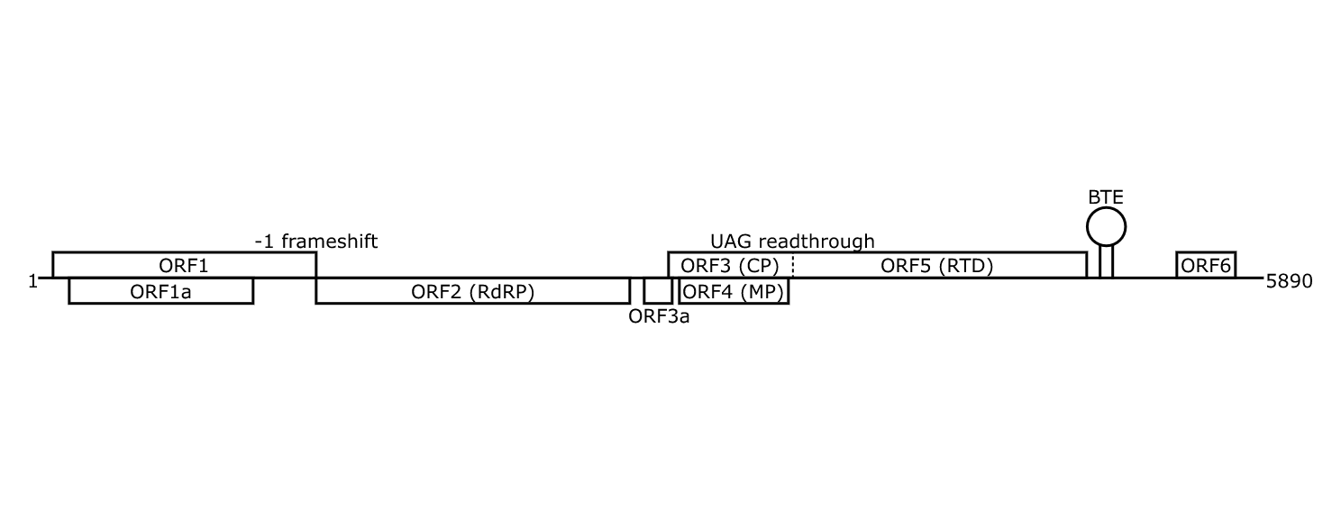
Figure 1. Genome organization of AaLV. RdRP, RNA-dependent RNA polymerase; CP, coat protein; MP, movement protein; RTD, read through domain; BTE, BYDV-like translation element.

Table 1: Sequence identities of AaLV compared to other members of the family Luteoviridae. *ALV1 is in this proposal.

 | Complete  genome | RdRP | CP
ALV1* | 44% | 57% | 56%
ChALV | 42% | 57% | 47%
RSDaV | 39% | 49% | 38%
BYDV-PAS | 38% | 44% | 45%
BYDV-PAV | 38% | 46% | 45%
BYDV-MAV | 38% | 46% | 40%
SbDV | 38% | 50% | 38%
BYDV-kerII | 37% | 46% | 43%
TuYV (Polerovirus) | 30% | 9% | 39%
GEV-1 (Enamovirus) | 24% | 7% | 31%

Apple luteovirus 1
Liu et al. reported the sequence of a virus potentially belonging to genus Luteovirus. As AaLV, it has been isolated from apple trees, and the authors proposed the name apple luteovirus 1 (ALV1, accession MF120198). Samples were taken from branches of symptomatic apple trees in Pennsylvania. Total RNA was isolated after first extracting the total nucleotides from the samples which were then prepared to be sequenced on the Illumina NextSeq platform. The authors analyzed the sequencing reads using CLC Genomics Workbench 9.5.2 and compared to the Viruses_NR and Viroids NCBI databases via BLASTx. Presence of the proposed ALV1 was confirmed through RT-PCR and subsequent sequencing. The genome was analyzed with CLC Workbench, Open Reading Frame Finder, ClustalW multiple alignments, and MEGA7. The genome of ALV1 was determined to be 6001 nts long and encodes ten possible ORFs (Figure 2). Like other luteoviruses, ALV1 contains a -1 ribosomal frameshift element at the junction of ORFs 1 and 2 that encodes for the RdRP. There is also an ORF3 coding for the CP, and ORF4 coding for an MP, and a readthrough element at the end of ORF3 results in the ORF5 readthrough domain (RTD). Additionally, ALV1 encodes an ORF3a, ORF6 and ORF7. The BTE sequence for ALV1 is GUACGUCCUGGUAGAACAGG, where underlined nucleotides differ from the consensus and the bold and italicized are insertions. Unlike other luteoviruses, there is an overlapping ORF contained entirely within ORF1, and a small ORF5a within ORF5. The authors report the predicted amino acid sequences of these ORFs do not appear to be similar to any known proteins.
The authors report that ALV1 is most similar to peach-associated luteovirus (not an officially recognized species) at 52.8% overall sequence identity and 63.1% amino acid sequence identity to the most similar ORF (ORF1-2, RdRp). The multiple sequence alignments and percent identity calculations performed for ALV1 included AaLV. These revealed ALV1 only shares approximately 50% sequence identity with other members in genus Luteovirus which is well below the species demarcation criteria for Luteoviridae (Table 2). Liu et al. (2018)’s neighbor-joining phylogenetic analysis shows that ALV1 nests well into a clade of other Luteovirus genus members. Our analysis of maximum likelihood trees resulted in the same topology (Figure 5). Whether comparing whole genomes, the RdRP or the CP, ALV1 was fairly grounded in clades with other Luteovirus species.
We propose the creation of a new species named Apple luteovirus 1 in the genus Luteovirus, typified by virus apple luteovirus 1 isolate PA8 (ALV1-PA8).

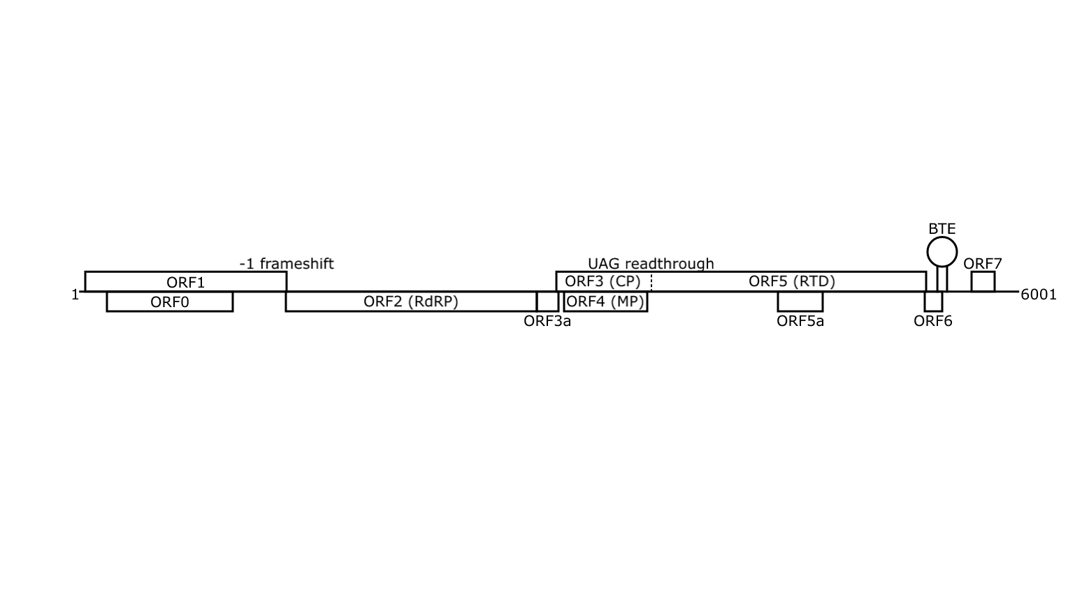
Figure 2. Genome organization of ALV1. RdRP, RNA-dependent RNA polymerase; CP, coat protein; MP, movement protein; RTD, read through domain; BTE, BYDV-like translation element.

Table 2: Sequence identities of ALV1 with other viruses in the family Luteoviridae. RdRP, RNA-dependent RNA polymerase; CP, coat protein.

 | Complete  genome | RdRP | CP
AaLV | 44% | 57% | 56%
ChALV | 40% | 56% | 44%
RSDaV | 39% | 47% | 35%
BYDV-PAS | 38% | 45% | 44%
BYDV-MAV | 38% | 45% | 40%
BYDV-kerII | 38% | 45% | 38%
BYDV-PAV | 37% | 45% | 43%
SbDV | 37% | 50% | 34%
TuYV (Polerovirus) | 29% | 9% | 35%
AEV-1 (Enamovirus) | 23% | 8% | 26%

Red clover associated luteovirus
Lenz et al. (2018) isolated dsRNA from red clover plants that showed dwarfism, small leaves, irregular vein clearing and mosaic. The sequencing library was prepared with a KAPA DNA Library Preparation kit, sequenced with an Illumina HiSeq 2500 system, and processed with CLC Genomics WorkBench 7.5. The complete genome was reported to be 5224 nt long and given the provisional name red clover-associated luteovirus (RCaV, accession MG597244). The genome contains five total ORFs with a genomic arrangement similar to classified members of the Luteovirus genus. Lenz et al. (2018) note that neither an ORF3a nor an ORF4 were found within the RCaV genome, resembling the genomes of the luteoviruses nectarine stem pitting-associated virus (NSPaV) and NSPaV-SK, and those of viruses in the genus Enamovirus. Within the putative ORF6, a GGACCCTGGGAAACAGG BTE sequence was detected, where the bold bases differ from the consensus BTE sequence in other Luteoviridae members.
The RCaV genome, RdRP and CP sequences were included in the MUSCLE alignments and FastTree phylogenies mentioned prior. Sequence identity calculations show that the RdRP of RCaV is most similar to ChALV, sharing 54% amino acid sequence identity. This difference is greater than 10%, which is the current species demarcation criteria for luteovirids. Phylogenetic analyses of the entire genome and RdRP shows the sequence clusters with other members in the genus Luteovirus (Figure 5A and B). The CP tree offers ambiguous evidence, but the lower values associated with the branches of the tree suggest this result is not confident (Figure 5C).
Thus, based upon these results, we propose the creation of a new species named Red clover associated luteovirus in the genus Luteovirus to classify red clover-associated luteovirus (RCaV), with RCaV-HZ8 being the exemplar isolate.

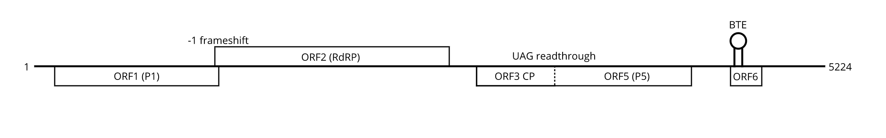
Figure 3. Genome organization of RCaV. RdRP, RNA-dependent RNA polymerase; CP, coat protein; MP, movement protein; RTD, read through domain; BTE, BYDV-like translation element.

Table 3: Sequence identities of RCaV with other members of the family Luteoviridae. RdRP, RNA-dependent RNA polymerase; CP, coat protein.

 | Complete  genome | RdRP | CP
NSPaV | 39% | 51% | 34%
RSDaV | 38% | 52% | 30%
BYDV-MAV | 38% | 48% | 34%
SbDV | 38% | 52% | 28%
ChALV | 38% | 54% | 31%
BYDV-PAV | 37% | 48% | 33%
BYDV-PAS | 37% | 47% | 34%
BLRV | 37% | 53% | 34%
PeVYV-1 (Polerovirus) | 30% | 10% | 29%
AEV-1 (Enamovirus) | 26% | 7% | 24%

Pumpkin polerovirus
Kidanemariam et al. (2019) reported the nearly complete genomic sequence of pumpkin polerovirus (PuPV, accession MG800833), a putative Polerovirus. Leaf samples from a symptomatic pumpkin plant were collected during a field survey in Kenya. The authors extracted total RNA from the samples and prepared them for Illumina MiSeq next generation sequencing (NGS). Sequencing reads were processed with FASTX-Toolkit and SolexaQA++ v.3.1.3 DynamicTrim and were then de novo assembled with Trinity v.2.0.3. Assembled reads were subjected to BLASTn analysis to identify potentially homologous sequences. The authors also mapped reads to a reference sequence and predicted ORFs with CLC Genomics Workbench v.7.5.1 and Geneious v.11.0.2. To validate their HTS data, Kidanemariam et al. employed Sanger sequencing to validate an approximately 600nt segment aligning perfectly to their HTS data. The near-complete PuPV genome comprises 5,810 nucleotides and harbors seven ORFs (Figure 4). Typical of other poleroviruses, PuPV contains an ORF0 and an ORF4 overlapping its ORF3. ORF2 is predicted to be translated from a -1 ribosomal frameshift event; the authors identified the putative slippery sequence to be GGGAAAC at position 1649-1655nt. ORF3 likely produces the CP, the overlapping ORF4 encodes the P4 movement protein, and readthrough of ORF3 leads to putative production of P5 from ORF5 (Figure 4). PuPV was also found to encode the ACG-initiated ORF3a. The authors’ BLASTn analysis revealed 82, 86, 93, 98, 97, 98, and 99% identity to ORFS 0, 1, 2, 3, 4, 5, and 3a of a South African isolate of pepo aphid-borne yellows virus (PABYV), but a BLASTp analysis showed only 73, 81, and 87% identity to the putative P0, P1, and P1-P2 proteins. Phylogenetic analysis of the hypothetical P2, P3, and P4 proteins showed that PuPV consistently forms clades with other poleroviruses. The PuPV genome, RdRP and CP sequences were included in the aforementioned MUSCLE alignments and FastTree analysis. The results show PuPV is very similar to pepo aphid-borne yellows virus (PABYV). The genomic sequence of PuPV is 91% identical to PABYV and the CP amino acid sequence is 97% identical. However, the RdRP amino acid sequence of PuPV is 84% identical to PABYV (Table 4).
Considering the current species demarcation criteria of at least 10% amino acid sequence difference in any gene product for recognized members in the family Luteroviridae and PuPV phylogenetically grouping into clades with other poleroviruses (Figure 5), we propose PuPV to represent a newly created species in the genus Polerovirus named Pumpkin polerovirus.

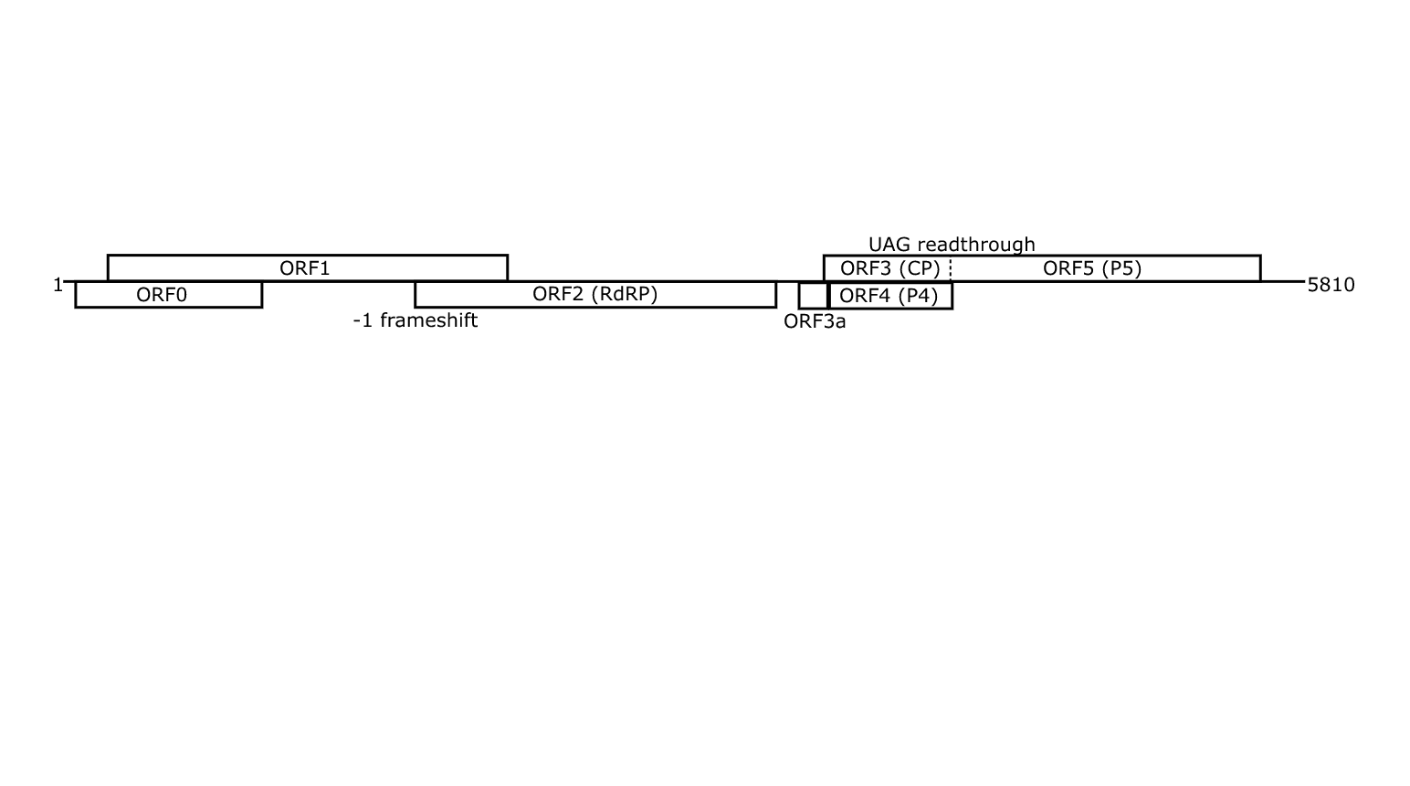
Figure 4. Genome organization of PuPV. RdRP, RNA-dependent RNA polymerase; CP, coat protein; MP, movement protein; RTD, read through domain; BTE, BYDV-like translation element.

Table 4: Sequence identities of PuPV with other viruses belonging to the family Luteoviridae. RdRP, RNA-dependent RNA polymerase; CP, coat protein. For extended virus names see legend of the Figure 1.

 | Complete  genome | RdRP | CP
PABYV | 91% | 84% | 97%
SABYV | 51% | 48% | 82%
CABYV | 50% | 38% | 80%
CLDV | 48% | 40% | 69%
MABYV | 47% | 39% | 78%
TuYV | 47% | 40% | 64%
BWYV | 46% | 39% | 63%
PeVYV-2 | 46% | 40% | 55%
AEV-1 (Enamovirus) | 33% | 24% | 33%
SbDV (Luteovirus) | 29% | 8% | 58%

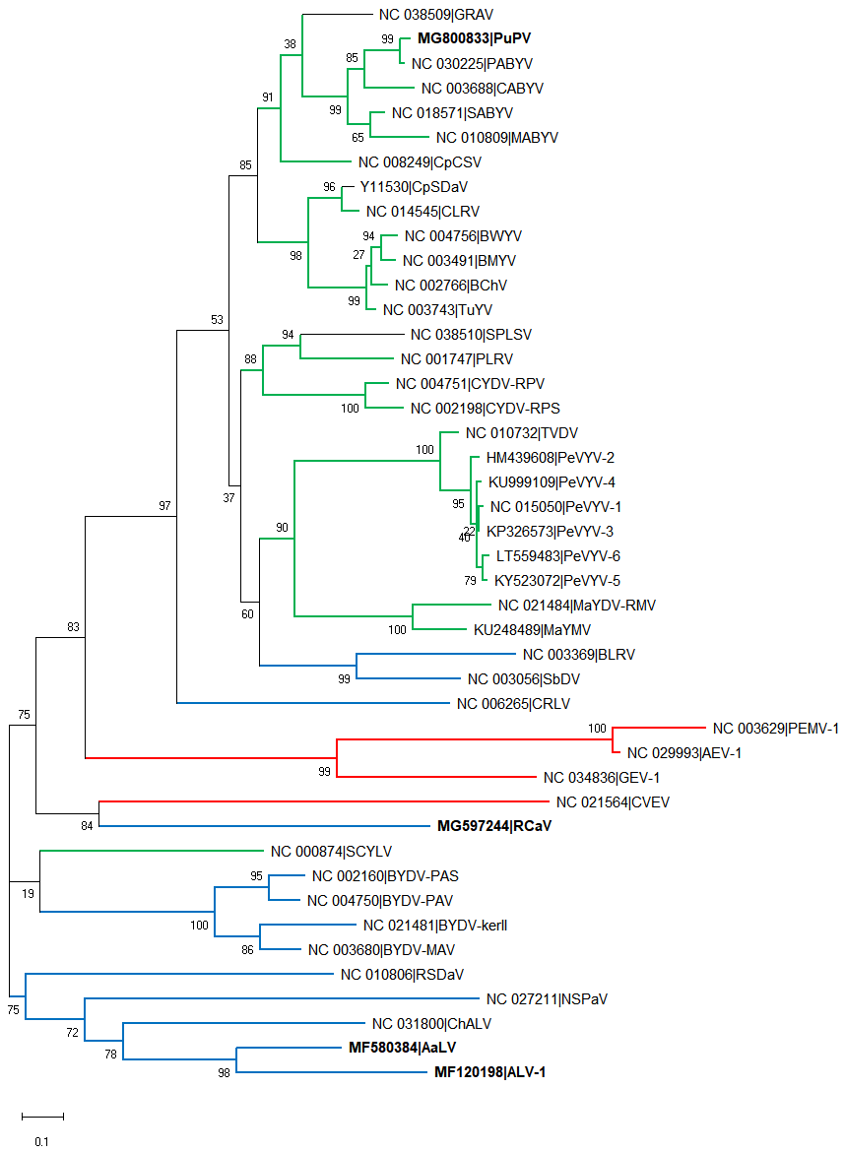
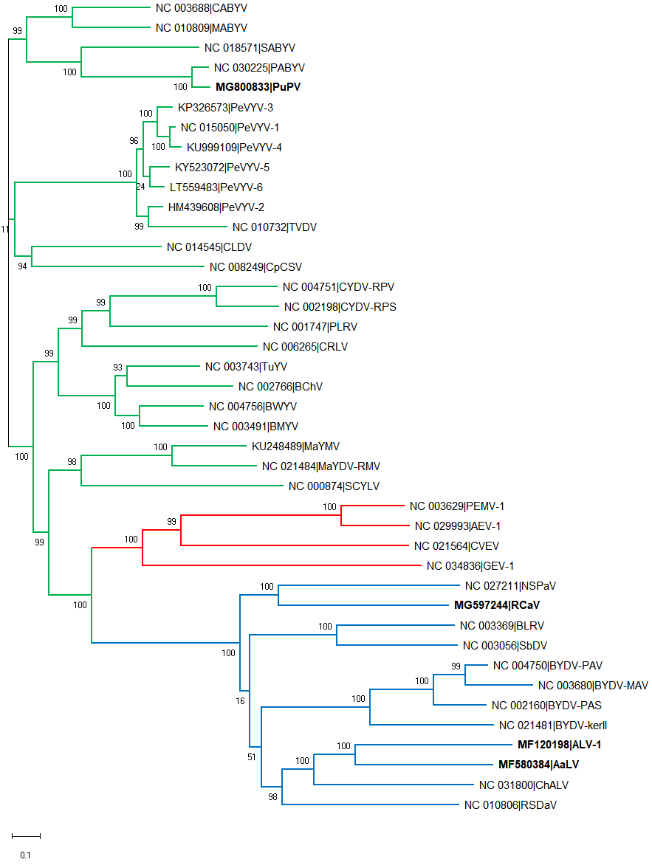
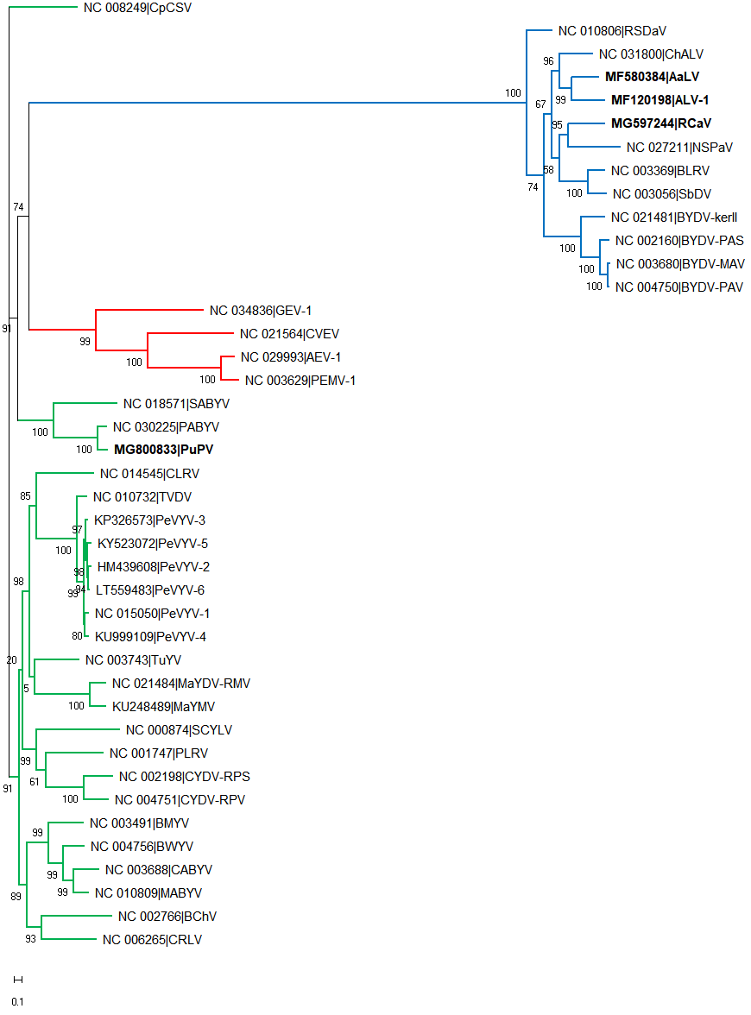
Figure 5. Phylogenetic comparisons of viruses belonging to proposed new species to other members of the family Luteoviridae. Red, genus Enamovirus; blue, genus Luteovirus; green, genus Polerovirus; black, unclassified. The proposed new species are bolded. A) Entire genomes. B) Coat proteins. C) RdRP frameshift products. ALV1, apple luteovirus 1; AaLV, apple-associated luteovirus ; AEV-1, alfalfa enamovirus 1; BYDV-kerII, barley yellow dwarf virus kerII; BYDV-MAV, barley yellow dwarf virus MAV; BYDV-PAS, barley yellow dwarf virus PAS; BYDV-PAV, barley yellow dwarf virus PAV; BLRV, bean leafroll virus; BChV, beet chlorosis virus; BMYV, beet mild yellowing virus; BWYV, beet western yellows virus; CRLV, carrot red leaf virus; CYDV-RPS, cereal yellow dwarf virus RPS; CYDV-RPV, cereal yellow dwarf virus RPV; ChALV, cherry associated luteovirus; CpCSV, chickpea chlorotic stunt virus; CpSDaV, chickpea stunt disease associated virus; CVEV, Citrus vein enation virus; CLDV, cotton leafroll dwarf virus; CABYV, cucurbit aphid-borne yellows virus; GEV-1, grapevine enamovirus 1; GRAV, groundnut rosette assistor virus; MaYDV-RMV, maize yellow dwarf virus RMV; MaYMV, maize yellow mosaic virus; MABYV, melon aphid-borne yellows virus; NSPaV, nectarine stem pitting associated virus; PEMV-1, pea enation mosaic virus 1; PABYV, pepo aphid-borne yellows virus; PeVYV-1-6, pepper vein yellows virus 1-6; PLRV, potato leafroll virus; RSDaV, rose spring dwarf-associated virus; PuPV, pumpkin polerovirus; RCaV, red clover-associated luteovirus; SbDV, soybean dwarf virus; SABYV, Suakwa aphid-borne yellows virus; SCYLV, sugarcane yellow leaf virus; SPLSV, sweet potato leaf speckling virus; TVDV, tobacco vein distorting virus; TuYV, turnip yellows virus.
C
B
A
References:
Edgar RC (2004) MUSCLE: multiple sequence alignment with high accuracy and high throughput. Nucleic Acids Research 32:1792-97.
Hall TA (1999) BioEdit: a user-friendly biological sequence alignment editor and analysis program for Windows 95/98/NT. Nucleic Acids Symposium Series 41:95-98.
Kidanermariam DB, Sukal AC, Abraham AD, Njuguna JN, Stomeo F, Dale JL, Harding RM, James AP (2019) Molecular characterization of a putative new polerovirus infecting pumpkin (Cucurbita pepo) in Kenya. Archives of Virology doi 10.1007/s00705-019-04219-8
Lenz O, Sarkisová T, Koloniuk I, Fránová J, Přibylová J, Špak J (2018) Red clover-associated luteovirus - a newly classifiable member of the genus Luteovirus with an enamo-like P5 protein. Archives of Virology 163:3439-3442.
Liu H, Wu L, Nikolaeva E, Peter K, Liu Z, Mollov D, Cao M, Li R (2018) Characterization of a new apple luteovirus identified by high-throughout sequencing. Virology Journal 15:85.
Price MN, Dehal PS, Arkin AP (2010) FastTree 2 – approximately maximum-likelihood trees for large alignments. PLoS ONE 5:e9490.
Shen P, Tian X, Zhang S, Ren F, Li P, Yu Y, Li R, Zhou C, Cao M (2018) Molecular characterization of a novel luteovirus infecting apple by next generation sequencing. Archives of Virology 163:761-765.

