
This Word module should be used for all taxonomic proposals.
Please complete Part 1 and:
either Part 3 for proposals to create new taxa or change existing taxa
or Part 2 for proposals of a general nature.
Submit the completed Word module, together with the accompanying Excel module named in Part 3, to the appropriate ICTV Subcommittee Chair.
The Word module explains and justifies your proposal. The Excel module is a critical document that will be used to implement the proposed taxonomic changes once they are approved and ratified. If proposals presented in the Word module are not presented accurately in the Excel module, the taxonomic changes cannot proceed.
For guidance, see the notes written in blue, below, and the Help Notes in file Taxonomic_Proposals_Help_2019.
Part 1: TITLE, AUTHORS, etc

Code assigned: | 2019.015P
Short title: Create 2 new genera (Dioscovirus and Vaccinivirus) including 2 new species, and 2 new species in the genus Badnavirus, in the family Caulimoviridae
Author(s) and email address(es):
Teycheney P-Y, Umber M, Vončina D, Almeida R, Geering A |  | teycheney@cirad.fr;  marie.umber@inra.fr;  dvoncina@agr.hr;  rodrigoalmeida@berkeley.edu;  Andrew.Geering@daf.qld.gov.au
Corresponding author
Pierre-Yves Teycheney, teycheney@cirad.fr
List the ICTV study group(s) that have seen this proposal:
A list of study groups and contacts is provided at http://www.ictvonline.org/subcommittees.asp . If in doubt, contact the appropriate subcommittee chair (there are six virus subcommittees: animal DNA and retroviruses, animal ssRNA-, animal ssRNA+, fungal and protist, plant, bacterial and archaeal) |  |  | Caulimoviridae Study Group
ICTV Study Group comments (if any) and response of the proposer:
Date first submitted to ICTV: |  |  |  | June 19, 2019
Date of this revision (if different from above):

ICTV-EC comments and response of the proposer:

Part 2: NON-STANDARD
Template for any proposal regarding ICTV procedures, rules or policy, not involving the creation of new taxonomy.
Text of proposal:

Part 3: PROPOSED TAXONOMY

Name of accompanying Excel module: 2019.015P.A.v1.Caulimoviridae_2gen_2sp.xlsx

1. Two new genera in the family Caulimoviridae

1.1. Creating genus Dioscovirus

Dioscorea nummularia associated virus (DNUaV) is a new species and a representative of a new genus of the Caulimoviridae for the following reasons:

a. The genome of DNUaV is composed of double-stranded (ds) DNA and is circular, based on the ability to amplify the whole genome using rolling-circle amplification. This genome is 8139 bp long and has four putative open reading frames (Fig. 1). ORF3 encodes a putative polyprotein containing coat protein, aspartic protease, reverse transcriptase (RT) and ribonuclease H (RH) domains. A transactivator domain, similar to that present in members of several Caulimoviridae genera, is present in the putative ORF4. DNUaV lacks an integrase enzyme and contains a viral movement protein (MP), features that distinguish the Caulimoviridae from the Pseudoviridae and Metaviridae. The DNUaV genome harbors a tRNA^{Met} primer binding site

b. DNUaV has unique genome features. DNUaV encodes four ORFs with the size of ORFs1-3 consistent with members of genera Badnavirus and Tungrovirus, as are the arrangement of the MP, CP, AP and RT-RNase H-coding regions in ORF3 (Fig. 1). The relative positions of ORF1 and ORF2 are similar to those of badnaviruses, while ORF2 and ORF3 overlap each other by 47 nt, which is similar to the badnaviruses cacao swollen shoot virus, gooseberry vein banding virus, piper yellow mottle virus and sweet potato pakakuy virus [31-33]. However, unlike those badnaviruses with a fourth ORF which always overlaps with ORF3, ORF4 of DNUaV is separated from ORF3 by a short intergenic region which is more similar to the genome organization of rice tungro bacilliform virus (RTBV), the sole member of the genus Tungrovirus. Further, the size of DNUaV ORF4 is also similar to that of RTBV. However, unlike RTBV, the DNUaV ORF4 gene product contains a conserved translation transactivator domain, which is typical of ORF6 of caulimoviruses and soymoviruses, and which is also present in ORF 4 of cavemoviruses and solendoviruses. However, unlike the DNUaV ORF4 sequence, the ORF4 sequences of both cavemoviruses and solendoviruses also includes the conserved coiled-coil motifs characteristic of the virion-associated protein.

c. Phylogenetic analysis using full length polimerase coding sequences shows that DNUaV groups within members of the family Caulimoviridae and is sister to the genus Badnavirus (Fig. 2) Pairwise sequence comparisons using either nucleotide or deduced amino acid sequences of the pol gene reveal an identity of 43 to 58% or 32 to 53%, respectively, between DNUaV and the type species for each genus in the family Caulimoviridae, which are magnitudes typical of different genera.

d. Derivation of the name: Dioscorea virus.

1.2. Creating genus Vaccinivirus

Blueberry fruit drop associated virus (BFDaV) is a new species and a representative of a new genus of the Caulimoviridae for the following reasons:

a. The genome of BFDaV is composed of dsDNA and is circular, based on the ability to amplify the whole genome using rolling-circle amplification. This genome is 9850 bp long, the largest known of any species in the Caulimoviridae. It has a single open reading frame (Fig. 4) encoding a putative polyprotein containing movement protein, pepsin-like aspartate protease, reverse transcriptase (RT) and ribonuclease H (RH) domains and a zinc binding motif, which are typical features of Caulimoviridae.

b. The genome of BFDaV has a single ORF, like that of petunia vein clearing virus (PVCV), a member of the genus Petuvirus. However, BFDaV and PVCV are paraphyletic (Fig. 2) and sequence similarity between the polyproteins encoded by BFDaV and PVCV is very low (14.82%). Additionally, the genome of BFDaV is 2,644 bp larger than that of PVCV and its intergenic region is significantly larger (2056 bp).

c. The genome of BFDaV shares 66% nt sequence identity with strawberry vein banding virus and cauliflower mosaic virus, two members of genus Caulimovirus, but only over a small portion of the genome (4 and 5% respectively). The rest of the BFDaV genome does not match with any identified viral sequence.

d. Derivation of the name: Vaccinium virus. (Vaccinium is the genus containing the cultivated blueberry).

2. Two new species in the genus Badnavirus

2.1. Creating species Codonopsis vein clearing virus (CoVCV)

Codonopsis vein clearing virus (CoVCV) can be considered a new species in the genus Badnavirus for the following reasons:
- CoVCV has a circular, 8,112 bp dsDNA genome with three putative ORFs (Fig. 3). ORF3 encodes a putative polyprotein with conserved reverse transcriptase, ribonuclease H, peptidase and zinc-binding domains/motifs which are typical features of badnaviruses.
- The genome of CoVCV harbors a tRNA^{Met} primer binding site.
- In phylogenetic analyses using the RT/RNAseH domain nucleotide sequence, CoVCV groups with members of the genus Badnavirus. Its closest relative is grapevine vein clearing virus (Fig. 5).
- CoVCV nucleotide sequence corresponding to the reverse trancriptase/RNaseH domains shares a maximum identity of 68.2% with those of other badnaviruses (Table 1), which is below the 80% threshold for discrimination of strains and species within the genus Badnavirus.

2.2. Creating species Grapevine badnavirus 1 (GBV 1)

Grapevine badnavirus 1 (GBV 1) can be considered a new species in the genus Badnavirus for the following reasons:
- GBV 1 has a circular, 7,145 bp dsDNA genome with three putative ORFs. ORF3 encodes a putative polyprotein with conserved reverse transcriptase, ribonuclease H, peptidase and zinc-binding domains/motifs which are typical features of badnaviruses (Fig. 4).
- The GBV 1 genome harbors a tRNA^{Met} primer binding site.
- In phylogenetic analyses using the RT/RNAseH domain nucleotide sequence, GBV 1 groups with members of the genus Badnavirus. Its closest relative is citrus yellow mosaic virus (Fig. 5).
- GBV 1 nucleotide sequence corresponding to the reverse trancriptase/RNaseH domains shares a maximum identity of 70.9% with those of other badnaviruses (Table 1), which is below the 80% threshold for discrimination of strains and species within the genus Badnavirus.

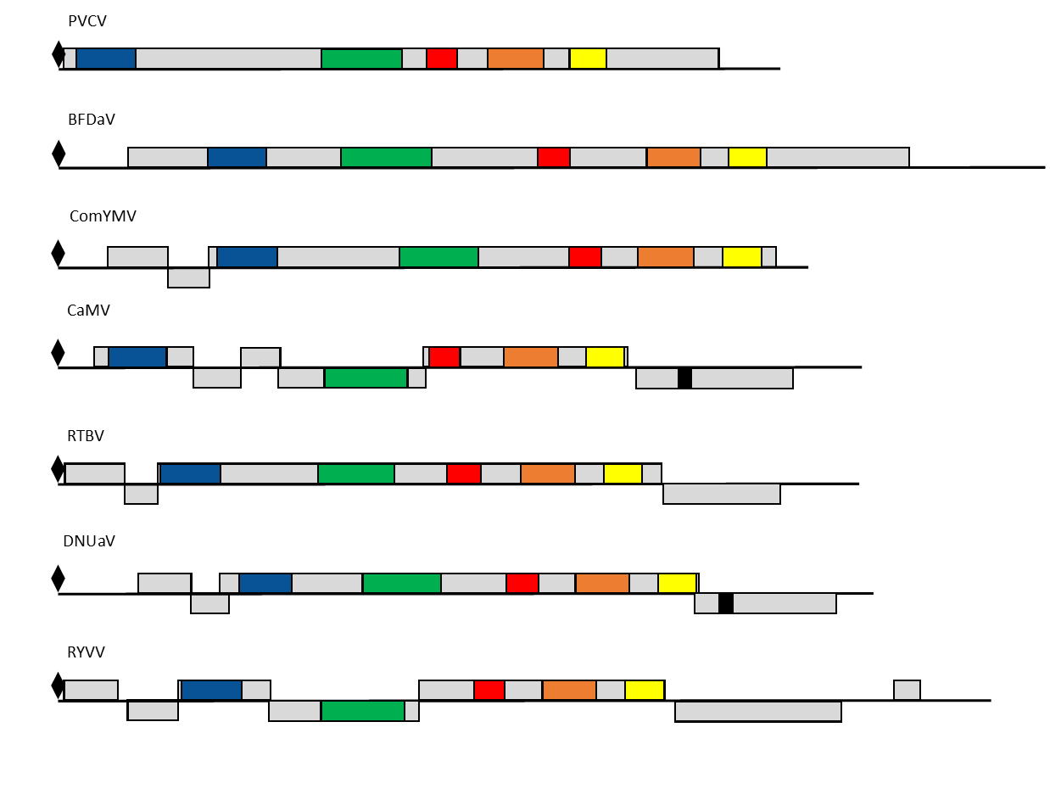
Figure 1. Schematic representation of the linearized genomes of Dioscorea nummularia associated virus (DNUaV) and Blueberry fruit drop associated virus (BFDaV) compared with the type species of the genera Petuvirus (Petunia vein clearing virus), Badnavirus (Commelina yellow mottle virus), Caulimovirus (Cauliflower mosaic virus), Tungrovirus (Rice tungro bacilliform virus), and Rosadnavirus (Rose yellow vein virus, RYVV). Conserved protein domains are indicated: dark blue, movement protein, corresponding to amino acids (aa) 1-327 of CaMV ORF2 protein; green, coat protein, corresponding to aa 261-429 of the CaMV ORF4 protein; black, zinc finger; red, pepsin-like aspartic protease; orange, reverse transcriptase; purple, RNase H; light blue, transactivator domain. The tRNAmet binding site (tRNAmet) is represented by a black diamond.

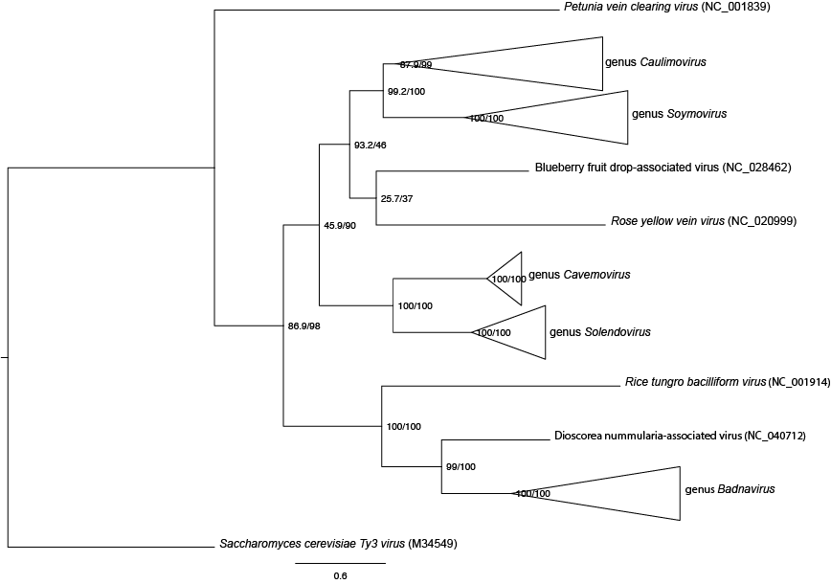

Figure 2. Phylogram of the Caulimoviridae, inferred from a polymerase gene sequence alignment (equivalent to nucleotides 3709-5655 of NC_001497). Protein sequences were first aligned using PROMALS3D, using the solved 3D structures of the retroviral-like protease (RVP) domain of human DDI1 protein (PDB: 3S8I_A) and the reverse transcriptase/ribonuclease H protein of Saccharomyces cerevisiae Ty3 virus (PDB: 4OL8_E) to guide the alignment. The protein alignment was then used to align corresponding DNA sequences using RevTrans. Evolutionary relationships were then hypothesized using the Maximum Likelihood method, implemented in IQ-TREE. Numbers in the nodes are aLRT and ultrafast bootstrap values from 10,000 samples, respectively. Saccharomyces cerevisiae Ty3 virus, type species of the genus Metavirus, was included as the outgroup.

Figure 3. Genome organization of Codonopsis vein clearing virus (CoVCV, MK044821). The positions of the three open reading frames are shown. The eight open boxes overlapping each other inside the circular genome map correspond to the PCR fragments used to determine the complete CoVCV genomic DNA sequence.

Figure 4. Genome organization of Grapevine badnavirus 1 (GBV 1, MF781082). Viral DNA is shown by thick black circular line with the position of three open reading frames (ORF1-ORF3, grey), and conserved functional motifs (color) in the ORF2 polyprotein. Abbreviations: RNase H, ribonuclease H; RT, reverse transcriptase; Pep A3, Cauliflower mosaic virus peptidase (A3); Zn-finger, Zinc knuckle. A visual genome summary was generated with DNAPlotter. Courtesy of D. Vončina.

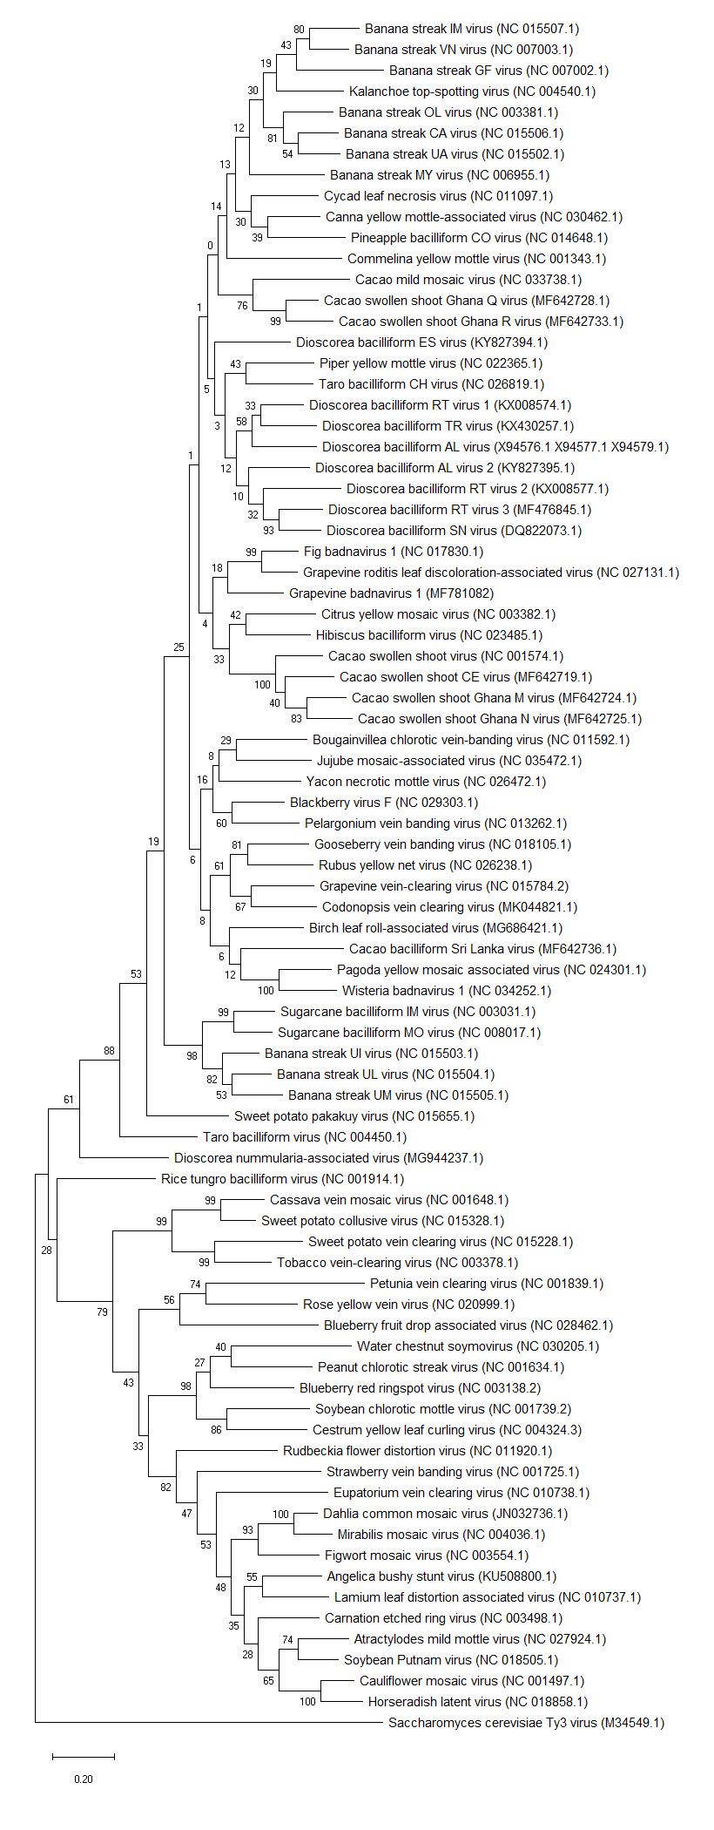
Badnavirus
Dioscovirus
Tungrovirus
Cavemovirus
Solendovirus
Petuvirus
Rosadnavirus
Soymovirus
Caulimovirus
Metavirus
Vaccinivirus

Figure 5. Phylogenetic tree showing placement of Dioscorea nummularia associated virus (DNUaV), Blueberry fruit drop associated virus, Codonopsis vein clearing virus (CoVCV) and Grapevine badnavirus 1 (GBV 1) in genera Dioscovirus, Vaccinivirus and Badnavirus. Maximum likelihood analysis with 1000 bootstrap sets were performed on nucleotide sequences corresponding to the RT-RNase H domains. Type species of other genera in the Caulimoviridae family are also included. Sequences of the proposed new species are shown in red boxes.

Table 1. Percent nucleotide identities for the Caulimoviridae in ORF3 nucleotide sequences corresponding to the conserved RT/RNAseH domain.
Viruses corresponding to proposed new species are highlighted in yellow.

References:
Diaz-Lara A, Martin RR (2016) Blueberry fruit drop-associated virus: a new member of the family Caulimoviridae isolated from blueberry exhibiting fruit-drop symptoms. Plant Disease 100:2211-2214.
Lim S, Park JM, Kwon SY, Cho HS, Kim HS, Lee SH, Moon JS (2019) Complete genome sequence of a tentative new member of the genus Badnavirus identified in Codonopsis lanceolata. Archives of Virology doi 10.1007/s00705-019-04238-5
Sukal AC, Kidanemariam DB, Dale JL, Harding RM, James AP (2018) Characterization of a novel member of the family Caulimoviridae infecting Dioscorea nummularia in the Pacific, which may represent a new genus of dsDNA plant viruses. PLoS One 13:e0203038
Vončina D, Almeida RPP (2018) Screening of some Croatian autochthonous grapevine varieties reveals a multitude of viruses, including novel ones. Archives of Virology 163:2239-2243.

