
This Word module should be used for all taxonomic proposals.
Please complete Part 1 and:
either Part 3 for proposals to create new taxa or change existing taxa
or Part 2 for proposals of a general nature.
Submit the completed Word module, together with the accompanying Excel module named in Part 3, to the appropriate ICTV Subcommittee Chair.
For guidance, see the notes written in blue, below, and the help notes in file Taxonomic_Proposals_Help_2018.
Part 1: TITLE, AUTHORS, etc

Code assigned: | 2018.003P |  | (to be completed by ICTV officers)
Short title: 1 new species in genus Pelarspovirus
Author(s):
Kay Scheets for Tombusviridae SG
Corresponding author with e-mail address:
kay.scheets@okstate.edu
List the ICTV study group(s) that have seen this proposal:
A list of study groups and contacts is provided at http://www.ictvonline.org/subcommittees.asp . If in doubt, contact the appropriate subcommittee chair (there are six virus subcommittees: animal DNA and retroviruses, animal ssRNA-, animal ssRNA+, fungal and protist, plant, bacterial and archaeal) |  | Tombusviridae SG
ICTV Study Group comments (if any) and response of the proposer:
Date first submitted to ICTV: |  |  | June 2nd, 2018
Date of this revision (if different to above):

ICTV-EC comments and response of the proposer:

Part 2: NON-STANDARD
Template for any proposal regarding ICTV procedures, rules or policy, not involving the creation of new taxonomy.
Text of proposal:

Part 3: PROPOSED TAXONOMY

Name of accompanying Excel module: 2018.003P.N.v1.Pelarspovirus_sp.xlsx
The taxonomic changes you are proposing should be presented on an accompanying Excel module, 2017_TP_Template_Excel_module. Please enter the file name of the completed module in this box.
Supporting material:
additional material in support of this proposal
Please explain the reasons for the taxonomic changes you are proposing and provide evidence to support them. The following information should be provided, where relevant:
- Species demarcation criteria: Explain how new species differ from others in the genus and demonstrate that these differences meet the criteria previously established for demarcating between species. If no criteria have previously been established, and if there will now be more than one species in the genus, please state the demarcation criteria you are proposing.
- Higher taxa:
  - There is no formal requirement to state demarcation criteria when proposing new genera or other higher taxa. However, a similar concept should apply in pursuit of a rational and consistent virus taxonomy.
  - Please indicate the origin of names assigned to new taxa at genus level and above.
  - For each new genus a type species must be designated to represent it. Please explain your choice.
- Supporting evidence: The use of Figures and Tables is strongly recommended (note that copying from publications will require permission from the copyright holder). For phylogenetic analysis, try to provide a tree where branch length is related to genetic distance.

A new virus named clematis chlorotic mottle virus (CICMV) was found in many samples of clematis from mid-western USA and the UK [McLaughlin et al, 2017, Mollov et al, 2014]. It produces 28-30 nm virions, and the sequence shows the 3,880 nt ssRNA genome encodes 5 genes for equivalent proteins encoded by viruses belonging to recognized pelarspovirus species. This includes a noncanonical start codon for the movement protein 2 (MP2) ORF, allowing the use of the same template sgRNA to express downstream ORFs. Phylogenetic analyses show that the RNA dependent RNA polymerase (RdRp) and coat protein (CP) each reside on a branch with the relevant proteins for current members of the genus (Fig. 1 and [McLaughlin et al, 2017]). One species demarcation criterion is the natural host range [Scheets et al, 2015]. ClCMV was found only in clematis species (order Ranunculales) which is different than the hosts for the three pelarspoviruses found in pelargoniums (order Geraniales), rosa rugosa leaf distortion virus (order Rosales) and elderberry latent virus (order Dipsacales). Therefore, CICMV it is unlikely to have hosts that overlap current genus members.

Species demarcation criteria in genus Pelarspovirus are:
- <75% amino acid sequence identity in RdRps and
- <75% amino acid sequence identity in CPs
- Natural host range

The % identities for ClCMV’s RdRp and CP are 51-54% and 43-48% for the five current pelarspoviruses, and 39-42% and 29-35% for alphacarmoviruses and trailing lespedeza virus 1, respectively, which are the next most similar viruses in the family (Table 1). Therefore, ClCMV is proposed to represent a new species in genus Pelarspovirus. Like other viruses in the family Tombusviridae the RNA in the 5’ and 3’ UTRs are predicted to fold into the structures necessary for cap independent translation (data not shown), indicating that the sequence is complete and correct.
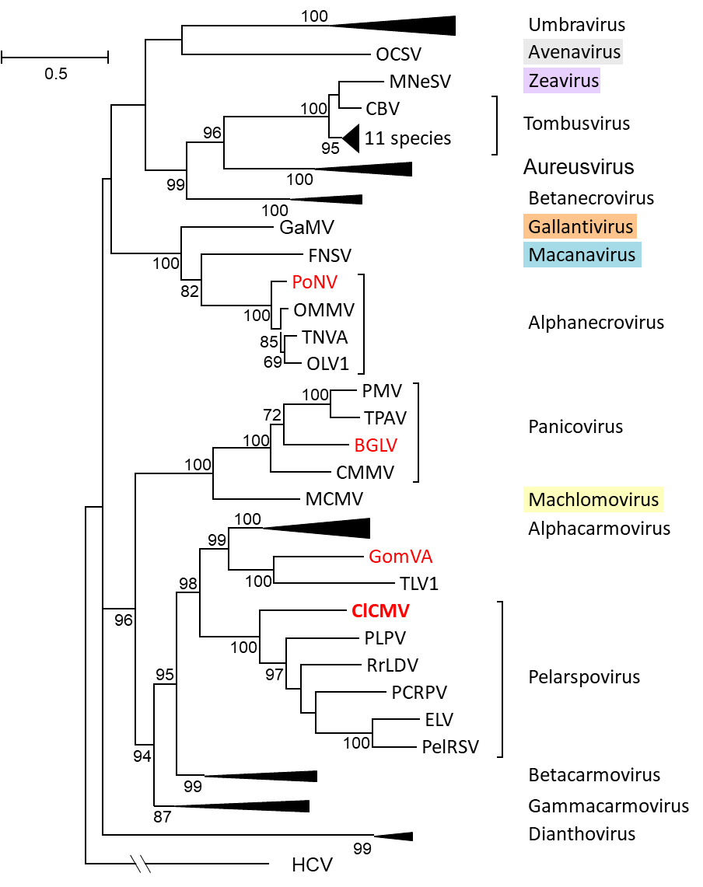
Figure 1. Phylogenetic (distance) analysis of the RdRps of tombusvirids with four possible new members (red font). The alignment was made using MUSCLE while trees were generated with the Maximum Likelihood (ML) algorithm in MEGA7 (Kumar et al. 2016) using 1000 bootstrap replicates (showing values >50%). All positions with less than 50% site coverage were eliminated. That is, fewer than 50% alignment gaps, missing data, and ambiguous bases were allowed at any position. There were 797 positions in the final dataset. Hepatitis C virus (HCV) RdRp (GQ870618.1) was used as the outgroup. Brackets mark uncollapsed genera. Monotypic genera names are in colored boxes. Sequence sources and virus names are in Table 2.

Table 1. Percent Identities of Polymerase and Coat Protein from ClCMV to Closely Related Tombusvirids

Table 2. Sequence IDs used for phylogenetic analyses of RdRps and CPs

Virus Abbreviation(s) | Species |  | Exemplar RefSeq # | Exemplar Virus GB #
 | genus Alphacarmovirus
CarMV-B | Carnation mottle virus |  | X02986 | NC_001265
AFBV-FL | Angelonia flower break virus |  | DQ219415 | NC_007733
CbMV-CA | Calibrachoa mottle virus |  | GQ244431 | NC_021926
HoRSV-CA | Honeysuckle ringspot virus |  | HQ677625 | NC_014967
NLVCV-AK | Nootka lupine vein clearing virus |  | *EF207438 | NC_009017
PFBV-MZ10 | Pelargonium flower break virus |  | AJ514833 | NC_005286
SgCV-MRN | Saguaro cactus virus |  | U72332 | NC_001780
 | genus Alphanecrovirus
TNVA-FM1B | Tobacco necrosis virus A |  | M33002 | NC_001777
OLV1-citrus | Olive latent virus 1 |  | X85989 | NC_001721
OMMV-GP | Olive mild mosaic virus |  | AY616760 | NC_006939
 | genus Aureusvirus
PoLV | Pothos latent virus |  | X87115 | NC_000939
CLSV | Cucumber leaf spot virus |  | EU127904 | NC_007816
JCSMV-Iran | Johnsongrass chlorotic stripe mosaic virus |  | AJ557804 | NC_005287
MWLMV-OH | Maize white line mosaic virus |  | EF589670 | NC_009533
YSV-DMSZ:PV0517 | Yam spherical virus |  | KF482072 | NC_022895
 | genus Avenavirus
OCSV-Llanwern | Oat chlorotic stunt virus |  | X83964 | NC_003633
 | genus Betacarmovirus
TCV-B | Turnip crinkle virus |  | M22445 | NC_003821
CCFV-CL | Cardamine chlorotic fleck virus |  | L16015 | NC_001600
HCRSV-Singapore | Hibiscus chlorotic ringspot virus |  | X86448 | NC_003608
JINRV | Japanese iris necrotic ring virus |  | D86123 | NC_002187
 | genus Betanecrovirus
TNVD-Hungary | Tobacco necrosis virus D |  | U62546 | NC_003487
BBSV-Ningxia | Beet black scorch virus |  | AF452884 | NC_004452
LWSV | Leek white stripe virus |  | X94560 | NC_001822
 | genus Dianthovirus
CRSV | Carnation ringspot virus |  | L18870 | NC_003530
RCNMV-Australia | Red clover necrotic mosaic virus |  | J04357 | NC_003756
SCNMV-59 | Sweet clover necrotic mosaic virus |  | L07884 | NC_003806
 | genus Gallantivirus
GaMV | Galinsoga mosaic virus |  | Y13463 | NC_001818
 | genus Gammacarmovirus
MNSV-Dutch | Melon necrotic spot virus |  | M29671 | NC_001504
CPMV-ATCC:PV955 | Cowpea mottle virus |  | U20976 | NC_003535
PSNV-Wakayama | Pea stem necrosis virus |  | AB086951 | NC_004995
SYMMV-Gunwi | Soybean yellow mottle mosaic virus |  | FJ457015 | NC_011643
 | genus Macanavirus
FNSV-Cauca | Furcraea necrotic streak virus |  | FJ768020 | NC_020469
 | genus Machlomovirus
MCMV-KS1 | Maize chlorotic mottle virus |  | X14736 | NC_003627
 | genus Panicovirus
PMV-109S | Panicum mosaic virus |  | U55002 | NC_002598
CMMV-Scotland | Cocksfoot mild mosaic virus |  | EU081018 | NC_011108
TPAV-05TGP00369 | Thin paspalum asymptomatic virus |  | JX848617 | NC_021705
 | genus Pelarspovirus
PelRSV-DMSZ:PV0304 | Pelargonium ringspot virus |  | AY038068 | NC_026240
ELV-ATCC:PV522 | Elderberry latent virus |  | AY038066 | NC_026239
PCRPV-GR57 | Pelargonium chlorotic ring pattern virus |  | AY038069 | NC_005985
PLPV-DMSZ:PV0193 | Pelargonium line pattern virus |  | AY613852 | NC_007017
RrLDV-MN-3 | Rosa rugosa leaf distortion virus |  | KC166238 | NC_020415
 | Clematis chlorotic mottle virus (proposed) |  | KX712140 | NC_033777
 | genus Tombusvirus
TBSV-cherry | Tomato bushy stunt virus |  | M21958 | NC_001554
AMCV-Bari | Artichoke mottled crinkle virus |  | X62493 | NC_001339
CIRV | Carnation Italian ringspot virus |  | X85215 | NC_003500
CBV-Bulgaria | Cucumber Bulgarian virus |  | AY163842 | NC_004725
CNV | Cucumber necrosis virus |  | M25270 | NC_001469
CyRV | Cymbidium ringspot virus |  | X15511 | NC_003532
EMCV-Israel | Eggplant mottled crinkle virus |  | JQ864181 | NC_023339
GALV-nipplefruit | Grapevine Algerian latent virus |  | AY830918 | NC_011535
MPV-PM75 | Moroccan pepper virus |  | **JX197071 | NC_020073
PLCV-T46 | Pelargonium leaf curl virus |  | KU187189 | NC_030452
PNSV-UPEV | Pelargonium necrotic spot virus |  | AJ607402 | NC_005285
 | genus Umbravirus
CMoV-Weddel | Carrot mottle virus |  | FJ188473 | NC_011515
CMoMV-Australia | Carrot mottle mimic virus |  | U57305 | NC_001726
ETBTV-18-2 | Ethiopian tobacco bushy top virus |  | KJ918748 | NC_024808
GRV-MC1 | Groundnut rosette virus |  | Z69910 | NC_003603
OPMV-PHEL 5235 | Opium poppy mosaic virus |  | EU151723 | NC_027710
PEMV2-WSG | Pea enation mosaic virus 2 |  | U03563 | NC_003853
TBTV-Ch | Tobacco bushy top virus |  | AF402620 | NC_004366
 | genus Zeavirus
MNeSV-AZ | Maize necrotic streak virus |  | AF266518 | NC_007729
 | unassigned tombusvirid
TLV1-06TGP01091 | Trailing lespedeza virus 1 |  | HM640935 | NC_015227
 | genus Hepacivirus
HCV-H77 | Hepacivirus C |  | GQ870618
 | unassigned viruses
BGLV | Bermudagrass latent virus |  | KX758441 | NC_032405.1
GomVA | Gompholobium virus A |  | ***KX184304 | NC_030742
PoNV | Potato necrosis virus |  | KP901095 | NC_029900
Blue font has correct RdRp annotation & was used
Red font has same incorrect RdRp annotation |  |  | * join RAP & RT with "X"
Asterisks indicate modifications to GenBank entries |  |  | ** insert "X" at RT site
Type species are bold |  |  | *** use "X" at RT site

References:
McLaughlin, M., Lockhart, B., Jordan, R., Denton, G., Mollov, D., 2017. Complete nucleotide sequence of clematis chlorotic mottle virus, a new member of the family Tombusviridae. Archives of Virology 162, 1373-1379.

Mollov, D, Lockhart, B, Phibbs, A, Creswell, T, Ruhl, G, Dorman, E, Kinard, G, Jordan R
Clematis chlorotic mottle virus, a novel virus occurring in clematis in the USA (2014)
(Abstr.) Phytopathology 104(Suppl. 3):S3.1.http://dx.doi.org/10.1094/PHYTO-104-11-S3.81

Scheets, K, Jordan, R, White, A, and Hernandez, C, (2015) ICTV taxonomic proposal 2014.006bfP.A.v3.Pelarspovirus. In the family Tombusviridae assign 5 previously unassigned species to a new genus, Pelarspovirus
https://talk.ictvonline.org/files/ictv_official_taxonomy_updates_since_the_8th_report/m/plant-official/5847

