
This Word module should be used for all taxonomic proposals.
Please complete Part 1 and:
either Part 3 for proposals to create new taxa or change existing taxa
or Part 2 for proposals of a general nature.
Submit the completed Word module, together with the accompanying Excel module named in Part 3, to the appropriate ICTV Subcommittee Chair.
For guidance, see the notes written in blue, below, and the help notes in file Taxonomic_Proposals_Help_2018.
Part 1: TITLE, AUTHORS, etc

Code assigned: | 2018.002F |  | (to be completed by ICTV officers)
Short title: Assigning 4 new and 2 unassigned genera to the family Marnaviridae
Author(s):
Andrew S. Lang, Marli Vlok, and Curtis A. Suttle
Corresponding author with e-mail address:
Andrew S. Lang, Department of Biology, Memorial University of Newfoundland, St. John’s, NL, Canada; aslang@mun.ca
List the ICTV study group(s) that have seen this proposal:
A list of study groups and contacts is provided at http://www.ictvonline.org/subcommittees.asp . If in doubt, contact the appropriate subcommittee chair (there are six virus subcommittees: animal DNA and retroviruses, animal ssRNA-, animal ssRNA+, fungal and protist, plant, bacterial and archaeal)
ICTV Study Group comments (if any) and response of the proposer:
Date first submitted to ICTV: |  |  | June 2018
Date of this revision (if different to above):

ICTV-EC comments and response of the proposer:

Part 3: PROPOSED TAXONOMY

Name of accompanying Excel module: 2018.002F.N.v1.Marnaviridae_3gen

Supporting material:

Summary
Metagenomic studies have discovered many novel viruses, including at the level of complete viral genomes. We have applied a sequence-based framework for analysis of twenty marine RNA viruses that provides the justification for taxonomic classification of these viruses within the family Marnaviridae. The twenty viruses include the original and sole representative of the family, Heterosigma akashiwo RNA virus (HaRNAV), 7 additional viruses represented by isolates, and 12 viruses discovered using metagenomics. Using RNA-dependent RNA polymerase (RdRp) phylogeny-based analyses, we propose to assign the previously unassigned genera Labyrnavirus (n=1) and Bacillarnavirus (n=3) to the family, and to create four additional new genera in the family with the proposed names Locarnavirus (n=4), Kusarnavirus (n=1), Salisharnavirus (n=4) and Sogarnavirus (n=6). Capsid amino acid pairwise comparisons were used to delineate species within genera.

Delineation of genera
Maximum-likelihood phylogenetic analysis of the RdRp domain sequences placed the 20 marine RNA virus sequences in a strongly supported monophyletic group relative to other Picornavirales sequences (Figure 1). The sole current Marnaviridae genus, Marnavirus, is basal within the clade (Figure 1). The analysis places the 20 viruses into seven clades that we propose as genera within the family Marnaviridae. These include the previously unassigned genera Bacillarnavirus and Labyrnavirus, and we propose the names Kusarnavirus, Locarnavirus, Salisharnavirus and Sogarnavirus for the four new genera.
Among the 20 viruses and 7 genera, there is a mixture of mono- and dicistronic genome organizations (Table 1). Genome organization can be useful for comparing virus groups but is not a sufficient marker for either family- or genus-level demarcations. While the majority of the 20 viruses analyzed here have a dicistronic genome organization, HaRNAV and SF-3 have a single predicted polyprotein encoded in their genomes. HaRNAV is the only representative of the genus Marnavirus, but SF-3 is one of four viruses falling within the genus Locarnavirus in our analyses. There is also precedent in support of our argument for the inclusion of members with different genomic organization into the family Marnaviridae. In the Secoviridae, another family within the order Picornavirales, both mono- and bipartite members are found. Like the proposed additions to the Marnaviridae, the Secoviridae form a monophyletic clade based on RdRp sequences.

Naming
For the novel genera, “rna” was incorporated into the names for consistency with the established genera. The name Locarnavirus is based on the name of Locarno beach, which is where the first marine RNA virus metagenomes originated from. Salisharnavirus is derived from the “Salish Sea”, the water mass around coastal southern British Columbia from which the first marine RNA virus sequences were amplified. Sogarnavirus refers to the Strait of Georgia (SOG), a major water body of the Salish Sea. The name Kusarnavirus is derived from the Afrikaans word for coastal.

Delineation of species within genera
We propose a conservative cut-off of 75% pairwise amino acid identity for the capsid polyprotein for species demarcation (Figure 2). This is 15% higher than our lowest observed value for what we have defined as species within the genera here. This is less stringent than the 90% cut-off for species in the families Iflaviridae and Dicistroviridae (Chen et al. 2011ab), but in accordance with the parameters required for species classification in the Secoviridae (Sanfacon et al. 2009, 2011).
For the proposed genus Locarnavirus, the Marine RNA virus JP-B was selected as the type species because it is located at the base of the clade and was the first virus discovered among those falling within the genus. For the proposed genus Sogarnavirus, the Marine RNA virus BC-1 virus was selected as the type representative because it is the only virus in the clade for which the genome assembly could be fully verified and where it was certain that the ORFs were complete. Chaetoceros tenuissimus RNA virus type II was selected for the proposed genus Salisharnavirus because it is the better-studied of the two isolates in the clade. Asterionellopsis glacialis RNA virus is the only member of the proposed genus Kusarnavirus.

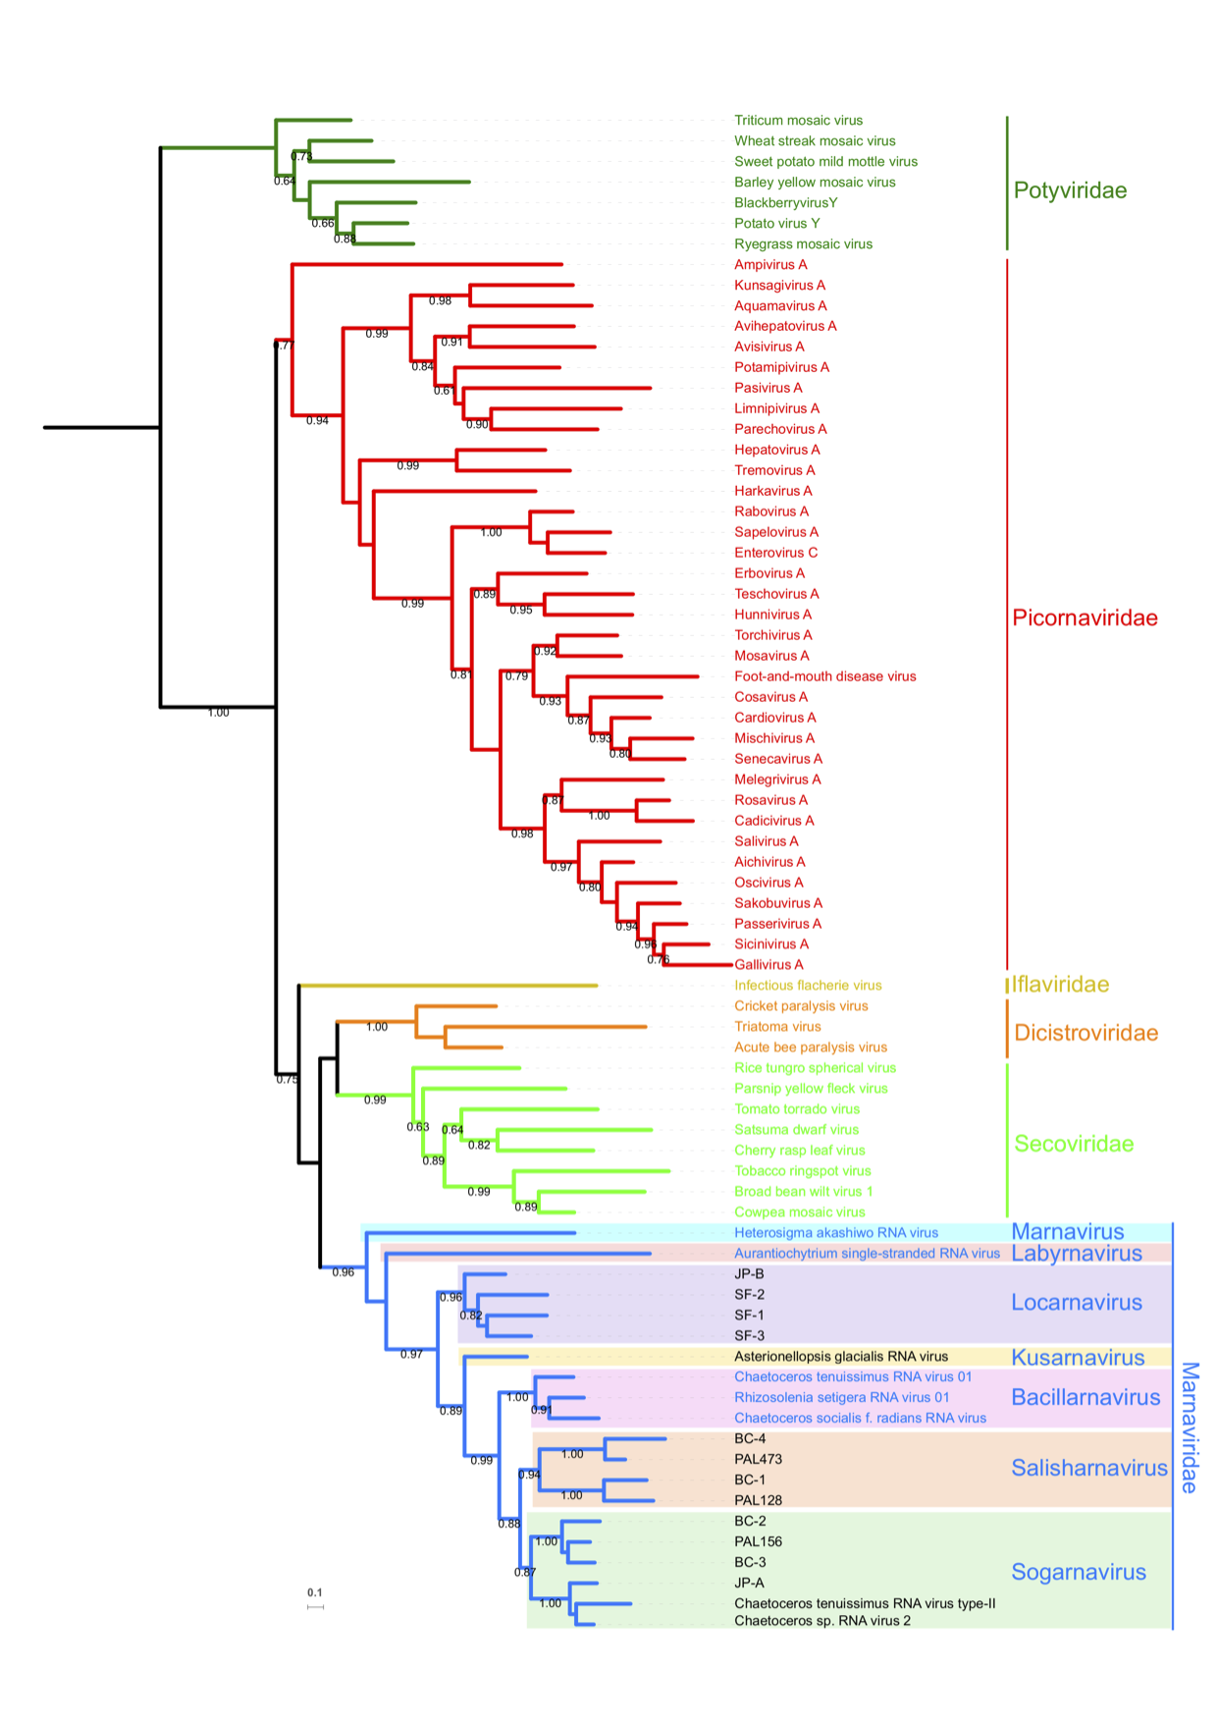

Figure 1. Maximum-likelihood phylogeny of the Picornavirales RNA-dependent RNA polymerase amino acid sequences rooted with sequences from the Potyviridae. Branch colours denote virus families: Potyviridae (dark green), Picornaviridae (red), Iflaviridae (yellow), Dicistroviridae (orange), Secoviridae (lime green) and Marnaviridae (blue). Existing and proposed genera within the Marnaviridae are indicated by coloured boxes. SH-like branch support values are indicated at the nodes when >0.7 and the maximum-likelihood scale bar is shown.

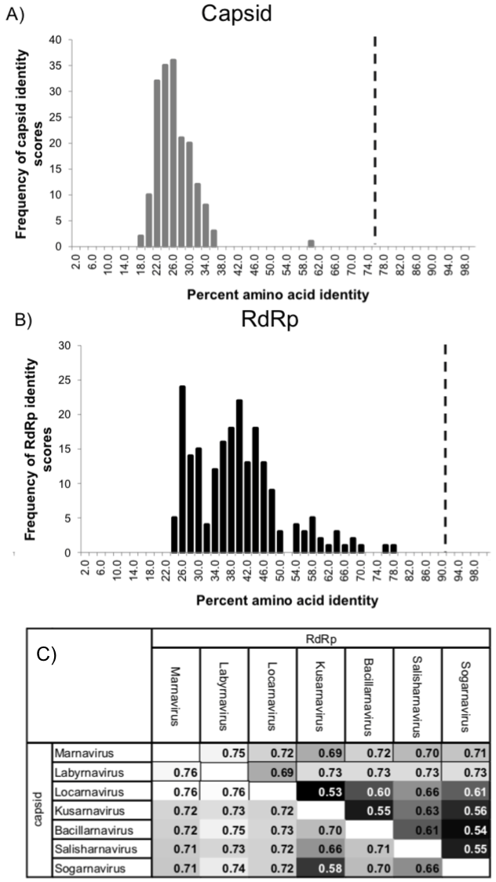

Figure 2. Pairwise comparisons of Marnaviridae member sequences. A. Pairwise identities calculated for the entire capsid polyprotein region quantified in bins. B. Pairwise identities calculated for the RdRp domain quantified in bins. C. Values for pairwise comparisons among genera.

Table 1. Summary of information for 20 viruses related to this proposal.
Genus | Species¹ | Accession number(s) |  | Genome |  |  | Host or source | Country | References
Genus | Species¹ | Nucleotide | Amino acid | Size (nt) | # ORFs | Architecture | Host or source | Country | References
Marnavirus | Heterosigma akashiwo RNA virus | AY337486 | AAP97137 | 8587 | One |  | Heterosigma akashiwo | Canada | Lang et al., 2004; Tai et al., 2003
Labyrnavirus | Aurantiochytrium single stranded RNA virus | AB193726 | BAE47143 | 9035 | Two |  | Aurantiochytrium sp. | Japan | Takao et al., 2006
Locarnavirus | Marine RNA virus JP-B | EF198242 | ABQ50601 ABQ50602 | 8926 | Two |  | Coastal marine | Canada | Culley et al., 2007
Locarnavirus | Marine RNA virus SF-2 | KF412901 | AGZ83339 AGZ83340 | 9321 | Two |  | Coastal wastewater | USA | Greninger and DeRisi, 2015
Locarnavirus | Marine RNA virus SF-1 | JN661160 | AFM44930 AFM44929 | 8970 | Two |  | Coastal wastewater | USA | Greninger and DeRisi, 2015
Locarnavirus | Marine RNA virus SF-3 | KF478836 | AHA44480 | 8648 | One |  | Coastal wastewater | USA | Greninger and DeRisi, 2015
Kusarnavirus | Asterionellopsis glacialis RNA virus | AB973945 | BAP16719 BAP16720 | 8842 | Two |  | Asterionellopsis glacialis | Japan | Tomaru et al., 2012
Bacillarnavirus | Chaetoceros tenuissimus RNA virus 01 | AB375474 | BAG30951 BAG30952 | 9431 | Two |  | Chaetoceros tenuissimus | Japan | Shirai et al., 2008
Bacillarnavirus | Rhizosolenia setigera RNA virus | AB243297 | BAE79742 BAE79743 | 8877 | Two |  | Rhizosolenia setigera | Japan | Nagasaki et al., 2004
Bacillarnavirus | Chaetoceros socialis f. radians RNA virus 01 | NC_012212 | BAH22517 BAH22518 | 9467 | Two |  | Chaetoceros socialis f. radians | Japan | Tomaru et al., 2009
Salisharnavirus | Marine RNA virus BC-4 | MH171300 |  | 8593 | Two |  | Coastal/oceanic marine | Canada | Vlok et al. unpublished
Salisharnavirus | Marine RNA virus PAL473 | KT727026 | AMK49159 AMK49160 | 6360 | Two |  | Coastal marine | USA | Miranda et al., 2016
Salisharnavirus | Marine RNA virus BC-1 | MG584187 |  | 8638 | Two |  | Coastal marine | Canada | Vlok et al. unpublished
Salisharnavirus | Marine RNA virus PAL128 | KT727023 | AMK49153 AMK49154 | 8660 | Two |  | Coastal marine | USA | Miranda et al., 2016
Sogarnavirus | Marine RNA virus BC-2 | MG584188 |  | 8843 | Two |  | Coastal marine | Canada | Vlok et al. unpublished
Sogarnavirus | Marine RNA virus PAL156 | KT727024 | AMK49155 AMK49156 | 7897 | Two |  | Coastal marine | USA | Miranda et al., 2016
Sogarnavirus | Marine RNA virus BC-3 | MG584189 |  | 8496 | Two |  | Coastal marine | Canada | Vlok et al. unpublished
Sogarnavirus | Marine RNA virus JP-A | EF198241 | ABQ50599 ABQ50600 | 9236 | Two |  | Coastal marine | Canada | Culley et al., 2007
Sogarnavirus | Chaetoceros tenuissimus RNA virus type II | AB971661 | BAP99818 BAP99819 | 9562 | Two |  | Chaetoceros tenuissimus | Japan | Kimura and Tomaru, 2015
Sogarnavirus | Chaetoceros species RNA virus01 | AB639040 | BAK40203 BAK40204 | 9417 | Two |  | Chaetoceros sp. | Japan | Tomaru et al., 2013
¹Assigned type species in existing genera and proposed type species in proposed genera are in bold.

References:
Chen YP, Nakashima N, Christian PD, Bakonyi T, Bonning BC, Valles SM, et al. (2011a). Dicistroviridae. In: Virus taxonomy: classification and nomenclature of viruses: Ninth report of the international committee on taxonomy of viruses, King, AMQ, Adams, MJ, Carstens, EB, & Lefkowitz, EJ (eds), Elsevier Academic Press, pp 840–845.
Chen YP, Nakashima N, Christian PD, Bakonyi T, Bonning BC, Valles SM, et al. (2011b). Iflaviridae. In: Virus taxonomy: classification and nomenclature of viruses Ninth report of the international committee on taxonomy of viruses, pp 846–849.
Culley AI, Lang AS, Suttle CA. (2007). The complete genomes of three viruses assembled from shotgun libraries of marine RNA virus communities. Virol J 4: 69.
Greninger AL, DeRisi JL. (2015) Draft genome sequences of marine RNA viruses SF-1, SF-2, and SF-3 recovered from San Francisco wastewater. Genome Announc 3: e00653-15
Kimura K, Tomaru Y. (2015). Discovery of two novel viruses expands the diversity of single-stranded DNA and single-stranded RNA viruses infecting a cosmopolitan marine diatom. Appl Environ Microbiol 81: 1120–1131.
Lang AS, Culley AI, Suttle CA. (2004). Genome sequence and characterization of a virus (HaRNAV) related to picorna-like viruses that infects the marine toxic bloom-forming alga Heterosigma akashiwo. Virology 320: 206–217.
Miranda JA, Culley AI, Schvarcz CR, Steward GF. (2016). RNA viruses as major contributors to Antarctic virioplankton. Environ Microbiol 18: 3714–3727.
Nagasaki K, Tomaru Y, Katanozaka N, Shirai Y, Nishida K, Itakura S, et al. (2004). Isolation and characterization of a novel single-stranded RNA virus infecting the bloom-forming diatom Rhizosolenia setigera. Appl Environ Mcrobiology 70: 704–711.
Sanfaçon H, Iwanami T, Karasev A V, van der Vlugt R, Wellink J, Wetzel T, et al. (2011). Secoviridae. In: Virus taxonomy: classification and nomenclature of viruses Ninth report of the international committee on taxonomy of viruses, King, AMQ, Adams, MJ, Carstens, EB, & Lefkowitz, EJ (eds), Elsevier Academic Press, pp 881–899.
Sanfaçon H, Wellink J, Le Gall O, Karasev A, Van Der Vlugt R, Wetzel T. (2009). Secoviridae: A proposed family of plant viruses within the order Picornavirales that combines the families Sequiviridae and Comoviridae, the unassigned genera Cheravirus and Sadwavirus, and the proposed genus Torradovirus. Arch Virol 154: 899–907.
Shirai Y, Tomaru Y, Takao Y, Suzuki H, Nagumo T, Nagasaki K. (2008). Isolation and characterization of a single-stranded RNA virus infecting the marine planktonic diatom Chaetoceros tenuissimus Meunier. Appl Environ Microbiol 74: 4022–4027.
Tai V, Lawrence JE, Lang AS, Chan AM, Culley AI, Suttle CA. (2003). Characterization of HaRNAV, a single-stranded RNA virus causing lysis of Heterosigma akashiwo (Raphidophyceae). J Phycol 39: 343–352.
Takao Y, Mise K, Nagasaki K, Okuno T, Honda D. (2006). Complete nucleotide sequence and genome organization of a single-stranded RNA virus infecting the marine fungoid protist. J Gen Virol 87: 723–733.
Tomaru Y, Takao Y, Suzuki H, Nagumo T, Nagasaki K. (2009). Isolation and characterization of a single-stranded RNA virus infecting the bloom-forming diatom Chaetoceros socialis. Appl Environ Microbiol 75: 2375–2381.
Tomaru Y, Toyoda K, Kimura K, Hata N, Yoshida M, Nagasaki K. (2012). First evidence for the existence of pennate diatom viruses. ISME J 6: 1445–1448.
Tomaru Y, Toyoda K, Kimura K, Takao Y, Sakurada K, Nakayama N, et al. (2013). Isolation and characterization of a single-stranded RNA virus that infects the marine planktonic diatom Chaetoceros sp. (SS08-C03). Phycol Res 61: 27–36.

