

The International Committee on Taxonomy of Viruses
Taxonomy Proposal Form, 2024

Part 1a: Details of taxonomy proposals

Title: | Create a new genus, Seraphanvirus, containing two species (Caudoviricetes)
Code assigned: | 2024.032B

Author(s), affiliation and email address(es):
Name | Affiliation | Email address | Corresponding author(s) X
Ganjoor MS | University of Isfahan, Iran | msg_isrc@yahoo.com
Bouzari M | University of Isfahan, Iran | bouzari@sci.ui.ac.ir | X
Soleimani-Delfan A | University of Isfahan, Iran | asdelfan2003@gmail.com

Part 1b: Taxonomy Proposal Submission
ICTV Subcommittee:
Animal DNA Viruses and Retroviruses |  | Bacterial viruses | X
Animal minus-strand and dsRNA viruses |  | Fungal and protist viruses
Animal positive-strand RNA viruses |  | Plant viruses
Archaeal viruses |  | General -

List the ICTV Study Group(s) that have seen or have been involved in creating this proposal:
Optional – complete only if formally voted on by an ICTV Study Group:
Study Group | Number of members
Study Group | Votes in support | Votes against | No vote

Submission date: | 09/12/2023

Part 1c: Feedback from ICTV Executive Committee (EC) meeting
Executive Committee Meeting Decision code: | X
A – Accept | X
Ac – Accept subject to revision by relevant subcommittee chair. No further vote required
U – Accept without revision but with re-evaluation and email vote by the EC
Uc – Accept subject to revision and re-evaluation and email vote by the EC
Ud – Deferred to the next EC meeting, with an invitation to revise based on EC comments
J - Reject
W - Withdrawn

Comments from the Executive Committee:

Part 1d: Revised Taxonomy Proposal Submission
Response of proposer:
Revision date: | DD/MM/YYYY

Part 3: TAXONOMIC PROPOSAL

Name of accompanying Excel module:
2024.032B.A.v1.Sepahanvirus_ng.xlsx

Taxonomic changes proposed:
Establish new taxon | X | Split taxon
Abolish taxon |  | Merge taxon
Move taxon |  | Promote taxon
Rename taxon |  | Demote taxon
Move and rename

Is any taxon name used here derived from that of a living person: |  | N
Taxon name | Person from whom the name is derived | Attached X

Abstract of Taxonomy Proposal:
Taxonomic rank(s) affected:
Genus

Description of current taxonomy:
These phages are currently unclassified.

Proposed taxonomic change(s):
To create a new genus, Sepahanvirus, within the class Caudoviricetes comprising two species, vB_Yru_GN1 and YerA41.

Justification:
Phages vB_Yru_GN1 and phage YerA41 exhibit nucleotide sequence similarity that falls within the demarcation threshold for the creation of a new genus.

- Text of Taxonomy proposal:
Taxonomic rank(s) affected:
Genus and species.

Description of current taxonomy:
Yersinia phages vB_Yru_GN1 and YerA41 are currently unclassified.

Proposed taxonomic change(s):
A new genus, Sepahanvirus is proposed, named after the ancient name Sepahan of the city Isfahan, where vB_Yru_GN1 was isolated.

Demarcation criteria:
Species demarcation criteria: Two phages are assigned to the same species if their genomes are more than 95% identical over their genome length for isolates. These values can be calculated by a number of tools, such as BLASTn [1] – usually calculated using intergenomic distance calculator VIRIDIC [5].

Genus demarcation criteria: In search for criteria that create cohesive and distinct genera that are reproducible and monophyletic, the Bacterial Viruses Subcommittee has established 70% nucleotide identity of the genome length as the cut-off for genera. Genus-level groupings should always be monophyletic in the signature genes, as tested with a phylogenetic tree [7].

Justification:
The vB_Yru_GN1 genome has very low homology to other bacteriophage sequences in the GenBank database. A complete genome sequence comparison using the BLASTn method revealed that the genome of Yersinia ruckery phage vB_Yru_GN1 (Table 1) had a maximum nucleotide identity of 97.95% and 94% coverage with Yersinia phage YerA41 [4]. Analysis with VIRIDIC demonstrates that these phages exhibit 92% nucleotide sequence similarity (Figure 1). Both vB_Yru_GN1 and YerA41 posses a myovirus morphology (Figure 2). Phylogenetic analysis using the Neighbor-joining method of the major capsid protein and DNA polymerase demonstrates that these phages form a monophyletic clade (Figure 3).

References:
1. Altschul SF, Madden TL, Schäffer AA, Zhang J, Zhang Z, Miller W, Lipman DJ (1997) Gapped BLAST and PSI-BLAST: a new generation of protein database search programs. Nucleic acids research 25:3389-3402
2. Felsenstein J (1985) Confidence limits on phylogenies: an approach using the bootstrap. evolution 39:783-791
3. Kumar S, Stecher G, Tamura K (2016) MEGA7: molecular evolutionary genetics analysis version 7.0 for bigger datasets. Molecular biology and evolution 33:1870-1874
4. Leskinen K, Pajunen MI, Vilanova MVG-R, Kiljunen S, Nelson A, Smith D, Skurnik M (2020) YerA41, a yersinia ruckeri bacteriophage: determination of a non-sequencable DNA bacteriophage genome via RNA-Sequencing. Viruses 12:620
5. Moraru C, Varsani A, Kropinski AM (2020) VIRIDIC—A novel tool to calculate the intergenomic similarities of prokaryote-infecting viruses. Viruses 12:1268
6. Saitou N, Nei M (1987) The neighbor-joining method: a new method for reconstructing phylogenetic trees. Molecular biology and evolution 4:406-425
7. Turner D, Kropinski AM, Adriaenssens EM (2021) A roadmap for genome-based phage taxonomy. Viruses 13:506
8. Zuckerkandl E, Pauling L (1965) Evolutionary divergence and convergence in proteins. Evolving genes and proteins. Elsevier, pp 97-166

Tables, Figures:
Table 1. Summary genome characteristics of bacterial viruses vB_Yru_GN1 and YerA41
Phage name | Accession number | Size (bp) | GC% | Protein | tRNAs
Yersinia ruckery phage vB_Yru_GN1 | LC779065 | 145093 | 32.1 | 205 | 2
Yersinia phage YerA41 | MW570730 | 145577 | 32.3 | 213 | 2
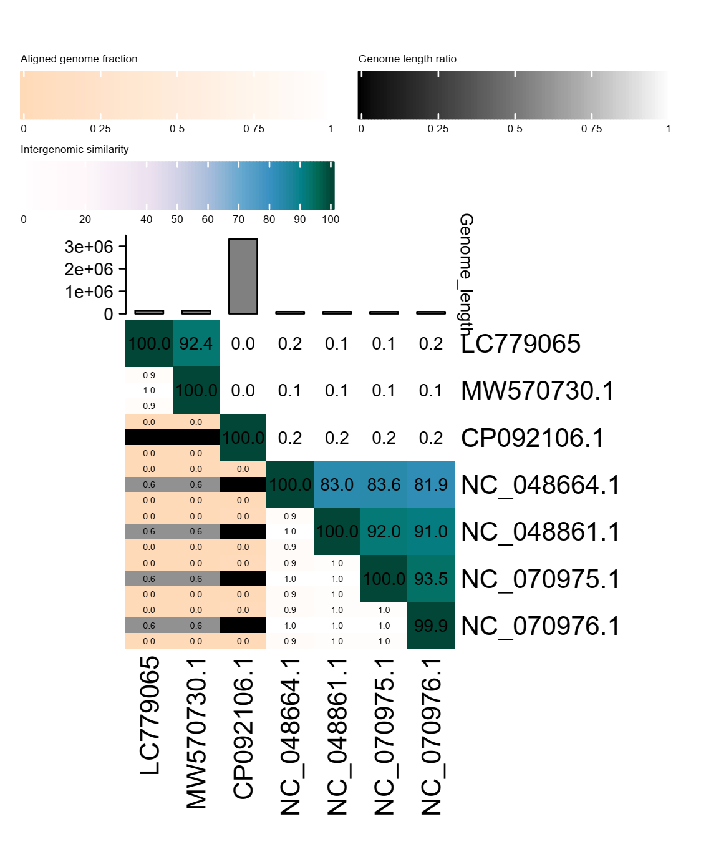
Figure 1. VIRIDIC (Virus Intergenomic Distance Calculator) heatmap illustrating pairwise intergenomic similarities amongst phage genomes.
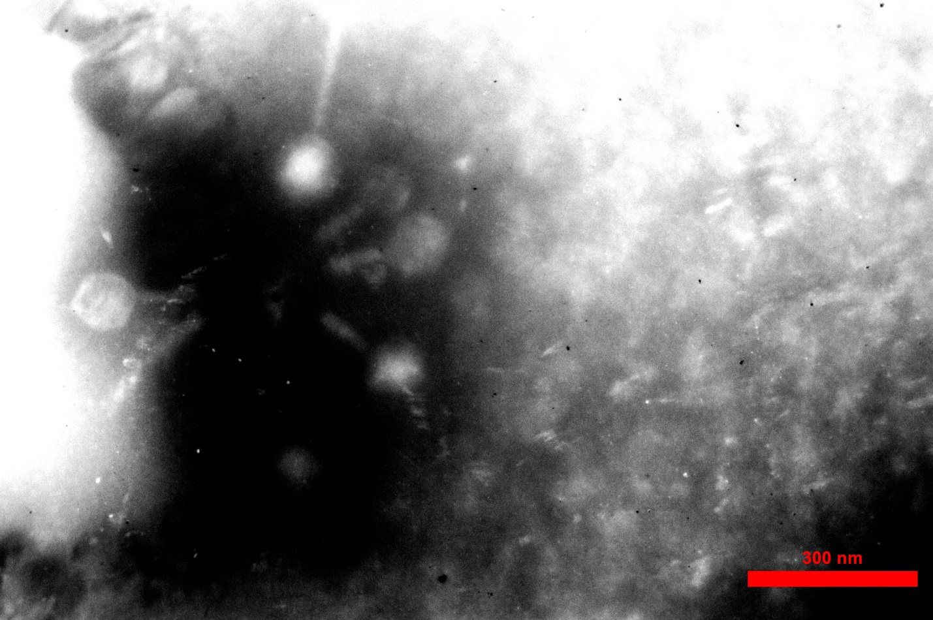
Figure 2. Transmission electron micrograph of vB_Yru_GN1, showing a myovirus morphology. Virion dimensions are a head ~130 nm in diameter and a contractile tail and neck of ~ 215 nm in length (filled arrow) and phages with contracted tails of ~ 96 nm in length (empty arrows).
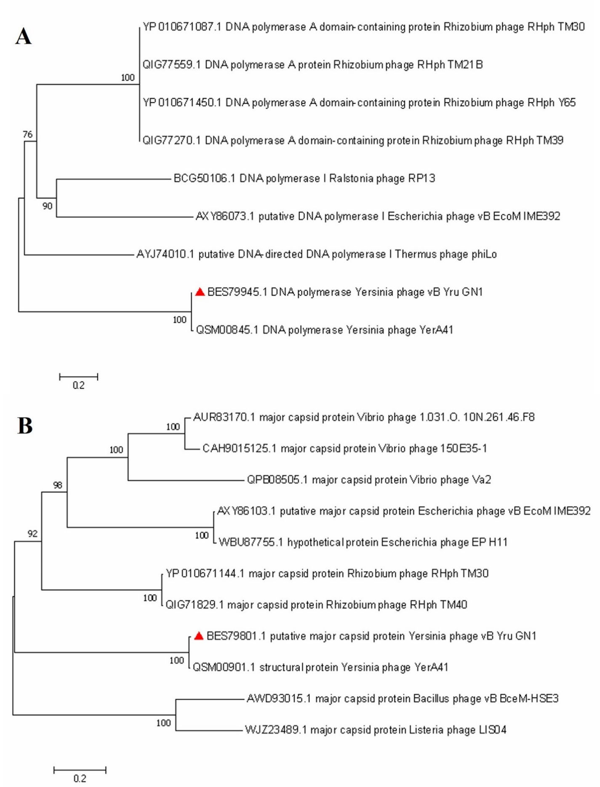
Figure 3. Neighbor-Joining phylogenetic trees [6] of (A) DNA polymerase and (B) major capsid proteins. The percentage of replicate trees in which the associated taxa clustered together in the bootstrap test (1000 replicates) are shown next to the branches [2]. The tree is drawn to scale, with branch lengths in the same units as those of the evolutionary distances used to infer the phylogenetic tree. The evolutionary distances were computed using the Poisson correction method [8]. Evolutionary analyses were conducted in MEGA7 [3]. The red triangle indicates the phage species reported in this proposal.

