

The International Committee on Taxonomy of Viruses
Taxonomy Proposal Form, 2024

Part 1a: Details of taxonomy proposals

Title: | Create a new family, Kruegerviridae, for a group of Gordonia phages (Class: Caudoviricetes)
Code assigned: | 2024.019B

Author(s), affiliation and email address(es):
Name | Affiliation | Email address | Corresponding author(s) X
Kurtböke, I | University of the Sunshine Coast, Australia | ikurtbok@usc.edu.au
Moraru C | Carl von Ossietzky Universität Oldenburg, Germany | liliana.cristina.moraru@uol.de
Tolstoy I | National Center for Biotechnology Information, MD, USA | tolstoy@ncbi.nlm.nih.gov
Kropinski AM | University of Guelph, Ontario, Canada [AMK] | Phage.Canada@gmail.com

Part 1b: Taxonomy Proposal Submission
ICTV Subcommittee:
Animal DNA Viruses and Retroviruses |  | Bacterial viruses | x
Animal minus-strand and dsRNA viruses |  | Fungal and protist viruses
Animal positive-strand RNA viruses |  | Plant viruses
Archaeal viruses |  | General -

List the ICTV Study Group(s) that have seen or have been involved in creating this proposal:
Actinophages Study Group

Optional – complete only if formally voted on by an ICTV Study Group:
Study Group | Number of members
Study Group | Votes in support | Votes against | No vote

Submission date: | 28/05/2024

Part 1c: Feedback from ICTV Executive Committee (EC) meeting
Executive Committee Meeting Decision code: | X
A – Accept
Ac – Accept subject to revision by relevant subcommittee chair. No further vote required | X
U – Accept without revision but with re-evaluation and email vote by the EC
Uc – Accept subject to revision and re-evaluation and email vote by the EC
Ud – Deferred to the next EC meeting, with an invitation to revise based on EC comments
J - Reject
W - Withdrawn

Comments from the Executive Committee:
Include text within the justification section of proposal abstract.

Part 1d: Revised Taxonomy Proposal Submission
Response of proposer:
Corrected.

Revision date: | 30/09/2024

Part 3: TAXONOMIC PROPOSAL

Name of accompanying Excel module:
2024.019B.A.v2.Kruegerviridae_nf.xlsx

Taxonomic changes proposed:
Establish new taxon | x | Split taxon
Abolish taxon |  | Merge taxon
Move taxon |  | Promote taxon
Rename taxon |  | Demote taxon
Move and rename

Is any taxon name used here derived from that of a living person: |  | Y/N
Taxon name | Person from whom the name is derived | Attached X

Abstract of Taxonomy Proposal:
Taxonomic rank(s) affected:
Realm Duplodnaviria, kingdom Heunggongvirae, phylum Uroviricota, class Caudoviricetes

Description of current taxonomy:
Vanleevirus currently exists as a floating genus in the class Caudoviricetes

Proposed taxonomic change(s):
A. To create a new genus Cafassovirus with four species
B. To create a new family, Kruegerviridae, for the Cafassovirus and Vanleevirus.

Justification:
By VIRIDIC analysis members of these two genera share ≥18.8% DNA sequence similarity and also share 46 protein homologs. The genera Vanleevirus and Cafassovirus form a deep-branching clade using tBLASTX distances, commensurate with the establishment of a new family of bacterial viruses.

- Text of Taxonomy proposal:
Taxonomic rank(s) affected: Species, genus and Family

Description of current taxonomy:

At present only the genus Vanleevirus exists.

Proposed taxonomic change(s):
A. To create a new genus Cafassovirus with four species
B. To create a new family, Kruegerviridae, for the Cafassovirus and Vanleevirus.

Demarcation criteria:
Species demarcation criteria: Two phages are assigned to the same species if their genomes are more than 95% identical over their genome length for isolates.
These values can be calculated by a number of tools, such as BLASTn [1,2] – usually calculated using intergenomic distance calculator VIRIDIC [3].

Genus demarcation criteria: In search for criteria that create cohesive and distinct genera that are reproducible and monophyletic, the Bacterial Viruses Subcommittee has established 70% nucleotide identity of the genome length as the cut-off for genera. Genus-level groupings should always be monophyletic in the signature genes, as tested with a phylogenetic tree. [10]

Subfamily demarcation criteria: Subfamilies are to be created when two or more genera are related below the family level. In practical terms, this usually means that they share a low degree of sequence similarity (usually about 40-50%) and that the genera form a clade in a marker tree phylogeny. [10]

Family demarcation criteria: The family is represented by a cohesive and monophyletic group in the main predicted proteome-based clustering tools (VirClust, ViPTree, GRAViTy dendrogram, vConTACT2 network). Members of the family share a significant number of orthologous genes (the number will depend on the genome sizes and number of coding sequences of members of the family). [10]

Justification:
The genera Vanleevirus and Cafassovirus form a deep-branching clade using tBLASTX distances and share 46 common genes.

References:
1. Sayers EW, Beck J, Bolton EE, Bourexis D, Brister JR, Canese K, Comeau DC, Funk K, Kim S, Klimke W, Marchler-Bauer A, Landrum M, Lathrop S, Lu Z, Madden TL, O'Leary N, Phan L, Rangwala SH, Schneider VA, Skripchenko Y, Wang J, Ye J, Trawick BW, Pruitt KD, Sherry ST. Database resources of the National Center for Biotechnology Information. Nucleic Acids Res. 2021 Jan 8;49(D1):D10-D17. doi: 10.1093/nar/gkaa892. PMID: 33095870
2. O'Leary NA, Wright MW, Brister JR, Ciufo S, Haddad D, McVeigh R, et al. Reference sequence (RefSeq) database at NCBI: current status, taxonomic expansion, and functional annotation. Nucleic Acids Res. 2016;44(D1):D733-45. doi: 10.1093/nar/gkv1189. PMID: 26553804.
3. Moraru C, Varsani A, Kropinski AM. VIRIDIC-A Novel Tool to Calculate the Intergenomic Similarities of Prokaryote-Infecting Viruses. Viruses. 2020 Nov 6;12(11):1268. doi: 10.3390/v12111268. PMID: 33172115; PMCID: PMC7694805. http://kronos.icbm.uni-oldenburg.de/viridic/
4. Nishimura Y, Yoshida T, Kuronishi M, Uehara H, Ogata H, Goto S. ViPTree: the viral proteomic tree server. Bioinformatics. 2017; 33(15):2379-2380. doi:10.1093/bioinformatics/btx157. PubMed PMID: 28379287. https://www.genome.jp/viptree/
5. Rohwer F, Edwards R. The Phage Proteomic Tree: a genome-based taxonomy for phage. J Bacteriol. 2002 Aug;184(16):4529-35. PubMed PMID: 12142423
6. Turner D, Reynolds D, Seto D, Mahadevan P. CoreGenes3.5: a webserver for the determination of core genes from sets of viral and small bacterial genomes. BMC Res Notes. 2013;6:140. doi: 10.1186/1756-0500-6-140. PMID: 23566564.
7. Davis P, Seto D, Mahadevan P. CoreGenes5.0: An Updated User-Friendly Webserver for the Determination of Core Genes from Sets of Viral and Bacterial Genomes. Viruses. 2022 Nov 16;14(11):2534. doi: 10.3390/v14112534. PMID: 36423143; PMCID: PMC9693508.
8. Dereeper A, Guignon V, Blanc G, Audic S, Buffet S, Chevenet F, Dufayard JF, Guindon S, Lefort V, Lescot M, Claverie JM, Gascuel O. Phylogeny.fr: robust phylogenetic analysis for the non-specialist. Nucleic Acids Res. 2008;36(Web Server issue):W465-9. doi: 10.1093/nar/gkn180. Epub 2008 Apr 19. PMID: 18424797.
9. Anisimova M, Gascuel O. Approximate likelihood-ratio test for branches: A fast, accurate, and powerful alternative. Syst Biol. 2006;55(4):539-52. PMID: 16785212. DOI: 10.1080/10635150600755453.
10. Turner D, Kropinski AM, Adriaenssens EM. A Roadmap for Genome-Based Phage Taxonomy. Viruses. 2021 Mar 18;13(3):506. doi: 10.3390/v13030506. PMID: 33803862; PMCID: PMC8003253.
11. Bin Jang H, Bolduc B, Zablocki O, Kuhn JH, Roux S, Adriaenssens EM, Brister JR, Kropinski AM, Krupovic M, Lavigne R, Turner D, Sullivan MB. Taxonomic assignment of uncultivated prokaryotic virus genomes is enabled by gene-sharing networks. Nat Biotechnol. 2019 Jun;37(6):632-639. doi: 10.1038/s41587-019-0100-8. Epub 2019 May 6. PMID: 31061483.
12. Bolduc B, Jang HB, Doulcier G, You ZQ, Roux S, Sullivan MB. vConTACT: an iVirus tool to classify double-stranded DNA viruses that infect Archaea and Bacteria. PeerJ. 2017 May 3;5:e3243. doi: 10.7717/peerj.3243. PMID: 28480138; PMCID: PMC5419219.
13. Moraru C. VirClust-A Tool for Hierarchical Clustering, Core Protein Detection and Annotation of (Prokaryotic) Viruses. Viruses. 2023 Apr 19;15(4):1007. doi: 10.3390/v15041007. PMID: 37112988; PMCID: PMC10143988.
14. Letunic I, Bork P. Interactive Tree Of Life (iTOL): an online tool for phylogenetic tree display and annotation. Bioinformatics. 2007 Jan 1;23(1):127-8. doi: 10.1093/bioinformatics/btl529. Epub 2006 Oct 18. PMID: 17050570.
15. Zhou T, Xu K, Zhao F, Liu W, Li L, Hua Z, Zhou X. itol.toolkit accelerates working with iTOL (Interactive Tree of Life) by an automated generation of annotation files. Bioinformatics. 2023 Jun 1;39(6):btad339. doi: 10.1093/bioinformatics/btad339. PMID: 37225402; PMCID: PMC10243930.
16. Nguyen LT, Schmidt HA, von Haeseler A, and Minh BQ (2015) IQ-TREE: A fast and effective stochastic algorithm for estimating maximum likelihood phylogenies. Molecular Biology and Evolution, 32:268-274. https://doi.org/10.1093/molbev/msu300
17. Hoang DT, Chernomor O, von Haeseler A, Minh BQ, Vinh LS (2018) UFBoot2: Improving the ultrafast bootstrap approximation. Molecular Biology and Evolution, 35:518–522. https://doi.org/10.1093/molbev/msx281
18. Kalyaanamoorthy S, Minh BQ, Wong TKF, von Haeseler A, and Jermiin JS (2017) ModelFinder: Fast Model Selection for Accurate Phylogenetic Estimates, Nature Methods, 14:587–589. https://doi.org/10.1038/nmeth.4285

Tables, Figures:
<Start here>

Figure 1. VIRIDIC heat map of a portion of the members of this family: VIRIDIC (Virus Intergenomic Distance Calculator; VIRIDIC (Virus Intergenomic Distance Calculator; [3]; http://rhea.icbm.uni-oldenburg.de/VIRIDIC/) computes pairwise intergenomic distances/similarities amongst phage genomes. Data values which are bordered in black correspond to strains. Abbreviations: phg = phage; Gord = Gordonia.

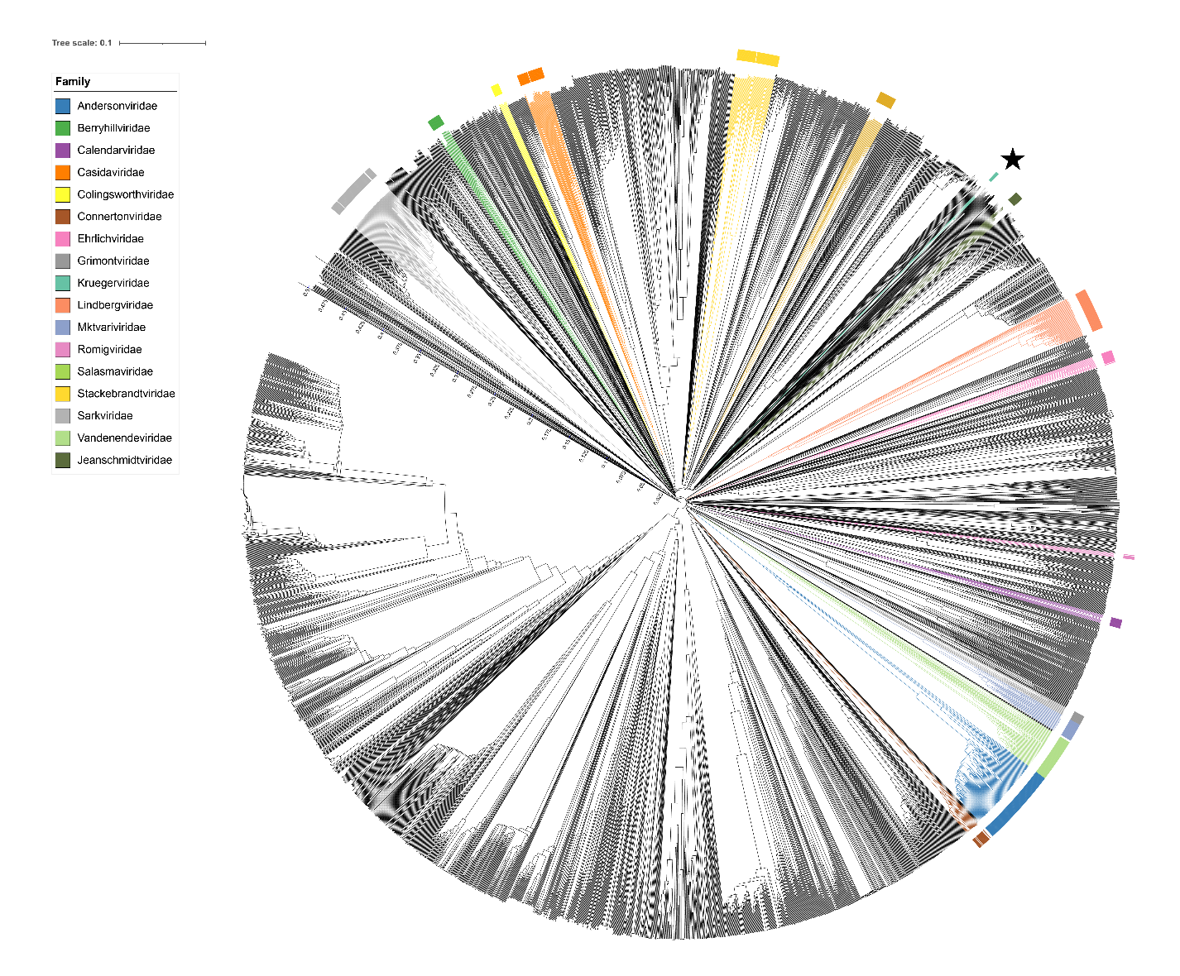
Figure 2. ViPTree [4] analysis Proteomic tree of 4,408 bacterial viruses with proposed viral families labeled by the coloured ring. The Kruegerviridae are marked with a star symbol. The hierarchical tree was created using ViPTreeGen (version 1.1.2) [4] and annotated using iToL [15-16]. The tree is based on a dissimilarity matrix generated by pairwise tBLASTx scores between each of the genomes.
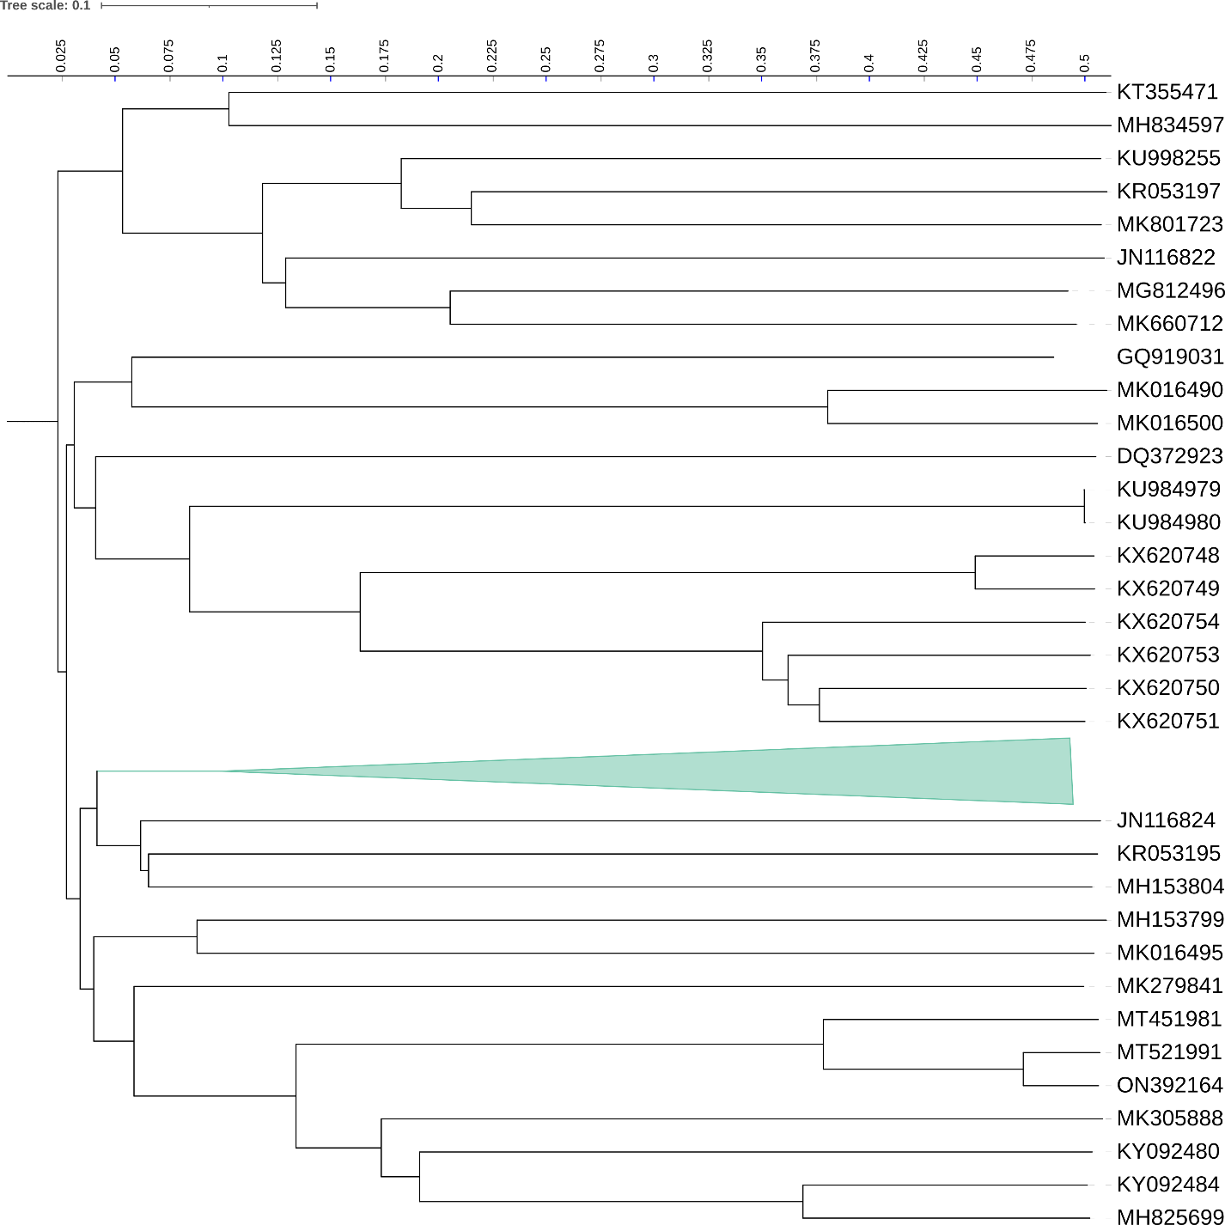
Figure 3. ViPTree [4] hierarchical tree pruned to show the proposed Kruegerviridae alongside neighbouring clades.

Figure 4. VirClust protein heatmap: at the first level, proteins are grouped based on their reciprocal BLASTP similarities into protein clusters, or PCs. At the second level, PCs are grouped based on their Hidden Markov Model (HMM) similarities into protein superclusters, or PSCs. AT the third, still experimental level, PSCs are grouped based on their HMM similarities into protein super-superclusters, or PSSC [13}.
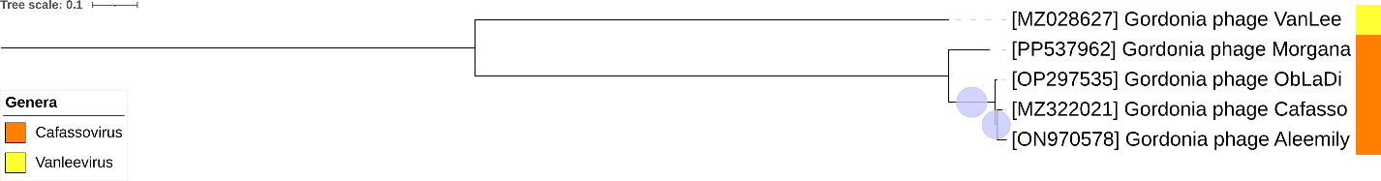
Figure 5. Core genome phylogeny of the proposed Kruegerviridae family of bacterial viruses. A partitioned protein ML phylogeny was created from 46 genes present in all species of the proposed family. Alignments were performed using MAFFT in e-insi mode and trimmed using trimAl with a gap threshold of 0.5. The tree was calculated using IQ-Tree2 with 1000 ultrafast (UF) bootstrap replicates and SH-Alrt tests with -m TEST to optimise models for each alignment [16-18]. The tree is rooted at the midpoint and UF bootstrap support ≥ 95% are shown. The coloured strips indicate proposed genera and subfamilies.

Table1. Signature genes in the proposed Kruegerviridae family of bacterial viruses. Genes were identified by clustering with MMSeqs2, with thresholds of 35% sequence similarity and 50% coverage.
protein cluster | No. of genomes (5 total) | Percentage of genomes present in protein cluster | Predicted gene function
1 | 5 | 100% | hypothetical protein
2 | 5 | 100% | tail terminator
3 | 5 | 100% | RepA-like replication initiator
4 | 5 | 100% | hypothetical protein
5 | 5 | 100% | head-to-tail adaptor
6 | 5 | 100% | DnaB-like dsDNA helicase
7 | 5 | 100% | head-to-tail stopper
8 | 5 | 100% | minor tail protein
9 | 5 | 100% | excision protein
10 | 5 | 100% | DnaQ-like DNA polymerase III subunit
11 | 5 | 100% | terminase small subunit
12 | 5 | 100% | IrrE-like protein
13 | 5 | 100% | helix-turn-helix DNA-binding domain protein
14 | 5 | 100% | Cro protein
15 | 5 | 100% | hypothetical protein
16 | 5 | 100% | terminase large subunit
17 | 5 | 100% | helix-turn-helix DNA binding domain protein
18 | 5 | 100% | PAPS reductase-like domain protein
19 | 5 | 100% | hypothetical protein
20 | 5 | 100% | portal vertex protein
21 | 5 | 100% | RecE-like exonuclease
22 | 5 | 100% | hypothetical protein
23 | 5 | 100% | hypothetical protein
24 | 5 | 100% | hypothetical protein
25 | 5 | 100% | hypothetical protein
26 | 5 | 100% | scaffolding protein
27 | 5 | 100% | tyrosine integrase
28 | 5 | 100% | MuF-like minor capsid protein
29 | 5 | 100% | major capsid protein
30 | 5 | 100% | DnaQ-like DNA polymerase III subunit
31 | 5 | 100% | hypothetical protein
32 | 5 | 100% | RecT-like protein
33 | 5 | 100% | major tail protein
34 | 5 | 100% | tape measure protein
35 | 5 | 100% | minor tail protein
36 | 5 | 100% | hypothetical protein
37 | 5 | 100% | minor tail protein
38 | 5 | 100% | HNH endonuclease
39 | 5 | 100% | hypothetical protein
40 | 5 | 100% | hypothetical protein
41 | 5 | 100% | minor tail protein
42 | 5 | 100% | hypothetical protein
43 | 5 | 100% | helix-turn-helix DNA binding domain protein
44 | 5 | 100% | RuvC-like resolvase
45 | 5 | 100% | hypothetical protein
46 | 5 | 100% | hypothetical protein

Proposals Data:
A. To create a new genus Cafassovirus with four species
B. To create a new family, Kruegerviridae, for the Cafassovirus and Vanleevirus.

Taxonomic Proposals:
- To create a new genus Cafassovirus with four species
Origin of the name of this taxon: This taxon was named after Gordonia phage Cafasso

Historical aspects: Gordonia siphophage Cafasso was isolated from McKeesport, PA soil by Kristen Butela (University of Pittsburgh, PA, USA) using Gordonia rubripertincta NRRL B-16540 as the host. It is temperate and was isolated as part of the Science Education Alliance-Phage Hunters Advancing Genomics and Evolutionary Science program. Phage Cafasso is part of the DZ Cluster in The Actinobacteriophage Database. It possesses circularly permuted genome.

Genomic characterization:
Phage name | INSDC | %G+C | Size (Kb) | Protein | Overall % DNA sequence identity (*) | Overall % homologous proteins (**)
Gordonia phage Cafasso | MZ322021.1 | 67.6 | 87.2 | 168 | 100 | 100
Gordonia phage Morgana | PP537962.1 | 67.5 | 87.5 | 173 | 80.3 | 89.3
Gordonia phage Aleemily | ON970578.1 | 67.6 | 86.2 | 164 | 94.0 | 94.6
Gordonia phage ObLaDi | OP297535.1 | 67.6 | 86.8 | 166 | 94.4 | 94.6

(*) determined using VIRIDIC [3]
(**) determined using CoreGenes 3.5 [6]

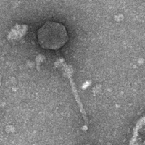
Electron micrograph: Electron micrographs of negatively stained Gordonia phage ObLaDi (https://phagesdb.org/phages/ObLaDi/) Limited permission was granted by The Actinobacteriophages Database (https://phagesdb.org/), funded by the Howard Hughes Medical

- To create a new family, Kruegerviridae, for the Cafassovirus and Vanleevirus

Origin of the name of this taxon: This taxon is named in honour of Dr. Albert Paul Krueger (b. 1902, Butte, Montana; d.1982 Oakland, CA). Hr received an M.D. from Stanford in 1929. "During his medical-school years (1927-29), he served as Acting Instructor and Assistant Professor of Bacteriology and Experimental Pathology, and developed his lifelong interest in microbiology. Following graduation from Stanford, he accepted a position at the Rockefeller Institute as an Associate in general physiology. It was here, in the laboratory of John Northrup, that he developed an interest in bacteriophage, an interest he carried back to Berkeley in 1931 when he joined the then Department of Bacteriology as an Associate Professor. Krueger's initial interest in bacteriophages was centered primarily around their biophysical and biochemical responses to various chemical inactivants such as heavy metals, salts, and heat. He then turned his attention to lysis and phage-precursor formation particularly in staphylococci; this became a lifetime interest." "In 1934, he was able to convince the Navy's Bureau of Medicine and Surgery to found Naval Laboratory Research Unit--1 with headquarters in the Life Sciences Building and with him as its commanding officer."

(Specific References: https://oac.cdlib.org/view?docId=hb4d5nb20m;NAAN=13030&doc.view=frames&chunk.id=div00090&toc.depth=1&toc.id=&brand=oac4; Wehner AP. In memoriam: Dr. Albert Paul Krueger. Int J Biometeorol. 1985 Sep;29(3):197-204. doi: 10.1007/BF02189649. PMID: 3902669.

(Photo credit: Wehner AP. In memoriam: Dr. Albert Paul Krueger. Int J Biometeorol. 1985 Sep;29(3):197-204. doi: 10.1007/BF02189649. PMID: 3902669.)

Historical aspects: The genus Vanleevirus was created through Taxonomy Proposal 2023.003B.Actinobacteriophage_singletons_25ng for Gordonia phage VanLee. By VIRIDIC analysis it shares ≥18.8% DNA sequence similarity to members of the Cafassovirus genus and 46 proteins.

