

The International Committee on Taxonomy of Viruses
Taxonomy Proposal Form, 2024

Part 1a: Details of taxonomy proposals

Title: | Create a new genus, Cepavirus, with two species (Caudoviricetes; Autographiviridae; Slopekvirinae) and a new species in the genera Suseptimavirus (Caudoviricetes; Gordonclarkvirinae) and Uetakevirus (Caudoviricetes).
Code assigned: | 2024.006B

Author(s), affiliation and email address(es):
Name | Affiliation | Email address | Corresponding author(s) X
Pas C | Ghent University, Department of Biotechnology, Valentin Vaerwyckweg 1, 9000 Gent, Belgium | celia.pas@ugent.be
Fieseler L | ZHAW School of Life Sciences and Facility Management, Centre for Food Safety and Quality Management, Einsiedlerstrasse 31, 8820 Wädenswil, Switzerland | lars.fieseler@zhaw.ch
Briers Y | Ghent University, Department of Biotechnology, Valentin Vaerwyckweg 1, 9000 Gent, Belgium | yves.briers@ugent.be | X

Part 1b: Taxonomy Proposal Submission
ICTV Subcommittee:
Animal DNA Viruses and Retroviruses |  | Bacterial viruses | X
Animal minus-strand and dsRNA viruses |  | Fungal and protist viruses
Animal positive-strand RNA viruses |  | Plant viruses
Archaeal viruses |  | General -

List the ICTV Study Group(s) that have seen or have been involved in creating this proposal:
Optional – complete only if formally voted on by an ICTV Study Group:
Study Group | Number of members
Study Group | Votes in support | Votes against | No vote

Submission date: | 27/11/2023

Part 1c: Feedback from ICTV Executive Committee (EC) meeting
Executive Committee Meeting Decision code: | X
A – Accept | X
Ac – Accept subject to revision by relevant subcommittee chair. No further vote required
U – Accept without revision but with re-evaluation and email vote by the EC
Uc – Accept subject to revision and re-evaluation and email vote by the EC
Ud – Deferred to the next EC meeting, with an invitation to revise based on EC comments
J - Reject
W - Withdrawn

Comments from the Executive Committee:

Part 1d: Revised Taxonomy Proposal Submission
Response of proposer:
Revision date: | DD/MM/YYYY

Part 3: TAXONOMIC PROPOSAL

Name of accompanying Excel module:
2024.006B.A.v1.Cepavirus_Suseptimavirus_Uetakevirus_4ns.xlsx

Taxonomic changes proposed:
Establish new taxon | X | Split taxon
Abolish taxon |  | Merge taxon
Move taxon |  | Promote taxon
Rename taxon |  | Demote taxon
Move and rename

Is any taxon name used here derived from that of a living person: |  | N
Taxon name | Person from whom the name is derived | Attached X

Abstract of Taxonomy Proposal:
Taxonomic rank(s) affected:
Genus and species.

Description of current taxonomy:
The bacterial viruses in this proposal are currently unclassified.

Proposed taxonomic change(s):
1. Creation of a new genus, Cepavirus, within the subfamily Slopekvirinae, family Autographiviridae.
2. Assign Escherichia phage vB_EcoP_PAS7 as a new species in the new genus, Cepavirus
3. Assign Escherichia phage vB_EcoP_PAS59 as a new species in the genus Suseptimavirus, subfamily Gordonclarkvirinae.
4. Assign Escherichia phage vB_EcoP_PAS6 as a new species within the genus Uetakevirus.

Justification:
These bacterial viruses fall within current genus and species demarcation criteria for inclusion within existing genera.

- Text of Taxonomy proposal:
Taxonomic rank(s) affected:
Genus and species.

Description of current taxonomy:
The subfamily Slopekvirinae in the family Autographiviridae was established in 2019, proposal 2019.103B.
The subfamily Gordonclarkvirinae was established in 2022, proposal 2022.034B.
The genus Uetakevirus was established in 2018, proposal 2018.007B.A.v4, renaming the historical genus Epsilon15virus.

Proposed taxonomic change(s):
1. Creation of a new genus, Cepavirus, within the subfamily Slopekvirinae, family Autographiviridae.
2. Assign Escherichia phage vB_EcoP_PAS7 as a new species in the new genus, Cepavirus
3. Assign Escherichia phage vB_EcoP_PAS59 as a new species in the genus Suseptimavirus, subfamily Gordonclarkvirinae.
4. Assign Escherichia phage vB_EcoP_PAS6 as a new species within the genus Uetakevirus.

Demarcation criteria:
Species demarcation criteria: Two phages are assigned to the same species if their genomes are more than 95% identical over their genome length for isolates.

Genus demarcation criteria: The Bacterial Viruses Subcommittee has established 70% nucleotide identity of the genome length as the cut-off for genera. Genus-level groupings should always be monophyletic in the signature genes, as tested with a phylogenetic tree.

Justification:
Taxonomic relatives of the isolated phages were first identified using BLASTn within the class Caudoviricetes (taxid:2731619) (Sayers et al., 2022). VICTOR phylogeny (Meier-Kolthoff & Göker, 2017) was then used to establish a phylogenetic tree of the phages and their phage relatives (Figure 1). Additionally, intergenomic similarity scores were obtained through VIRIDIC alignment (Figure 2) (Moraru et al., 2020).

Escherichia phage vB_EcoP_PAS7 (PAS7; OQ921331) is related to phages of different genera within the Slopekvirinae phage subfamily, with its closest relatives Enterobacter phages ENC16 (OL355133) and phiKDA1 (NC_027980.1) of the Koutsourouvirus genus, with similarity scores of 36.0 and 35.2 % respectively (Figure 1,2). These scores are lower than 70 %, indicating that this phage isolate belongs to a different genus than its taxonomically related phages. We therefore propose a new viral genus Cepavirus within the Slopekvirinae subfamily, and a complementing new species Cepavirus PAS7 within this new genus with phage PAS7 as its exemplar virus. We chose this genus name for its easy pronounceability, named after the Spanish translation of ‘strain’, referring to the strain specific nature of phages, with phage PAS7 as an exemplar phage that infects only specific E. coli strains.

The close relatives of Escherichia phage vB_EcoP_PAS59 (PAS59; OQ921332) all belong to the lytic phage subfamily Gordonclarkvirinae. With an intergenomic similarity score of 86.0 %, Escherichia phage EK010 (LC553734) is its closest relative (Figure 1,2). Phage EK010 is currently classified in the genus Suseptimavirus within the subfamily Gordonclarkvirinae. As the closest phage relative has less than 95 % similarity with phage PAS59, we propose a new phage species Suseptimavirus PAS59 within the genus Suseptimavirus.

The closely related phages of Escherichia phage vB_EcoP_PAS61 (PAS61; OQ921333) all belong to the temperate phage genus Uetakevirus (Figure 1,2). With a similarity score of 78.7 % with its closest relative phage phiV10 (NC_007804.2), we propose a new phage species Uetakevirus PAS61 within the genus Uetakevirus with phage PAS61 as its exemplar virus.

References:
Meier-Kolthoff, J. P., & Göker, M. (2017). VICTOR: genome-based phylogeny and classification of prokaryotic viruses. Bioinformatics, 33(21), 3396–3404. https://doi.org/10.1093/BIOINFORMATICS/BTX440
Moraru, C., Varsani, A., & Kropinski, A. M. (2020). VIRIDIC—A Novel Tool to Calculate the Intergenomic Similarities of Prokaryote-Infecting Viruses. Viruses, 12(11). https://doi.org/10.3390/v12111268
Sayers, E. W., Bolton, E. E., Brister, J. R., Canese, K., Chan, J., Comeau, D. C., Connor, R., Funk, K., Kelly, C., Kim, S., Madej, T., Marchler-Bauer, A., Lanczycki, C., Lathrop, S., Lu, Z., Thibaud-Nissen, F., Murphy, T., Phan, L., Skripchenko, Y., … Sherry, S. T. (2022). Database resources of the national center for biotechnology information. Nucleic Acids Research, 50(D1), D20–D26. https://doi.org/10.1093/NAR/GKAB1112
Turner D, Kropinski AM, Adriaenssens EM. A Roadmap for Genome-Based Phage Taxonomy. Viruses. 2021 Mar 18;13(3):506. doi: 10.3390/v13030506. PMID: 33803862; PMCID: PMC8003253.

Tables, Figures:
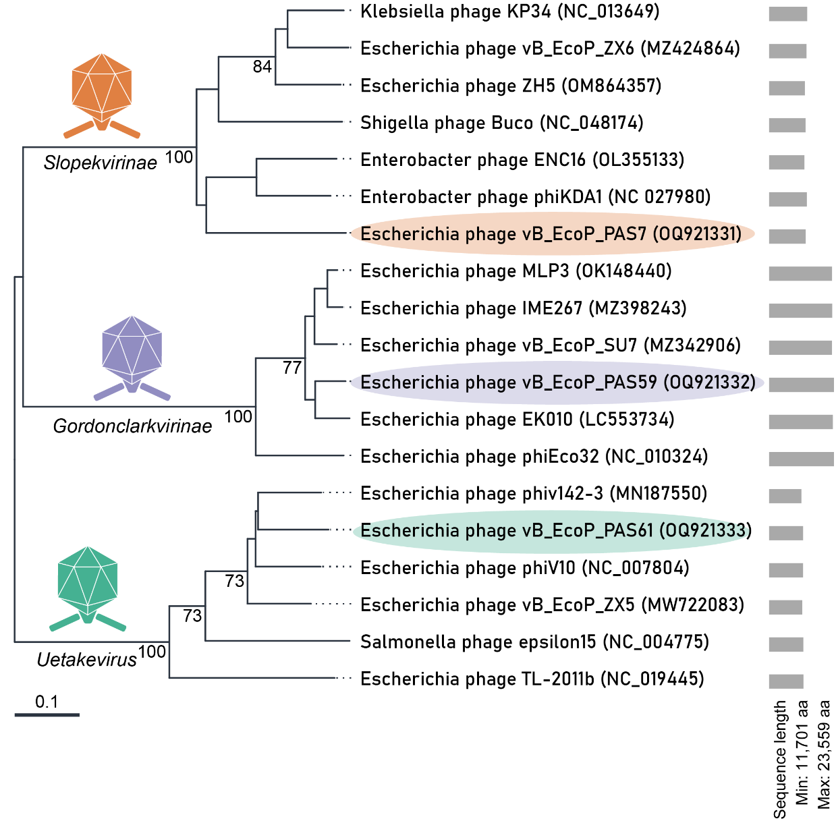
Figure 1: VICTOR phylogeny of the isolated phage genomes and their respective taxonomic relatives. Phage isolates for taxonomy proposal are outlined. This tool uses the Genome Blast Distance Phylogeny approach to calculate intergenomic distances, including 100 pseudo-bootstrap replicates for calculating branch support (Meier-Kolthoff & Göker, 2017).

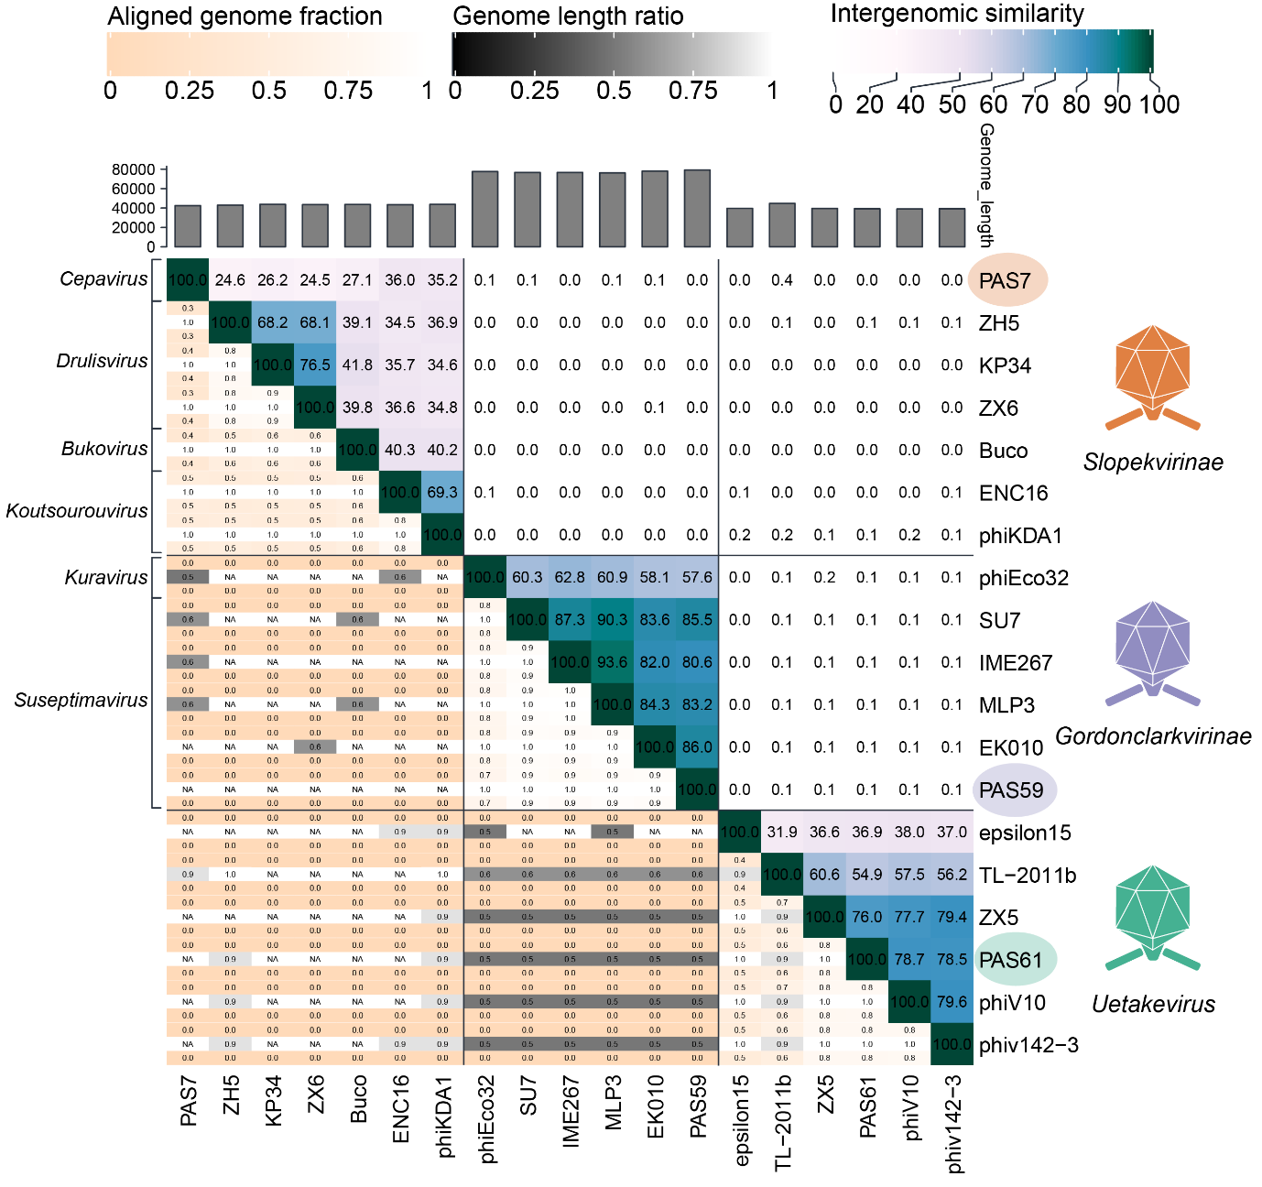
Figure 2: Genomic similarities of the isolated phage genomes to their respective taxonomic relatives through VIRIDIC genome alignment (Moraru et al., 2020). Isolated phages are indicated using orange, purple and green ellipses. Intergenomic similarity scores of 36.0, 78.1 and 86.0 % were identified between the isolated phage genomes and their closest taxonomic relatives (phages ENC16, EK010 and phiV10 respectively).

