

The International Committee on Taxonomy of Viruses
Taxonomy Proposal Form, 2024

Part 1a: Details of taxonomy proposals

Title: | Create a new family, Casidaviridae, for a group of Arthrobacter-Microbacterium phages (Class: Caudoviricetes)
Code assigned: | 2024.005B

Author(s), affiliation and email address(es):
Name | Affiliation | Email address | Corresponding author(s) X
Kurtböke, I | University of the Sunshine Coast, Australia | ikurtbok@usc.edu.au
Moraru C | Carl von Ossietzky Universität Oldenburg, Germany | liliana.cristina.moraru@uol.de
Tolstoy I | National Center for Biotechnology Information, MD, USA | tolstoy@ncbi.nlm.nih.gov
Kropinski AM | University of Guelph, Ontario, Canada [AMK] | Phage.Canada@gmail.com | x

Part 1b: Taxonomy Proposal Submission
ICTV Subcommittee:
Animal DNA Viruses and Retroviruses |  | Bacterial viruses | x
Animal minus-strand and dsRNA viruses |  | Fungal and protist viruses
Animal positive-strand RNA viruses |  | Plant viruses
Archaeal viruses |  | General -

List the ICTV Study Group(s) that have seen or have been involved in creating this proposal:
Actinophages Study group

Optional – complete only if formally voted on by an ICTV Study Group:
Study Group | Number of members
Study Group | Votes in support | Votes against | No vote

Submission date: | 20/05/2024

Part 1c: Feedback from ICTV Executive Committee (EC) meeting
Executive Committee Meeting Decision code: | X
A – Accept
Ac – Accept subject to revision by relevant subcommittee chair. No further vote required
U – Accept without revision but with re-evaluation and email vote by the EC
Uc – Accept subject to revision and re-evaluation and email vote by the EC | X
Ud – Deferred to the next EC meeting, with an invitation to revise based on EC comments
J - Reject
W - Withdrawn

Comments from the Executive Committee:
The genus Manhattenvirus is not monophyletic by core genome phylogeny and probably needs splitting. Consider revising the genus names Honkvirus and Vroomvirus

Part 1d: Revised Taxonomy Proposal Submission
Response of proposer:
We also dislike Honkvirus but generally we name genera after the name given to the individual isolate. The name Vroomvirus was changed to Hilgardvirus, since “Vroom” leads to confusion with Mycobacterium phage Vroom. Exemplars of the genus Manhattenvirus are all temperate bacteriophages which The Actinobacteriophage Database has grouped into Subcluster AZ1. We have found that the 70% cutoff for membership in a genus does not work satisfactorily with temperate phages. We propose to re-examine Manhattenvirus in the future following the isolation of additional member species

Revision date: | 30/09/2024

Part 3: TAXONOMIC PROPOSAL

Name of accompanying Excel module:
2024.005B.A.v2.Casidaviridae_nf.xlsx

Taxonomic changes proposed:
Establish new taxon | x | Split taxon
Abolish taxon |  | Merge taxon
Move taxon |  | Promote taxon
Rename taxon |  | Demote taxon
Move and rename

Is any taxon name used here derived from that of a living person: |  | N
Taxon name | Person from whom the name is derived | Attached X

Abstract of Taxonomy Proposal:
Taxonomic rank(s) affected:
Realm Duplodnaviria, kingdom Heunggongvirae, phylum Uroviricota, class Caudoviricetes

Description of current taxonomy:
At present the following taxa exist as floating genera in the order Caudoviricetes:
Zetavirus, Baileybluvirus. The subfamily Azeevirinae is currently a floating taxon in the order Caudoviricetes and consists of four genera; Galvastonvirus, Yangvirus, Manhattanvirus and Liebevirus.

Proposed taxonomic change(s):
- To create a new genus, Gardenstatevirus, with two species
- To create a new genus, Percivalvirus, with two species
- To create a new single species genus Mabodamacavirus
- To create a new genus, Barnstormervirus with two species
- To create a new single species genus Honkvirus
- To create a new single species genus Cenunavirus
- To create a new species in Baileybluvirus
- To create seven new species in the genus Yangvirus
- To create two new species in the genus Manhattanvirus
- To create a new single species genus, Emotionvirus
- To create a new single species genus, Hilgardvirus
- To create a new single species genus, Swepdovirus
- To create one new species in the genus Liebevirus
- To promote the subfamily Azeevirinae to create a new family, Casidaviridae

Justification:
We propose the creation of a new family, Casidaviridae, after examination of 21 bacteriophages related to the genera Zetavirus, Baileybluvirus, Yangvirus, Manhattanvirus and Liebevirus on the basis of nucleotide sequence similarity, tblastx distances and core gene phylogeny. The subfamily Azeevirinae will be promoted to create this new family.

Text of Taxonomy proposal:
Taxonomic rank(s) affected: Species, Genus and Family

Description of current taxonomy:

Currently phages of this type are recognized in six genera: Baileybluvirus, Galvastonvirus, Liebevirus, Manhattanvirus, Yangvirus and Zetavirus; largely temperate siphophages with cohesive 3’- termini infecting Arthrobacter and Microbacterium species.

Proposed taxonomic change(s):
- To create a new genus, Gardenstatevirus, with two species
- To create a new genus, Percivalvirus, with two species
- To create a new single species genus Mabodamacavirus
- To create a new genus, Barnstormervirus with two species
- To create a new single species genus Honkvirus
- To create a new single species genus Cenunavirus
- To create a new species in Baileybluvirus
- To create seven new species in the genus Yangvirus
- To create two new species in the genus Manhattanvirus
- To create a new single species genus, Emotionvirus
- To create a new single species genus, Hilgardvirus
- To create a new single species genus, Swepdovirus
- To create one new species in the genus Liebevirus
- To create a new family, Casidaviridae

Demarcation criteria:
Species demarcation criteria: Two phages are assigned to the same species if their genomes are more than 95% identical over their genome length for isolates.
These values can be calculated by a number of tools, such as BLASTn [1,2] – usually calculated using intergenomic distance calculator VIRIDIC [3].

Genus demarcation criteria: In search for criteria that create cohesive and distinct genera that are reproducible and monophyletic, the Bacterial Viruses Subcommittee has established 70% nucleotide identity of the genome length as the cut-off for genera. Genus-level groupings should always be monophyletic in the signature genes, as tested with a phylogenetic tree. [10]

Subfamily demarcation criteria: Subfamilies are to be created when two or more genera are related below the family level. In practical terms, this usually means that they share a low degree of sequence similarity (usually about 40-50%) and that the genera form a clade in a marker tree phylogeny. [10]

Family demarcation criteria: The family is represented by a cohesive and monophyletic group in the main predicted proteome-based clustering tools (VirClust, ViPTree, GRAViTy dendrogram, vConTACT2 network). Members of the family share a significant number of orthologous genes (the number will depend on the genome sizes and number of coding sequences of members of the family). [10]

Justification:
We propose the creation of a new family, Casidaviridae, after examination of 21 bacteriophages related to the genera Zetavirus, Baileybluvirus, Yangvirus, Manhattanvirus and Liebevirus on the basis of nucleotide sequence similarity, tblastx distances and core gene phylogeny.

References:
1. Sayers EW, Beck J, Bolton EE, Bourexis D, Brister JR, Canese K, Comeau DC, Funk K, Kim S, Klimke W, Marchler-Bauer A, Landrum M, Lathrop S, Lu Z, Madden TL, O'Leary N, Phan L, Rangwala SH, Schneider VA, Skripchenko Y, Wang J, Ye J, Trawick BW, Pruitt KD, Sherry ST. Database resources of the National Center for Biotechnology Information. Nucleic Acids Res. 2021 Jan 8;49(D1):D10-D17. doi: 10.1093/nar/gkaa892. PMID: 33095870
2. O'Leary NA, Wright MW, Brister JR, Ciufo S, Haddad D, McVeigh R, et al. Reference sequence (RefSeq) database at NCBI: current status, taxonomic expansion, and functional annotation. Nucleic Acids Res. 2016;44(D1):D733-45. doi: 10.1093/nar/gkv1189. PMID: 26553804.
3. Moraru C, Varsani A, Kropinski AM. VIRIDIC-A Novel Tool to Calculate the Intergenomic Similarities of Prokaryote-Infecting Viruses. Viruses. 2020 Nov 6;12(11):1268. doi: 10.3390/v12111268. PMID: 33172115; PMCID: PMC7694805. http://kronos.icbm.uni-oldenburg.de/viridic/
4. Nishimura Y, Yoshida T, Kuronishi M, Uehara H, Ogata H, Goto S. ViPTree: the viral proteomic tree server. Bioinformatics. 2017; 33(15):2379-2380. doi:10.1093/bioinformatics/btx157. PubMed PMID: 28379287. https://www.genome.jp/viptree/
5. Rohwer F, Edwards R. The Phage Proteomic Tree: a genome-based taxonomy for phage. J Bacteriol. 2002 Aug;184(16):4529-35. PubMed PMID: 12142423
6. Turner D, Reynolds D, Seto D, Mahadevan P. CoreGenes3.5: a webserver for the determination of core genes from sets of viral and small bacterial genomes. BMC Res Notes. 2013;6:140. doi: 10.1186/1756-0500-6-140. PMID: 23566564.
7. Davis P, Seto D, Mahadevan P. CoreGenes5.0: An Updated User-Friendly Webserver for the Determination of Core Genes from Sets of Viral and Bacterial Genomes. Viruses. 2022 Nov 16;14(11):2534. doi: 10.3390/v14112534. PMID: 36423143; PMCID: PMC9693508.
8. Dereeper A, Guignon V, Blanc G, Audic S, Buffet S, Chevenet F, Dufayard JF, Guindon S, Lefort V, Lescot M, Claverie JM, Gascuel O. Phylogeny.fr: robust phylogenetic analysis for the non-specialist. Nucleic Acids Res. 2008;36(Web Server issue):W465-9. doi: 10.1093/nar/gkn180. Epub 2008 Apr 19. PMID: 18424797.
9. Anisimova M, Gascuel O. Approximate likelihood-ratio test for branches: A fast, accurate, and powerful alternative. Syst Biol. 2006;55(4):539-52. PMID: 16785212. DOI: 10.1080/10635150600755453.
10. Turner D, Kropinski AM, Adriaenssens EM. A Roadmap for Genome-Based Phage Taxonomy. Viruses. 2021 Mar 18;13(3):506. doi: 10.3390/v13030506. PMID: 33803862; PMCID: PMC8003253.
11. Bin Jang H, Bolduc B, Zablocki O, Kuhn JH, Roux S, Adriaenssens EM, Brister JR, Kropinski AM, Krupovic M, Lavigne R, Turner D, Sullivan MB. Taxonomic assignment of uncultivated prokaryotic virus genomes is enabled by gene-sharing networks. Nat Biotechnol. 2019 Jun;37(6):632-639. doi: 10.1038/s41587-019-0100-8. Epub 2019 May 6. PMID: 31061483.
12. Bolduc B, Jang HB, Doulcier G, You ZQ, Roux S, Sullivan MB. vConTACT: an iVirus tool to classify double-stranded DNA viruses that infect Archaea and Bacteria. PeerJ. 2017 May 3;5:e3243. doi: 10.7717/peerj.3243. PMID: 28480138; PMCID: PMC5419219.
13. Moraru C. VirClust-A Tool for Hierarchical Clustering, Core Protein Detection and Annotation of (Prokaryotic) Viruses. Viruses. 2023 Apr 19;15(4):1007. doi: 10.3390/v15041007. PMID: 37112988; PMCID: PMC10143988.
14. Letunic I, Bork P. Interactive Tree Of Life (iTOL): an online tool for phylogenetic tree display and annotation. Bioinformatics. 2007 Jan 1;23(1):127-8. doi: 10.1093/bioinformatics/btl529. Epub 2006 Oct 18. PMID: 17050570.
15. Zhou T, Xu K, Zhao F, Liu W, Li L, Hua Z, Zhou X. itol.toolkit accelerates working with iTOL (Interactive Tree of Life) by an automated generation of annotation files. Bioinformatics. 2023 Jun 1;39(6):btad339. doi: 10.1093/bioinformatics/btad339. PMID: 37225402; PMCID: PMC10243930.
16. Nguyen LT, Schmidt HA, von Haeseler A, and Minh BQ (2015) IQ-TREE: A fast and effective stochastic algorithm for estimating maximum likelihood phylogenies. Molecular Biology and Evolution, 32:268-274. https://doi.org/10.1093/molbev/msu300
17. Hoang DT, Chernomor O, von Haeseler A, Minh BQ, Vinh LS (2018) UFBoot2: Improving the ultrafast bootstrap approximation. Molecular Biology and Evolution, 35:518–522. https://doi.org/10.1093/molbev/msx281
18. Kalyaanamoorthy S, Minh BQ, Wong TKF, von Haeseler A, and Jermiin JS (2017) ModelFinder: Fast Model Selection for Accurate Phylogenetic Estimates, Nature Methods, 14:587–589. https://doi.org/10.1038/nmeth.4285

Tables, Figures:
Figure 1. VIRIDIC heat map of a portion of the members of this family: VIRIDIC (Virus Intergenomic Distance Calculator; VIRIDIC (Virus Intergenomic Distance Calculator; [3]; http://rhea.icbm.uni-oldenburg.de/VIRIDIC/) computes pairwise intergenomic distances/similarities amongst phage genomes. Data values which are bordered in black correspond to strains. Abbreviations: phg = phage; Arth = Arthrobacter; Micr = Microbacterium. The yellow highlighted accession numbers and phage names in Column A represent ICTV-recognized species. the complete VIRIDIC heatmap is provided as supplementary material.
Conclusions: There are several major clades, but the question raised is whether the Armstrongvirus group is sufficiently closely related to the Yangvirus group to be considered in the same family.
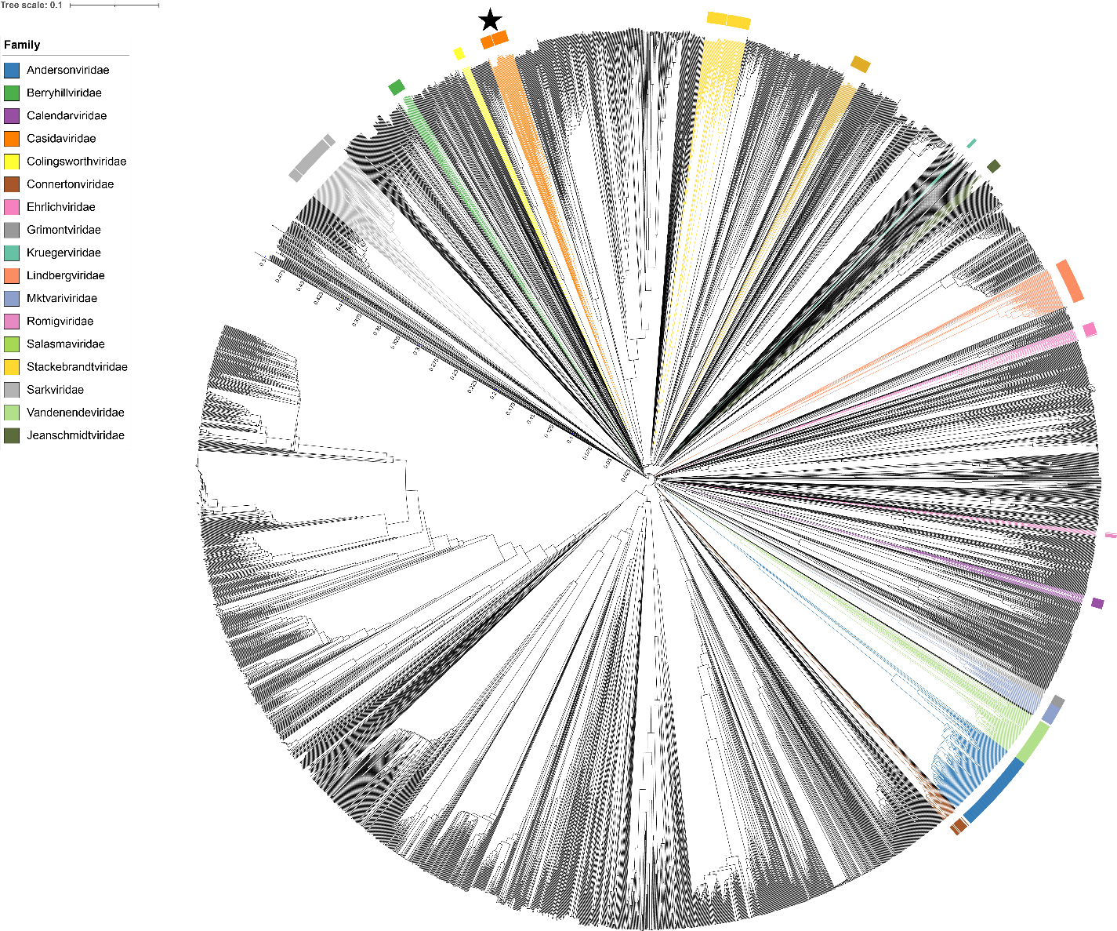
Figure 2. ViPTree [4] analysis Proteomic tree of 4,408 bacterial viruses with proposed viral families labeled by the coloured ring. The Casidaviridae are marked with a star symbol. The hierarchical tree was created using ViPTreeGen (version 1.1.2) [4] and annotated using iToL [15-16]. The tree is based on a dissimilarity matrix generated by pairwise tBLASTx scores between each of the genomes.
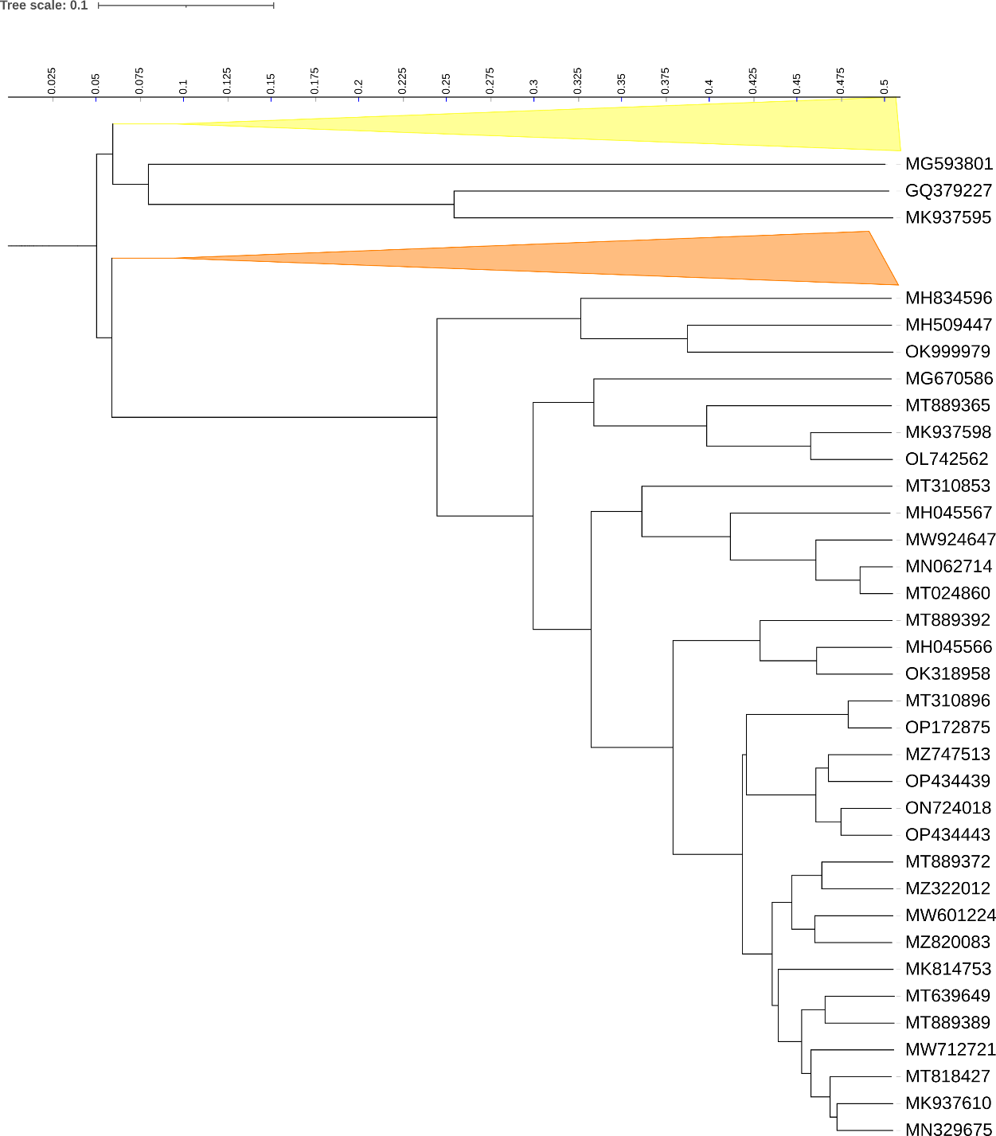
Figure 3. ViPTree [4] hierarchical tree pruned to show the proposed Colingsworthviridae alonside neighbouring clades. The proposed families Colingsworthviridae (yellow) and Casidaviridae (orange) are shown as collapsed clades.

Figure 4. VirClust protein heatmap of the Yangvirus group: at the first level, proteins are grouped based on their reciprocal BLASTP similarities into protein clusters, or PCs. At the second level, PCs are grouped based on their Hidden Markov Model (HMM) similarities into protein superclusters, or PSCs. AT the third, still experimental level, PSCs are grouped based on their HMM similarities into protein super-superclusters, or PSSC [13].

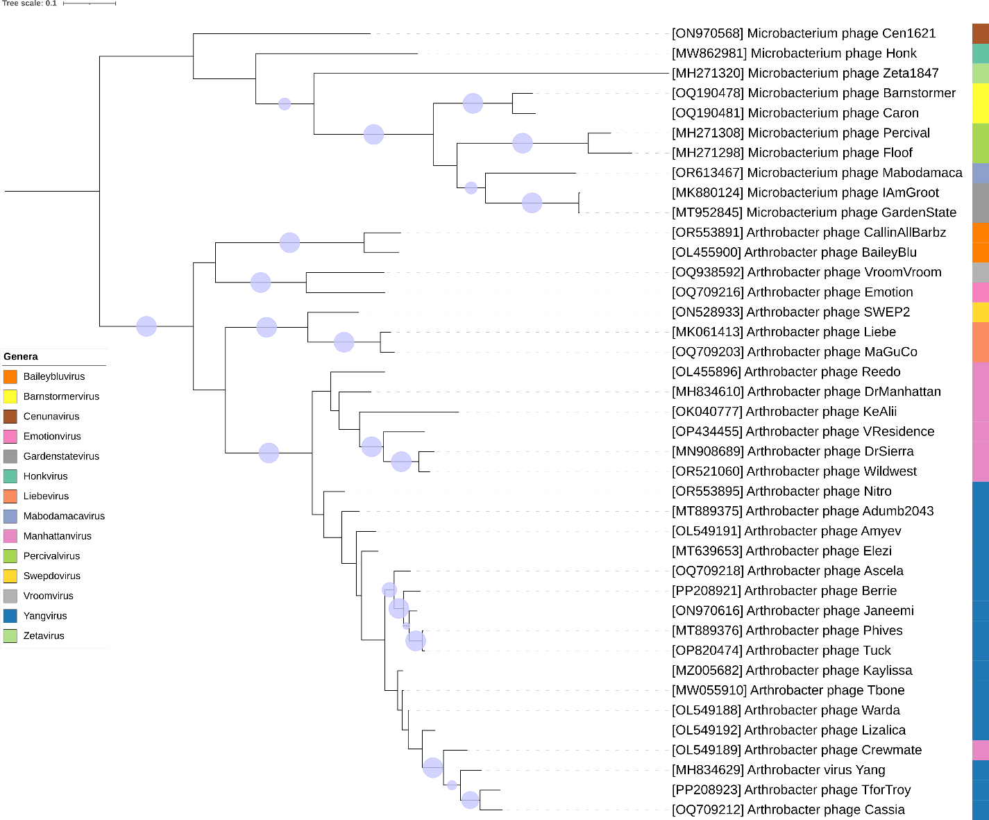
Figure 5. Core genome phylogeny of the proposed Casidaviridae family of bacterial viruses. A partitioned protein ML phylogeny was created from 6 genes present in all species of the proposed family. Alignments were performed using MAFFT in e-insi mode and trimmed using trimAl with a gap threshold of 0.5. The tree was calculated using IQ-Tree2 with 1000 ultrafast (UF) bootstrap replicates and SH-Alrt tests with -m TEST to optimise models for each alignment. The tree is rooted at the midpoint and UF bootstrap support ≥ 95% are shown. The coloured strips indicate proposed genera and subfamilies.
Table 1. Signature genes in the proposed Casidaviridae family of bacterial viruses. Genes were identified by clustering with MMSeqs2, with thresholds of 35% sequence similarity and 50% coverage.
protein cluster | No. of genomes (14 total) | Percentage of genomes present in protein cluster | Predicted gene function
1 | 40 | 100% | exonuclease
2 | 40 | 100% | deoxynucleoside monophosphate kinase
3 | 40 | 100% | LAGLIDADG endonuclease
4 | 40 | 100% | hypothetical protein
5 | 40 | 100% | recombination directionality factor
6 | 40 | 100% | DNA polymerase
7 | 39 | 97.50% | DNA primase
8 | 39 | 97.50% | Holliday junction resolvase
9 | 39 | 97.50% | hypothetical protein

Proposals Data:
- To create a new genus, Gardenstatevirus, with two species
- To create a new genus, Percivalvirus, with two species
- To create a new single species genus Mabodamacavirus
- To create a new genus, Barnstormervirus with two species
- To create a new single species genus Honkvirus
- To create a new single species genus Cenunavirus
- To create a new species in Baileybluvirus
- To create seven new species in the genus Yangvirus
- To create two new species in the genus Manhattanvirus
- To create a new single species genus, Emotionvirus
- To create a new single species genus, Hilgardvirus
- To create a new single species genus, Swepdovirus
- To create one new species in the genus Liebevirus
- To create a new family, Casidaviridae

Taxonomic Proposals:

- To create a new genus, Gardenstatevirus, with two species

Origin of the name of this taxon: This taxon was named after a virus of its type Microbacterium phage GardenState

Historical aspects: Microbacterium siphophage GardenState was isolated from soil from New Jersey by Paulina Onisko using Microbacterium sp. ISAT203 as the host at James Madison University, Cranford, NJ. It is temperate and was isolated as part of the Science Education Alliance-Phage Hunters Advancing Genomics and Evolutionary Science program. Phage GardenState is a member of the EH cluster as defined by The Actinobacteriophage Database and possesses 11 nt 3' Sticky Overhangs (CGGGGAGGCAT).

Genomic characterization:

Phage name | INSDC | Size (kb) | %GC | Protein | Overall % DNA sequence identity (*) | Overall % homologous proteins (**)
Microbacterium phage GardenState | MT952845.1 | 45.4 | 70.0 | 76 | 100 | 100
Microbacterium phage IAmGroot | MK880124.2 | 45.6 | 70.0 | 75 | 93.8 | 96.0
(*) determined using VIRIDIC [3]
(**) determined using CoreGenes 3.5 [6]

Electron micrograph: N/A

- To create a new genus, Percivalvirus, with two species

Origin of the name of this taxon: This taxon was named after a virus of its type Microbacterium phage Percival

Historical aspects: Microbacterium siphophage Percival was isolated from soil from Cabot, PA USA by Johnathon Schiebel (University of Pittsburgh) using Microbacterium foliorum NRRL B-24224 as the host at James Madison University, Cranford, NJ. It is temperate and was isolated as part of the Phage Hunters Integrating Research and Education program. Phage Percival is a member of the EH cluster as defined by The Actinobacteriophage Database and possesses 11 nt 3' Sticky Overhangs (CGGGGAGGCAT).

Genomic characterization:

Phage name | INSDC | Size (kb) | %G+C | Protein | Overall % DNA sequence identity (*) | Overall % homologous proteins (**)
Microbacterium phage Percival | MH271308.1 | 47.4 | 69.6 | 74 | 100 | 100
Microbacterium phage Floof | MH271298.1 | 48.5 | 69.0 | 80 | 69.1 | 81.1
(*) determined using VIRIDIC [3]
(**) determined using CoreGenes 3.5 [6]

Electron micrograph: Electron micrographs of negatively stained Microbacterium phage Percival (https://phagesdb.org/phages/Percival/). Limited permission was granted by The Actinobacteriophages Database (https://phagesdb.org/), funded by the Howard Hughes Medical Institute, to use this electron micrograph for this taxonomy proposal; it cannot be reused without permission of The Actinobacteriophages Database.

- To create a new single species genus Mabodamacavirus

Origin of the name of this taxon: This taxon was named after the first virus of its type Microbacterium phage Mabodamaca

Historical aspects: Microbacterium phage Mabodamaca was isolated from soil by Edwin Vazquez (University of Puerto Rico at Cayey) using Microbacterium foliorum NRRL B-24224 as the host. It is temperate and was isolated as part of the Science Education Alliance-Phage Hunters Advancing Genomics and Evolutionary Science program. Phage Mabodamaca is a member of the EH cluster as defined by The Actinobacteriophage Database and possesses 11 nt 3' Sticky Overhangs (CGGGGAGGCAT).

Genomic characterization:

Phage name | INSDC | Size (kb) | %G+C | Protein | Overall % DNA sequence identity (*) | Overall % homologous proteins (**)
Microbacterium phage Mabodamaca | OR613467.1 | 49.0 | 69.8 | 73 | 100 | 100

Electron micrograph: N/A

- To create a new genus, Barnstormervirus with two species

Origin of the name of this taxon: This taxon was named after the first virus of its type Microbacterium phage Barnstormer

Historical aspects: Microbacterium phage Barnstormer was isolated from soil from Edinburg , VA, by Timothy Joseph Edelman using Microbacterium sp. ISAT203 as the host at James Madison University. It is temperate and was isolated as part of the Science Education Alliance-Phage Hunters Advancing Genomics and Evolutionary Science program. Phage Barnstormer is a member of the EH cluster as defined by The Actinobacteriophage Database and possesses 11 nt 3' Sticky Overhangs (CGGGGAGGCAT).

Genomic characterization:

Phage name | INSDC | Size (kb) | %G+C | Protein | Overall % DNA sequence identity (*) | Overall % homologous proteins (**)
Microbacterium phage Barnstormer | OQ190478.1 | 46.9 | 69.5 | 77 | 100 | 100
Microbacterium phage Caron | OQ190481.1 | 47.7 | 70.1 | 80 | 80.5 | 87.0
(*) determined using VIRIDIC [3]
(**) determined using CoreGenes 3.5 [6]

Electron micrograph: N/A

- To create a new single species genus Honkvirus

Origin of the name of this taxon: This taxon was named after the first virus of its type Microbacterium phage Honk

Historical aspects: Microbacterium phage Honk was isolated from soil from New Jersey by Megan Ulbrich using Microbacterium foliorum NRRL B-24224 as the host at University of Pittsburgh. It is temperate and was isolated as part of the Science Education Alliance-Phage Hunters Advancing Genomics and Evolutionary Science program. Phage Honk is a member of the EH cluster as defined by The Actinobacteriophage Database and possesses 11 nt 3' Sticky Overhangs (CGAAGCGGCAT).

Genomic characterization:

Phage name | INSDC | Size (kb) | %G+C | Protein | Overall % DNA sequence identity (*) | Overall % homologous proteins (**)
Microbacterium phage Honk | MW862981.1 | 50.2 | 70.3 | 82 | 100 | 100

Electron micrograph: N/A

- To create a new single species genus Cenunavirus

Origin of the name of this taxon: This taxon was named after the first virus of its type Microbacterium phage Cen1621

Historical aspects: Microbacterium phage Cen1621 was isolated from soil by Ketsy M. Torres-Arroyo using Microbacterium foliorum NRRL B-24224 as the host at the University of Puerto Rico at Cayey. It is temperate and was isolated as part of the Science Education Alliance-Phage Hunters Advancing Genomics and Evolutionary Science program. Phage Cen1621 is a member of the EH cluster as defined by The Actinobacteriophage Database and possesses 11 nt 3' Sticky Overhangs (CGAGGCGGCAT).

Genomic characterization:

Phage name | INSDC | Size (kb) | %G+C | Protein | Overall % DNA sequence identity (*) | Overall % homologous proteins (**)
Microbacterium phage Cen1621 | ON970568.1 | 49.4 | 70.7 | 75 | 100 | 100

Electron micrograph: N/A

- To create a new species in Baileybluvirus

Origin of the name of this taxon: N/A

Historical aspects: The genus Baileybluevirus was established through Taxonomy Proposal 2022.011B.Baileybluevirus_ng

Genomic characterization:

Phage name | INSDC | Size (kb) | Protein | Overall % DNA sequence identity (*) | Overall % homologous proteins (**)
Arthrobacter phage BaileyBlu | OL455900.1 | 40.4 | 61 | 100 | 100
Arthrobacter phage CallinAllBarbz | OR553891.1 | 41.2 | 62 | 78.8 | 91.8
(*) determined using VIRIDIC [3]
(**) determined using CoreGenes 3.5 [6]

Electron micrograph: N/A

- To create seven new species in the genus Yangvirus

Origin of the name of this taxon: N/A

Historical aspects: The genus Yangvirus was created through Taxonomy Proposal 2019.093B

Genomic characterization:

Phage name | INSDC | Size (kb) | Protein | Overall % DNA sequence identity (*) | Overall % homologous proteins (**)
Arthrobacter phage Yang | MH834629.1 | 43.2 | 68 | 100 | 100
Arthrobacter phage Janeemi | ON970616.1 | 43.9 | 69 | 69.8 | 79.4
Arthrobacter phage Tuck | OP820474.1 | 44.0 | 69 | 67.9 | 82.3
Arthrobacter phage Berrie | PP208921.1 | 43.8 | 69 | 70.6 | 77.9
Arthrobacter phage Ascela | OQ709218.1 | 44.2 | 71 | 73.9 | 83.8
Arthrobacter phage Cassia | OQ709212.1 | 44.3 | 69 | 83.0 | 88.2
Arthrobacter phage TforTroy | PP208923.1 | 43.7 | 69 | 82.4 | 86.8
Arthrobacter phage Nitro | OR553895.1 | 44.4 | 70 | 71.6 | 86.8
(*) determined using VIRIDIC [3]
(**) determined using CoreGenes 3.5 [6]

Electron micrograph: N/A

- To create two new species in the genus Manhattanvirus

Origin of the name of this taxon: N/A

Historical aspects: The genus Manhattanvirus was created through Taxonomy Proposal 2022.010B.Azeevirinae_nsf. These are temperate phages belonging to

Genomic characterization:

Phage name | INSDC | Size (kb) | Protein | Overall % DNA sequence identity (*) | Overall % homologous proteins (**)
Arthrobacter phage DrManhattan | MH834610.1 | 42.6 | 72 | 100 | 100
Arthrobacter phage VResidence | OP434455.1 | 42.2 | 70 | 63.8 | 77.8
Arthrobacter phage Wildwest | OR521060.1 | 43.7 | 65 | 66.4 | 77.8
(*) determined using VIRIDIC [3]
(**) determined using CoreGenes 3.5 [6]

Electron micrograph: N/A

- To create a new single species genus, Emotionvirus

Origin of the name of this taxon: This taxon was named after the first virus of its type Arthrobacter phage Emotion

Historical aspects: Microbacterium phage Emotion was isolated from soil from Lakewood, CA USA by Dominic Garza and Michelle Zorawik using Arthrobacter sulfureus ATCC 19098 as the host at University of California, Los Angeles. It is temperate and was isolated as part of the Science Education Alliance-Phage Hunters Advancing Genomics and Evolutionary Science program. Phage Emotion is a member of the AZ cluster/AZ4 subcluster as defined by The Actinobacteriophage Database and possesses 11 nt 3' Sticky Overhangs (CGAAGCGGCAT). While it lacks an integrase all other members of the AZ Cluster have one.

Genomic characterization:

Phage name | INSDC | Size (kb) | Protein | Overall % DNA sequence identity (*) | Overall % homologous proteins (**)
Arthrobacter phage Emotion | OQ709216.1 | 45.1 | 73 | 100 | 100

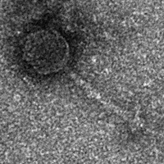
Electron micrograph: Electron micrographs of negatively stained Arthrobacter phage Emotion (https://phagesdb.org/phages/Emotion/). Limited permission was granted by The Actinobacteriophages Database (https://phagesdb.org/), funded by the Howard Hughes Medical Institute, to use this electron micrograph for this taxonomy proposal; it cannot be reused without permission of The Actinobacteriophages Database.

- To create a new single species genus, Hilgardvirus

Origin of the name of this taxon: This taxon was named after the ring road (Hilgard Ave) around the UCLA campus where the first virus of its type Arthrobacter phage VroomVroom was isolated

Historical aspects: Arthrobacter phage VroomVroom was isolated from soil from Los Angeles, CA US by Dominic Garza using Arthrobacter sulfureus ATCC 19098 as the host at the University of California, Los Angeles. It is temperate and was isolated as part of the Science Education Alliance-Phage Hunters Advancing Genomics and Evolutionary Science program. Phage VroomVroom is a member of the AZ Cluster/Subcluster AZ4 as defined by The Actinobacteriophage Database and possesses 11 nt 3' Sticky Overhangs (CGAACTGGCAT). Unlike the majority of Cluster AZ members, VroomVroom does not have an identifiable integrase gene.

Genomic characterization:

Phage name | INSDC | Size (kb) | %G+C | Protein | Overall % DNA sequence identity (*) | Overall % homologous proteins (**)
Arthrobacter phage VroomVroom | OQ938592.1 | 43.2 | 66.9 | 66 | 100 | 100

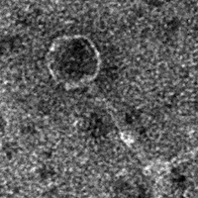
Electron micrograph: Electron micrographs of negatively stained Arthrobacter phage VroomVroom (https://phagesdb.org/phages/VroomVroom/). Limited permission was granted by The Actinobacteriophages Database (https://phagesdb.org/), funded by the Howard Hughes Medical Institute, to use this electron micrograph for this taxonomy proposal; it cannot be reused without permission of The Actinobacteriophages Database.

L. To create a new single species genus, Swepdovirus

Origin of the name of this taxon: This taxon was named after the first virus of its type Arthrobacter phage SWEP2

Historical aspects: Arthrobacter phage SWEP2 was isolated from soil from New Jersey by C. Ruan (College of Land Science and Technology, China Agricultural University,
Beijing, China) using Arthrobacter sp. 5B as the host.

Genomic characterization:

Phage name | INSDC | Size (kb) | Protein | Overall % DNA sequence identity (*) | Overall % homologous proteins (**)
Arthrobacter phage SWEP2 | ON528933.2 | 43.4 | 64 | 100 | 100

Electron micrograph: N/A

- To create one new species in the genus Liebevirus

Origin of the name of this taxon: N/A.

Historical aspects: The genus Liebevirus was created through Taxonomy Proposal 2019.093B

Genomic characterization:

Phage name | INSDC | Size (kb) | Protein | Overall % DNA sequence identity (*) | Overall % homologous proteins (**)
Arthrobacter phage Liebe | MK061413.1 | 45.8 | 69 | 100 | 100
Arthrobacter phage MaGuCo | OQ709203.1 | 43.9 | 63 | 87.1 | 84.1
(*) determined using VIRIDIC [3]
(**) determined using CoreGenes 3.5 [6]

Electron micrograph: N/A

- To create a new family, Casidaviridae

Origin of the name of this taxon: This taxon is named in honour of American industrial microbiologist Lester E. Casida Jr. (b. 1928, Columbia, Mo.; d. 2017, State College, PA). “Earl received B.S., M.S., and Ph.D. degrees in Bacteriology from the University of Wisconsin. He was a Research Scientist for Pabst Laboratories, Abbott Laboratories, and Pfizer. At Pfizer, he developed and patented the first commercial fermentation for the production of the amino acid, L-lysine. Subsequently, he was a Professor of Microbiology at the Pennsylvania State University for 36 years. He taught and did research in the fields of Industrial Microbiology and Microbial Ecology, and wrote a textbook on Industrial Microbiology that is still widely used today.”

(Photo copied from https://www.legacy.com/us/obituaries/centredaily/name/lester-casida-obituary?id=7756461)

Rationale: This group of temperate phages together with the genus Zetavirus, share ≥7.9% DNA sequence similarity and 6 homologous proteins and therefore fulfil the criteria which we have established for recognizing a new family.

