

Part 1: TITLE, AUTHORS, APPROVALS, etc

Code assigned: | 2023.080B
Short title: Create a new genus (Bglawtbvirus) with a single species in Caudoviricetes
Author(s) and email address(es)
Yingwang Ye, Na Ling, Ting Wang, Bin Cheng | Yeyingwang04@126.com; naling@hfut.edu.cn;  tingwang07@126.com;  3486400294@qq.com
Author(s) institutional address(es) (optional)
Hefei University of Technology, China (YYW, LN, WT, CB)

Corresponding author
Ting Wang
List the ICTV Study Group(s) that have seen this proposal
Bacterial Viruses Subcommittee,
Caudoviricetes Study Group

ICTV Study Group comments and response of proposer
ICTV Study Group votes on proposal
Study Group | Number of members
Study Group | Votes support | Votes against | No vote
Authority to use the name of a living person
Is any taxon name used here derived from that of a living person (Y/N) | N

Taxon name | Person from whom the name is derived | Permission attached (Y/N)

Submission dates
Date first submitted to SC Chair | May 2023
Date of this revision (if different to above)
ICTV-EC comments and response of the proposer
Part 2: NON-TAXONOMIC PROPOSAL
Text of proposal

Part 3: TAXONOMIC PROPOSAL
Name of accompanying Excel module
Bglawtbvirus _TP_Template_Excel.xlsx
Abstract
In this study, a new phage vB_BglM_WTB was isolated from sewage treatment works, which showed very low coverage and similarity (query coverage of < 3% and percentage identity < 77% as the highest values) to phages deposited in GenBank. For accuracy, alignment was performed using VIRIDIC with additional phage genome sequences with similarity to vB_BglM_WTB. The results showed that vB_BglM_WTB had low similarity to all other phages, with the highest similarity to phage Burkholderia Maja at 25.7%, which was well below the defined threshold of 70% in the genus. The results of the major capsid protein phylogenetic tree and the whole genome phylogenetic tree showed that we recommend the establishment of a genus Bglawtbvirus.
Text of proposal
Species demarcation criteria: Two phages are assigned to the same species if their genomes are more than 95% identical over their genome length for isolates.
These values can be calculated by a number of tools, such as the intergenomic distance calculator VIRIDIC[1] and BLASTn[2].

Genus demarcation criteria: In search for criteria that create cohesive and distinct genera that are reproducible and monophyletic, the Bacterial Viruses Subcommittee has established 70% nucleotide identity of the genome length as the cut-off for genera. Genus-level groupings should always be monophyletic in the signature genes, as tested with a phylogenetic tree [3].

Supporting evidence
Source of the name of this taxon: This genus is named after the word “Burkholderia gladiolus” where, in 2022, Burkholderia phage vB_BglM_WTB was isolated from the Huaihe Road Throttlewell sewage Treatment Plant, China.

GenBank Summary:

Phage name | INSDC | Size (Kb) | GC% | Protein | tRNAs
Burkholderia phage vB_BglM_WTB | OQ735257 | 68.5 | 60.04% | 112 | 0

VIRIDIC heat map: VIRIDIC (Virus Intergenomic Distance Calculator) computes pairwise intergenomic distances/similarities amongst phage genomes. VIRDIC analysis of phages with high similarity after BLAST comparison showed that Burkholderia phage vB_BglM_WTB had the highest similarity with Burkholderia phage Maja (Caudoviricetes, Bcepfunavirus) and Burkholderia phage BcepF1 (Caudoviricetes, Bcepfunavirus), but both were well below the genus level (< 70%) similarity threshold. Therefore, we recommend establishing a new genus for which the name Bglawtbvirus is proposed.
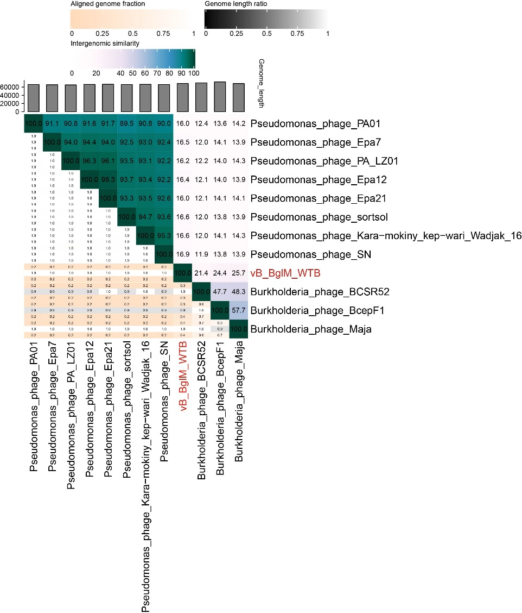
Figure 1. The heat map by VIRIDIC analysis

Phylogenetic analysis: Genome-wide and major coat protein neighbour-joining phylogenetic trees were constructed with MEGA 11. The phylogenetic tree of major coat proteins suggested that phage WTB was in a subfamily branch with Burkholderia phage BCSR52, Burkholderia phage Maja, Burkholderia phage BcepF1. Genomic phylogeny indicated that phage WTB was alone in one branch and is distantly related to all other phages. The research suggested that the WTB may have a common ancestor with these Burkholderia phages. Combined with the comparative genomic analysis, it is proposed that phage WTB should form a new genus.
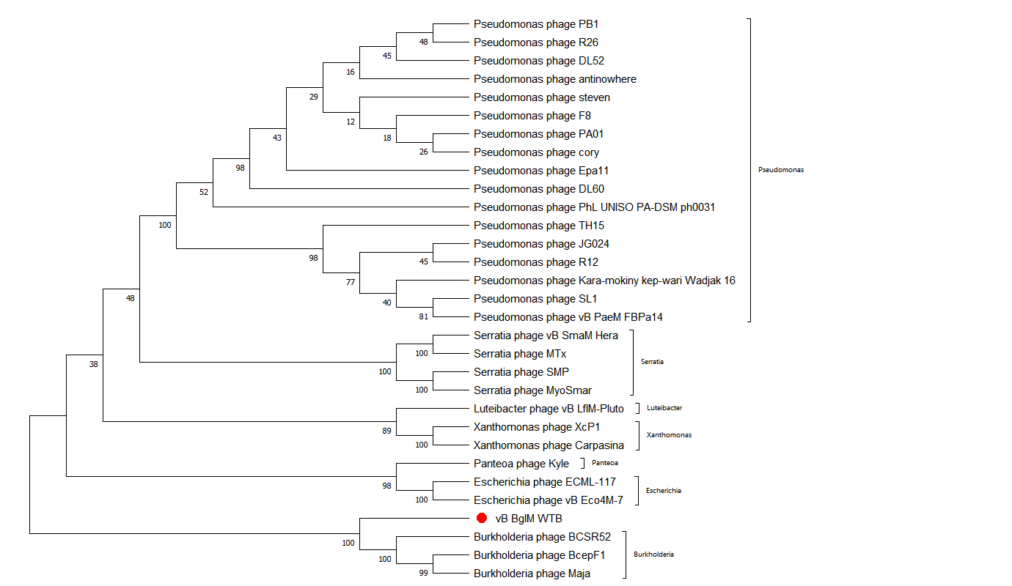
Fig. 2. Phylogenetic analysis of the selected phages based on major capsid protein. The sequences were aligned using the MEGA 11, and the phylogenetic tree was generated using the neighbor-joining method with 1000 bootstrap replicates. The numbers in the graph are used to represent the degree of reliability of this branch structure, with values ranging from 0% to 100%. Higher values indicate more evidence in support of the branch.
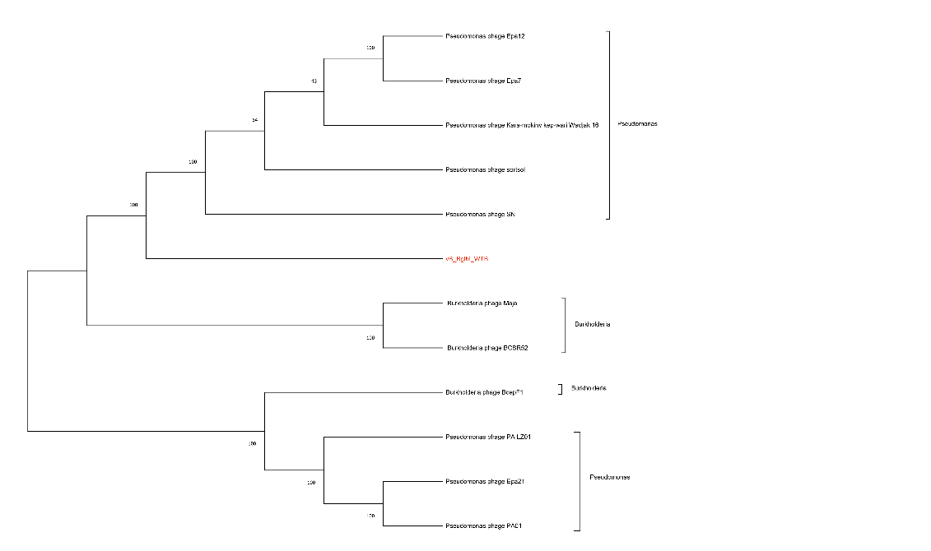
Fig. 3. Phylogenetic tree based on the whole genome. The tree was constructed by downloading the whole genome sequences of 11 phages with similarity to WTB from NCBI. The sequences were aligned using the MEGA 11, and the phylogenetic tree was generated using the neighbor-joining method with 500 bootstrap replicates. The tree indicated that phage WTB was alone in one branch and is distantly related to all other phages. The research suggested that the phage may have a common ancestor with these Burkholderia phages.

Electron micrograph:
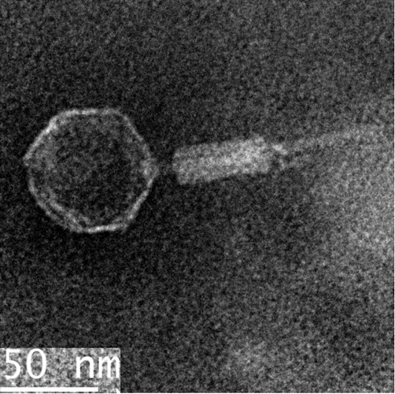

References

1. Moraru C, Varsani A, Kropinski AM (2020) VIRIDIC—A Novel Tool to Calculate the Intergenomic Similarities of Prokaryote-Infecting Viruses. Viruses. Doi:10.3390/v12111268
2. Sayers EW, Bolton EE, Brister JR, Canese K, Chan J, Comeau Donald C, Connor R, Funk K, Kelly C, Kim S, Madej T, Marchler-Bauer A, Lanczycki C, Lathrop S, Lu Z, Thibaud-Nissen F, Murphy T, Phan L, Skripchenko Y, Tse T, Wang J, Williams R, Trawick Barton, Pruitt Kim, Sherry Stephen (2022) Database resources of the national center for biotechnology information. Nucleic Acids Research 50:D20-D26
3. Turner D, Kropinski AM, Adriaenssens EM (2021) A Roadmap for Genome-Based Phage Taxonomy. Viruses 13

