

Part 1: TITLE, AUTHORS, APPROVALS, etc

Code assigned: | 2023.070B
Short title: Create one (1) genus and eight (8) new species in the family Inoviridae (Tubulavirales)

Author(s) and email address(es)
Knezevic P, Gavric D, Yang M, Kropinski AM, Lavigne R, Adriaenssens EM | petar.knezevic@dbe.uns.ac.rs; damir.gavric@dbe.uns.ac.rs; ymy@scau.edu.cn; Phage.Canada@gmail.com; rob.lavigne@kuleuven.be; Evelien.Adriaenssens@quadram.ac.uk
Author(s) institutional address(es) (optional)
University of Novi Sad [PK, DG]
South China Agricultural University, Guangzhou, China [MY]
University of Guelph, Canada [AMK]
KU Leuven, Belgium [RL]
Quadram Institute Bioscience, UK [EMA]
Corresponding author
Knezevic P
List the ICTV Study Group(s) that have seen this proposal

Bacterial Viruses Subcommittee, Tubulavirales Study Group
ICTV Study Group comments and response of proposer
ICTV Study Group votes on proposal
Study Group | Number of members
Study Group | Votes support | Votes against | No vote

Authority to use the name of a living person
Is any taxon name used here derived from that of a living person (Y/N)

Taxon name | Person from whom the name is derived | Permission attached (Y/N)

Submission dates
Date first submitted to SC Chair | June 2023
Date of this revision (if different to above)
ICTV-EC comments and response of the proposer
Part 2: NON-TAXONOMIC PROPOSAL
Text of proposal

Part 3: TAXONOMIC PROPOSAL
Name of accompanying Excel module
2023.070B.N.v1.Inoviridae_8ns_1ng.xlsx
Abstract
We propose eight (8) new species within existing genera of the family Inoviridae and one (1) new genus Anademivirus with one (1) new species.

Text of proposal
The aim of the proposal is:

- To create new genus Anademivirus and species Anademivirus AFP
The bacteriophage Alteromonas phage phiAFP1 belongs to family Inoviridae, and shows a distinct genome sequence in comparison to other known phages (<1.5% similarity) (Table 1). It shows negligible similarity of genome sequence of Enterobacteria phage If1, indicating a new species. The amino-acid sequence of Zot and CoaB are distinct from other bacteriophages (< 37.7% similarity; Figure 1A and 1B), indicating a new genus. We create a new genus Anademivirus (from lat. anadema, anadematis – band for the hair, head-band). The only species in the genus is Anademivirus AFP1. Its host is Alteromonas macleodii and the phage was isolated from South China Sea.
- To create two new species Villovirus V5 and Villovirus FR
Two strains infecting Vibrio parachaemolyticus: Vibrio phage V5 detected in shrimp pond water (India) and Vibrio phage vB_VpI_FR1 isolated from the Bohai bay in TangShan, China show significant similarity with other members of the genus Villovirus. The new species Villovirus V5 and Villovirus FR differ from other members of the genus, as genome sequences share 36.6-73.5% similarity. Their Zot and CoaB protein amino-acid sequences are similar to other members of genus Villovirus (80.5-100%) and significant number of proteins are homologous (supporting evidence Table 2; Fig. 2).
- To create 6 new species Versovirus VipaK, Versovirus Vipa4291, Versovirus Vipa26, Versovirus Vipa36, Versovirus Vipa10 and Versovirus Vipa71
They share characteristics with the members of the genus Versovirus, and genome sequence is similar 70.3-82.0%, indicating new species (Table 3). There is a significant similarity of Zot and CoaB protein amino-acid sequences (97.5-99.8%) and significant number of proteins are homologous (supporting evidence Table 3, Fig. 2).

Descriptions of the families Inoviridae and Plectroviridae, as well as demarcation criteria are described in the ICTV Report chapters and profiles [1, 2] (ictv.global/report/plectroviridae; ictv.global/report/inoviridae).
Species demarcation: „Phages of the same species share >95% DNA sequence similarity (identity × query coverage) and significant amino-acid sequence similarity of the adhesion protein (CoaA).“
Genus demarcation: “For genus demarcation, beside considerable similarity of DNA sequences confirmed by BLASTn, the phage should have significant similarity of both Zot and Coat B (major capsid) proteins. Each of the proposed genera comprise phages with similar DNA sequences; phages in different genera differ from each other by >50% in the amino-acid sequence of the major coat (CoaB; p8) and morphogenesis (Zot; p1) proteins as assessed using the BLASTp algorithm.”

Supporting evidence

Table 1. New species (strain is in bold) and the new genus Anademivirus (members of the genus are highlighted in orange)
 | GenBank Access. No. | Genome lenght (nt) | Mol% G+C | No. CDS | DNA (% seq. Identity) | Proteome (No. of homologous proteins) | Zot | CoaB
Alteromonas phage phiAFP1 | MT975991.1 | 5859 | 40.6 | 8 | 100 | 8 | 100 | 100
Inoviridae sp. Isolate ctbf525 | MH616815.1 | 5715 | 50.8 | 9 | 1.5 | 1 | 0 | 0
Enterobacteria phage If1 | NC_001954 | 8454 | 43.7 | 10 | 1.0 | 1 | 0 | 0
Ralstonia phage RSM1 | NC_008574 | 9004 | 60.0 | 15 | 0 | 4 | 33.7 | 33.7
Stenotrophomonas phage SMA9 | NC_007189 | 6907 | 62.4 | 7 | 0 | 3 | 27.4 | 0

Figure 1. “One click” phylogeny tree [3] of Inoviridae, based on amino-acid sequences of morphogenesis protein (A) and coat protein (B); the new species and genus is indicated by orange color
A)

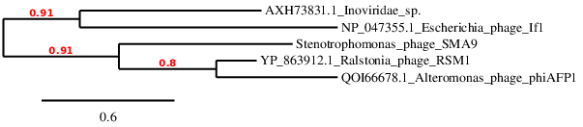
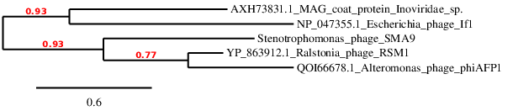
B)

Table 2. New species (in bold) in the genus Villovirus (members of the genus are highlighted in green)
 | GenBank Access. No. | Genome lenght (nt) | Mol%G+C | No. CDS | DNA (% seq. Identiti) | Proteome (No. of homologous proteins) | Zot | CoaB
Vibrio phage V5 | OL512807.1 | 6658 | 43.7 | 10 | 100 | 10 | 100 | 100
Vibrio phage vB_VpI_FR1 | OP628074.1 | 6080 | 42.9 | 9 | 73.5 | 7 | 80.5 | 82.9
Vibrio phage Vf33 | NC_005948.1 | 7965 | 45.7 | 7 | 36.6 | 6 | 77.1 | 74.0
Vibrio phage VALG phi8 | NC_073760.1 | 7311 | 46.3 | 10 | 36.6 | 6 | 77.1 | 71.4
Fibrovirus fs1 | NC_004306 | 6340 | 43.4 | 15 | 0 | 6 | 45.9 | 63.2
Vibrio phage VEJ | NC_012757 | 6842 | 43.0 | 11 | 0 | 6 | 45.6 | 63.2
Vasivirus VAI | NC_073758.1 | 6117 | 42.5 | 10 | 20.1 | 2 | 11.5 | 9.5
Affertcholeramvirus CTXphi | NC_015209.1 | 10638 | 44.6 | 13 | 16.6 | 4 | 19.4 | 0
Subteminivirus SMA7 | NC_021569 | 7069 | 62.3 | 10 | 0 | 3 | 20.0 | 0

Table 3. New species (strains in bold) in the genus Versovirus (members of the genus are highlighted in violet)
 | GenBank Access. No. | Genome lenght (nt) | Mol%G+C | No. CDS | DNA (% seq. Identiti) | Proteome (No. of homologous proteins) | Zot | CoaB
Vibrio phage vB_VipaK | MT188664.1 | 10809 | 44.0 | 15 | 100 | 15 | 100 | 100
Vibrio phage vB_Vipa4291 | MT188665.1 | 9663 | 45.0 | 15 | 81.0 | 12 | 100 | 99.8
Vibrio phage vB_Vipa36 | MT188663.1 | 9721 | 44.7 | 15 | 78.0 | 11 | 98.8 | 99.8
Vibrio phage vB_Vipa26 | MT188662.1 | 10893 | 44.7 | 18 | 70.3 | 11 | 99.8 | 100
Vibrio phage vB_Vipa10 | MT188666.1 | 9318 | 45.0 | 14 | 82.0 | 11 | 99.8 | 100
Vibrio phage vB_Vipa71 | MT193890.1 | 10295 | 44.5 | 13 | 72.2 | 11 | 100 | 100
Vibrio phage VfO3K6 | NC_002362.1 | 8784 | 45.2 | 10 | 73.1 | 8 | 99.8 | 97.5
Vibrio phage VALG phi6 | NC_073759.1 | 8529 | 44.3 | 13 | 74.5 | 10 | 99.6 | 98.8
Villovirus Vf33 | AB012573.1 | 7965 | 45.7 | 7 | 36.8 | 3 | 9.8 | 0
Vicialiavirus VCY | NC_016162 | 7103 | 41.4 | 11 | 0.8 | 6 | 68.6 | 28.7
Capistrivirus KSF1 | NC_006294 | 7107 | 44.4 | 12 | 0 | 5 | 40.6 | 19.9

Figure 2. “One click” phylogeny tree [3] of Inoviridae, based on amino-acid sequences of morphogenesis protein (A) and coat protein (B); the new species in genera Villovirus and Versovirus are indicated by green and violet color, respectively.

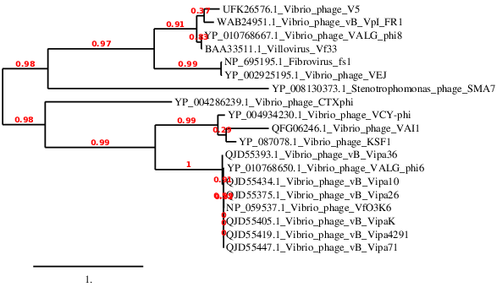
A)

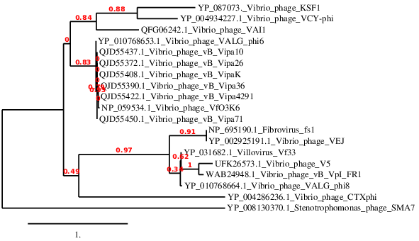
B)

References

- Knezevic P, Adriaenssens EM, ICTV Report Consortium (2021) ICTV Virus Taxonomy Profile: Plectroviridae, J Gen Virol https://doi.org/10.1099/jgv.0.001597
- Knezevic P, Adriaenssens EM, ICTV Report Consortium (2021) ICTV Virus Taxonomy Profile: Inoviridae, J Gen Virol in press
- Dereeper A.. Guignon V., Blanc G., Audic S., Buffet S., Chevenet F., Dufayard J.F., Guindon S., Lefort V., Lescot M., Claverie J.M., Gascuel O. (2008). Phylogeny.fr: robust phylogenetic analysis for the non-specialist. Nucleic Acids Res. W465-9. https://doi.org/10.1186/1756-0500-6-140
- Turner D, Reynolds D, Seto D, Mahadevan P. CoreGenes3.5: a webserver for the determination of core genes from sets of viral and small bacterial genomes. BMC Res Notes. 2013;6:140. doi: 10.1186/1756-0500-6-140. PMID: 23566564.

