

.
Part 1: TITLE, AUTHORS, APPROVALS, etc

Code assigned: | 2023.057B
Short title: Create one new family (Saffermanviridae) including one new genus, two new species, and five existing species (Caudoviricetes)
Author(s) and email address(es)
Avrani S, Schwartz DA | savrani@univ.haifa.ac.il; danschw@iu.edu
Author(s) institutional address(es) (optional)
Corresponding author
Avrani S
List the ICTV Study Group(s) that have seen this proposal

Caudoviricetes Study Group

ICTV Study Group comments and response of proposer

ICTV Study Group votes on proposal

Study Group | Number of members
Study Group | Votes support | Votes against | No vote

Authority to use the name of a living person
Is any taxon name used here derived from that of a living person (Y/N) | Y

Taxon name | Person from whom the name is derived | Permission attached (Y/N)
Morrisvirus | Mary-Ellen Morris | Y
Saffermanviridae | Robert S. Safferman | Y

Submission dates
Date first submitted to SC Chair | March 2023
Date of this revision (if different to above)
ICTV-EC comments and response of the proposer

Part 2: NON-TAXONOMIC PROPOSAL
Text of proposal

Part 3: TAXONOMIC PROPOSAL
Name of accompanying Excel module
2023.057B.N.v1.Saffermanviridae_nf.xlsx
Abstract
We propose the creation of a new family Saffermanviridae including the new genera Morrisvirus (includes three species - Morrisvirus LPP1, Morrisvirus Pboyong3, and Morrisvirus JingP1) and Arthrovirus (includes one species - Arthrovirus TR020), and two new species - Wumptrevirus LPP2 and Wumpquatrovirus Lbo240yong1. Moreover, we propose that additional four existing species belong to this family as well.

Text of proposal
Species demarcation criteria: Two phages are assigned to the same species if their genomes are more than 95% identical over their genome length for isolates.
These values can be calculated by a number of tools, such as BLASTn [1] – usually calculated using intergenomic distance calculator VIRIDIC [2].

Genus demarcation criteria: In search for criteria that create cohesive and distinct genera that are reproducible and monophyletic, the Bacterial Viruses Subcommittee has established 70% nucleotide identity of the genome length as the cut-off for genera. Genus-level groupings should always be monophyletic in the signature genes, as tested with a phylogenetic tree [3].

Family demarcation criteria: The family is represented by a cohesive and monophyletic group in the main predicted proteome-based clustering tools (ViPTree, GRAViTy dendrogram, vConTACT2 network). Members of the family share a significant number of orthologous genes (the number will depend on the genome sizes and number of coding sequences of members of the family) [3].

Supporting evidence
VIRIDIC heat map: The similarity between the DNA sequence of the genomes that belong to the proposed Saffermanviridae family was calculated by VIRIDIC (Virus Intergenomic Distance Calculator) [2]. Leptolyngbya phage LPP-2 had 89.9% and 89.5% identity to cyanophage PP (Wumptrevirus PP) and Phormidium phage WMP3 (Wumptrevirus WMP3) respectively. Strains with >95% DNA sequence identity belong to the same species, and strains with >70% DNA sequence identity belong to the same genus [3].Therefore, we propose that Leptolyngbya phage LPP-2 is a new species that belongs to the genus Wumptrevirus (Wumptrevirus LPP2). The DNA sequence similarity of Leptolyngbya phage LPP-1, Plectonema phage JingP1, and Plectonema phage Pbo-yong3 to any other phage genome is <70%, but similarity within this group is between 70% and 95%, and thus we suggest they are three new species that belong to a new genus. The DNA sequence similarity of Leptolyngbya phage Lbo240-yong1 to the Phormidium phage WMP4 genome is between 70% and 95%, and thus we suggest it is a new species that belongs to the genus Wumpquatrovirus (Wumpquatrovirus Lbo240yong1). The DNA sequence similarity of Arthronema virus TR020 to any other phage genome is <70%, and thus we suggest it is a new species that belongs to a new genus.
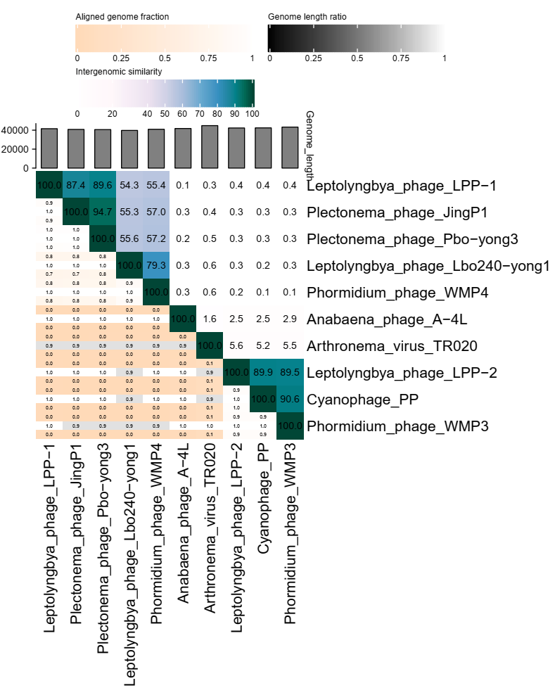

ViPTree analysis: ViPTree generates viral proteomic trees [4]. ViPTree analysis shows that all phages that belong to the new family Saffermanviridae (marked with a blue rectangle) form a monophyletic group. Phages that are not found in the ViPTree dataset are marked with red stars.

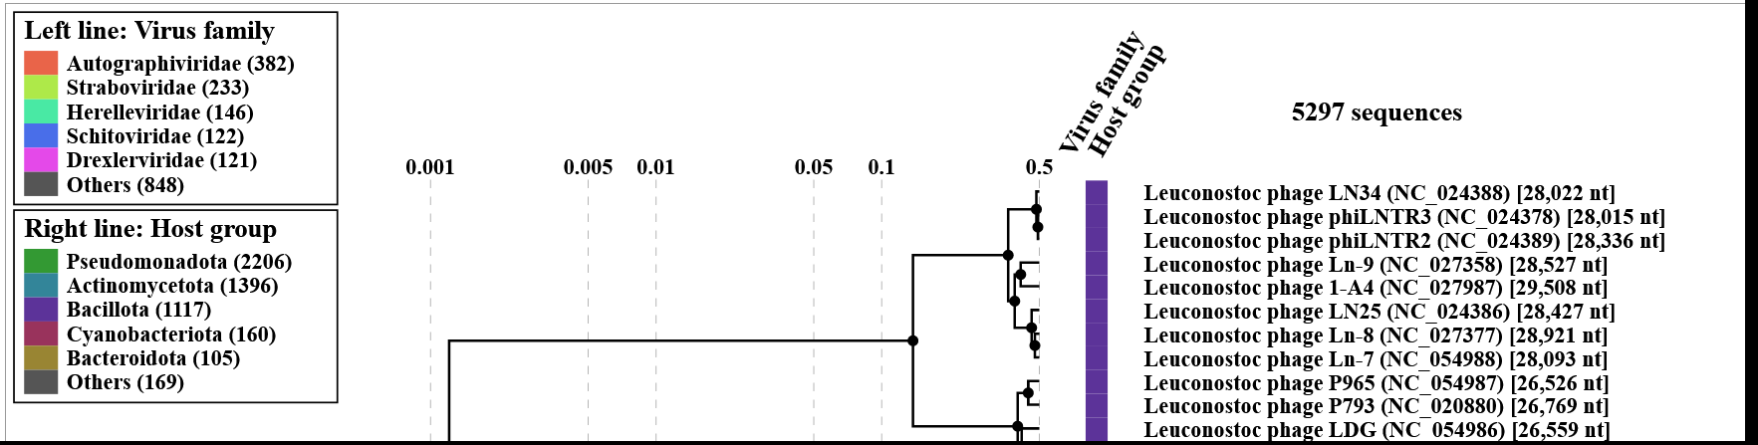
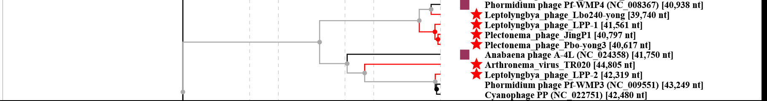

Phylogeny: Phylogenetic tree of homologs of the terminase gene, generated by “One Click” Mode of phylogeny.fr webserver [5]. Branch support values (out of 100) are shown. Genes from Saffermanviridae (proposed), Zobellviridae, and Autogaphiviridae phages are depicted in green, black, and blue, respectively. Calothrix parietina FACHB-288 and Aphanizomenon flos-aquae WA102 represent terminase genes from prophages within these cyanobacterial genomes. Cyanophage BHS3 is a partial genome obtained from a metagenome [6]. Therefore, the latter three genomes are not part of this application.

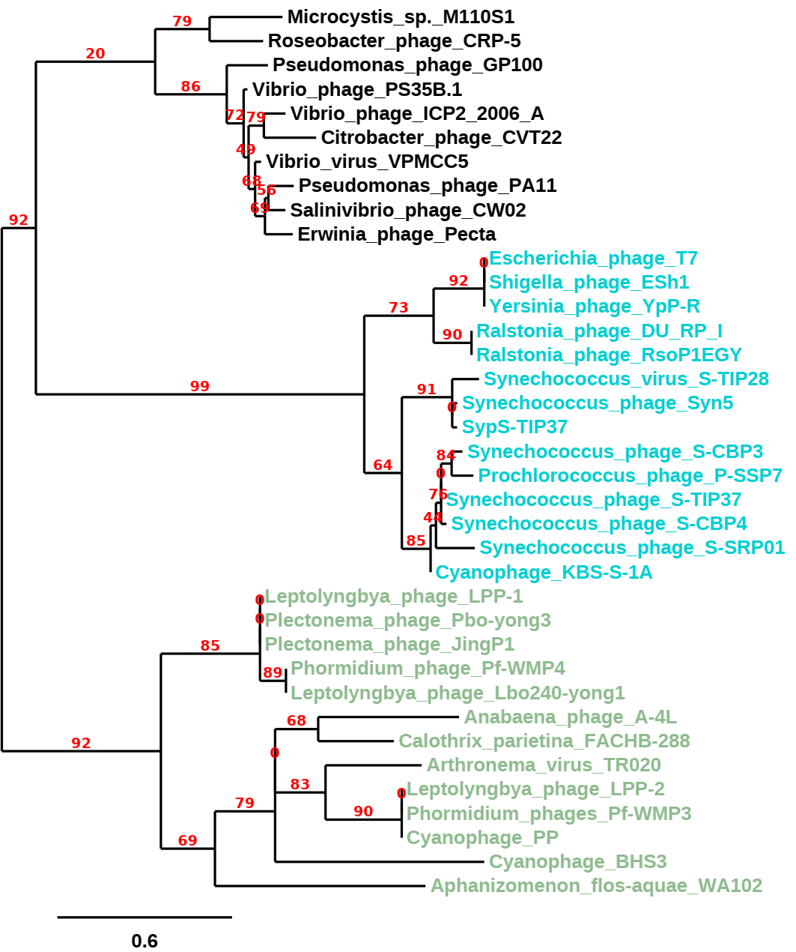

vConTACT clustering: Protein network of bacterial and archaeal genomes, generated by vConTACT [7] and adapted from [8]. Each node represents a genome, and edges represent proteins that are significantly related. Green nodes represent phages that belong to the proposed Saffermanviridae family, which forms a distinct cluster, and blue nodes represent other viruses from the vConTACT dataset. A blowup of the proposed Saffermanviridae cluster is shown on the right. Calothrix parietina FACHB-288 and Aphanizomenon flos-aquae WA102 represent genes from prophages within the cyanobacterial genomes. Cyanophage BHS3 is a partial genome obtained from a metagenome [6]. Therefore, the latter three genomes are not part of this application.

Proposals
- Create a new species, Wumptrevirus LPP2
- Create a new species, Wumpquatrovirus Lbo240yong1
- Create a new genus, Arthrovirus with one species
- Create a new genus, Morrisvirus with three species
- Create a new family, Saffermanviridae, for these six species and move four additional phages to this family.

- Create a new species, Wumptrevirus LPP2
Historical aspects: LPP-2, strain SPI was isolated on the filamentous cyanobacteria Plectonema boryanum in the mid-1960s from a waste stabilization pond in St. Paul, Indiana, USA by Mary Ellen Morris and Robert S. Safferman [9]. The genome of this phage was only recently sequenced [8]. It was previously shown that LPP-2 can enter a lysogenic infection cycle [10], however, only now when its genome is sequenced, the integration site was identified [8].

Electron micrograph: N/A

Genome summary:

Phage name | INSDC | Size (Kb) | GC% | Protein | Overall % DNA sequence identity (*) | Overall % homologous proteins (**)
Cyanophage PP | KF598865.1 | 42.48 | 46.4 | 41 | 100 | 100
Phormidium phage Pf-WMP3 | EF537008.1 | 43.25 | 46.5 | 41 | 90.6 | 87.8
Leptolyngbya phage LPP-2 | OP590147.1 | 42.32 | 46.5 | 38 | 89.9 | 89.5
(*) determined using VIRIDIC [2]
(**) determined using CoreGenes 3.5 [11]

Data supporting the creation of this taxon: At the DNA sequence level Leptolyngbya phage LPP-2 shares 89.9% DNA sequence similarity with and its closest relative, Cyanophage PP, which suggest that it forms a new species, within the same genus of Cyanophage PP (Wumptrevirus). Therefore, we propose to classify Leptolyngbya phage LPP-2 as Wumptrevirus LPP2.

- Create a new species, Wumpquatrovirus Lbo240yong1

Historical aspects: Lbo240-yong1 was isolated on the filamentous cyanobacteria Leptolyngbya boryana from Lake Sunhu in China.
Genome summary:

Phage name | INSDC | Size (Kb) | GC% | Protein | Overall % DNA sequence identity (*) | Overall % homologous proteins (**)
Phormidium phage Pf-WMP4 | DQ875742.1 | 40.94 | 51.8 | 45 | 100 | 100
Leptolyngbya phage Lbo240-yong1 | OM897575.1 | 39.74 | 52.0 | 42 | 90.6 | 75.56
(*) determined using VIRIDIC [2]
(**) determined using CoreGenes 3.5 [11]

Data supporting the creation of this taxon: At the DNA sequence level Leptolyngbya phage Lbo240-yong1 shares 90.6% DNA sequence similarity with and its closest relative, Phormidium phage Pf-WMP4, which suggest that it forms a new species, within the same genus of Phormidium phage Pf-WMP4 (Wumpquatrovirus). Therefore, we propose to classify Leptolyngbya phage Lbo240-yong1 as Wumpquatrovirus Lbo240yong1.

- Create a new genus, Arthrovirus with one species

Origin of the name of this taxon: This taxon is named after the name of the host of this virus, Arthronema.

Historical aspects: TR020 was isolated from a culture of Arthronema africanum originated in quiet. It was suggested to be a temperate phage that was induced from the host genome [12].

Electron micrograph: See [12].

Genome summary:

Phage name | INSDC | Size (Kb) | GC% | Protein | Overall % DNA sequence identity (*) | Overall % homologous proteins (**)
Arthronema virus TR020 | MT457475.1 | 44.8 | 45.8 | 42 | 100 | 100
(*) determined using VIRIDIC [2]
(**) determined using CoreGenes 3.5 [11]

Data supporting the creation of this taxon: At the DNA sequence level Arthronema virus TR020 and shares DNA sequence similarity greater than 70% with no other sequenced phage, which suggest that TR020 forms a new genus.

- Create new genus, Morrisvirus with three species

Origin of the name of this taxon: This taxon is named in honour of Mary-Ellen Morris who isolated the first cyanophage LPP-1 together with Dr. Robert S. Safferman. Morris (b. 1936) joined the staff of the Taft Center in 1959 after obtaining her B.S. degree from the University of Cincinnati. In this center she studied various organisms. Many of her studies focused on cyanobacteria (previously called Blue-Green Algae) and their viruses. This was a pioneering study since Mary-Ellen Morris and Robert S. Safferman were the first to discover these viruses.
 | 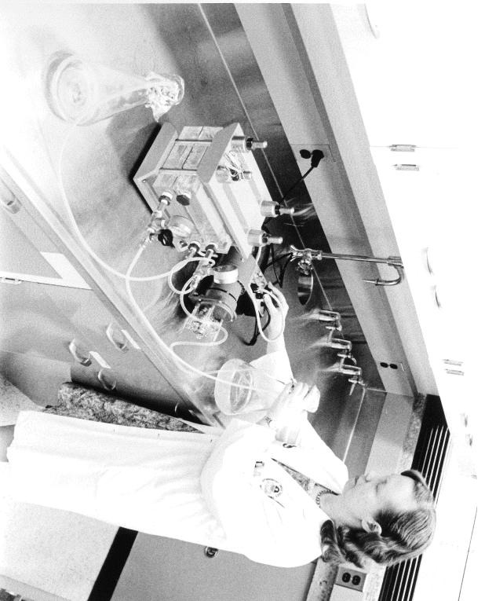
(kindly provided by Debra Swigart and Fred William)

Historical aspects: LPP-1 was isolated in the early 1960s on the filamentous cyanobacteria Plectonema boryanum from a waste-stabilization pond in southeastern Indiana, USA [13]. This was the first time that a virus that infects cyanobacteria was identified. The isolation of LPP-1 led to a massive study of freshwater cyanophages, and later on to the study of marine cyanophages as well. LPP-1 was shown to infect 11 strains of filamentous cyanobacteria of the LPP (Lyngbya, Plectonema, and Phormidium) group. Recently the genome of LPP-1 (together with LPP-2) was sequenced, revealing that they belong to the same taxonomic group (we suggested that they belong to the same family) [8]. Genome sequences of both phages suggest that they are relatives of five previously sequenced cyanophages. All of these relatives are short tailed phages that infect filamentous cyanobacteria [8].

Electron micrograph: N/A.

Genome summary:

Phage name | INSDC | Size (Kb) | GC% | Protein | Overall % DNA sequence identity (*) | Overall % homologous proteins (**)
Leptolyngbya phage LPP-1 | OP589309.1 | 41.56 | 52.1 | 42 | 100 | 100
Plectonema phage Pbo-yong3 | OP056300.1 | 40.62 | 52.4 | 51 | 89.6 | 90.5
Plectonema phage JingP1 | ON677538.1 | 40.80 | 52.3 | 49 | 87.4 | 85.7
(*) determined using VIRIDIC [2]
(**) determined using CoreGenes 3.5 [11]

Data supporting the creation of this taxon: At the DNA sequence level Leptolyngbya phage LPP-1 and its closest relatives, Plectonema phage Pbo-yong3 and Plectonema phage JingP1 share 89.6% and 87.4% DNA sequence similarity (respectively), which suggest that they are 3 species that belong to the same genus. The closest phage to these three phages is Phormidium phage WMP4 (57% DNA similarity with Pbo-yong3), which suggests that the three phages form a new genus.

- Create a new family, Saffermanviridae, for these two species and move five additional phages to this family

Origin of the name of this taxon: This taxon is named in honour of Robert S. Safferman, who together with Mary-Ellen Morris isolated and characterized the first virus to infect a cyanobacterium. That virus, LPP-1, is a member of this family. Safferman (b. 1932, Bronx, New York, USA) is an American Microbiologist. He obtained his B.S. from Brooklyn College in 1955 and his PhD from Rutgers University in 1960. Later he joined the Robert A. Taft Sanitary Engineering Center of the U.S. Department of Health, Education, and Welfare,
in Cincinati, OH, which was later incorporated into the newly formed Environmental Protection Agency. There he rose to become the chief of the branch of biological methods.

Safferman is the recipient of Special Service award Sanitary Engineering Center, United States Public Health Service, 1963; Gans medal Society Water Treatment and Examination, England, 1970; named Federal Employee of Year, Cincinnati, 1974. He is a fellow of the American Academy Microbiology and a member of the International Committee on Taxonomy of Viruses.

 | 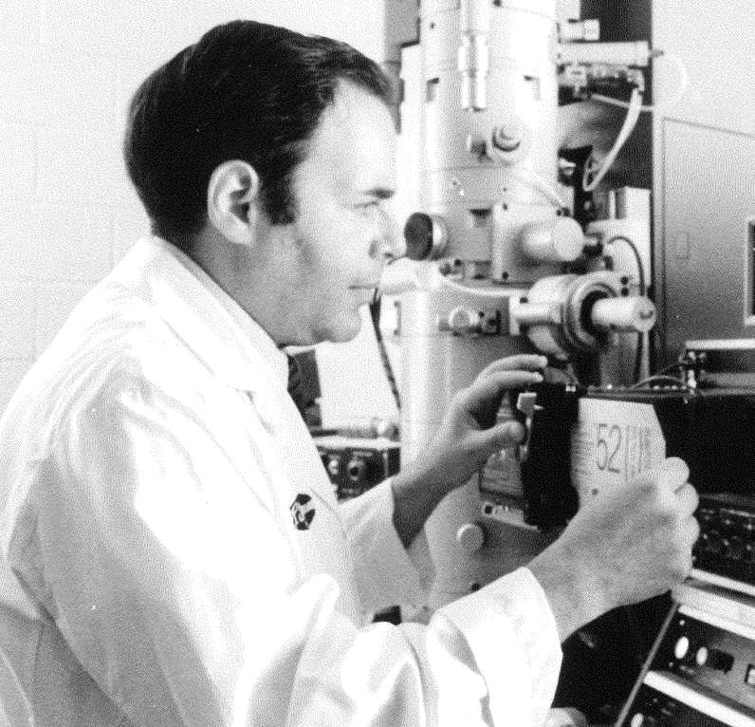
(kindly provided by Prof. Steven I. Safferman and Fred Williams)

Genome summary:

Phage name | INSDC | Size (Kb) | GC% | Protein | Overall % DNA sequence identity (*) | Overall % homologous proteins (**)
Cyanophage PP | KF598865.1 | 42.48 | 46.4 | 41 | 100 | 100
Phormidium phage Pf-WMP3 | EF537008.1 | 43.25 | 46.5 | 41 | 90.6 | 87.8
Leptolyngbya phage LPP-2 | OP590147.1 | 42.32 | 46.5 | 38 | 89.9 | 89.5
Leptolyngbya phage LPP-1 | OP589309.1 | 41.56 | 52.1 | 42 | 0.4 | 31
Phormidium phage Pf-WMP4 | DQ875742.1 | 40.94 | 51.8 | 45 | 0.4 | 28.9
Anabaena phage A-4L | KF356198.1 | 41.75 | 43.4 | 38 | 2.7 | 44.7
Arthronema virus TR020 | MT457475.1 | 44.81 | 45.8 | 55 | 5.8 | 38.2
(*) determined using VIRIDIC [2]
(**) determined using CoreGenes 3.5 [11]

Logic for creation of this taxon: Although at the DNA sequence level, this group of phages shares, in some cases, very low sequence identity, there are other characteristics that in our opinion make them part of a single family. vConTACT [7] analysis (see above) shows that these phages form a distinct cluster. These phages form a monophyletic cluster both in a maximum likelihood tree based on the amino acid sequence of their terminase gene, and in a proteomic tree calculated by ViPTree [4] based on the proteomic sequence of their whole genomes (see above). Moreover, using the CoreGenes 3.5 [11] tool, which identifies core genes in viral genome groups, we were able to identify 12 core genes shared by all seven genomes of this group. These core genes included: DNA primase/helicase, DNA polymerase, two tail fiber proteins, endopeptidase, internal protein, tail tubular protein B, tail tubular protein A, major capsid protein, scaffolding protein, portal protein, and terminase. The average gene number per genome in this group is 42.9, and thus the 12 core genes represent, on average, 28% of these genomes.

References

1. Sayers EW, Beck J, Bolton EE, et al (2021) Database resources of the National Center for Biotechnology Information. Nucleic Acids Res 49:D10–D17. https://doi.org/10.1093/nar/gkaa892
2. Moraru C, Varsani A, Kropinski AM (2020) VIRIDIC — A Novel Tool to Calculate the Intergenomic Similarities of Prokaryote-Infecting Viruses. Viruses 12:1268. https://doi.org/10.3390/v12111268
3. Turner D, Kropinski AM, Adriaenssens EM (2021) A roadmap for genome-based phage taxonomy. Viruses 13:1–10. https://doi.org/10.3390/v13030506
4. Nishimura Y, Yoshida T, Kuronishi M, et al (2017) ViPTree: The viral proteomic tree server. Bioinformatics 33:2379–2380. https://doi.org/10.1093/bioinformatics/btx157
5. Shaalan H, Cattan-Tsaushu E, Li K, Avrani S (2023) Sequencing the genomes of LPP-1 , the first isolated cyanophage, and its relative LPP-2 reveal different integration mechanisms in closely related phages. Harmful Algae. https://doi.org/10.1016/j.hal.2023.102409
6. Pei J, Grishin N V. (2007) PROMALS: Towards accurate multiple sequence alignments of distantly related proteins. Bioinformatics 23:802–808. https://doi.org/10.1093/bioinformatics/btm017
7. Dereeper A, Guignon V, Blanc G, et al (2008) Phylogeny.fr: robust phylogenetic analysis for the non-specialist. Nucleic Acids Res 36:465–469. https://doi.org/10.1093/nar/gkn180
8. Guindon S, Dufayard JF, Lefort V, et al (2010) New algorithms and methods to estimate maximum-likelihood phylogenies: Assessing the performance of PhyML 3.0. Syst Biol 59:307–321. https://doi.org/10.1093/sysbio/syq010
9. Zablocki O, van Zyl LJ, Kirby B, Trindade M (2017) Diversity of dsDNA viruses in a South African hot spring assessed by metagenomics and microscopy. Viruses 9:. https://doi.org/10.3390/v9110348
10. Bolduc B, Jang H Bin, Doulcier G, et al (2017) vConTACT: An iVirus tool to classify double-stranded DNA viruses that infect Archaea and Bacteria. PeerJ 2017:1–26. https://doi.org/10.7717/peerj.3243
11. Safferman RS, Morris ME (1967) Observations on the occurrence, distribution, and seasonal incidence of blue-green algal viruses. Appl Microbiol 15:1219–1222. https://doi.org/10.1128/am.15.5.1219-1222.1967
12. Padan E, Shilo M, Oppenheim AB (1972) Lysogeny of the blue-green alga Plectonema boryanum by LPP2-SPI cyanophage. Virology 47:525–526. https://doi.org/10.1016/0042-6822(72)90294-2
13. Turner D, Reynolds D, Seto D, Mahadevan P (2013) CoreGenes3.5: a webserver for the determination of core genes from sets of viral and small bacterial genomes. BMC Res Notes 6:140. https://doi.org/10.1186/1756-0500-6-140
14. Safferman RS, Morris M-E (1963) Algal virus: Isolation. Science 140:679–680. https://doi.org/10.1126/science.140.3567.679

