

Part 1: TITLE, AUTHORS, APPROVALS, etc

Code assigned: | 2023.049B
Short title: To create six (6) new genera of Enterococcus infecting phages (Caudoviricetes)
Author(s) and email address(es)
Wittmann J, Adriaenssens EM, Turner D, Moraru C | Johannes.Wittmann@dsmz.de; Evelien.adriaenssens@quadram.ac.uk; Dann2.Turner@uwe.ac.uk; liliana.cristina.moraru@uol.de
Author(s) institutional address(es) (optional)
Leibniz Institute DSMZ – German Collection of Microorganisms and Cell Cultures GmbH, Braunschweig, Germany [JW]
Quadram Institute Bioscience, Norwich Research Park, Norwich, UK [EMA]
Department of Applied Sciences, University of the West of England, Bristol, UK [DM]
Carl von Ossietzky Universität Oldenburg, Germany [CM]

Corresponding author
J Wittmann

List the ICTV Study Group(s) that have seen this proposal

Schitoviridae Study Group, Bacterial Viruses Subcommittee
Caudoviricetes Study Group, Bacterial Viruses Subcommittee

ICTV Study Group comments and response of proposer

ICTV Study Group votes on proposal

Study Group | Number of members
Study Group | Votes support | Votes against | No vote
Authority to use the name of a living person

Is any taxon name used here derived from that of a living person (Y/N) | N

Taxon name | Person from whom the name is derived | Permission attached (Y/N)

Submission dates
Date first submitted to SC Chair | May 2023
Date of this revision (if different to above)
ICTV-EC comments and response of the proposer
Part 2: NON-TAXONOMIC PROPOSAL
Text of proposal

Part 3: TAXONOMIC PROPOSAL
Name of accompanying Excel module
2023.049B.N.v1.Caudoviricetes_Enterococcus_6ng.xlsx
Abstract

Here, we propose to create six (6) new genera, Aramisvirus, containing two (2) new species; Efemunavirus, containing two (2) new species; Delfunavirus, containing two (2) new species; Efemquintavirus, containing one (1) new species; Amiranvirus, containing one (1) new species; and Thiercelinvirus, containing one (1) new species, in the group of Enterococcus infecting phages in the Caudoviricetes class using genome-based comparisons.

Text of proposal
Amiranvirus: The name derived from a Georgian mythic hero and titan, Amiran. Enterococcus phage vb_GEC_Ef_S_9 as the first member of this genus has a genome size of 33,631 bp with 54 CDS. It was isolated from sewage in Georgia.
Aramisvirus: The name derived from the first isolated phage of this genus, Enterococcus phage Aramis. The genomes of phages Aramis and dArtagnan consist of 42,697 bp and 42,884 bp, respectively with 72 and 71 CDS, respectively.
Delfunavirus: The name derived from the first isolated phage of this genus, Enterococcus phage vB_EfaS-DELF1 [1]. Phage vB_EfaS-DELF1 was isolated in Iran. Genome sizes of members of this genus range from of 40,248 bp up to 41,014 bp.
Efemquintavirus: The name derived from the first isolated phage of this genus, Enterococcus phage IME-EFm5 was isolated from sewage in China [2]. Its genome consists of 42,265 bp with 70 CDS.
Efemunavirus: The name derived from the first isolated phage of this genus, Enterococcus phage IME-EFm1. It was isolated from hospital wastewater and showed morphological features of a siphovirus [3]. Phages IME-EFm1 and have genome sizes of 42,597 bp and 42,236 bp, respectively with 70 and 66 CDS, respectively.
Thiercelinvirus: The name derived from microbiologist M. E. Thiercelin who first introduced the term “enterococcus” at the end of the 19th century. The first isolated phage of this genus, Enterococcus phage 9184 was isolated from wastewater in the US [4]. Its genome consists of 44,108 bp with 74 CDS.

Supporting evidence

Electron micrograph: None available

Species demarcation criteria We have chosen 95% DNA sequence identity as the criterion for demarcation of species in this new genus. Each of the proposed species differs from the others with more than 5% at the DNA level as confirmed with VIRIDIC [5, 6].

VIRIDIC heat map: VIRIDIC (Virus Intergenomic Distance Calculator; http://rhea.icbm.uni-oldenburg.de/VIRIDIC/) computes pairwise intergenomic distances/similarities amongst phage genomes.

To analyze the similarities or relationship, respectively, between the Aeromonas phages and other published phages, we used ViPTree (https://www.genome.jp/viptree/; [6]) which is originally based on the Phage Proteomic Tree [7].

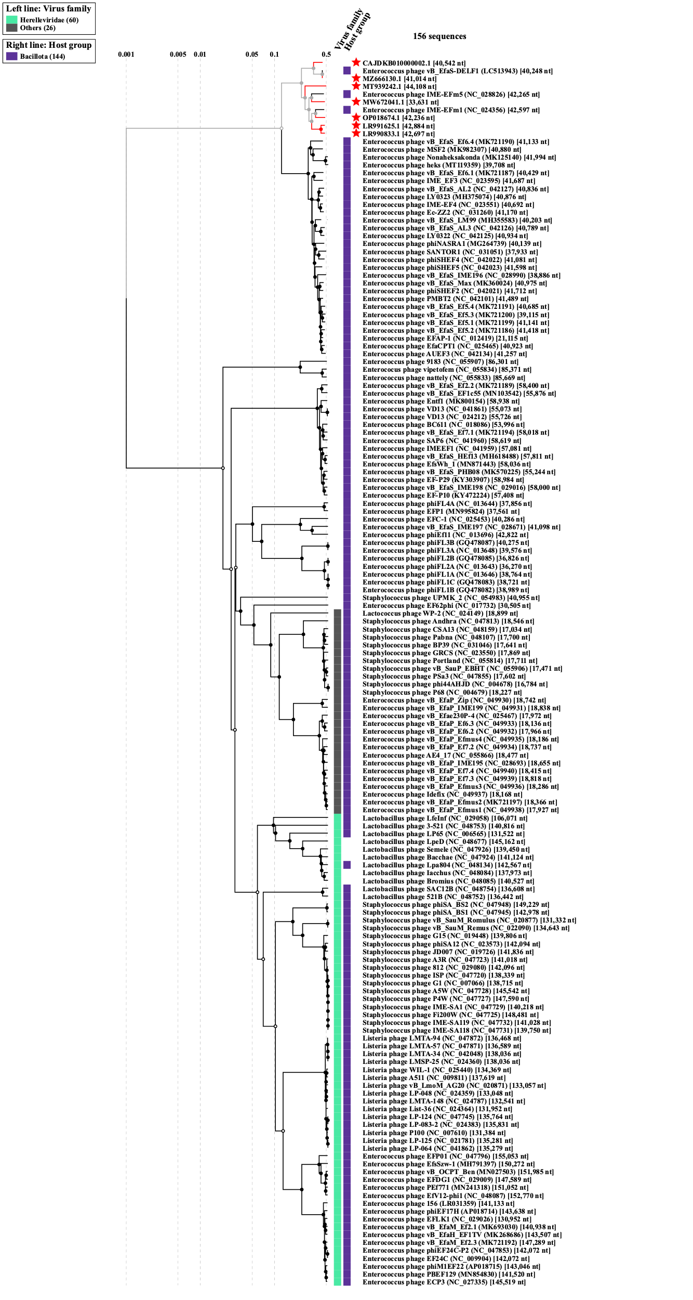
ViPTree analysis of Enterococcus phages of this study with related viruses.
References
- Soleimani-Delfan A, Bouzari M, Wang R. vB_EfaS-DELF1, a novel Siphoviridae bacteriophage with highly effective lytic activity against vancomycin-resistant Enterococcus faecalis. Virus Res. 2021 Jun;298:198391. doi: 10.1016/j.virusres.2021.198391.

- Gong P, Cheng M, Li X, Jiang H, Yu C, Kahaer N, Li J, Zhang L, Xia F, Hu L, Sun C, Feng X, Lei L, Han W, Gu J. Characterization of Enterococcus faecium bacteriophage IME-EFm5 and its endolysin LysEFm5. Virology. 2016 May;492:11-20. doi: 10.1016/j.virol.2016.02.006.

- Wang Y, Wang W, Lv Y, Zheng W, Mi Z, Pei G, An X, Xu X, Han C, Liu J, Zhou C, Tong Y. Characterization and complete genome sequence analysis of novel bacteriophage IME-EFm1 infecting Enterococcus faecium. J Gen Virol. 2014 Nov;95(Pt 11):2565-2575. doi: 10.1099/vir.0.067553-0.

- Morrisette T, Lev KL, Canfield GS, Duerkop BA, Kebriaei R, Stamper KC, Holger D, Lehman SM, Willcox S, Arias CA, Rybak MJ. Evaluation of Bacteriophage Cocktails Alone and in Combination with Daptomycin against Daptomycin-Nonsusceptible Enterococcus faecium. Antimicrob Agents Chemother. 2022 Jan 18;66(1):e0162321. doi: 10.1128/AAC.01623-21.

- Moraru C. VIRIDIC (Virus Intergenomic Distance Calculator) computes pairwise intergenomic distances/similarities amongst phage genomes. http://rhea.icbm.uni-oldenburg.de/VIRIDIC/

- Moraru C, Varsani A, Kropinski AM. VIRIDIC-A Novel Tool to Calculate the Intergenomic Similarities of Prokaryote-Infecting Viruses. Viruses. 2020 Nov 6;12(11):1268. doi: 10.3390/v12111268

- Nishimura Y, Yoshida T, Kuronishi M, Uehara H, Ogata H, Goto S. ViPTree: the viral proteomic tree server. Bioinformatics. 2017 Aug 1;33(15):2379-2380. doi: 10.1093/bioinformatics/btx157.

- Rohwer F, Edwards R. The Phage Proteomic Tree: a genome-based taxonomy for phage. J Bacteriol. 2002 Aug;184(16):4529-35. doi: 10.1128/JB.184.16.4529-4535.2002.

