

Part 1: TITLE, AUTHORS, APPROVALS, etc

Code assigned: | 2023.048B
Short title: Create one new subfamily (Munstervirinae) including four new genera within the class Caudoviricetes

Author(s) and email address(es)
Buttimer C, Shkoporov A, Kropinski A, Turner D, Draper L-A, Ross R-P, Hill C | colin.buttimer@ucc.ie; andrey.shkoporov@ucc.ie; phage.canada@gmail.com; Dann2.Turner@uwe.ac.uk; l.draper@ucc.ie, p.ross@ucc.ie; c.hill@ucc.ie
Author(s) institutional address(es) (optional)

APC Microbiome Ireland & School of Microbiology, University College Cork, College Road, Cork, Ireland [CB, AS, RPR, CH]
Department of Pathobiology, University of Guelph, Guelph, Ontario, Canada [AK]
Department of Applied Sciences, University of the West of England, Bristol, UK [DT]

Corresponding author
C. Buttimer
List the ICTV Study Group(s) that have seen this proposal
ICTV Study Group comments and response of proposer

ICTV Study Group votes on proposal

Study Group | Number of members
Study Group | Votes support | Votes against | No vote
Authority to use the name of a living person

Is any taxon name used here derived from that of a living person (Y/N) | N

Taxon name | Person from whom the name is derived | Permission attached (Y/N)

Submission dates
Date first submitted to SC Chair | May 2023
Date of this revision (if different to above)
ICTV-EC comments and response of the proposer

Part 2: NON-TAXONOMIC PROPOSAL
Text of proposal

Part 3: TAXONOMIC PROPOSAL
Name of accompanying Excel module
2023.048B.N.v1.Munstervirinae_nsf.xlsx
Abstract
Here, we propose the creation of a new subfamily “Munstervirnae” comprising four new genera, the new genera “Ahaonvirus” and “Adovirus” both comprising two new species and the new genera “Atrivirus” and “Aceathervirus”, each containing one new species. These proposals are based on genomic comparisons.

Text of proposal

Supporting evidence

Source of the names used for taxa:
Munstervirnae: The name is the province of Ireland where phages were first isolated [1].

Genus names: Derived from the names of numbers in the Irish language.
Species demarcation criteria:
In this proposal, we have chosen 95% DNA sequence idenitity/similarity as the criterion for the demarcation of a species. Each proposed species genome differs by more than 5% in nucleotide identity/similarity as determined by the BLASTN algorithm and VIRIDIC (Table 1-2, Figure 2) [2].

Subfamily and genus demarcation criteria:
Ruminococcus phages phiRgPS_6, phiRgIBDN1, phiRg519T2, phiRg507T2_2, phiRg507T2_3 and phiRgRM10 are all temperate phages infecting Ruminococcus gnavus. Genomes of these phages are homologous sharing >50% nucleotide similarity and possessing gene synteny allowing their placement within a novel subfamily (Figure 2 & 3). Nucleotide identity/similarity can be found between phages phiRg507T2_2 and phiRg507T2_3 on one hand, and phages phiRg519T2 and phiRgIBDN1 on the other, of >70% allowing placement within two separate novel genera (Figure 2, Table 1 & 2). Similarly, phages phiRgRM10 and phiRgPS_6 can be placed within their own separate novel genera (Figure 2). Nucleotide similarity of >70% can be found between phage phiRgIBDN1 and phages phiRg507T2_2. The convention of placing phage into different genera based on the demarcation of sharing nucleotide identity/similarity of ≥70 can be difficult to apply to temperate phages due their more recombinogenic nature, as typified by phage phiRgIBDN. However, gene products related to DNA functions are more conserved between phage phiRgIBDN1 and phiRg519T2, indicating these phages are better placed within the same genus (Figure 4). Designation of proposed subfamily and genera are also supported by phylogenetic analysis using the proteome of these phages (Figure 5).
All phages with the proposed subfamily possess genomes that range between 36,510 and 37,780 bp with a GC content of 41-42%. The number of open reading frames (ORFs) found on the genomes of these phages ranged from 54 to 59, with each possessing either one or two tRNA genes (Tables 1 to 4). All phages possess an integrase gene and have been demonstrated to be able to form prophage on the genome of their host bacterium [1]. Transmission electron microscopy of phiRgPS6, phiRg507T2_2,phiRg507T2_3 and phiRg519T2 revealed virions with a classic siphovirus morphology with icosahedral heads (55-61 nm in diameter), with long flexible non-contractile tails (195-204 nm) possessing very discreet baseplates (Figure 1) [1].

History:
Isolation source of the phages forming the proposed subfamily of the Munstervirnae:
- Phage phiRgPS6 was isolated from a pooled human faecal sample in Co. Cork, Ireland [1].
- Phages phiRgIBDN1, phiRg519T2, phiRg507T2_2 and phiRg507T2/3 were isolated from the faeces of individuals suffering from inflammatory bowel disease in Co. Cork, Ireland [1].
- Phage phiRgRM10 was isolated from a sample obtained from a farm in Co. Tipperary, Ireland [1].

Electron micrograph:

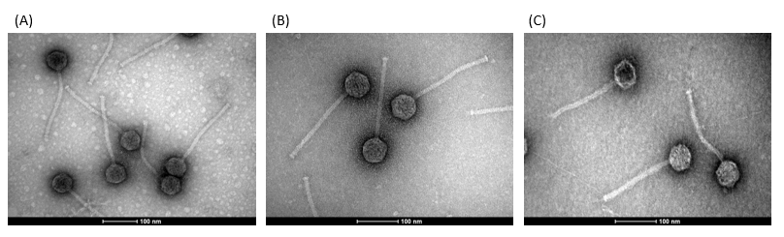

Figure 1. Transmission electron micrographs. The micrographs of Ruminococcus gnavus phages (A) phiRg507T2_2, (B) phiRg507T2_3, and (C) phiRgPS_6. Phages where negatively stained with 0.5% w/v uranyl acetate. The scale represents 100 nm [1].

GenBank Summary:

Table 1. Properties of the two phages belonging to the genus Ahaonvirus
Phage | INSDC accession number | Genome size (bp) | GC content (%) | Number of ORFs | Number of tRNA genes | Nucleotide homology (%)* | Homologous Proteins (%)**
phiRg507T2_2 | MT980836 | 37,304 | 42 | 54 | 2 | 100 | 100
phiRg507T2_3 | MT980837 | 36,510 | 42 | 54 | 2 | 86 | 89

Table 2. Properties of the two phages belonging to the genus Adovirus
Phage | INSDC accession number | Genome size (bp) | GC content (%) | Number of ORFs | Number of tRNA genes | Nucleotide homology (%)* | Homologous Proteins (%)**
phiRgIBDN1 | MT980840 | 37,233 | 41 | 58 | 2 | 100 | 100
phiRg519T2 | MT980838 | 36,865 | 42 | 58 | 2 | 73 | 81

Table 3. Properties of the phage forming the genus Atrivirus
Phage | INSDC accession number | Genome size (bp) | GC content (%) | Number of ORFs | Number of tRNA genes | Nucleotide homology (%)* | Homologous Proteins (%)**
phiRgPS6 | MT980839 | 37,780 | 41 | 59 | 2 | - | -

Table 4. Properties of the phage forming the genus Aceathervirus
Phage | INSDC accession number | Genome size (bp) | GC content (%) | Number of ORFs | Number of tRNA genes | Nucleotide homology (%)* | Homologous Proteins (%)**
phiRM10 | MT980841 | 36,920 | 42 | 58 | 1 | - | -

* Determined using BLASTN; ** Determined using CoreGenes 5 [3]

Phylogeny:
Figure 2. Heatmap showing nucleotide similarity of Ruminococcus phages as calculated with VIRIDIC [2].

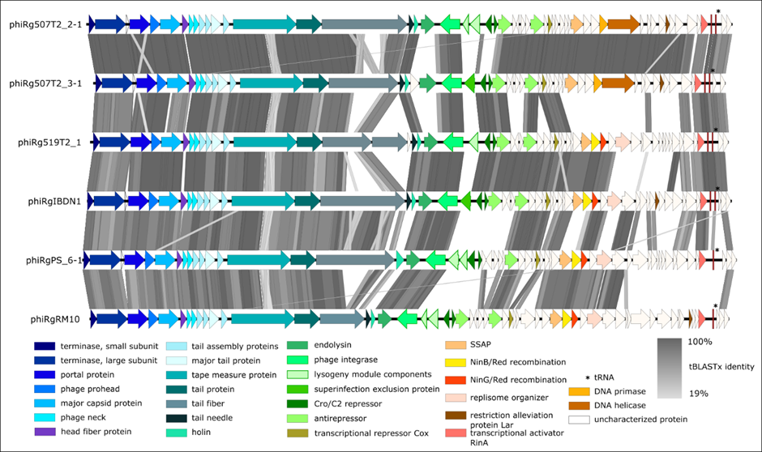
Figure 3. Comparison of the genomes of Ruminococcus phages isolated in this study employing BLASTN and visualisation with Easyfig [4]. The genome maps display arrows indicating the locations and orientation of ORFs among different phage genomes. Arrows have been colour-coded describing their predicted roles (see key), and shading between the genome maps indicates the level of identity.

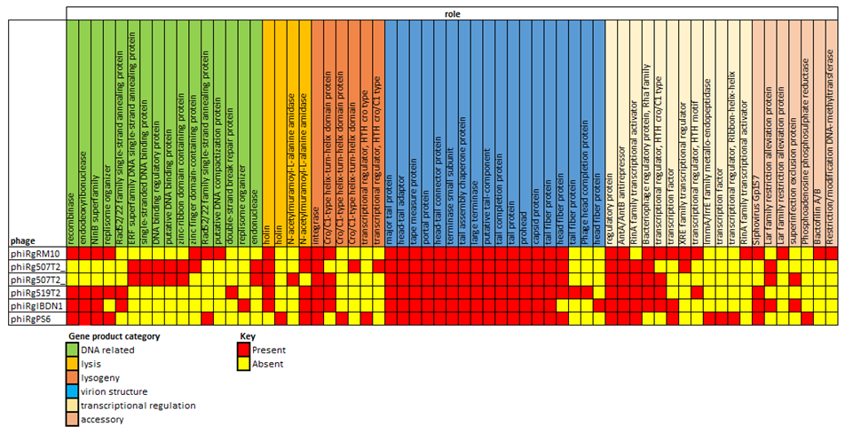
Figure 4. Heatmap illustrates shared genes as calculated by Proteinortho [5] (Identity = 30%, coverage = 70%) among Ruminococcus phages where function of their gene product could be determined. Key describes color coding for the presence absence of genes among phages and the category gene product function is allocated for the gene product in question.

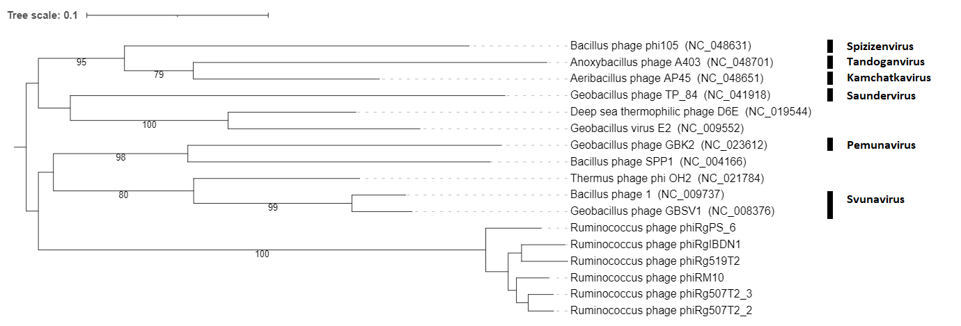
Figure 5. Amino acid VICTOR-generated phylogenomic Genome-BLAST Distance Phylogeny (GBDP) tree inferred using the formula D4 and yielding average support of 67% [6]. The phylogram includes this study’s Ruminococcus phages and those that share an evolutionary connection. The genus (if allocated) of phages in the analysis is illustrated. Branch support was inferred from 100 pseudo-bootstrap replicates.

References

1. Buttimer C, Khokhlova E, Stein L, et al Temperate bacteriophages infecting the mucin-degrading bacterium Ruminococcus gnavus from the human gut. In press.
2. Moraru C, Varsani A, Kropinski AM (2020) VIRIDIC—A Novel Tool to Calculate the Intergenomic Similarities of Prokaryote-Infecting Viruses. Viruses 2020, Vol 12, Page 1268 12:1268. https://doi.org/10.3390/V12111268
3. Turner D, Reynolds D, Seto D, Mahadevan P (2013) CoreGenes3.5: a webserver for the determination of core genes from sets of viral and small bacterial genomes. BMC Res Notes 6:140. https://doi.org/10.1186/1756-0500-6-140
4. Sullivan MJJ, Petty NKK, Beatson SAA (2011) Easyfig: a genome comparison visualizer. Bioinformatics 27:1009–1010. https://doi.org/10.1093/bioinformatics/btr039
5. Lechner M, Findeiß S, Steiner L, et al (2011) Proteinortho: Detection of (Co-)orthologs in large-scale analysis. BMC Bioinformatics 12:124. https://doi.org/10.1186/1471-2105-12-124
6. Meier-Kolthoff JP, Göker M (2017) VICTOR: genome-based phylogeny and classification of prokaryotic viruses. Bioinformatics 33:3396–3404. https://doi.org/10.1093/bioinformatics/btx440
7. O'Leary NA, Wright MW, Brister JR, Ciufo S, Haddad D, McVeigh R, et al. Reference sequence (RefSeq) database at NCBI: current status, taxonomic expansion, and functional annotation. Nucleic Acids Res. 2016;44(D1):D733-45. doi: 10.1093/nar/gkv1189. PMID: 26553804.
8. Sayers EW, Beck J, Bolton EE, Bourexis D, Brister JR, Canese K, Comeau DC, Funk K, Kim S, Klimke W, Marchler-Bauer A, Landrum M, Lathrop S, Lu Z, Madden TL, O'Leary N, Phan L, Rangwala SH, Schneider VA, Skripchenko Y, Wang J, Ye J, Trawick BW, Pruitt KD, Sherry ST. Database resources of the National Center for Biotechnology Information. Nucleic Acids Res. 2021 Jan 8;49(D1):D10-D17. doi: 10.1093/nar/gkaa892. PMID: 33095870

