

Part 1: TITLE, AUTHORS, APPROVALS, etc

Code assigned: | 2023.013B
Short title: create one genus, Bunatrivirus, containing one species, Bunatrivirus B13, in the class Caudoviricetes
Author(s) and email address(es)
Kazantseva OA, Piligrimova EG, Shadrin AM | olesyakazantseva@bk.ru; e.piligrimova@ibpm.ru; andrey2010s@gmail.com
Author(s) institutional address(es) (optional)
Corresponding author
Kazantseva OA
List the ICTV Study Group(s) that have seen this proposal

Caudoviricetes Study Group

ICTV Study Group comments and response of proposer

ICTV Study Group votes on proposal

Study Group | Number of members
Study Group | Votes support | Votes against | No vote
Authority to use the name of a living person

Is any taxon name used here derived from that of a living person (Y/N) | N

Taxon name | Person from whom the name is derived | Permission attached (Y/N)

Submission dates
Date first submitted to SC Chair | May 2023
Date of this revision (if different to above)
ICTV-EC comments and response of the proposer

Part 2: NON-TAXONOMIC PROPOSAL
Text of proposal

Part 3: TAXONOMIC PROPOSAL
Name of accompanying Excel module
2023.013B.N.v1.Bunatrivirus_ng.xlsx
Abstract

We propose a new genus, Bunatrivirus, containing one phage species, Bunatrivirus B13, a temperate Bacillus-infecting bacteriophage with a siphovirus morphotype.

Text of proposal
Bacillus phage В13 was isolated by mitomycin C induction from its host strain B. cereus VKM B-13. On the propagating host B. cereus VKM B-370, B13 formed turbid plaques with an approximate diameter of 1-1.5 mm. When propagated on VKM B-370 in LB broth, even at the highest multiplicity of infection (MOI =10), the phage did not ensure complete lysis of the culture. B13 encodes a site-specific integrase, the presence of which, along with the phage’s plaque morphotype and growth dynamics, indicates a temperate lifestyle.
The B13 genome is 36,864 bp long, with 53 predicted CDSs and the GC-content of 34.8%. The whole-genome arrangement is typical of temperate phages, with the majority of genes (90.6%) located on one strand and several lysogenic pathway genes located on the other strand. The tail genes of B13 are typical of phages with a siphovirus morphotype (long non-contractile flexible tail).
It was confirmed experimentally through a restriction analysis that the phage uses the 3′-cos DNA packaging mechanism [1].
We have chosen 95% DNA sequence identity as the criterion for species demarcation. The calculated BLASTN identity of the B13 genome to the known viruses is significantly less than 95% (calculated as % coverage multiplied by % identity), suggesting the virus represents a new phage species.
We have chosen the previously established cut-off of 70% nucleotide identity of the full genome length as the genus demarcation threshold [2]. As of August 2022, the closest relative, Bacillus phage phi4J1, is only 31% identical to B13 at the nucleotide level (total BLASTN identity, calculated as % coverage multiplied by % identity), meaning that B13 cannot be assigned to any of the existing phage genera.

We therefore propose the creation of a new phage genus, Bunatrivirus, containing one phage species, Bunatrivirus B13.

Supporting evidence
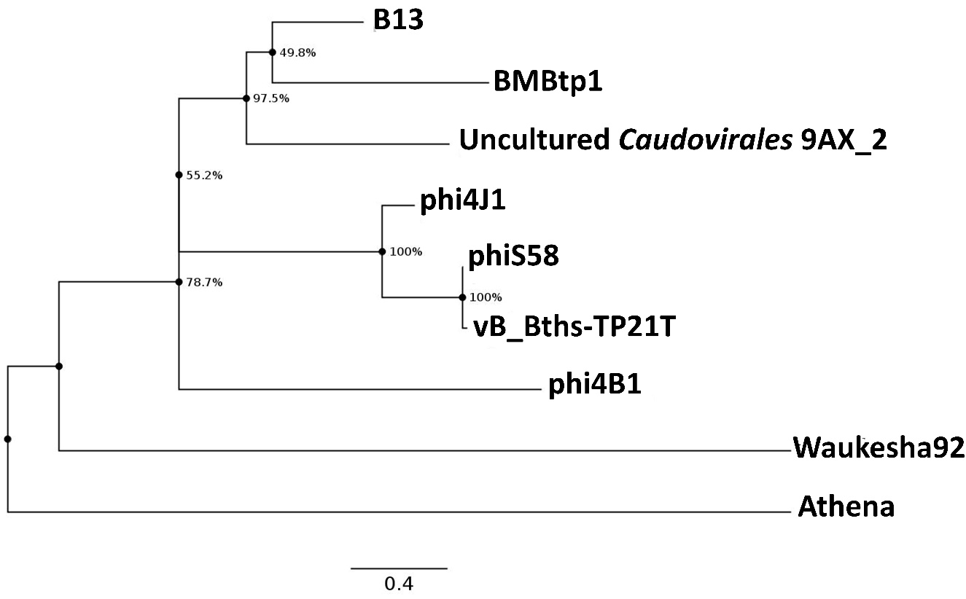
Figure 1 - The Maximum Likelihood phylogram inferred from a ClustalW alignment of the concatenated sequences of all the proteins encoded by B13 and the closest viruses. Node numbers represent bootstrap support values (out of 1000 replicates). Scale bar represents the number of amino-acid substitutions per site.

References
1) Kazantseva OA, Piligrimova EG, Shadrin AM (2022) Novel Bacillus-Infecting Bacteriophage B13—The Founding Member of the Proposed New Genus Bunatrivirus. Viruses 14, 2300.
https://doi.org/10.3390/v14102300
2) Turner D, Kropinski AM, Adriaenssens EM (2021) A roadmap for genome-based phage taxonomy. Viruses 13.3: 506.
https://doi.org/10.3390/v13030506

