

Part 1: TITLE, AUTHORS, APPROVALS, etc

Code assigned: | 2022.087B
Short title: Creation of new genera and species in the family Straboviridae (Caudoviricetes)
Author(s) and email address(es)
Millard A, Puxty R | Adm39@le.a.cuk;r.puxty@warwick.ac.uk;
Author(s) institutional address(es) (optional)
University of Leicester,UK [AM]
University of Warwick, UK [RP]

Corresponding author
Andrew Millard
List the ICTV Study Group(s) that have seen this proposal

Bacterial Viruses Subcommittee, Tevenvirinae Study Group

ICTV Study Group comments and response of proposer

ICTV Study Group votes on proposal

Study Group | Number of members
Study Group | Votes support | Votes against | No vote
Teven phages | 2 | 0 | 0
Authority to use the name of a living person

Is any taxon name used here derived from that of a living person (Y/N) | N

Taxon name | Person from whom the name is derived | Permission attached (Y/N)

Submission dates
Date first submitted to SC Chair | May 2022
Date of this revision (if different to above)
ICTV-EC comments and response of the proposer

Part 2: NON-TAXONOMIC PROPOSAL
Text of proposal

Part 3: TAXONOMIC PROPOSAL
Name of accompanying Excel module
2022.087B.N.v1.Straboviridae_update.xlsx
Abstract

Building on the recent description of the Straboviridae family, this adds further species to existing genera within the Straboviridae.

Text of proposal
Species demarcation criteria: Two phages are assigned to the same species if their genomes are more than 95% identical over their genome length for isolates using VIRIDIC

Genus demarcation criteria: In search for criteria that create cohesive and distinct genera that are reproducible and monophyletic, the Bacterial Viruses Subcommittee has established 70% nucleotide identity of the genome length as the cut-off for genera. Genus-level groupings should always be monophyletic in the signature genes, as tested with a phylogenetic tree [1]. Comparative genomic similarity was calculated with VIRIDIC[2]. Trees were created using ViPTree standalone version, using default settings [3], that builds on the original Phage Proteomic tree developed by Rohwer and Edwards [4]

Supporting evidence

Origin of the name of this taxon:
Kanagawavirus threeohfive (Kosakonia phage 305)
Kanagawavirus eclm (Enterobacter phage vB_EclM_Q7622)
Kanagawavirus mime (Enterobacter phage vB_EhoM-IME523)

Genome summary:

Phage name | INSDC | Size (Kb) | GC% | CDS | tRNA | Overall % homologous proteins (**)
Kosakonia phage 305 | MZ348423 | 174.78 | 40 | 292 | 7 | 47
Enterobacter phage vB_EclM_Q7622 | MN087708 | 172.763 | 40 | 298 | 8 | 47
Enterobacter phage vB_EhoM-IME523 | OL989991 | 173.871 | 40 | 305 | 8 | 47

Top BLASTn hits of Kosakonia phage 305 .

Description | Query Cover | Per. Ident | Acc. Len | Accession | ICTV Taxa
Enterobacter phage vB_EclM_Q7622, complete genome | 90% | 95.05% | 173871 | OL989991.1
Enterobacter phage vB_EhoM-IME523 | 90% | 95.21% | 172763 | MN087708.1
Enterobacter phage vB_EclM_CIP9, complete genome | 89% | 92.73% | 174924 | NC_048849.1 | Kanagawavirus
Enterobacter phage ENC9, partial genome | 89% | 94.77% | 173639 | OL355124.1
Pectobacterium bacteriophage PM2, complete genome | 29% | 77.64% | 170286 | KF835987.1

VIRIDIC heat map: VIRIDIC (Virus Intergenomic Distance Calculator) heatmap was computed using genomes that are currently within the genus Kanagawavirus and top blast hits.

Phylogenetic analysis

Phylogenetic analysis was carried out with VipTree [3] using default settings, and visualised in iTOL [5]. Phages 305, vB_EclM_Q7622 and vB_EhoM-IME523 form a monophyletic clade with other phages in the genus Kanagawavirus [Green shaded box]. Combined with the VIRIDIC analysis above, three new species within the genus Kanagawavirus are described. Phages within this genus share a core-gene content of 47 genes as determined by analysis using ROARY with settings of 90% identity [6].

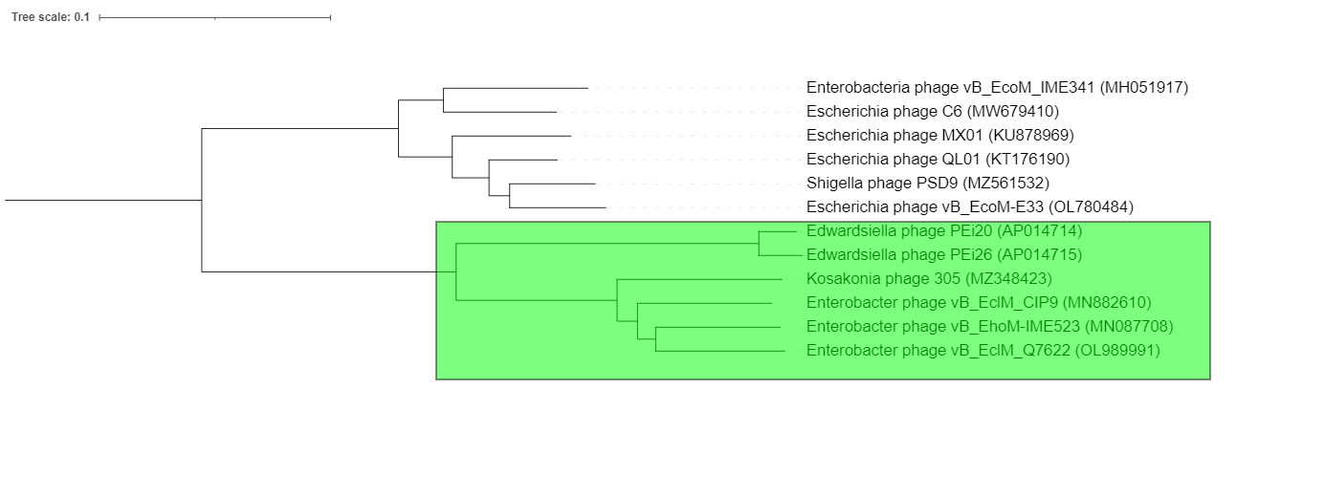

Origin of the name of this taxon:

“Moonvirus kayemsixteen” named after the isolate Salmonella phage KM16 within the genus Moonvirus

VIRIDIC heat map: VIRIDIC (Virus Intergenomic Distance Calculator) heatmap was computed using genomes that are currently within the genus Moonvirus which were identified by comparison of the genome by mash analysis against a database of compete phage genomes [7].

genome | KT001915 | MW325771.1 | KM236240 | MG250484
KT001915 | 100 | 83.097 | 85.368 | 87.337
MW325771.1* | 83.097 | 100 | 85.66 | 86.87
KM236240 | 85.368 | 85.66 | 100 | 89.471
MG250484 | 87.337 | 86.87 | 89.471 | 100

KM16 has >70% ANI with other phages classified within Moonvirus and <95% ANI with any phage assigned an existing species

Genome summary:

Phage name | INSDC | Size (Kb) | GC% | Protein | tRNA | Overall % homologous proteins (**)
Salmonella phage KM16 | MW325771 | 170.126 | 38.613 | 278 | 14 | 175

Phylogenetic analysis was carried out with VipTree [3] using default settings, and visualised in iTOL [5]. Phage KM16 forms a monophyletic clade with phage Merlin, Moon and CF1 [Pink shaded box]. Combined with the VIRIDIC analysis above phage KM16 represents the first isolate of a new species within the genus Moonvirus. The four phages within this gene share a core-gene content of 173 genes as determined by analysis using ROARY with settings of 90% identity [6]

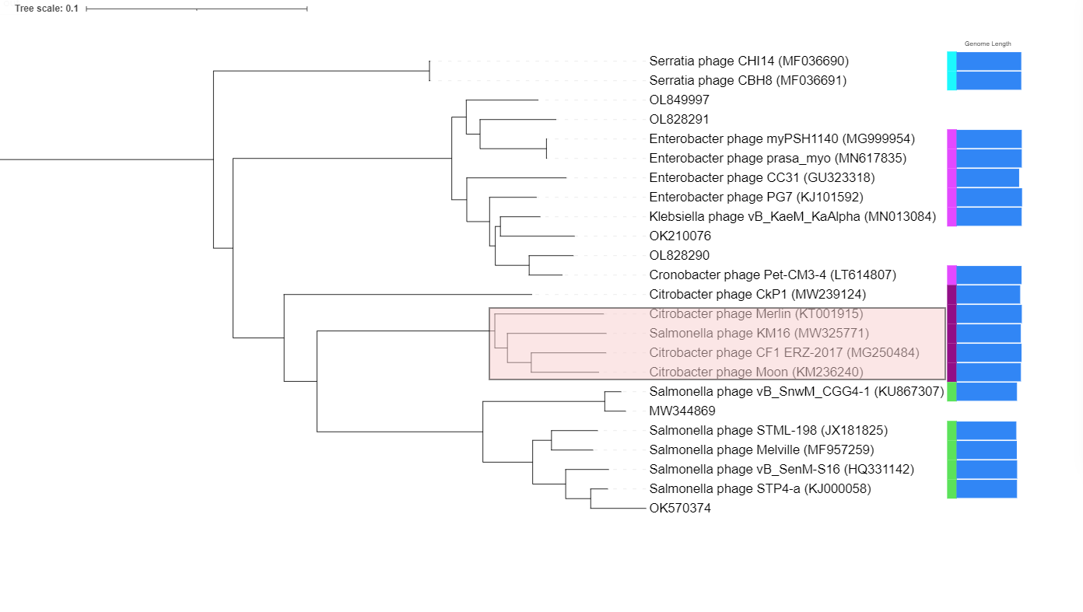

Origin of the name of this taxon:

Creation of one new species within the genus Gaprivervirus

Gaprivervirus arezed
Genome summary:

Phage name | INSDC | Size (Kb) | GC% | Protein | tRNA | Overall % homologous proteins (**)
Escherichia phage vB_EcoM_RZ | MW598459 | 170318 | 40.147 | 290 | 2 | 140

VIRIDIC heat map: VIRIDIC (Virus Intergenomic Distance Calculator) heatmap was computed using genomes that are currently within the genus Gaprivervirus.

Phages have >70% ANI with other phages classified within Gaprivervirus and <95% ANI

Phylogenetic analysis was carried out with VipTree [3] using default settings, and visualised in iTOL [5]. A phylogeny was constructed from top hits from mash analysis and all phages currently classified within the genus Gaprivervirus. The new genomes form a single clade with other phages classified as Gaprivervirus [Pinkish shaded box below]. Genomic comparison of all genomes in this monophyletic group using ROARY with settings of 90% identity [6], results in a core set of 140 genes.
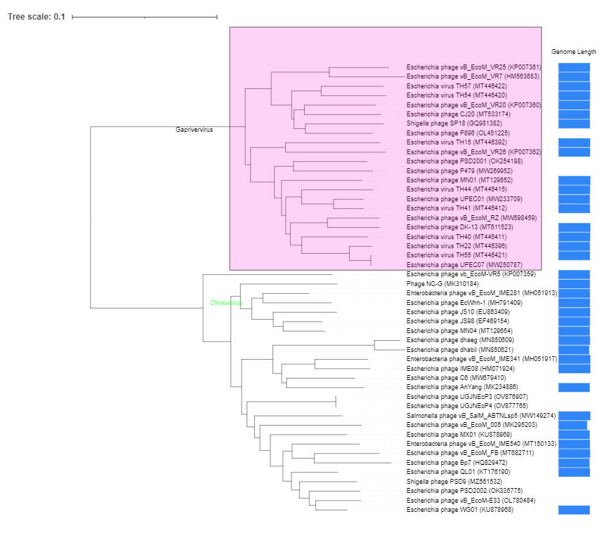

References

1. Turner D, Kropinski AM, Adriaenssens EM (2021) A roadmap for genome-based phage taxonomy. Viruses 13:. https://doi.org/10.3390/v13030506
2. Moraru C, Varsani A, Kropinski AM (2020) VIRIDIC — A Novel Tool to Calculate the Intergenomic Similarities of. Viruses 12:1268
3. Nishimura Y, Yoshida T, Kuronishi M, et al (2017) ViPTree: The viral proteomic tree server. Bioinformatics. https://doi.org/10.1093/bioinformatics/btx157
4. Rohwer F, Edwards R (2002) The phage proteomic tree: A genome-based taxonomy for phage. J Bacteriol. https://doi.org/10.1128/JB.184.16.4529-4535.2002
5. Letunic I, Bork P (2007) Interactive Tree Of Life (iTOL): An online tool for phylogenetic tree display and annotation. Bioinformatics 23:127–128. https://doi.org/10.1093/bioinformatics/btl529
6. Page AJ, Cummins C a., Hunt M, et al (2015) Roary: rapid large-scale prokaryote pan genome analysis. Bioinformatics 31:3691–3693. https://doi.org/10.1093/bioinformatics/btv421
7. Cook R, Brown N, Redgwell T, et al (2021) INfrastructure for a PHAge REference Database: Identification of Large-Scale Biases in the Current Collection of Cultured Phage Genomes. PHAGE. https://doi.org/10.1089/phage.2021.0007

